
CS4135 – Software Architectures Project
Assignment 2: Requirements and UML Documentation
Group 6
22356843 Shane Hanley
22348573 Niall Roche
22353364 Darragh O' Sullivan
22345272 Joseph Fitzgerald
Department of Computer Science and Information Systems
Faculty of Science and Engineering
University of Limerick

Table of Contents
Table of Contents 1
1. Project Overview 2
2. Team Members' Contribution 3
3. Architecture Style Identification 5
3.1 Primary Style: Microservices Architecture 6
3.2 Supporting Style: Event-Driven Architecture 6
3.3 Frontend Architecture 6
3.4 Justification 6
4. Requirements Analysis & Condensed SRS 6
4.1 Functional Requirements 7
4.1.1 User Authentication & Authorisation 7
4.1.2 Prescription Management 7
4.1.3 Inventory Management 7
4.1.4 Notification Service 7
4.1.5 Billing 7
4.1.6 Analytics 7
4.2 Non-Functional Requirements 7
4.3 Scope Prioritization and Implementation Constraints 8
4.4 Use Cases Summary 8
5. UML Domain Model – Class Diagram 9
6. Component Diagram 10
7. Workflow / Process Diagram 11
8. Conclusion 11
9. Appendices 12
Appendix A: GitHub Repository 13
Appendix B: Wiki & Project Planner 13
Appendix C: Technology Stack Summary 13

1. Project Overview
The Pharmacy Management Prescription Tracking System is a full-stack pharmacy platform designed to manage the complete prescription lifecycle, inventory, billing, and patient engagement for community and hospital pharmacies. The system supports key stakeholders including prescribers, pharmacists, pharmacy technicians, patients, managers, and system administrators.
At a high level, the system enables prescribers to send electronic prescriptions to a selected pharmacy, where pharmacists and technicians can validate, clinically review, fill, and prepare medications for pickup or delivery. Patients receive automated notifications as their prescription moves through statuses such as "New", "Processing", "Ready for Pickup", or "Rejected". The platform also provides billing and analytics capabilities, helping pharmacies manage payments, track key performance indicators, and monitor controlled substances.
The frontend is implemented using React with functional components, React hooks, and Redux Toolkit for global state management. It provides role-specific dashboards and protected routes for patients, pharmacists, and managers, while handling asynchronous API calls and error states (pending, fulfilled, rejected) in a consistent manner. A responsive layout with shared navigation, strict form validation, and environment-based configuration (.env) supports a production-ready user experience.
The backend is built as a set of Spring Boot microservices, fronted by a Spring Cloud API Gateway that acts as the single-entry point from the frontend. Core services include User, Prescription, Patient, Inventory, Billing, Order Fulfillment, Notification, Analytics, and the API Gateway itself. These services use a layered architecture (Controller, Service, Repository), Data Transfer Objects (DTOs), Spring Data JPA, and Bean Validation to ensure separation of concerns and data integrity. Security is implemented via stateless JWT-based authentication, with role-based access control (RBAC) enforced using method-level annotations. Inter-service communication uses REST for synchronous operations and RabbitMQ/Kafka for asynchronous messaging.

2. Team Members' Contribution
All group members contributed equally to the development of this document.

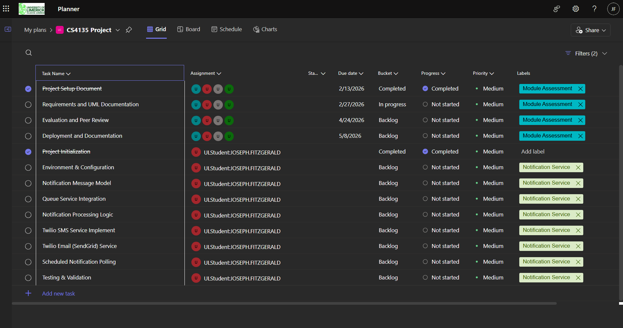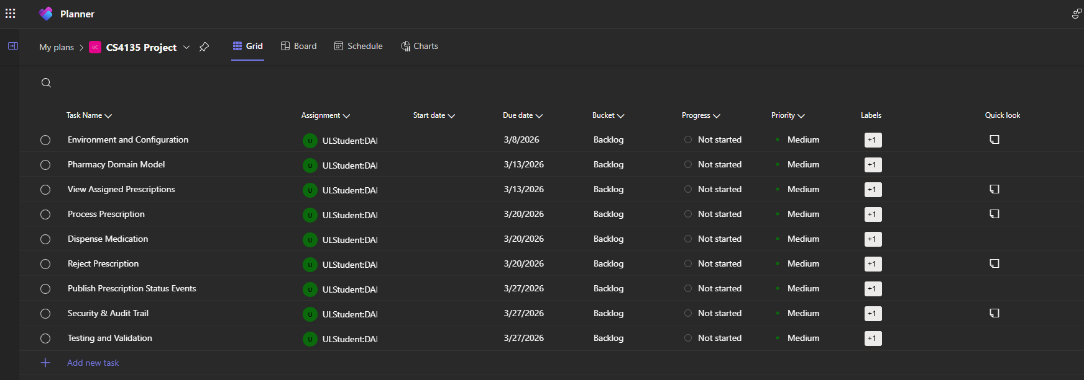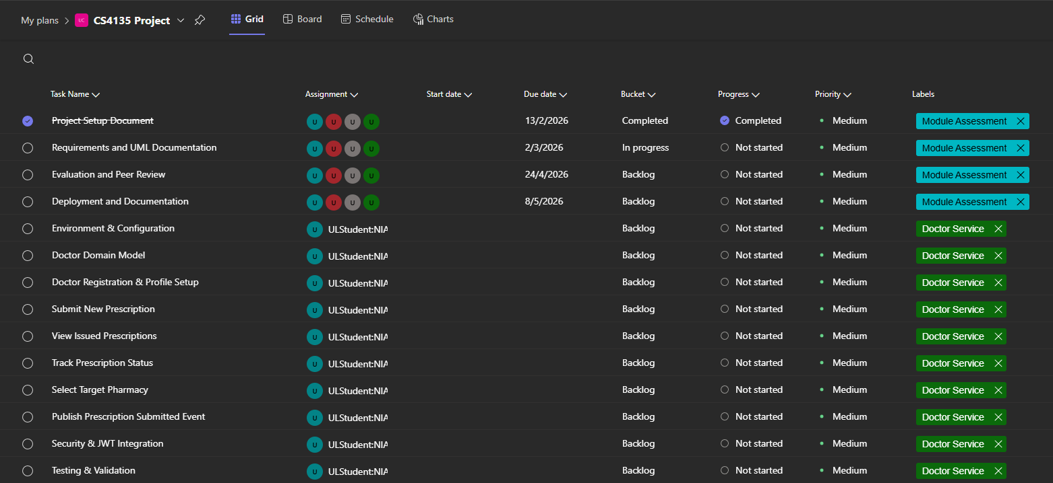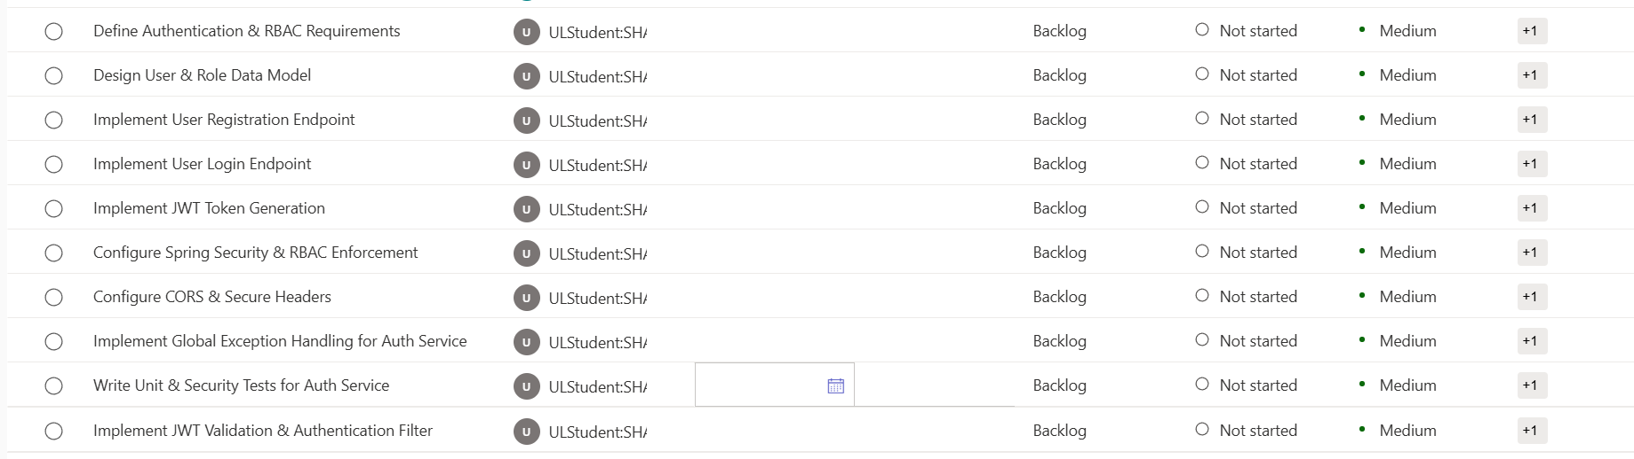

Student | Student ID | Service / Module | Responsibilities
Shane Hanley | 22356843 | User Authentication & Authorization Service | User registration & login, Role-Based Access Control (RBAC), JWT token generation & validation. Tech: Node.js + Express, JWT, BCrypt, PostgreSQL.
Niall Roche | 22348573 | Doctor Service | Doctor dashboard, sending prescriptions, tracking prescription status. Endpoints: GET/POST /doctor/prescriptions, GET /doctor/prescriptions/:id/status.
Darragh O' Sullivan | 22353364 | Pharmacy Service | Pharmacy dashboard, view & process prescriptions, update prescription status, trigger Notification Service. Endpoints: GET/PUT /pharmacy/prescriptions/:id/status.
Joseph Fitzgerald | 22345272 | Notification Service | Send email/ sms notifications on prescription status changes, integrate with SMTP providers (Gmail, SendGrid), queue-based system using RabbitMQ or Kafka.

3. Architecture Style Identification
The Pharmacy Management Prescription Tracking System employs a Microservices Architecture as its primary architectural style, complemented by an event-driven messaging layer for asynchronous inter-service communication.

3.1 Primary Style: Microservices Architecture
The system decomposes its functionality into a suite of independently deployable, loosely coupled services. Each service owns its own domain and database, communicates over well-defined REST APIs, and can be scaled independently. The core services are:
- User Service – handles authentication, authorisation, and JWT token management.
- Prescription Service – manages the full prescription lifecycle.
- Patient Service – manages patient profiles and history.
- Inventory Service – tracks medication stock levels and triggers reorder events.
- Billing Service – generates invoices and records payments.
- Notification Service – sends asynchronous email notifications via SMTP.
- Analytics Service – aggregates metrics on prescription volumes and revenue.
- API Gateway – serves as the single-entry point, routing and authenticating all client requests.

This decomposition follows the Single Responsibility Principle at the service level: each service aligns with a distinct business capability, enabling independent development and deployment by individual team members.

3.2 Supporting Style: Event-Driven Architecture
Asynchronous communication between services is implemented via RabbitMQ or Kafka message brokers. When a prescription changes status, the Prescription Service publishes an event to the message queue. The Notification Service subscribes to these events and dispatches the appropriate email to the patient. Similarly, inventory deduction events are published when a prescription is dispensed. This decoupling improves system resilience and scalability, as the Notification Service can process messages at its own pace without blocking the Prescription Service.

3.3 Frontend Architecture
The React frontend follows a Flux/Redux architecture pattern, where all application state is managed in a centralised Redux store. Components dispatch actions, which are handled by Redux Toolkit slices. Asynchronous operations use createAsyncThunk to model pending, fulfilled, and rejected states explicitly. Protected routes and role-based rendering ensure the correct views are shown to each user type (Doctor, Pharmacist, Patient, Manager).

3.4 Justification
The microservices style was selected because the system's four student developers can independently own and develop individual services without risk of merge conflicts on a monolithic codebase. It also mirrors real-world pharmacy IT systems, which require high availability of the prescription and notification workflows even if ancillary services (e.g., analytics) are temporarily unavailable. The API Gateway ensures a consistent security boundary across all services.

4. Requirements Analysis & Condensed SRS

4.1 Functional Requirements

4.1.1 User Authentication & Authorisation
- FR-1: The system shall allow users to register with a unique email, password, and role (Doctor, Pharmacist, Patient, Admin).
- FR-2: The system shall authenticate users via a username/password login and return a signed JWT access token.
- FR-3: The system shall enforce role-based access control on all protected endpoints using JWT claims.
- FR-4: The system shall invalidate sessions upon logout and reject expired tokens.

4.1.2 Prescription Management
- FR-5: A Doctor shall be able to submit a new prescription specifying medication, dosage, patient contact details, and target pharmacy.
- FR-6: A Doctor shall be able to view a list of all prescriptions they have issued and their current statuses.
- FR-7: A Pharmacist shall be able to view all prescriptions assigned to their pharmacy with a status of 'New'.
- FR-8: A Pharmacist shall be able to update the status of a prescription to: Processing, Ready for Pickup, or Rejected (with reason).
- FR-9: The system shall persist a full audit trail of all prescription status transitions.

4.1.3 Inventory Management
- FR-10: The system shall maintain a lot-based stock record for each medication at each pharmacy.
- FR-11: When a prescription is dispensed (status set to Ready for Pickup), the system shall automatically deduct the prescribed quantity from the inventory.
- FR-12: When stock falls below the configured reorder threshold, the system shall generate a low-stock event.

4.1.4 Notification Service
- FR-13: The system shall send an automated email to the patient when their prescription transitions to New, Processing, Ready for Pickup, or Rejected.
- FR-14: Notifications shall be dispatched asynchronously via a message queue (RabbitMQ/Kafka) to decouple the Prescription Service from email sending.

4.1.5 Billing
- FR-15: Upon a prescription reaching Ready for Pickup status, the Billing Service shall generate an invoice record.
- FR-16: The system shall allow a Pharmacist or Manager to record payment against a billing record.

4.1.6 Analytics
- FR-17: A Manager shall be able to view a dashboard showing prescription volume, revenue, and controlled substance metrics over configurable date ranges.

4.2 Non-Functional Requirements
- NFR-1 Security: All API endpoints (except login/register) shall require a valid JWT token. Passwords shall be hashed using BCrypt. CORS shall be restricted to the configured React frontend origin.
- NFR-2 Scalability: Each microservice shall be independently scalable. The message queue shall buffer spikes in notification demand.
- NFR-3 Reliability: Global exception handling (ControllerAdvice) shall return standardised JSON error responses for all 4xx and 5xx errors. The system shall handle 401 Unauthorized responses gracefully, redirecting users to the login page.
- NFR-4 Maintainability: All services shall follow a strict layered architecture (Controller → Service → Repository) with DTOs decoupling API contracts from JPA entities. Bean Validation shall enforce input constraints.
- NFR-5 Observability: OpenAPI/Swagger documentation shall be available for all REST endpoints. Meaningful commit messages and a branching strategy (feature branches per service) shall be maintained in the GitHub repository.
- NFR-6 Persistence: The system shall use PostgreSQL (or H2 for local testing) with Spring Data JPA. All entities shall include audit fields (createdAt, updatedAt) and appropriate relational constraints.
- NFR-7 Usability: The React frontend shall implement consistent error messaging, loading indicators for async operations, and redirect logic for unauthorised access.

4.3 Scope Prioritization and Implementation Constraints
Due to the academic timeframe and team size (four developers), the system requirements have been prioritised according to core business value.
The Prescription Management, User Authentication, and Notification workflows are considered core functional requirements and represent the minimum viable product (MVP) necessary to demonstrate the system’s primary objective: managing the end-to-end prescription lifecycle.
The Inventory Management and Billing services, while architecturally designed and documented as independent microservices, are considered secondary (non-essential) features within the scope of this project. These services enhance realism and reflect real-world pharmacy systems; however, they are not critical to demonstrating the primary prescription workflow.
In an ideal production-ready implementation, Inventory and Billing would be fully implemented and integrated. However, given time constraints, these services may be:
- Implemented in a simplified or stubbed form, or
- Architecturally designed but only partially implemented
This prioritisation ensures that the core prescription submission, processing, and notification pipeline remains fully functional even if ancillary services are reduced in scope.

4.4 Use Cases Summary
UC # | Actor | Use Case | Brief Description
UC-01 | Doctor | Submit Prescription | Doctor selects a pharmacy, enters patient and medication details, and submits a new prescription.
UC-02 | Doctor | Track Prescription | Doctor views the current status of any prescription they have issued.
UC-03 | Pharmacist | Process Prescription | Pharmacist reviews a new prescription, checks inventory, and sets status to Processing.
UC-04 | Pharmacist | Dispense Medication | Pharmacist confirms medication is ready, triggering stock deduction, invoice generation, and patient notification.
UC-05 | Pharmacist | Reject Prescription | Pharmacist marks a prescription as Rejected with an optional reason, notifying the patient.
UC-06 | Patient | View Prescriptions | Patient views all active prescriptions and their current statuses.
UC-07 | Patient | Receive Notification | Patient receives an automated email at each prescription status change.
UC-08 | Admin | Manage Users | Admin can create, update, or deactivate user accounts and reassign roles.
UC-09 | Manager | View Analytics | Manager views dashboard KPIs: prescription volumes, revenue, and controlled substance metrics.

5. UML Domain Model – Class Diagram
The class diagram below models the core domain entities of the Pharmacy Management System and their relationships. The User base class is extended by Doctor, Pharmacist, and Patient, capturing the role-based identity of each actor. The Prescription entity sits at the centre of the domain, linked to its issuing Doctor, owning Patient, and processing Pharmacist. Prescription status transitions are captured by the PrescriptionStatus enumeration. Peripheral entities — InventoryItem, BillingRecord, and Notification — are triggered by or associated with Prescription lifecycle events.

NOTE: Billing and inventory management are included in the UML diagram but may not be implemented in the project. See section 4.3 for more details.

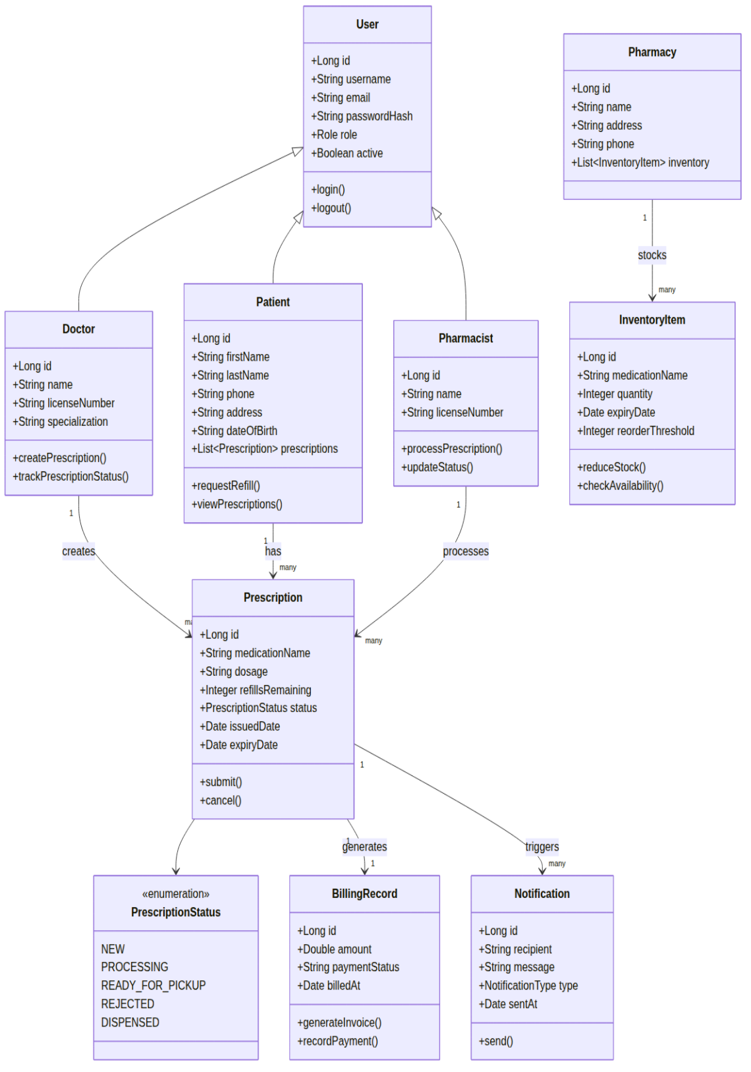

Figure 1: UML Domain Model Class Diagram — Pharmacy Management Prescription Tracking System

6. Component Diagram
The component diagram below illustrates the high-level architectural decomposition of the system. The React frontend communicates exclusively through the Spring Cloud API Gateway, which validates JWT tokens before routing requests to the appropriate microservice. Synchronous communication between services occurs via REST. Asynchronous communication — particularly prescription status events consumed by the Notification Service — is mediated through RabbitMQ or Kafka. Each service persists its data in an isolated PostgreSQL database, adhering to the Database-per-Service pattern of microservices architecture.

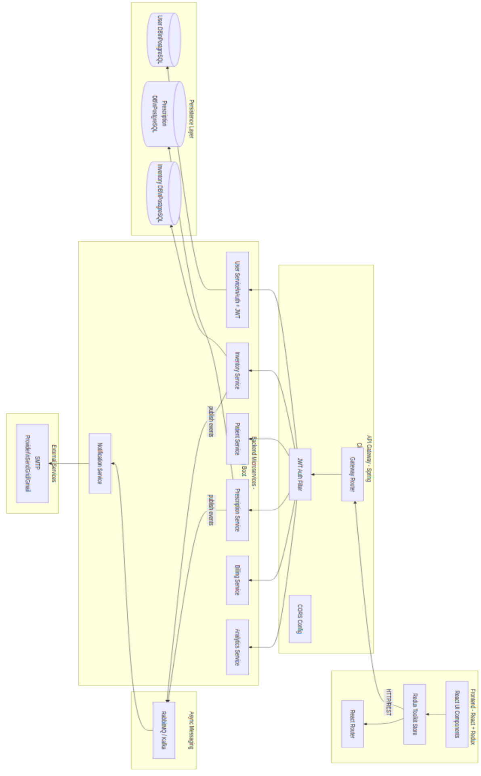Figure 2: System Component Diagram — Microservices Architecture with API Gateway and Messaging Layer

7. Workflow / Process Diagram
The sequence diagram below illustrates the primary prescription workflow — from a Doctor submitting a new prescription through to the Patient receiving a 'Ready for Pickup' notification. Key interactions shown include the API Gateway's routing and authentication responsibilities, the Prescription Service's coordination with the Inventory and Billing services upon status updates, and the Notification Service's asynchronous dispatch of emails at each key lifecycle event. This diagram reflects the most critical and representative end-to-end scenario in the system.

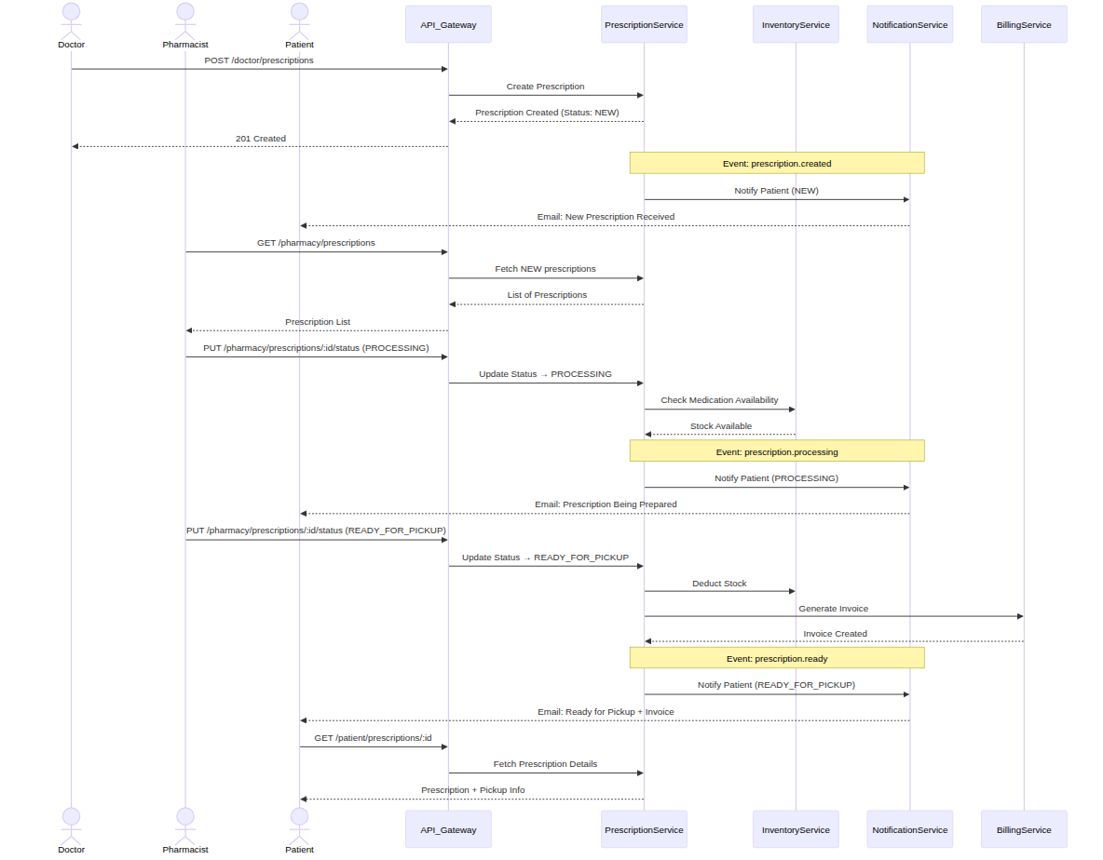
Figure 3: Prescription Lifecycle Sequence Diagram — Doctor Submission to Patient NotifFigure 3: Figure 3: Prescription Lifecycle Sequence Diagram — Doctor Submission to Patient Notification

8. Conclusion
This document has presented a comprehensive requirements and UML documentation package for the Pharmacy Management Prescription Tracking System developed by Group 6. The project's microservices architecture, supported by an event-driven messaging layer, provides a solid foundation that aligns well with both the functional requirements of a real-world pharmacy system and the academic objectives of CS4135.
The requirements analysis demonstrates a clear separation of concerns across authentication, prescription management, inventory, billing, notifications, and analytics — each mapped to a dedicated service and team member. The UML artefacts (class diagram, component diagram, and sequence diagram) collectively provide a complete picture of the system's domain model, structural composition, and dynamic behaviour.
The architecture choices made — Spring Boot microservices, Spring Cloud Gateway, Redux Toolkit on the frontend, and asynchronous messaging via RabbitMQ/Kafka — are well-justified by the need for independent development, scalability, and resilience. Going forward, the team will build on this documentation as the reference specification during implementation, ensuring that the delivered system remains aligned with the design intent captured here.

9. Appendices

Appendix A: GitHub Repository
Repository: https://github.com/ShaneHanley/CS4135-Project

Appendix B: Wiki & Project Planner
Wiki: https://github.com/ShaneHanley/CS4135-Project/wiki
Microsoft Planner: https://planner.cloud.microsoft/webui/v1/plan/GwUPy9Dg-E-eI9f3jqD2z5cAHaZW

Appendix C: Technology Stack Summary
Layer | Technology | Purpose
Frontend | React, Redux Toolkit, React Router | UI components, global state, client-side routing
API Gateway | Spring Cloud Gateway | Single entry point, JWT filter, routing
Backend Services | Spring Boot (Java) | Business logic, REST APIs, layered architecture
Security | JWT, BCrypt, Spring Security | Stateless auth, password hashing, RBAC
Messaging | RabbitMQ / Kafka | Async event-driven communication
Persistence | PostgreSQL, Spring Data JPA | Relational data storage, ORM
Documentation | OpenAPI / Swagger | Live REST API documentation
DevOps | GitHub, Microsoft Planner | Version control, project tracking

