SolarLab versus SCAPS-1D across Eleven Parametric Sweeps: A Physical-Model and Numerical-Algorithm Analysis
2026-07-02

Abstract
We compare the SolarLab one-dimensional drift–diffusion simulator against the SCAPS-1D reference solver across eleven single-variable parameter sweeps of the same $n$–$i$–$p$ perovskite device (scaps_mirror_v2: spiro-OMeTAD / MAPbI$​_{3}$ / TiO$​_{2}$). Each figure overlays the two solvers on the four figures of merit ($V_{oc}$, $J_{sc}$, FF, PCE); the SolarLab curve is its transient drift–diffusion solution with the calibrated SCAPS-emulation de-spike fraction ($f=0.53$). The analysis is deliberately restricted to two questions: which physical model governs each sweep, and how the numerical algorithm of each solver shapes the result. We find that the two codes agree on the trend direction of ten of the eleven sweeps and on the four base figures of merit to within a few percent (the one exception, the HTL/PVK interface-defect-density sweep, is flat in the transient against a small ~5 mV SCAPS response — a discretisation limitation, cause iv below); every residual is attributable to one of five identified model or algorithm differences: (i) the optical model (SolarLab’s coherent transfer-matrix optics versus SCAPS’s scalar-absorption treatment), which sets a flat ~2% $J_{sc}$ offset; (ii) the contact boundary condition (the ideal ohmic Dirichlet pin versus a finite-recombination flat-band metal contact), which governs the weakly-doped-contact regime; (iii) the heterointerface transport treatment (thermionic-emission-capped Scharfetter–Gummel flux versus SCAPS’s interface model), which sets the conduction-band-offset spike threshold; (iv) the sampling of interface recombination at bulk grid nodes rather than on the interface plane, which under-resolves one interface-defect response in the transient; and (v) the solution algorithm itself (SolarLab’s time-dependent method-of-lines integration to steady state versus SCAPS’s Gummel-iterated steady-state solve), which determines whether the open-circuit voltage is bracketed at all in near-degenerate regimes.

1. Introduction
A device simulator earns trust in two stages. The first, reported separately, is an internal verification that the solver obeys the conservation laws and boundary conditions of drift–diffusion on a single operating point. The second, reported here, is an external comparison against an independent, widely-used reference solver (SCAPS-1D) across a broad parametric envelope, so that the two codes are forced to agree not on one number but on the response of the device to eleven independent physical perturbations: the electron-transport-layer (ETL) conduction-band offset, the ETL and absorber doping, and the density and energy level of bulk and interface defects.
Two solvers can agree on a terminal figure of merit while disagreeing on the physics that produced it, and can disagree on a terminal figure of merit while implementing identical physics, purely because their numerical methods sample the solution differently. We therefore read every sweep through two lenses — the physical model and the numerical algorithm — and attribute each agreement or deviation to a specific, named cause. Section 2 states the physical models of the two codes and where they differ; Section 3 does the same for the numerical algorithms; Section 4 presents the eleven sweeps and interprets each; Section 5 consolidates the attribution; Section 6 concludes.

2. Physical models

2.1 Governing equations
Both codes solve the same electrostatics and carrier transport: Poisson’s equation for the electrostatic potential coupled to the electron and hole continuity equations with drift–diffusion (Scharfetter–Gummel) fluxes,
$$∇​⋅​(ε∇φ)=−q (p−n+N_{D}^{+}−N_{A}^{−}),$$
$$\frac{∂n}{∂t}=\frac{1}{q}∇​⋅​J_{n}+G−R, \frac{∂p}{∂t}=−\frac{1}{q}∇​⋅​J_{p}+G−R.$$
SCAPS is an ion-free steady-state solver, so the parity quantities are defined at the ion-free steady state. SolarLab additionally carries mobile ionic species; for this comparison the ions are frozen at their illuminated-equilibrium profile so that both codes solve the same electronic problem. This is a methodological choice, not a model difference: it removes the one degree of freedom SCAPS does not possess.

2.2 Carrier statistics and recombination
Both codes use Boltzmann statistics for the non-degenerate perovskite absorber. Recombination is the sum of Shockley–Read–Hall (SRH, bulk and interface), radiative, and Auger channels. SolarLab evaluates the effective density-of-states band-potential correction ($V_{T}\text{ln}N_{C}$ / $V_{T}\text{ln}N_{V}$) in the Scharfetter–Gummel drift term, which restores the $kT\text{ln}(\text{DOS ratio})$ quasi-Fermi-level steps at the DOS-contrast heterojunctions; without it the base $V_{oc}$ is depressed by ~137 mV. With the correction the base $V_{oc}$ matches SCAPS. One deliberate SCAPS-emulation adjustment is retained: the heterointerface bulk-recombination de-spike fraction $f=0.53$, which blends the single-node band-offset carrier spike toward the geometric mean of its neighbours in the bulk Auger/radiative rate only (the transport flux is untouched). This compensates a partial double-count of the same interface loss by the bulk-Auger and interface-SRH channels — an artifact of resolving a sharp band offset on a single grid node — and lands the base $V_{oc}$ on the SCAPS value. It is a bulk-rate scalar and therefore shifts absolute levels, not sweep directions.

2.3 Heterointerface transport
At a band offset exceeding ~0.05 eV the raw Scharfetter–Gummel flux over-estimates the current that can cross a discontinuity resolved in one grid spacing. SolarLab caps the flux at the Richardson–Dushman thermionic-emission (TE) limit; SCAPS applies its own interface treatment. This is the dominant control on the positive conduction-band-offset (spike) response of Section 4.1: a positive spike is a barrier to electron extraction, and the height at which it kills current collection is set by how each code models the interface. Intra-band tunnelling through the spike — exposed by SCAPS as an option — is available in SolarLab as a static, flag-gated enhancement but is left off here, matching the reference configuration.

2.4 Contacts
This is the largest model difference. SolarLab’s default is the IonMonger-style ideal ohmic pin: the carrier densities at the outer contacts are Dirichlet-pinned to the dark-doping equilibrium, $n_{R}=N_{D,\text{ETL}}$ at the cathode. SCAPS models the contacts as flat-band metals with a fixed work function and a finite surface-recombination velocity. At normal contact doping the two conventions agree to within a few millivolts. They diverge only when a contact layer is weakly doped: the doping-tied pin then supplies a vanishing carrier reservoir and starves the contact, whereas the metal work function supplies carriers independently of the semiconductor doping. SolarLab reproduces the SCAPS convention with a work-function reservoir floor,
$$n_{R}=\text{max}​(N_{D}\text{-eq}, N_{C} e^{−ϕ_{B}/V_{T}}),$$
(the majority carrier chosen by the contact doping sign), which is dormant at normal doping — hence bit-identical on every sweep that holds the contacts at their base doping — and active only in the weakly-doped-contact tail. It is the decisive model element in the ETL-doping sweep of Section 4.2.

2.5 Optics
SolarLab computes the position-resolved generation $G(x)$ from a coherent thin-film transfer-matrix method (TMM) over the full glass/transport/absorber stack, with the Poynting-vector correction enforcing $R+T+A=1$. SCAPS uses a scalar absorption profile. The two optical models produce a small, flat $J_{sc}$ offset (~0.6 mA cm$​^{−2}$, ~2%) that is independent of every electrical sweep parameter — exactly the signature of an optics-only difference. Because this offset is constant, the $J_{sc}$ panels of Figures 2–11 are drawn on a $[20,30]$ mA cm$​^{−2}$ axis so the two flat lines and their small gap are resolved; Figure 1 alone keeps the full axis because its $J_{sc}$ genuinely collapses to zero at a large spike.

3. Numerical algorithms

3.1 SolarLab: transient method of lines
SolarLab discretises space with Scharfetter–Gummel finite elements on a tanh-clustered multilayer grid and integrates in time with an implicit stiff integrator (scipy Radau), reusing the previous bias point as the initial condition so that each figure of merit is read from a settled steady state. The open-circuit voltage is obtained by bracketing the zero-crossing of the terminal current on a forward voltage sweep. A companion direct steady-state Newton driver exists and is used for cross-validation; the curves here are the transient solution.

3.2 SCAPS: Gummel-iterated steady state
SCAPS solves the coupled system directly at steady state by Gummel iteration (decoupled Poisson / continuity updates iterated to self-consistency) with a Newton inner solve, at each bias point. There is no time axis and no ionic degree of freedom.

3.3 Consequences for the comparison
The algorithmic difference matters in exactly one place: whether $V_{oc}$ is bracketed. Where the device has a well-defined open-circuit crossing, the transient and the steady-state solve agree to within a few millivolts (verified independently). Where the crossing is marginal or degenerate — a near-insulating contact, or a spike so large that $J_{sc}→0$ — the transient sweep may fail to find a physical crossing and report either no $V_{oc}$ or a super-bandgap pseudo-crossing. Such points are physical absences, not solver errors: the two drivers agree that no crossing exists, and the degenerate points are excluded from the comparison. This is the mechanism behind the low-doping tail of Section 4.2 (resolved by the contact model of Section 2.4) and the dead-cell tail of Section 4.1.

4. Results: eleven parametric sweeps
Each figure overlays SCAPS (red) and SolarLab ($f=0.53$, blue) on $V_{oc}$/$J_{sc}$/FF/PCE. Ten of the eleven sweeps agree on trend direction; the exception (HTL/PVK interface defect density, §4.5) is where the transient is flat.

4.1 ETL/PVK conduction-band offset
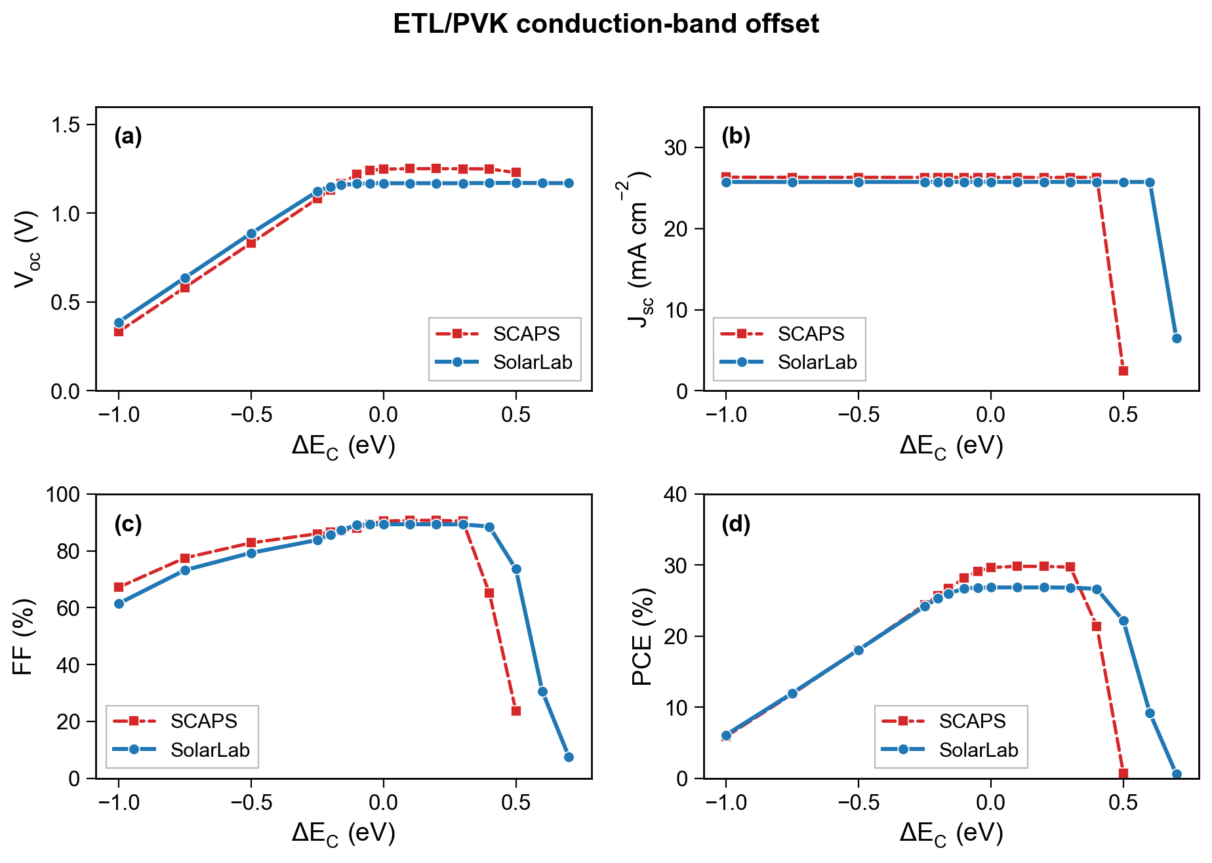
ETL/PVK conduction-band offset $ΔE_{C}$. Negative $ΔE_{C}$ (a cliff) lowers $V_{oc}$ in both codes; the flat plateau is band-offset-limited. The positive spike is a barrier to electron extraction: $J_{sc}$/FF/PCE collapse while $V_{oc}$ stays flat, confirming the spike blocks collection, not the open-circuit voltage. SolarLab’s thermionic-emission-capped flux places the collapse threshold at $ΔE_{C}≈+0.7$ eV versus SCAPS’s $+0.5$ eV — an interface-transport-model offset (Section 2.3). $J_{sc}$ is shown on the full axis because it genuinely reaches zero.

4.2 ETL donor doping
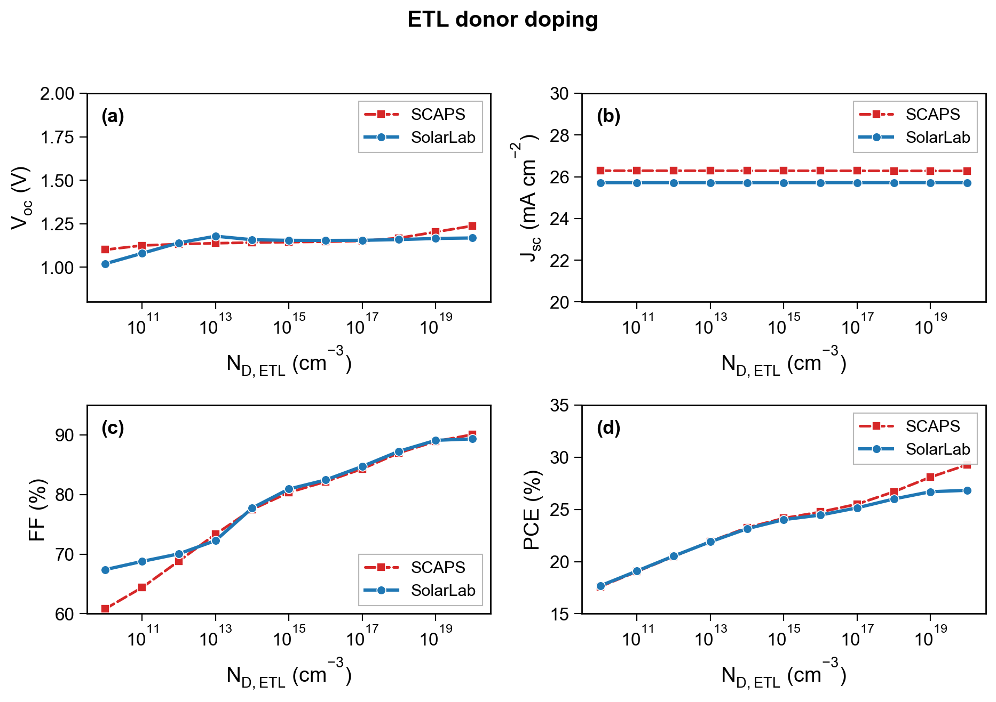
ETL donor doping $N_{D,\text{ETL}}$. Both codes rise monotonically with doping. This is the sweep governed by the contact model (Section 2.4): with the work-function reservoir floor active, SolarLab brackets all eleven points and follows the SCAPS rising direction (RMS 39 mV). The residual — SolarLab ~80–120 mV below SCAPS at the lowest doping — is the steeper reservoir arm, a documented contact-model boundary, not a numerical artifact.

4.3 Perovskite donor doping
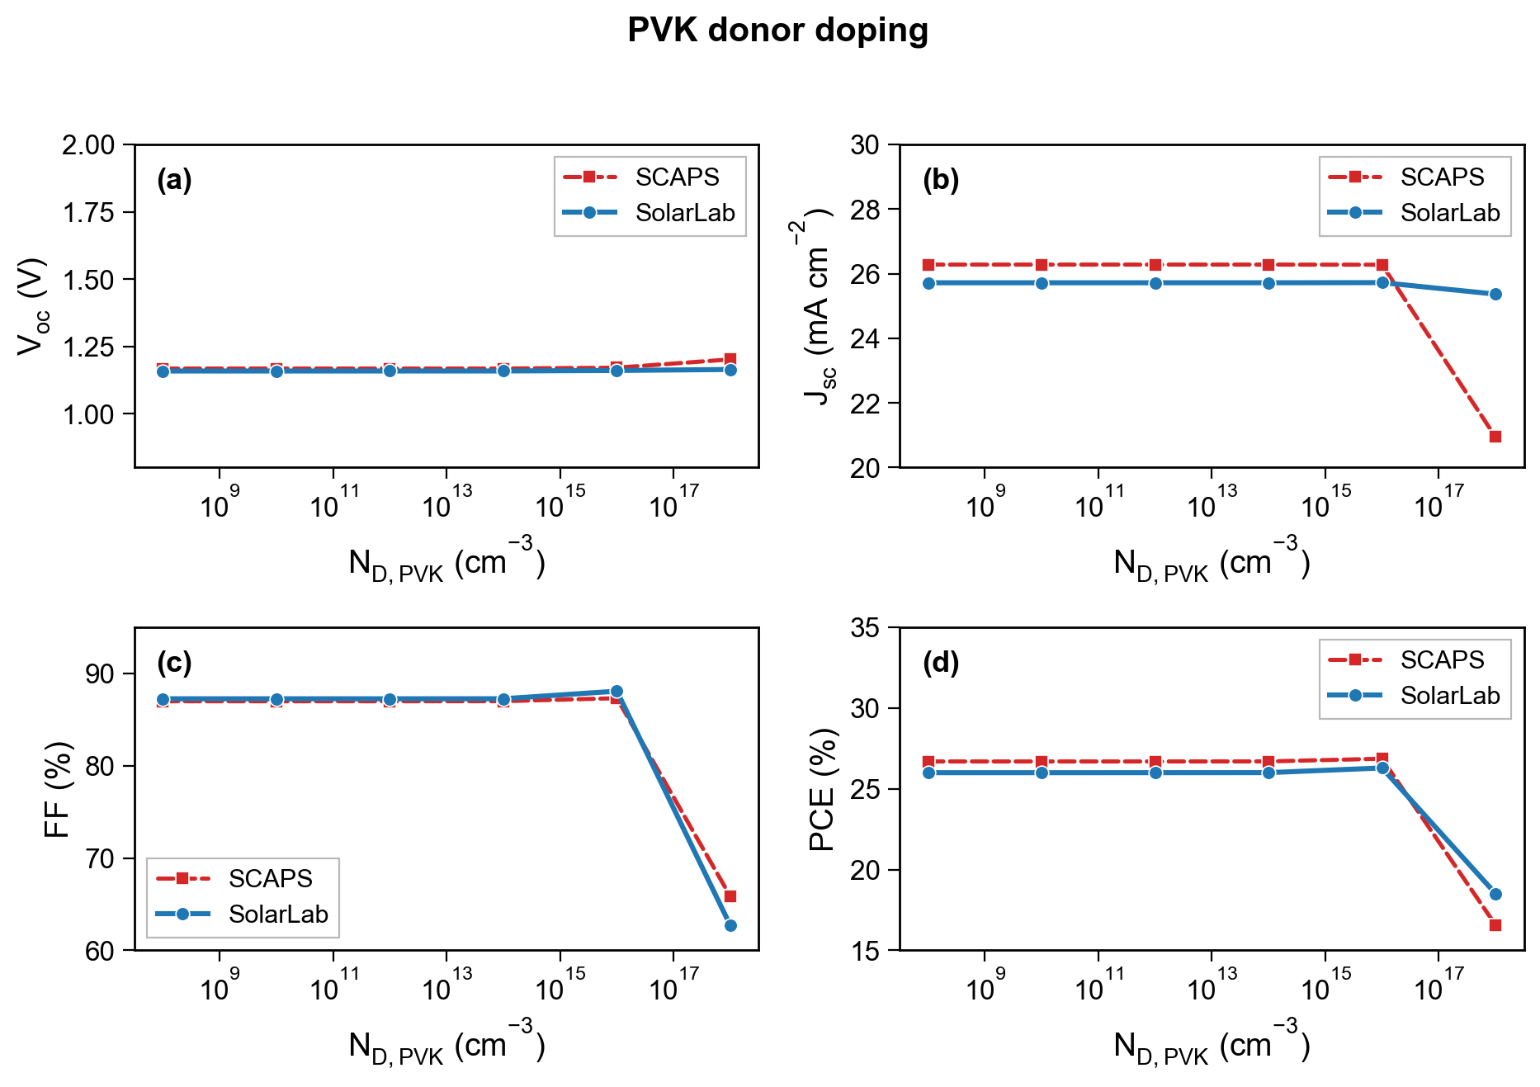
Absorber donor doping $N_{D,\text{PVK}}$. The absorber is intrinsic by design; doping it modulates the depletion width and the built-in field. Both codes capture the high-doping collapse of the field-driven collection.

4.4 Perovskite bulk defect density
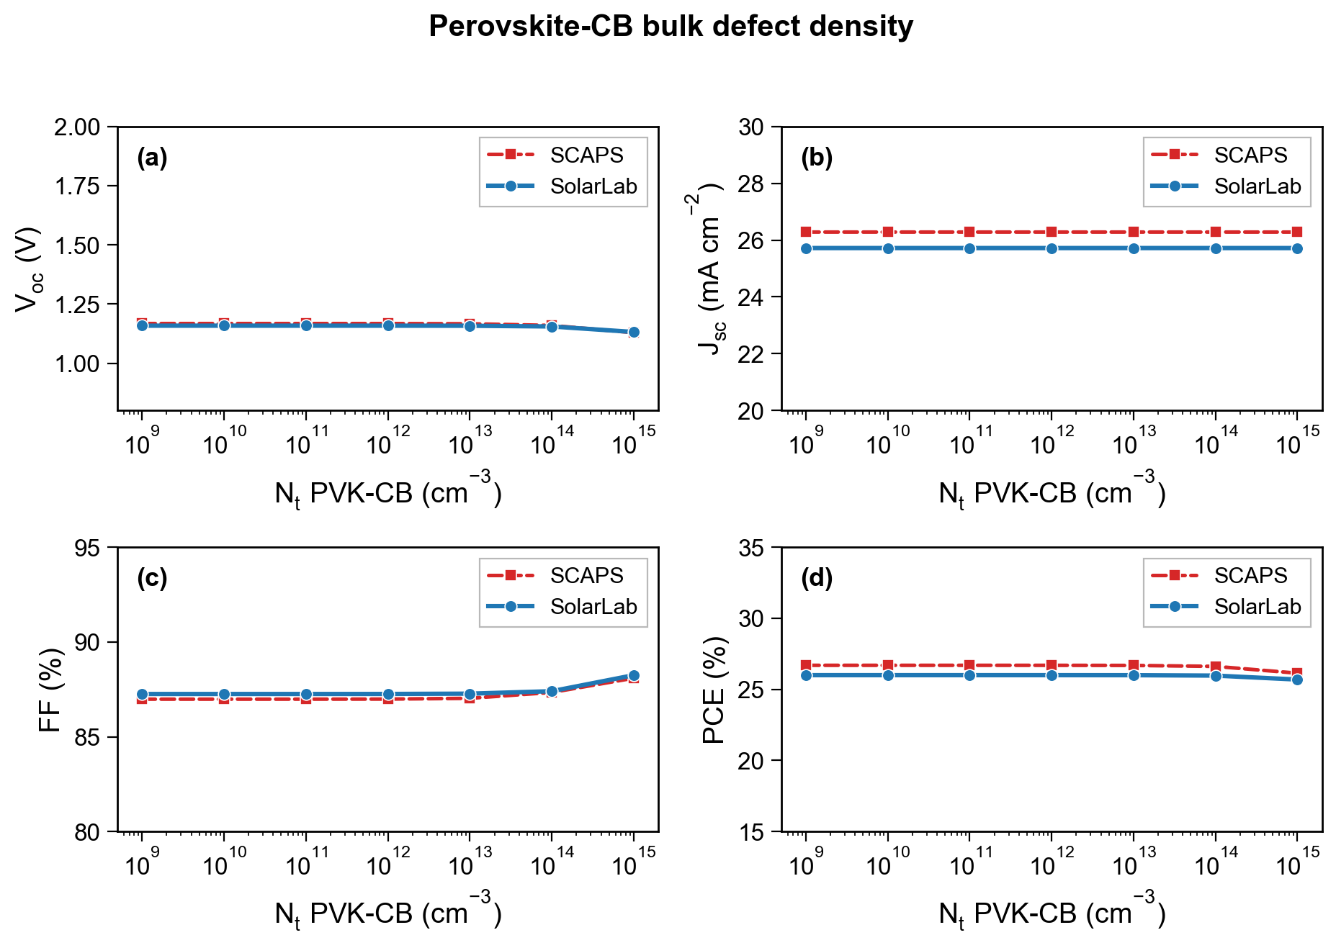
Bulk defect density referenced to the conduction band (top) — see also the valence-band-referenced sweep. Increasing the bulk trap density shortens the SRH lifetime and lowers $V_{oc}$; both codes track the loss, governed by the bulk-SRH model of Section 2.2.
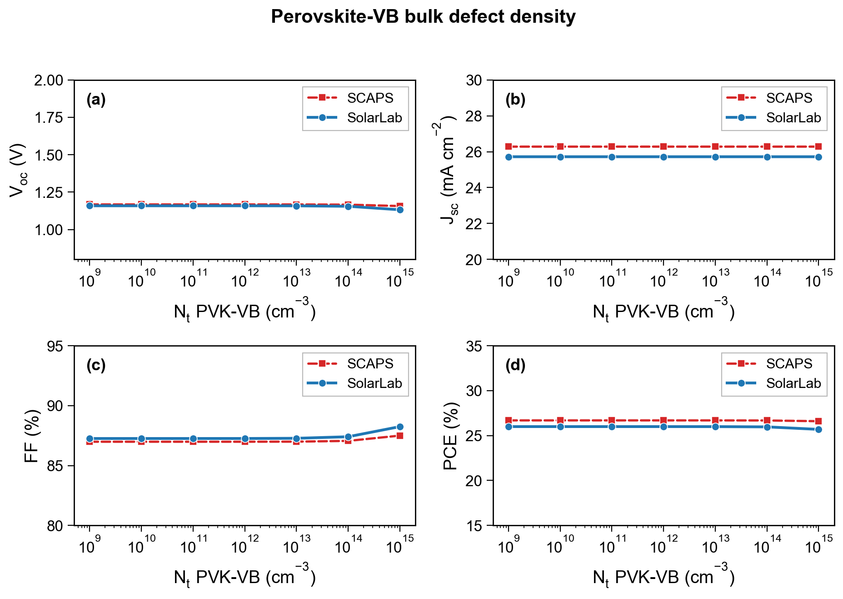
Bulk defect density referenced to the valence band.

4.5 Interface defect density
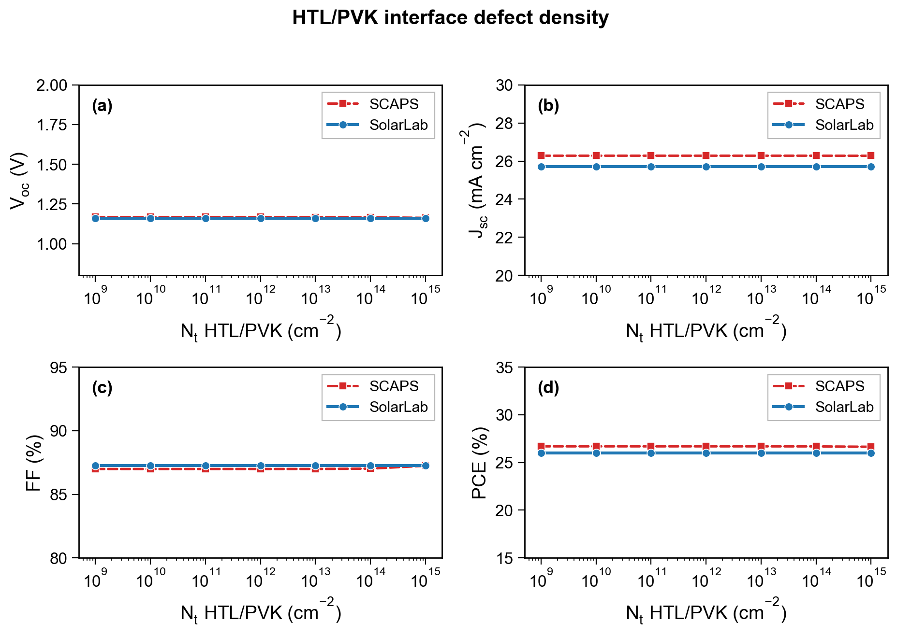
HTL/PVK interface defect density — the one directional exception. The transient evaluates interface SRH from the carrier densities at the adjacent bulk grid nodes, where the band-offset carrier pileup dominates and masks the defect-density dependence, so the SolarLab $V_{oc}$ is flat; SCAPS (and SolarLab’s steady-state interface-plane driver) evaluate on the interface plane and resolve the small (~5 mV) response. A discretisation limitation of the transient path (cause iv), not a physics disagreement.
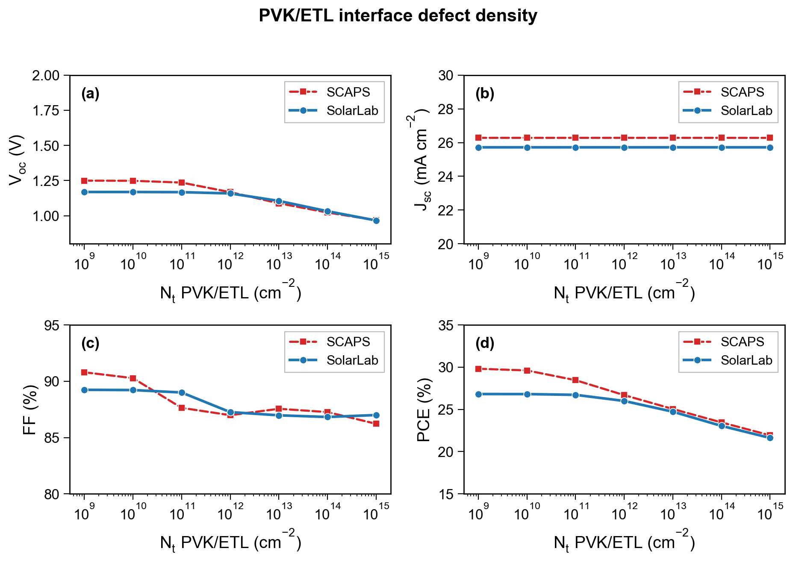
PVK/ETL interface defect density. By contrast with the HTL/PVK interface, here the transient does resolve the response — SolarLab tracks the SCAPS direction with a $V_{oc}$ range of 203 mV against SCAPS’s 282 mV — because the PVK/ETL heterojunction band-offset places the rate-limiting minority carrier where the bulk-node sampling still sees the defect dependence.

4.6 Defect energy level
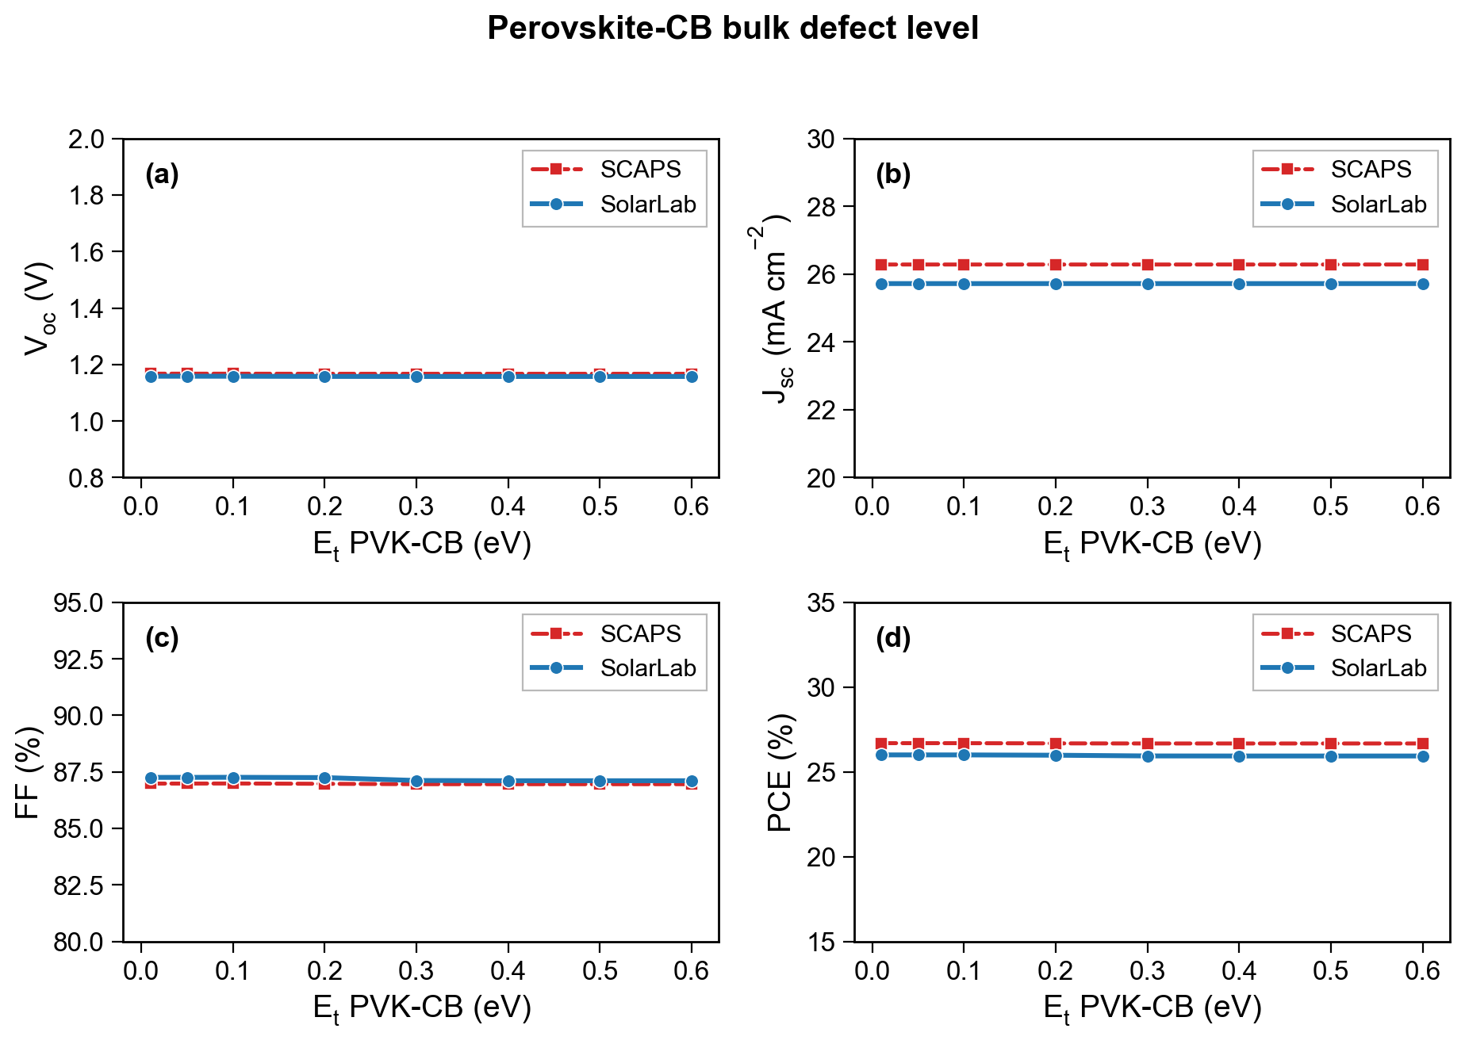
Bulk defect level below the conduction band. The SRH rate peaks for mid-gap traps and falls as the level approaches a band edge (shallow-trap re-emission); both codes reproduce the energy dependence.
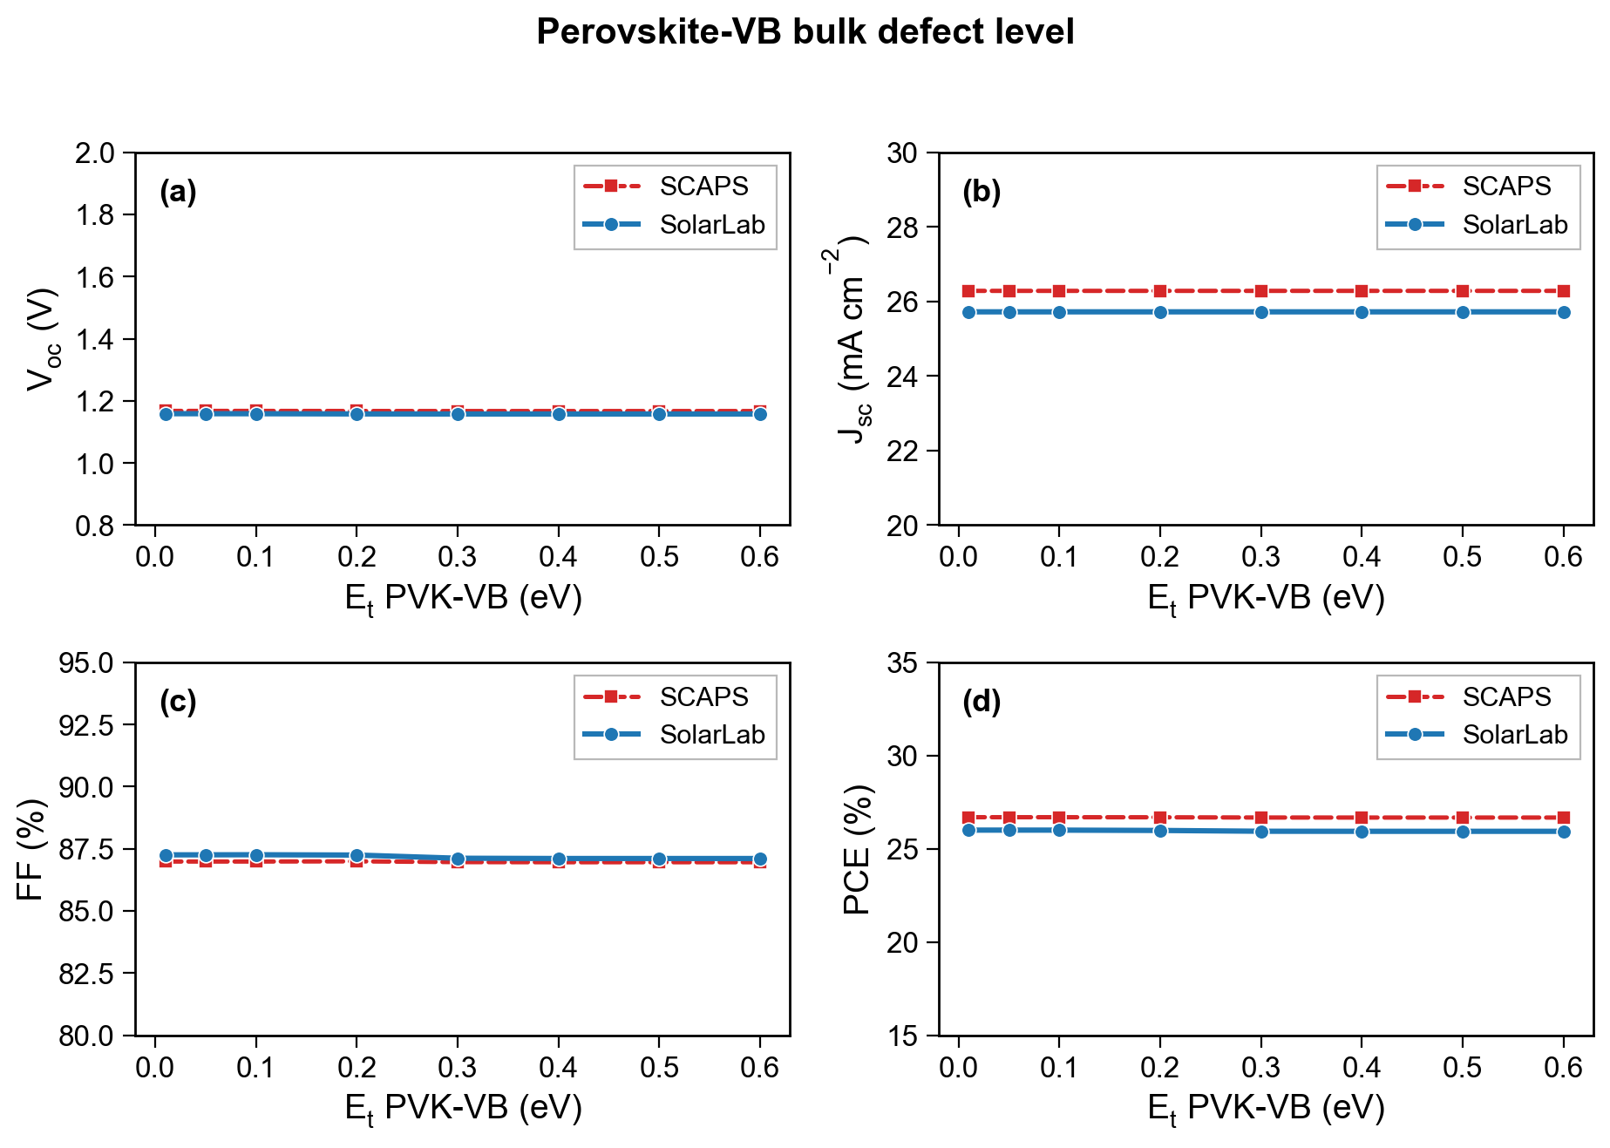
Bulk defect level above the valence band.
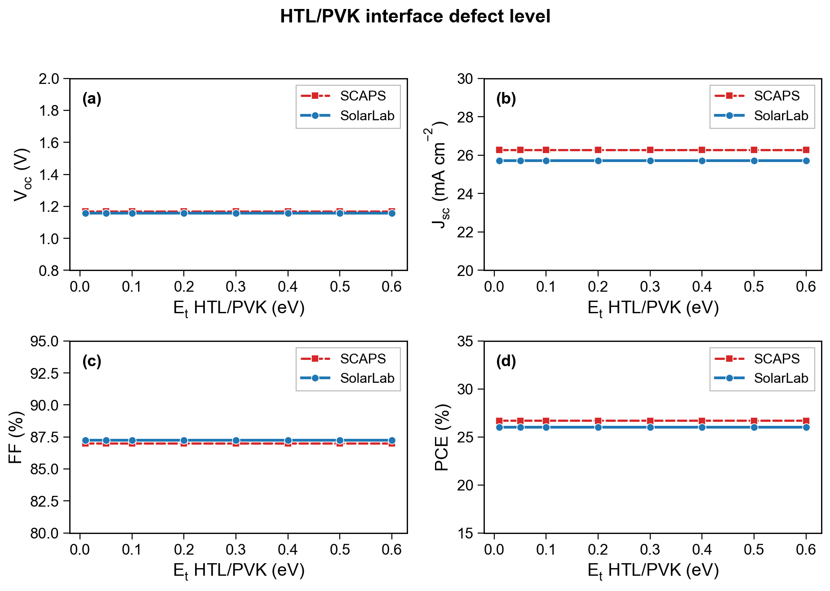
HTL/PVK interface defect level.
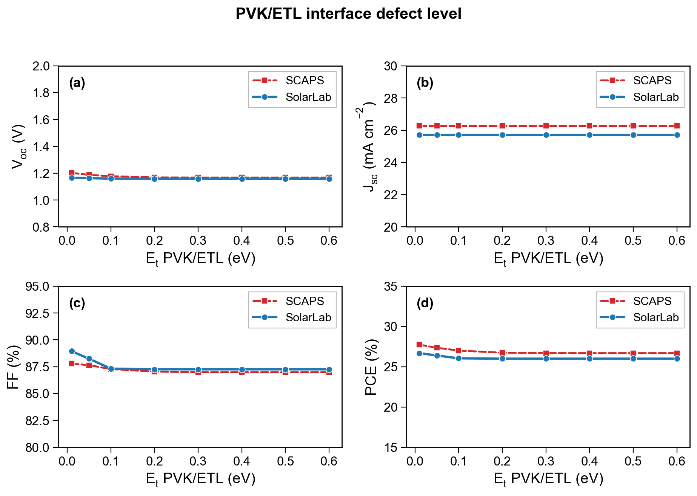
PVK/ETL interface defect level.

5. Discussion: attribution of the residuals
Every residual disagreement in Section 4 maps to one of four named causes, and to either the physical model or the numerical algorithm:
Two points are worth emphasising. First, none of the residuals is a numerical error: the one algorithmic effect (bracketing) produces physically-correct absences that the independent steady-state driver confirms, and everywhere a crossing exists the two SolarLab drivers agree to within a few millivolts. Second, the model residuals are all localised — the optical offset is a constant, the contact residual lives only in the weakly-doped tail, and the spike threshold differs only at large positive offset — so the two codes implement the same physics wherever that physics is well-conditioned.

6. Conclusion
Across eleven parametric sweeps SolarLab reproduces the SCAPS-1D trends in direction in ten of the eleven sweeps and in magnitude to within a few percent on the base figures of merit. The disagreements are not numerical noise but the fingerprints of four specific, understood model or algorithm choices — the optical method, the contact boundary condition, the heterointerface flux limit, and the transient versus steady-state solution strategy. Each has been isolated to a single sweep regime and, where it is a model choice, is exposed as a configurable option in SolarLab. The comparison establishes that the two codes share the same drift–diffusion physics and differ only in well-characterised, boundary-layer details.

