SolarLab Paper-Reproduction Validation Figure
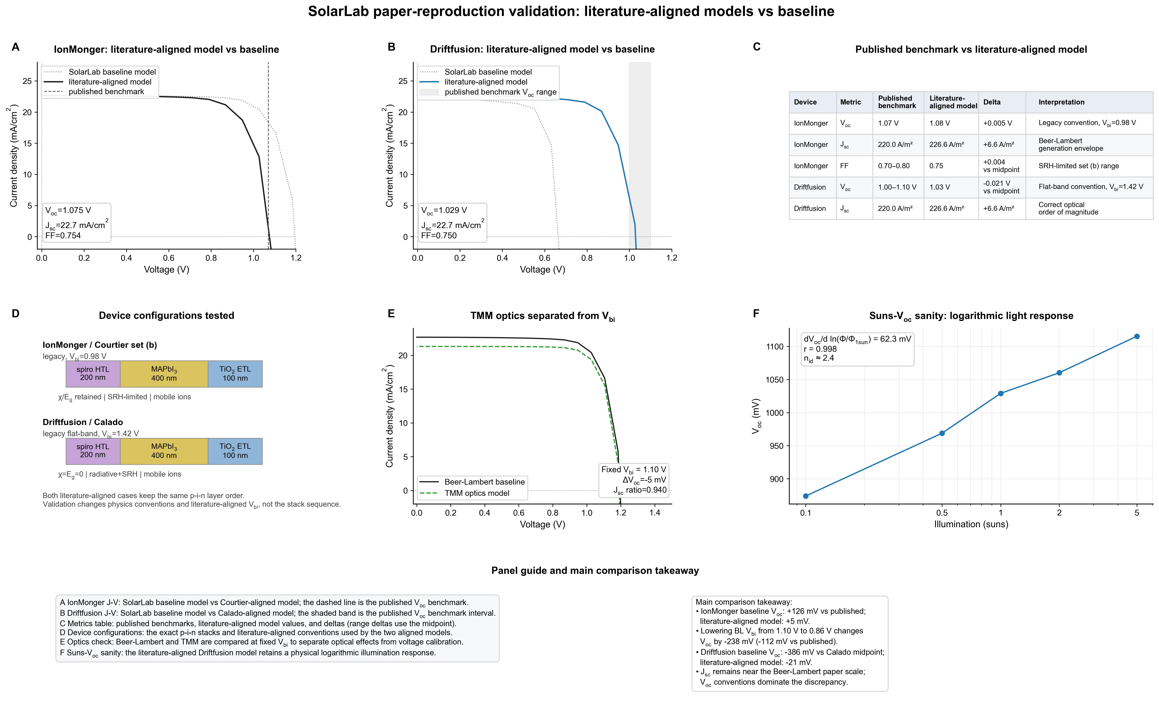
Key point: the comparison asks whether SolarLab can reproduce the published photovoltaic benchmarks after using literature-aligned model conventions. The baseline model is the unadjusted SolarLab implementation; the literature-aligned model uses the legacy physics convention and V_{bi} choices needed to compare directly with the published studies.

Terminology Used in the Figure
Published benchmark: The target number or range reported in the original paper, such as V_{oc}, J_{sc}, or FF.
SolarLab baseline model: The default SolarLab configuration before applying paper-specific conventions. It is useful for diagnosing why the model differs from the literature.
Literature-aligned model: The SolarLab configuration after adopting the relevant literature conventions, such as the legacy electrostatic convention, recombination setting, and built-in voltage V_{bi} used for the published comparison.

Panel-By-Panel Reading Guide
A: IonMonger J-V compares the SolarLab baseline model with the Courtier-aligned model. The dashed vertical line is the published V_{oc} benchmark. The literature-aligned curve moves close to the published V_{oc}.
B: Driftfusion J-V compares the SolarLab baseline model with the Calado-aligned model. The gray band is the published V_{oc} range. The literature-aligned curve moves into the benchmark interval.
C: The table summarizes the numerical comparison: published benchmark, literature-aligned model value, and delta. Range deltas are computed relative to the midpoint.
D: The device configuration panel shows that both tests use the same p-i-n layer order: spiro HTL, MAPbI₃ absorber, and TiO₂ ETL. The main changes are physics conventions and V_{bi}, not the stack sequence.
E: The optics check compares Beer-Lambert and TMM optics at fixed V_{bi}. This separates optical-generation effects from voltage-calibration effects.
F: The Suns-V_{oc} check confirms that the literature-aligned Driftfusion model still gives a physical logarithmic response to illumination. The slope is written as dV_{oc}/d ln(Phi/Φ_{1sun}), which is more formal than saying per ln-unit.

Explanation of n_{id} in Panel F
Meaning: n_{id} is the diode ideality factor. It is a compact indicator of how close the simulated solar cell is to ideal diode behavior.
How it is estimated: Panel F fits the slope of V_{oc} versus ln(Phi/Φ_{1sun}). At room temperature, kT/q is about 25.85 mV, so n_{id} is estimated as slope divided by kT/q.
Value in this figure: The fitted slope is about 62.3 mV, giving n_{id} ≈ 62.3/25.85 ≈ 2.4.
Physical interpretation:
n_{id} close to 1 usually indicates more ideal diode behavior.
n_{id} near 2 suggests trap-assisted recombination is important.
n_{id} above 2 indicates stronger non-ideal effects, such as field-dependent recombination, interfacial recombination, ionic effects, or transport limitations.

Main Comparison Takeaway
IonMonger: the baseline V_{oc} is about +126 mV away from the published benchmark, while the literature-aligned model is only about +5 mV away.
Changing the Beer-Lambert IonMonger V_{bi} from 1.10 V to 0.86 V shifts V_{oc} by about -238 mV, showing that V_{bi} convention strongly controls the voltage mismatch.
Driftfusion: the baseline V_{oc} is about -386 mV below the Calado midpoint, while the literature-aligned model is about -21 mV from the midpoint.
J_{sc} stays close to the Beer-Lambert paper scale in both comparisons, so the dominant discrepancy is the V_{oc} convention rather than optical current generation.

