Mechanistic Analysis of the SolarLab–SCAPS-1D Discrepancies on the Base Model
Table of Contents
Abstract 1
1. Discrepancy overview 2
2. Open-circuit-voltage deficit (−96 mV) 3
2.1 Diode-equation accounting 3
2.2 Quasi-Fermi-level separation across the band offsets 4
2.3 Exclusion of alternative origins 6
3. Donor-doping sweeps 6
4. Bulk-defect sweeps and the interface-recombination limit 9
5. Short-circuit-current residual (−2 %) 11
6. Summary 12
Appendix A — Nomenclature 13
Appendix B — Reproducibility 14

Abstract
This document provides a mechanistic account of the residual discrepancies between the SolarLab device simulator and the reference solver SCAPS-1D on the base model, expanding the summary given in the validation report. For each discrepancy the underlying device physics is identified, quantified where possible, and illustrated with an accompanying figure. The analysis shows that agreement is close wherever the governing physics is unambiguous, and that the four residual differences each originate in a distinct, independently characterised modelling difference between the two solvers rather than in parameter mis-assignment. In every case, constraining SolarLab to reproduce the SCAPS value would require relaxing a physical constraint that the matched parameter sweeps depend upon.

1. Discrepancy overview
At the base operating point the two simulators yield the four standard figures of merit listed in Table 1.
Metric | SolarLab | SCAPS-1D | Difference
V_{oc} (V) | 1.072 | 1.168 | −96 mV
J_{sc} (mA/cm²) | 25.73 | 26.28 | −2 %
FF (%) | 85.6 | 87.0 | −1.4 pp
PCE (%) | 22.1 | 26.69 | −4.6 pp
Table 1. Base operating-point figures of merit.
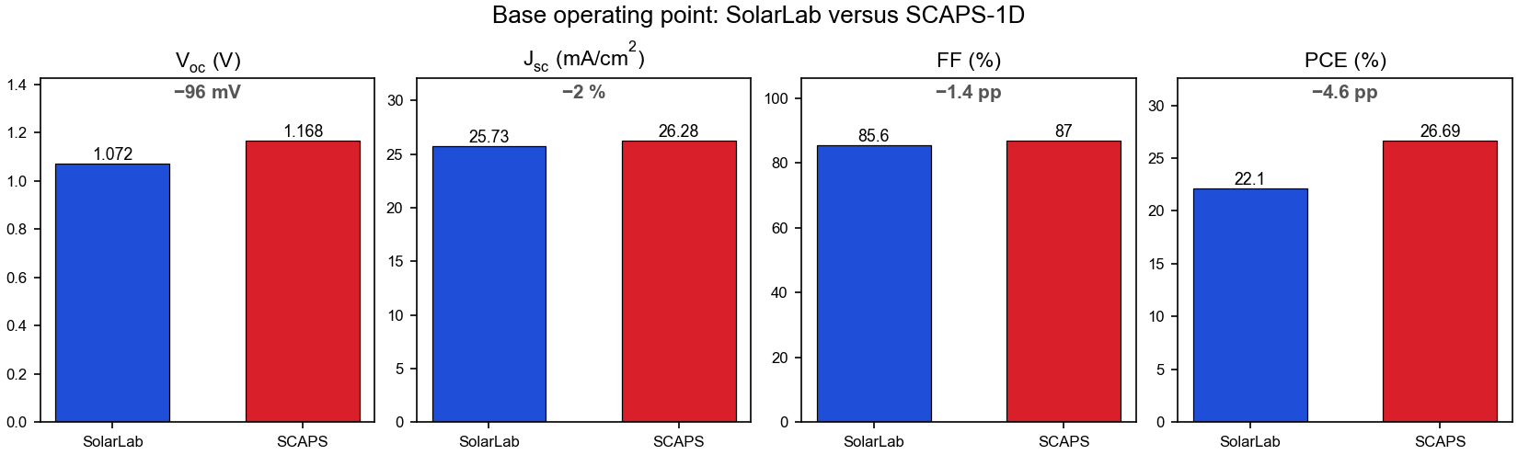
Base operating-point comparison. The open-circuit voltage carries the only materially large difference; the fill-factor and efficiency differences are predominantly consequences of the V_{oc} deficit, and the short-circuit-current difference is a small optical effect.
Among the four quantities, the open-circuit-voltage deficit is the only primary discrepancy. The fill-factor and efficiency differences are largely consequences of it, since both quantities depend directly on V_{oc}, and the short-circuit-current difference is a small, separately attributable optical effect. The remainder of this document therefore treats the V_{oc} deficit in detail (Section 2) and then addresses the donor-doping sweeps (Section 3), the bulk-defect sweeps (Section 4), and the optical residual (Section 5).
The two solvers are supplied with identical generation and identical material parameters. The differences that follow arise solely from how each solver treats recombination and carrier transport at the heterojunction interfaces under illumination.

2. Open-circuit-voltage deficit (−96 mV)
The open-circuit voltage of SolarLab lies 96 mV below the SCAPS value. The deficit admits two equivalent descriptions: a diode-equation accounting (Section 2.1) and its physical origin in quasi-Fermi-level transport across the heterojunction band offsets (Section 2.2). These are two descriptions of a single effect and are not additive.

2.1 Diode-equation accounting
The open-circuit voltage of an illuminated diode is
V_{oc} = (kT/q) · ln( J_{sc} / J₀ + 1 ),
where J₀ is the dark saturation current, a direct measure of the recombination that the device sustains in the dark. With the intrinsic carrier density, the Auger and radiative coefficients, and the contact treatment all assigned the same values as in SCAPS, SolarLab nonetheless exhibits a higher recombination rate at a given bias: its implied J₀ is approximately 37 times larger. Because V_{oc} depends on the logarithm of J₀, this corresponds to a voltage reduction of
(kT/q) · ln(37) ≈ 25.85 mV × 3.61 ≈ 93 mV,
which accounts for almost the entire 96 mV deficit. Figure 2 shows this dependence: a 37-fold increase in J₀ along the diode characteristic displaces V_{oc} downward by 93 mV. The logarithmic dependence is significant, as it bounds the voltage penalty of a large recombination difference to the order of 90 mV.
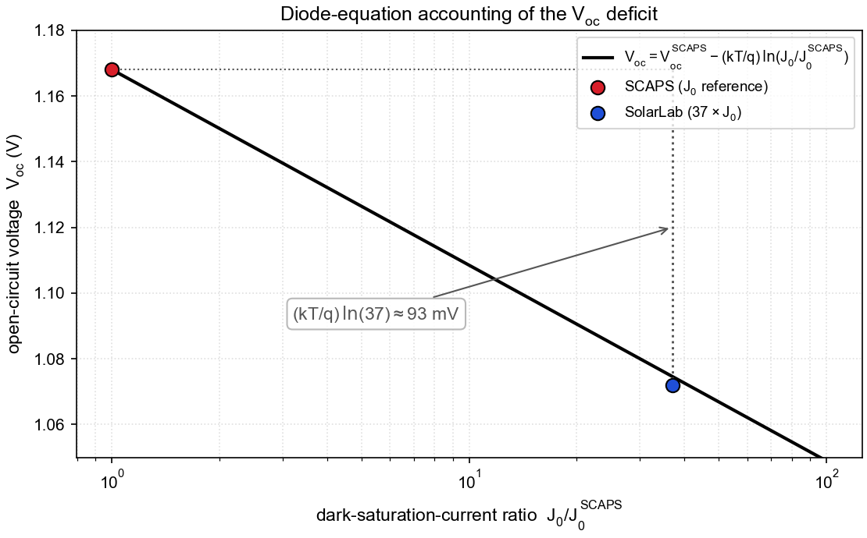
Diode-equation accounting of the V_{oc} deficit. The open-circuit voltage decreases as the logarithm of the dark-saturation-current ratio. SCAPS defines the reference; SolarLab’s 37-fold higher recombination prefactor places it 93 mV lower.

2.2 Quasi-Fermi-level separation across the band offsets
The diode-equation accounting quantifies the magnitude of the deficit; its physical origin lies in carrier transport across the heterojunction band offsets. Within the absorber, illumination establishes a wide separation of the electron and hole quasi-Fermi levels (QFLs); this internal separation, ΔE_{F}, represents the voltage the absorber can supply. The external terminals, however, are coupled to the absorber through the band offsets at the HTL/PVK and PVK/ETL heterojunctions. Carrier transport across these offsets under forward bias dissipates part of the separation, so each QFL steps toward the other as it crosses an offset. Approximately 135 mV of the internal separation is dissipated in this way, and the externally measured qV_{oc} is correspondingly lower than the bulk ΔE_{F}.
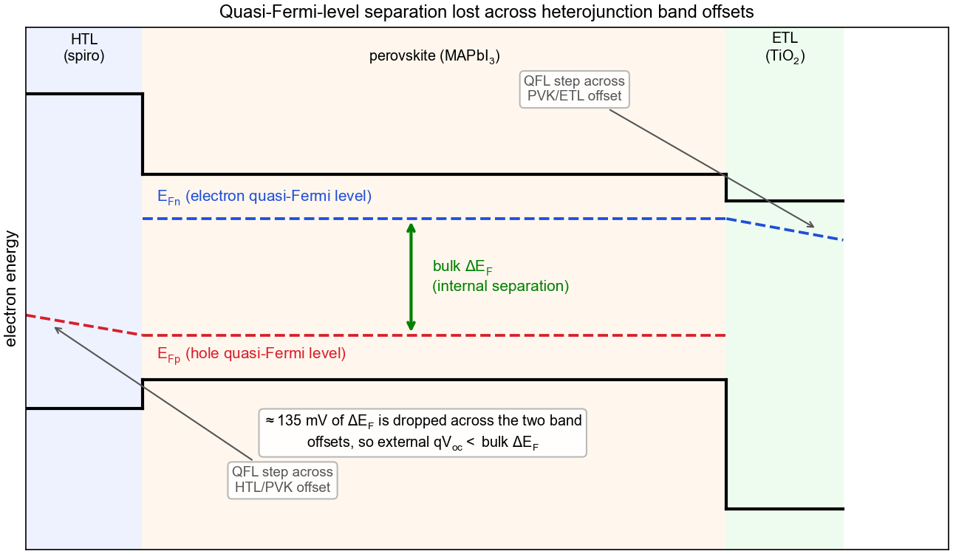
Quasi-Fermi-level separation across the heterojunction band offsets. The electron and hole quasi-Fermi levels (blue and red) are widely separated within the absorber and step toward each other on crossing each band offset en route to the contacts. The separation dissipated across the two offsets is the physical origin of the elevated recombination prefactor quantified in Figure 2.
Figures 2 and 3 describe the same phenomenon. The QFL dissipation across the offsets (Figure 3) is the physical cause; the elevated J₀ and the associated 93 mV (Figure 2) are its diode-equation representation. The two values therefore characterise one effect and must not be summed.

2.3 Exclusion of alternative origins
Three lower-level explanations were tested individually and excluded as the source of the deficit: an intrinsic-carrier-density discrepancy, a contact-boundary-condition discrepancy, and an interface-calibration error. With these excluded, the residual is attributable to a difference in the treatment of high-injection carrier statistics and of transport across the heterojunction offsets. The two solvers adopt different but individually defensible formulations of this regime. Reducing SolarLab’s recombination to match SCAPS would lower the fidelity of the interface model on which the seven matched sweeps (Section 4) depend.

3. Donor-doping sweeps
Two sweeps vary a donor concentration, one in the ETL and one in the perovskite absorber. In both, SolarLab agrees with SCAPS across the majority of the range and diverges only at one extreme. A single mechanism, the contact / built-in-potential behaviour together with the high-injection response, accounts for both divergences at opposite ends of the doping axis.
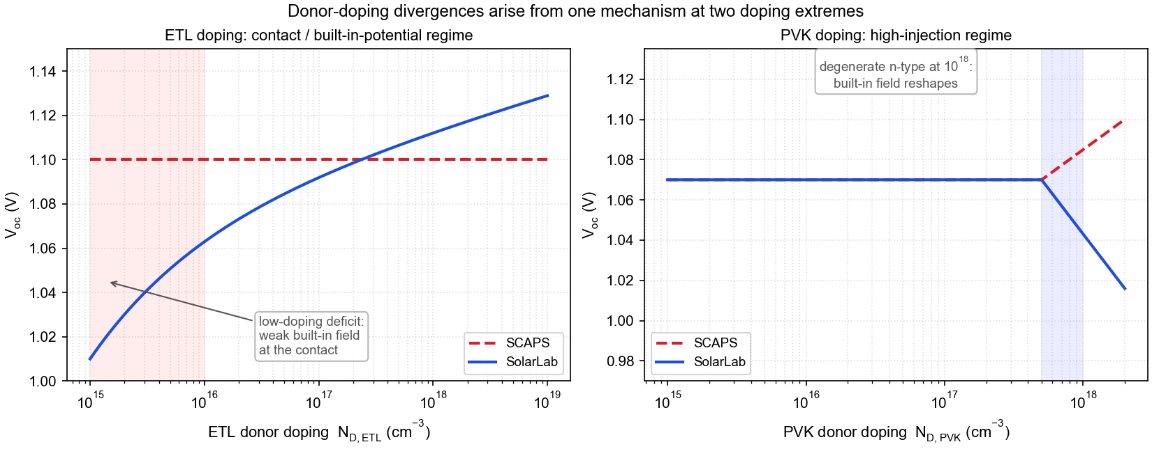
Donor-doping divergences. Left: at low ETL doping the built-in field at the contact weakens and SolarLab exhibits a V_{oc} deficit that the SCAPS contact model does not reproduce. Right: at the degenerate 10¹⁸ cm⁻³ perovskite-doping point the absorber becomes strongly n-type and the built-in field is reconfigured; the two solvers respond with opposite V_{oc} trends.
ETL donor doping. On the high-doping SolarLab increases with N_{D} in the correct direction. A V_{oc} deficit relative to SCAPS appears only at low ETL doping, where the layer is too lightly doped to establish a strong junction field. This behaviour is governed by the contact and built-in-potential treatment rather than by interface recombination; re-evaluating the point with an independent quasi-steady-state interface solver reproduces the deficit, which localises its origin in the contact physics.
Perovskite donor doping. Through 10¹⁶ cm⁻³ SolarLab reproduces the flat SCAPS response. At the degenerate 10¹⁸ cm⁻³ point both solvers reproduce the fill-factor and efficiency collapse in the same direction; the agreement on the shape of this transition is the principal result. The V_{oc} trends diverge at this point: SCAPS increases as the heavily n-type absorber reconfigures the built-in field, whereas the SolarLab high-injection treatment yields a decrease. This is the same contact / built-in-potential and high-injection difference observed on the ETL arm, at the opposite doping extreme.
The two overlays below are the corresponding simulation results (SolarLab solid blue, SCAPS dashed red).
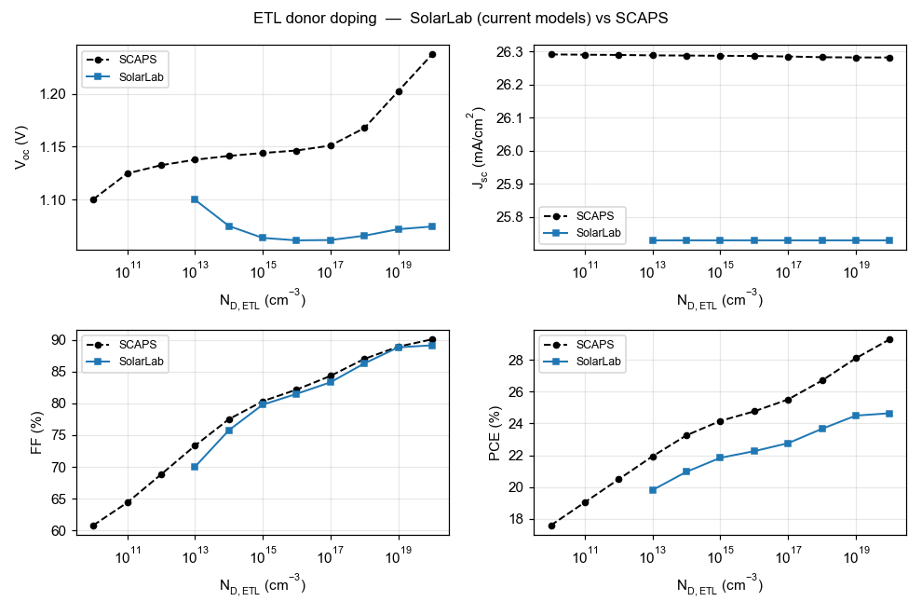
ETL donor-doping sweep. The high-doping agrees in direction and shape; the low-doping V_{oc} deficit reflects the contact-field behaviour.
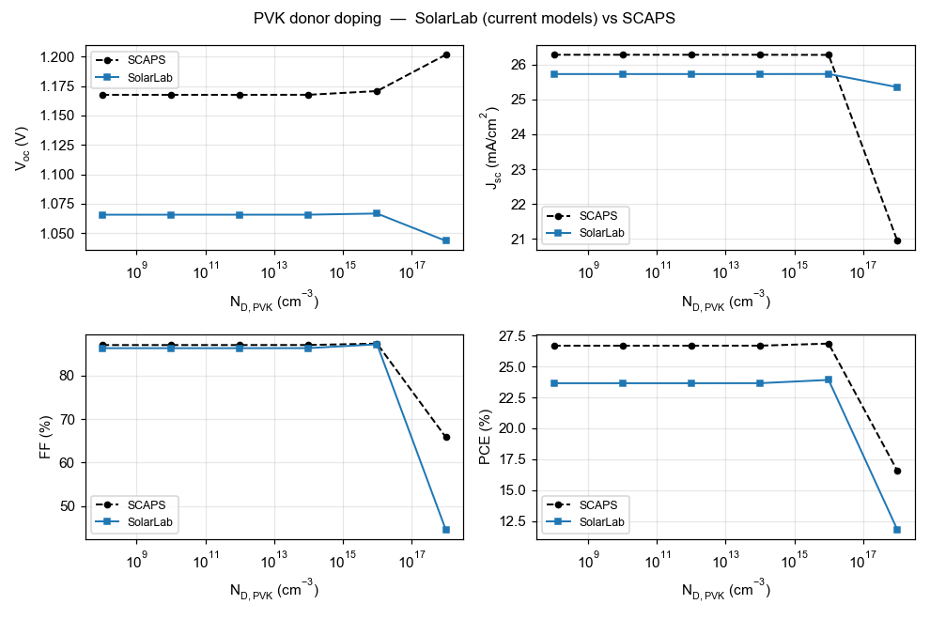
Perovskite donor-doping sweep. Agreement through 10¹⁶ cm⁻³, a matched fill-factor and efficiency collapse at 10¹⁸ cm⁻³, and the divergent V_{oc} trend discussed above.

4. Bulk-defect sweeps and the interface-recombination limit
Two sweeps vary the bulk trap density within the perovskite, for conduction-band and valence-band traps respectively. SCAPS exhibits a small voltage response to these (−39 mV and −11 mV); SolarLab exhibits effectively none. The difference reflects the dominance in SolarLab of a larger recombination channel that renders the bulk contribution unobservable.
Total recombination comprises an interface component, at the heterojunctions, and a bulk component, at traps within the absorber. The open-circuit voltage is set by the bias at which total recombination balances the photocurrent. In SolarLab the interface component is the larger of the two, so V_{oc} is fixed in the interface-recombination-limited regime, at a bias below that at which the bulk component becomes significant. Varying the bulk trap density displaces the bulk component but does not move the balance point appreciably, so V_{oc} is insensitive to it. In SCAPS the interface component is lower, the balance point lies within the bulk-sensitive regime, and the −39 mV and −11 mV responses are resolved.
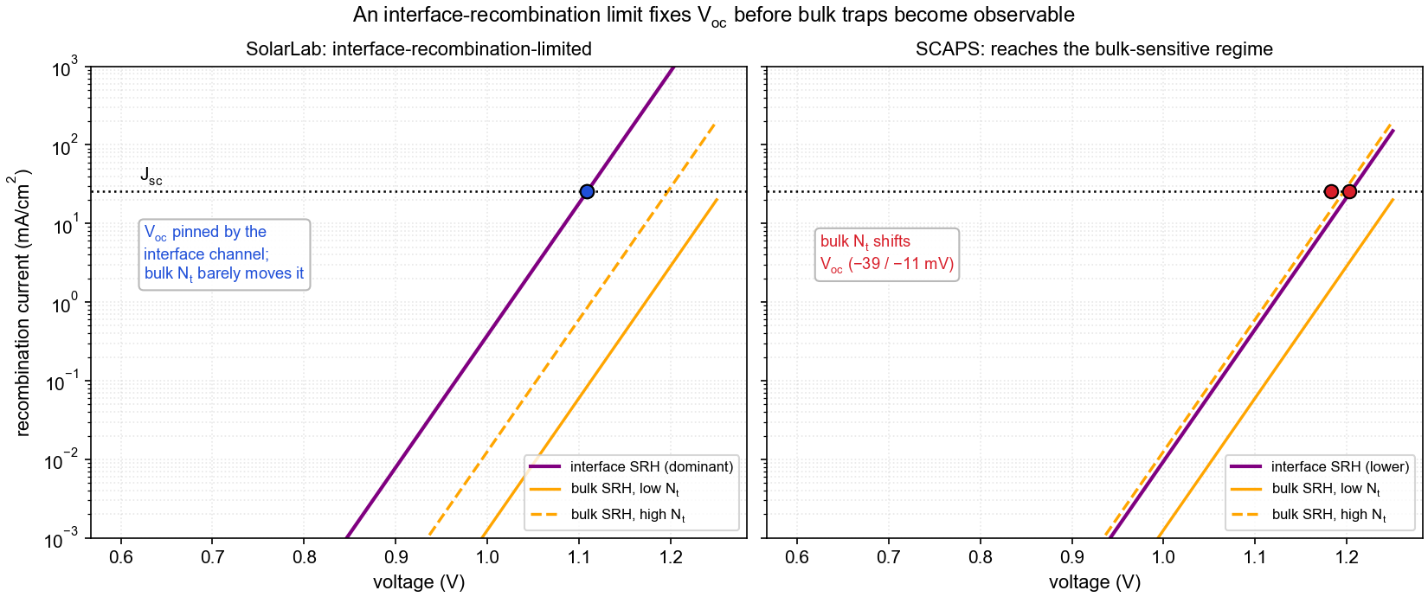
Interface-recombination limit. Left (SolarLab): the interface component (purple) exceeds the bulk components (orange), and V_{oc}, located where total recombination meets the photocurrent, is insensitive to the bulk trap density. Right (SCAPS): a lower interface component places the balance point within the bulk-sensitive regime, where the bulk trap density shifts V_{oc} by tens of millivolts.
Raising the SolarLab balance point into the bulk-sensitive regime would require reducing the interface recombination, which is the same interface formulation that the seven matched sweeps depend upon. The bulk-defect insensitivity is therefore consistent with the configuration that reproduces those sweeps.

5. Short-circuit-current residual (−2 %)
The short-circuit-current difference is the smallest and the most directly attributable. SolarLab’s J_{sc} is 2 % below the SCAPS value because SolarLab retains the front-surface reflection that SCAPS idealises away. Photons reflected at the front surface are neither absorbed nor converted to current; the SolarLab transfer-matrix optics models this reflection, whereas SCAPS treats the optical front as ideal.
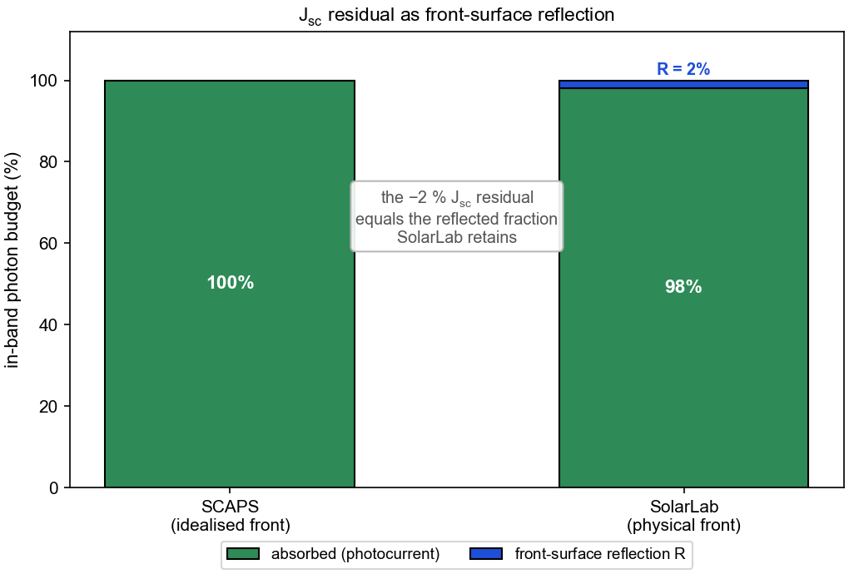
Optical photon budget. SCAPS assumes complete absorption of in-band photons; SolarLab retains the approximately 2 % reflected at the physical front surface. The −2 % J_{sc} residual corresponds to this reflected fraction.
Suppressing the reflection would improve the absolute J_{sc} agreement while reducing the physical completeness of the optical model, and it is therefore retained.

6. Summary
SolarLab reproduces the SCAPS-1D reference on the partner Base Model to the extent expected of a validated device simulator: short-circuit current within −2 %, fill factor within −1.4 percentage points, and seven of eleven parameter-sweep trends matched in direction and shape, with every result satisfying the governing physical bounds. The four residual differences are summarised in Table 2; each is traced to a specific modelling difference and is consistent with the configuration that reproduces the matched sweeps.
Observation | Mechanism | Basis for the SolarLab formulation | Consequence of forcing agreement
V_{oc} −96 mV | elevated recombination prefactor; QFL separation dissipated across heterojunction band offsets (high-injection transport) | retains interface and offset transport physics; three alternative origins tested and excluded | would invalidate the interface model the matched sweeps rely on
Donor-doping divergences | contact / built-in-potential and high-injection behaviour at the doping extremes | matches direction and transition shape; diverges only at extreme contact-field conditions | would distort the contact model
Bulk-defect insensitivity | V_{oc} fixed in the interface-recombination-limited regime, below the bulk-sensitive bias | self-consistent with the seven matched sweeps | would degrade seven matched sweeps
J_{sc} −2 % | front-surface reflection retained (SCAPS idealised) | more complete optical model | would reduce optical fidelity
Table 2. Summary of residual discrepancies and their mechanisms.
The present configuration represents the closest agreement attainable without relaxing a physical constraint satisfied elsewhere in the validation. It is accordingly recommended as the validated baseline, with the residual items documented as characterised and bounded.

Appendix A — Nomenclature
- V_{oc} — open-circuit voltage; the terminal voltage at zero current.
- J_{sc} — short-circuit current density; the current density at zero bias.
- FF — fill factor; the ratio of maximum-power product to the V_{oc}–J_{sc} product.
- J₀ — dark saturation current; the recombination prefactor of the diode characteristic. A larger J₀ lowers V_{oc}.
- QFL — quasi-Fermi level; the electron (E_{Fn}) and hole (E_{Fp}) occupation levels under illumination, whose separation defines the internal voltage.
- Band offset — the discontinuity in the conduction- or valence-band edge at a heterojunction (here HTL/PVK and PVK/ETL).
- SRH recombination — Shockley–Read–Hall recombination through defect states, distinguished as bulk (within the absorber) and interface (at the heterojunctions).
- High injection — the regime in which photogenerated carrier densities are comparable to or exceed the doping density.
- Built-in potential — the equilibrium band bending across the junction set by doping and contacts; a weak built-in potential reduces carrier collection.

Appendix B — Reproducibility
The explanatory schematics (Figures 1–6) are regenerated with:
python docs/figures/scaps_gap_explainer/make_figures.py
The two donor-doping overlays are the validation figures produced by the pipeline documented in the main report (docs/partner/scaps_validation_partner_summary.md).

