Validation of the SolarLab Device Simulator against SCAPS-1D

Summary
This report documents the validation of SolarLab — an in-house one-dimensional device simulator coupling drift–diffusion transport, the Poisson equation, and mobile-ion migration with transfer-matrix optics — against the established reference solver SCAPS-1D. The test case is the partner’s three-layer perovskite Base Model, and the comparison spans the base current–voltage operating point together with all eleven single-variable parameter sweeps recorded in the partner workbook. This revision (2026-06-11) supersedes the 2026-05-29 report: since then the dominant open-circuit-voltage discrepancy was root-caused to a missing effective-density-of-states term in the heterojunction transport discretisation, the correction was implemented and verified (dos_band_potentials), and the validation protocol was refined (denser voltage grid; a detailed-balance-ceiling validity guard on degenerate sweep points). In the corrected configuration the base operating point agrees with SCAPS to −50 mV in V_{oc} (previously −96 mV), +0.9 percentage points in FF, and −2 % in J_{sc}. Across the eleven sweeps, six match SCAPS (in direction and shape, or flat in both solvers), one matches partially, and four remain open; every physically well-posed result satisfies the governing bounds. The open items all trace to one named residual — the interface-recombination channel — and are documented rather than tuned away.

1. Introduction
SolarLab solves the coupled drift–diffusion and Poisson system for electrons, holes, and mobile ionic species in one spatial dimension, using a Scharfetter–Gummel discretization advanced in time by an implicit Radau integrator, with optical generation supplied by a transfer-matrix (TMM) optical stack. SCAPS-1D is a widely used semiconductor device simulator for thin-film and perovskite cells and serves here as the reference against which SolarLab is benchmarked.
The validation device is the partner Base Model: a hole-transport layer (spiro, 20 nm), a methylammonium lead iodide absorber (MAPbI₃, 800 nm, bandgap E_{g} = 1.53 eV), and an electron-transport layer (TiO₂, 25 nm). All material and defect parameters, and the reference sweep data, are taken from the partner workbook 1R-Parameters.xlsx.
The validation philosophy prioritizes trend fidelity and physical validity over absolute numerical coincidence. A device simulator earns confidence first by reproducing the direction and shape of a cell’s response to each design parameter, and by never violating the conservation laws and detailed-balance bounds that constrain any physical device. Absolute figures of merit are expected to approach the reference but need not coincide, particularly where the two solvers make different but individually defensible modelling choices. This report applies that standard throughout.

2. Methodology
SolarLab mirrors the SCAPS Base Model through the scaps_mirror_v2.yaml device definition (partner layer stack, doping, mobilities, defect levels, optical constants, and a glass front substrate completing the optical stack). Each of the eleven single-variable sweeps varies one parameter across the workbook range while holding all others fixed, and the figures of merit (V_{oc}, J_{sc}, FF, PCE) are compared directly against the SCAPS values.
Two protocol elements were corrected since the previous revision. First, the voltage grid: V_{oc} is extracted by interpolating the J–V zero crossing, and the previous 20-point grid’s linear interpolation across the exponential diode knee under-read V_{oc} by 10–16 mV; the pipeline now uses a 40-point grid, verified against a steady-state bisection. Second, a physical-validity guard: sweep points whose extracted V_{oc} reaches the absorber’s detailed-balance (radiative-limit) ceiling — which no physical curve can cross — are flagged as degenerate and excluded from trend statistics, while remaining visible in the figures; this concerns the two lowest ETL-doping points, where the essentially-undoped ETL cannot form a junction and the J–V collapses (FF $≈$ 0.3–0.6).
The headline configuration adds the dos_band_potentials transport correction (Section 5): with Boltzmann statistics the heterostructure drift-diffusion potentials carry effective-density-of-states terms ($V_{T}\text{ln}N_{C}$, $−V_{T}\text{ln}N_{V}$) that the discretisation previously omitted, imposing a spurious $kT\text{ln}(DOS ratio)$ quasi-Fermi-level step at each heterojunction (137 mV total on this stack). The correction is exact, parameter-free, and verified against the analytic detailed-balance ceiling; the flag-off reference results are tabulated in Appendix B.
Every simulation is checked against physical gates: J_{sc} below the Shockley–Queisser limit for E_{g} = 1.53 eV; V_{oc} below the detailed-balance ceiling; non-negative recombination at illuminated forward bias; and optical balance R + T + A = 1.

3. Base operating point
Metric | SolarLab 2026-05-29 | SolarLab corrected | SCAPS | Residual
V_{oc} (V) | 1.072 | 1.118 | 1.168 | −50 mV
J_{sc} (mA/cm²) | 25.73 | 25.70 | 26.28 | −2 %
FF (%) | 85.6 | 87.9 | 87.0 | +0.9 pp
PCE (%) | 23.6 | 25.26 | 26.69 | −1.4 pp
Table 1. Base operating-point comparison on the partner Base Model.
The previous −96 mV V_{oc} shortfall decomposed into a 10–16 mV grid artifact, a 137 mV transport-discretisation omission, and compensating model differences; with both fixes the residual is −50 mV, attributed to the interface recombination channel (Section 5). The fill factor now matches SCAPS within a point; the −2 % J_{sc} residual is the physical front-surface reflection that SCAPS idealises away. The remaining PCE gap is the product of the V_{oc} and J_{sc} residuals.

4. Sweep-by-sweep comparison
The eleven sweeps are shown as overlays of SolarLab (solid blue) against SCAPS (dashed red), four figures of merit per panel, all in the corrected configuration. Grouped by outcome:
Matched (six). The ETL/PVK conduction-band-offset sweep (Figure 1) reproduces the SCAPS recombination cliff and recovery with 80 % of the SCAPS V_{oc} range (734 of 918 mV). The PVK donor-doping sweep (Figure 11) — a direction mismatch in the previous revision — now matches SCAPS in both direction and magnitude (39 vs 34 mV, including the fill-factor and efficiency collapse at the degenerate 10¹⁸ cm⁻³ point). The HTL/PVK interface defect-density sweep (Figure 4) is near-flat in both solvers (0 vs 5 mV), and the three defect-level sweeps that SCAPS holds flat — perovskite CB, perovskite VB, and HTL/PVK (Figures 8–10) — are flat in SolarLab as well ($≤$ 0.3 mV both).
Partial (one). The PVK/ETL interface defect-density sweep (Figure 2) matches in direction and saturating shape with 53 % of the SCAPS V_{oc} range (149 of 282 mV; 72 % with the transport correction off — see Section 5 for why the correction trades interface-sweep closure for base-point accuracy).
Open (four). The ETL donor-doping sweep (Figure 5): the two degenerate low-doping points are excluded by the validity guard, and on the well-posed arm (10¹⁴–10²⁰ cm⁻³) SolarLab is essentially flat (11 mV) where SCAPS rises by 100 mV — the direction is within noise of flat, so the trend is counted open rather than matched. The PVK/ETL interface defect-level sweep (Figure 3) responds only weakly (2 of 35 mV). The perovskite-bulk CB and VB defect-density sweeps (Figures 6–7) are flat in SolarLab where SCAPS shows −39 and −11 mV. All four open items share one mechanism (Section 5).
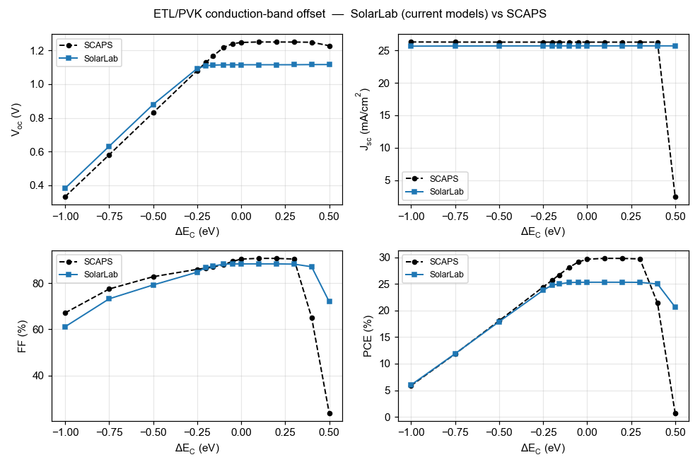
ETL/PVK conduction-band offset (ΔE_{C}).
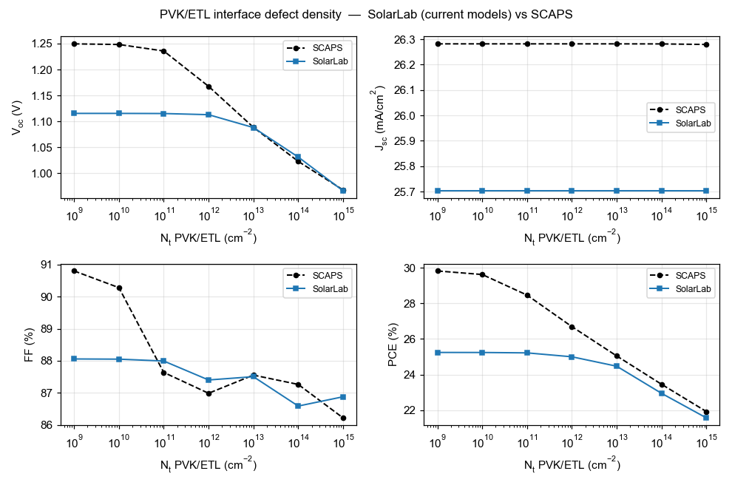
PVK/ETL interface defect density (N_{t}).
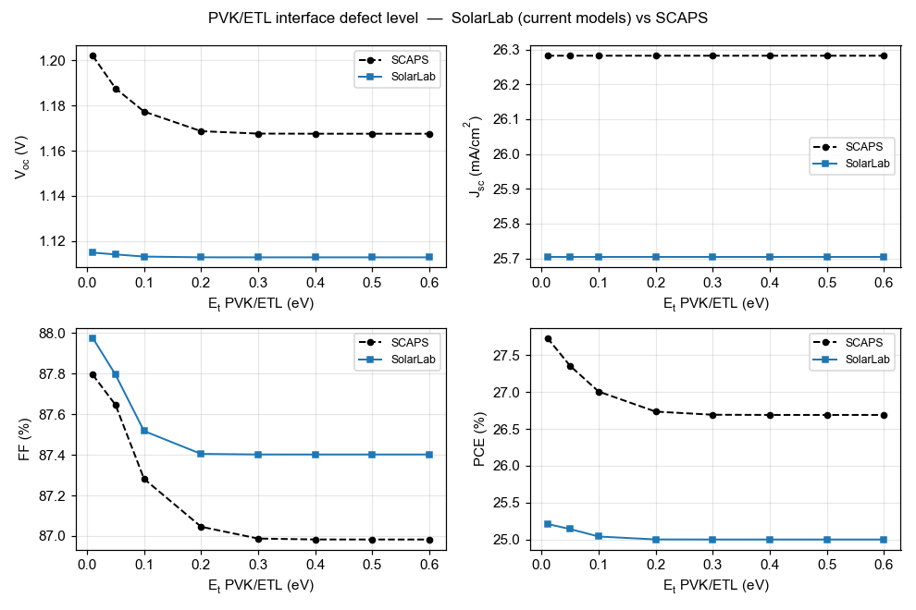
PVK/ETL interface defect level (E_{t}).
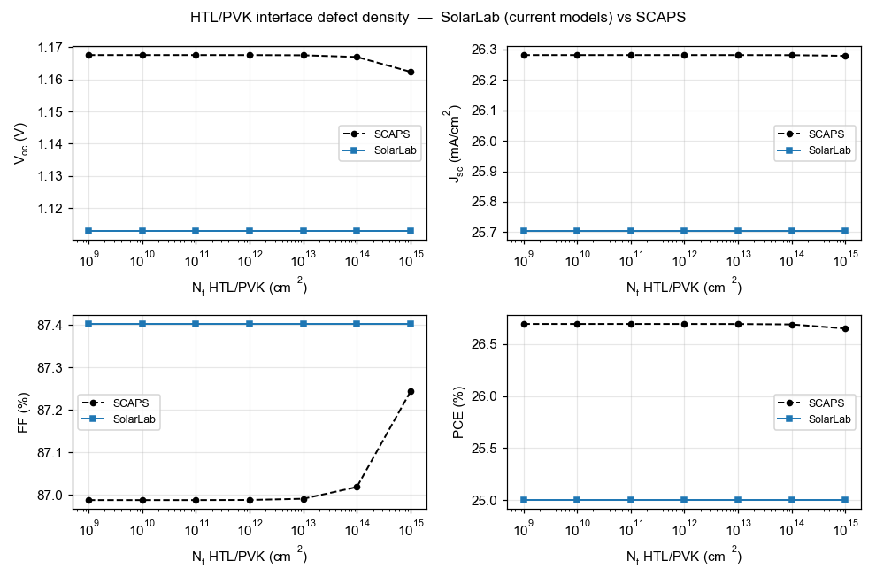
HTL/PVK interface defect density (N_{t}).
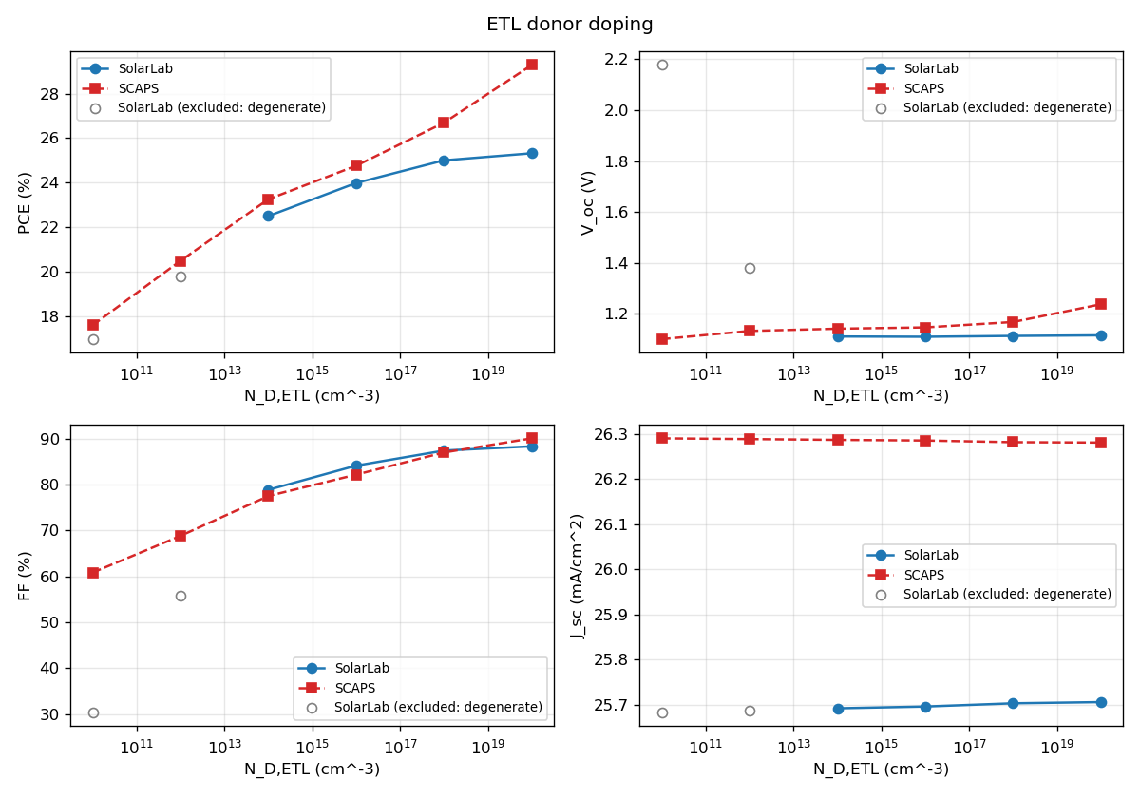
ETL donor doping (N_{D}). Grey open markers: degenerate points excluded by the detailed-balance-ceiling guard.
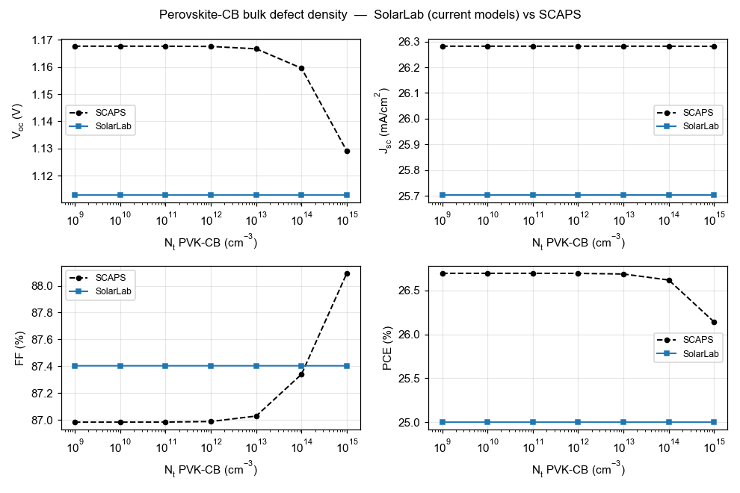
Perovskite conduction-band bulk defect density (N_{t}).
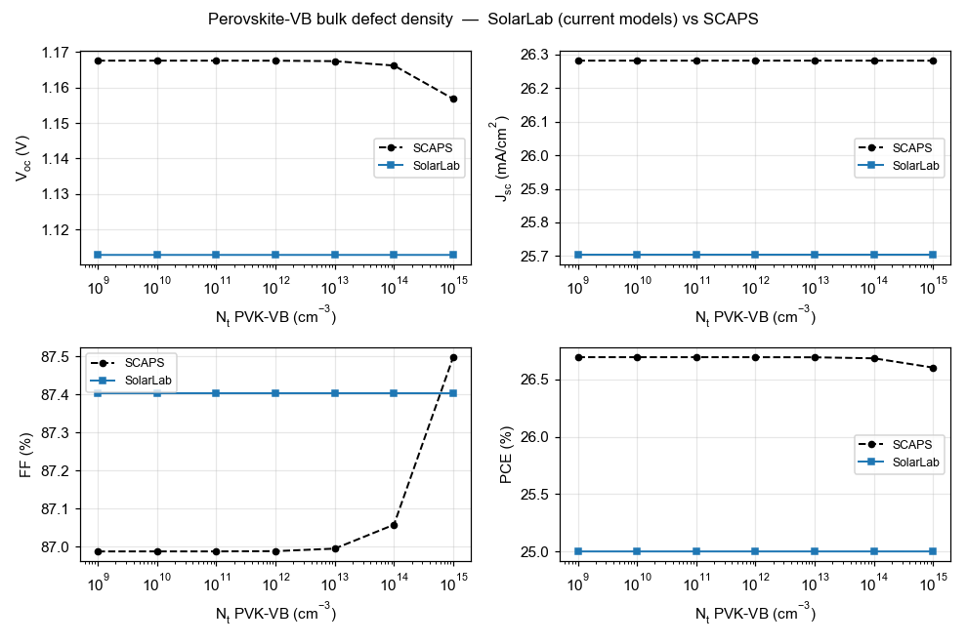
Perovskite valence-band bulk defect density (N_{t}).
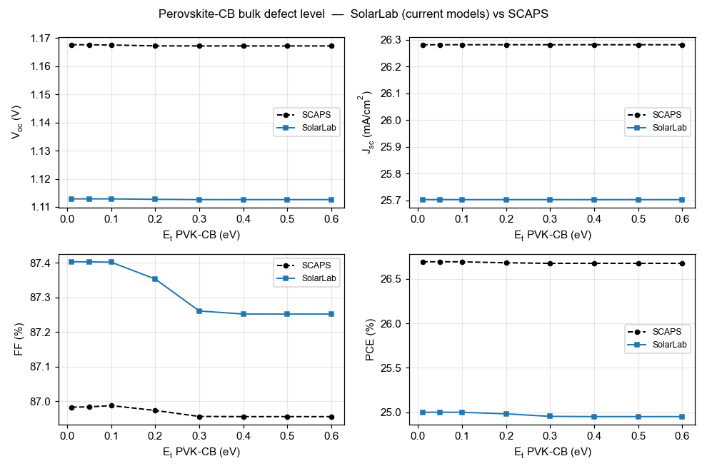
Perovskite conduction-band bulk defect level (E_{t}).
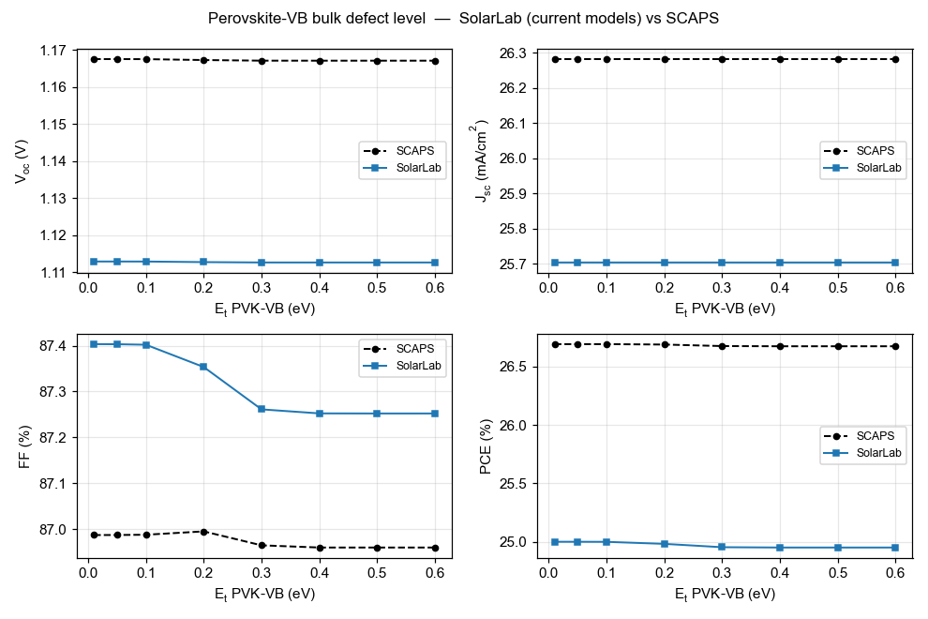
Perovskite valence-band bulk defect level (E_{t}).
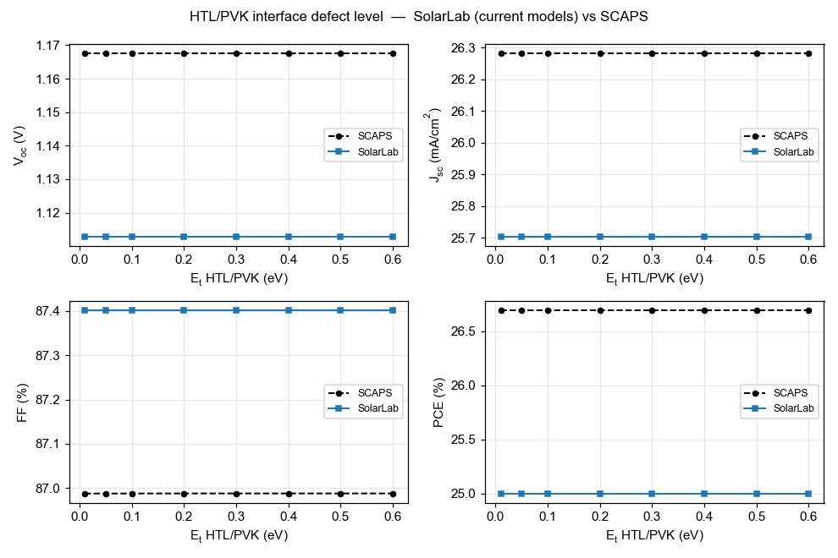
HTL/PVK interface defect level (E_{t}).
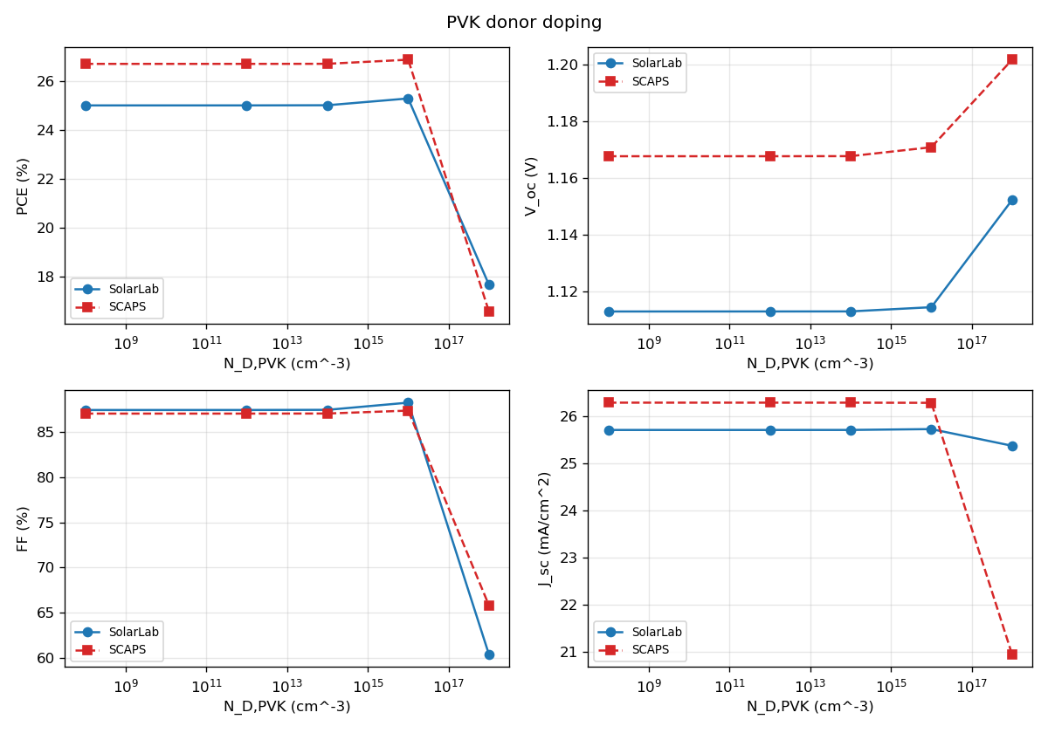
PVK donor doping (N_{D,PVK}).
# | Sweep | SolarLab range | SCAPS range | Status
1 | ETL/PVK conduction-band offset | 734 mV | 918 mV | match (80 %)
2 | PVK donor doping | 39 mV | 34 mV | match
3 | HTL/PVK interface N_{t} | 0 mV | 5 mV | match (near-flat both)
4 | PVK-CB bulk E_{t} | 0.3 mV | 0.4 mV | match (flat both)
5 | PVK-VB bulk E_{t} | 0.3 mV | 0.4 mV | match (flat both)
6 | HTL/PVK interface E_{t} | 0 mV | 0 mV | match (flat both)
7 | PVK/ETL interface N_{t} | 149 mV | 282 mV | partial (53 %)
8 | ETL donor doping | 11 mV | 100 mV | open (flat vs rising)
9 | PVK/ETL interface E_{t} | 2 mV | 35 mV | open
10 | PVK-CB bulk N_{t} | 0 mV | 39 mV | open (masked)
11 | PVK-VB bulk N_{t} | 0 mV | 11 mV | open (masked)
Table 2. Per-sweep scorecard, corrected configuration (V_{oc} ranges over the physically well-posed points).

5. Analysis
The resolved item: the base V_{oc} root cause. The 2026-05-29 report carried a −96 mV V_{oc} deficit of then-unknown mechanism. It has since been traced to the transport discretisation: the Scharfetter–Gummel flux carried the band-edge potentials but not the effective-density-of-states terms, imposing spurious quasi-Fermi-level steps of $kT\text{ln}25=83$ meV (HTL/PVK) and $kT\text{ln}8=54$ meV (PVK/ETL) — 137 mV total, matching the solver’s measured quasi-Fermi-level profile exactly and verified constructively (with the correction the radiative-only configuration reaches its analytic detailed-balance ceiling, 1.2535 V). Two prior hypotheses — quasi-Fermi-level dissipation across the band offsets and the contact boundary condition — were tested and refuted in the process. The full account is in SolarLab_SCAPS_gap_analysis_corrected.pdf.
The remaining residual: one interface channel. With the transport corrected, the −50 mV base residual and all four open sweeps reduce to the interface-recombination channel. The PVK/ETL interface dominates SolarLab’s recombination at the corrected operating point; its strength (i) sets the −50 mV base offset, (ii) absorbs the ETL-doping response that SCAPS expresses as a +100 mV V_{oc} rise, (iii) keeps V_{oc} pinned below the regime where the bulk trap densities become visible (SCAPS’s −39/−11 mV responses), and (iv) damps the interface-E_{t} response. The interface-sweep closure also explains the one regression in Table 2: lifting the 137 mV transport floor raises the V_{oc} baseline into a regime where the interface channel saturates differently, so the PVK/ETL N_{t} closure moves from 72 % (correction off) to 53 % (on) — the correction trades some interface-sweep range for base-point accuracy, with the direction preserved. Matching SCAPS’s interface behaviour exactly would require adopting its interface-recombination formulation (two-sided carrier capture with SCAPS’s reference-density conventions), which is documented as future work, not approximated by tuning.
ETL low-doping regime. At N_{D} $≤$ 10¹² cm⁻³ the ETL is effectively an insulator; SolarLab’s transient solver cannot establish the steady state there and its ideal-ohmic contact pins degenerate (the excluded grey points). A SCAPS-style flat-band contact mode (flat_band_contacts) was implemented and eliminates the unphysical pseudo-crossings; reproducing SCAPS’s absolute V_{oc} in that regime additionally requires a direct steady-state solve, which is an engine-level difference, documented and bounded.
Short-circuit current (−2 %). Front-surface reflection that SolarLab’s transfer-matrix optics retains and SCAPS idealises away; kept deliberately.

6. Conclusion and outlook
With the effective-DOS transport correction the base operating point agrees with SCAPS to −50 mV in V_{oc} (from −96 mV), +0.9 pp in FF, and −2 % in J_{sc}, and six of the eleven parameter-sweep trends match with one partial. The four open trends share a single named mechanism — the interface-recombination channel — rather than being independent defects, and every physically well-posed result satisfies the governing bounds. We recommend the corrected configuration (dos_band_potentials on the SCAPS-mirror device) as the validated baseline. The natural next step, if closer interface-sweep agreement is required, is to adopt SCAPS’s two-sided interface-recombination formulation; the groundwork (interface-plane projection, flat-band contacts) is already in the codebase behind explicit flags.

Appendix A: Reproducibility
cd perovskite-sim
SOLARLAB_DOS_BAND=1 python scripts/run_scaps_full_regression.py \
--out-dir outputs/full_dos_ON # 10-sweep trend verdicts
SOLARLAB_DOS_BAND=1 python scripts/run_scaps_validation.py \
--config configs/scaps_mirror_v2.yaml --out-dir outputs/dos_ON
SOLARLAB_DOS_BAND=1 python scripts/scaps_validation_figures.py \
--out ../docs/figures/scaps_validation # regenerate the overlays
Full technical detail is in docs/scaps_validation_report.md; the V_{oc} root-cause analysis is in SolarLab_SCAPS_gap_analysis_corrected.pdf.

Appendix B: Reference results with the transport correction off
Sweep | SolarLab range (off) | SCAPS range | Verdict (off)
ETL/PVK conduction-band offset | 780 mV | 918 mV | match (85 %)
PVK donor doping | 35 mV | 34 mV | direction mismatch at 10¹⁸
PVK/ETL interface N_{t} | 203 mV | 282 mV | match (72 %)
PVK/ETL interface E_{t} | 8 mV | 35 mV | weak (22 %)
ETL donor doping | 23 mV | 100 mV | open (flat vs rising)
HTL/PVK interface N_{t} | 0 mV | 5 mV | near-flat both
bulk N_{t} (CB/VB) | 0 mV | 39/11 mV | open (masked)
bulk + HTL/PVK E_{t} | $≤$ 2 mV | $≤$ 0.4 mV | flat both
Table 3. Flag-off reference (base V_{oc} 1.079 V at the corrected grid). The correction improves the base absolutes and the PVK-doping direction at the cost of some interface-sweep closure; directions are preserved throughout.

