Harmony across four centuries: cadence, chromaticism and the shared trajectory of classical, jazz and popular music
Xin (Shane) Miao
Department of Geography, Geology and Planning, Missouri State University, Springfield, MO 65897, USA. Correspondence: xinmiao@missouristate.edu
Short title: Harmony across four centuries
Keywords: corpus musicology; harmonic syntax; cultural evolution; computational music analysis; music geography; cadence; chromaticism
Manuscript for Humanities and Social Sciences Communications (Article). Main text about 6,500 words; 5 figures; 3 tables; Supplementary Information with 9 tables, 2 figures and 1 data file.

Abstract
Harmonic change has been studied corpus by corpus. Here we measure chord-level harmony on 3,539 expert-annotated pieces spanning Western classical music (1565–1931), jazz (1925–2007) and Anglo-American popular music (1949–2002) with one set of measures: seventh and extended chords, non-diatonic chords, which chords prepare the tonic, root motion and chord entropy. Within classical music, seventh chords rise from 2% to 54% of chords; the authentic cadence peaks at 65% of tonic arrivals in 1750–1850 and then declines, with a change point at 1805 (95% CI 1790–1810) that survives composer, corpus and mode adjustment. Popular music retraces that decline in thirty years. Clustering 136 composers and artists on harmonic profile yields six groups that cut across genre and century. In a space-time frame, harmony tracks time within every repertoire; geography adds nothing within classical music or jazz and only a modest signal among modern artists.

Introduction
Music changes, and the change leaves traces that can be counted. Over the past fifteen years, corpus studies have turned those traces into histories: of timbre and chord types in the Billboard charts^{2,3}, of melodic complexity in chart-topping songs⁴, of tonal complexity in two thousand classical recordings⁵, of the modes that organised Western art music before 1750 and dissolved after 1800^{6,58}, and of the widening range of pitch classes and intervals composers used between 1360 and 1940^{7,8}. The cultural-evolution framework that unifies this work treats a repertoire as a population of works whose statistical properties drift, are selected and occasionally jump^{1,10}.
Three questions remain open in that literature, and they are the questions this study addresses. The first is the shape of long-run harmonic change. Within classical music there is broad agreement that something called tonal or harmonic complexity rises with the nineteenth century as its pivot^{5,7,8,9}, but the evidence is at the level of pitch-class content, automatically inferred labels or audio features, and the measures that music theory itself uses to describe harmonic style — which chords prepare the tonic, how roots move, how predictable the next chord is — have been reported for a single composer⁶¹, two dozen composers¹¹ or a single century⁵⁷, or — for the ratio of plagal to authentic motion — estimated from audio chord recognition⁵ and automatic analysis⁹, not from expert annotations across the whole span of annotated repertoire. The second is whether the twentieth century simplified or complicated harmony. Audio and melodic studies report restriction and simplification in popular music^{2,4} and even in classical and jazz⁴⁰; studies of pitch and chord content find complexity roughly flat^{38,39} or stable¹⁶; and the two camps locate their turning points in different years (1964, 1983 and 1991³ against 1975, 1996 and 2000⁴). The audio and melodic studies cannot separate harmony from timbre, arrangement and loudness, and the symbolic studies that can^{15,16,39} cover one popular corpus over three decades. The third is whether classical, jazz and popular music share one harmonic system. Theorists have argued both that an “extended common practice” runs from Renaissance polyphony to Bill Evans¹⁷ and can be captured by one generative grammar^{18,19}, and that rock operates distinct tonal systems in which IV- and bVII-based closure replaces V→I^{20–23}. The quantitative comparisons so far are synchronic^{24,25} or compare popular repertoires with one another¹⁶; no study has put expert chord-level measures for the three repertoires on one time axis (a note-network study spans six genres over four centuries, but with heuristic dates and genre labels and no harmonic labels⁴⁰). The infrastructure for doing so now exists²⁶, but it has not been used for a diachronic analysis.
A fourth question sits behind the other three and has barely been asked of harmony at all: does place matter, once time is accounted for? Music sociology and geography describe cities as sites of harmonic innovation — bebop New York, Merseybeat Liverpool, rockabilly Memphis, Muscle Shoals soul^{32,33} — and network studies place composers and other creators in geographic space^{30,31}, but no study relates chord-level harmony to the city in which the music was made. The distance-matrix designs needed for such a test are standard in comparative musicology^{35,36,37}, where they show that geographic proximity predicts musical similarity between societies; whether it predicts similarity between composers who share a city and a decade is unknown. One quantitative result points the way: geographic proximity structured the transmission of drum-break sampling until about 2000 and not afterwards³⁴.
We address all four questions with a single pipeline applied to 3,539 pieces from five corpora: the Distant Listening Corpus and the When in Rome meta-corpus (classical, Roman numerals, 1565–1931), the Weimar Jazz Database (jazz solos, 1925–2007), the McGill Billboard corpus (Hot 100 singles, 1958–1991) and the Rock Corpus (1949–2002). Every chord in every corpus is converted to one representation — a root relative to the local tonic, a quality, an extension level, and flags for chromaticism and applied function — from which the same sixteen measures (fourteen of them forming a harmonic profile) are computed for every piece. The measures were chosen to speak to the three theoretical debates: seventh-chord and extension rates and non-diatonic rates for the complexity debate; the shares of tonic arrivals prepared by V, IV and bVII, and the rate at which V actually proceeds to I, for the question of cadential syntax; root-motion classes⁴⁸ for the question of a shared grammar; and chord entropy and rarefied vocabulary for predictability. We then place each composer and artist in a harmonic space, cluster them without regard to genre or date, and place each piece in a space-time frame — longitude, latitude and year — in which Mantel and partial Mantel tests ask whether harmonic distance follows geographic distance after temporal distance is removed.
The contribution is therefore not the question of long-run change, which others have asked^{6,7,9}, but the measures, the span and the frame: expert chord-level cadence, root-motion and entropy measures from 1565 to 2000; three repertoires on one axis; and the first test of geography against time for harmony itself. We find a rise and fall of the authentic cadence with a datable turning point, a popular-music trajectory that retraces the classical one in thirty years, six cross-genre harmonic groups among 136 composers and artists, and a geographic signal that is absent within classical music and jazz once time is controlled and modest among modern artists. We also find, and report as a methodological result, that one of the standard measures — the seventh-chord rate — is not comparable across annotation traditions in popular music, and we show which conclusions survive that fact.

Results

The data
After conversion to the common representation, merging of repeated chords and exclusion of pieces with fewer than eight chord events, the dataset holds 3,539 pieces and 411,490 chord events: 2,058 classical pieces (1,280 from the Distant Listening Corpus, 778 from When in Rome; 1565–1931), 412 jazz solos (1925–2007), 876 Billboard singles (1958–1991) and 193 Rock Corpus songs (1949–2002). Table 1 gives the corpora; Supplementary Table S1 the per-era counts and the share of minor-mode pieces, which varies from 2% (1950s popular music) to 64% (early Baroque) and 65% (1900–49) and is controlled for below. All rates are means of per-piece values; the 95% intervals are composer-cluster bootstrap intervals (composers resampled with replacement, 400 draws), which are wider than piece-level intervals wherever one composer dominates an era. Eras follow conventional period boundaries for classical music and stylistic periods for jazz and popular music; binning by quarter-century and decade instead (Supplementary Fig. S1) gives the same trajectories.

Seventh chords go from exception to default
The seventh chord is the clearest monotonic trend in the classical corpus (Fig. 1a). Chords carrying a seventh are 2% of events in the sixteenth century (Goudimel’s 1565 psalm settings contain almost none; Monteverdi and Schütz use them in 6–7%), 15% in the seventeenth, 27% in the late Baroque (Corelli 22%, Couperin 34%, J. S. Bach 27%), 29% in the Classical era, 37% in 1800–49, 43% in 1850–99 (Chopin 48%, Grieg 49%, Tchaikovsky 46%) and 54% in 1900–49 (Medtner 50%, Bartók 69%, Schulhoff 96%). Extensions above the seventh follow later: 1–3% of events before 1800, 3% in the early Romantic era, 7% after 1850 and 18% after 1900.
Jazz begins where late Romanticism ends. Swing-era lead sheets carry sevenths on 63% of chords; by bebop (1945–59) the figure is 91%, and it stays there (90% in 1960–74, 88% after 1975). What continues to change in jazz is the extension layer, which rises from under 1% in the swing era to 12% in the modal and post-bop years — the move classical music made between 1850 and 1930, compressed into twenty years. Jazz chord symbols and classical Roman numerals have not been calibrated against each other on the same music, so the jazz and classical levels of this measure are compared with that caveat (Discussion); the within-repertoire trends do not depend on it.
Popular music runs the other way. On the Billboard chord symbols, sevenths fall from 34% of chords in 1950–64, when doo-wop, rhythm and blues and rock and roll still carried the blues dominant seventh, to 29% in 1965–74, 27% in 1975–84 and 24% after 1985, while extensions rise from 3% to 8%. This result is stated for the Billboard corpus alone, for a reason given under Robustness: the Rock Corpus’s Roman-numeral convention records sevenths on 4.6% of chords in the same recordings that Billboard’s chord symbols record at 23.5%.

The authentic cadence rises, peaks and declines
The share of all arrivals on the tonic that come from the dominant — the authentic cadence as a surface statistic, not a formal cadence in the sense of Caplin⁵⁴ or Nobile²³ — traces an arc (Fig. 1b; Table 2). It is 50% in the Renaissance sample, 54% in the early Baroque, 63% in the late Baroque, 65% in the Classical era and 64% in 1800–49, then 52% after 1850 and 43% after 1900. The probability that a V chord goes on to I at all behaves differently before 1750 and similarly after: 70%, 68%, 63%, 66%, 65%, 55%, 51% across the same seven eras, so that the eighteenth century’s cadential stereotypy lies in which chords reach the tonic rather than in what follows V. Tonic arrivals from IV fall from 22% in the Renaissance to 7–10% from 1700 onward and stay there.
A single change point fitted to the piece-level series places the turn in the authentic cadence at 1805 (95% bootstrap CI 1790–1810; ΔBIC against a straight line +260; a second break adds little, ΔBIC +2), and the turn in descending-fifth root motion at 1770 (1750–1810; +192). The arc is not an artefact of which composers happen to be sampled in each era, of which corpus annotated them, or of the shifting share of minor-mode pieces: in a mixed-effects model with a random intercept per composer and fixed effects for corpus and mode, the slope of the authentic-cadence share changes by −0.30 per century after 1850 (95% CI −0.44 to −0.16), the probability that V proceeds to I by −0.22 (−0.36 to −0.09) and the descending-fifth share by −0.14 (−0.22 to −0.06); the mode coefficients are small (−0.03 for V→I share) and leave the hinge terms unchanged (Supplementary Table S5).
Popular music compresses this three-century arc into thirty years. In 1950–64 V still prepares 47% of tonic arrivals and IV 34%; in 1965–74 the two are level (36% and 35%); by 1985 IV→I (28%) and V→I (34%) are joined by bVII→I, which rises from 2% to 14%, and a V chord proceeds to I less than half the time (45%, against 70% in 1950–64). In the cross-repertoire mixed model (year × genre, random intercept per artist) the V→I share falls by 0.33 per century in popular music against 0.02 in classical music over the same years. The most frequent transition in 1950–64 is I→IV, followed by IV→I; by 1985 IV→I leads. Jazz keeps the dominant: V prepares 67% of tonic arrivals in the swing era and 65% in bebop, and V proceeds to I 85% of the time in bebop — higher than in any classical era — before loosening in the modal years (50% and 77%).

Chromaticism is flat for two centuries, then climbs
Non-diatonic chords — chords whose root or quality does not belong to the local key — are 13% of events in the Renaissance sample, 22% in the early Baroque and then between 20% and 24% from Corelli to Schubert, a plateau of two hundred years (Fig. 1c). They rise to 29% after 1850 and 40% after 1900. Chords on chromatic roots, a stricter measure, are under 1% in the Renaissance, 3% in the Baroque, 6% in the Classical and early Romantic eras, 8% in the late Romantic era and 15% after 1900; the mode-adjusted mixed model gives this measure a slope change of +0.13 per century after 1850 (CI +0.07 to +0.19). Because minor keys carry more non-diatonic chords under our rule (the minor coefficient is +0.09 for the non-diatonic rate), the era means partly reflect the mode mix; the mixed-model estimates do not. Jazz non-diatonic rates (29–38%) match late Romantic and early-twentieth-century classical values. Popular music is the most diatonic music in the corpus, at 10–16%.

Vocabulary, predictability and root motion
The number of distinct chord types in a random sample of forty chords (rarefied vocabulary) is 9.5 in the Renaissance sample and then almost constant from 1600 to 1900, at 13.6–14.6, before jumping to 20.4 after 1900 (Fig. 1d). The pooled entropy of the next chord given the current one rises from 2.7 bits in the Renaissance to 3.5 in the early Baroque, dips to 3.1 in the Classical era — the most predictable music in the corpus, as a chord-embedding study of part of the same data also found¹¹ — and climbs through 3.6 (1800–49) and 4.0 (1850–99) to 4.5 bits after 1900. Jazz is far more predictable than its chord vocabulary suggests (2.3–2.6 bits), because the ii–V–I cycle dominates its transitions (ii7→V7 and V7→I7 are 8% of all bebop transitions each). Popular music lies between (2.5–3.3 bits), rising from the 1950s to 1975–84 and falling back to 3.0 after 1985.
Root motion separates three grammars (Fig. 2). Classical and jazz harmony run on descending fifths: 30–36% of root moves in every classical era from 1600 to 1850, and 42–56% in jazz. Rock after 1965 runs on steps and thirds: step motion rises from 19% of root moves in 1950–64 to 27% in 1965–74 and 33–34% after 1975, while descending fifths fall from 36% to 23%. Classical music after 1850 drifts in the same direction, with descending fifths falling from 35% to 24% by 1900–49 and third motion doubling from 10% to 19%. The most frequent chords tell the same story: I, V7, V, i, IV, ii in the Classical era; I7, V7, ii7, IV7, VI7 in bebop; I, IV, V, i, vi in 1965–74 rock, with V7 — the first or second chord of every classical era from 1750 — fifth.

Composers and artists on one harmonic map
The 136 composers and artists with at least five located pieces were placed in a fourteen-dimensional harmonic space (the measures above, with tonic share and minor-quality share in place of rarefied vocabulary, which is undefined for short pieces) and clustered by Ward’s method into six groups, without reference to genre or date (Fig. 3). The groups cut across both, and we describe them before the statistics that qualify them:
- Bebop to contemporary jazz (40): from Eldridge and Lester Young through Parker, Coltrane, Rollins and Getz to Lovano, Redman and Brecker, with Marvin Gaye, and Kenny Rogers as a border member.
- Chromatic and extended (8): Bartók and Schulhoff with the post-bop players Dolphy, Shorter, Henderson, Dorham and Liebman, and Stevie Wonder.
- Triadic, diatonic, plagal (24): Goudimel’s 1565 psalm harmonisations with the Beatles, Dylan, the Rolling Stones, the Beach Boys, Otis Redding, Wilson Pickett, the Eagles, Abba, Elton John and Billy Joel.
- bVII- and step-driven rock (11): Led Zeppelin, Bowie, Heart, the Police, Michael Jackson, Tina Turner, the Pet Shop Boys.
- Dominant-seventh diatonic (19): Händel and the Lieder composers Reichardt and Lang with early jazz (Armstrong, Dodds, Bechet, Goodman) and rock and roll and rhythm and blues (Chuck Berry, Elvis Presley, James Brown, Ray Charles, the Everly Brothers).
- Common practice (34): every other classical composer, from Peri, Monteverdi and Corelli to Rachmaninoff, with the band Chicago as the one modern member.
The pairings are the finding that a genre-blind clustering produces: a sixteenth-century psalter and 1960s pop share triads, diatonic roots and a plagal, weak-dominant syntax; Bartók’s bagatelles and Wayne Shorter’s tunes share chromatic roots and extended chords; a 1920s New Orleans band and a 1950s Memphis record share dominant sevenths over I, IV and V. The first two principal components of the profile (35% and 26% of variance) run from triadic-plagal to seventh-chord, fifth-driven harmony and from cadential to extended, chromatic, step-driven harmony. The partition is moderately separated and not sharply so: silhouette is 0.26 at six groups and nearly flat from four to eight (0.23–0.26), so six was chosen for interpretability rather than by a criterion; k-means reproduces it (adjusted Rand index 0.71) and it is stable under bootstrap resampling of composers (mean ARI 0.77, 90% interval 0.61–0.91). Each composer’s membership confidence (the share of resamples in which it stays with its original cluster-mates; conf in the deposited composer table) is below 0.5 for five units: Kenny Rogers (0.24), Billy Joel (0.38), Chicago (0.40), Heart (0.46) and Sonny Rollins (0.50). Earlier work had found composer clustering in classical corpora alone^{27,28} and several harmonic grammars within the Billboard corpus²⁹; here both appear in one map.

Geography after time
Each located piece (3,318 of 3,539; 100% of classical, jazz and Rock Corpus pieces and 75% of Billboard singles) was placed at the city where it was made and its year, in a frame that equates one century with 1,000 km. Ward clustering in this frame yields 25 scenes — Leipzig and Köthen 1720–25, Vienna 1772–1827, Paris 1832–1923, New York 1931–75, Nashville and Memphis 1956–80, London 1963–91 and so on — whose harmonic profiles are listed in Supplementary Table S3 and shown in the interactive space-time cube that accompanies this article (Fig. 4).
Mantel tests on the 136 composers and artists (5,000 permutations; Table 3, with Benjamini–Hochberg adjustment over the twenty tests) show that harmonic distance tracks temporal distance within every repertoire. Among the 39 classical composers in 23 cities, harmony correlates with time (r = 0.29, p = 0.014, adjusted 0.028) and not with geography (r = 0.01, p = 0.31; partial r given time −0.03). The 49 jazz performers show the same pattern (time r = 0.23, p = 0.003; geography r = −0.13). The 48 popular artists show a significant temporal signal (r = 0.17, p = 0.011) and a weak, non-significant geographic one (r = 0.10, p = 0.14). Pooling jazz and popular artists (n = 97), however, yields a geographic correlation that survives both time and the adjustment (r = 0.18, p = 0.012; partial r given time 0.19, p = 0.008), and it survives a further partial for genre (r = 0.15, p = 0.022): the signal is not simply New York jazz against London and Los Angeles rock, and the within-genre tests, with 48 or 49 units, cannot resolve it. Pooling all 136 units inverts the pattern — geography significant, time not — and the partial correlation of geography given time is 0.19 (p = 0.002); we attribute this to the Atlantic coinciding with the classical–modern divide, an interpretation the test itself cannot confirm. At the piece level inside the classical corpus, a piece’s harmonically nearest neighbour by another composer is a median 48 years away (random partner by another composer: 85 years, 95% null interval 84–88, p < 0.001) and in the same city 9.9% of the time, against 5.2% for a random partner (p < 0.001) but 9.6% (null interval 8.8–10.6%, p = 0.28) for a random partner no further away in time: the same-city excess is entirely accounted for by temporal proximity.

Robustness
Six checks were run after the main analysis (Methods; Supplementary Tables S4–S9). (1) Notation. Twelve recordings transcribed in both the Rock Corpus and McGill Billboard allow a paired comparison of the two annotation traditions. Among the fourteen profile measures, cadence shares, root-motion classes and chromaticism agree closely (r = 0.85–0.98; paired mean differences with 95% intervals that include zero and are smaller than the between-era differences interpreted above, except for IV→I, whose interval of −0.19 to +0.02 is comparable to them). Seventh-chord rate does not agree (4.6% versus 23.5%; 95% CI of the difference +0.03 to +0.35, Wilcoxon p = 0.01), nor do the pooled entropy and vocabulary measures (r = 0.62–0.69). Seventh and extension rates for popular music are therefore reported from Billboard alone and treated as unmeasured for Rock Corpus pieces in the composer clustering; with n = 12 the agreement on the other measures is evidence of comparability, not proof of equivalence. (2) The two classical corpora. Six composers appear in both the Distant Listening Corpus and When in Rome; on different pieces, the two corpora give seventh-chord rates within 0.05 of each other for five of the six and chromatic-root rates within 0.03 for five of the six (Supplementary Table S9), while When in Rome gives a higher V→I share for three of the six (Bach 0.65 against 0.53, Mozart 0.78 against 0.65 on ten pieces, Beethoven 0.71 against 0.65), on different works, so the offset mixes repertoire with annotation practice. Because the Renaissance sample is When in Rome only and 1900–49 is mostly DCML, this offset could flatten the two ends of the cadence arc; the corpus fixed effect in the mixed models absorbs it, and the hinge estimates stand. (3) Composer, corpus and mode effects. The mixed-effects models keep every main result. (4) Change points. A broken line is preferred to a straight line by ΔBIC 24–260 for all seven classical measures tested, but only the authentic cadence (1805, CI 1790–1810), descending fifths (1770, 1750–1810) and V→I resolution (1820, 1810–1860) have a single break located to within a few decades, and only for the authentic cadence does a second break add nothing (ΔBIC +2). For non-diatonic rate, chromatic roots, seventh-chord rate and chord entropy the single break is poorly located (CIs of 100–280 years) and a two-break model is preferred, consistent with gradual or multi-stage rather than punctuated change. (5) Bars without chords. Treating a no-chord stretch as a break in the progression rather than bridging it changes no cadence or root-motion share in any era by more than 0.006. (6) Cluster sensitivity. Removing any single measure leaves the six groups largely intact (ARI 0.70–0.98); removing all cadence, root-motion or chord-quality measures lowers agreement to 0.63–0.77; average and complete linkage do not reproduce the groups (ARI 0.09 and 0.25), so the groups are a Ward/k-means partition of a continuous space rather than discrete types.

Discussion

One trajectory or three
The measures that bear on the “extended common practice”¹⁷ give a split answer, and the split is informative. On chord quality the three repertoires lie on one line: jazz begins at the seventh-chord rate where late Romantic music leaves off, and its extension layer repeats, in twenty years, the move classical harmony made between 1850 and 1930. On syntax they do not. Jazz keeps the descending fifth and the authentic cadence — V proceeds to I more reliably in bebop than in any classical era — while popular music after 1965 abandons both for step motion, IV→I and bVII→I, as rock theorists have argued from analysis^{20–23,53} and smaller corpora^{13,14}. The composer map puts the point more sharply: the groups that emerge without reference to genre pair a sixteenth-century psalter with 1960s pop, Bartók with Wayne Shorter, and New Orleans jazz with Memphis rock and roll. The result is consistent with the synchronic finding that classical and popular repertoires share a core of progressions and differ in their characteristic idioms^{24,25}, and it adds the time axis: the shared core is the diatonic triad and the fifth, and the idioms that separate the repertoires are the ones that changed fastest after 1850 and after 1965.

Punctuated or gradual
The classical series contain both kinds of change, and the change-point analysis sorts them. The measures of which chords are used — seventh-chord rate, chord entropy — move smoothly: their single break is unlocated and a two-break model fits better, and the seventh-chord slope steepens after 1850 (+0.15 per century, CI +0.03 to +0.26) without a turning point. The measures of how chords follow one another — the authentic cadence, descending-fifth motion, the probability that V reaches I — turn at points that can be dated to within a few decades: 1805 (1790–1810) for the cadence, 1770 (1750–1810) for descending fifths, 1820 (1810–1860) for V→I resolution. Those dates fall where period studies of audio features place a boundary⁵ and where chord-embedding predictability is at its maximum¹¹. Broze and Shanahan’s observation for jazz, that chord frequencies drift while transitions jump¹², therefore generalises to classical music. For popular music the largest change in any measure between adjacent periods is the fall of V→I and rise of IV→I between 1950–64 and 1965–74, which coincides with the first of Mauch et al.’s three revolutions (1964)³ and precedes the melodic simplification dated to 1975⁴. After 1975 the cadential measures keep moving in the same direction — bVII→I from 12% in 1975–84 to 14% after 1985, V→I resolution from 55% to 45% — while chord vocabulary and entropy are flat, which agrees with the finding of a stable US-pop chord vocabulary 1958–1991¹⁶ and with the loop-based, schema-poor harmony reported for the charts after 1991⁵⁶.

Complexity
Whether twentieth-century music became simpler depends on the measure and the repertoire. Classical music became more complex on every measure we have (sevenths, extensions, chromaticism, vocabulary, entropy), and the acceleration after 1850 is robust to composer, corpus and mode effects; the plateau after 1800 reported for choral music from audio⁵⁵ does not appear in these expert chord labels. Jazz is complex in vocabulary and chord quality and simple in syntax; its transition entropy (2.3–2.6 bits) is the lowest in the corpus, below the Renaissance sample. Popular music is diatonic, triadic and, after 1965, syntactically loose: its transition entropy rises from 2.5 to 3.3 bits while its vocabulary stays small. These are three different profiles, and a single “complexity” axis^{2,4,40} cannot represent them; two of the three principal components of the composer space are needed. The disagreement between audio studies that find restriction² and symbolic studies that find stability^{16,38} is, in our data, a disagreement about which component is being measured.

Geography
Within classical music and within jazz, harmony follows time and not place: composers who share a city and a decade are no more alike than composers who share only the decade, and the same-city excess among harmonically nearest neighbours disappears against a time-matched null. Two readings are available. One is that harmonic style in these repertoires travelled faster than people did: scores, lead sheets and recordings circulated, and a composer in Bergen in 1890 wrote the harmony of 1890 rather than the harmony of Bergen. The other is that the geographic signal lives at a scale the within-repertoire tests do not reach. Our cities lie mostly in two regions, so those tests ask whether London differs from Vienna or Memphis from Los Angeles, not whether Europe differs from North America; the pooled test, which does ask that, finds geography significant and time not, but cannot separate the Atlantic from the classical–modern divide. The one positive result is in between: among the 97 jazz and popular artists together, geographic distance predicts harmonic distance after time and genre are removed (partial r = 0.15, p = 0.02), a signal that the 48-unit popular test shows in the same direction without reaching significance (r = 0.10). The modern scenes that drive it — Nashville, Memphis and Macon against London and Los Angeles, New York jazz against the West Coast — are the ones that scene sociology describes^{32,33}, and the time-dependent weakening of geographic structure found for sampling after 2000³⁴ and the regional structure found in contemporary charts³⁷ suggest where to look next: at a finer temporal grain, in the decades before recordings circulated freely. Country-level diffusion of music videos⁶⁰ and society-level comparisons of song features³⁶ find geographic structure at larger scales than ours; the present result says that, at the scale of cities within one region, harmonic style was not local once its date is known. Geographic distance between cities on different continents, and the sampling of only two regions, also limit the power of the pooled test, which we therefore do not interpret further.

Limitations
Four limitations bound these claims. First, the corpora annotate differently. The paired test shows that cadence, root-motion and chromaticism measures survive the change from Roman numerals to chord symbols and seventh-chord rate does not; we have handled the measure that fails, and the two classical corpora agree on shared composers, but jazz chord symbols and classical Roman numerals have never been compared on the same music (a jazz “I7” is a notated chord that an analyst of Brahms might fold into a plain I), and national annotation traditions label chromatic chords differently⁵⁰. The within-repertoire trends are the safer findings; the cross-repertoire levels of chord-quality measures are the least safe. Second, sampling is uneven and canonical: 1700–49 is 739 pieces, 561 of them by Bach; 1900–49 is 92 pieces by eleven composers; Billboard is the Hot 100, the Rock Corpus a critics’ canon weighted toward the 1960s, the Weimar database solos selected for transcription. Capping every composer at thirty pieces per era and resampling (Supplementary Fig. S2) moves no era share by more than 0.04 and no entropy by more than 0.06 bits, the largest shifts being in the early Baroque, but the corpora cannot tell us about music that was not canonised; crowd-sourced resources⁵⁹ would extend the popular side at the cost of annotation quality. Third, the mode mix changes over history⁵¹ and our chromatic-root rule treats some chords as chromatic in minor keys; the mixed models adjust for mode and the hinge estimates are unchanged, but the era means in Table 2 are not mode-stratified. Jazz harmony here is the lead sheet under an improvised solo⁴⁷, not the voicings played, and dates are recording dates. Fourth, the locations are the cities where the music was made, verified against biographical sources for all 412 musician entries (Supplementary Data 1), but at city resolution, and for 15% of modern pieces the source could not settle the city in the relevant year (marked low confidence); the geographic null should be read as a null at that resolution and within those regions. Twenty Mantel tests, ten mixed models and fourteen paired tests were run; we report the Benjamini–Hochberg adjustment for the Mantel family, under which the within-repertoire temporal correlations and the modern geographic one survive, and treat the mixed-model and paired tests as descriptive of effects whose direction was fixed in advance.

What the result means for the history of harmony
The arc of the authentic cadence is the central finding. The dominant’s hold on the tonic was not a fixed property of tonal music but a statistic that rose from one tonic arrival in two around 1600 to two in three around 1800 and fell back to two in five by 1920 and one in three in the popular music of the 1980s. The mechanisms differed — chromatic substitution and extended tonality in art music, modal and plagal syntax in rock — and on other measures (root motion, entropy) the twentieth century is far from the sixteenth. But on the measure that defines the common practice, the sixteenth century and the twentieth resemble each other more than either resembles the eighteenth. That is the sense in which the common practice was a period.

Methods
Corpora. Five expert-annotated chord corpora were used (Table 1). The Distant Listening Corpus (DCML, EPFL) supplies Roman-numeral harmony annotations in the DCML standard^{41–43} for 1,280 movements and songs from Monteverdi (1590) to Schulhoff (1931), with composition dates from the corpus metadata. The When in Rome meta-corpus⁴⁴ supplies 778 further Roman-numeral analyses of works not present in DCML (Bach chorales, Goudimel psalm settings, Monteverdi madrigals other than DCML’s, Haydn quartets, the remaining Beethoven sonatas and about 180 Lieder; duplicates were identified by composer and work and the DCML analysis kept), read with music21; dates were assigned per opus or collection and are accurate to about five years. The Weimar Jazz Database^{46,47} supplies the lead-sheet chord sequence, key and recording year for 412 transcribed solos (1925–2007); the chords are those of the tune, not the voicings played. The McGill Billboard corpus⁴⁵ supplies Harte chord symbols and a tonic for 876 Hot 100 singles (1958–1991), dated by chart entry; the Rock Corpus¹⁴ supplies Roman-numeral analyses of 193 songs from the Rolling Stone 500 (1949–2002), dated by release year. The three modern corpora were taken from the ChoCo integration²⁶. Corpora are the units of annotation practice and are entered as a fixed effect in the mixed models.
Unified chord representation. Every chord label was converted to the same event: a root expressed as a pitch class relative to the local tonic (the key of the annotation for Roman-numeral corpora; the annotated tonic for Billboard; the lead-sheet key for Weimar, with a mode inferred from the quality of chords on the tonic); a quality (major, minor, diminished, augmented, suspended, power, augmented sixth, other); an extension level (triad, added sixth, seventh, ninth or above); a seventh type; flags for a chromatic root (not in the major scale, or in minor not in the harmonic-minor collection), applied function and inversion; a duration in beats where the source gives one; and a cadence label where the DCML annotations give one. Minor-tonic songs are encoded relative to their own tonic (parallel encoding), the choice de Clercq recommends as the lesser evil for popular music⁴⁹. Consecutive identical labels were merged, since the popular corpora repeat a chord bar by bar; a piece then contributes one event per change of harmony. Pieces with fewer than eight events after merging were dropped (3,539 remain). Spans annotated as having no chord were excluded from chord counts and, in the main analysis, bridged for transition counts; the strict alternative is reported under Robustness.
Measures. Sixteen measures were computed per piece; fourteen of them form the harmonic profile used for clustering and distances. Chord quality: seventh rate (share of events with a seventh or higher extension), extension rate (ninth or above), non-diatonic rate (root or quality outside the key), chromatic-root rate, minor-quality share and tonic share. Cadential syntax: the share of arrivals on a tonic triad that come from scale degree 5 (V→I share), from 4 (IV→I) and from flat 7 (bVII→I), and the probability that a chord on degree 5 is followed by one on degree 1 (V resolves to I). Root motion: following Meeùs’s harmonic vectors⁴⁸, each root move was classed as a descending fifth, ascending fifth, step (one or two semitones in either direction), third, tritone or repetition, and the shares of descending fifths, steps and thirds were taken; collapsing chords and moves into a few functional classes is the information-theoretically justified way to compare corpora with different chord vocabularies⁵². Predictability: the Shannon entropy of the piece’s chord-label distribution. These fourteen form the profile. Two further measures are reported in the era tables but not used for clustering because they are undefined for short pieces: the expected number of distinct labels in a random sample of 40 events (rarefied vocabulary, 30 draws) and beats per chord where durations are available. All measures are means over pieces within a group, so that long pieces do not dominate; 95% intervals are percentile bootstrap intervals over composers (composer-cluster bootstrap, 400 resamples), so that the 561 Bach pieces count as one composer’s evidence; piece-level intervals, which are narrower, are given in the repository. Two pooled measures — the entropy of the next chord given the current chord, and the pooled chord distribution — were computed per era from all transitions in that era.
Periods. Classical pieces were grouped into Renaissance (before 1600), early Baroque (1600–99), late Baroque (1700–49), Classical (1750–99), early Romantic (1800–49), late Romantic (1850–99) and early twentieth century (1900–49); jazz into swing (before 1945), bebop and hard bop (1945–59), modal and post-bop (1960–74) and 1975 onward; popular music into 1950–64, 1965–74, 1975–84 and 1985 onward. The same measures were also binned by 25 years (classical) and by decade (jazz and popular), omitting bins with fewer than five pieces.
Mixed-effects and change-point models. For each classical measure a linear mixed model was fitted by restricted maximum likelihood (statsmodels 0.15): metric ~ year (per century, centred on 1750) + a hinge term max(0, year − 1850) + corpus + mode (minor = 1), with a random intercept per composer (59 composers, 2,058 pieces); the models without the mode term are also reported. The 1850 hinge is a fixed, pre-specified test of whether the slope changes in the second half of the period, not an estimate of the change year, which the change-point analysis provides. Across repertoires, metric ~ year × genre with a random intercept per composer or artist. Change points were located by least-squares hinge regression on piece-level values over a grid of candidate years (1600–1910, 5-year steps), with a 95% confidence interval from 200 bootstrap resamples of pieces and model comparison by BIC against a straight line and against a two-break line.
Locations. Each piece was assigned the city where it was made: for classical composers, the composer’s residence timeline at the piece’s date (J. S. Bach’s 1720 solo works in Köthen, the 1725 chorales in Leipzig; Chopin in Warsaw to 1830 and Paris thereafter); for jazz performers, the recording base of the period; for popular artists, the city in which the records were made (London for the Beatles from 1963, Los Angeles for Motown artists after the label’s 1972 move, Muscle Shoals for Wilson Pickett). Every one of the 412 musician entries (59 classical composers, 74 jazz performers, 279 popular artists) was checked against a cited biographical source (English Wikipedia, national biographical dictionaries, encyclopaedias; Supplementary Data 1 gives the source for each): 269 timelines were confirmed, 72 corrected, and 71 left as assigned because the source did not settle the year in question (marked low confidence). Coordinates come from a gazetteer of 105 cities. 3,318 pieces (94%) were located.
Space-time frame and scenes. Each located piece was placed at (x, y, t), with x and y in equirectangular kilometres and t = year × 10 km, so that one century equals 1,000 km and a decade counts as much as 100 km — a scale at which a composer’s working life in one city forms a compact cloud. Ward clustering of these coordinates, cut at 26 clusters with clusters under eight pieces merged into their nearest neighbour within 1,500 km-equivalents, gave 25 scenes, each profiled by the mean of the fourteen measures.
Composer space and clustering. The 136 composers and artists with at least five located pieces were described by the mean of the fourteen measures, standardised with piece-level means and standard deviations. For artists represented only in the Rock Corpus, seventh and extension rates were treated as unmeasured (see Robustness) and imputed with the median of the other popular artists. Ward clustering on all fourteen standardised measures was cut at six groups; silhouette scores for two to ten groups, agreement with k-means (adjusted Rand index), and stability under 300 bootstrap resamples of composers were computed, with each composer’s membership confidence defined as the share of resamples in which it was grouped with its original cluster-mates. For display, the first three principal components were computed from the same matrix (a varimax factor solution is offered in the interactive map); grouping and display are separate steps.
Mantel tests. For each subset of composers and artists, three distance matrices were formed: harmonic (Euclidean in the standardised fourteen-measure space), temporal (absolute difference of median years) and geographic (great-circle distance between cities). Mantel correlations with 5,000 permutations tested harmony against time and against geography; partial Mantel correlations (residual method) tested each after removing the linear effect of the other, and, for the pooled modern subset, after also removing a same-genre indicator matrix. The twenty p-values of the Mantel family were adjusted by the Benjamini–Hochberg procedure. At the piece level within the classical corpus, each piece’s harmonically nearest neighbour by a different composer was compared on year gap and on sharing a city with two nulls: a random partner by a different composer (1,000 draws) and a random partner by a different composer no further away in time than the observed neighbour (300 draws).
Robustness checks. (1) Twelve recordings transcribed in both the Rock Corpus and McGill Billboard were matched by title and performer (same recording, covers excluded) and every measure compared by paired Wilcoxon test, Pearson correlation and the 95% interval of the paired mean difference, judged against the range of that measure across the four popular-music periods. (2) Composers present in both classical corpora were compared on their per-corpus means. (3) The mixed models above, with and without the mode term. (4) The change-point models above. (5) The whole pipeline was re-run with no-chord spans treated as breaks in the progression, so that no transition is counted across them. (6) The six-group solution was recomputed with each measure removed in turn, with each family of measures removed, with k-means and with average and complete linkage, and with composer profiles from the strict no-chord run, and compared with the published solution by adjusted Rand index.
Software and AI assistance. Python 3.13 with pandas, NumPy, SciPy, scikit-learn, statsmodels and music21; the interactive space-time cube and composer map use Three.js and D3. The analysis code, the source retrieval for the location table and the literature search were carried out with the assistance of a large language model (Claude, Anthropic) under the author’s direction and review, as stated under Use of artificial intelligence. All code, intermediate tables and the location table with its sources are in the repository cited under Code availability.

Data availability
All source corpora are public: the Distant Listening Corpus (github.com/DCMLab, CC BY-NC 4.0), When in Rome (github.com/MarkGotham/When-in-Rome), ChoCo (github.com/smashub/choco), which bundles the McGill Billboard, Rock Corpus and Weimar Jazz Database partitions. The per-piece measure table, era and composer summaries, scene and cluster tables, the verified location table with its sources, and the robustness outputs are in the project repository (github.com/ShaneM73/harmony-space-time, data/). A tagged release of the repository will be deposited on Zenodo at submission and its DOI added here.

Code availability
The full pipeline (corpus loaders, unified representation, measures, era summaries, locations, space-time scenes, composer clustering, Mantel tests, mixed-effects and change-point models, robustness checks) and the interactive space-time cube and composer map are at github.com/ShaneM73/harmony-space-time under an open licence (code under the MIT licence; derived data tables under CC BY 4.0, subject to the licences of the source corpora); the live app is at shanem73.github.io/harmony-space-time.

Author contributions
X.M. conceived the study, designed the space-time framework, directed the analysis, interpreted the results and wrote the paper.

Competing interests
The author declares no competing interests.

Ethics
The study uses published musical annotations and biographical information about historical and public figures; no human participants were involved.

Use of artificial intelligence
In line with Nature Portfolio policy, the use of a large language model is documented here and in Methods. Claude (Anthropic) was used under the author’s direction to write and run the analysis code, to retrieve and check the biographical sources for the location table, to compile the literature review with verified citations, to draft and revise text and to produce the Chinese translation of the manuscript; every analysis, source and sentence was reviewed by the author, who takes responsibility for the content. The model does not meet authorship criteria and is not an author.

Funding
This research received no specific grant from any funding agency in the public, commercial or not-for-profit sectors.

References
- Savage, P. E. Cultural evolution of music. Palgrave Commun. 5, 16 (2019). https://doi.org/10.1057/s41599-019-0221-1
- Serrà, J., Corral, Á., Boguñá, M., Haro, M. & Arcos, J. L. Measuring the evolution of contemporary western popular music. Sci. Rep. 2, 521 (2012). https://doi.org/10.1038/srep00521
- Mauch, M., MacCallum, R. M., Levy, M. & Leroi, A. M. The evolution of popular music: USA 1960–2010. R. Soc. Open Sci. 2, 150081 (2015). https://doi.org/10.1098/rsos.150081
- Hamilton, M. & Pearce, M. Trajectories and revolutions in popular melody based on U.S. charts from 1950 to 2023. Sci. Rep. 14 (2024). https://doi.org/10.1038/s41598-024-64571-x
- Weiß, C., Mauch, M., Dixon, S. & Müller, M. Investigating style evolution of Western classical music: a computational approach. Music. Sci. 23, 486–507 (2019). https://doi.org/10.1177/1029864918757595 (fill: confirm vol/pages)
- Harasim, D., Moss, F. C., Ramirez, M. & Rohrmeier, M. Exploring the foundations of tonality: statistical cognitive modeling of modes in the history of Western classical music. Humanit. Soc. Sci. Commun. 8, 5 (2021). https://doi.org/10.1057/s41599-020-00678-6
- Moss, F. C., Lieck, R. & Rohrmeier, M. Computational modeling of interval distributions in tonal space reveals paradigmatic stylistic changes in Western music history. Humanit. Soc. Sci. Commun. 11 (2024). (fill: DOI)
- Moss, F. C., Neuwirth, M. & Rohrmeier, M. The line of fifths and the co-evolution of tonal pitch-classes. J. Math. Music (2022). https://doi.org/10.1080/17459737.2022.2044927 (fill)
- Sailor, M. Deep Learning for Large-Scale Harmonic Analysis: A Corpus Study of Western Harmony from 1700–1900. PhD dissertation, Yale University (2025). https://elischolar.library.yale.edu/gsas_dissertations/1574
- Nakamura, E. & Kaneko, K. Statistical evolutionary laws in music styles. Sci. Rep. 9 (2019). https://doi.org/10.1038/s41598-019-52380-6
- Anzuoni, E., Ayhan, S., Dutto, F., McLeod, A. P., Moss, F. C. & Rohrmeier, M. A. Chord embeddings of harmonic progressions reveal historical trends. In Proc. Sound and Music Computing Conference (2021).
- Broze, Y. & Shanahan, D. Diachronic changes in jazz harmony: a cognitive perspective. Music Percept. 31, 32–45 (2013).
- de Clercq, T. & Temperley, D. A corpus analysis of rock harmony. Pop. Music 30, 47–70 (2011). https://doi.org/10.1017/S026114301000067X
- Temperley, D. & de Clercq, T. Statistical analysis of harmony and melody in rock music. J. New Music Res. 42, 187–204 (2013). https://doi.org/10.1080/09298215.2013.788039
- Léveillé Gauvin, H. “The times they were a-changin’”: a database-driven approach to the evolution of musical syntax in popular music from the 1960s. Empir. Musicol. Rev. 10, 215–238 (2015). https://doi.org/10.18061/emr.v10i3.4467
- Moss, F. C. & Nakamura, E. Modeling the evolution of harmony in popular music from different cultural contexts. In Proc. Computational Humanities Research (CHR 2024), CEUR Workshop Proceedings, 137–152 (2024).
- Tymoczko, D. A Geometry of Music: Harmony and Counterpoint in the Extended Common Practice (Oxford Univ. Press, 2011).
- Rohrmeier, M. Towards a generative syntax of tonal harmony. J. Math. Music 5, 35–53 (2011).
- Rohrmeier, M. The syntax of jazz harmony: diatonic tonality, phrase structure, and form. Music Theory Anal. 7, 1–62 (2020). https://doi.org/10.11116/MTA.7.1.1
- Everett, W. Making sense of rock’s tonal systems. Music Theory Online 10(4) (2004).
- Biamonte, N. Triadic modal and pentatonic patterns in rock music. Music Theory Spectr. 32, 95–110 (2010). https://doi.org/10.1525/mts.2010.32.2.95
- Doll, C. Hearing Harmony: Toward a Tonal Theory for the Rock Era (Univ. of Michigan Press, 2017).
- Nobile, D. Form as Harmony in Rock Music (Oxford Univ. Press, 2020).
- Sears, D. R. W. & Forrest, D. Triadic patterns across classical and popular music corpora: stylistic conventions, or characteristic idioms? J. Math. Music 15, 140–153 (2021). https://doi.org/10.1080/17459737.2021.1925762
- Windholz, M. O., Sears, D. R. W. & Moss, F. C. Harmonic patterns in Brazilian choro: a data-driven comparison with Western classical and Anglophone popular music. MusMat 10 (2026). (fill)
- de Berardinis, J., Meroño-Peñuela, A., Poltronieri, A. & Presutti, V. ChoCo: a chord corpus and a data transformation workflow for musical harmony knowledge graphs. Sci. Data 10, 641 (2023). https://doi.org/10.1038/s41597-023-02410-w (fill: article no.)
- White, C. W. Changing styles, changing corpora, changing tonal models. Music Percept. 31, 244–253 (2014). (fill: confirm)
- Almeida, F., Bernardes, G. & Weiß, C. Mid-level harmonic audio features for musical style classification. In Proc. ISMIR 2022, 210–217 (2022).
- Shaffer, K. et al. A cluster analysis of harmony in the McGill Billboard dataset. Empir. Musicol. Rev. 14, 146–162 (2020). https://doi.org/10.18061/emr.v14i3-4.5576
- Schich, M. et al. A network framework of cultural history. Science 345, 558–562 (2014).
- Park, D., Bae, A., Schich, M. & Park, J. Topology and evolution of the network of western classical music composers. EPJ Data Sci. 4, 2 (2015). https://doi.org/10.1140/epjds/s13688-015-0039-z
- Bennett, A. & Peterson, R. A. (eds) Music Scenes: Local, Translocal, and Virtual (Vanderbilt Univ. Press, 2004).
- Connell, J. & Gibson, C. Sound Tracks: Popular Music, Identity and Place (Routledge, 2003).
- Youngblood, M. Cultural transmission modes of music sampling traditions remain stable despite delocalization in the digital age. PLoS ONE 14, e0211860 (2019). https://doi.org/10.1371/journal.pone.0211860
- Brown, S. et al. Correlations in the population structure of music, genes and language. Proc. R. Soc. B 281, 20132072 (2014). https://doi.org/10.1098/rspb.2013.2072
- Passmore, S. et al. Global musical diversity is largely independent of linguistic and genetic histories. Nat. Commun. 15 (2024). https://doi.org/10.1038/s41467-024-48113-7
- Lee, H., Polak, R., Anglada-Tort, M., Schönwiesner, M., Park, M. & Jacoby, N. Do melody and rhythm coevolve? Preprint at arXiv:2605.05982 (2026).
- Parmer, T. & Ahn, Y.-Y. Evolution of the informational complexity of contemporary Western music. In Proc. ISMIR 2019, 175–182 (2019).
- Warrell, J., Salichos, L., Gancz, M. & Gerstein, M. B. Latent evolutionary signatures: a general framework for analysing music and cultural evolution. J. R. Soc. Interface 21, 20230647 (2024). https://doi.org/10.1098/rsif.2023.0647
- Di Marco, N., Loru, E., Galeazzi, A., Cinelli, M. & Quattrociocchi, W. Decoding musical evolution through network science. Preprint at arXiv:2501.07557 (2025).
- Neuwirth, M., Harasim, D., Moss, F. C. & Rohrmeier, M. The Annotated Beethoven Corpus (ABC): a dataset of harmonic analyses of all Beethoven string quartets. Front. Digit. Humanit. 5, 16 (2018). https://doi.org/10.3389/fdigh.2018.00016
- Hentschel, J., Neuwirth, M. & Rohrmeier, M. The Annotated Mozart Sonatas: score, harmony, and cadence. Trans. Int. Soc. Music Inf. Retr. 4, 67–80 (2021). https://doi.org/10.5334/tismir.63
- Hentschel, J., Rammos, Y., Moss, F. C., Neuwirth, M. & Rohrmeier, M. A. An annotated corpus of tonal piano music from the long 19th century. Empir. Musicol. Rev. 18, 84–95 (2023). https://doi.org/10.18061/emr.v18i1.8903
- Gotham, M., Micchi, G., Nápoles López, N. & Sailor, M. When in Rome: a meta-corpus of functional harmony. Trans. Int. Soc. Music Inf. Retr. 6, 150–166 (2023). https://doi.org/10.5334/tismir.165
- Burgoyne, J. A., Wild, J. & Fujinaga, I. An expert ground-truth set for audio chord recognition and music analysis. In Proc. ISMIR 2011, 633–638 (2011).
- Pfleiderer, M., Frieler, K., Abeßer, J., Zaddach, W.-G. & Burkhart, B. (eds) Inside the Jazzomat: New Perspectives for Jazz Research (Schott Campus, 2017).
- Frieler, K. Constructing jazz lines: taxonomy, vocabulary, grammar. In Jazzforschung heute (eds Pfleiderer, M. & Zaddach, W.-G.) 104–131 (Edition EMVAS, 2019).
- Meeùs, N. Toward a post-Schoenbergian grammar of tonal and pre-tonal harmonic progressions. Music Theory Online 6(1) (2000).
- de Clercq, T. How should corpus studies of harmony in popular music handle the minor tonic? In Proc. Future Directions of Music Cognition 44–48 (2021). https://doi.org/10.18061/FDMC.2021.0006
- Gotham, M. Chromatic chords in theory and practice. In Proc. ISMIR 2023, 272–278 (2023). https://doi.org/10.5281/zenodo.10265275
- Horn, K. & Huron, D. On the changing use of the major and minor modes 1750–1900. Music Theory Online 21(1) (2015).
- Jacoby, N., Tishby, N. & Tymoczko, D. An information theoretic approach to chord categorization and functional harmony. J. New Music Res. 44, 219–244 (2015). https://doi.org/10.1080/09298215.2015.1036888
- Moore, A. F. The so-called “flattened seventh” in rock. Pop. Music 14, 185–201 (1995). (fill: confirm)
- Caplin, W. E. Classical Form (Oxford Univ. Press, 1998).
- Henzel, B., Müller, M. & Weiß, C. Style evolution in Western choral music: a corpus-based strategy. Comput. Humanit. Res. 1, e13 (2025). https://doi.org/10.1017/chr.2025.10016
- Chander, A. & Quinn, I. The decline of harmonic schemata in popular music chord loops. EasyChair Preprint 10295 (2023).
- Moss, F. C. Transitions of Tonality: A Model-Based Corpus Study. PhD thesis, EPFL (2019).
- Albrecht, J. D. & Huron, D. A statistical approach to tracing the historical development of major and minor pitch distributions, 1400–1750. Music Percept. 31, 223–243 (2014). (fill: confirm)
- Kantarelis, S. et al. Chordonomicon: a dataset of 666,000 songs and their chord progressions. Preprint at arXiv:2410.22046 (2024).
- Dueñas, M. & Mandel, A. The structure of global cultural networks: evidence from the diffusion of music videos. PLoS ONE 18, e0294149 (2023). https://doi.org/10.1371/journal.pone.0294149
- Moss, F. C., Neuwirth, M., Harasim, D. & Rohrmeier, M. Statistical characteristics of tonal harmony: a corpus study of Beethoven’s string quartets. PLoS ONE 14, e0217242 (2019). https://doi.org/10.1371/journal.pone.0217242

Tables
Table 1. Corpora. Pieces are those with at least eight chord events after merging repeated chords; years are the range of piece dates.
Corpus | Annotation | Pieces | Chord events | Years | Dating
McGill Billboard | Harte chord symbols with tonic | 876 | 84,413 | 1958–1991 | chart entry year
Distant Listening Corpus (DCML, EPFL) | Roman numerals, DCML standard | 1,280 | 206,289 | 1590–1931 | composition date from corpus metadata
Rock Corpus (RS200) | Roman numerals | 193 | 18,247 | 1949–2002 | release year
Weimar Jazz Database | lead-sheet chord symbols under transcribed solos | 412 | 27,945 | 1925–2007 | recording year
When in Rome meta-corpus | Roman numerals, several analytical traditions | 778 | 74,596 | 1565–1915 | per opus or collection, ±5 years
Total |  | 3,539 | 411,490 | 1565–2007
Table 2. Era summary. (a) Chord quality, vocabulary and predictability; (b) cadential syntax and root motion. Values are means of per-piece values in per cent, with 95% composer-cluster bootstrap intervals in parentheses; Vocab/40 is the expected number of distinct chord types in 40 chords; entropy is the pooled entropy of the next chord given the current chord. Popular seventh and extension rates are from Billboard only. Minor % is the share of minor-mode pieces.
(a)
Era | Pieces | Composers | Minor % | Sevenths | 9ths+ | Non-diatonic | Chromatic roots | Vocab/40 | Entropy (bits)
Renaissance <1600 | 62 | 2 | 23 | 2 (0–5) | 0 (0–0) | 13 (7–23) | 1 (1–1) | 9.5 (7.9–11.9) | 2.72
Early Baroque 1600–99 | 296 | 7 | 64 | 15 (6–20) | 3 (1–4) | 22 (18–31) | 3 (2–5) | 14.1 (13.3–14.6) | 3.50
Late Baroque 1700–49 | 739 | 6 | 50 | 27 (19–33) | 1 (1–3) | 20 (18–20) | 3 (1–3) | 14.1 (12.7–14.4) | 3.39
Classical 1750–99 | 334 | 9 | 27 | 29 (27–31) | 1 (1–2) | 22 (18–25) | 6 (5–7) | 13.6 (12.7–14.9) | 3.13
Early Romantic 1800–49 | 384 | 11 | 38 | 37 (34–42) | 3 (2–7) | 24 (21–27) | 6 (5–7) | 14.0 (12.9–15.5) | 3.58
Late Romantic 1850–99 | 151 | 20 | 38 | 43 (35–48) | 7 (3–10) | 29 (24–31) | 8 (5–10) | 14.6 (12.5–15.7) | 3.96
Early 20th c. 1900–49 | 92 | 11 | 65 | 54 (46–68) | 18 (9–31) | 40 (35–47) | 15 (10–21) | 20.4 (17.8–22.1) | 4.48
Jazz: swing <1945 | 66 | 16 | 6 | 63 (57–70) | 1 (0–2) | 29 (25–34) | 7 (5–11) | 12.4 (10.8–14.6) | 2.27
Jazz: bebop 1945–59 | 172 | 37 | 11 | 91 (89–93) | 4 (3–5) | 32 (29–34) | 11 (10–13) | 11.1 (10.3–11.8) | 2.63
Jazz: post-bop 1960–74 | 78 | 23 | 27 | 90 (84–94) | 12 (7–18) | 38 (32–42) | 18 (13–23) | 10.7 (9.5–11.9) | 2.49
Jazz 1975+ | 96 | 20 | 25 | 88 (84–91) | 11 (7–16) | 35 (29–40) | 14 (11–17) | 11.4 (10.3–12.3) | 2.61
Popular 1950–64 | 211 | 101 | 2 | 34 (28–40) | 3 (1–4) | 10 (8–13) | 4 (3–5) | 7.0 (6.3–7.8) | 2.55
Popular 1965–74 | 361 | 198 | 20 | 29 (24–33) | 5 (4–6) | 16 (14–18) | 7 (6–9) | 7.4 (6.9–7.9) | 3.11
Popular 1975–84 | 331 | 182 | 20 | 27 (23–31) | 7 (5–8) | 16 (14–19) | 9 (7–11) | 8.4 (7.9–9.0) | 3.31
Popular 1985+ | 166 | 105 | 23 | 24 (19–30) | 8 (6–11) | 14 (11–17) | 7 (5–10) | 7.7 (7.1–8.4) | 3.01
(b)
Era | V→I | IV→I | bVII→I | V→I resolves | Desc. 5ths | Steps | Thirds
Renaissance <1600 | 50 (49–53) | 22 (13–26) | 3 (2–3) | 69 (66–76) | 30 (29–31) | 28 (27–28) | 14 (12–19)
Early Baroque 1600–99 | 54 (38–63) | 11 (8–17) | 4 (1–9) | 68 (64–73) | 34 (26–37) | 29 (26–30) | 14 (11–20)
Late Baroque 1700–49 | 63 (59–75) | 7 (5–9) | 1 (0–1) | 63 (61–72) | 36 (35–44) | 25 (17–31) | 11 (7–12)
Classical 1750–99 | 65 (62–67) | 8 (6–9) | 0 (0–1) | 66 (63–68) | 36 (34–37) | 26 (24–29) | 10 (9–11)
Early Romantic 1800–49 | 64 (59–66) | 9 (8–10) | 0 (0–1) | 65 (58–70) | 35 (33–36) | 20 (17–23) | 10 (9–11)
Late Romantic 1850–99 | 52 (49–59) | 10 (6–11) | 0 (0–1) | 55 (50–64) | 29 (28–32) | 23 (21–25) | 14 (11–16)
Early 20th c. 1900–49 | 43 (34–50) | 9 (7–11) | 4 (3–5) | 51 (39–59) | 24 (19–28) | 29 (26–33) | 19 (15–22)
Jazz: swing <1945 | 67 (61–74) | 11 (6–15) | 0 (0–1) | 87 (84–91) | 50 (48–53) | 16 (14–20) | 12 (10–15)
Jazz: bebop 1945–59 | 64 (60–69) | 15 (11–20) | 3 (1–5) | 84 (81–88) | 56 (53–58) | 18 (15–20) | 10 (9–11)
Jazz: post-bop 1960–74 | 50 (37–68) | 12 (6–18) | 6 (2–10) | 77 (69–86) | 42 (34–50) | 32 (25–40) | 9 (7–10)
Jazz 1975+ | 54 (48–59) | 15 (10–20) | 4 (2–7) | 79 (74–86) | 47 (43–52) | 21 (17–27) | 15 (12–18)
Popular 1950–64 | 47 (42–52) | 34 (29–39) | 2 (1–4) | 70 (65–75) | 36 (34–38) | 19 (16–22) | 14 (11–17)
Popular 1965–74 | 36 (32–39) | 35 (32–40) | 6 (5–8) | 61 (57–66) | 29 (27–31) | 27 (25–29) | 15 (12–17)
Popular 1975–84 | 34 (30–39) | 32 (28–36) | 12 (8–15) | 56 (51–61) | 26 (24–29) | 33 (30–36) | 15 (14–17)
Popular 1985+ | 34 (28–41) | 28 (22–36) | 14 (9–19) | 45 (39–52) | 23 (20–25) | 33 (30–37) | 17 (14–19)
Table 3. Mantel and partial Mantel tests. Pearson correlations between distance matrices (harmonic: Euclidean in the standardised 14-measure space; temporal: difference of median years; geographic: great-circle distance between cities), with permutation p-values (5,000 permutations) and, after the semicolon, Benjamini–Hochberg-adjusted p-values over the twenty tests. The last row adds a same-genre indicator matrix as a second covariate.
Subset | n | Harmony ~ time | Harmony ~ geography | Geography given time | Time given geography
all composers and artists (5+ pieces) | 136 | −0.07 (0.925; 0.973) | 0.15 (0.008; 0.028) | 0.19 (0.002; 0.017) | −0.13 (0.998; 0.998)
classical composers only | 39 | 0.29 (0.014; 0.028) | 0.01 (0.308; 0.410) | −0.03 (0.455; 0.568) | 0.29 (0.013; 0.028)
modern artists only (jazz, rock/pop) | 97 | 0.06 (0.081; 0.135) | 0.18 (0.012; 0.028) | 0.19 (0.008; 0.028) | 0.08 (0.047; 0.086)
jazz performers only | 49 | 0.23 (0.003; 0.017) | −0.13 (0.884; 0.973) | −0.13 (0.897; 0.973) | 0.23 (0.002; 0.017)
rock/pop artists only | 48 | 0.17 (0.011; 0.028) | 0.10 (0.138; 0.197) | 0.10 (0.137; 0.197) | 0.18 (0.009; 0.028)
modern artists, geography given time and genre | 97 |  |  | 0.15 (0.022) | −0.05 (0.837)

Figures
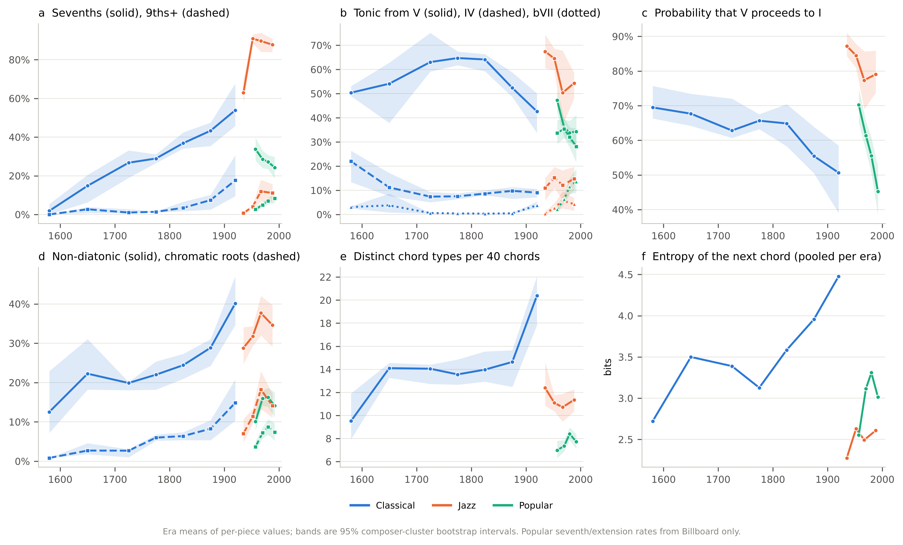
Figure 1. Harmonic trajectories, 1565–2000. Era means of per-piece values for classical (blue), jazz (orange) and popular music (green), with 95% composer-cluster bootstrap bands. (a) Share of chord events carrying a seventh (solid) or a ninth or higher extension (dashed); popular values from Billboard only. (b) Share of arrivals on the tonic prepared by V (solid), IV (dashed) and bVII (dotted). (c) Probability that a chord on scale degree 5 is followed by one on degree 1. (d) Non-diatonic chords (solid) and chords on chromatic roots (dashed). (e) Expected number of distinct chord types in a random sample of 40 chords. (f) Entropy of the next chord given the current chord, pooled per era.
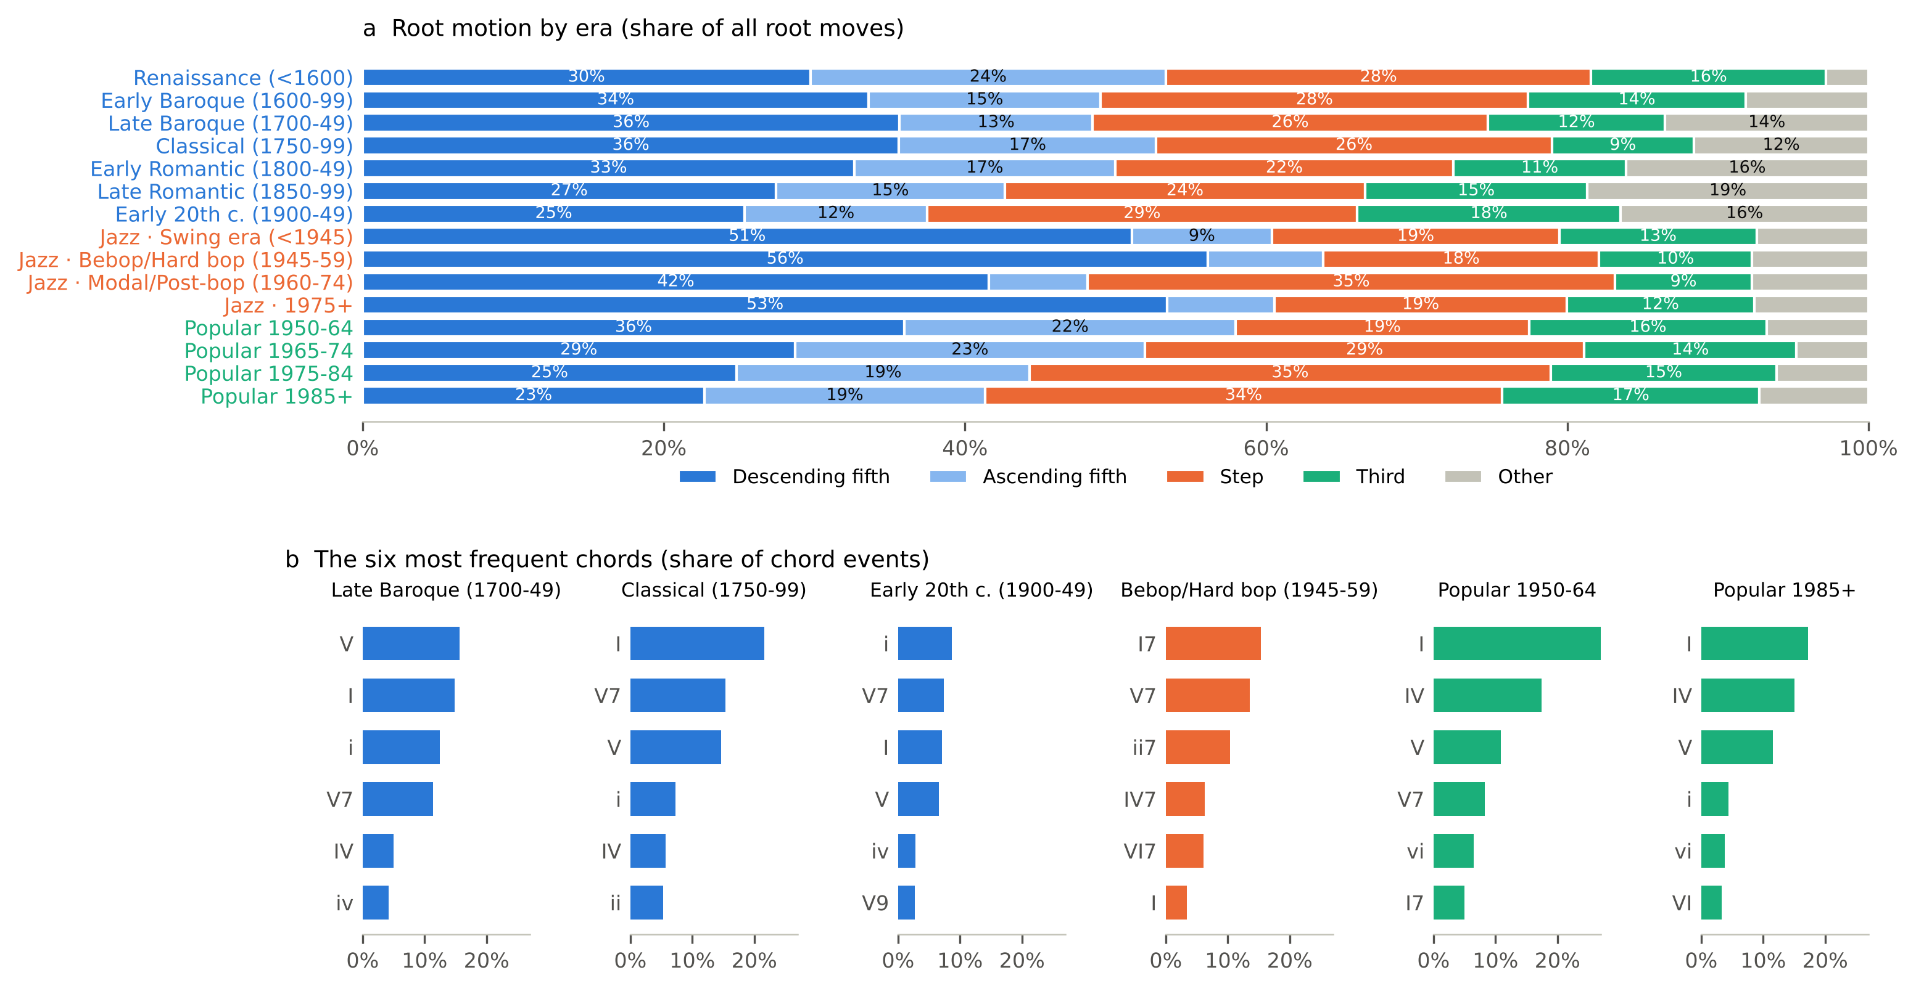
Figure 2. Three grammars of root motion. (a) Share of all root moves by class per era: descending fifth, ascending fifth, step (one or two semitones), third, other (tritone, repetition). Era labels are coloured by repertoire. (b) The six most frequent chord labels, as a share of chord events, in six representative eras.
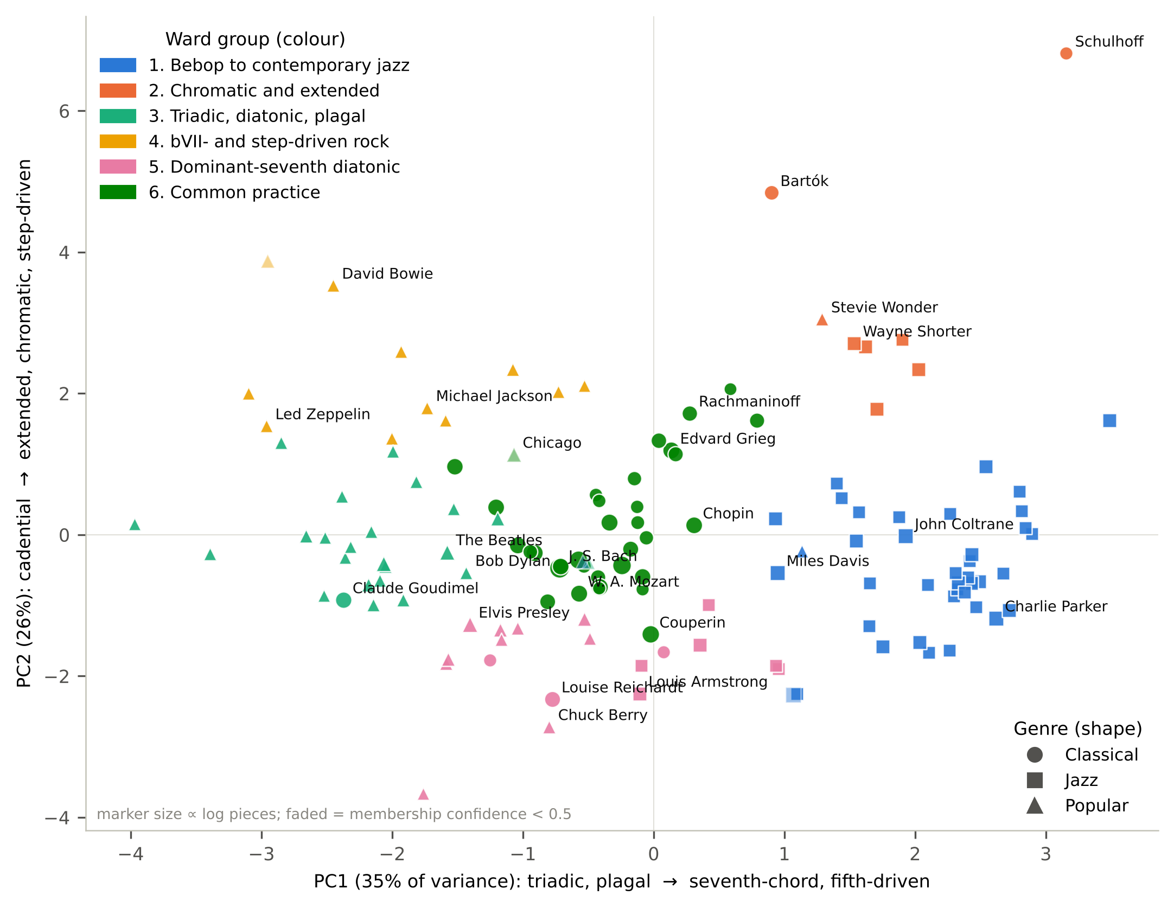
Figure 3. Composers and artists on one harmonic map. The 136 composers and artists with at least five located pieces on the first two principal components of the standardised 14-measure harmonic profile. Colour gives the Ward group, shape the repertoire, marker size the logarithm of the number of pieces; faded markers have a bootstrap membership confidence below 0.5. Selected names are shown.
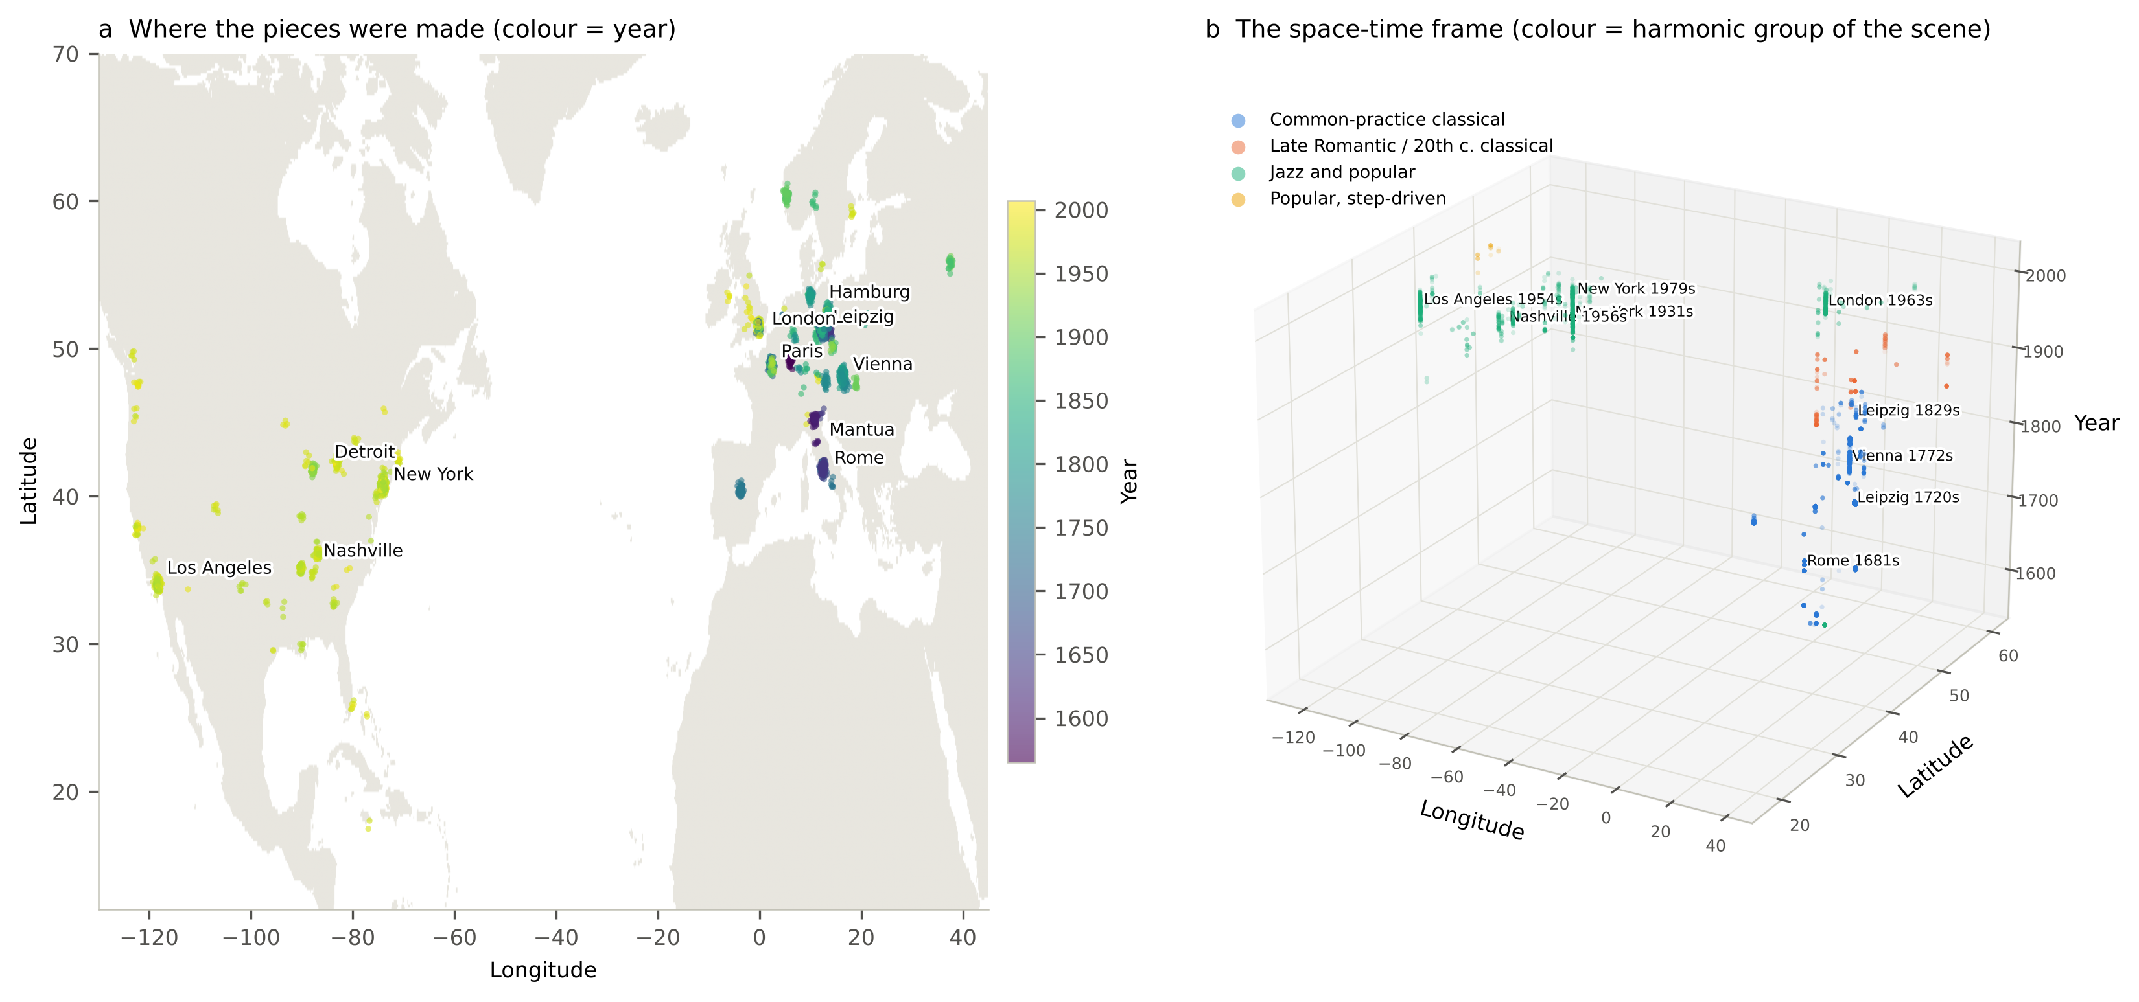
Figure 4. The space-time frame. (a) The 3,318 located pieces at the city where they were made, coloured by year, with the largest scenes labelled (points jittered by 0.25°). (b) The same pieces at (longitude, latitude, year), coloured by the harmonic group of their scene, with scenes of more than 120 pieces labelled. The interactive version at shanem73.github.io/harmony-space-time can be rotated and filtered by year.
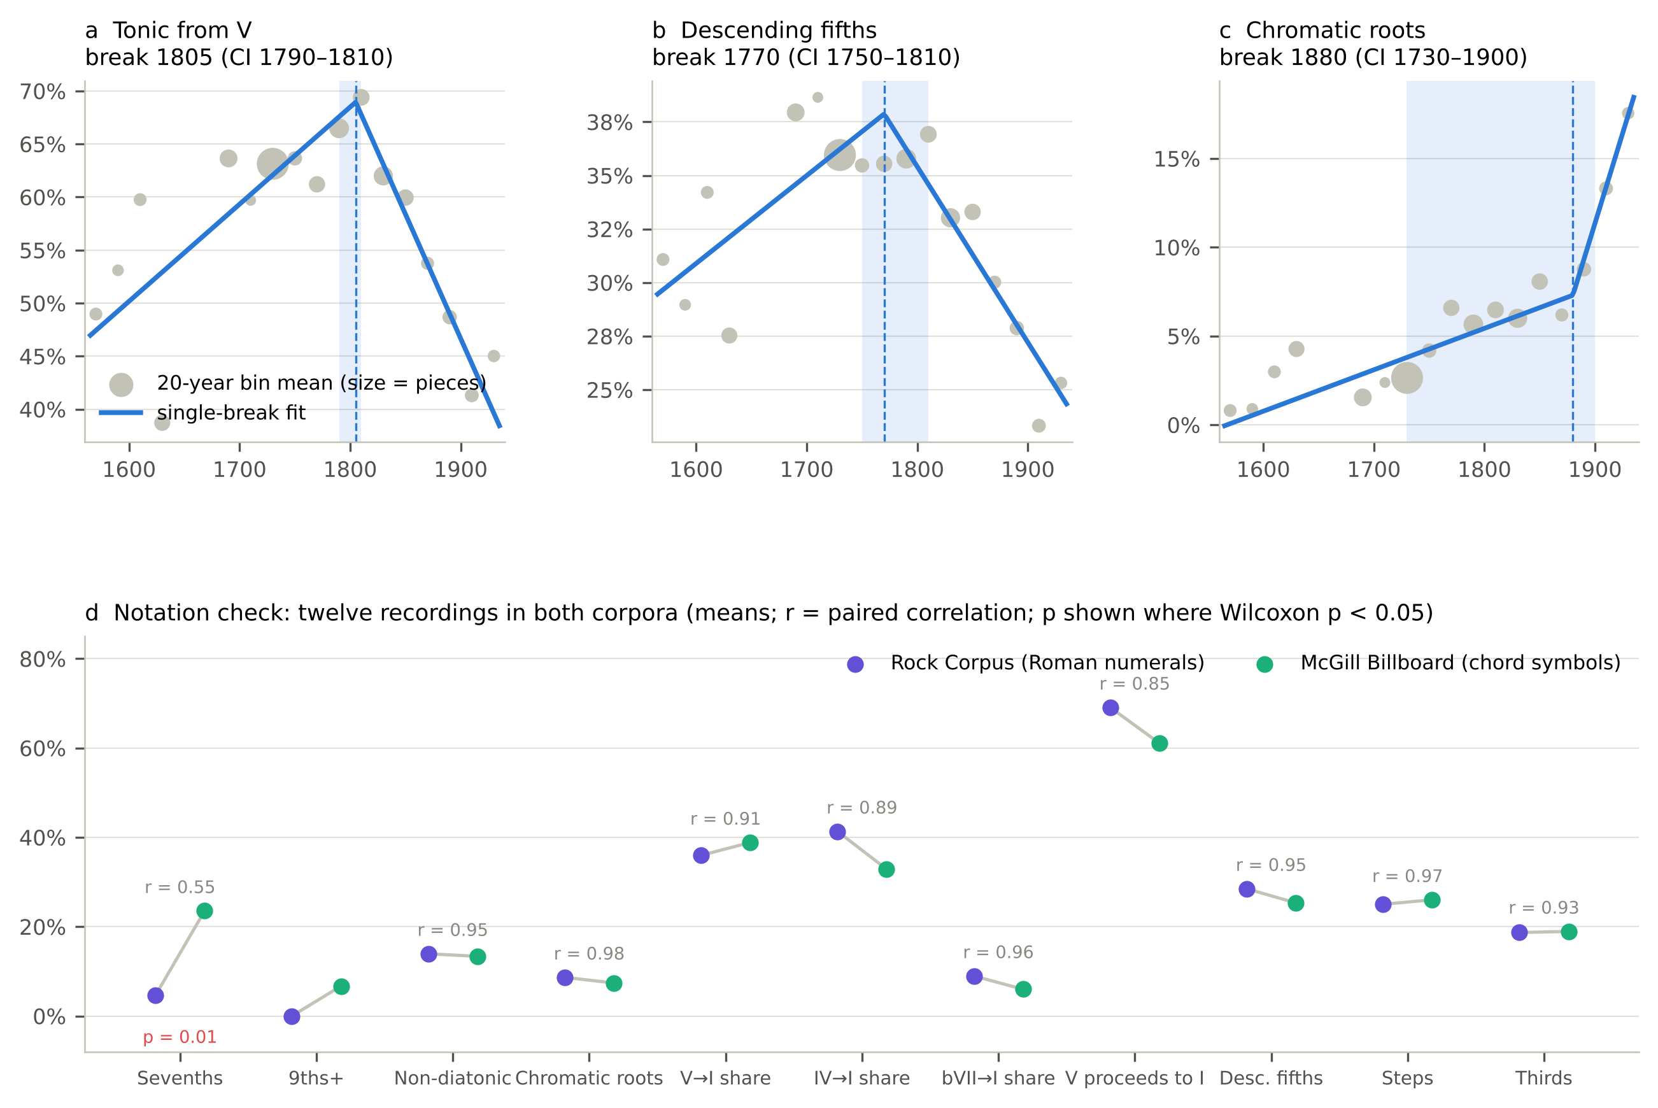
Figure 5. Robustness. (a–c) Single-break least-squares fits to piece-level classical values of the V→I share, the descending-fifth share and the chromatic-root rate; grey dots are 20-year bin means sized by the number of pieces, the dashed line the fitted break year and the shaded band its 95% bootstrap interval. (d) The notation check: for twelve recordings transcribed in both the Rock Corpus (Roman numerals) and McGill Billboard (chord symbols), the mean of each measure in each corpus, the paired correlation r, and the Wilcoxon p-value where below 0.05.

