Opening and Running the Project:

* Open VimeoBatchReplace.sln

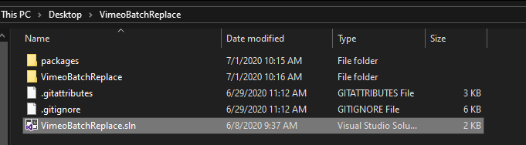

* Make sure the play button is set to IIS Express (Google Chrome), then click it to start

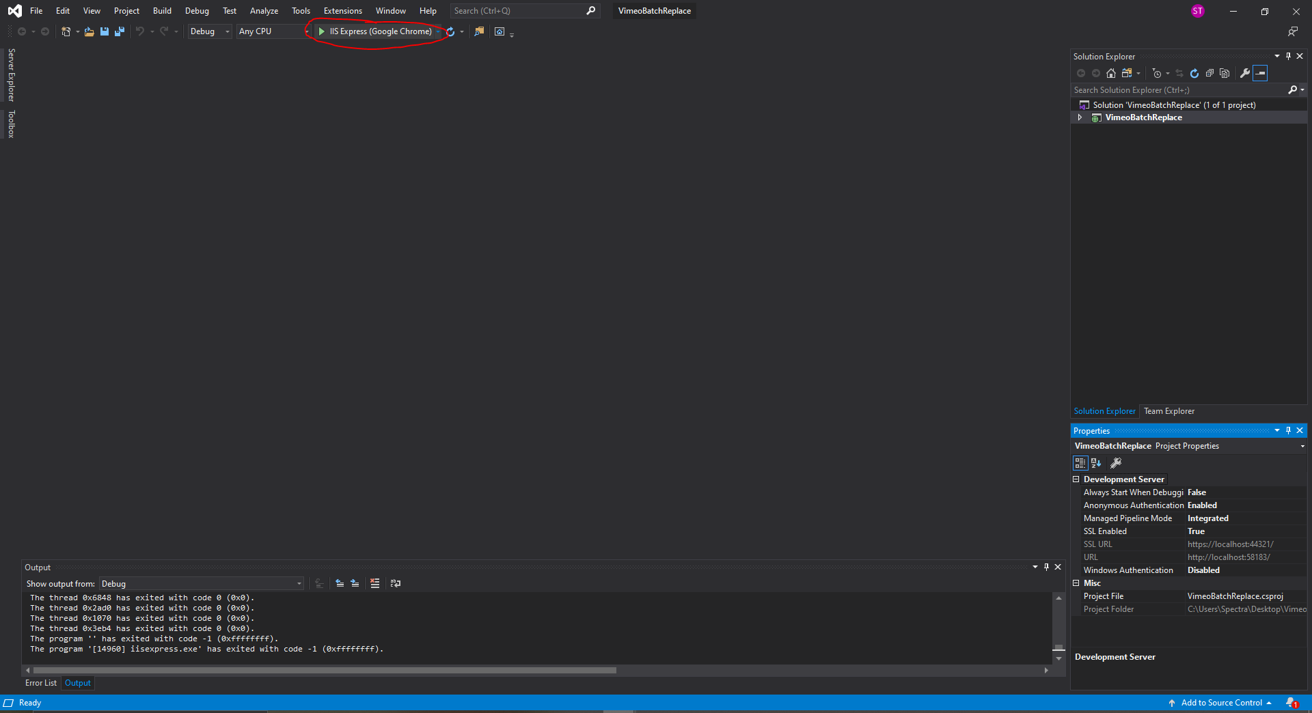

The Interface:

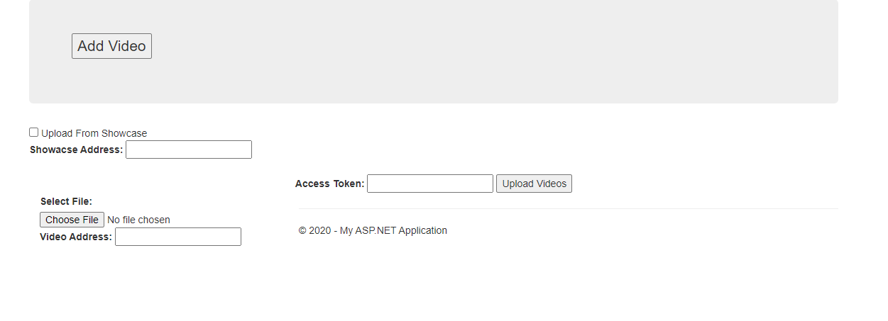

* Upload From Showcase: If this option is selected, only the Showcase Address and Access Token need to be filled out to upload videos
* Showcase Address: The id number of the showcase to replace videos from

* Access Token: A unique code that gives upload access for our Vimeo Account
* Upload Videos: Click this button when you are done to run the script
* Select File: Select the video file you want uploaded and put the address of the
* Add Video: Adds another Choose File button and Video Address Box
* Choose File: The video file to be uploaded
* Video Address: The id number of the video to be replaced (used if not uploading from showcase)

