**Characters:**

**Likeness:**

Butler

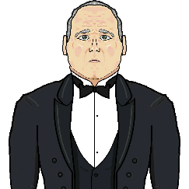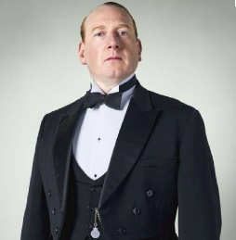

<http://www.stgeorges.co.uk/sites/default/files/blog_uploads/2012/12/Verb-noun-collocations-English-Butlers-are-back.png>

Host

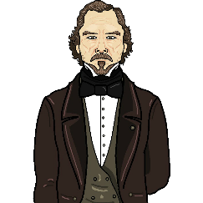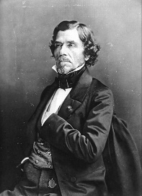

<https://upload.wikimedia.org/wikipedia/commons/thumb/6/62/F%C3%A9lix_Nadar_1820-1910_portraits_Eug%C3%A8ne_Delacroix.jpg/745px-F%C3%A9lix_Nadar_1820-1910_portraits_Eug%C3%A8ne_Delacroix.jpg>

Player (Clergyman)

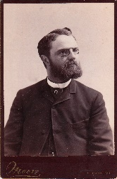

<https://cabinetcardgallery.files.wordpress.com/2011/03/ludlow-preacher_0001.jpg>

Police Officer

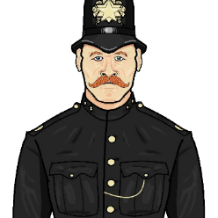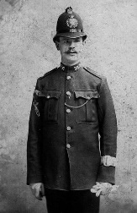

<https://c1.staticflickr.com/5/4065/4438595812_15017ee01b_b.jpg>

Politician

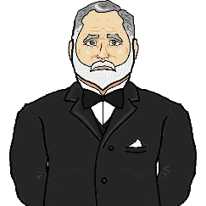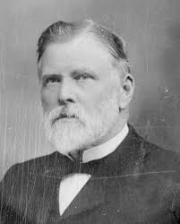

<https://upload.wikimedia.org/wikipedia/commons/a/ac/John_Duthie%2C_ca_1900.jpg>

Rival

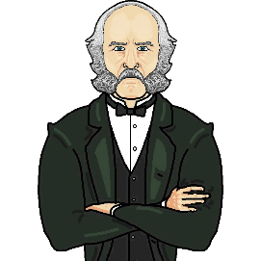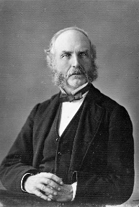

<https://nzhistory.govt.nz/files/styles/fullsize/public/images/fd-fenton.jpg?itok=_Kgos6Hb>

Sister

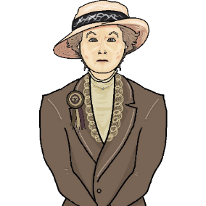

<https://cdn1.thr.com/sites/default/files/imagecache/portrait_300x450/2015/09/meryl_streep_suffragette-4.jpg>

**Portrait Backgrounds and Frames**

Rival Framed

<https://contestimg.wish.com/api/webimage/56ecefb2bb8d773d37628ec6-large.jpg?cache_buster=768ce2a63bfb14f728dc53664f41a2ac>

Butler Framed

<http://www.letsbeecool.com/image/cache/Vintage%20Bracelet%20Banner/digital-photography-indoor-backdrop-backgrounds-photo-studio-1024x832.jpg>

Host Framed

<https://ae01.alicdn.com/kf/HTB1BOdpJFXXXXcjXFXXq6xXFXXXG/canvas-studio-background-flowers-stor-photo-props-photography-backdrops-retro-vinyl-5x7ft-or-3x5ft.jpg_640x640.jpg>

Politician Framed

<https://ae01.alicdn.com/kf/HTB1yR2mIpXXXXXqXVXXq6xXFXXX5/8x10ft-Angel-Art-Wall-photography-backdrops-scenic-vinyl-print-photo-background-for-portrait-studio-photo-shoot.jpg_640x640.jpg>

Sister Framed

<https://ae01.alicdn.com/kf/HTB1VezeJVXXXXaRXVXXq6xXFXXXD/5ftx7ft-Retro-Wood-Flooring-Stand-On-Castle-Background-Wedding-Marry-Photo-Studio-Photography-Backdrop-Window-Photographic.jpg_640x640.jpg>

Policeman Framed

<https://ae01.alicdn.com/kf/HTB1RWgeQFXXXXaiXpXXq6xXFXXXG/5x7ft-Thin-fabric-cloth-Printed-photography-background-Bricks-wall-wood-floor-backdrop.jpg>

Sister Portrait

<https://d2bzigf9wlkj42.cloudfront.net/item_images/images/000/053/590/large/7393-8843847201-spanish-hand-carved-baroque-style-frame20141022-828-44muiu.png?1413991205>

Politician Portrait

<https://lowyfineartservices.files.wordpress.com/2013/03/031213.jpg>

Host Portrait

<https://upload.wikimedia.org/wikipedia/commons/6/64/Ferdinand_Bol_-_Self-Portrait_-_WGA2366.jpg>

Butler Portrait

<https://upload.wikimedia.org/wikipedia/commons/0/00/Phineas_Gage_Cased_Daguerreotype_WilgusPhoto2008-12-19_Unretouched_Color.jpg>

Rival Portrait

<http://www.birminghammuseums.org.uk/system/images/W1siZiIsIjIwMTYvMDEvMDYvNHBhOXdkdmZ3Yl9WYW5EeWNrX3BvcnRyYWl0X05hdGlvbmFsX1BvcnRyYWl0X0dhbGxlcnlfTG9uZG9uLmpwZyJdLFsicCIsInRodW1iIiwiNzAweCJdXQ/VanDyck%20portrait%20%C2%A9%20National%20Portrait%20Gallery%2C%20London.jpg>

Policeman Portrait

<https://i.pinimg.com/236x/23/6d/f4/236df4f97ac1d847782f40642cf5c67f--police-crime-police-cars.jpg>

**Items**

Used Cup

<https://proportiodivina.nl/wp-content/uploads/2015/10/Rozenburg-Den-Haag-Schellink-1900-cup-1.jpg>

Poison Bottle

<http://infoindustria.com.ua/wp-content/uploads/2015/11/Myishyak.jpg>

Gun Case

<https://i.pinimg.com/474x/ae/69/4c/ae694c3dc80dd02b57918952f0d61450--mechanical-art-gun-cases.jpg>

Bloody Knife

<https://i0.wp.com/www.pokusnageneracija.com/wp-content/uploads/2017/07/Blood-Knife.png?w=955>

Mangled Toaster

<https://s-media-cache-ak0.pinimg.com/originals/51/b5/7b/51b57b0e3362b74e8bf84736cd4e2b33.jpg>

Pamphlet

<http://upload.wikimedia.org/wikipedia/en/c/c1/Socialist-ad-1920.jpg>

Threatening Letter

<http://waller.ub.uu.se/images/Waller_Ms_dk/01521/f_001a.jpg>

Ledger

<https://thumbs.worthpoint.com/zoom/images3/1/0413/04/c1890-1900-ledger-photography-film_1_dd07761334c7c859549d3a870913f7ea.jpg>

RSVPs

<https://cdn.pixabay.com/photo/2017/01/29/21/25/background-2019432_640.png>

Diary

<https://alwaysbackroads.files.wordpress.com/2012/05/atc-9jun1900-page.jpg>

Letter of Termination

<https://www.jamescumminsbookseller.com/pictures/medium/39676.jpg>

**Rooms**

Lounge

<http://www.chicagopostcardmuseum.org/images/exhibit_halls/art_institute_of_chicago/ThornePhoto_Jeremiah_Lee_Mansion_Drawing_Room_MA_1768.jpg>

Kitchen

<http://kilaz.co/wp-content/uploads/2016/06/kitchen-chandeliers-access-lighting-glass-wall-sconce-chandelier-glass-brass-sconce.jpg>

Hallway

<http://www.driehausmuseum.org/img/blog/Main_Hall_big.jpg>

Bedroom

<http://www.amazadesign.com/wp-content/uploads/Glamorous-Calm-King-Bedroom-Sets-With-Bed-Mattress-For-Aparment-Design-Ideas-With-Modern-Traditional-Furniture-Sets-Ideas-And-Beautiful-Rug-Design-Also-Laminate-Dark-Wood-Flooring-Ideas.jpg>

Library

<http://lowres-picturecabinet.com.s3-eu-west-1.amazonaws.com/115/main/1/343983.jpg>

Office

<http://www.connectorcountry.com/wp-content/uploads/2017/09/full-size-of-home-decor-amazing-ideas-living-room-modern-together-with-innovative-captivating-office-decorating-photos-to-decorate-your.jpg>

Frame

<https://s-media-cache-ak0.pinimg.com/originals/c0/3b/2c/c03b2cb5cc1e04bbe8dc1763e1ea49d6.png>

**Background Images**

Background Wallpaper

<http://eskipaper.com/images/victorian-wallpaper-2.jpg>

Mini-Map

**Epilogue Images**

Butler Free

<http://upload.wikimedia.org/wikipedia/commons/e/ee/Amesservants.jpg>

Politician Free

<https://twt-media.washtimes.com/media/image/2017/03/30/aptopix_britain_brexit_96536.jpg>

Rival Free

<http://www.nrm.org.uk/img/nrm/worksphotos/Crewe/1996-7316_CR_MC_335.jpg>

Sister Free

<https://socialistworker.org/sites/default/files/images/AmalgamatedClothingWorkersStrike1915-a.jpg>

Prison Cell

<https://www.gannett-cdn.com/-mm-/2a86b1d7123b86acb53df25eb242bce249eb2d91/c=0-198-3888-2395&r=x1683&c=3200x1680/local/-/media/2017/11/07/TennGroup/JacksonTN/636456636396777321-ThinkstockPhotos-454176809.jpg>

**Music and Sounds**

**Other**

Invite

<http://gomezisdan.com/images/postcard-web.png>

<http://gomezisdan.com/images/postcard-back-plain.png>

Conversation Frame

<https://media.overstockart.com/optimized/cache/data/frames/FR-6996G24X36-1000x1000.png>