**Testing**

**Unit Testing**

*Bluetooth module connections:*

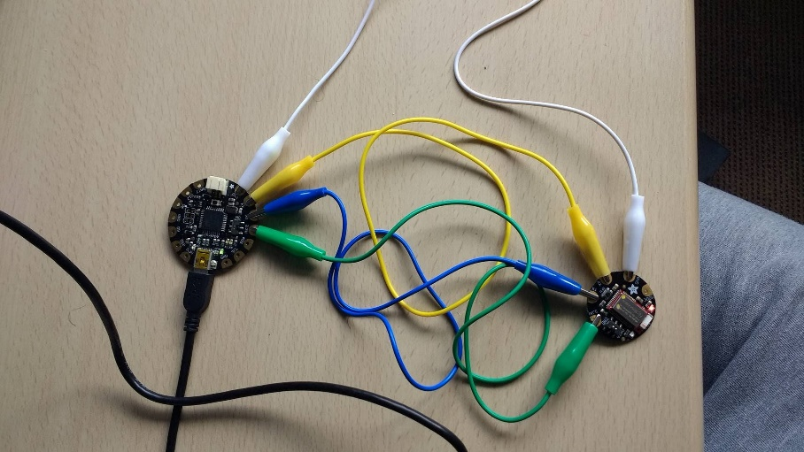

**Bluetooth Receive Test**

This test was conducted to check that the Flora’s Bluetooth module was functioning and receiving messages, which were sent from Adafruit’s Bluefruit LE app on my android smartphone.

This was the message sent from the bluefruit app (left) and received in the bluefruit module as seen here in the Serial Monitor (right).

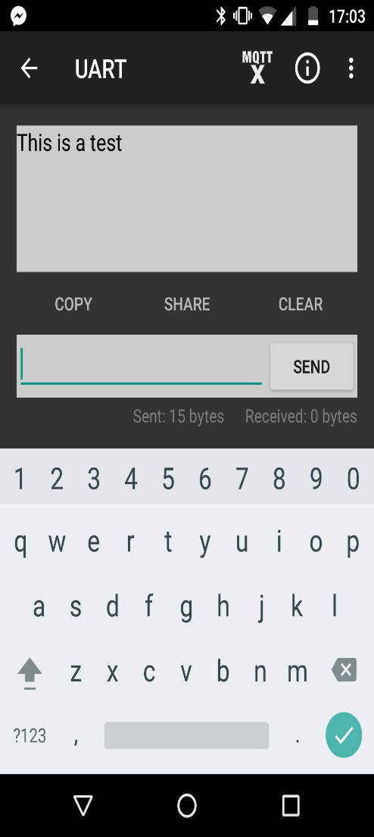 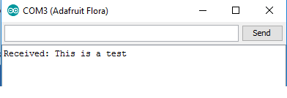

**Bluetooth Confirmation Test**

I wrote this test to check that the Flora’s Bluetooth module could send a message back to the phone when it received a message. Again sent from the Bluefruit app.

As can be seen in the images below, the Serial Monitor registers that the bluefruit is sending the confirmation message “0” after receving a message from the phone, and the app (left) receives the confirmation message.

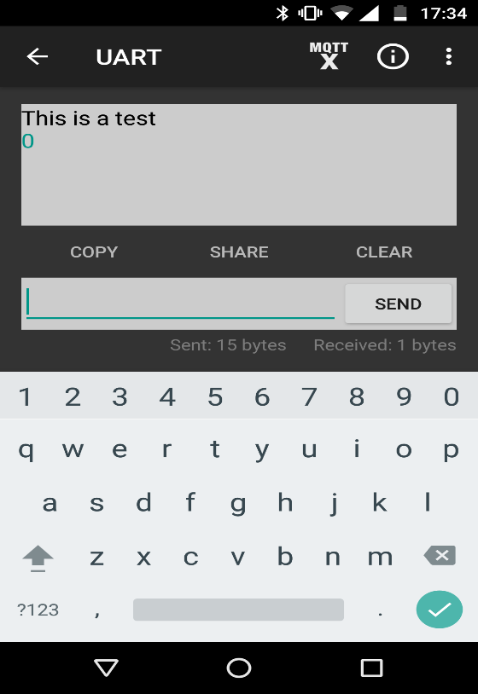 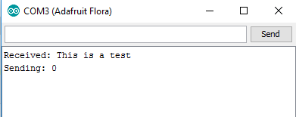

**GPS Fix Test**

This test checks that the GPS can get a fix on the current location.

Below is a screenshot of the Serial Monitor showing the output of my test program, with the latitude and longitude of my location at my home.

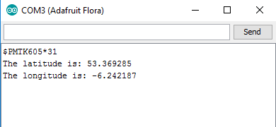

Below on the left is an image of the latitude and longitude values inserted into google maps and their position on the map, and on the right is my address input to google maps.

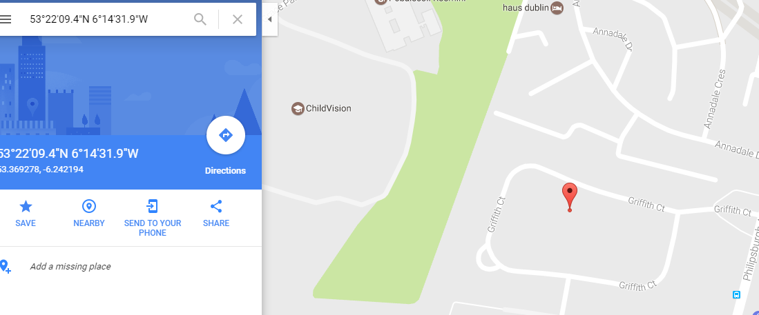 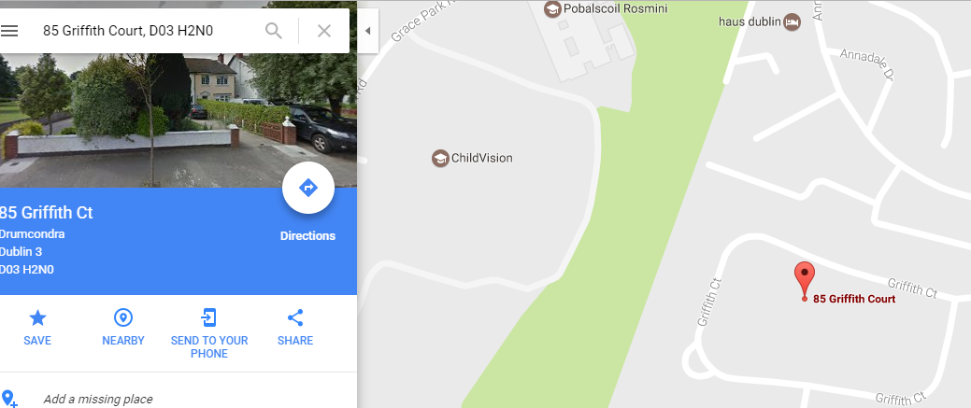

As is evident from the photos, the GPS can fix location to a good degree of accuracy.

**LatLng Distance Test**

This test checks the distance function for calculating the numbers of meters between two latitude and longitude values.

In my test program, I used the latitude and longitude values of the Glasnevin and St.Patricks DCU campuses. I printed out the result of the distance between the two locations in the Serial Monitor.

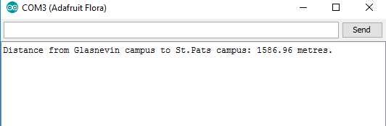

This result from my test program matched well with an online calculator for latitude and longitude distance, which can be seen in the image below.

