Analysis Report Template

Student Full Name | SHANE ROWELL FERNANDO | Student ID No. | 20241087
Case Study Title
Case Study (A): Predicting Clients Loan Status. [Total 43 Marks]
Research Question: Does machine learning have the potential to assist banker and finance analysts in predicting which client can be approved a loan?

Task (1) – Domain Understanding: Classification
The financial risk analysts decided that classification modelling is required. Indicate in the table below for each of the listed
variables in your data which ones you should RETAIN and can be included in the classification modelling of loan approval status, and the variables you should DROP (REMOVE). Justify your decision logically and/or by research (for any research, include in-text citation using
the Harvard style) [3 Marks]
Variable Name | RETAIN or DROP | Brief justification for retention or dropping with in-text citation.
ID | DROP | Unique client identifier with no predictive value. Including it would  cause the model to learn arbitrary patterns from record numbers  rather than meaningful financial attributes.
Sex | DROP | Not present in the dataset after exploration. Using sex as a predictor  also raises ethical concerns under equality legislation as it could  introduce discriminatory bias into automated lending decisions  (Hurley and Adebayo, 2016).
Age | RETAIN | Age is a relevant financial indicator as younger clients may have  shorter credit histories and lower income stability, both of which  influence loan risk assessment (Hurley and Adebayo, 2016).
Education Qualifications | DROP | Not present in the dataset after exploration. Education level alone is  not a direct indicator of creditworthiness or repayment ability.
Income | RETAIN | Annual gross income directly determines a client's capacity to service  debt repayments and is one of the strongest predictors of loan  approval (Kvamme et al., 2018).
Home Ownership | RETAIN | Residential property status reflects financial stability. Clients who own  property is generally considered lower risk by lenders (Hand and  Henley, 1997).
Employment Length | RETAIN | Years of employment indicates income stability and job security, both  key considerations in credit risk assessment.
Loan Intent | RETAIN | The purpose of borrowing provides contextual risk information as  certain loan intents carry different default risk profiles (Kvamme et al.,  2018).
Loan Amount | RETAIN | The requested loan value directly affects the lender's risk exposure  and is a core input in determining approval eligibility.
Loan Interest Rate | RETAIN | Interest rate reflects the risk premium applied to a client's loan  and is strongly associated with creditworthiness and approval.
Loan-to-Income Ratio (LTI) | RETAIN | LTI is a standard lending metric used to assess affordability. A high LTI  indicates the client may struggle to meet repayment obligations (Hand  and Henley, 1997).
Payment Default on File | RETAIN | A recorded payment default is one of the strongest negative indicators  of creditworthiness and significantly increases the probability of  rejection.
Credit History Length | RETAIN | A longer credit history provides more data to assess repayment  behaviour and financial reliability over time (Hurley and Adebayo,  2016).
Loan Approval Status | RETAIN | This is the target variable for the classification model representing the  outcome the model is trained to predict.
Maximum Loan Amount | DROP | Only known after a loan has been approved. Including it in the  classification model constitutes data leakage, artificially inflating  model performance (Kvamme et al., 2018).
Credit Application Acceptance | DROP | Directly derived from the loan approval outcome and therefore  redundant with the target variable. Including it would cause data  leakage as it encodes the same information the model predicts.
References
Hand, D.J. and Henley, W.E. (1997) 'Statistical classification methods in consumer credit scoring: a review', Journal of the Royal Statistical Society: Series A, 160(3), pp. 523–541.

Hurley, M. and Adebayo, J. (2016) 'Credit scoring in the era of big data', Yale Journal of Law and Technology, 18(1), pp. 148–216.

Kvamme, H., Sellereite, N., Aas, K. and Sjursen, S. (2018) 'Predicting mortgage default using convolutional neural networks', Expert Systems with Applications, 102, pp. 207–217.

Task (2) – Exploring and Understanding Your Dataset
With the aid of your Final Python Notebook 1, for your RETAINED input variables and your class “Target” variable, produce 1)basic descriptive stats and 2)variable scale type, then 3)plot the distribution of your target variable. (Paste the three screenshots of code OUTPUTS ONLY for evidence of these elements).
[2 Marks]

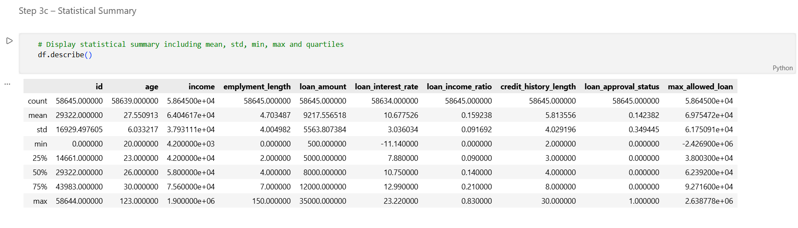
(output of df. describe())

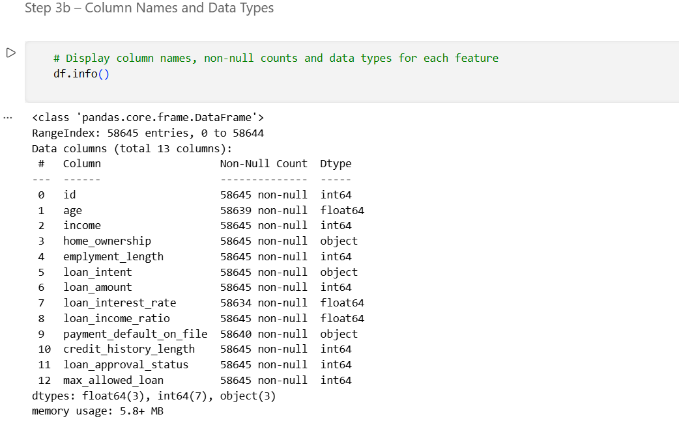
(output of df.info())

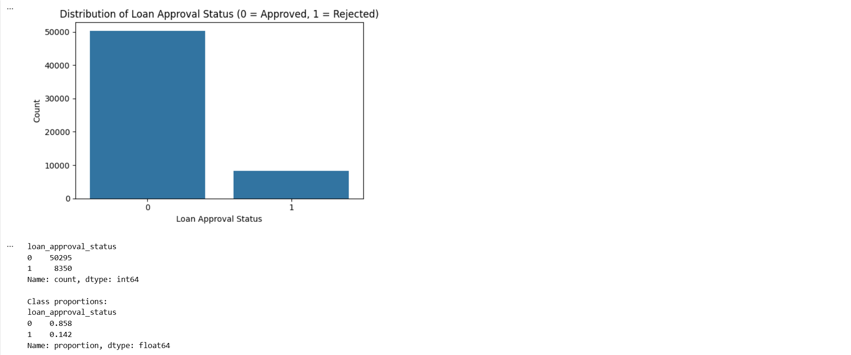

(count plot showing the distribution of loan_approval_status)

Task (3) – Data Preparation: Cleaning and Transforming your data
a) With the aid of your Final Python Notebook 1, when you first explored your retained variables in the loan dataset, you may have found some issues. 1) Report any issues you found in your retained dataset variables. Based on the issues you found in your data, 2)suggest a suitable possible method to fix each of these issues and 3)provide your justification for using your suggested fix method. Use the table below to organise your findings and analysis, and add more rows if needed
[4 Marks]
 | Variable Name | Issue found | Proposed fix | Justification for used fix method
1 | Age | 6 missing values (0.01%) | Mean imputation | Age is continuous with very few missing values. Mean imputation is appropriate when missingness is low and distribution is not heavily skewed, preserving dataset size without significant bias (García et al., 2010).
2 | Loan Interest Rate | 11 missing values (0.02%) | Mean imputation | Continuous numerical variable. With only 11 missing records out of 58,645 the proportion is negligible. Mean imputation maintains the overall distribution while avoiding data loss.
3 | Payment Default on File | 5 missing values (0.01%) | Mode imputation | Categorical variable. Mode imputation replaces missing values with the most frequent category, which is the standard approach for nominal variables as the mean is not meaningful (García et al., 2010).
4 | Maximum Loan Amount | Contains large negative values e.g. -2,426,900 | Remove negative rows from regression dataset | Negative loan amounts are physically impossible and represent data entry errors. Removed from regression dataset to prevent corrupted values distorting model training.
5 | Home Ownership | Categorical text values | LabelEncoder | Machine learning algorithms require numerical input. LabelEncoder maps each category to a unique integer making the variable compatible with all classifiers (Brownlee, 2020).
6 | Loan Intent | Categorical text values | LabelEncoder | Same justification as Home Ownership. Multiple categories converted to numerical form for model compatibility.
7 | Payment Default on File | Categorical text values Y/N | LabelEncoder | Binary categorical variable converted to 0 and 1 using LabelEncoder to enable numerical processing by classifiers.

Task (3) – Data Preparation: Cleaning and Transforming your data
b) With the aid of Python packages and your Final Python Notebook 1, implement your suggested fixes of issues in the previous Task 3-a in your final Python Notebook1.
1) Show evidence (before and after) of implementing your suggested fix to the problems you identified for your dataset in Task 3-a.
To show your evidence, paste screenshots of your relevant code OUTPUTS ONLY (Do not paste the code).
2) Indicate and annotate the issue and the fix in each of your provided evidence screenshots.
[4 Marks]
Output screenshot of the issue before the fix | Output screenshot after fixing the issue

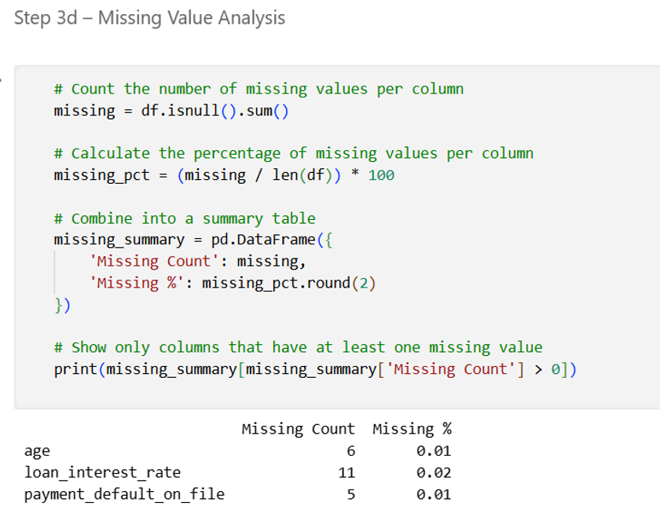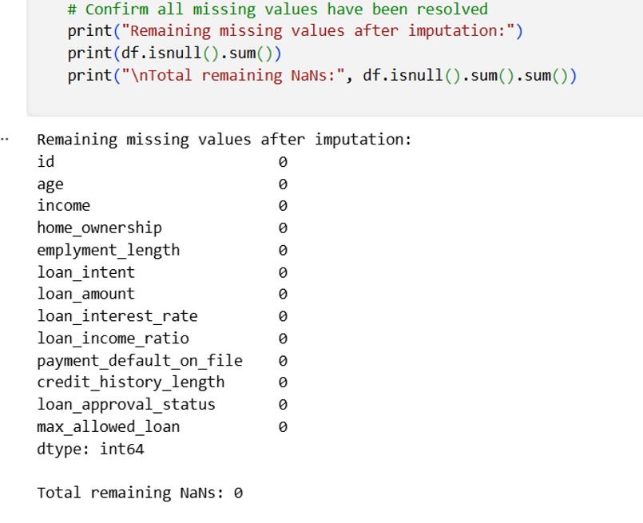

(Before imputation) (After imputation (0 missing values))

Output screenshot of the issue before the fix | Output screenshot after fixing the issue

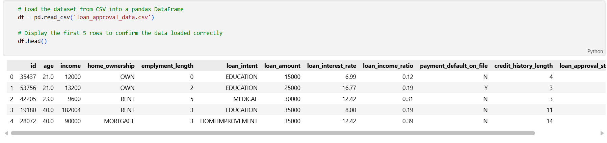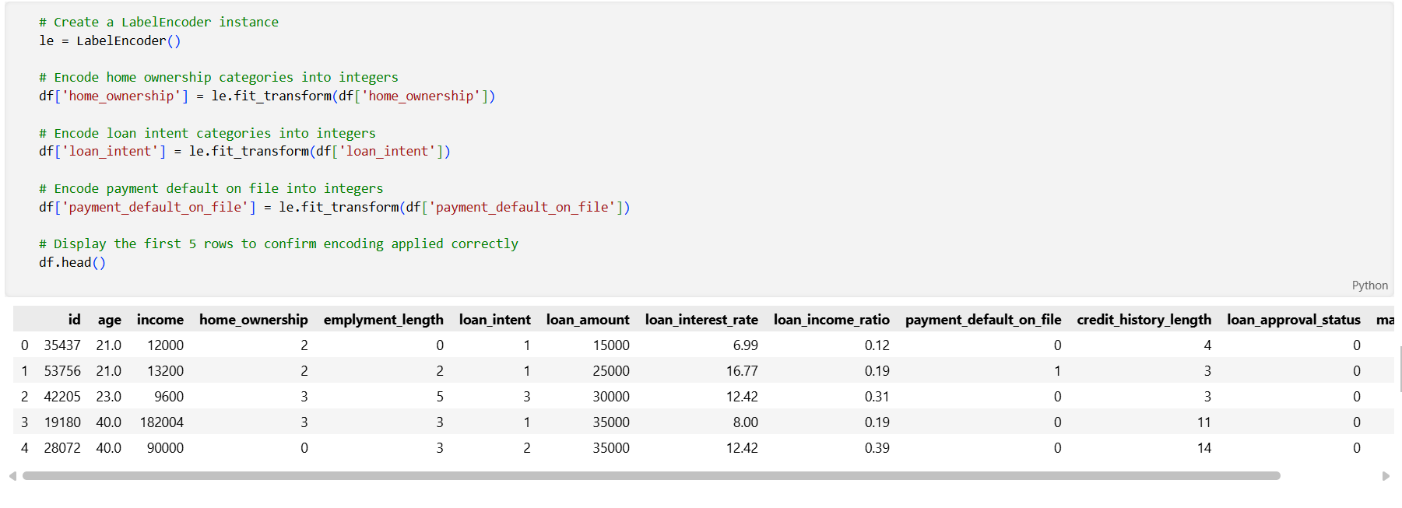

(Before encoding (categorical text values)) (After encoding (integer values))

Output screenshot of the issue before the fix | Output screenshot after fixing the issue

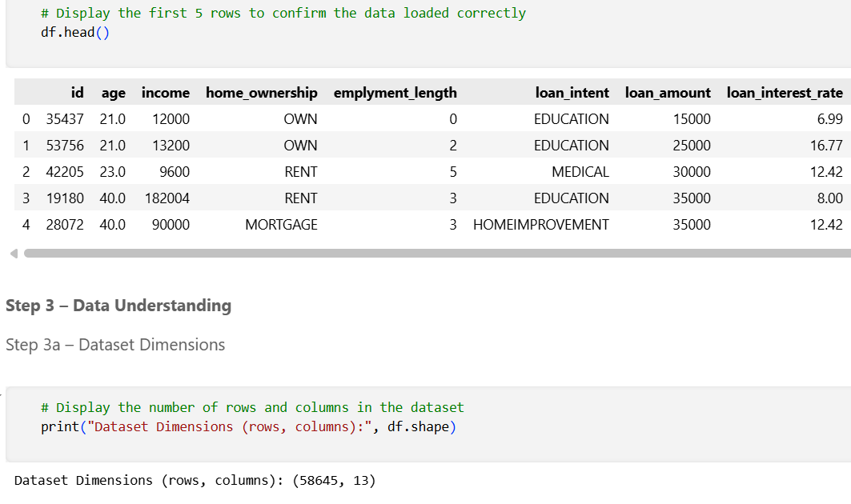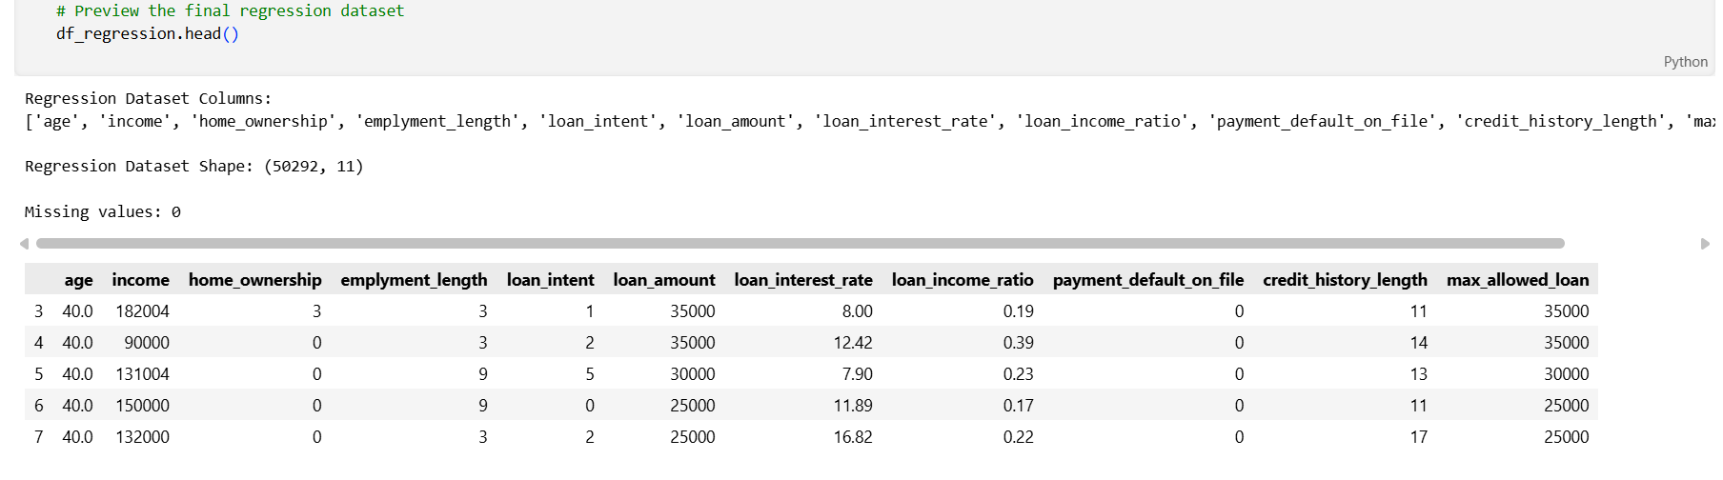
(Negative values in max_allowed_loan) (Negative max loan values removed. Dataset reduced to 50,292)

Task (4) – Classification Modelling of Clients Loan Approval Status
a) In your Final Python Notebook 2, you built THREE different models to predict loan approval status: Logistic Regression (LR), K Nearest Neighbour (KNN) and Naïve Bayes (NB). These algorithms are a mix of parametric and non-parametric algorithms.
1) Note down the type of each algorithm (parametric vs non-parametric),
2) name any learnable parameters, and
3) list any strategic hyperparameters for each algorithm which you want to consider tuning. Organise your answer in the table below:
[3 Marks]
Algorithm Name | Algorithm Type | Learnable Parameters | Some Strategic Hyperparameters
Naïve Bayes (NB) | Parametric | Mean and variance per feature per class, prior class probabilities | var_smoothing
Logistic Regression (LR) | Parametric | Feature coefficients (weights), bias term (intercept) | C (regularisation strength), penalty (L1 or L2), max_iter
K-Nearest Neighbour (KNN) | Non-parametric | None — KNN is a lazy learner storing the full training set | n_neighbors (k), metric (Euclidean or Manhattan), weights

Task (4) – Classification Modelling of Clients Loan Approval Status
b) With the aid of your Final Python Notebook 2, use the training–test split approach with your retained applicable input features only and the target output feature to build your predictive classification models.
[3 Marks]
i. Screenshot
1) the list of all feature names used for building your classification models and the corresponding
2) data shape function output. (Paste screenshots of the relevant code output only; do not paste the Python code).

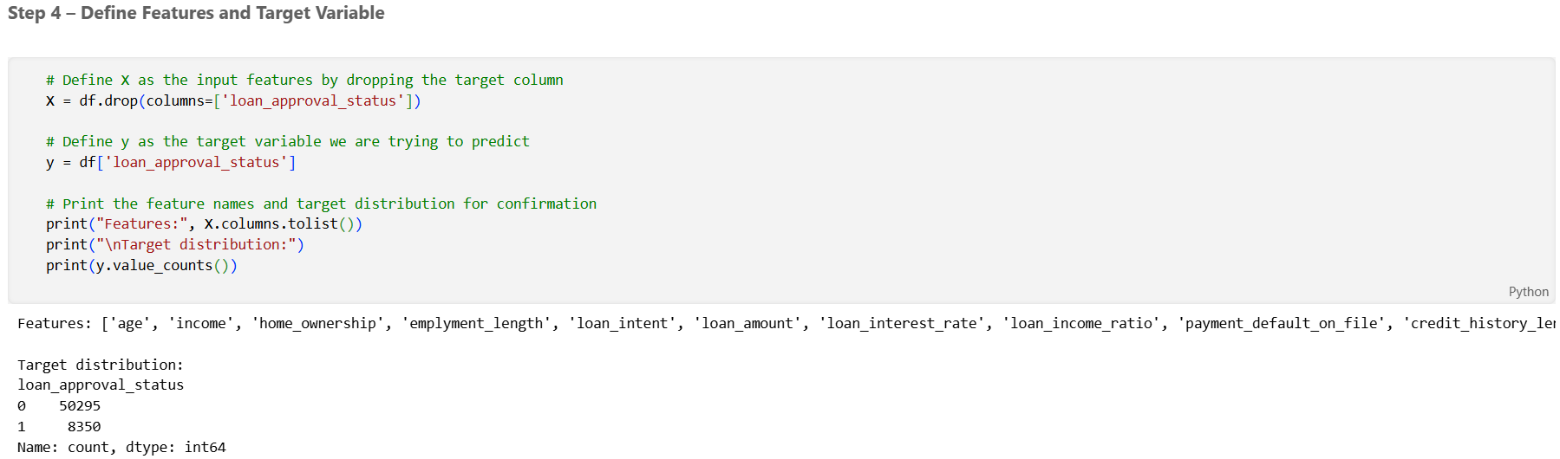

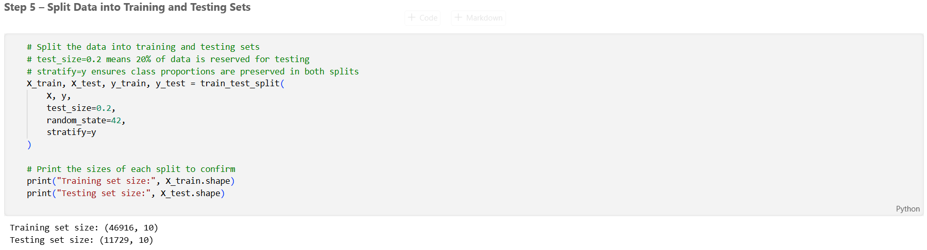

ii. In less than 150 words, research and justify (defend) your choice of the training-test split ratio and provide an in-text citation.

An 80/20 training-test split was applied, allocating 80% of records (46,916) to training and 20% (11,729) to testing. This ratio is widely adopted in machine learning practice as it provides the model with sufficient data to learn meaningful patterns while reserving an adequately sized independent test set for reliable performance evaluation (Brownlee, 2020). With 58,645 records, the 20% test set yields 11,729 unseen instances which is large enough to produce statistically stable performance estimates across all three classifiers. A smaller test set would reduce evaluation reliability while a larger one would unnecessarily limit training data available for generalisation.
References
Brownlee, J. (2020) Hands-on machine learning with Scikit-Learn. Available at: https://machinelearningmastery.com (Accessed: 14 April 2026).

iii. Provide as evidence the code block line and code output from your Final Python Notebook 2 that ensures two conditions:
1) all your models were tested on the same test instances (clients) in your dataset;
2) the labels ratio of approval Status “Accept” to “Reject” is the same in the training and test subsets.
3) State the training-test split function parameters in your code line that are responsible for meeting both conditions.
4) In less than 150 words, research and justify (defend) your decision to implement both conditions in your Python Notebook 2 notebook with in-text citations where possible.



Two conditions were implemented in the split. First, random_state=42 ensures all three models are trained and tested on identical partitions so performance differences reflect genuine algorithmic differences rather than sampling variation (Géron, 2019). Second, stratify=y preserves the original class distribution of 85.8% approved and 14.2% rejected in both subsets. Without stratification, random sampling on an imbalanced dataset risks underrepresenting the minority class in the test set, producing misleading evaluation results (He and Garcia, 2009). Together these parameters ensure consistent, reproducible and representative evaluation.
References with in-text citation
Géron, A. (2019) Hands-on machine learning with Scikit-Learn, Keras and TensorFlow. 2nd edn. Sebastopol: O'Reilly Media.

He, H. and Garcia, E.A. (2009) 'Learning from imbalanced data', IEEE Transactions on Knowledge and Data Engineering, 21(9), pp. 1263–1284.

Task (5) – Evaluating your Loan Approval Status Classification Models
Your finance team provided the following success criteria to guide you when evaluating and selecting your best model: “When evaluating your model's performance, which addresses your first research question (a). The model is expected to misclassify clients’ applications. Thus, the model should aim to predict as many “Reject” status for clients as many as possible to decrease the risk of future defaulted loan payments. However, the model should demonstrate that its high “Reject” prediction rate is mainly due to a larger number of correctly detected (predicted) rejected loan applications.”

a) With the aid of Final Python Notebook 2, for each of your models (Logistic Regression LR, Naive Bayes NB and K-Nearest Neighbours KNN)
1) paste the test confusion matrix,
2) the classification report and
3) the AUC-ROC curve graphs
as screenshots from the output of your Python code.
[3 Marks]

1) Screenshot of the test confusion matrix for (NB, LR, and KNN); make sure you title each matrix with its algorithm name

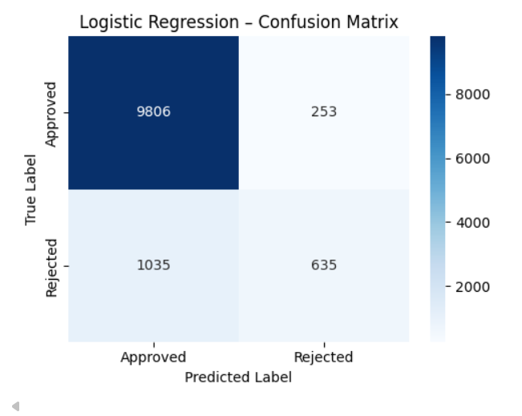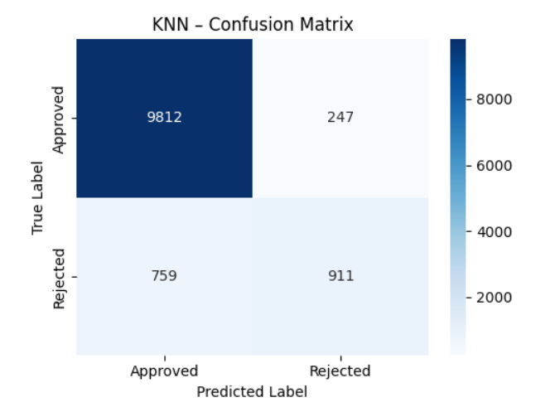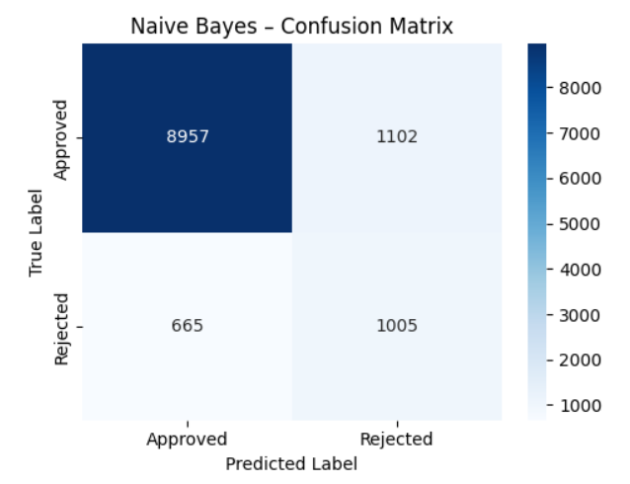

(Logistic Regression) (KNN) (Naive Bayes)

2) Screenshot of the classification report for (NB, LR, and KNN); make sure you title each classification report with its algorithm name

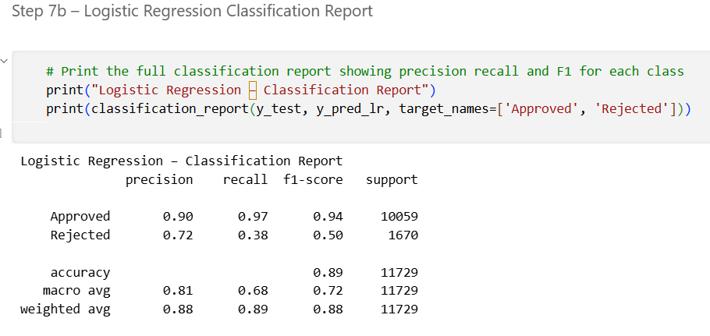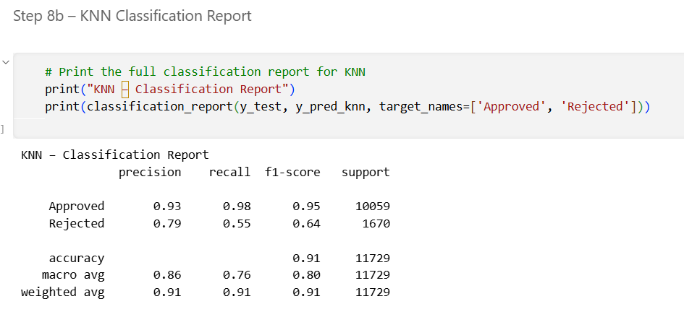
(for Logistic Regression) (KNN)

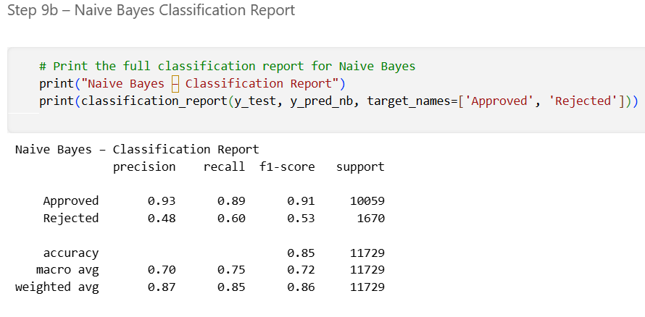
(Naive Bayes)

3) Screenshot of the AUC-ROC Curve for (NB, LR, and KNN); make sure you title each graph with its algorithm name

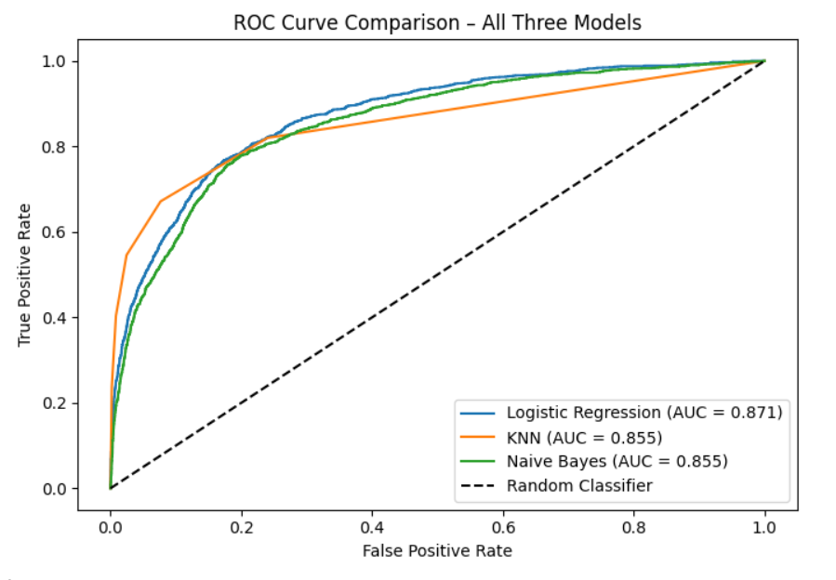

Task (5) – Evaluating your Loan Approval Status Classification Models
b) Five different classification evaluation metrics are calculated in your Final Python Notebook 2.
1) State which evaluation metric/metrics to “USE or “DO NOT USE” to closely interpret the above success criteria.
2) For justification, explain how closely your choice of “USE” or “DO NOT USE” for a metric interprets the given success criteria.
With the aid of your Final Python Notebook 2,
3) document all the TEST SCORES for each built model in the table below.
[7 Marks]
Metric | 1) USE or DO NOT USE | 2) Justification for choosing “USING” or “NOT USING” this metric in relation to the success criteria | Model | 3) Metric Test Score
Accuracy | DO NOT USE | Accuracy is misleading on imbalanced datasets. With 85.8% approved records a model predicting approved for every client achieves high accuracy without detecting any rejections, failing the success criteria entirely (He and Garcia, 2009). | NB | 0.8493
 |  |  | LR | 0.8902
 |  |  | KNN (k=7) | 0.9142
Recall | USE | Recall directly measures the proportion of actual rejections correctly identified. The success criteria require maximising reject predictions which is precisely what recall captures (He and Garcia, 2009). | NB | 0.60
 |  |  | LR | 0.38
 |  |  | KNN (k=7) | 0.55
Precision | USE | Precision measures whether reject predictions are correct. The success criteria specify high reject rates must be driven by correctly detected rejections not false alarms, which precision directly validates (Hand and Henley, 1997). | NB | 0.48
 |  |  | LR | 0.72
 |  |  | KNN (k=7) | 0.79
F1-score | USE | F1 is the harmonic mean of precision and recall, appropriate for imbalanced datasets. It balances both success criteria objectives — maximising reject detection while ensuring those detections are accurate (He and Garcia, 2009). | NB | 0.53
 |  |  | LR | 0.50
 |  |  | KNN (k=7) | 0.64
AUC-Roc | USE | AUC-ROC measures the model's ability to discriminate between approved and rejected clients across all thresholds. A higher AUC confirms the model consistently ranks rejected clients above approved ones (Hand et al., 2001). | NB | 0.8548
 |  |  | LR | 0.8714
 |  |  | KNN (k=7) | 0.8549

Task (5) – Evaluating your Loan Approval Status Classification Models
c) Suggest a single best approval status classification model based on the ‘USED’ performance metrics scores you identified in Task (5-b). In less than 100 words, briefly describe how well your best model satisfies the needs of your finance team.
[2 Marks]
KNN with k=7 is selected as the best performing classification model. Across all used metrics KNN achieved the highest F1 score of 0.64, the highest precision of 0.79 for rejected applications and the highest AUC of 0.8549. While Naive Bayes achieved a marginally higher recall of 0.60, its precision of 0.48 means nearly half its reject predictions are incorrect, failing the success criteria requirement that high reject rates must be driven by correctly detected rejections. KNN provides the strongest overall balance between correctly identifying rejected clients and ensuring those predictions are accurate.

Task (5) – Evaluating your Loan Approval Status Classification Models
d) To enhance your selected best model/s performance (from Task 5-c), tune some of its possible hyperparameters, which you indicated in Task (4-a) for that specific algorithm. With the aid of Final Python Notebook 2, Re-train and test the best algorithm again with GridSearchCV
[5 Marks]
i. With the aid of your Final Python Notebook 2,
1) Paste into this report the line of code which shows evidence of specifying a parameters grid and applying the GridSearchCV function to rebuild your selected best model.
2) Then, document the estimated best hyperparameters for the optimised model.

CODE:
# Define the parameter grid to search over for KNN
param_grid = {'n_neighbors': [3, 5, 7, 9, 11, 13, 15]}

# Run GridSearchCV using F1 score as the optimisation metric
# cv=5 means 5-fold cross validation is used during the search
grid_search = GridSearchCV(
KNeighborsClassifier(),
param_grid,
cv=5,
scoring='f1',
n_jobs=-1
)

# Fit the grid search on the training data
grid_search.fit(X_train, y_train)

# Print the best parameters and best cross validation score found
print("Best Parameters:", grid_search.best_params_)
print("Best Cross-Validation F1 Score:", round(grid_search.best_score_, 4))
ESTIMATED BEST HYPERPARAMETER:

Best hyperparameter identified: n_neighbors = 7. Best cross-validation F1 score: 0.6302.

ii. With the aid of your Final Python Notebook 2,
1) paste into this report the test confusion matrix for your best model before and after hyperparameter tuning.
2) Also, document the new score/s of the “USED” performance metric/s of your choice to interpret the success criteria indicated in Task (5.b) before and after tuning.
3) Comment on whether the tuning of hyperparameters of your best model improved its positive predictive ability in line with the success criteria.

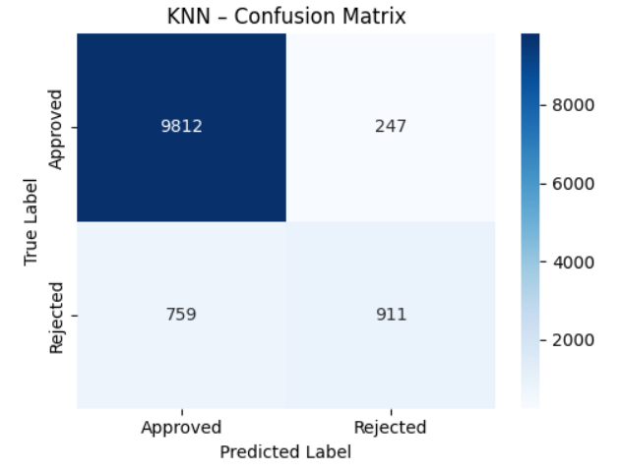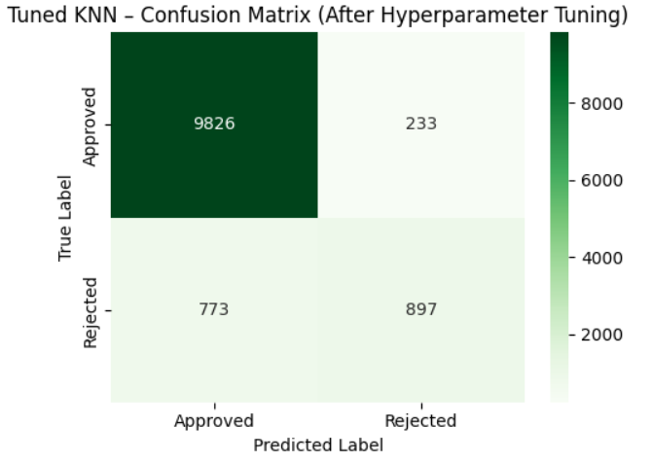

(KNN confusion matrix before tuning (k=5)) (Tuned KNN confusion matrix (k=7))

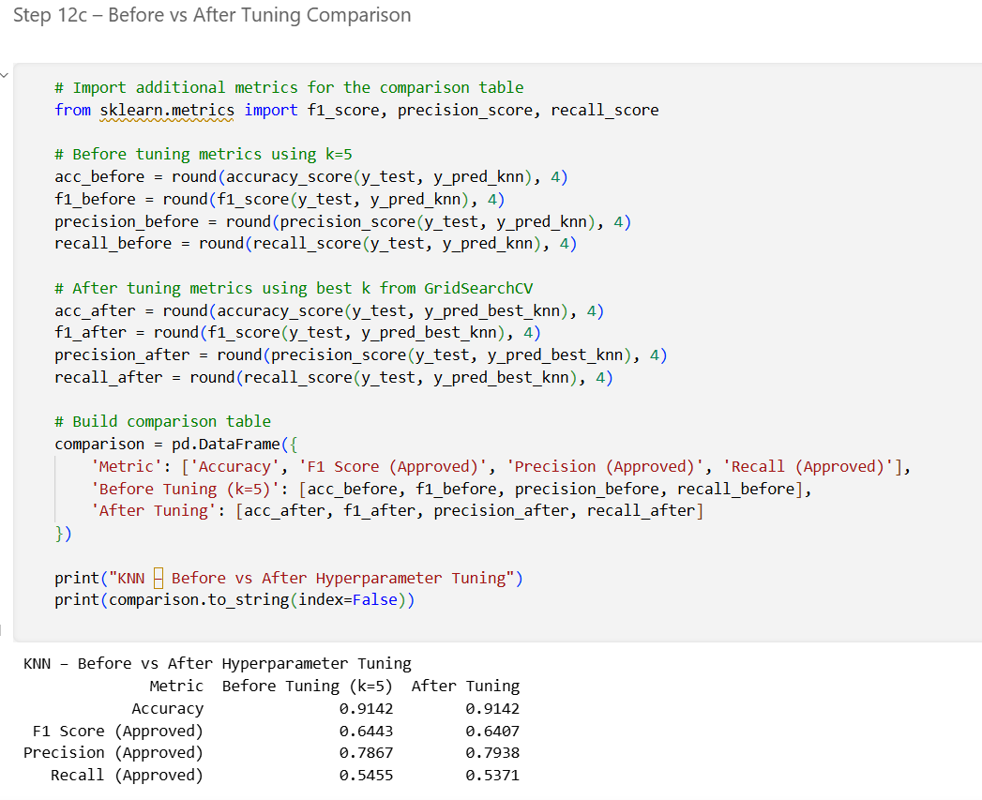

(Before vs After comparison table output)

Hyperparameter tuning via GridSearchCV confirmed k=7 as optimal. Performance metrics show marginal differences from the default k=5 — accuracy remained identical at 0.9142 and F1 showed a negligible decrease from 0.6443 to 0.6407. Precision improved slightly from 0.7867 to 0.7938 indicating marginally more accurate reject predictions after tuning. Recall decreased slightly from 0.5455 to 0.5371. Overall results suggest KNN was already near its performance ceiling at k=5, and k=7 is the statistically confirmed optimal configuration. The precision improvement aligns with the success criteria requirement that reject predictions must be driven by correctly detected rejections.

Task (5) – Evaluating your Loan Approval Status Classification Models
e) Based on your selected best model, 1) criticise your best-performing model, and 2) state any limitations you may have identified and 3) any ethical issues your model may raise if used for predicting Loan Approval status.
[2 Marks]
KNN has notable limitations in this lending context. As a distance-based algorithm it is computationally expensive at prediction time, calculating distances to all 46,916 training instances per client — this does not scale well for real-time loan processing. KNN also lacks interpretability and cannot explain why a specific client was rejected, a significant limitation in a regulated financial environment where lenders may be legally required to provide reasons for adverse credit decisions under the UK Consumer Credit Act. Additionally, KNN is sensitive to irrelevant features meaning performance depends heavily on preprocessing quality. Ethically, if the training data reflects historical lending biases such as lower approval rates for certain income groups, KNN will perpetuate those biases without any correction mechanism, potentially producing unfair and discriminatory automated decisions (Hurley and Adebayo, 2016).

Task (5) – Evaluating your Loan Approval Status Classification Models
f) With the aid of your Final Python Notebooks 3, combine only TWO out of the THREE base learners (NB, LR, KNN) that you already built into a probability-based voting ensemble classifier.
[5 Marks]
i. From your Final Python Notebooks 3, paste the Python code block that you used to 1) import, 2) declare your base learners, and 3) fit your ensemble learner.
CODE:

# Declare the Logistic Regression base learner
lr_base = LogisticRegression(random_state=42, max_iter=1000)
# Declare the Naive Bayes base learner nb_base = GaussianNB()
# Train Logistic Regression on the scaled training data
lr_base.fit(X_train_scaled, y_train)
# Train Naive Bayes on the scaled training data
nb_base.fit(X_train_scaled, y_train)
# Declare the voting ensemble using Logistic Regression and Naive Bayes
# voting='soft' means predictions are based on averaged class probabilities
ensemble = VotingClassifier(
estimators=[
('Logistic Regression', LogisticRegression(random_state=42,
max_iter=1000)),
('Naive Bayes', GaussianNB())
],
voting='soft'
)
# Fit the ensemble on the scaled training data
ensemble.fit(X_train_scaled, y_train)

ii. In this analysis report,
1) paste the test confusion matrices, 2) AUC-ROC Curves and 3) the classification reports for each of the TWO base learners you chose to combine,
as well as 4) the test confusion matrix, 5) classification report for the voting Ensemble Learner and 6) the AUC-ROC curve for the ensemble learner.
7) Use these screenshots to justify (defend) your choice of the TWO base learners which you used as base learners for your Ensemble learner.

1) Paste the test confusion matrices for each base learner (2 x matrices )

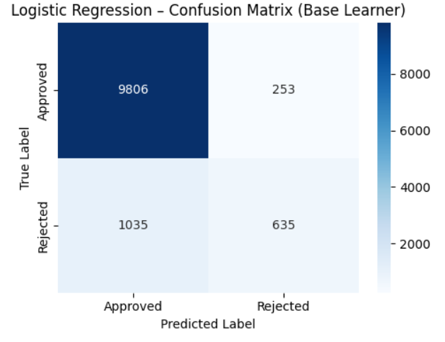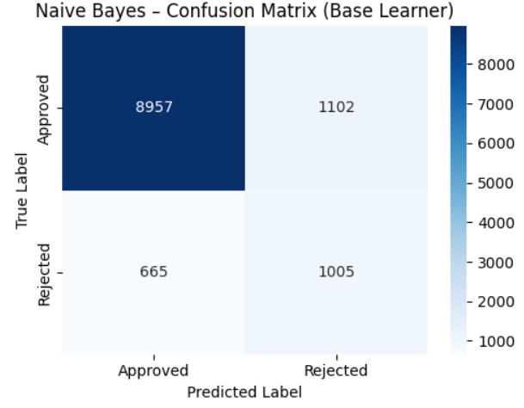

(Confusion matrix for LR base learner) (Confusion matrix for NB base learner)

2) Paste the AUC-ROC for each Base learner (2 x AUC-ROC graphs)

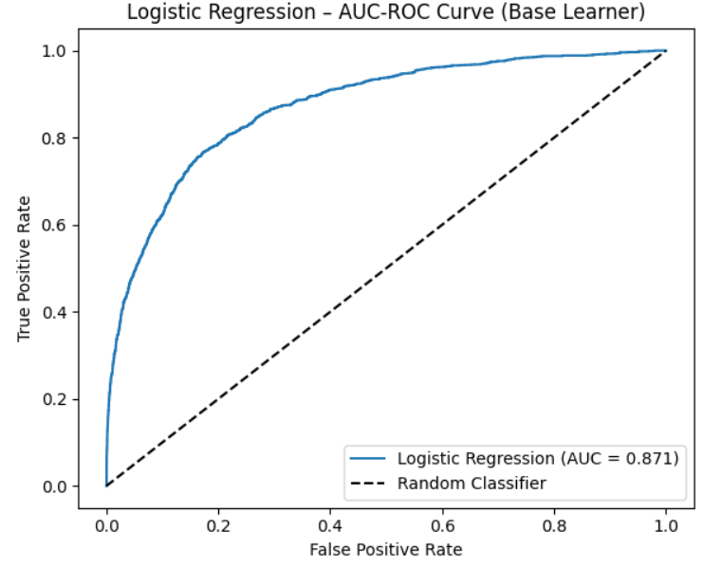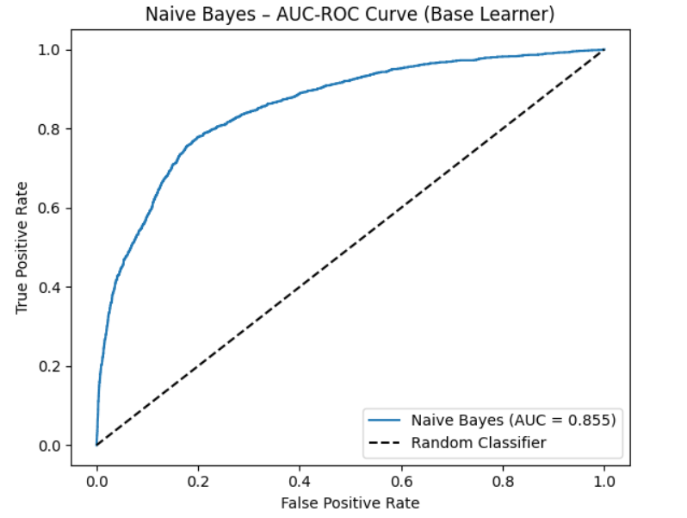

(ROC curve for LR base learner) (ROC curve for NB base learner)

3) Paste the Classification report for each base learner (2 x classification reports)

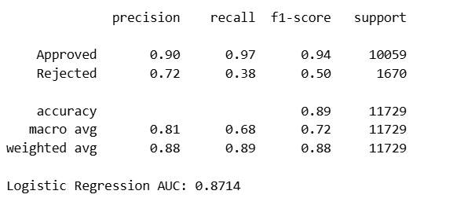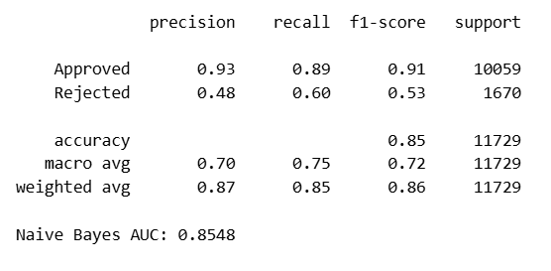

(Classification report for LR base learner) (Classification report for NB base learner)

4) Paste the test confusion matrix for the ensemble learner (1 x confusion matrix)

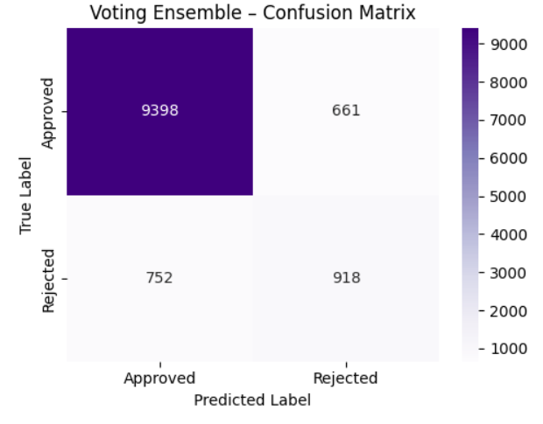

(Confusion matrix for Voting Ensemble)

5) Paste the AUC-ROC for the ensemble learner (optional) (1 x AUC-ROC graph)

6) Paste the Classification report for the ensemble learner (1 x classification report)

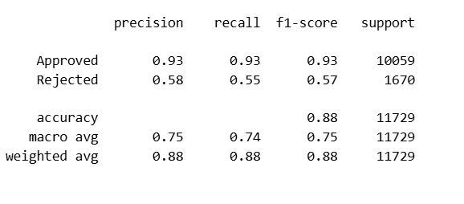
(Classification report for Voting Ensemble)

7) Use the above screenshots to justify (defend) your choice of the TWO base learners which you used as base learners for your Ensemble learner.

Logistic Regression and Naive Bayes were selected as base learners as they are complementary in approach. Logistic Regression is a discriminative model learning decision boundary directly from data while Naive Bayes is a generative probabilistic model modelling the underlying data distribution. Combining models with different learning strategies reduces correlated errors and improves ensemble robustness (Géron, 2019). KNN was excluded as a lazy learner that does not produce well-calibrated class probabilities, making it unsuitable for soft probability-based voting which requires reliable probability estimates from each base learner.

iii. Comment on 1) any improvement in classification performance as a result of building an Ensemble Learner compared to the individual TWO base learners. 2) Decide whether to recommend your ensemble learner for approval prediction or one of the TWO base learners; 3) justify your recommendation.

The voting ensemble achieved an F1 score of 0.5651 for the rejected class, outperforming both Logistic Regression (0.4965) and Naive Bayes (0.5322) individually. The ensemble also achieved higher precision of 0.58 compared to Naive Bayes (0.48), producing more accurate reject predictions. However, the ensemble accuracy of 0.8795 and F1 of 0.5651 remain below KNN's accuracy of 0.9142 and F1 of 0.64 from Notebook 2. Therefore, while the ensemble demonstrates clear improvement over its individual base learners, KNN remains the stronger model for loan approval prediction in terms of the success criteria. The individual KNN model is recommended for deployment given its superior F1, precision and AUC performance.

Case Study Title
Case Study (B): Predicting Maximum Loan Amount.
Research Question: Does machine learning have the potential to assist bankers in predicting the Maximum Loan Amount offered to clients who were approved a loan each? [Total 36 Marks]

Task (1) – Domain Understanding and Designing Your Regression Experiments
The bankers decided that regression modelling is required to predict Maximum Loan Amount for those who are approved a loan. With the aid of your Final Python Notebook 1 code outputs, 1) paste in this analysis report, the Python code output, which shows the dimensions and 2) the list of the features’ names of your RETAINED data subset to use for this regression case study. [2 Marks]

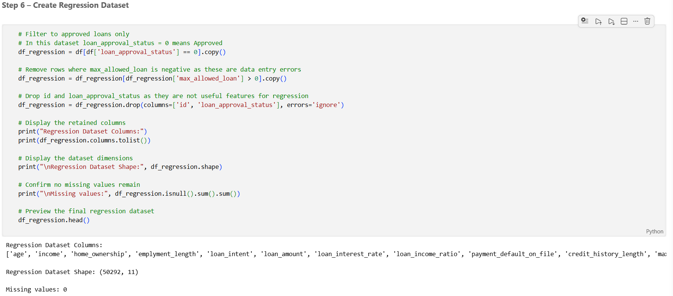

(Regression dataset: 50,292 approved client records, 10 input features, 1 regression target (max_allowed_loan))

Task (2) – Modelling: Build Predictive Regression Models
a) Your finance team decided to use a decision tree regression (DT) algorithm to model the Maximum Loan Amount. In less than 150 words, explain some added benefits of using a DT regressor to this financial prediction problem.
[2 Marks]
Decision tree regressors offer several benefits for predicting maximum loan amounts. First, they are highly interpretable — the decision path from root to leaf can be read as a sequence of logical rules, allowing financial analysts to understand and explain exactly how a predicted loan amount was reached for any given client (Géron, 2019). This is particularly valuable in a regulated lending environment where decisions may need to be justified. Second, decision trees handle both numerical and categorical features natively without requiring feature scaling, reducing preprocessing complexity. Third, they are non-parametric and make no assumptions about the underlying data distribution, making them flexible for real-world financial datasets that often contain complex non-linear relationships between client attributes and loan values (Breiman et al., 1984). Finally, decision trees can capture interactions between features such as the combined effect of income and age on maximum loan amount without requiring explicit feature engineering.
References with in-text citation
Breiman, L., Friedman, J., Olshen, R. and Stone, C. (1984) Classification and Regression Trees. Boca Raton: CRC Press.

Géron, A. (2019) Hands-on machine learning with Scikit-Learn, Keras and TensorFlow. 2nd edn. Sebastopol: O'Reilly Media.

Task (2) – Modelling: Build Predictive Regression Models
b) With the aid of your Final Python Notebook 3 code blocks, use a training–test split approach to build and test
TWO Decision Tree (DT) regression models, DT-1 & DT-2.
[6 Marks]
i. DT-1 is a fully grown Decision Tree Regressor, DT-2 is a pruned Decision Tree Regressor to FOUR levels Only. 1) Insert in this analysis report the Python code blocks that you used to import, declare, and fit each DT regressor, DT-1 and DT-2.
DT-1 is declared and fitted as a fully grown Decision Tree Regressor with no depth restriction as shown below.

CODE:

# Declare and train DT-1 with no depth restriction
dt1 = DecisionTreeRegressor(random_state=42)

# Fit on the regression training data
dt1.fit(X_reg_train, y_reg_train)

# Generate predictions on the test set
y_pred_dt1 = dt1.predict(X_reg_test)

DT-2 is declared and fitted as a pruned Decision Tree Regressor limited to a maximum depth of 4 levels as shown below.

CODE:

# Declare and train DT-2 limited to a maximum depth of 4 levels
dt2 = DecisionTreeRegressor(max_depth=4, random_state=42)

# Fit on the regression training data
dt2.fit(X_reg_train, y_reg_train)

# Generate predictions on the test set
y_pred_dt2 = dt2.predict(X_reg_test)

ii. Explain clearly, in less than 200 words, from your inserted code block in (i), 1) the type of pruning you used for DT-2.
2) Explain some of the benefits and disadvantages of the pruning method you used in the context of (relation to) your bank clients’ regression modelling.
DT-2 uses pre-pruning, implemented by setting the max_depth parameter to 4. Pre-pruning restricts tree growth during the training process itself by halting further splitting once the tree reaches the specified maximum depth, regardless of whether additional splits could reduce training error further (Géron, 2019).

In the context of loan client regression modelling, pre-pruning offers several benefits. A tree limited to 4 levels is significantly more interpretable than a fully grown tree, allowing financial analysts to trace exactly which features drove the maximum loan amount prediction for any given client. This interpretability is valuable in a regulated lending environment where decisions may need to be explained and justified. Pre-pruning also reduces overfitting by preventing the model from memorizing noise in the training data, improving generalization to unseen client records.

However, pre-pruning carries disadvantages. Setting max_depth to 4 may cause underfitting if the true relationships between client attributes and maximum loan amounts require deeper splits to capture accurately. The chosen depth is also a manually set threshold and selecting an inappropriate value without systematic tuning could result in a model that is either too simple to capture meaningful patterns or insufficiently constrained to generalize well (Géron, 2019).

Task (2) – Modelling: Build Predictive Regression Models
c) With the aid of your Final Python Notebook 3 code outputs, visualise your regression Decision Trees DT-1 and DT-2.
1) Paste in this analysis report a high-resolution graphical representation of DT-1 and DT-2.
[4 Marks]

DT-1 is a fully grown tree with a depth of 25 levels and 22,950 leaf nodes. Due to its size, it cannot be rendered as a readable graphic. The top 3 levels of the decision rules are presented below as a structural overview.

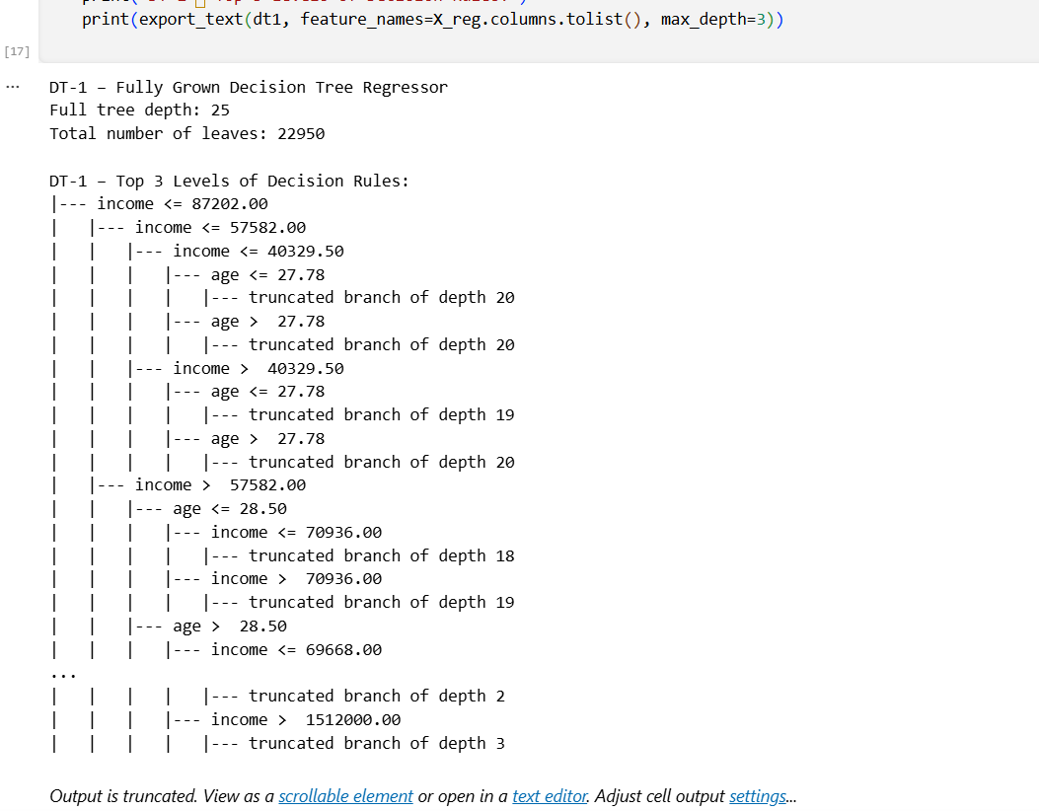

(Figure 4: DT-1 Fully Grown Decision Tree — top 3 levels of decision rules (NB3, Step 10))

DT-2 is pruned to a maximum depth of 4 levels with 16 leaf nodes. The full graphical representation is shown below:

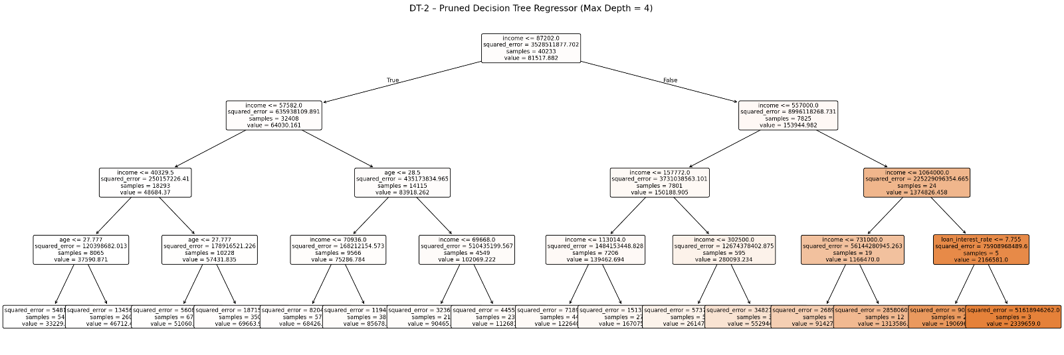

(DT-2 Pruned Decision Tree Regressor — Maximum Depth 4, 16 leaf nodes (NB3, Step 11))

Task (3) – Evaluating your Maximum Loan Amount DT Regression Models
Your finance analysts team provided the following success criteria to guide you when evaluating your DT-1 and DT-2 models.
“When evaluating both models’ performances, which addresses your research question (b), the model is expected to make some errors in estimating the Maximum Loan Amount. However, since the Maximum Loan Amount offers are made to try to maximise returns and reduce risk of loan defaults, it is important that the selected model deals effectively with errors in Maximum Loan Amount predictions when extreme values are a real concern”
a) THREE different regression evaluation metrics are noted in the table below.
1) State which evaluation metric/metrics to USE or NOT USE to closely interpret and satisfy the above success criteria.
2) Justify (Defend) your choice of USE or DO NOT USE for each metric.
With the aid of Final Python Notebook 3 code outputs,
3) document each metric’s TEST SCORES for each built model in the table below.
[8 Marks]
Metric | 1) USE or DO NOT USE | 2) Justification for choosing “USING” or “NOT USING” this metric in relation to the success criteria | Model | 3) Metric Test Score
MSE | USE | MSE squares each prediction error which penalises large deviations more heavily than small ones. Since the success criteria states extreme values are a real concern in maximum loan amount prediction, MSE is appropriate as it amplifies the impact of outlier errors making it sensitive to the very cases the criteria highlights (Géron, 2019). | DT-1 (Fully Drown) | 49,531,650.00
 |  |  | DT-2 (Pruned) | 374,722,900.00
MAE | USE | MAE measures the average absolute error in GBP making it directly interpretable in the context of loan amount predictions. It gives a clear and meaningful indication of how far off the model's estimates are on average, useful for communicating accuracy to non-technical financial analysts (Géron, 2019). | DT-1 (Fully Drown) | 1,213.79
 |  |  | DT-2 (Pruned) | 11,801.04
R-Square | USE | R-Squared indicates the proportion of variance in maximum loan amount explained by the model. A higher R-Squared confirms the model captures underlying patterns in client attributes effectively, supporting confidence in its predictions for approved loan clients (Kvamme et al., 2018). | DT-1 (Fully Drown) | 0.9822
 |  |  | DT-2 (Pruned) | 0.8650

Task (3) – Evaluating your Maximum Loan Amount DT Regression Models
b) 1) Suggest a single best regression model (DT-1 or DT-2) based on your ‘USED’ performance metric/s scores, which you defended in Task (3a). 2) Explain how your suggested model fulfils the success criteria.
[4 Marks]
DT-1 is selected as the best regression model based on all three used metrics. DT-1 achieved a significantly lower MAE of £1,213.79 compared to DT-2's MAE of £11,801.04, meaning its maximum loan amount predictions deviate by an average of only £1,213 from actual values. DT-1 also achieved a substantially lower MSE of 49,531,650 versus DT-2's 374,722,900, confirming it handles extreme loan amount values more effectively in line with the success criteria which specifically highlights the importance of managing large prediction errors. Additionally, DT-1's R-Squared of 0.9822 indicates it explains 98.22% of the variance in maximum loan amounts compared to DT-2's 86.50%. Across all three metrics DT-1 consistently and substantially outperforms DT-2, fulfilling the success criteria requirement of a model that deals effectively with prediction errors particularly when extreme values are a concern.

Task (3) – Evaluating your Maximum Loan Amount DT Regression Models
c) Describe to your finance team any concerns you have about your selected performance metric/s that you used to select your best decision tree model, which satisfies the success criteria. [200 words maximum] with in-text citation.
[4 Marks]
Despite DT-1's strong performance, there are notable concerns about the selected metrics. MSE, while sensitive to extreme values as required by the success criteria, is expressed in squared GBP units making it difficult to interpret directly in a financial context. A MSE of 49,531,650 is not intuitively meaningful to bankers without conversion to RMSE (Root Mean Squared Error) which would express the error in the same unit as the loan amount. Additionally, DT-1's exceptionally high R-Squared of 0.9822 raises concerns about overfitting. As a fully grown tree with 22,950 leaf nodes and no depth restriction, DT-1 may have memorised the training data rather than learning generalisable patterns, meaning its strong test performance could be partially attributable to the specific random split used rather than true predictive power (Géron, 2019). MAE, while interpretable, treats all errors equally regardless of magnitude and therefore does not fully capture the risk posed by large prediction errors in high value loan cases, which are precisely the scenarios the success criteria identify as most critical.
References with in-text citation
Géron, A. (2019) Hands-on machine learning with Scikit-Learn, Keras and TensorFlow. 2nd edn. Sebastopol: O'Reilly Media.

Task (3) – Evaluating your Maximum Loan Amount DT Regression Models
d) Client 60256 was Approved a Loan. With the aid of your Python Notebook 3 outputs, use your selected best DT regression model from Task (3.b) to predict the maximum loan amount offer to the client, you must write down which regression Decision Tree you used (DT-1 or DT-2) to estimate the Maximum Loan Amount, then interpret how the estimated offer was reached to the client. Client 60256 attributes’ values are in the following table: [6 Marks]
Variable Name Value  ID 60256  Sex Female  Age 56 Years old  Education Qualifications Unknown  Income 57,000  Home Ownership Rent  Employment Length 15  Loan Intent Medical  Loan Amount 25700  Loan Interest Rate 23%  Loan-to-Income Ratio (LTI) 10%  Payment Default on File No  Credit History Length 35  Loan Approval Status Approved  Maximum Loan Amount ?  Credit Application Acceptance 0 | DT-1 was used to predict the maximum loan amount for Client 60256 as it was identified as the best performing regression model in Task 3b based on the lowest MAE, lowest MSE and highest R-Squared across all evaluation metrics.  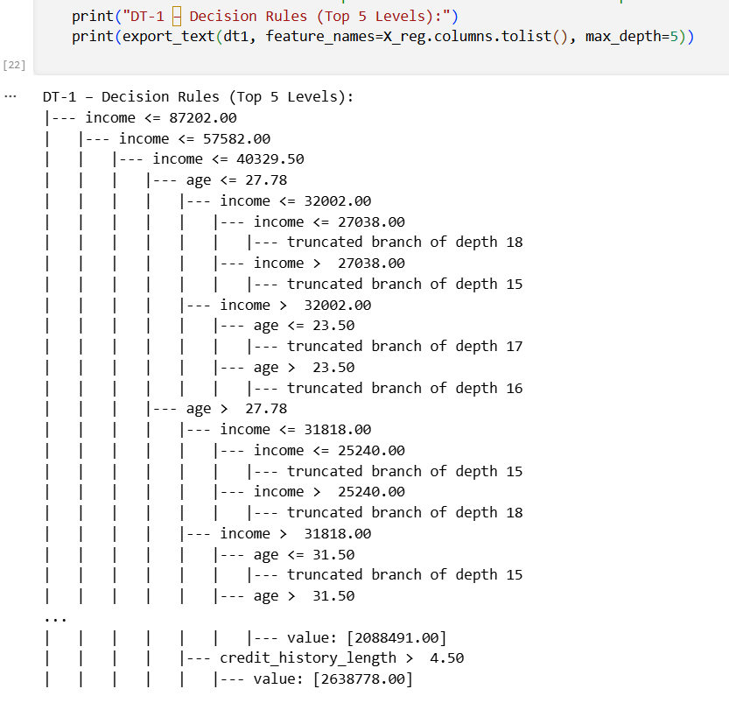  (Decision Path for Client 60256)  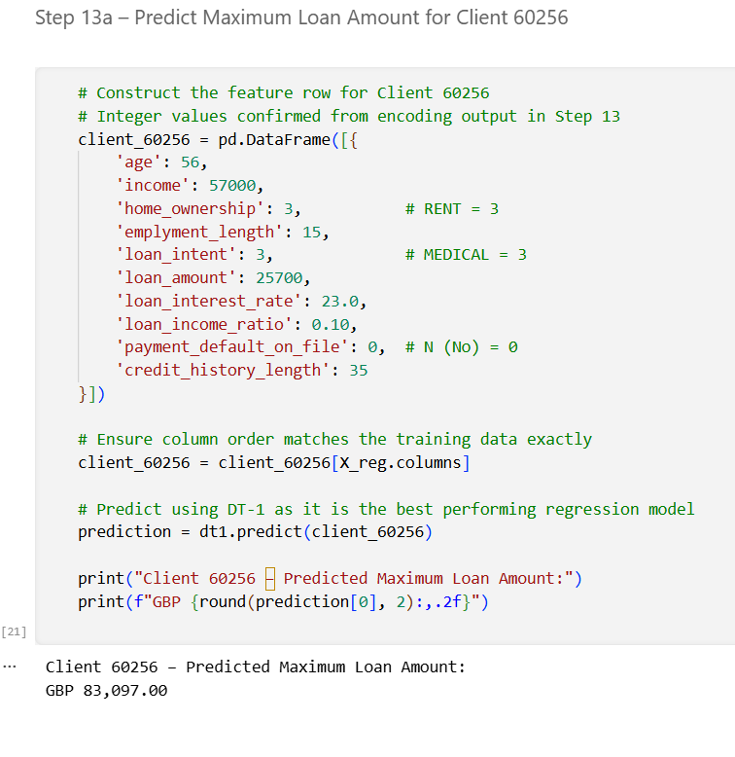  (Prediction output)  DT-1 predicted a maximum loan amount of £83,097.00 for Client 60256. The decision path can be interpreted as follows. Client 60256 has an income of £57,000 which satisfies the first split condition of income ≤ 87,202, directing the client into the lower income branch. Within this branch the client's income of £57,000 is greater than the threshold of 57,582, placing them in the higher sub-branch of the lower income group. The client's age of 56 years is greater than the age threshold of 27.78 years, directing them into the older client branch. Through subsequent splits based on income and age the model arrives at a leaf node with a predicted value of £83,097. This indicates that a 56-year-old client with an income of £57,000 seeking a medical loan fall into a client segment for which lenders are willing to offer a maximum loan of approximately £83,097 based on historical approved client data.

