Live Session Assignment 7

Nikhil Gupta

2020-02-23 21:42:23

Table of Contents

# Setup

library(tswge)

## Warning: package 'tswge' was built under R version 3.5.3

library(dplyr)

## Warning: package 'dplyr' was built under R version 3.5.3

##   
## Attaching package: 'dplyr'

## The following objects are masked from 'package:stats':  
##   
## filter, lag

## The following objects are masked from 'package:base':  
##   
## intersect, setdiff, setequal, union

library(tidyverse)

## Warning: package 'tidyverse' was built under R version 3.5.2

## -- Attaching packages ---------------------------------------------------------------------- tidyverse 1.2.1 --

## v ggplot2 3.2.1 v readr 1.1.1  
## v tibble 2.1.3 v purrr 0.3.3  
## v tidyr 0.8.2 v stringr 1.3.1  
## v ggplot2 3.2.1 v forcats 0.3.0

## Warning: package 'ggplot2' was built under R version 3.5.3

## Warning: package 'tibble' was built under R version 3.5.3

## Warning: package 'purrr' was built under R version 3.5.3

## -- Conflicts ------------------------------------------------------------------------- tidyverse_conflicts() --  
## x dplyr::filter() masks stats::filter()  
## x dplyr::lag() masks stats::lag()

#source("common_functions.R")

# My Calculations

# Imaginary Roots  
theta = c(2, -1.5)  
factor.wge(phi = theta)

##   
## Coefficients of Original polynomial:   
## 2.0000 -1.5000   
##   
## Factor Roots Abs Recip System Freq   
## 1-2.0000B+1.5000B^2 0.6667+-0.4714i 1.2247 0.0980  
##   
##

acf1 = true.arma.aut.wge(theta = theta)

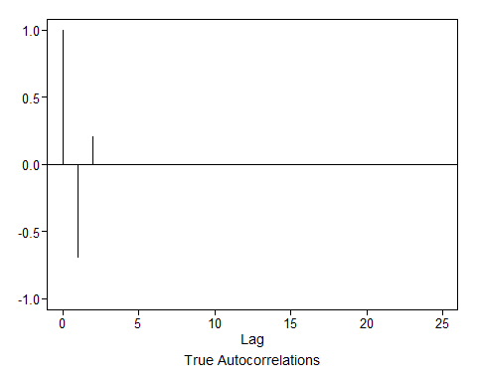

# Non Invertible since abs reciprocal > 1 for one of the roots  
# The invertible model will have the reciprocal of the current roots  
  
# Original Roots  
root1_org = complex(real = 0.6667, imaginary = 0.4714)  
root2_org = complex(real = 0.6667, imaginary = -0.4714)  
  
# Inverse of the roots  
inv_root1 = 1/root1_org  
inv_root2 = 1/root2_org   
  
inv_root1

## [1] 0.9999897-0.7070574i

inv_root2

## [1] 0.9999897+0.7070574i

# Compute Characteristic Equation  
prod = inv_root1 * inv_root2  
prod

## [1] 1.49991+0i

# Char equation: (z - inv_root1) * (z - inv_root2)  
# = [Z - (1 -0.707i)] * [Z - (1 + 0.717i)]  
# = Z^2 -Z -0.717i*Z -Z +0.717i*Z + prod  
# = Z^2 -2Z + 1.5   
# = 1 -1.3333Z + 0.6667Z^2  
  
theta = c(1.333, -0.667)  
factor.wge(phi = theta)

##   
## Coefficients of Original polynomial:   
## 1.3330 -0.6670   
##   
## Factor Roots Abs Recip System Freq   
## 1-1.3330B+0.6670B^2 0.9993+-0.7076i 0.8167 0.0981  
##   
##

acf2 = true.arma.aut.wge(theta = theta)



print(paste0("Are the ACFs for the 2 models equal: ", all(round(acf1$acf,3) == round(acf2$acf,3))))

## [1] "Are the ACFs for the 2 models equal: TRUE"

cat("\n------------------------------\n")

##   
## ------------------------------

print(acf1$acf)

## [1] 1.0000000 -0.6896552 0.2068966 0.0000000 0.0000000 0.0000000  
## [7] 0.0000000 0.0000000 0.0000000 0.0000000 0.0000000 0.0000000  
## [13] 0.0000000 0.0000000 0.0000000 0.0000000 0.0000000 0.0000000  
## [19] 0.0000000 0.0000000 0.0000000 0.0000000 0.0000000 0.0000000  
## [25] 0.0000000 0.0000000

cat("\n------------------------------\n")

##   
## ------------------------------

print(acf2$acf)

## [1] 1.0000000 -0.6897157 0.2070285 0.0000000 0.0000000 0.0000000  
## [7] 0.0000000 0.0000000 0.0000000 0.0000000 0.0000000 0.0000000  
## [13] 0.0000000 0.0000000 0.0000000 0.0000000 0.0000000 0.0000000  
## [19] 0.0000000 0.0000000 0.0000000 0.0000000 0.0000000 0.0000000  
## [25] 0.0000000 0.0000000

# Answer provided in HW Solutions

theta = c(-1.333, -0.667)  
factor.wge(phi = theta)

##   
## Coefficients of Original polynomial:   
## -1.3330 -0.6670   
##   
## Factor Roots Abs Recip System Freq   
## 1+1.3330B+0.6670B^2 -0.9993+-0.7076i 0.8167 0.4019  
##   
##

acf3 = true.arma.aut.wge(theta = theta)

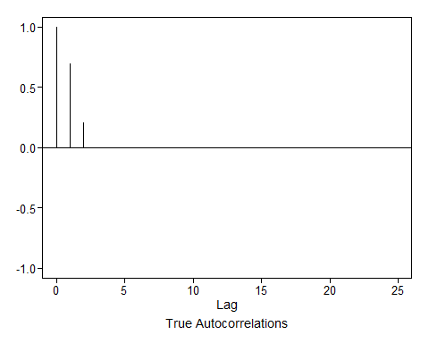

print(paste0("Are the ACFs for the 2 models equal: ", all(round(acf1$acf,3) == round(acf3$acf,3))))

## [1] "Are the ACFs for the 2 models equal: FALSE"

cat("\n------------------------------\n")

##   
## ------------------------------

print(acf1$acf)

## [1] 1.0000000 -0.6896552 0.2068966 0.0000000 0.0000000 0.0000000  
## [7] 0.0000000 0.0000000 0.0000000 0.0000000 0.0000000 0.0000000  
## [13] 0.0000000 0.0000000 0.0000000 0.0000000 0.0000000 0.0000000  
## [19] 0.0000000 0.0000000 0.0000000 0.0000000 0.0000000 0.0000000  
## [25] 0.0000000 0.0000000

cat("\n------------------------------\n")

##   
## ------------------------------

print(acf3$acf)

## [1] 1.0000000 0.6897157 0.2070285 0.0000000 0.0000000 0.0000000 0.0000000  
## [8] 0.0000000 0.0000000 0.0000000 0.0000000 0.0000000 0.0000000 0.0000000  
## [15] 0.0000000 0.0000000 0.0000000 0.0000000 0.0000000 0.0000000 0.0000000  
## [22] 0.0000000 0.0000000 0.0000000 0.0000000 0.0000000