10.9 Seasonal Models - More General Model

Chad Madding

March 8, 2020

## Model

$$(1−B^{12})(1−1.5B+0.8B^{2})(X−50)=a_{t}$$

x=gen.aruma.wge(n=200, s=12,phi = c(1.5,-0.8), sn=87)

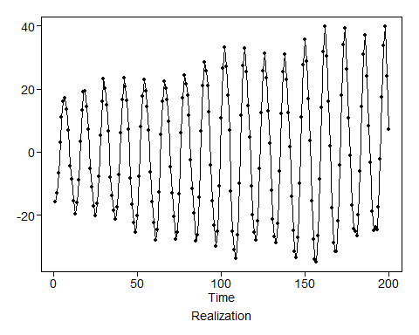

# add in the mean  
x=x+50

## Visualize The Data

See what we are dealing with:

plot=plotts.sample.wge(x,lag.max = 60)

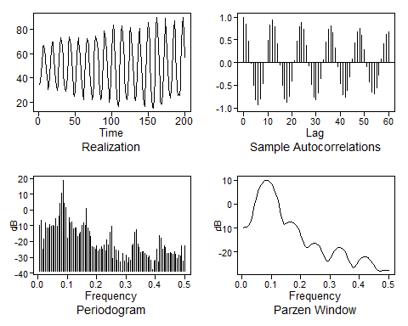

## Overfit Factor Table

Use a number over what you think the seasonality looks to be.

d15=est.ar.wge(x,p=17, type = 'burg')

##   
## Coefficients of Original polynomial:   
## 1.3330 -0.5138 -0.1128 -0.1721 0.1693 -0.0499 -0.0030 -0.0388 0.0590 -0.1264 0.0688 0.8973 -1.2428 0.4347 0.0738 0.1762 -0.1623   
##   
## Factor Roots Abs Recip System Freq   
## 1-1.7276B+0.9985B^2 0.8651+-0.5031i 0.9992 0.0838  
## 1-1.0028B+0.9955B^2 0.5036+-0.8665i 0.9977 0.1662  
## 1+1.0010B+0.9936B^2 -0.5037+-0.8676i 0.9968 0.3337  
## 1-0.0157B+0.9930B^2 0.0079+-1.0035i 0.9965 0.2487  
## 1+1.7329B+0.9899B^2 -0.8753+-0.4941i 0.9949 0.4182  
## 1+0.9836B -1.0166 0.9836 0.5000  
## 1-0.9136B 1.0945 0.9136 0.0000  
## 1-1.4286B+0.7747B^2 0.9220+-0.6638i 0.8802 0.0993  
## 1-0.7137B 1.4011 0.7137 0.0000  
## 1+0.7516B+0.3366B^2 -1.1166+-1.3132i 0.5801 0.3621  
##   
##

Look in the factor table for patterens matching know seasonal tables.

Here is a factor table of $(1−B^{12})$.

#(1-B^12)  
factor.wge(c(rep(0,11),1))

##   
## Coefficients of Original polynomial:   
## 0.0000 0.0000 0.0000 0.0000 0.0000 0.0000 0.0000 0.0000 0.0000 0.0000 0.0000 1.0000   
##   
## Factor Roots Abs Recip System Freq   
## 1-1.0000B+1.0000B^2 0.5000+-0.8660i 1.0000 0.1667  
## 1-1.0000B 1.0000 1.0000 0.0000  
## 1-1.7321B+1.0000B^2 0.8660+-0.5000i 1.0000 0.0833  
## 1+1.0000B+1.0000B^2 -0.5000+-0.8660i 1.0000 0.3333  
## 1-0.0000B+1.0000B^2 0.0000+-1.0000i 1.0000 0.2500  
## 1+1.7321B+1.0000B^2 -0.8660+-0.5000i 1.0000 0.4167  
## 1+1.0000B -1.0000 1.0000 0.5000  
##   
##

**Note:** The factor 1-0.9136B is not very close to the unit circle, but since all other factors are consistent with $(1−B^{12})$ we conclude that this overfit table suggests $(1−B^{12})$ also.

## Transform

Base on the overfit table we can now transform the data to remove the seasonality.

Transform data to create $Y_{t}=(1−B^{12})X_{t}$

#rep will repeat the 11 zeros then we can add a one at the end  
y=artrans.wge(x,phi.tr = (c(rep(0,11),1)))

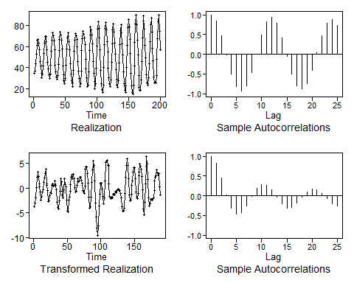

The transformed data appear stationary, so we use AIC to identify a model.

We use **aic5.wge** to model the transformed data (y) When using AIC to model data that has been stationarized using the seasonal transform $(1−B^{12})$, it is good practice to allow a range of p values to include s to uncover any seasonal stationary information that might be in the data. In R code to follow, we consider the range p=0:13 and q=0:3

# y is the transformed data  
aic5.wge(y,p=0:13,q=0:3)

## ---------WORKING... PLEASE WAIT...   
##   
##   
## Five Smallest Values of aic

## p q aic  
## 19 4 2 0.06290065  
## 9 2 0 0.06764617  
## 20 4 3 0.06910374  
## 13 3 0 0.07338218  
## 10 2 1 0.07361012

AIC selects an ARMA(4,2) model. Factoring the ARMA(4,2) model we obtain:

est = est.arma.wge(y,p=4, q=2, factor = TRUE)

##   
## Coefficients of Original polynomial:   
## 1.8831 -2.1943 1.5169 -0.6321   
##   
## Factor Roots Abs Recip System Freq   
## 1-0.4098B+0.8135B^2 0.2519+-1.0798i 0.9019 0.2135  
## 1-1.4733B+0.7771B^2 0.9480+-0.6231i 0.8815 0.0925  
##   
##

est$phi

## [1] 1.8831035 -2.1942981 1.5169278 -0.6321408

est$theta

## [1] 0.4957013 -0.9262404

**Note:** The dominant behavior of the transformed data is a pseudo cyclic behavior of length about 10 $(f_{0}=.10)$. The factors associated with frequency about $f_{0}=.2$ essentially cancel.

We can look for a simpler model using BIC. Use the y data.

aic5.wge(y,p=0:13,q=0:3,type='bic')

## ---------WORKING... PLEASE WAIT...   
##   
##   
## Five Smallest Values of bic

## p q bic  
## 9 2 0 0.1192915  
## 13 3 0 0.1422426  
## 10 2 1 0.1424706  
## 11 2 2 0.1692218  
## 17 4 0 0.1700640

BIC picks a simpler AR(2) model. This is consistent with:

* The pseudo cyclic data
* Damping cyclical sample autocorrelations

**Decision:** We choose to model the transformed data as an AR(2).

est2=est.ar.wge(y,p=2)

##   
## Coefficients of Original polynomial:   
## 1.4653 -0.7597   
##   
## Factor Roots Abs Recip System Freq   
## 1-1.4653B+0.7597B^2 0.9644+-0.6215i 0.8716 0.0911  
##   
##   
##   
## Coefficients of Original polynomial:   
## 1.4653 -0.7597   
##   
## Factor Roots Abs Recip System Freq   
## 1-1.4653B+0.7597B^2 0.9644+-0.6215i 0.8716 0.0911  
##   
##

We can now write our model using data collected from **est.ar.wge**.

#Get the phi's for the model  
est2$phi

## [1] 1.4652837 -0.7596714

#Get the White Noise Var  
est2$avar

## [1] 1.036377

#Figure the mean with the original x data  
mean(x)

## [1] 49.77867

#### Our final model:

$$(1−B^{12})(1−1.47B+0.76B^{2})(x_{t}−49.78)=a_{y} σ_{a}^{2}=1.04$$

#### The Original Model:

$$(1−B^{12})(1−1.5B+0.8B^{2})(X−50)=a_{t}$$

### 10.9.4 Concept Check

Consider the attached Southwest Airlines flight delay data (SWADelay.csv). Use **est.ar.wge()** to overfit an **AR(15)** model with the Burg estimates. We are trying to gauge if there is sufficient evidence to suggest a $(1−B^{12})$ factor is in the model. Look at the factor table, and answer the following questions.

#read in the data  
SWA = read.csv("swadelay.csv",header = TRUE)  
plotts.wge(SWA$arr_cancelled)

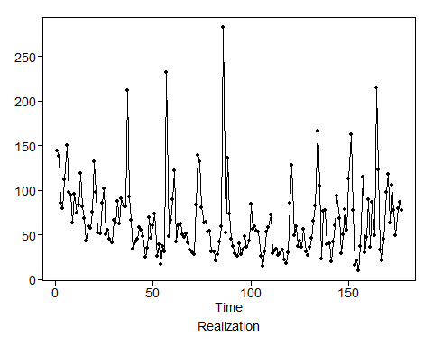

#Get and an estimate using the arr_delay information  
#Overfitting with and AR(15)  
d15SW=est.ar.wge(SWA$arr_delay,p=15, type = 'burg')

##   
## Coefficients of Original polynomial:   
## 0.4443 0.0482 -0.0541 0.0820 0.0090 0.0304 0.0410 -0.0837 0.0588 0.0568 0.0252 0.3759 -0.0127 -0.0074 -0.1486   
##   
## Factor Roots Abs Recip System Freq   
## 1-0.9700B 1.0310 0.9700 0.0000  
## 1-0.9946B+0.9342B^2 0.5323+-0.8872i 0.9666 0.1640  
## 1-1.6636B+0.9322B^2 0.8923+-0.5259i 0.9655 0.0848  
## 1+0.9229B -1.0836 0.9229 0.5000  
## 1+1.6328B+0.8443B^2 -0.9669+-0.4994i 0.9189 0.4241  
## 1-0.1460B+0.8319B^2 0.0877+-1.0928i 0.9121 0.2372  
## 1+0.7038B+0.7209B^2 -0.4882+-1.0719i 0.8490 0.3180  
## 1+0.7885B+0.5243B^2 -0.7520+-1.1584i 0.7241 0.3416  
## 1-0.7182B 1.3924 0.7182 0.0000  
##   
##

*10.9.4* What is the root associated with the factor (from the factor table you generated) that would be matched with the $(1−B)$ term from the $(1-B^{12}) factor table?

Express your response rounded to four decimal places. *1.0310*

*10.9.5* Look at the system frequencies from the factor table you generated. What is the system frequency associated with the the factor that would be matched with the $(1−1.732B+B^{2})$ factor from the $(1−B^{12})$ factor table?

factor.wge(phi = c(rep(0,11),1))

##   
## Coefficients of Original polynomial:   
## 0.0000 0.0000 0.0000 0.0000 0.0000 0.0000 0.0000 0.0000 0.0000 0.0000 0.0000 1.0000   
##   
## Factor Roots Abs Recip System Freq   
## 1-1.0000B+1.0000B^2 0.5000+-0.8660i 1.0000 0.1667  
## 1-1.0000B 1.0000 1.0000 0.0000  
## 1-1.7321B+1.0000B^2 0.8660+-0.5000i 1.0000 0.0833  
## 1+1.0000B+1.0000B^2 -0.5000+-0.8660i 1.0000 0.3333  
## 1-0.0000B+1.0000B^2 0.0000+-1.0000i 1.0000 0.2500  
## 1+1.7321B+1.0000B^2 -0.8660+-0.5000i 1.0000 0.4167  
## 1+1.0000B -1.0000 1.0000 0.5000  
##   
##

Express your response rounded to four decimal places. *0.0848*

*10.9.6* Do you feel that there is enough evidence to suggest a $(1−B^{12})$ factor should be present in our final model?

*Yes*

This is subjective, but there is only one term that doesn’t match up almost exactly (the $(1+B+B^{2})$) B. No. We will take this answer, but you would almost have some domain knowledge or other evidence to not include a $(1−B^{12})$ in this case. Note: The spectral density shows a clear peak at 1/12 = .08, but this does not in and of itself mean that $(1−B^{12})$ is appropriate. There are many other factors of smaller degree that will yield this frequency.

*Note:* The spectral density shows a clear peak at 1/12 = .08, but this does not in and of itself mean that $(1−B^{12})$ is appropriate. There are many other factors of smaller degree that will yield this frequency.