Unit 10: For Live Session

Chad Madding

March 9, 2020

### Select a data set, and complete one of each model ID below:

#### ARIMA

First we read in the data.

# read in the data  
x <- read.csv("energydata_complete.csv", header = TRUE)

Convert the data to time series

#Just looking at the Appliances data  
x=ts(x$Appliances)

Plot the data and see the associated (damping) sample autocorrelations

#Plot the data  
#plotts.sample.wge(x)

We will follow the Classical Box-Jenkins Procedure for Including a Unit Root in the Model.

If data are wandering and sample autocorrelations damp slowly difference the data with a d-1

# difference the data  
x.d1=artrans.wge(x,phi.tr=1)

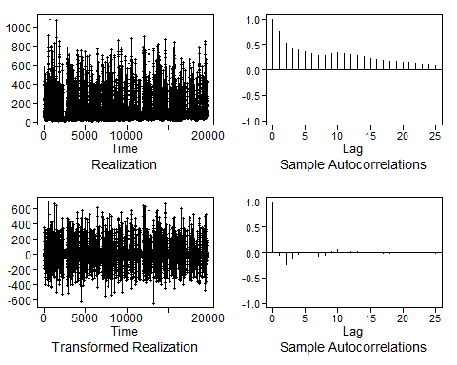

The data looks stationary so there is no need to difference the data again. Estimate the parameters of the “stationarized data”.

# x.d1 appears to be stationary  
aic5.wge(x.d1,p=0:5,q=0:2)

## ---------WORKING... PLEASE WAIT...   
##   
##   
## Five Smallest Values of aic

## p q aic  
## 11 3 1 8.393990  
## 12 3 2 8.394081  
## 14 4 1 8.394091  
## 15 4 2 8.394184  
## 17 5 1 8.394186

AIC picks an ARMA(3,1)

# AIC picks an ARMA(3,1)  
# which seems reasonable from  
est.x.d1=est.arma.wge(x.d1,p=3,q=1)

##   
## Coefficients of Original polynomial:   
## 0.7314 -0.2026 0.0692   
##   
## Factor Roots Abs Recip System Freq   
## 1-0.5870B 1.7036 0.5870 0.0000  
## 1-0.1444B+0.1178B^2 0.6129+-2.8480i 0.3433 0.2163  
##   
##

Pull out what will make up the final model

#Pull out what will make up the final model  
est.x.d1$phi

## [1] 0.73141244 -0.20260369 0.06916294

est.x.d1$theta

## [1] 0.9188227

est.x.d1$avar

## [1] 4418.181

mean(x)

## [1] 97.69496

#(1_B)^2(1-1.27B+.68B^2)(Xt-1512)=at WHV=1.03

** Final Model

$$(1−B)(1−0.731B+0.203B^{2}−0.069B^{3})(X_{t}+97.69)=a_{t} σ_{a}^{2}=4418.18$$

**