QM Lab Course Project

Design Document

Group 3

Angela Stankowski (ans723), Bengin Lee (bel529), Connor Nettleton-Gooding (cwn973), Corey Hickson (crh208), Darvin Zhang (ddz369), James McKay (jlm012), Jordan Wong (jtw289), Mack Mahmoud (mtm464), Matt Hamilton (mch986), Michael Kelly (mlk121), Michael Ruffell (mar492), Mitchell Lau (chl929), Royce Meyer (brm979), Shane Williamsom (saw056)

March 6th, 2016

# Introduction

For our design document, we are aiming to use the requirements and create a system architecture, plan out certain design model and design patterns we may want to use, and look at classes we may want, how our system will flow with a sequence diagram, and time estimates of different portions of the project.

# Architectures

For our system, we are hoping to employ a number of architectures. Overall, we would like to have a broad architecture which we can use to describe generally how our system works. This section will look at different architectures and how we might employ them.

**3-Tier Architecture**

The most common architecture for a web application would be the 3-tier architecture, with a front end client that handles all of the visual and interactive aspects that users would handle, with a application tier handling all of the collaboration and ensuring each client is updating to the most recent version of the document, and a backend storing and managing all of the data we choose to keep (currently undetermined).

**2-Tier Architecture**

A 2-tier architecture would effectively host our entire application on the client side with minimal interaction happening with the database, except for storage. Our complete from end client would send relevant data back to our backend as needed.

**Server-client**

Alternatively, we could setup a client side application which would run the bulk of the work, while occasionally interacting with the server side. This would be very similar in style to the 2-tier architecture.

**Model-view-controller**

Lastly, is a variation on the model-view-controller. The primary focus of the application would be the view and its functionality, while being controlled in the back with a controller, and storing relevant information in our model as needed. The benefit of this would be possible greater utilization of the model, as we could break apart the actual app and have state information in the model.

## Decision Matrix

To help determine which architecture we should pursue, we created a decision matrix as seen below.

|  |  |  |  |  |  |  |  |  |  |
| --- | --- | --- | --- | --- | --- | --- | --- | --- | --- |
|  |  |  |  | Rankings |  |  |  |  |  |
|  | Applicability | Modularity | Ease of Implementation | Adaptability | Collaborability | Useability | Security | Testability | Total |
| Weight (1->5) | 4 | 2 | 2 | 4 | 5 | 4 | 3 | 5 |  |
|  |  |  |  |  |  |  |  |  |  |
| Architectures (1->10) |  |  |  |  |  |  |  |  |  |
| 3-Tier Architecture | 8 | 7 | 7 | 8 | 8 | 9 | 9 | 8 | 235 |
| 2-Tier Architecture | 7 | 6 | 8 | 6 | 6 | 8 | 6 | 5 | 185 |
| Server-client | 6 | 5 | 6 | 6 | 5 | 5 | 7 | 5 | 161 |
| Model-View-Controller | 6 | 8 | 7 | 7 | 8 | 8 | 5 | 8 | 209 |

**Figure 2.1:** Decision matrix of different architecture possibilities for our system

We choose to make our matrix based off of applicability, adaptability, usability, and security to meet stakeholder requirements. We choose modularity, ease of implementation, collaborability, and testability to meet the team’s requirements to have something we would be successful in using.

From this diagram, we can see that a 3-tier architecture comes out as the most likely to succeed architecture for our overall system. Considering the diagram, as well as our based on our research, we have decided to go forward with a 3-tier architecture for our overall system.

## Architecture Diagrams

Using the 3-tier architecture, we have come up with a broad diagram of how our system will work. In our client level, users will be able to access the QM Lab web app, and interact with it through there. That client will work with the application level to handle input and push output back to the client.

The application will be running using the Google Realtime API, shown on the diagram. While our system does not include creating the Realtime servers, or Google Drive storage, they have been included to help understand the scope of the architecture (beyond what we are creating). Additionally, we have included a path to our PostgreSQL server for any data storage or data handling.

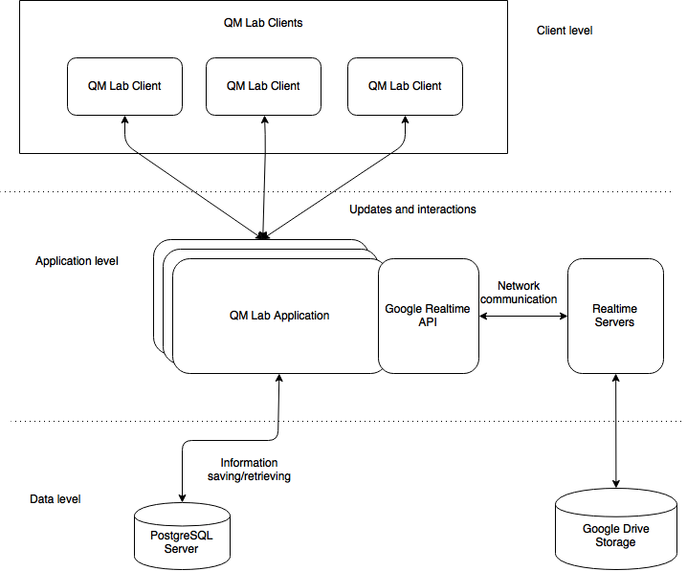

**Figure 2.2:** Overall diagram of our system architecture

**The following part of this section is an addition for ID3.**

For our system, we have made a minor change and decided the data layer will not include any PostgreSQL databases, as the Google Drive storage handles all of the data for us.

On top of this, our design now accounts for greater detail. An updated diagram can be seen below (Note: To learn more/better understand the diagram, please view the added section directly below the diagram and the software tools section).



**Figure 2.3:** Overall diagram of our system architecture

# System Overview

**The following part of this section is an addition for ID3.**

To better describe our system, we have outlined the different components (that make up the client, application, and data layers).

The overall system includes:

* a **client layer** that includes **HTML, CSS, Webix.js, and Joint.js (jquery.js, lodex.js, backbone.js)**,
* an **application layer** with **Google Realtime API, Google Realtime Server**,
* and a **data layer** with **Google Drive Storage**.

Next, we described the way the system interacts with all of the tools. QM-Lab can be broken into 2 pieces. It allows collaboration by using Google's Realtime API, and easy, user-friendly modeling through Joint.JS

Looking at just the modeling, Joint.JS allows the diagrams to be built with a largely model-view-controller pattern. The actual diagram's data is stored in a model called the "graph". Each element of the diagram is stored in the graph as "cells", each with its own self-contained information. These elements can be further sub-typed very broadly as "links" and "nodes".

The user can view and interact with the diagram through what Joint.JS calls the "paper". The paper allows the diagram's graph to be attached and then renders all information about the graph in the paper's "view". Depending on the size of the graph versus that of the paper, some elements may not be rendered (or, rendered outside the view).

Any element currently being rendered by the paper allows for the user to easily click on it and begin dragging around the paper, as well as linking and delinking with just a click.

The collaborative part, using Google's Realtime API, reacts to "change" events in Joint.JS. Any time something in the diagram is updated, the change gets saved in the collaborative model. Then, Google's Realtime API sends an update to all connected collaborators with that change. Google's Realtime API then informs Joint.JS of that change, before Joint.JS

updates the given diagram element accordingly. From a technical standpoint, the data being

transferred by the Realtime API is simply JSON.

# Software Tools

**The following is an addition for ID2.**

Within this section, we list a number of tools which we are implementing.

**Joint.js**

A Javascript library which specializes in focusing on the interactions and visualizations of graphs and diagrams. Chosen due to its simplicity and ease of use in creating the visual entities as well as their connecting components in our project, thus, speeding up development.

**Google Reatime API**

Google Realtime API allows collaboration as a service for files in Google Drive via the use of operational transforms. The API is a JavaScript library hosted by Google that provides collaborative objects, events, and methods for creating collaborative applications. For example, if one wrote code to manipulate maps, lists, and your own custom JavaScript data model objects. When your code makes a change to the data model on behalf of some user, the data model automatically changes for all the users on the document, hence realtime.

**Selenium**

Chosen as the main testing program of our project. Selenium itself is a web application testing framework that allows you to write tests in many programming languages like Java, C#, Groovy, Perl, PHP, Python and Ruby. The advantages of using Selenium include that members in our group have experience with it. The current consensus is that it will be used for all tests.

**jQuery, Backbone, and Lodash**

Required dependencies of Joint.js. Will help considerably with the interface and framework.

**The following is an addition for ID3.**

**Joint.js**

In addition to the previous description, Joint.js specifically deals with the creation of the logic behind the graphs, nodes, and links. It also handles events(mouse click) and resizing components of the objects.

**Google Realtime API**

In addition to the previous description, we call upon the realtime API for a lot of things: including finding and loading items - adding new items, attaching listeners to the objects so they can act in “realtime”, authorizing access and giving authority for certain projects, creating/saving/editing with interactions with the server/database.

**Webix.js**

Webix is a JavaScript and HTML5 framework which was chosen to be used in the project. The library simplifies creating desktop web applications with highly responsive user interfaces. Webix is being used for the general UI and the layout of the system (separating the UI components into manageable/sensible format), such as the setting of the toolbar.

**Google Realtime Server**, **Google Drive Storage**

Although we do not directly access or call upon either of these tools directly, we do use them through the google realtime API. When we call upon the realtime API, this sends a message to the server and, if needed, to the Google Drive Storage. Therefore, allowing users to interact and collaboratively work on projects online in real time(through the API and server) and save/retrieve the data for the projects(through Google Drive Storage).

**HTML, CSS**

HTML currently is currently only used for the index page as the view. CSS used for stylization. Each .js library has their own css.

# Models

In our system, we are considering a number of different models to design our system with. Below are some of those patterns and models and what we might use them for.

## Flyweight Design Pattern

A structural design pattern that focuses on using minimal memory by being an object that shares its data along with other objects. The reasons as to why this pattern was considered was because it was that it had the highlight of being very easily managed, similar to excel. This could apply to the different objects (eg. agents, maps, etc) for quick and fast access.

## Singleton

A creational design pattern that restricts the instantiation of a class to one object. The advantage of this pattern over global variables is that you are absolutely sure of the number of instances when you use singleton, and, you can change your mind and manage any number of instances (control and flexibility).

## Observer (Publish-Subscribe)

A behavioural design pattern that is used for one-to-many relationship between objects such as if one of the objects is modified, its dependent objects are to be notified automatically.

By adapting the observer pattern, we gain the benefits of supporting the principle of loosely coupled designs between objects that interact and to allow sending data to many other objects in a very efficient manner.

**The following part of this section is an addition for ID3.**

Since creating the detailed class diagram of the system from before (with the flyweight design pattern), we have since realized that the flyweight design pattern is not necessary because JointJS can create objects fast enough that we will not need the speed of a flyweight pattern.

For our current design, we have briefly looked at classes we may need or classes we might want to consider. In future iterations of the design, we will go into specific detail and define the different classes and their usage (including function calls, etc.).

## Login Page

A potential class that will provide the user with a login and a password in appropriate text boxes and a confirmation of this operation (a “submit” button). If a user already has an account they should be able to login or else they will have to create an account. The system should save this information and their projects created.

## Main Page

The main page is available to the user following their login. The basic function of this page is a menu guideline. It will contain the ability(submenu) to create and edit pages and potentially to edit your profile or view other profiles (which would mean an addition of a chat system or a friend system).

## Project

A section of the main with submenus to allow:

1. Project

* Add new
* View
* Edit
* Delete
* Create group

2. Import

* Ability to import a project

3. Authoritize to

* Edit/view for other user
* Give privilege levels to only view certain items for certain users

4. My profile

* View asset(s) of project
* Projects that are created/given to me

## Edit

On creation or edit of a project from the main menu, the program will be sent to the edit page. The edit page will contain a menu of **Assets:**

1. Add

* New page, duplicate page
* UML, Sequence diagrams, etc
* Text, pictures

2. Import

* Pictures, fonts
* Other projects

3. Edit

* Change layout
* Change font, colors, size of file

4. Export

* The project
* Possibly a .pdf, .png, .jpg filetype of the project

The user clicks on necessary item in the menu in order to perform operation. There should also be a way to see who else is currently working on a project at the same time as another.

Since this is an early rendition of our design document, the exact functions and classes or even tools have not been completely decided yet. Therefore, there are not functions with descriptions included (eg. pre, post, error conditions), instead are just brainstorming and loose descriptions of what we are currently planning for.

These are potential other modules and classes that compose them:

* Authenticator - way of identifying if an account’s username and password match during login, or even for other cases.
* Database - again, undecided if it should be used, but it would need many classes and to communicate with other modules in order to store or retrieve the data the program needs as it's called by the client.
* Server (composed of classes) - What the program sends requests to and is responded back or given an error if the connection is unsuccessful.
* Log - a class that tracks down who did what and at what time, what errors were made, and at what time they were made.

We may also want to consider a class that tracks the different objects on the screen. Additionally, it would be helpful to have a class that manages our interface with the Google Realtime API.

# Detailed Classes

**The following is an addition for ID2.**

For our software, we have begun creating a detailed design using a UML class diagram. It can be seen below, or at better resolution within the ‘doc’ folder (under design_doc_diagrams) on our GitHub repository.

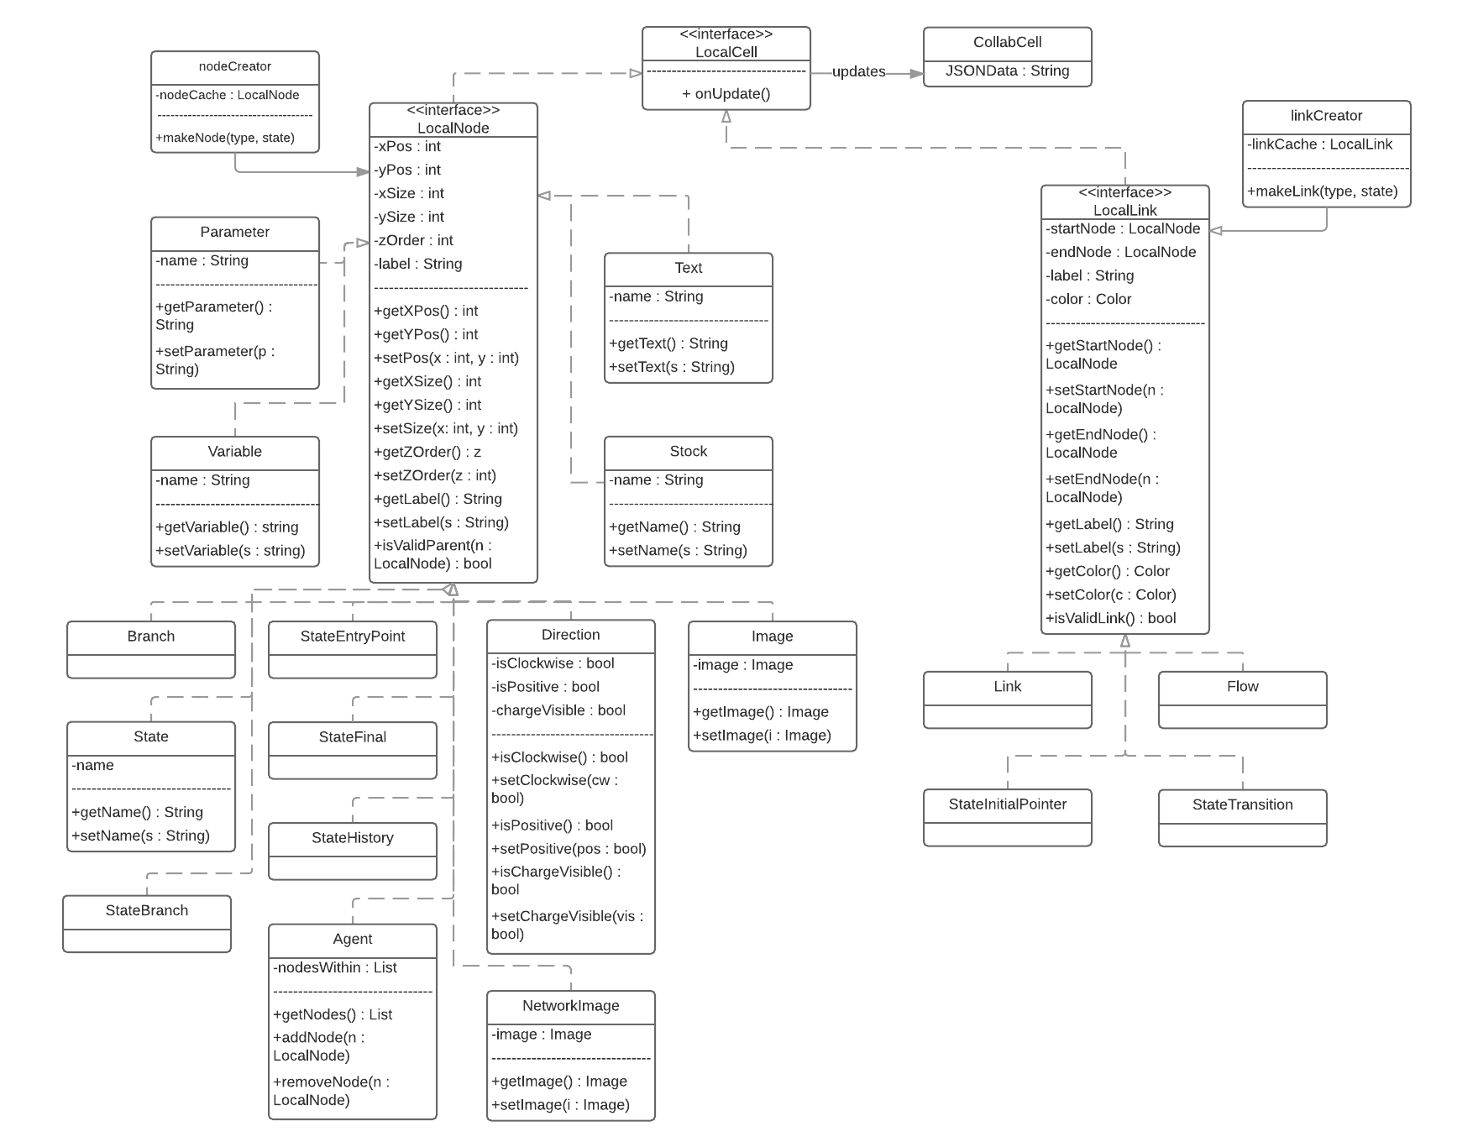

**Figure 6.1:** Detailed class diagram of the modelling objects

This detailed class diagram will be the contract with the development team on starting the actual software. With this, in the next deliverable, the development team will begin to implement the classes. For the next deliverable, we will complete the detailed class diagram (to include a controller for the application).

**The following is an addition for ID3.**

We have created a flow diagram that describes how our system interacts with Google’s products on a very low level, as seem below. This diagram can be seen in higher resolution within our GitHub repository under the **doc** folder.

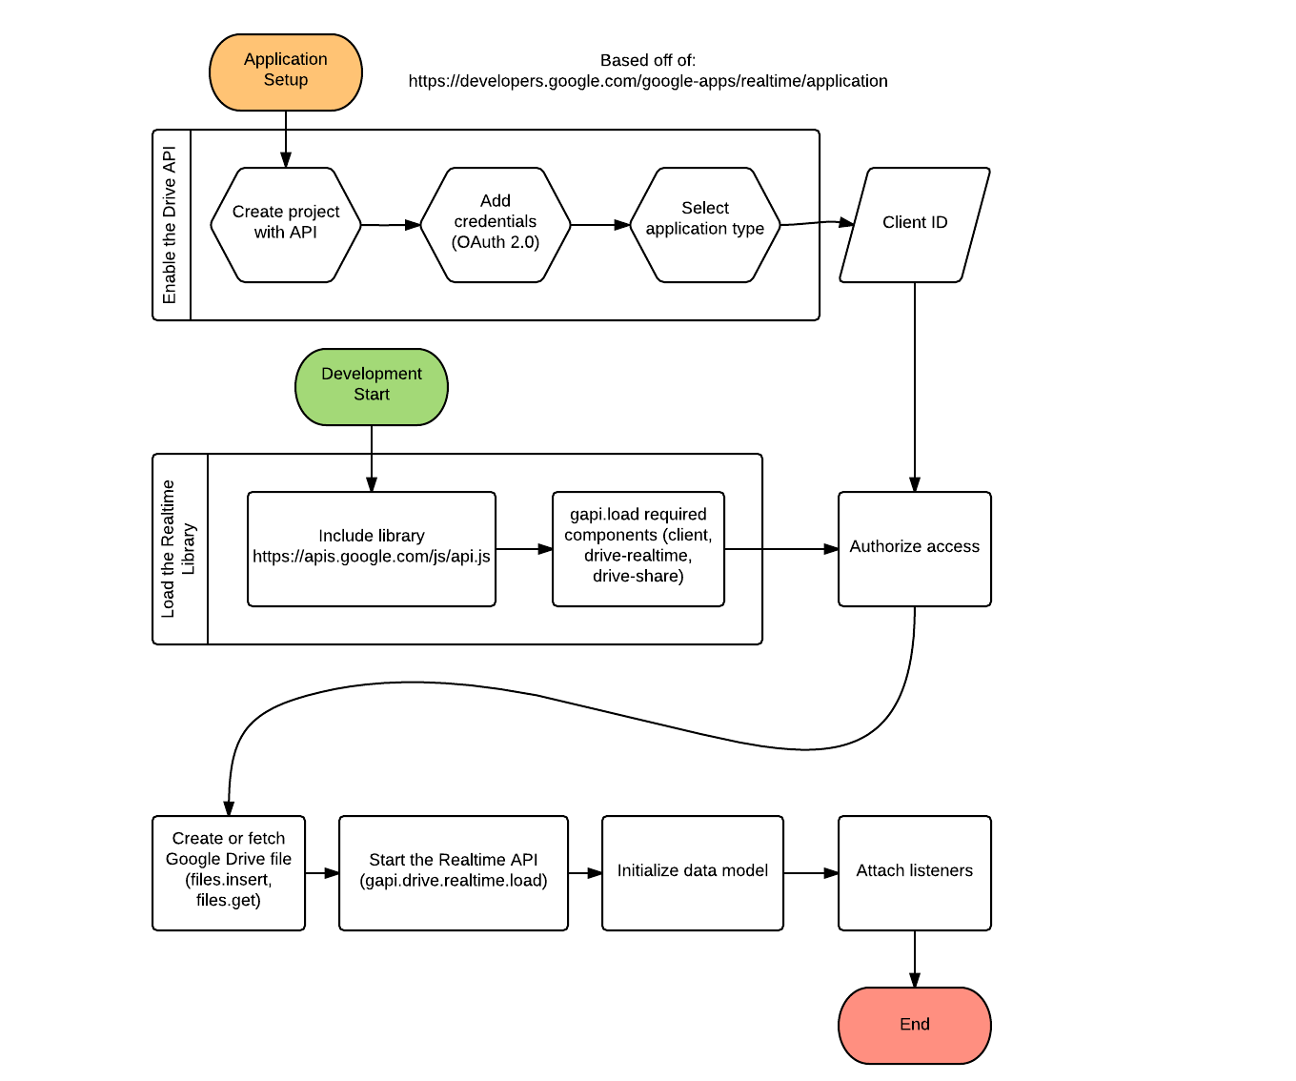

**Figure 6.2:** Low level flow diagram for Google products

In addition to this Google flow diagram, we have further filled out our class diagram as seen below. A better resolution can be in our GitHub repository under ‘doc’>’design_doc_diagrams’.



**Figure 6.3:** Detailed class diagram

# Detailed Class Descriptions

**The following is an addition for ID2.**

This section describes the detailed descriptions of each of the classes from the detailed classes section. It covers key modules and ignores getters and setters.

|  |
| --- |
| **LocalNode <<Interface>>** |
| **Input:** None  **Output:** None  **Layer:** Data |
| **Description:**  As an interface, this module will be an abstract class that gives explanations properties of many objects that will interface our system. It gives them the backbone of many classes within our system, however does not tell exactly how to implement the methods/attributes as this is an interface class. The objects implementing this interface are typically each one that is not a link (which is simply a connection between two objects that have implemented this interface) such as an image class, or a variable class. |
| **Attributes:**  xPos::int - Keeps track of the node object’s x position on the coordinate map  yPos::int - Keeps track of the node object’s y position on the coordinate map  xSize::int - The size of the object in terms of its width x  ySize::int - The size of the object in terms of its height y  zOrder::int - The order of the object within the framework. The z axis, if you will, making the  object able to go on top of one another based on its zOrder.  label:String - The static label displayed beneath whichever object this is |
| **Methods:**  pre: n is not null  post: none  error: to be determined  IsValidParent(LocalNode n)::Bool - Checks if the node is a valid parent of node n (ie. an agent is a valid parent for images). True if it is a valid parent, false otherwise. |

|  |
| --- |
| **LocalLink <<Interface>>** |
| **Input:** None  **Output:** None  **Layer:** Data |
| **Description:**  As an interface, this module will be an abstract class that gives explanations properties of many objects that will interface our system. This module is responsible for linking two objects that have LocalNode properties. Henceforth, the classes that will implement this interface are ones that draw connections between two node objects, such as a line or a flow. |
| **Attributes:**  startNode::LocalNode - The node object that initiates the connection (link)  endNode::LocalNode - The node object that receives the link  label:String - The static label which is visually displayed beneath the link  color:: Color - The color of the link/object |
| **Methods:**  pre: none  post: none  error: to be determined  IsValidLink()::bool - Checks if a link between the startNode and endNode is valid to be created |

|  |
| --- |
| **Direction** |
| **Input:** None  **Output:** None  **Layer:** Data |
| **Description:**  A class that implements the LocalNode interface. It is a property that can be used to determine the direction of an object, and thus allowing rotations of the object, back and forth. |
| **Attributes:**  isClockwise::bool - true if the direction is clockwise, false if counter clockwise  isPositive::bool - true if the polarity is positive, false if negative  chargeVisible::bool - true if the polarity is to be displayed, false if not |
| **Methods:**  The methods of this function are precisely getters and setters. The only difference is that the getters check if the state of the object is in the correct form before returning with a bool. |

|  |
| --- |
| **Agent** |
| **Input:** Takes various LocalNodes and holds them within itself (visually, as well)  **Output:** None  **Layer:** Data |
| **Description:**  A class that implements the LocalNode interface. The given class is able to create an “agent” object which can hold other objects relationally (who have implemented LocalNode). |
| **Attributes:**  nodesWithin::List<LocalNode> - a list of LocalNode’s that are currently within the agent object |
| **Methods:**  pre: n is not null  post: a new LocalNode added inside the agent  error: to be determined  AddNode(LocalNode n)::void - when an object is inserted into the agent, it must be checked if implements LocalNode and then added to the nodesWithin list.  pre: n is not null, n exists in the agent  post: the node n is removed from the agent  error: to be determined  RemoveNode(LocalNode n)::void - when an LocalNode is removed from the agent, remove from the nodesWithin list. |

|  |
| --- |
| **LocalCell <<Interface>>** |
| **Input:** None  **Output:** None  **Layer:** Data |
| **Description:** This is the local copy of a shareable object. When it is updated, it updates the corresponding shareable object. |
| **Attributes:** None |
| **Methods:**  pre: none  post: the shareable object is updated to match the local object  error: to be determined  onUpdate()::void - updates the shareable object to match the local object |

|  |
| --- |
| **CollabCell** |
| **Input:** Receives update transfer from a object with LocalCell properties  **Output:** Changes the JSONData of a property  **Layer:** Data |
| **Description:**  A class that is updated by objects with LocalCell properties. |
| **Attributes:**  JSONData::String - the JSON... |
| **Methods:** None |

**The following is an addition for ID3.**

Changes to the detailed class descriptions were not updated in this document, however they are shown in the actually implementation (large descriptions with pre and post conditions on all the functions). They will most likely be added next deliverable.

# Sequence Diagrams

Below is a general sequence diagram that shows the order of actions that take place when the user logs into the system and creates/modifies a project. As we go forward in the project, we will create more sequence diagrams to describe our system.

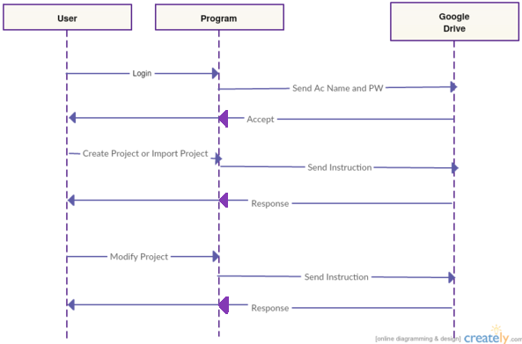

**Figure 8.1:** Overall sequence diagram of our system architecture

**The following is an addition for ID2.**

A general sequence diagram for the visual representation of how our 3-tier architecture:

.

**Figure 8.2:** General sequence diagram of 3-tier architecture

# Time Estimates

To better understand the scope of the project, and how much development time each feature or requirement will need, we have created estimates based off of our requirements for how long we think each portion will take. This is summarized below.

|  |  |
| --- | --- |
| Requirement document | 7 hrs |
| Design document | 13 hrs |
| User manual | 8 hrs |
| Test planning | 10 hrs |
| Testing | 45 hrs |
| Debug | 30 hrs |

|  |  |
| --- | --- |
| Implementation (must have features): | 10+10+8+5+8+8+6 = 55 hrs |
| Support multiple users (OT) | 10 hrs |
| To create, save, and import | 10 hrs |
| Support system dynamic diagram, stock diagrams, agent, picture ........... and text | 8 hrs |
| One of a small number of shapes and images | 5hrs |
| Create variables and links between components | 8 hrs |
| A link for the project that for sharing | 8 hrs |
| Able to create agent objects which can hold other objects relationally | 6 hrs |

|  |  |
| --- | --- |
| Implementation (should have features): | 10+10+5+5+5= 35 hrs |
| A login system | 10 hrs |
| A log of who edited what at certain points - potentially save state/backups | 10 hrs |
| Power to select a set of the diagram | 5 hrs |
| Ability to resize and color the elements for a diagram | 5 hrs |
| Change the font/style of text within components | 5 hrs |

|  |  |
| --- | --- |
| Implementation could have: | 7+10+20+20+5+13+5= 80 hrs |
| Customized components such as a user specified picture is added and named to the elements available for a certain project/team | 7 hrs |
| Customizable overlay for the software | 10 hrs |
| A chat system - private chat | 20 hrs |
| General templates to guide users | 20 hrs |
| Differents styles of components (different looks available for say a UML class diagram) | 5 hrs |
| Undo function possibly based on history | 13 hrs |
| Support of video maybe a slideshow/add pages to a project? | 5 hrs |

# Conclusion

In conclusion, we have decided that for our overall system we think the 3-tier architecture will provide the best architecture for our web application. We have defined a number of models and patterns we believe will come in handy during the implementation and briefly touched on the classes we may want.

We modelled our system with sequence diagram to describe the flow we expect to have, and last have laid out our predicted time outcomes for various portions of the project.