Using Python to scrape the Apache 2 page

2.1

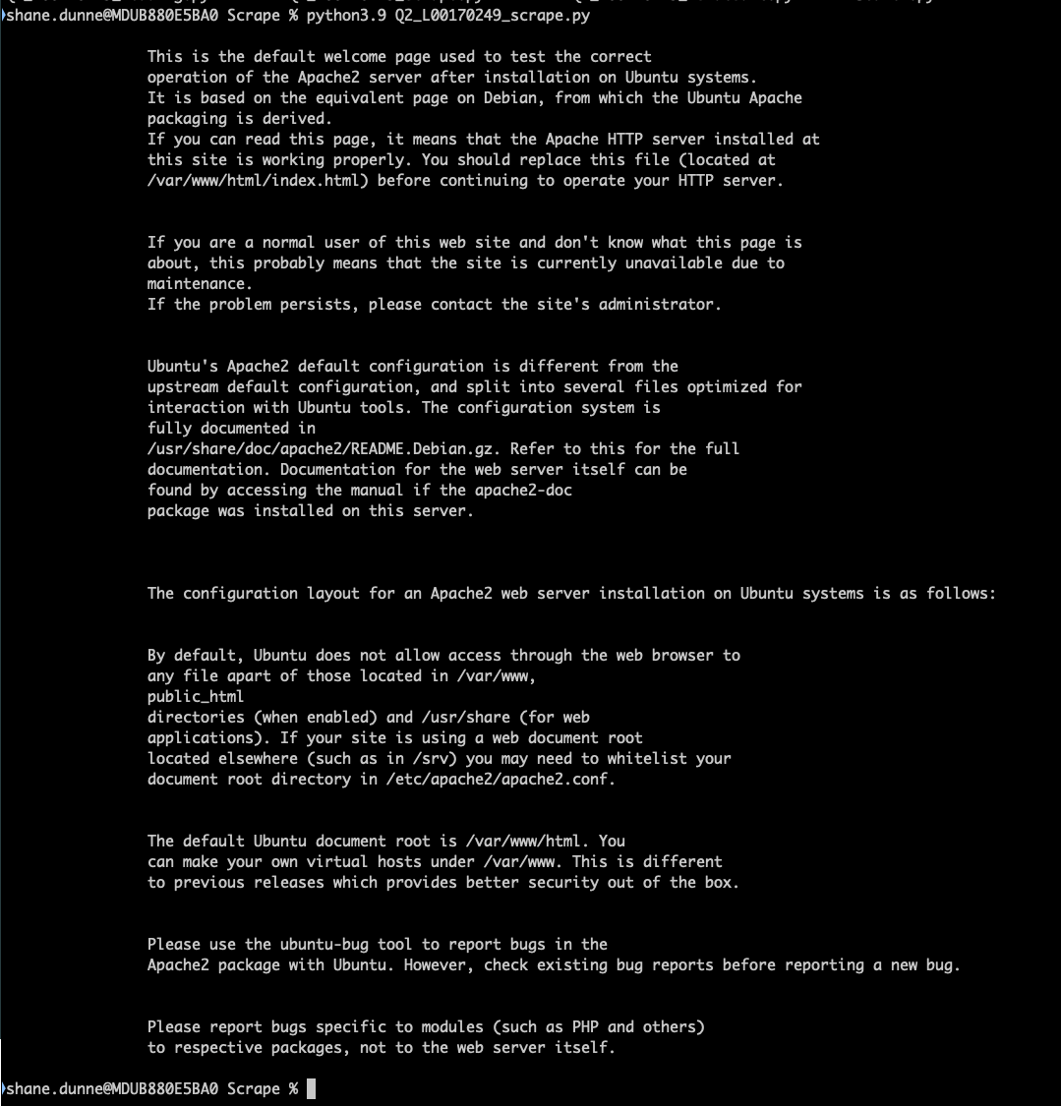

2.2

How many times the word Apache 2 appears on the webpage

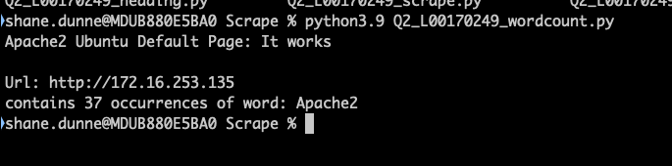

2.3

Pull the heading of the website from the Apache 2 page

