Q5

Install Curl, Create a directory with 2 sub directories and then to run a command to see when the files were last accessed

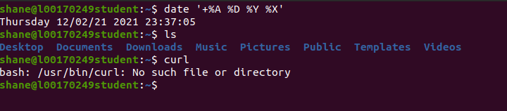

Showing time and date and no lab directory and curl not installed

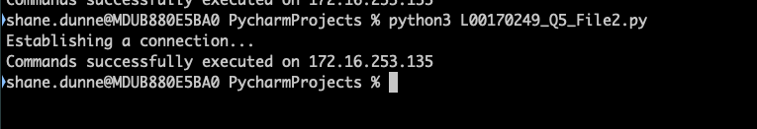

Screenshot showing Python script running

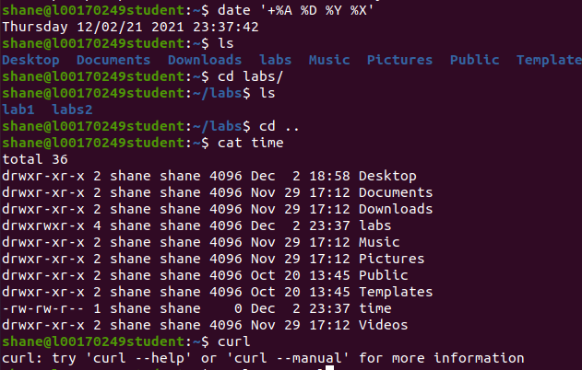

Screenshot showing directory Labs and 2 sub directories lab1 and lab2. Also showing a file called time which has the contents of the command to see when files last accessed. Also it shows curl installed

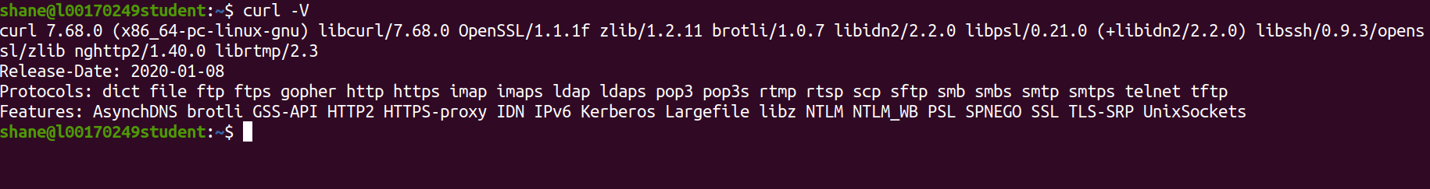

Screenshot showing the Curl version installed