**Introduction**

Interconnected computer hardware is essential to their effective collaboration. The CPU (central processing unit) and GPU (graphics processing unit) are two essential parts that cooperate to power a gadget. For completing a variety of tasks and providing outstanding performance, these two processing units are necessary. Therefore, knowing the CPU and GPU is crucial for anyone looking to maximize their computing performance and comprehend the trends of each unit, not just computer enthusiasts.

A total of 4,854 produced chips from AMD, Intel, NVIDIA, ATI, and other companies are included in the collection. AMD and Intel are the market leaders, producing 1,662 and 1,392 chips, respectively. However, NVIDIA has produced 1,201 chips, ATI, a less well-known vendor, has produced 535 chips, and the other suppliers have produced 64 chips.

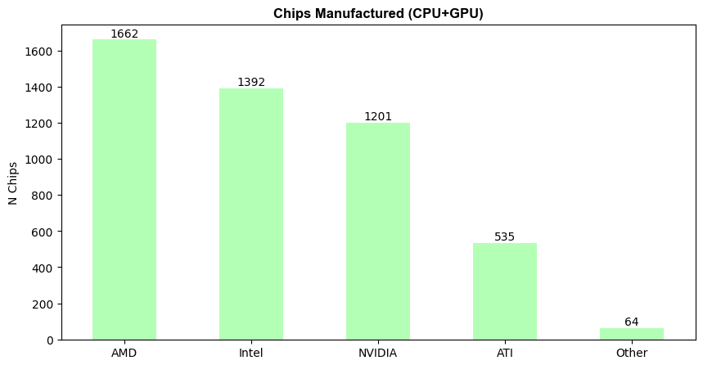

*Figure 1.* *Chips Manufactured (CPU and GPU)*

Using high performance chips results in higher watts, which improves performance, but they also raise the temperature and use more power. Thermal Design Power, or TDP, is a factor to consider when selecting a CPU or GPU cooler. Choosing the best cooler for a user's system can be made easier with an understanding of TDP. The maximum load that a component, like a CPU or GPU, can produce is known as its TDP. Accordingly, it is a theoretical indicator of the amount of heat a processor will produce and is frequently used to calculate how much cooling that component needs (DarkFlash, 2024). Furthermore, as more complicated computations and jobs can be handled by CPUs with greater TDP levels, these CPUs are frequently more powerful. However, this also implies that they produce more heat and use more electricity. On the other hand, CPUs with lower TDP ratings might not provide the same level of performance but are typically more energy-efficient (LivewireDev, 2024).

The dataset's lowest TDP (Thermal Design Power) was found in Intel chips. Beginning with the Intel Atom Z612, Z600, Z620, Z500, Z515, Z610, and Z610, which have just 1.00 TDP and 2.00 TDP, respectively, the Intel Atom Z510

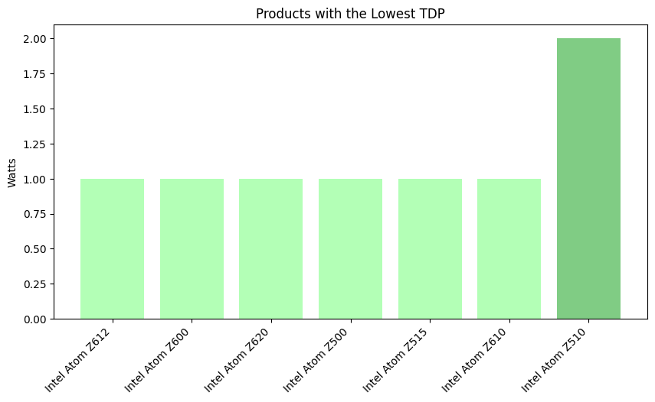

*Figure 2. Products with Lowest TDP (Thermal Design Power)*

**CPU TDP, Process Size, Die Size, Transistor and Frequency Trend**

Simply described, CPU is the brain of the computer, handling processing, data input and output, and storage (Geeksforgeeks, 2021). Today's market is crowded with CPU makers, including AMD and Intel. In the given statistics, AMD managed to create 950 chips, while Intel managed to make 1,242 chips.

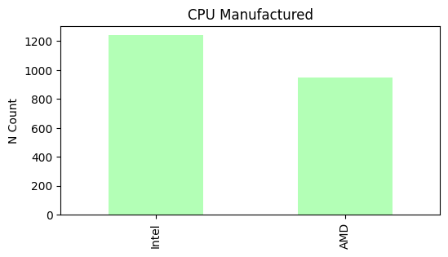

*Figure 3. CPU Manufactured by Intel and AMD*

**CPU TDP (Thermal Design Power) and its Trend**

As previously stated, TDP measures the heat of a processor's output and is frequently used to ascertain how much cooling that component needs. The Intel Atom range has the lowest TDP (Figure 2) of the two CPU makers shown in Figure 3. Accordingly, a low TDP indicates that the CPU or gadget is made to use very little power and produce very little heat.

The trend of TDP was impacted by the fluctuating demand for CPUs with low and high CPUs over the years. There was a discernible increase in demand for better performance CPUs between the years 2000 and 2005. The need for low performance energy and devices that can handle demanding tasks may be the reason for the rise and fall in produced processors between 2005 and 2010. Since 2010, the pattern has continued to fluctuate. It did, however, climb significantly in 2015 and peak in 2020. Given the development of gaming, graphics, and other tasks requiring more intensive power, this upward tendency may indicate a need for high-performing processors.

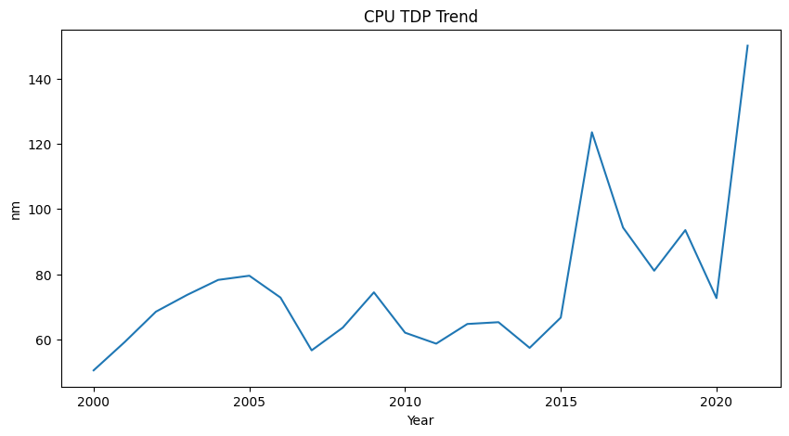

*Figure 4. CPU TDP Trend*

**CPU Process Size Trend**

Simply said, a process size is the actual size of the parts that go into making a chip. The performance, efficiency, and overall capability of a process are significantly influenced by its scale (George, 2024).  
  
Over the previous six years, produced chips have ranged from 180 nm to 75 nm. Because of the process size of these CPUs, the technology is comparatively older and may employ larger transistors, which results in slower and less effective performance. However, CPUs that have been manufactured since 2006 have performed better since they are smaller, starting at 75 nm.

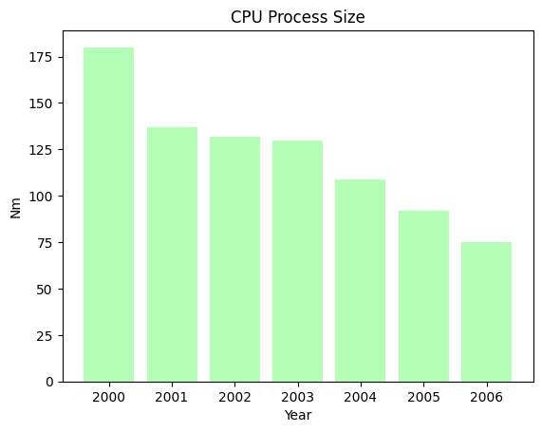

*Figure 5. CPU Process Size from Year 2000 to 2006*

Over time, the size of CPU processes decreases. AMD EPYC 7262 has the smallest process size in 2019 at just 7.00 nm. AMD EPYC 7F32, AMD Ryzen 7 4800U, AMD Ryzen 5 4600GE, AMD Ryzen 7 4800H, AMD EPYC 7F52, and AMD EPYC 7643 have the next smallest process sizes, each at 7 nm. According to the provided data, the CPU's process size has remained constant over the last two years despite decreasing.

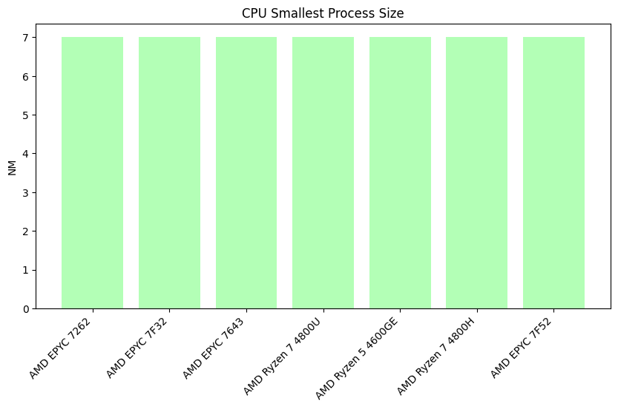

*Figure 6. CPUs Smallest Process Size from Year 2019 to 2021*

A range of the values is displayed in the graph below. The fact that the process size has decreased from 180 nm in 2000 to just 7 nm in 2019 and 2021 indicates that technology has advanced and that the device's performance, power efficiency, and applications have improved. Even though the dataset shows some increase or volatility, this could suggest that, although being more prevalent and necessary for this cutting-edge technology, high performance produced chips are unquestionably more costly. However, some users may prefer a different process size because to its price and suitability for a particular device.

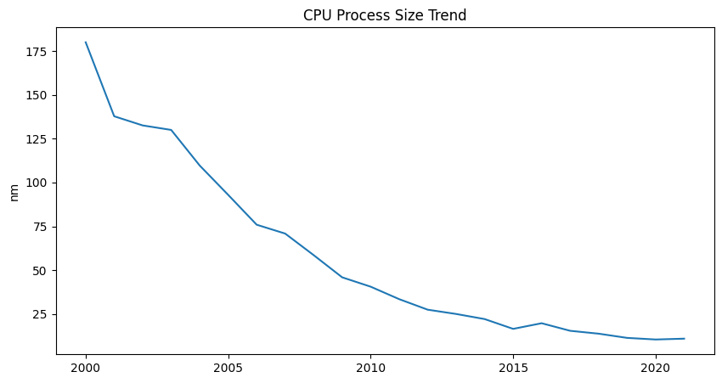

*Figure 7. CPU Process Size Trend*

**CPU Die Size Trend**

Regarding CPUs, a die size is a tiny piece of silicon that is used to construct the microprocessor. It provides the framework upon which the central processing unit (CPU) that drives computers and other devices is constructed. Furthermore, a die has complex circuitry and parts required for the processor to carry out calculations and carry out commands (Lenovo, 2021).

According to the dataset provided, the smallest CPU die size came from the AMD Athlon 64 (F3) family in 2007, which included models 3500+, 4000+, and 3800+ with 1.00 mm2 (65 nm). The AMD Athlon 64 LE line, which included the -1600, -1640, and -1620 with 3.0 mm2, came after it. The Intel Core i5-3470T with 6.0 mm2 comes last.

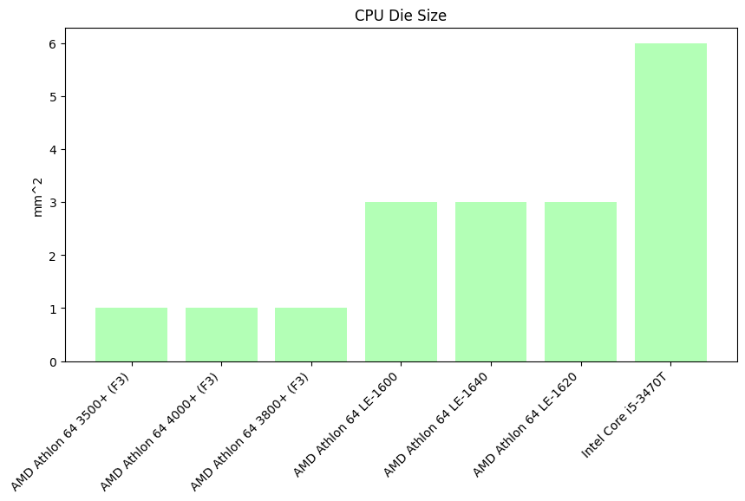

*Figure 8. CPU Die Size*

Instead of exhibiting a steady linear reduction, the CPU die size trend displayed in the line graph exhibits considerable fluctuations over time. Although die size increased between 2000 and 2005, there were also periods when it decreased, such as the 2005–2010 rise.

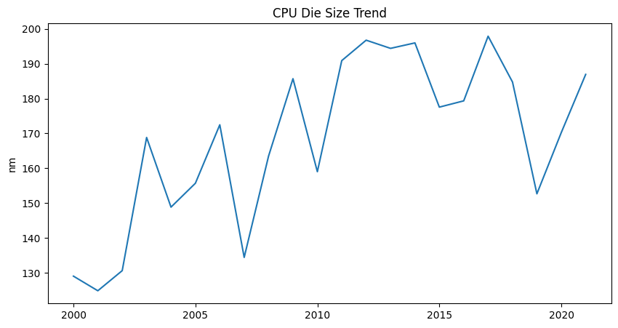

*Figure 9. CPU Die Size Trend*

**CPU Transistor Trend**

A CPU's transistor is a semiconductor that amplifies and functions as a switch for electronic signals, controlling their flow of voltage or current (GeeksforGeeks,2023). With only 37 million transistors between 2001 and 2004, the statistics indicated that the following processors would have the smallest transistor counts: AMD Sempron 2600+, AMD Athlon 1700+, AMD Athlon XP 1600+, AMD Athlon XP 2000+, AMD Athlon XP 1800+, AMD Sempron 2400+, and AMD Athlon 1333. Given that the number of transistors stays constant during these years, this could suggest a steady linear trend.

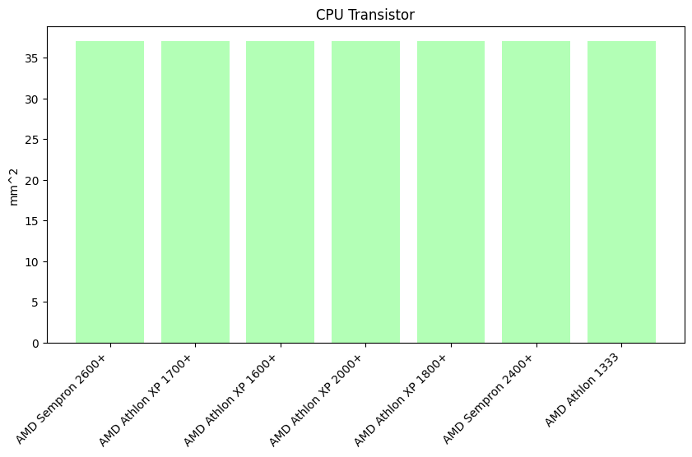

*Figure 10. Products with Lowest Transistor Count*

Conversely, a transistor with a large count may manage more operations at once and carry out more complicated tasks, both of which improve overall performance. AMD Ryzen Threadripper 2970WX, AMD Ryzen Threadripper 2990WX, AMD Ryzen Threadripper 2920X each have 19,200 transistors, while AMD Ryzen 9 5900HX, AMD Ryzen 5 5500U, and AMD Ryzen 5 4600U each have 9,800 transistors.

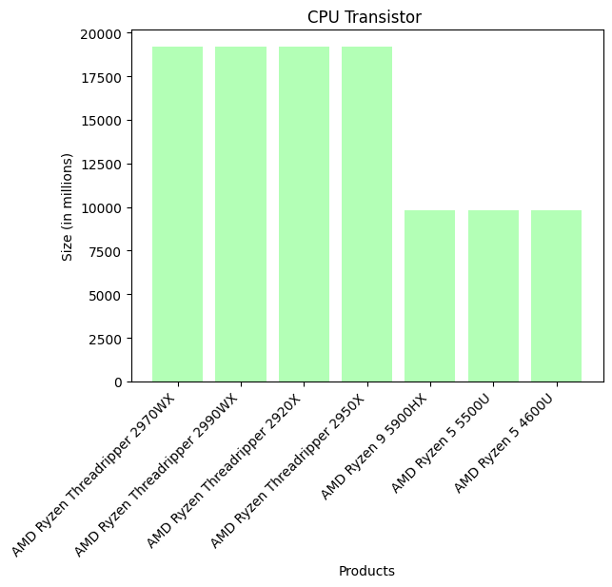

*Figure 11. Products with Highest Transistor Count*

The goods with the most transistors are displayed in the above table. It enables more functional, energy-efficient, and high-performance processors. The information provided suggests that the number of transistors has been steadily increasing over time.

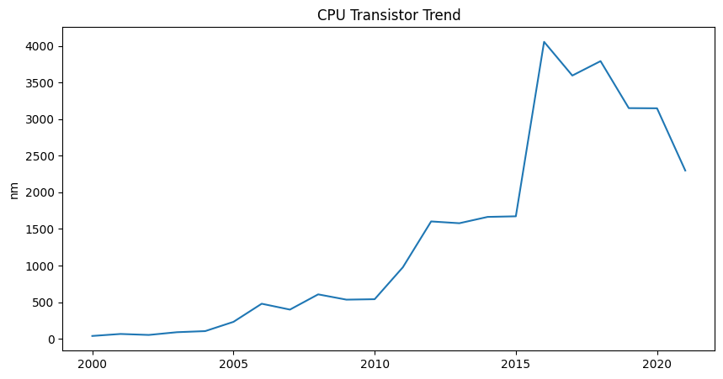

*Figure 12. CPU Transistor Trend*

The line graph suggests that between the years 205 and 2020, the number of transistors increased and fluctuated. Given that adding transistors increases power consumption and heat output, this data may suggest that while a high transistor count is in fact beneficial for improved computer performance, there is also a discernible decrease in transistor count, which may suggest that improved performance is not always guaranteed.

**CPU Frequency Trend**

Another name for a CPU's frequency is its clock speed. It gauges how quickly commands can be carried out by the central processing unit (GeeksforGeeks, 2020). The goods with the lowest clock speeds are displayed in the data below. The products with the lowest clock speeds include AMD Athlon 600, AMD Athlon 650, AMD Atom E625C, AMD Atom E625CT, AMD Atom E620T, AMD Atom E620, and AMD Athlon 600, which have clock speeds of 600.00 MHz and 650 MHz, respectively.

*Figure 13. CPU Frequency Trend*

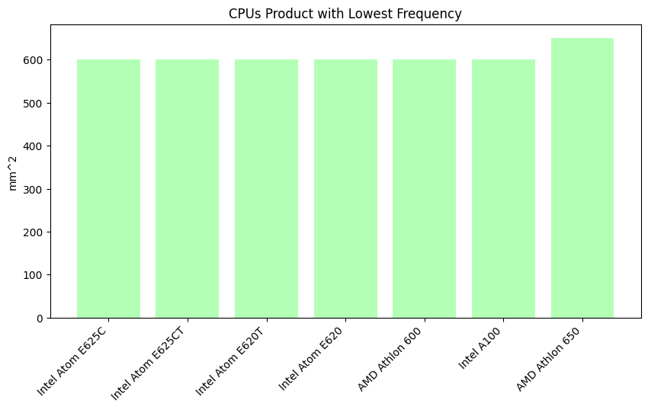

*Figure 13. Top 7 Products with Lowest Frequency*

Conversely, the products with the highest frequency are the AMD FX-9590 (4700 MHz), AMD FX-9370 (4400 MHz), Intel Core i7-7740X (4300 MHz), Intel Pentium Gold G6605 (4300 MHz), Intel Core i3-7360X (4300 MHz), Intel Core i3-7350K (4200 MHz), and finally, Intel Core i3-7340 (4200 MHz).

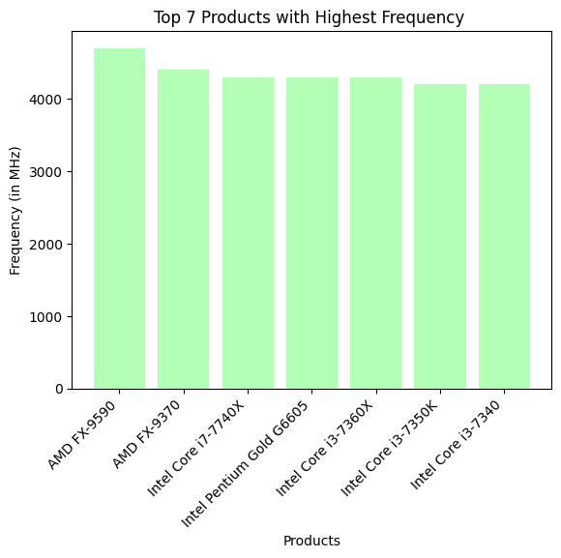

*Figure 14. Top 7 Products with Highest Frequency*

The CPU's frequency trend over time is displayed in the graph below. It shows a consistent rise in frequency, especially in the early 2000s, which was followed by slower development and fluctuation periods. This trend may indicate that the industry was focused on improving the clock speed of computers starting in the early 2000s. The trend plateaued between 2015 and 2020, which could indicate that the vendor was having trouble with heat generation and electricity consumption. As a result, the trend eventually declined before 2020.

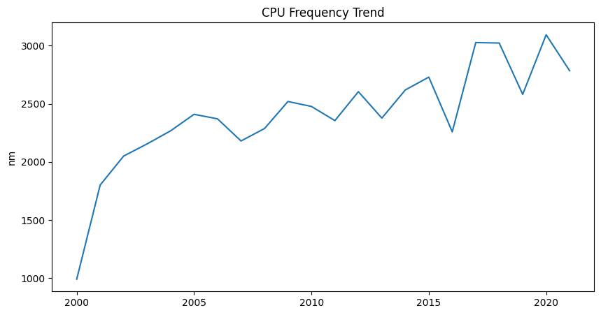

*Figure 15. CPU Frequency Trend*

**GPU TDP, Process Size, Die Size, Transistor and Frequency Trend**

A Graphics Processing Unit (GPU) is a specialized electronic circuit in a computer that speeds up the processing of images and videos in a computer system (GeeksforGeeks,2024). There are various GPU vendors in the market today and the includes NVDIA ,AMD,ATI, Intel and other. Overall, in the given data, NVIDIA was able to manufactured 1,201 chips while AMD was able to manufactured 712 chips. Other vendor such as ATI manufactured 535 chips, Intel has 150 and other vendors on the dataset manufactured 64 GPU chips. A computer's specialized electronic circuit known as a Graphics Processing Unit (GPU) expedites the processing of images and films (GeeksforGeeks, 2024). NVDIA, AMD, ATI, Intel, and other companies are among the many GPU providers available on the market today. All things considered, NVIDIA produced 1,201 chips and AMD produced 712 chips, according to the statistics provided. Additional companies on the list produced 64 GPU chips, Intel produced 150, and ATI produced 535.

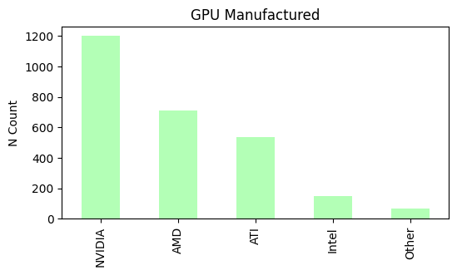

*Figure 16. GPU Manufactured*

**GPU TDP (Thermal Design Power) Trend**

As previously stated, TDP is the maximum energy that a GPU is intended to produce during a demanding workload and that a cooling solution needs to dissipate. The dataset shows an increase and fluctuation in line with the trend of CPUs. This may indicate that manufacturers may focus on producing power-efficient chips or chips with high performance throughout the year.

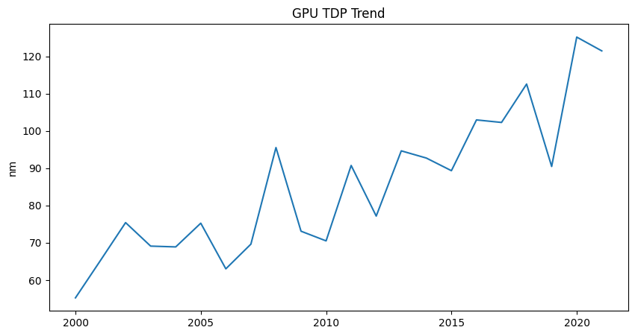

*Figure 17. GPU TDP Trend*

**GPU Process Size Trend**

The physical dimensions of the chip's constituent parts are referred to as a GPU's process size. The performance, efficiency, and overall capability of a process are significantly influenced by its scale (George, 2024).

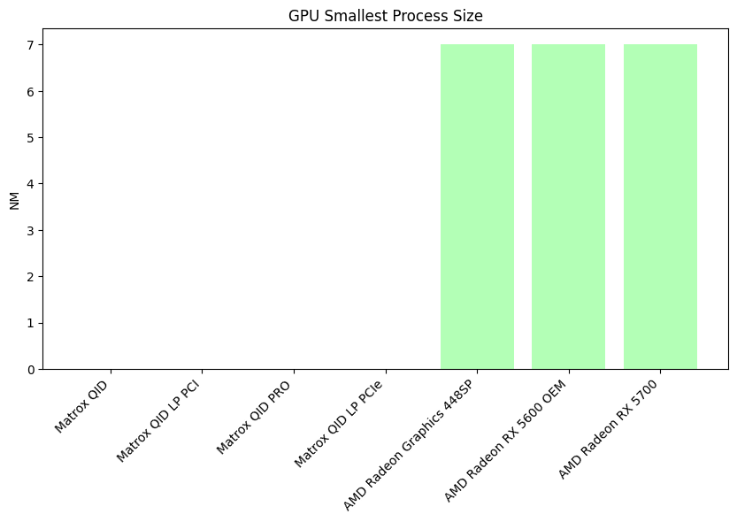

*Figure 18. GPU Process Size*

The items with the smallest process sizes that can process photos and videos with great performance are depicted in the above figure. There is currently no information available about the Matrox manufacturer's product process size using the dataset provided. AMD Radeon Graphics 448SP, AMD Radeon RX 5600 OEM, and AMD Radeon RX 5700 are the only ones with a 7nm process size.   
  
The size of manufactured GPU chips is decreasing, which is comparable to the trend in CPU process size. The NVIDIA Vanta LT, a 250 nm GPU chip that was first produced in 2000, was the largest. The ATI Radeon 7000 with 180 nm, which was produced in 2001, came next. The size of GPU chips has been decreasing ever since.

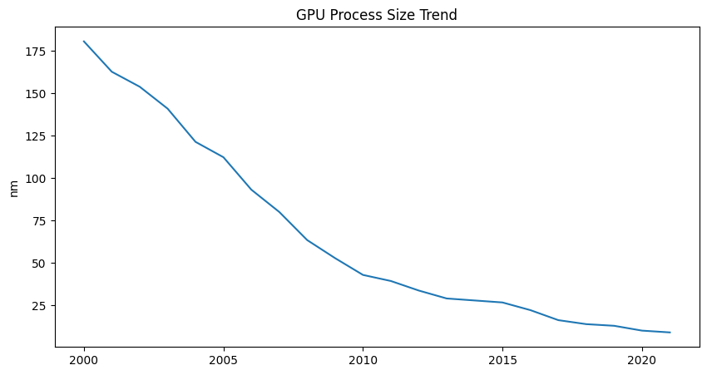

*Figure 19. GPU Process Size Trend*

The trend in GPU process size is depicted in the above figure. It suggests that the GPU's chip size has improved, becoming smaller but more potent.

**GPU Die Size Trend**

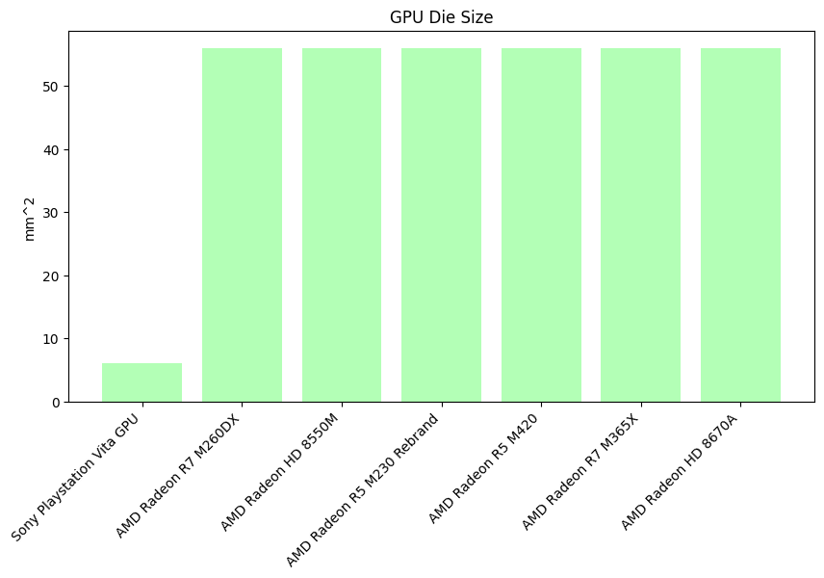 Die size, which is influenced by the pitch or how small the logic gates are etched, is the square inch of silicon that the logic occupies in a GPU. The actual silicon chip in the graphics card that houses the transistors and circuitry required to process graphics and carry out calculation tasks is known as a die.  
  
In general, a smaller die size is more thermally and power-efficient. While higher die sizes allow for improved performance and computational capabilities, smaller die sizes are actually used on controllers. Although it is often intended for a laptop, a larger die size also translates into higher power consumption and heat generation.

*Figure 20. GPU Die Size*

The products with the smallest die size are displayed in the above figure. With a die size of just 6 mm2, the Sony Radeon R7 M260DX, AMD Radeon HD 8550M, AMD Radeon R5 M230 Rebrand, AMD Radeon R5 M420, AMD Radeon R7 M365X, and AMD Radeon HD 8670A come next, each measuring 56.00 mm2.

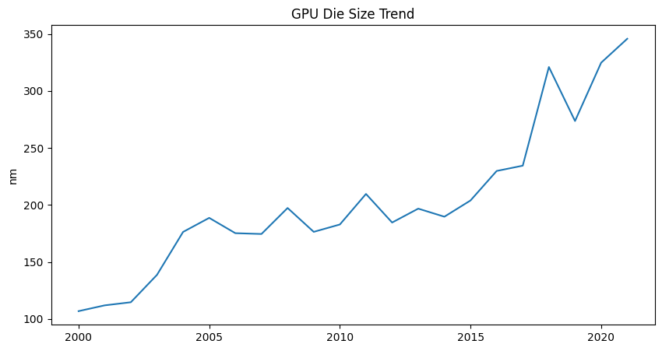

*Figure 21. GPU Die Size Trend*

The figure above shows the steady state where the size of GPU die is growing from year 2000s to recent years. However, this die size fluctuating slightly from 100 nm to 200 nm. Post 2010, there is noticeable upward trend thus this may imply that GPUs have become much more powerful and complex.

**GPU** **Transistor Trend**

Similarly to CPU, a GPUs’ transistor is a semiconductor that controls voltage or current flow in electronic signals and it amplifies and acts as a switch for them (GeeksforGeeks,2023). The transistor with lowest count is from ATI with only 8 million transistor count followed by NVIDIA Tegra 3 GPU, Matrox Millennium G550, Matrox Millennium G550 PCIe, Matrox Millennium G450, Matrox Millennium G450 LP, Matrox Millennium G450 x2 MMS with only 10 million transistor count.

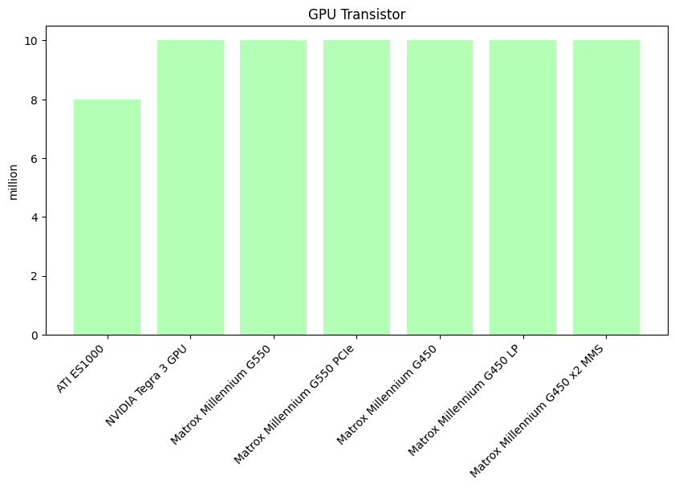

*Figure 21. GPU Transistor*

The graph below shows a variation of the values. From the year 2000 with 180 nm process size down to 2019 to 2021 with only 7 nm signifies that there is an improvement of technology and achieve higher performance, power efficiency and application-wise of the device. Although there’s some rise or fluctuation on the dataset this may imply that although high performance manufactured chips are more common and needed now for this cutting -edge technology it is indeniably more expensive. On the other hand variation of process size may be preffered by some user for its affordability and its function for certain device.

**GPU Frequency Trend**

GPU frequency describes how quickly the processor can render an image or video. Based on the provided information, the lowest frequency products are those made by Intel (with a clock speed of just 100 MHz), NVIDIA (105 MHz), ATI (120 MHz), and Matrox (125 MHz).

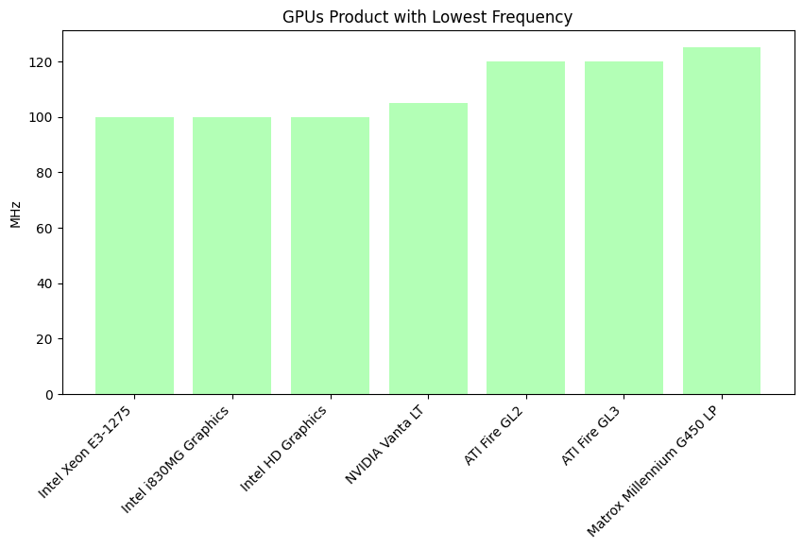

*Figure 22. GPU Products with lowest frequency*

The goods with the lowest frequency or clock speed are displayed in the above figure. It is evident that the clock speed has increased, for example, from 100 MHz to 125 MHz.

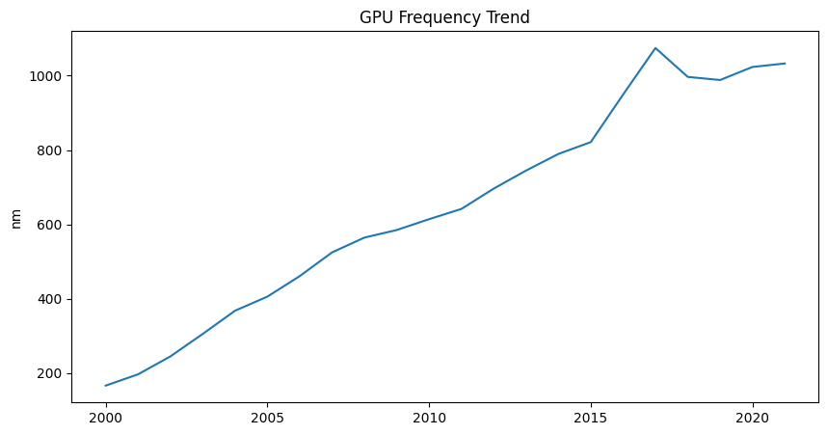

*Figure 23. GPU Frequency Trend*

According to the previous statistic, the frequency increased steadily between 2000 and 2015, reaching a notable peak in that year.

.

**Findings**

TDP

Low Thermal Design Power (TDP) indicates a greater emphasis on energy or power efficiency, which is perfect for applications where power is essential. Furthermore, it will produce very little heat or heat according to the chip's TDP. Still, there are several disadvantages, such poor performance. Microcontrollers and other simple tasks are the only things a processor with low TDP can do.  
  
On the other hand, strong processors that can provide top-tier performance are linked to a high TDP. This indicates that the produced chips are capable of handling intensive tasks like gaming and rendering, among others. But it also means that there will be a huge increase in heat generation and power usage.

Process Size

Only a small number of transistors are employed on the chip, and the bigger the process size, the larger the transistors used. In addition to causing slower performance, this also results in inefficient use of power. On the other hand, a chip with a smaller manufacturing process size uses smaller transistors, which implies that a single chip may include several transistors. Higher performance and greater power efficiency are the outcomes of this.

Die Size

The die size trend varies greatly, as seen in both line graphs. This could mean that a computer is being made to accommodate new feature or performance requirements.

Transistor

An increased transistor count indicates that the computer can process and perform better, uses less energy, and has features that can propel the development of high-end computing. A low transistor count, on the other hand, would hinder its functionality; for example, it would only be sufficient for simple tasks, one at a time.  
  
Higher transistor counts, however, do not always translate into better performance because they can result in higher power consumption and heat generation.

Frequency

This also refers to the computer's clock speed. Better response times result from increased frequency because the computer can process more commands or operations per second, which speeds up program execution, computations, and input response.

**Recommendation**

**TDP**

It is crucial to match the user's CPU's thermal output with the cooler's TDP rating when choosing one. To effectively manage the surplus heat for high-TDP processors (such as those used for gaming or rendering jobs), think about using liquid cooling systems or high-performance air coolers.

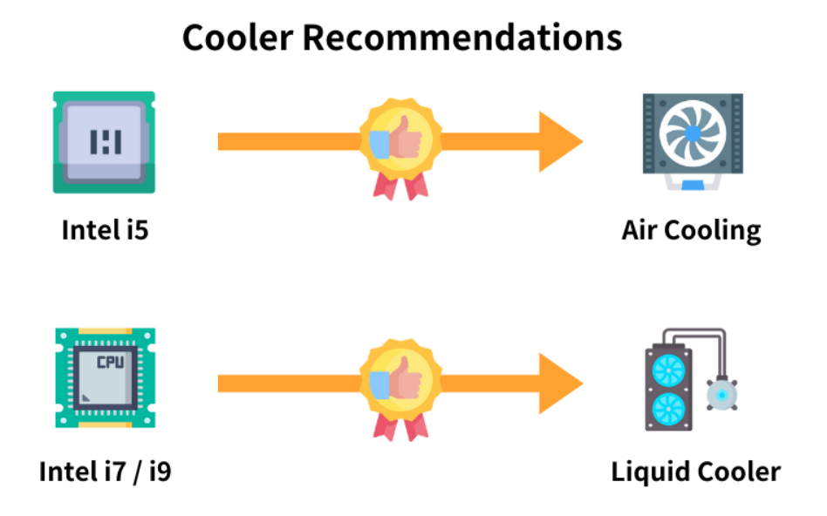

*Image from darkFlash , “What is TDP?”*

**Process Size**

Choose smaller processes when looking at process sizes for improved performance, especially in high-speed computing or gaming. On the other hand, for simpler job or budget systems, greater process sizes could be more economical.

**Die Size**

If portability and power efficiency are important considerations, go for GPUs or CPUs with smaller die sizes. However, in order to increase efficiency without sacrificing performance, manufacturers need also concentrate on balancing the die size of its heat management (see the data fluctuation in both CPU and GPU).

**Transistors**

For demanding tasks or applications like gaming, rendering, or even high-end computing, computers or devices with a lot of transistors should be mentioned. Conversely, manufacturers ought to develop energy-efficient transistors as well.

**Frequency**

Fast frequency also translates into fast clock speed, making it perfect for tasks requiring quick reactions, such complex mathematics or games. A device with a moderate frequency, however, can provide respectable performance with less power usage for energy-conscious users. Last but not least, manufacturers can also develop or modify the chip frequency in response to consumers' immediate needs.