

1 Jaguar and Panther Performance • Year 2025 Data Analysis Report

**Comparative Performance Analysis**

**of Jaguar and Panther:**

**Data Analysis**

**Year 2025 Data Analysis Report**

***January, 2025***

***Prepared by,***

**Shane Althea M. Sormela**

**BSME 3C**

Highlights of the Report

* The mean, median, and mode of the Jaguar dataset are greater than those of the Panther dataset, indicating that Jaguar values are generally higher.
* Jaguar exhibits greater variability and spread in the sample, as evidenced by its higher variance and standard deviation.
* The Panther dataset exhibits significantly reduced coefficient variation and standard deviation, indicating that the results are less dispersed and more stable.

# Knowing the Stability and Data Spread of Jaguar and Panther Resistor Measurements

## Examining Jaguar's Performance

* The Jaguar dataset, as illustrated in Figure 1, shows a wide range of values from 790 to 1840 ohms, indicating high measurement variability. Additionally, Jaguar has a 1050 range.

Figure 1: Jaguar’s Dataset

Jaguar =[997, 1153, 920, 1074, 1013, 960, 890,

910, 944, 1065, 1083, 1820, 859, 1043,

1710,933, 790, 999, 1028, 976, 1015, 932, 957,

936, 977, 1037, 997, 1730, 1046, 1840]

Range = max – min Range = 1840 – 790

**Range = 1050**

* As seen in Figure 2, the computed mean value is 1087.80 ohms.

Figure 2: Jaguar’s Mean Calculation

Mean Formula:

∑ 𝑥

x̄ =

𝑁

x̄ = (997+ 1153+ 920+ 1074+ 1013+ 960+ 890+

910+ 944+ 1065+ 1083+ 1820+ 859+ 1043+

1710+933+790+ 999+ 1028+ 976+ 1015+ 932+

957+ 936+ 977+ 1037+ 997+ 1730+

1046,+1840) / 30

x̄ = 32,634

30

**x̄ = 1,087.80**

* The Jaguar dataset shows a positive skew, with some higher readings influencing the average, as evidenced by the median of 998 (Figure 3), which is just below the mean.

Figure 3: Jaguar’s Median Calculation

Mean Formula:

(𝑛 + 1)

𝑚𝑒𝑑𝑖𝑎𝑛 =

2

m = 30+1

2

m = 15.5th place m = 997 + 999

**m = 998**

* The estimated median is pretty near to the mode, which is 997 ohms.

Figure 4: Arranged dataset from smallest to largest

Jaguar = [790,859,890,910,920,932,933,936,944

,957,960,976,977,997,997,999,1013,10

15,1028,1037,1043,1046,1065,1074,10

83,1153,1710,1730,1820,1840]

**mode = 997 ohms**

* There is a significant degree of variation or dispersion, as indicated by the variance of 80749.82.

(997-1087.80) =1

(936-1087.80) 2=3844

(977-1087.80) 2=441 (1840-1087.80)

2=708964

2

(1710-1087.80) 2=506944

(1730-1087.80)

2=535824

(1153-1087.80)2=24025

(944-1087.80) 2=2916

(933-1087.80) 2=4225

(932-1087.80) 2=4356

(957-1087.80) 2=1681

(920-1087.80) 2= 6084

(1065-1087.80) 2=4489

(790-1087.80) 2=43264

(1046-1087.80)

2=2304

(1074-1087.80)2= 5776

(1083-1087.80) 2=7225

(999-1087.80) 2=1

(1015-1087.80) 2=289

(1043-1087.80) 2=2025

(890-1087.80) 2=11664

(910-1087.80) 2=7744

= (𝑥 − x̄)^2

(997-1087.80)2= 1

(1037-1087.80)

2=1521

2

(976-1087.80) =484

(859-1087.80) 2=19321

2

(960-1087.80) =1444

𝑛−1

var = √∑(𝑥−x̄)^2

(1028-1087.80) 2=900

(1820-1087.80) 2= 675684

(1013-1087.80) 2=225

Figure 5: Variance Calculation

=(𝑥 − x̄)^2

= 1.890954695x1011

S2 = ∑(𝑥−x̄)^2

𝑛−1

s = √1.890954695 x 10

11

30−1

**s =80749.82**

* Based on calculations, the standard deviation is 284.17

Figure 6: Standard Deviation Calculation

**o =**√**80749.82**

**o = 284.17**

## 0.26 is the coefficient or variation

Figure 7: C.V Calculation

cv = 𝑜

𝑢

cv = 284.17

1087.80

**cv = 0.26**

**Summary**

Last but not least, the calculated data also show that the dataset value is clustered very closely around the median range, suggesting significant variability or spread in the data, and showing moderate relative variability (CV at 0.26), implying that while there is some variability, it is not excessively high. The mean is noticeably higher than the median, suggesting that there are a few larger values (outliers) pulling the average upward; conversely, the median being lower than the mean suggests that the data is right-skewed, where some higher values disproportionately affect the mean.

## Analyzing the Performance of Panther

* The dataset also displays a broad range of values from 590 to 1710 ohms, as seen in Figure 7. Furthermore, Panther has a range of 1120.

Figure 8: Panther Dataset

**Panther** = [590,790,891,907,934,935,942,946,960,969,975,978,982,986,99

0,999,1007,1011,1026,1026,1035,1038,1041,1073,1076,1078,1

083,1090,1092,1710]

Range = max – min Range = 1710-590

**Range = 1120**

* As may be seen below, the computed mean value is 1005.33. This shows that the data is right-skewed, which means that the average is pulled upward by a small number of higher values.

Figure 9: Panther Dataset

Mean Formula:

∑ 𝑥

x̄ =

𝑁

**Panther** = [ 590+790+891+907+934+935+942+946

+960+969+975+978+982+986+990+99

9+1007+1011+1026+1026+1035+1038

+1041+1073+1076+1078+1083+1090+

1092+1710 ]

x̄ = 30,160 / 30

**x̄ = 1005.33**

(1007-1005.33)2= 2.79

(790-1005.33)2=46,367

(960-1005.33)2= 2054.81

(999-1005.33)2= 40.07

2

(1092-1005.33)2=

(891-1005.33) 2= 13071

(1041-1005.33) = 1272.35

7511.69

(969-1005.33)2= 1319.87

2

(1073-1005.33) = 4579.23

2

(907-1005.33)2= 9668.79

(1710-1005.33) =

2

(975-1005.33)2= 919.91

(1011-1005.33)2= 32.15

(1076-1005.33) = 4994.25

496559.81

2

= (𝑥 − x̄)^2

(590-1005.33)2= 172,499

Figure 12: Variance Calculation

var = √∑(𝑥−x̄)^2

(934-1005.33)2= 5087.97

(978-1005.33)2= 746.93

𝑛−1

(935-1005.33)2= 4946.31

(982-1005.33) = 544.29

2

(1078-1005.33)2=

(1026-1005.33)2= 427.25 5280.92

(1026-1005.33)2= 427.25

(1090-1005.33)2= 7169

(1083-1005.33) =

6032.63

2

(942-1005.33)2= 4010.69

(986-1005.33)2= 373.65

(1035-1005.33)2= 880.31

(946-1005.33)2= 3520.05

(990-1005.33)2= 235

(1038-1005.33) = 1067.33

* Conversely, the computed median is 994.50

Figure 10: Panther’s Median Calculation

Mean Formula:

(𝑛 + 1)

𝑚𝑒𝑑𝑖𝑎𝑛 =

2

m = 30+1

2

m = 15.5th place m = 990 + 999

**m = 994.5**

* The mode of Panther is 1026. This positive skewness is further highlighted by the fact that the mode in the provided data is great is greater than the median

Figure 11: Panther Dataset

**Panther** = [ 590+790+891+907+934+935+942+946

+960+969+975+978+982+986+990+99

9+1007+1011+**1026+1026**+1035+1038

+1041+1073+1076+1078+1083+1090+

1092+1710 ]

**Mode = 1026 ohms**

* The variance that was computed is 27,642.85.

.

=(𝑥 − x̄)^2

= 22159687527.55

S2 = ∑(𝑥−x̄)^2

𝑛−1

s = √22159687527.55

30−1

**s =27,642.85**

* According to the computation, the standard deviation is 166.26.

Figure 13: Standard Deviation Calculation

**o =**√**27,642.85**

**o = 166.26**

* 0.17 is the coefficient of variation

Figure 14: C.V Calculation

cv = 𝑜

𝑢

cv = 166.26

1005.33

**cv = 0.17**

## Summary

A few larger values (outliers) are dragging the average upward, as evidenced by the mean being marginally higher than the median. According to this distribution's right skew, the mean is only slightly impacted by higher values. Values are closely concentrated around the median in this rather consistent data set. The moderate variability (CV at 0.17), in contrast to Jaguar, indicates reliable performance with minimal spread.

# Comparative Evaluation of Jaguar and Panther Statistics

|  |  |  |
| --- | --- | --- |
| **Metric** | **Jaguar** | **Panther** |
| Range (ohms) | 1050 | 1120 |
| Mean (ohms) 1005.33 | 1087.80 | 1005.33 |
| Median (ohms) 994.50 | 998 | 994.50 |
| Mode (ohms) | 997 | 1026 |
| Variance | 80,749.82 | 27,642.85 |
| Standard Deviation | 284.17 | 166.26 |
| Coefficient of Var. | 0.26 | 0.17 |

## Analysis

Mean and Median

* The means of both datasets are higher than the medians, indicating a right-skewed distribution.
* Additionally, Jaguar has higher mean which indicates larger data value compared to Panther.

Variability

* + Jaguar’s data showed significant greater variability and standard deviation compare to Panther.
  + In addition, the coefficient of variation also highlights the difference between Jaguar (0.26) and Panther (0.17).

Range

* + The Panther’s range (1120) is little greater than Jaguar’s (1050).

Skewness

* + Although both datasets have a right skew, Panther’s mean and median are closer to Jaguar’s in the computed data. This indicates that Panther’s data is less skewed.

Conclusion

Panther performs better overall based on the available data, particularly because it is less influenced by higher values and has less variability (in the dataset). However, Jaguar's performance is less predictable in real-world applications due to its considerable unpredictability, even though it has higher ohms values.

**APPENDIX A**

**Tables and Figures**

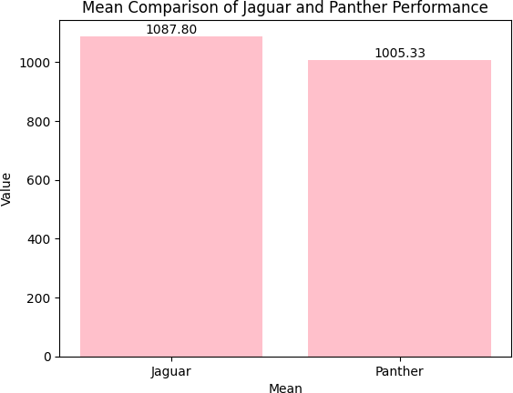

*Figure 15*. Mean Comparison

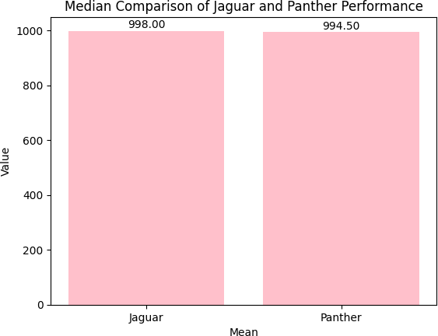

*Figure 16.* Median Comparison

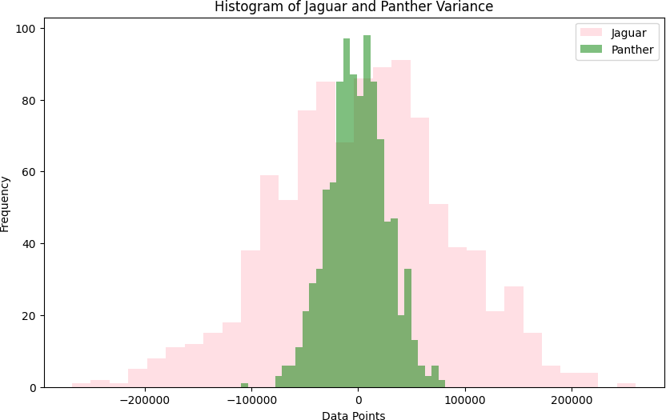

*Figure 17*. Comparing Variances with Histograms

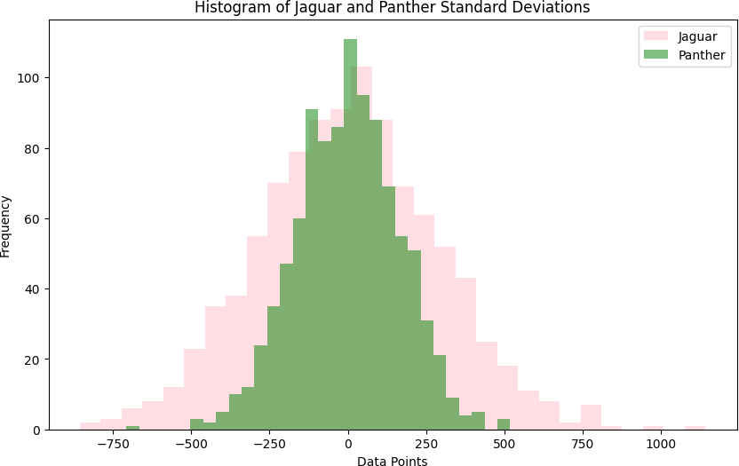

*Figure 18*. Comparing Standard Deviations with a Histogram

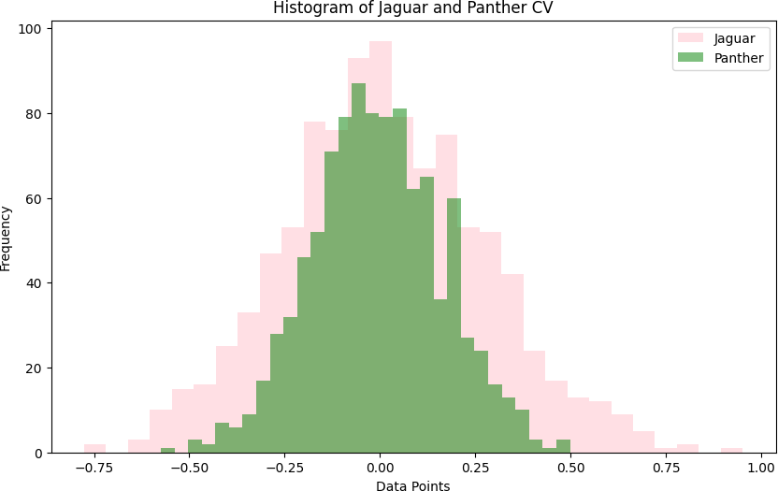

*Figure 19*. Variance Coefficient using Histogram