Installation

* Require packages

1. Anaconda python 3.6

* How to run

use command python main.py under the path ./hw1 with terminal, or any other compiler open ./HW1/main.py just like Jupyter Notebook, pycharm and run it then you can see the result.

After running the main.py results of mean, standard deviation, prior and error rate will show in terminal and visualization result for each testing data will show at the same time.

Visualization between each feature in testing data

Title: [current/total] label: class i (ground truth)

Two states:

1. pass: predict correctly, color of title will be green
2. error: predict wrongly, color of title will be red

Blow is an example when error occurred

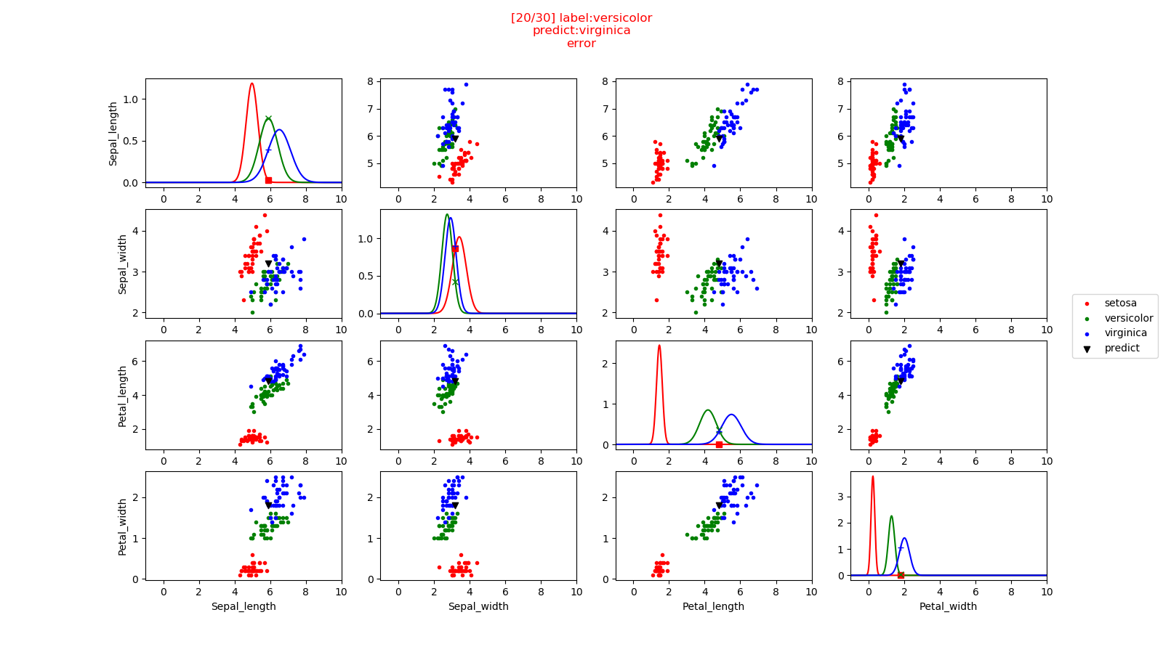

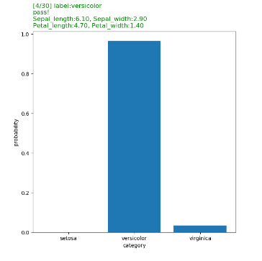If you want to see the probability histogram for each class you can cancel the comment in main.py line:222, it will run after visualize.