[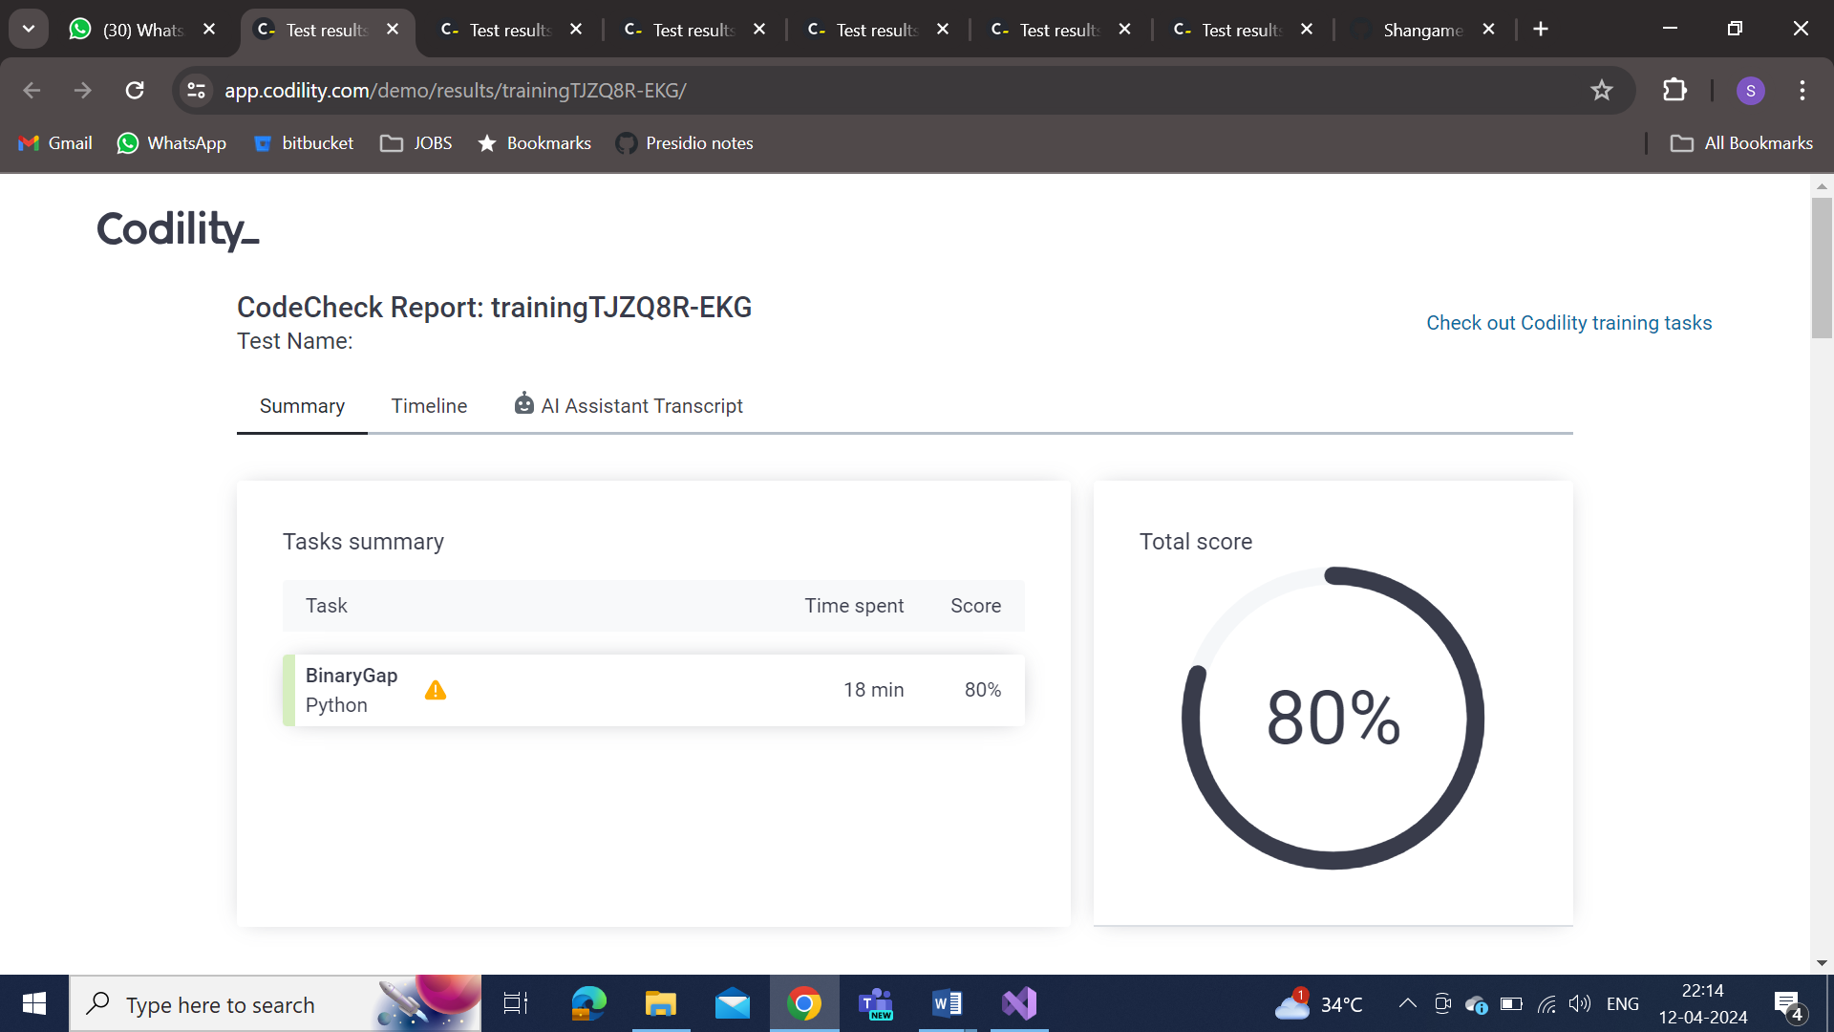](https://app.codility.com/demo/results/trainingTJZQ8R-EKG/)

[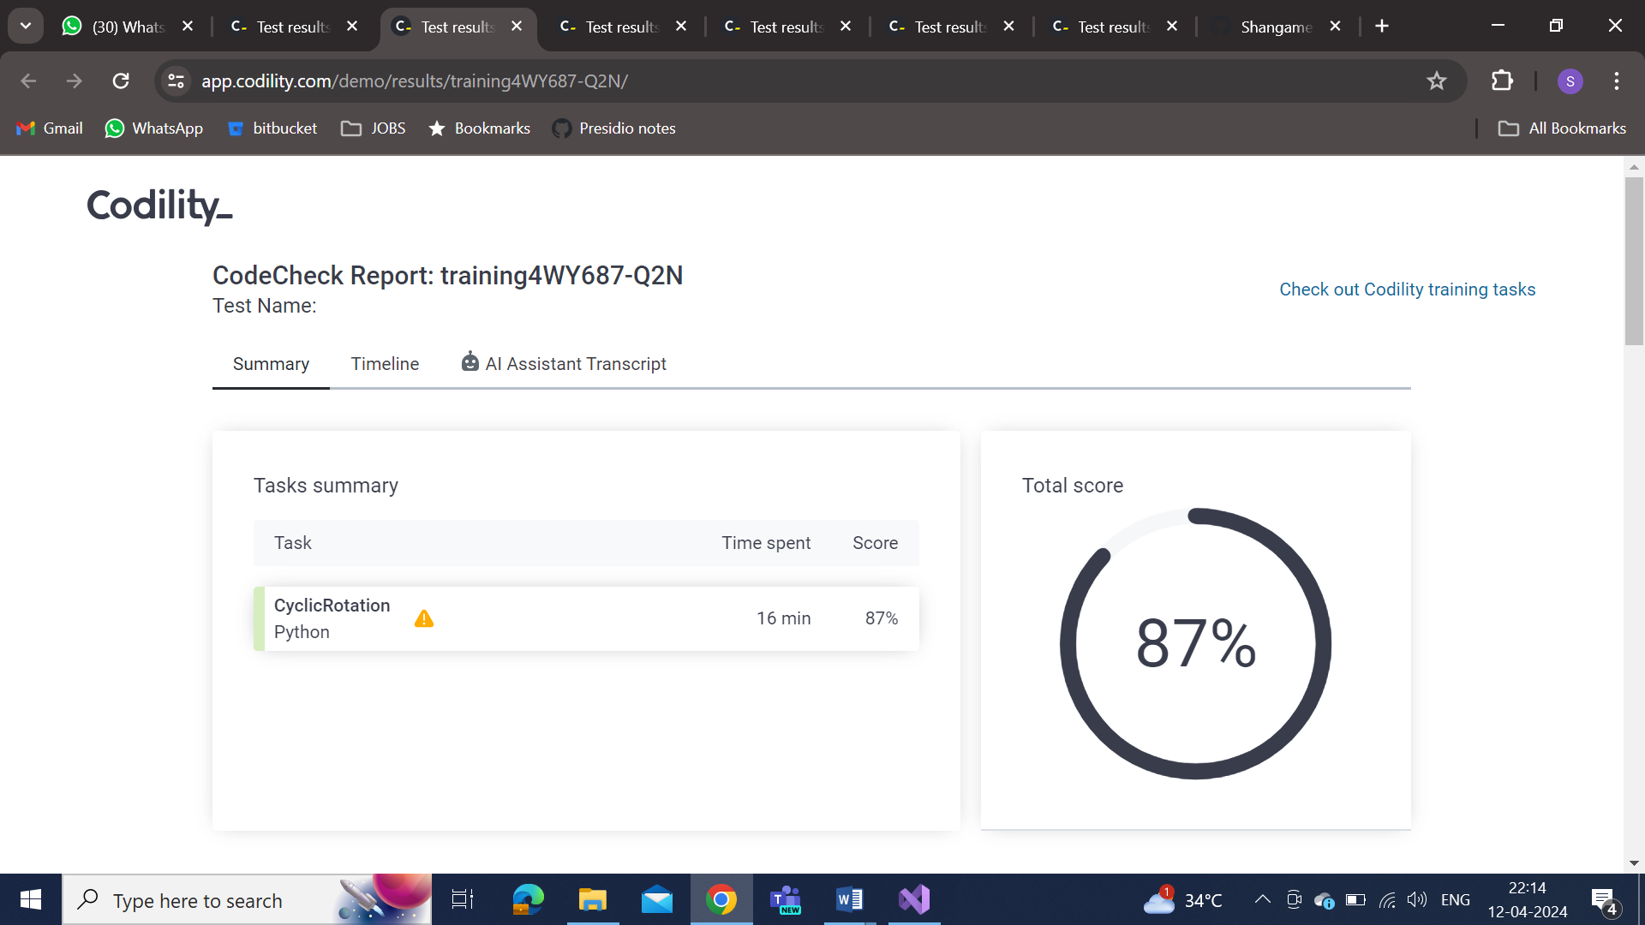](https://app.codility.com/demo/results/training4WY687-Q2N/)

[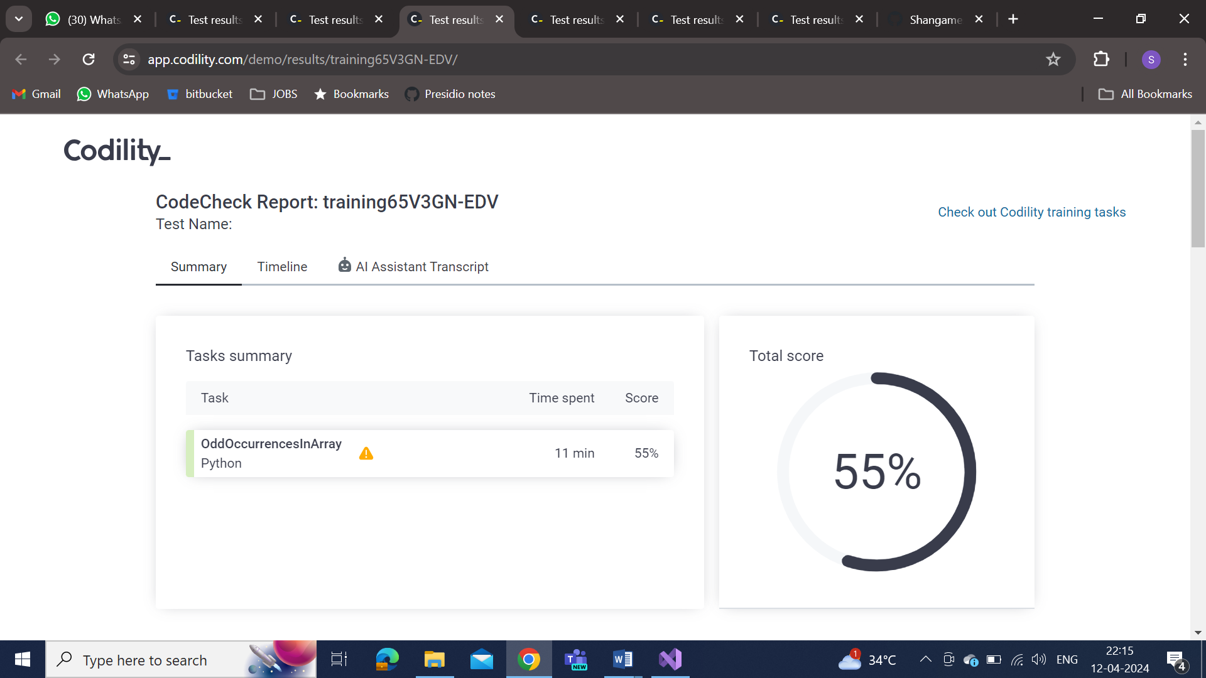](https://app.codility.com/demo/results/training65V3GN-EDV/)

[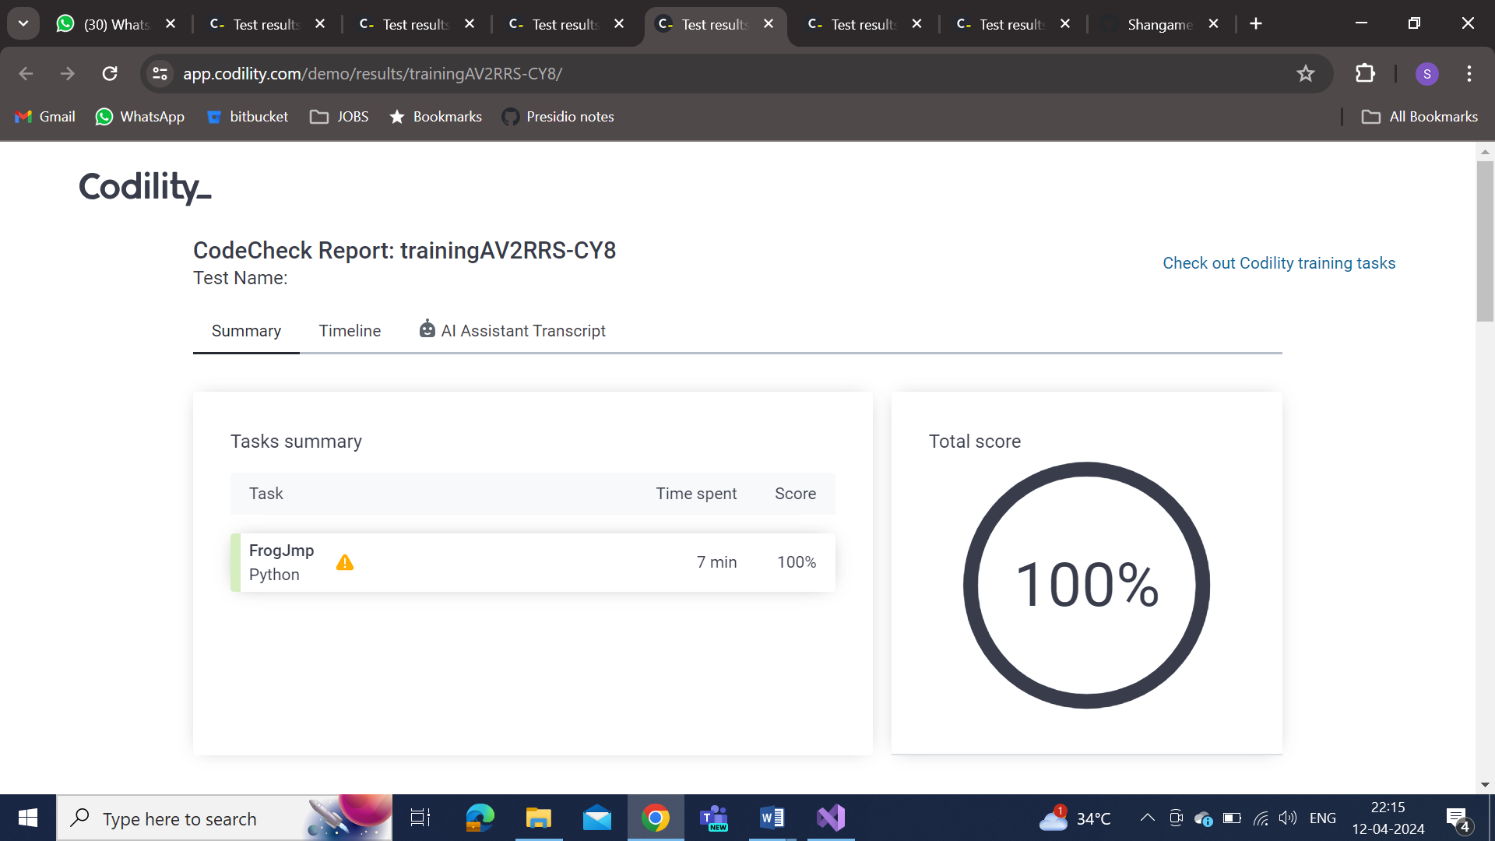](https://app.codility.com/demo/results/trainingAV2RRS-CY8/)

[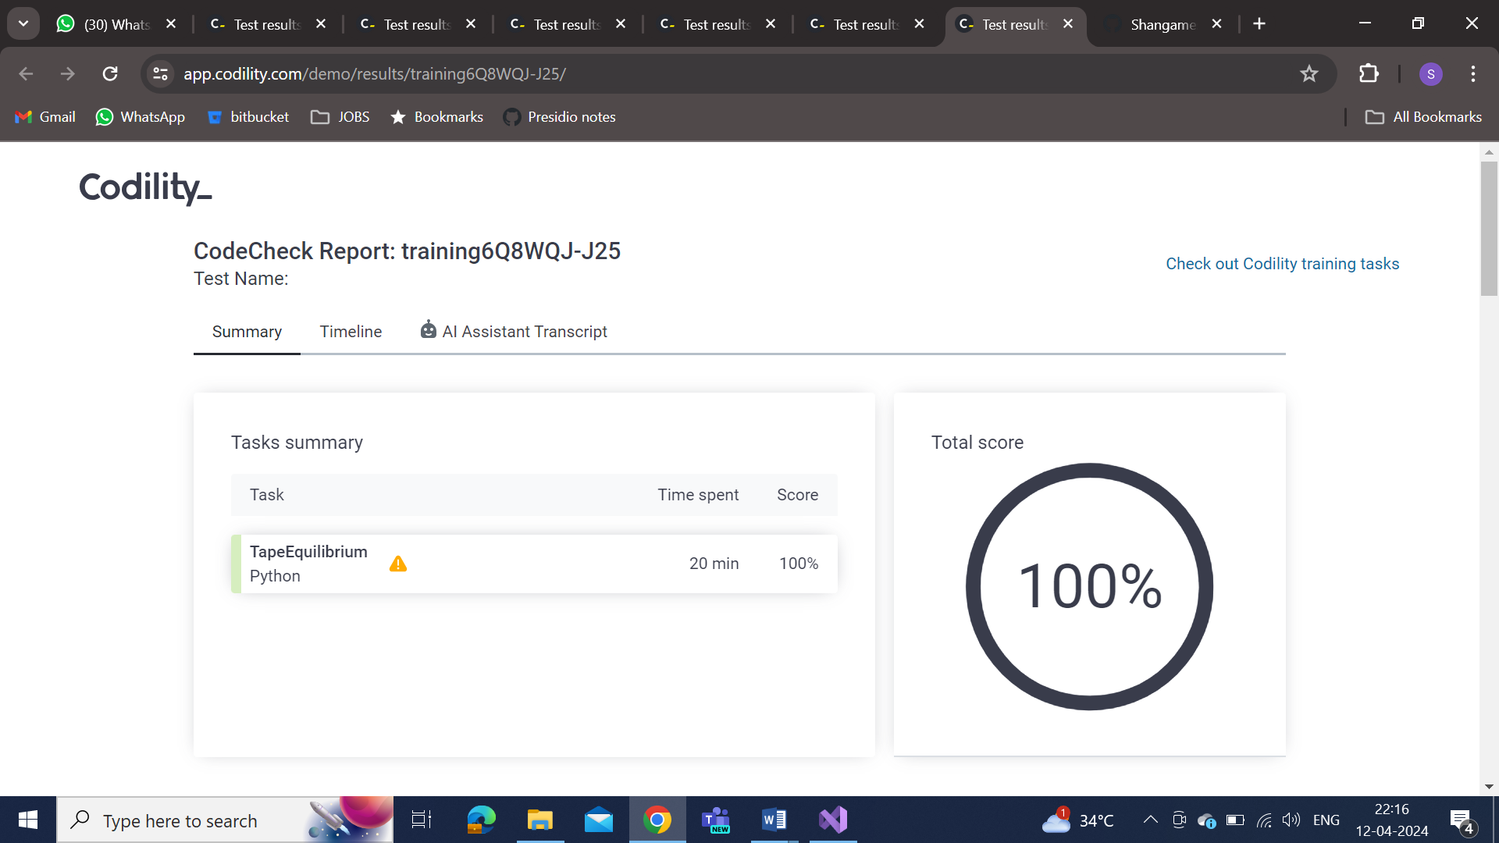](https://app.codility.com/demo/results/trainingCKZ54J-YGG/)[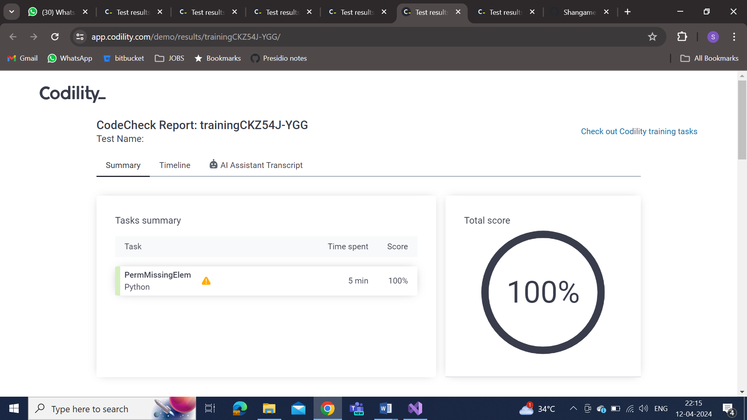](https://app.codility.com/demo/results/training6Q8WQJ-J25/)