1.CRUD APPLICATION OUTPUTS:

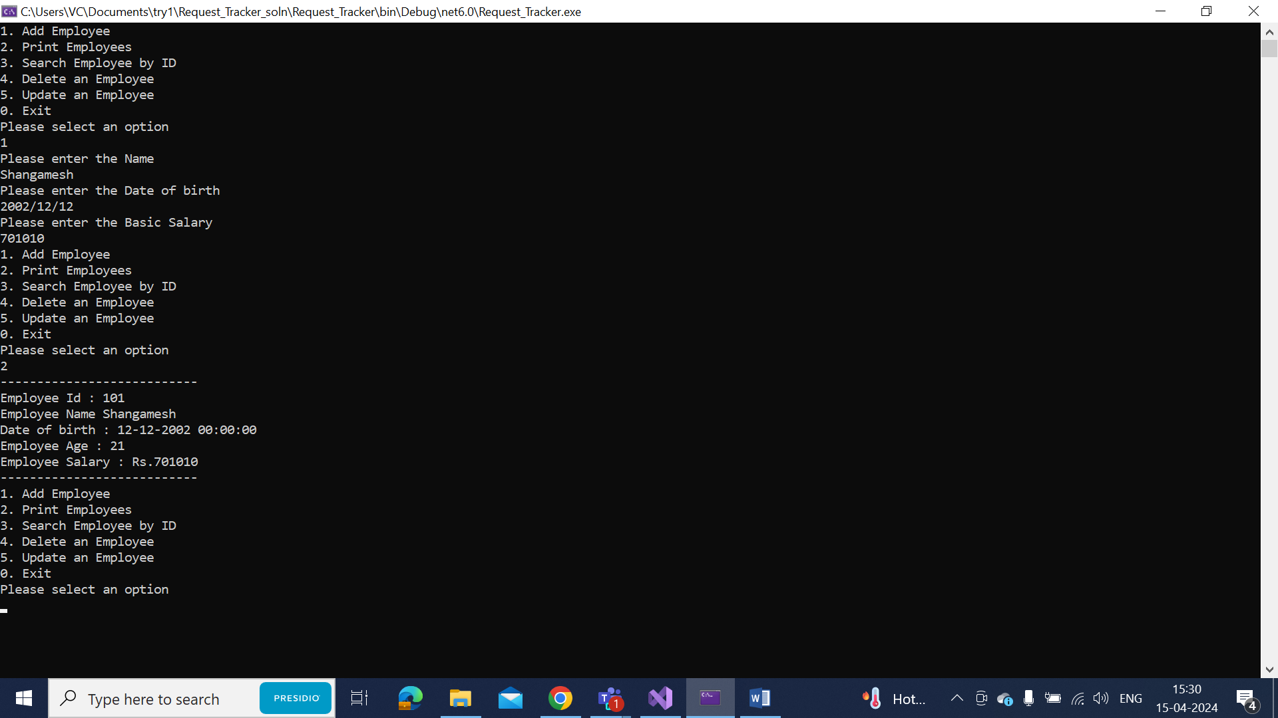

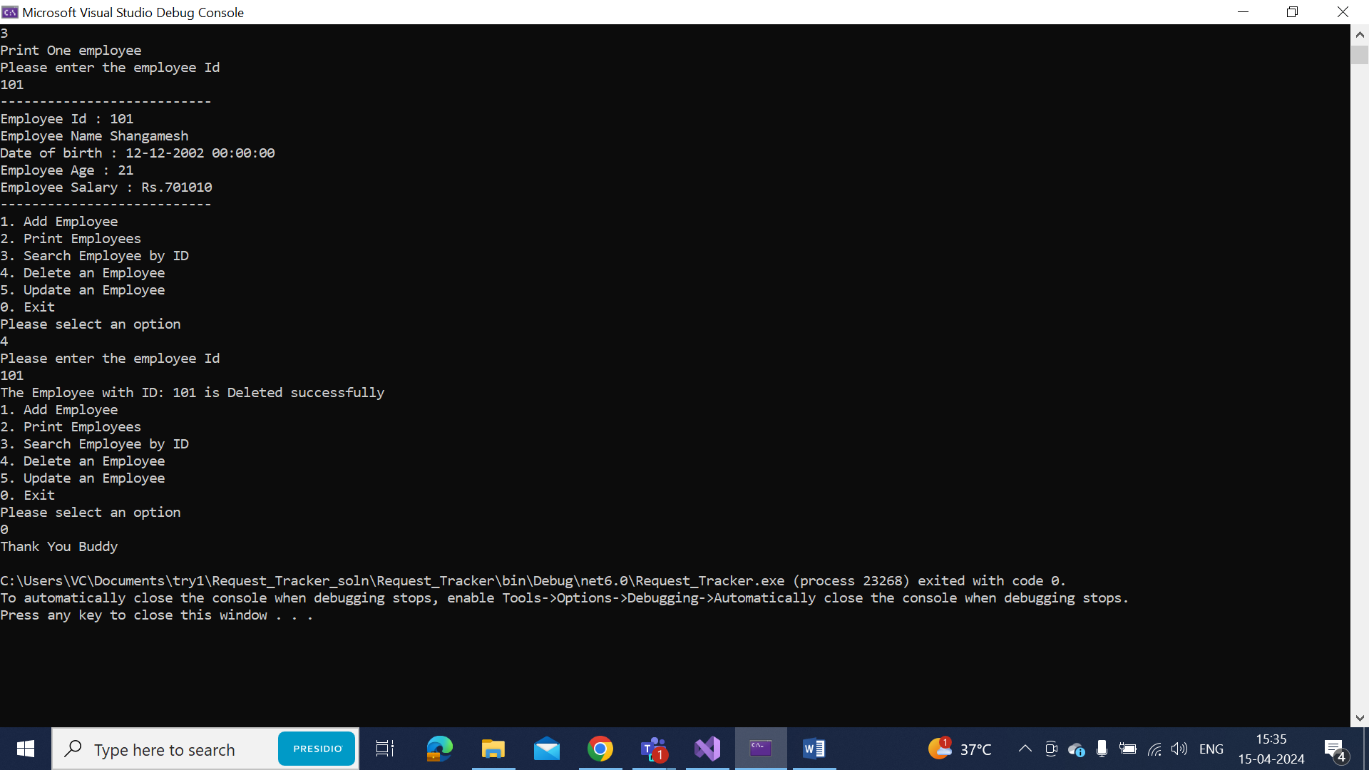

2.Bulls and Cows game :

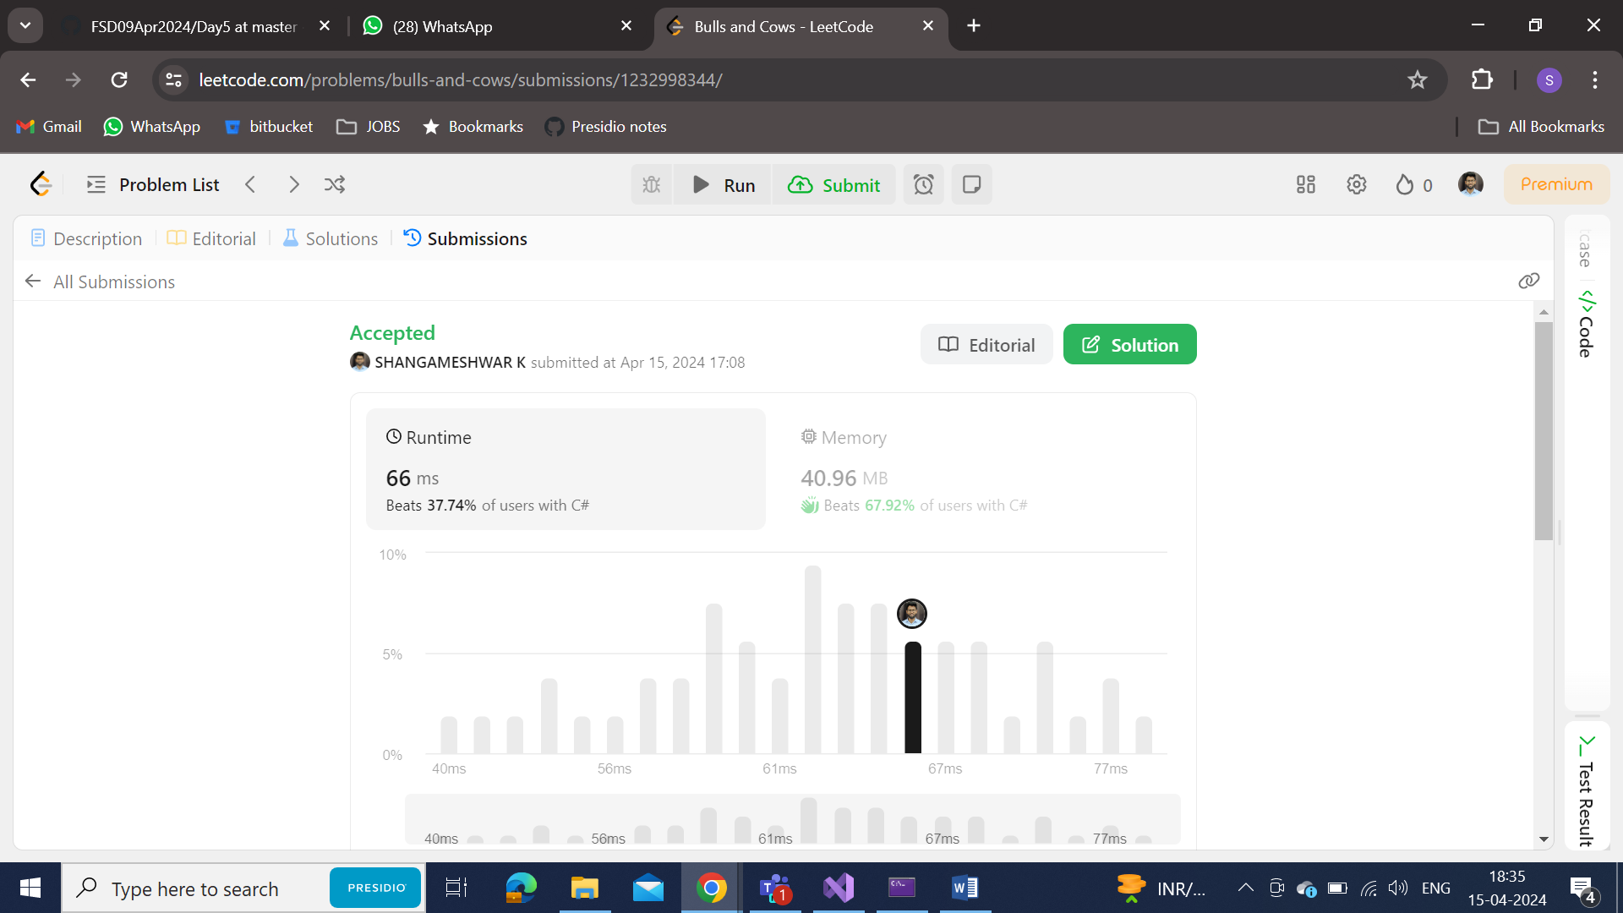

CODE:

public class Solution {

public string GetHint(string secret, string guess) {

char[] secArr = secret.ToCharArray();

char[] gueArr = guess.ToCharArray();

char[] secArrCopy = new char[secArr.Length];

Array.Copy(secArr, secArrCopy, secArr.Length);

int x = 0, y = 0;

for(int i = 0; i < secArr.Length; i++)

{

if (secArr[i] == gueArr[i])

{

x++;

secArr[i] = '^';

gueArr[i] = '^';

}

}

for(int i = 0; i < gueArr.Length; i++)

{

if (gueArr[i] != '^')

{

for(int j = 0; j < secArrCopy.Length; j++)

{

if (secArrCopy[j] == gueArr[i] && secArr[j] != gueArr[j])

{

y++;

secArrCopy[j] = '^';

break;

}

}

}

}

return $"{x}A{y}B";

}

}

**Console Op:**

