Home Theater Facade
Assignment 4 | Software Design Patterns | Astana IT University

1 Introduction
A home theater needs several devices to work together before a movie can start. A client must prepare the room, load the movie, configure the projector and amplifier, start playback, and handle shutdown. Repeating that sequence in every client makes the application harder to use and easier to break.
This Java project uses Option B from the assignment. HomeTheaterFacade provides watchMovie(String title) and endMovie(). The ordinary Client uses only these operations. The project is a stateful console simulation: it models device behavior and dependencies without controlling physical equipment or playing a real video file.

Subsystem responsibilities
Class | Responsibility and interaction
DvdPlayer | Stores power, loaded movie, and playback state; rejects playback without a loaded movie.
Amplifier | Stores a DVD input and volume; checks that its selected input is playing before audio output.
Projector | Stores power and display mode; checks the DVD playback state and screen position.
Screen | Stores and changes whether the screen is lowered.
TheaterLights | Stores brightness and rejects values outside 0 to 100 percent.

Why the facade simplifies the system
Without the facade, the client needs five device objects and twelve startup operations. With the facade, the client creates one object and requests a movie session. The facade owns coordination; the devices retain their own validation and state changes. In particular, projection and audio are requested only after DVD playback starts.
HomeTheaterFacade theater = new HomeTheaterFacade();
theater.watchMovie("Inception");
theater.endMovie();

2 UML class diagram
The diagram shows the ordinary client, the facade, five subsystem classes, and the exception used for coordination failures.
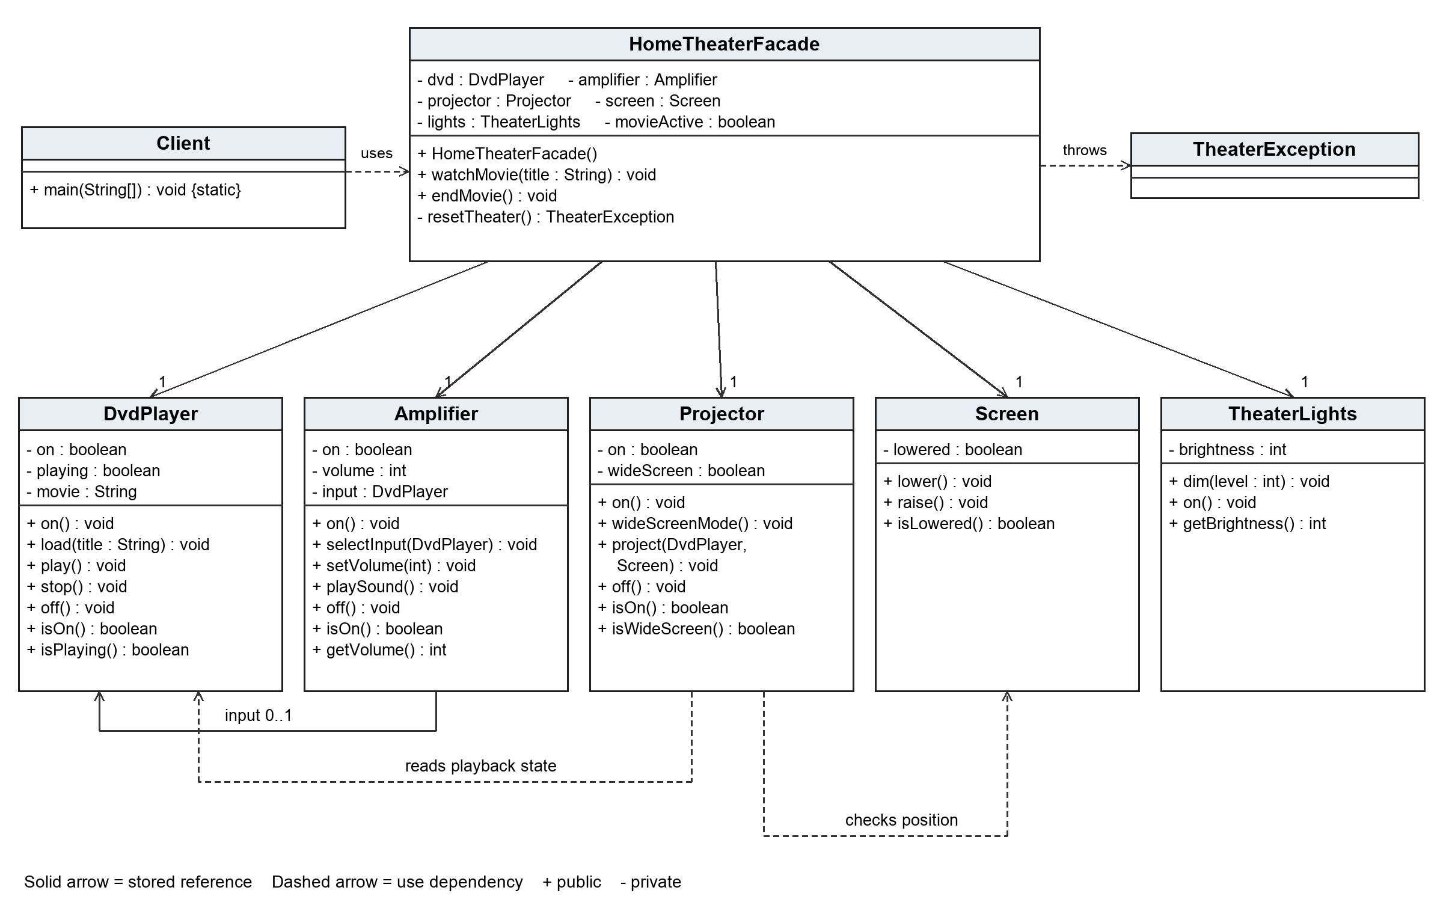
Each facade device association has multiplicity 1. Amplifier retains zero or one DVD input. The package-private injection constructor and private power guards are omitted for readability.

3 Clean Code principles
The following annotated excerpts are taken from the implementation. Each example explains the principle and the reason it improves this design.

3 1 Meaningful names
Names describe the requested behavior. watchMovie and endMovie explain the client API. selectInput and wideScreenMode explain device configuration. MOVIE_BRIGHTNESS and MOVIE_VOLUME explain the meaning of the defaults instead of leaving unexplained numbers.
private static final int MOVIE_BRIGHTNESS = 15;
private static final int MOVIE_VOLUME = 30;
// The calls state the purpose of each setting.
lights.dim(MOVIE_BRIGHTNESS);
amplifier.setVolume(MOVIE_VOLUME);

3 2 Single responsibility
The facade coordinates the session. It delegates device rules to the device that owns the relevant state. Projector checks the screen and video source; the facade does not copy these checks into its startup sequence.
// HomeTheaterFacade delegates projection.
projector.project(dvd, screen);
// Projector owns the screen-position rule.
if (!screen.isLowered()) {
throw new IllegalStateException(
"Lower the screen before projection.");
}

3 3 Encapsulation and a small public API
The facade keeps the devices private and final. Its public constructor requires no device knowledge, and its operation parameters do not expose subsystem types. A package-private constructor supports failure tests without becoming part of the ordinary public API.
private final DvdPlayer dvd;
private final Amplifier amplifier;
// Client sees the session operations only.
theater.watchMovie("Inception");
theater.endMovie();

3 Clean Code principles continued

3 4 Small focused methods
Each device operation handles one understandable action. DvdPlayer.play validates power and loaded media, updates playback state, and reports the result. A private requirePower helper keeps that precondition consistent within the class.
public void play() {
requirePower();
if (movie == null) {
throw new IllegalStateException(
"Load a movie before playback.");
}
playing = true;
System.out.println("DVD playing: " + movie);
}

3 5 Avoiding duplication
Normal shutdown and failed startup share resetTheater. Keeping the six cleanup actions in one place prevents the two paths from developing different reset behavior. The shared policy switches devices off, raises the screen, and restores full brightness.
// Used by both endMovie and the startup catch block.
TheaterException cleanupFailure = resetTheater();
// One list defines the cleanup sequence.
List.<Runnable>of(amplifier::off, projector::off,
dvd::stop, dvd::off, screen::raise, lights::on)

3 6 Explicit error handling
Invalid client requests are rejected before changing devices. If a subsystem fails during startup, TheaterException retains the original cause. During cleanup, each action has its own try/catch so later actions still run. Suppressed exceptions retain additional cleanup failures instead of losing them.
// Inside the cleanup loop, for each action:
try {
action.run();
} catch (RuntimeException cause) {
failure.addSuppressed(cause);
}
If startup and cleanup both fail, the startup exception remains the cause and the aggregated cleanup exception is suppressed. Failed cleanup does not imply that every device is safely reset; the failure is reported and endMovie can be retried.

4 Validation and conclusion

Observed behavior
The demo starts Inception, configures all five devices, and restores the theater during shutdown. Compilation used --release 17 -Xlint:all -Werror. All 31 local behavioral scenarios passed. These are project tests, not instructor tests. The local compiler and runtime were JDK 25.0.2 targeting Java 17; the repository also contains a GitHub Actions configuration that selects JDK 17.
Test group | What the checks verify
Session behavior | Valid startup, call order, shutdown, repeated sessions, and duplicate-start rejection.
Input and device rules | Null and blank titles, numeric bounds, powered devices, loaded media, and playback prerequisites.
Coordination failures | Failure after each of 12 startup operations; rollback and successful retry.
Cleanup failures | All cleanup steps attempted; multiple failures preserved; a later shutdown retry works.
Pattern structure | Public subsystem classes can be coordinated directly without using the facade.

Conclusion
HomeTheaterFacade hides object creation, device configuration, ordering, audio and video setup, and cleanup coordination. The ordinary client therefore depends on one session-level interface. The subsystem classes remain public and unaware of the facade. Advanced callers can still use them directly, provided they respect the device preconditions and coordinate cleanup themselves.
The implementation supports one session in a single-threaded simulation. It resets to a defined standard state rather than restoring earlier custom settings. These limits keep the example focused on the Facade pattern.

5 GitHub repository
GITHUB_REPOSITORY_URL

References
Assignment 4 Facade Pattern Instructions. Course handout supplied with this assignment.
Refactoring Guru. Facade. https://refactoring.guru/design-patterns/facade
Oracle. Java SE 17 Throwable API. https://docs.oracle.com/en/java/javase/17/docs/api/java.base/java/lang/Throwable.html

