Temporal persistency and popular differentiation facilitate cross-modal transfer learning

Summary

Introduction
Transfer of learning describes the influence of previously acquired knowledge and skills on the acquisition of new ones (Thorndike & Woodworth, 1901). The phenomenon pervades adaptive behavior, and its reach has long been taxonomized from near to far transfer (Barnett & Ceci, 2002). Prior frameworks have characterized transfer mainly at the behavioral and psychological levels (Perkins & Salomon, 1999), and even contemporary neural evidence on transfer itself has remained largely at brain-region resolution (Rasooli et al., 2024). A persistent conceptual difficulty is that the overall transfer advantage conflates at least two distinct processes: the ability to start a new task from an elevated initial state, and the ability to keep improving faster once the new task is underway. Whether and how these two components are supported by different cellular and circuit mechanisms is largely unknown.
Recent work has begun to approach this question at the level of neural populations. Mice can bidirectionally generalize sensorimotor task rules between touch and vision through abstract cortical representations, and silencing experiments indicate that congruent multimodal representations in associative cortex support such cross-modal generalization (Guyoton et al., 2025). At the representational level, cross-context decoder generalization has been used to define abstract coding geometry in hippocampus and prefrontal cortex (Bernardi et al., 2020). These studies establish that shared, abstract population codes can underlie rule transfer, but they leave open how previously recruited cell ensembles are reused at the onset of a new task, and how population organization evolves over subsequent training days.
Two long-standing literatures provide candidate mechanisms for these processes. In the engram literature, specific sparsely distributed cell assemblies are recruited during learning, and their tagging, inhibition, and reactivation causally control memory retrieval (Ryan et al., 2015), a framework consolidated in current reviews of engram cells (Josselyn & Tonegawa, 2020). Engrams of temporally proximate events tend to overlap through excitability-based competition (Rashid et al., 2016), providing a cellular substrate for linking related experiences (Choucry et al., 2024). The extent to which such ensemble reuse drives transfer of a sensorimotor association to a cue of a different modality, however, has not been tested directly. In the population-dynamics literature, behavior is generated within low-dimensional neural manifolds whose structure constrains what can be learned (Sadtler et al., 2014), and population dynamics more generally serve as the computational substrate of behavior (Vyas et al., 2020). Short-timescale learning can proceed by reassociating population activity within the existing manifold (Golub et al., 2018), and changes within a preserved population structure can likewise enable rapid learning (Perich et al., 2018), while manifold stability across months maintains consistent behavior (Gallego et al., 2020). Learning in motor cortex refines population structure at fine spatial scales rather than uniformly elevating activity (Komiyama et al., 2010); its structural counterpart is the rapid formation and selective stabilization of motor-learning synapses (Xu et al., 2009), and cross-day imaging shows that learning also amplifies sensory representations in visual cortex (Poort et al., 2015). In addition, stimulus-driven engagement of cortex is accompanied by a widespread reduction of trial-to-trial variability (Churchland et al., 2010). These findings suggest that prior training could leave behind a reusable population geometry that lowers trial-to-trial divergence at the onset of transfer and shapes how quickly the new task is subsequently learned.
A key open question is whether the initial advantage at transfer onset and the later advantage in learning speed rest on the same or on dissociable cellular signatures and circuits. Computational work provides one specific hypothesis for the latter: heterogeneity in intrinsic neuronal properties makes spiking network learning faster, more stable, and more robust in temporally structured tasks (Perez-Nieves et al., 2021). If response heterogeneity plays an analogous role in vivo, it should be elevated during transfer learning and should predict the speed of subsequent improvement, ideally with an identifiable upstream modulator. The motor thalamus is a plausible candidate, because motor learning refines thalamic influence on primary motor cortex to enable reliable execution of learned movements (Ramot et al., 2025); moreover, higher-order thalamocortical motifs are positioned to modulate cortical processing in a state-dependent manner (Halassa & Sherman, 2019), within cortico-thalamo-cortical loops whose cellular composition supports flexible top-down control (Shepherd & Yamawaki, 2021).
Here we addressed these questions by longitudinally imaging the same neurons across days in the tongue-related region of mouse primary motor cortex (MOp) during a cue-delayed-licking paradigm, in which mice first learned an auditory-cued water task and were then transferred to a visually cued version of the same task. This approach builds on our earlier in vivo imaging of immediate early gene expression, which revealed layer-specific, sparsely coded long-term memory engram cells in the mammalian neocortex (Xie et al., 2014). MOp sits on the cue-to-lick sensorimotor pathway delineated by cortical activity flow in mice (Guo et al., 2014), and mouse motor-cortical populations exhibit low-dimensional, monotonic preparatory dynamics well suited to state-space analysis (Inagaki et al., 2018). Its output neurons are organized into projection classes with layer-specific functions (Oswald et al., 2013), and movement-specific signaling is distributed differentially across these classes (Currie et al., 2022), enabling a layered analysis of transfer. Combining across-day two-photon imaging in layers 2/3 and 5 with chemogenetic inhibition of tagged ensembles and of posterior thalamus, we decomposed the cross-modal transfer advantage into an initial-performance component tied to reactivation of prior ensembles and reduced trial-to-trial divergence, and a subsequent-learning component tied to enhanced response heterogeneity under thalamic modulation. Critically, the two components proved doubly dissociable: inhibiting the tagged ensemble impairs initial transfer performance, whereas inhibiting the posterior thalamus flattens the learning slope while leaving initial performance intact. A one-week pause between tasks abolishes the reuse of prior ensembles and attenuates the transfer advantage, whereas a network simulation reproduces how inhibition inherited from prior training raises response heterogeneity, suppresses noise-triggered reverse learning, and thereby accelerates transfer. Encoding and decoding analyses further characterize how cue and choice information is carried by MOp populations during transfer (Runyan et al., 2017), and how this relates to the reuse of prior-task cells. Together, these results show that the initial and learning-speed advantages of transfer rest on dissociable cellular signatures and circuits — ensemble reuse setting where transfer starts, and thalamus-modulated response heterogeneity determining how fast it proceeds — offering a cell-ensemble-level account of how prior experience shapes new learning.

Results

Inter-trial stability and inter-cell heterogeneity of the cortical response of the transfer task
To determine how prior auditory learning shapes cortical processing of a novel visual cue, mice were trained on a cross-modal transfer paradigm: after learning an audio–water association task, the cue modality was switched to light while the reward rule remained unchanged (Figure 1A). Mice with auditory pre-training (transfer) attained a higher hit rate than naïve mice trained directly on the light cue across the first seven light-water blocks (Figure 1B). To follow the underlying cortical representations, we performed two-photon calcium imaging in layer 2/3 and layer 5 of the primary motor cortex (MOp) across auditory training and the subsequent light training (Figure 1C). In naïve mice, single cells responded to the first light cue with large and trial-variable calcium transients, whereas the same cells recorded after auditory learning responded more consistently from trial to trial, and this trial-to-trial consistency was already present in the first light-water block (Figure 1D).
We first quantified trial-to-trial stability at cue +1 s — the moment at which water is delivered, and thus the latest time point at which cortical activity can still influence the reward outcome of the trial — using an inter-trial divergence index, defined as the trial-to-trial variance of the population response relative to its squared mean, computed separately for each layer and each mouse. In L2/3, transfer mice showed markedly lower divergence than naïve mice upon their first light-water block, whereas in L5 the two groups did not differ (Figure 1E). Across the 25 mice of both cohorts, inter-trial divergence correlated strongly and negatively with first-block hit rate (Figure 1F), indicating that mice whose cortical population responses were more stable at cue +1 s performed better at the very first exposure to the light cue. Divergence, however, did not predict how fast mice subsequently learned (Figure 1G). Inter-trial stability therefore accounts for the starting point of transfer, but not for the speed of new learning, prompting us to search for a population property that tracks learning speed.
We next measured response heterogeneity (RH), the across-cell standard deviation of trial-mean z-scored responses at cue +1 s, as an index of functional differentiation within the recorded population. In learning theory, a spread of response profiles across network units provides the differentiated updates that gradient descent requires, and thereby accelerates convergence (Saxe et al., 2014). In biological networks, heterogeneity plays a comparable enabling role, promoting robust learning (Perez-Nieves et al., 2021). Intuitively, RH reflects how strongly the recorded cells are polarized into cue-excited and cue-suppressed subpopulations: a single transfer block shows a wider spread of per-cell response amplitudes than a naïve block (Figure 1J). Quantitatively, RH correlated significantly with the sigmoid learning slope in L5 but not in L2/3 (Figure 1H): mice with more heterogeneous L5 responses learned the light task faster. Consistently, transfer mice exhibited significantly higher RH than naïve mice in L5, whereas the L2/3 difference did not reach significance; fully learned audio-water blocks showed the highest RH in both layers (Figure 1I). Thus, inter-trial stability governs immediate transfer performance, while inter-cell heterogeneity, particularly in L5, governs the speed of subsequent learning.
Two sets of control observations support this framework (Figure S1). First, the behavioral quantification in Figure 1B used the delayed paradigm, in line with the conventional design of such transfer tasks, whereas all imaging analyses above were performed in the undelayed paradigm, in which water is delivered at a fixed time (800 ms after cue offset) on every trial regardless of licking; this response-independent reward timing gives the external task events a trial-invariant temporal anchor, which is required for aligning calcium signals across trials. To confirm that the behavioral advantage does not depend on this paradigm difference, we re-examined learning in the undelayed variant: transfer mice still outperformed naïve mice from the very first block and reached asymptotic performance in fewer blocks (Figure S1A–D). Second, during transfer, the ensemble that had been active in learned audio-water blocks was re-engaged by the light cue: among cells active at cue +1 s in learned audio-water blocks, the reactivation fraction was higher on hit than on miss trials (Figure S1E–G), and roughly one seventh of them (76/511) were active again in the first transfer light-water block (Figure S1H). The ensemble carrying the auditory memory is therefore recruited by the novel visual cue, and the degree of this recruitment covaries with trial outcome.
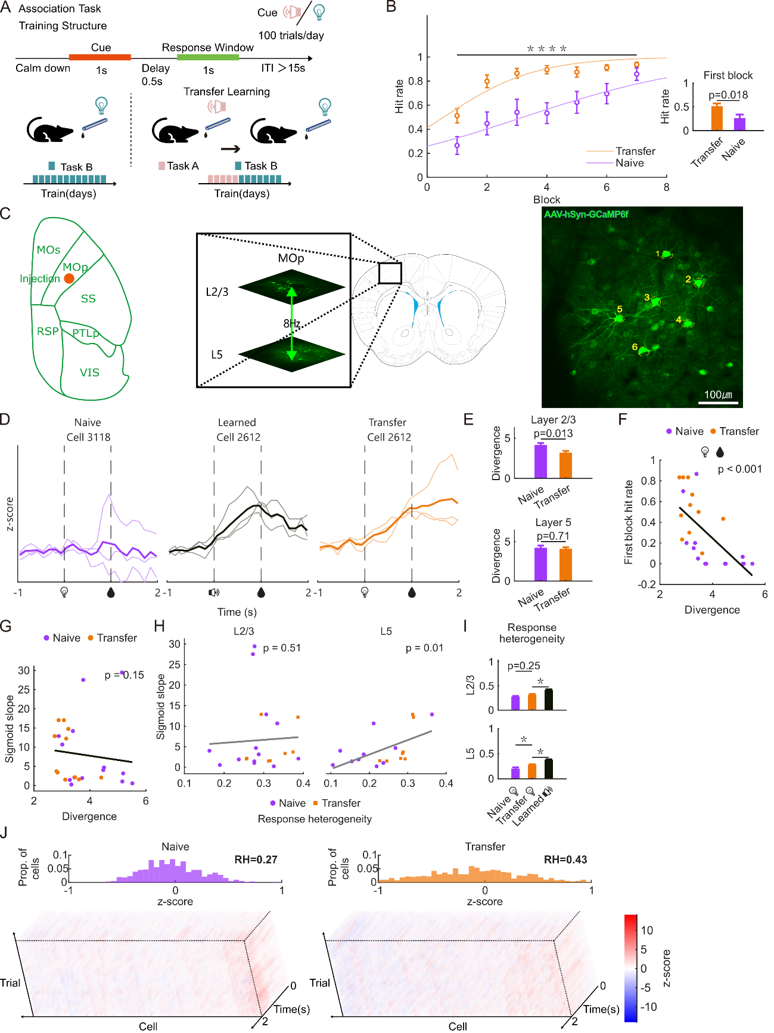
Figure 1 | Inter-trial stability and inter-cell heterogeneity of the cortical response predict distinct components of the transfer advantage.
- Schematic of the cross-modal transfer paradigm (delayed version). Each trial comprised a calm-down period, a 1 s cue (auditory or visual), a 0.5 s delay and a 1 s response window; water was delivered immediately upon the first lick inside the response window, and trials without a lick in the window received no water (inter-trial interval > 15 s; 100 trials per day). Mice first learned the audio–water association (task A); after reaching criterion, the cue was switched to light with the reward rule unchanged (task B; transfer group), whereas control mice were trained directly on the light cue (task B only; naïve group).
- BLight-water learning performance in the delayed paradigm of **A** (1 s cue, 0.5 s delay, 1 s response window; water upon licking within the response window). Left, block-wise mean ± SEM hit rate across blocks 1–7 with group-level sigmoid fits: transfer (audio-pretrained; n = 15 mice) vs naïve (n = 8); transfer outperformed naïve overall (linear mixed-effects model, Performance ~ Block + Group + (1|Mouse), group effect p = 0.012). Right, first-block hit rate (transfer 0.51 ± 0.06 vs naïve 0.34 ± 0.13, mean ± SEM; p = 0.19 by one-way ANOVA with multiple-comparison correction, n.s.).
- Two-photon calcium imaging in MOp across auditory training and the subsequent light training, performed in the undelayed paradigm (Figure S1A). Left, dorsal view of the cortex with the AAV-hSyn-GCaMP6f injection site in MOp (orange dot; adjacent areas MOs, SS, RSP, PTLP and VIS outlined). Middle, coronal section with the imaging field enlarged: two imaging planes in L2/3 and L5 were sampled alternately at 8 Hz by vertically oscillating the objective lens of the two-photon microscope (green double-headed arrow). Right, example field of view with individually numbered GCaMP6f-expressing cells; scale bar, 100 μm.
- Representative single-cell traces across trials (z-score, cue onset at 0 s, water at 1 s): naïve light-water block (left), learned audio-water block (middle), and the first transfer light-water block of the same cell as the middle panel (right).
- Per-mouse inter-trial divergence at cue +1 s, computed within each layer. Top, L2/3: naïve 4.16 ± 0.25 (n = 14 mice) vs transfer 3.19 ± 0.24 (n = 11), rank-sum p = 0.0093. Bottom, L5: naïve 4.23 ± 0.29 (n = 11) vs transfer 4.09 ± 0.21 (n = 10), p = 0.70. Divergence is the trial-to-trial variance of the population response normalized by its squared mean.
- First-block hit rate vs inter-trial divergence across the 25 mice of both cohorts (Spearman ρ = −0.755, p = 1.3 × 10⁻⁵).
- Sigmoid learning slope vs inter-trial divergence (Spearman ρ = −0.296, p = 0.15, n = 25 mice, n.s.). Divergence explains early performance but not learning speed.
- Per-mouse response heterogeneity (RH) vs sigmoid learning slope. L5: ρ = 0.571, p = 0.015 (n = 18 mice: 10 naïve, 8 transfer); L2/3: ρ = 0.151, p = 0.51, n.s. (n = 21: 13 naïve, 8 transfer). Each mouse contributes one slope (fitted across blocks, layer-independent) plotted against its layer-specific RH.
- Per-mouse RH at cue +1 s for naïve light-water, transfer light-water, and learned audio-water cohorts, by layer (p values from multiple-comparison correction, as displayed). In L5, transfer > naïve (p = 0.009); in L2/3, transfer vs naïve n.s. (p = 0.25); learned audio-water exceeded transfer in both layers (L2/3, p = 0.002; L5, p = 0.002). RH is the across-cell SD of trial-mean z-scores at cue +1 s (cells restricted to |z| ≤ 1).
- Representative naïve (610 cells, RH = 0.27) and transfer (499 cells, RH = 0.43) light-water blocks: distributions of per-cell trial-mean z-score at cue +1 s (top) and single-trial × cell × time heatmaps (bottom).

Encoding ensemble facilitates first-block performance
The first-block transfer advantage implies that auditory learning leaves a cortical representation that the light task can read out immediately. To identify what is transferred, we trained two linear decoders on MOp population activity: a cue decoder that discriminates auditory from light stimuli on calibration blocks, and a behavior decoder that discriminates hit from miss trials on audio-water training blocks; both were then applied, without retraining, to the held-out transfer light-water block (Figure 2A). In their training contexts both decoders tracked their labels (Figure 2A, left). In the transfer light-water block, however, only the behavior decoder separated light hit from light miss trials, whereas the cue decoder remained at chance throughout the trial (Figure 2A, right). Auditory learning therefore transfers an outcome-related code, not a cue-specific one.
The behavior decoder relied predominantly on hit-preferring cells: their absolute weights at 1.0 s after cue onset exceeded those of miss-preferring cells across all pooled cells and in 9 of 10 mice individually (Figure 2B and inset), and hit-preferring cells also outnumbered miss-preferring cells in the pooled population (2520 vs 2038; Figure 2C). Within the first transfer light-water block, hit-preferring cells evaluated on hit trials were more trial-stable than miss-preferring cells on miss trials (Figure 2D), and at cue +1 s they also showed higher mean activity on hit trials than miss-preferring cells did on miss trials, although this difference did not reach significance (Figure 2E). Auditory learning thus shapes a subset of outcome-selective, trial-stable hit cells — an encoding ensemble — whose activity tracks the outcome of the ongoing light trial.
To test whether this ensemble is causally required for transfer, we permanently tagged the cells active during the last audio-water training block with cFos-TRAP and silenced them during subsequent light training (Figure 2F, G). Silencing the tagged ensemble impaired light-water learning relative to control mice (Figure 2H), showing that the ensemble established by auditory learning is re-used for learning the new cue rather than merely correlated with it.
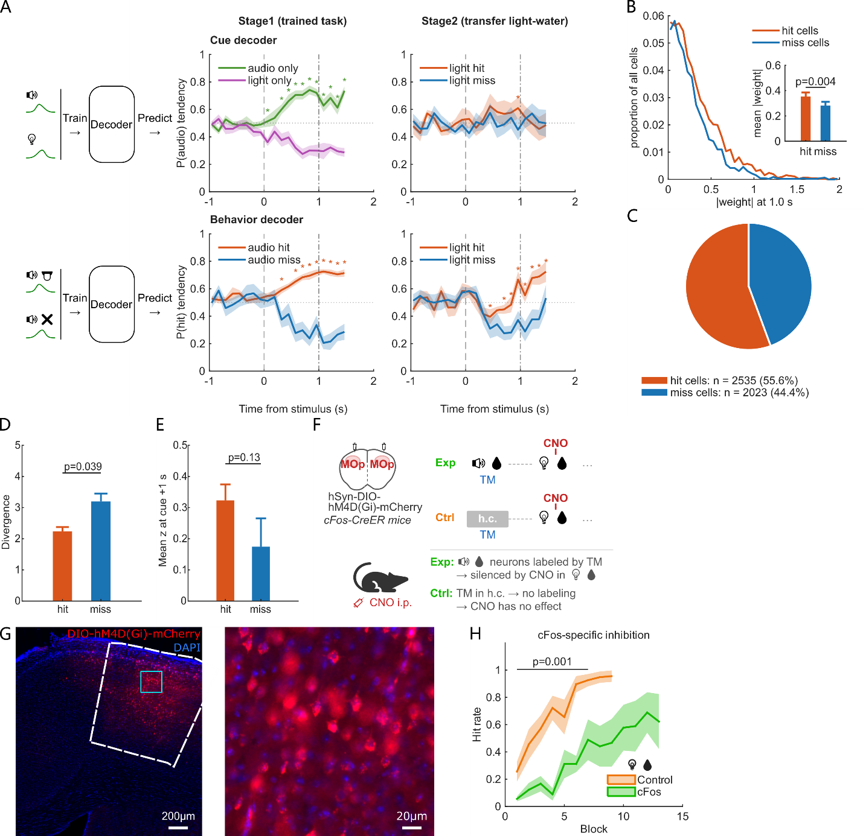
Figure 2 | The transferred outcome code is carried by an encoding ensemble required for transfer learning.
- Combined decoder schematic and decoder probability tendency (mean ± SEM across mice; n = 10 mice per decoder). Left, decoder design and train-test split; middle/right, decoder outputs in the training context and in the held-out transfer light-water block. In the training context, decoder performance was evaluated self-train-test by 5-fold cross-validation: in each fold 20% of trials were held out as the test set and the remaining 80% were used for training (class-balanced, with the two trial classes downsampled to equal size); the out-of-fold predictions of all folds were pooled to give the plotted curves, which were fitted separately at each of the 20 time points. In the transfer context, each decoder was trained once on all class-balanced training trials and applied to the held-out transfer light-water block without retraining. Top, cue decoder; bottom, behavior decoder. Asterisks mark time points at which the two trial classes differed (paired t-test per time point, Benjamini–Hochberg corrected, q < 0.05): the behavior decoder separated light hit from light miss trials at 8 of 20 time points, whereas the cue decoder separated them at none. Dashed and dash-dotted vertical lines, cue onset and water delivery.
- Distribution of absolute decoder weights at 1.0 s after cue onset, shown per 0.05-wide |weight| bin as the proportion of all 4558 decoder cells, for hit-preferring (weight > 0) and miss-preferring (weight < 0) cells. Weights were computed on class-balanced training trials (majority class downsampled to minority size, averaged over 100 draws). Inset, per-mouse mean absolute weight of the two groups (n = 10 mice; sign-rank p = 0.0039).
- Cell-count composition of the decoder: hit-preferring 2520 cells (55.3%) vs miss-preferring 2038 cells (44.7%).
- Inter-trial divergence at cue +1 s within the first transfer light-water block, computed for hit-preferring cells on hit trials and for miss-preferring cells on miss trials (paired per mouse; n = 9 mice; sign-rank p = 0.039). Divergence is defined as in Figure 1E.
- Mean z-score at cue +1 s of hit-preferring cells on hit trials and miss-preferring cells on miss trials within the first transfer light-water block (paired per mouse; n = 10 mice; hit 0.32 ± 0.06 vs miss 0.18 ± 0.10; sign-rank p = 0.13).
- Schematic of cFos-TRAP: cells active during the last audio-water training block were permanently tagged and silenced during subsequent light training.
- Confocal images of cFos-driven tagging in MOp.
- Light-water learning curve of mice with the tagged ensemble silenced (n = 3) and control mice (n = 9): block-wise mean ± SEM hit rate; group effect of a linear mixed-effects model over blocks 1–7 (Performance ~ Block + Group + (1|Mouse), p = 1.4 × 10⁻³).

Stable encoding ensemble fades over time
The encoding ensemble is causally required for immediate transfer (Figure 2). We next asked how long this ensemble remains available for the new task. In a separate cohort we inserted a 7-day home-cage interval, without training or imaging, between the last audio-water training block and the first light-water block (Figure 3A). The interval impaired light-water learning: mice with the 7-day gap attained lower hit rates across the first seven light-water blocks than continuously trained mice, and the deficit was already present in the very first block (Figure 3B). Consistently, the population response of the first transfer block was less trial-stable after the gap: inter-trial divergence at cue +1 s was higher than in the no-gap cohort (Figure 3C, top).
To ask whether the encoding ensemble itself survived the interval, we trained a decoder of the cue-evoked response — pre- versus post-cue population activity in learned audio-water blocks — and applied it, without retraining, to the held-out transfer light-water block (Figure 3D). Because this decoder needs no outcome labels, every mouse of both cohorts could be included. Cross-validated self-tests confirmed that both cohorts carried a robust cue-evoked code in the training context. In the no-gap cohort this code was still readable on the transfer block, where the decoder separated pre- from post-cue activity beyond chance. After 7 days it was not: the same decoder stayed indistinguishable from a decoder trained on shuffled labels, and the two cohorts differed in how strongly the cue-evoked code was read out on transfer trials (Figure 3D). The cue-evoked ensemble therefore decays, within 7 days, below the level that the new task can read out.
Direct inspection of the ensemble confirmed this decay (Figure 3E). Among cells that had been active at cue +1 s in learned audio-water blocks, the no-gap cohort re-engaged a substantial fraction during transfer light-water, whereas the 7-day gap cohort showed only sparse reactivation, and per-mouse reactivation probability was correspondingly lower after the gap (Figure 3C, bottom). The encoding ensemble that supports immediate transfer thus fades over a 7-day interval, together with the behavioral advantage it confers.
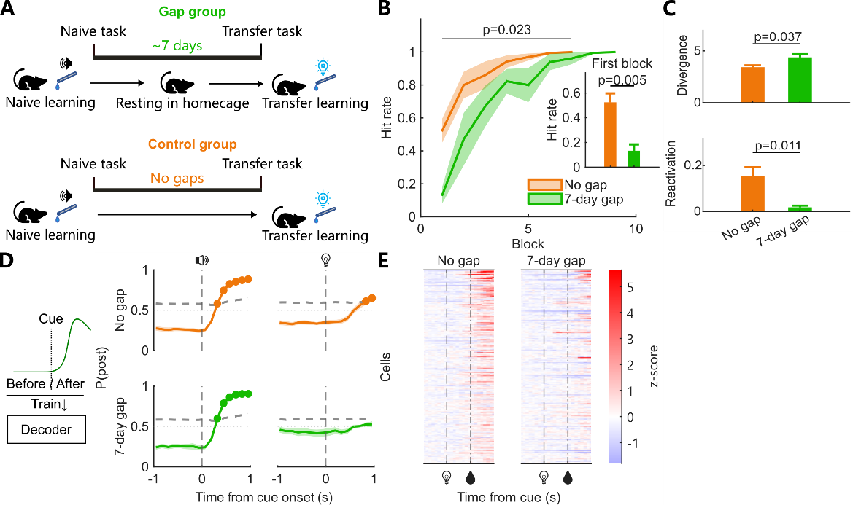
Figure 3 | The encoding ensemble and the transfer advantage fade over a 7-day interval.
- Schematic of the 7-day gap design: mice learned the audio–water task, remained in the home cage for 7 days without training or imaging, and were then transferred to the light-water task.
- Light-water learning curve of mice transferred with no gap (n = 11 mice) or after a 7-day gap (n = 6 mice): block-wise mean ± SEM hit rate; group effect of a two-way ANOVA over blocks 1–7, p = 0.023. Inset, first-block hit rate per mouse (0.52 ± 0.08 vs 0.13 ± 0.06; rank-sum p = 0.0045).
- Top, inter-trial divergence at cue +1 s within the first transfer light-water block (no gap 3.42 ± 0.20, n = 11 mice; 7-day gap 4.39 ± 0.33, n = 6 mice; rank-sum p = 0.037); divergence is defined as in Figure 1E, and cells missing data in any trial were excluded cell-wise without excluding mice. Bottom, reactivation probability P(transfer-active | learned-active) at cue +1 s per mouse (no gap 0.15 ± 0.04, n = 11 mice; 7-day gap 0.018 ± 0.008, n = 6 mice; rank-sum p = 0.011); layer values combined by learned-active cell counts.
- Cue-response decoder. Per mouse, a LASSO logistic decoder was trained on the mean population activity of the pre-cue window (−1 to 0 s; label 0) versus the post-cue window (0 to 1 s; label 1) of learned audio-water trials and read out at every time point as P(post). Left, self-train-test by 5-fold cross-validation in which one fifth of the trials, with their pre- and post-cue samples together, was held out of training in each fold and the out-of-fold P(post) was pooled across folds (accuracy 0.92 ± 0.03 and 0.96 ± 0.03). Right, the same decoder applied without retraining to the held-out transfer light-water block (accuracy 0.65 ± 0.04 vs 0.56 ± 0.01). Grey dashed line, 95th percentile of a label-shuffled permutation null (200 shuffles); filled dots, time points above the null (no gap: 6/16 and 2/16; 7-day gap: 6/16 and 0/16). P(post) at 0.96 s: 0.65 ± 0.04 vs 0.53 ± 0.04, one-sided permutation p = 0.037. Lines, mean ± SEM across mice.
- Z-score heatmaps of the first transfer light-water block, one lane per group. Cells were selected as active at cue +1 s (> baseline mean + 3σ, baseline −3 to 0 s) in the learned audio-water block of the same group, sorted by the learned response at cue +1 s, and are shown in the transfer block only (group-level median across mice; no gap 511 cells, 7-day gap 290 cells). Dashed and dash-dotted vertical lines, cue onset and water delivery.

Indirect manipulation on heterogeneity: TH inhibition
The correlation between response heterogeneity and learning speed (Figure 1H) suggests that heterogeneity contributes causally to transfer, but a correlational measure cannot establish this. To manipulate heterogeneity indirectly, we chemogenetically inhibited the thalamic (PO) input to MOp during light-water training (Figure 4A), a manipulation verified histologically (Figure 4B). Thalamus-inhibited mice eventually reached the same asymptotic performance as control mice but learned more slowly: the group-level sigmoid fit of the light-water learning curve was markedly shallower, whereas performance in the very first block did not differ between the two groups (Figure 4C). Consistent with a causal role of heterogeneity, thalamus inhibition lowered response heterogeneity in L5 but not in L2/3 (Figure 4D). Thalamic drive therefore sustains the inter-cell heterogeneity that accelerates transfer learning.
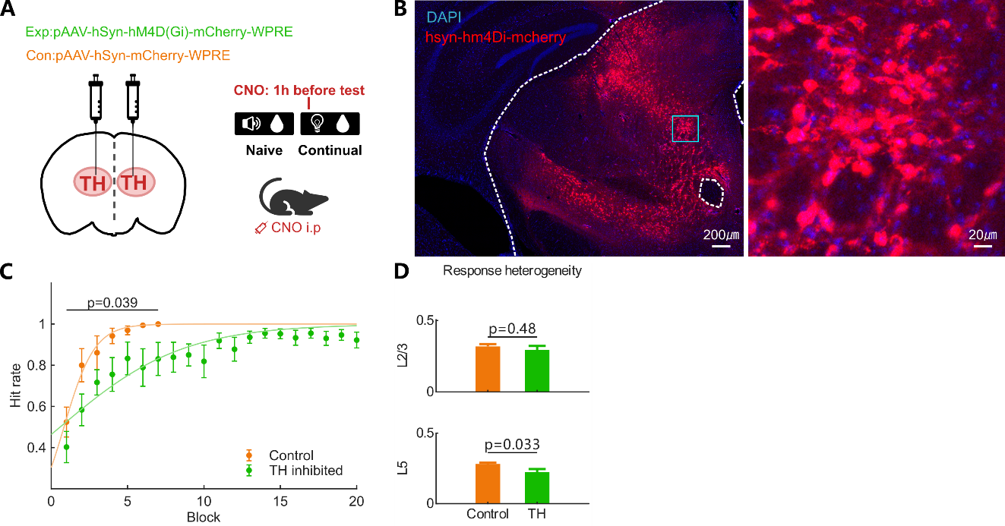
Figure 4 | Thalamus inhibition lowers response heterogeneity and slows transfer learning.
- Schematic of chemogenetic inhibition of the thalamic (PO) input to MOp during light-water training.
- Histological verification of chemogenetic effector expression.
- Light-water learning curve of control mice (n = 11) and thalamus-inhibited mice (n = 12, including behavior-only chemogenetic-inhibition mice): block-wise mean ± SEM hit rate with group-level sigmoid fits (control slope 1.00; TH inhibited 0.25). Group effect of a two-way ANOVA over blocks 1–7, p = 0.039; first-block hit rate did not differ between groups (0.52 ± 0.08 vs 0.40 ± 0.08; rank-sum p = 0.29). Sigmoid fits use carry-forward performance (sessions after a mouse first reached 100% are filled with 1.0).
- Per-mouse response heterogeneity at cue +1 s, by layer. Top, L2/3: control 0.32 ± 0.02 (n = 8 mice) vs TH inhibited 0.29 ± 0.03 (n = 5), rank-sum p = 0.62. Bottom, L5: control 0.28 ± 0.01 (n = 8) vs TH inhibited 0.22 ± 0.03 (n = 5), rank-sum p = 0.030. Heterogeneity is defined as in Figure 1I.

Validation of response heterogeneity on RNN model
To test whether the causal chain inferred from the in-vivo data can be generated by a minimal circuit, we simulated the task in a recurrent network model in which cue-driven cortical dynamics, a taught behavioural readout and plastic inhibitory circuits interact (Figure 5A). Simulated mice first learned cue A during pretraining; naïve mice then learned cue B from scratch, whereas transfer mice inherited the cue A circuit and learned cue B on top of it. Transfer mice acquired cue B faster than naïve mice, and the group-level sigmoid fit of the learning curve was correspondingly steeper (Figure 5B). Tracking the first formal training trials showed that the cue A ensemble was reactivated by cue B in transfer mice, whereas naïve mice recruited a largely new population (Figure 5C). During cue B learning, transfer mice showed higher response heterogeneity among L5 excitatory cells than naïve mice, whereas the heterogeneity of the remaining populations was lower in transfer mice (Figure 5D). At the synaptic level, cue A learning broadened the distribution of connection weights of the excitatory connection types before cue B training began (Figure 5E). Reducing the teaching signal to mimic thalamic inhibition slowed cue B learning (Figure 5F) and selectively lowered the heterogeneity of L5 excitatory cells while leaving the other populations unchanged (Figure 5G), mirroring the in-vivo thalamus-inhibition experiments (Figure 4C,D). The model therefore reproduces both the transfer advantage and its dependence on thalamus-sustained response heterogeneity.
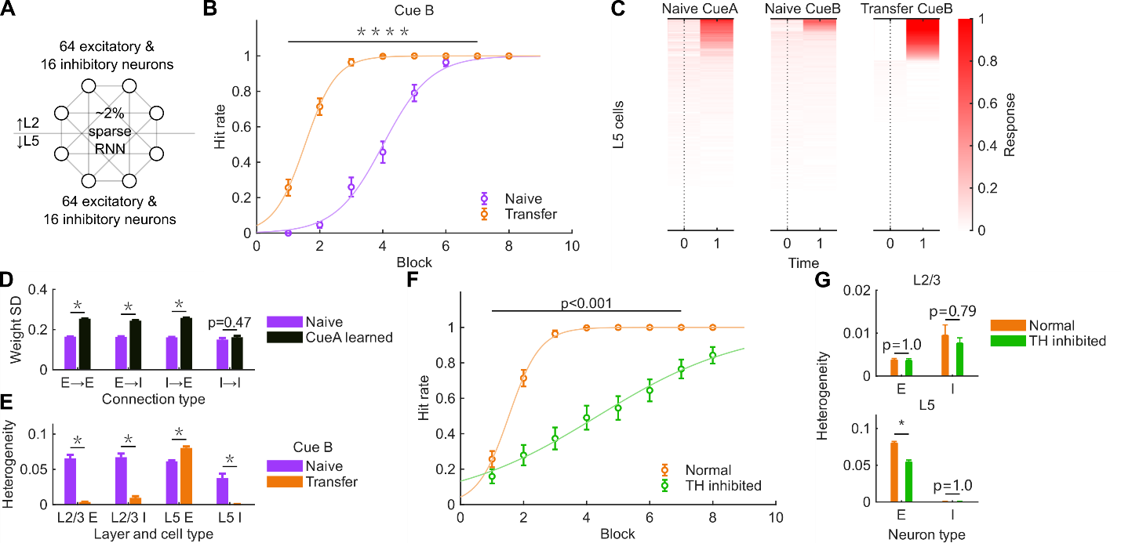
Figure 5 | A recurrent network model reproduces the transfer advantage and its dependence on thalamus-driven heterogeneity.
- Schematic of the recurrent network model: cue-driven L2/3 and L5 excitatory populations, local plastic inhibitory pools, and a taught behavioural readout.
- Simulated cue B learning curves of naïve (n = 50 simulated mice) and transfer (n = 50) mice: block-wise mean ± SEM hit rate with group-level sigmoid fits (naïve slope 1.32; transfer slope 2.03). Group effect of a two-way ANOVA over blocks 1–7, p < 0.001; the transfer slope exceeded the naïve slope in a permutation test of the slope difference (10,000 permutations, p < 0.001).
- L5 response of the first formal training unit over the first two recurrent iterations, one lane per condition: cue A pretraining of the transfer seeds (left), naïve formal training on cue B (middle) and transfer formal training on cue B (right). Values are the per-mouse median across trials of the raw L5 response; 50 mice × 64 L5 cells per lane; rows sorted by descending within-lane response integral. Dotted line, cue onset.
- Model response heterogeneity during cue B learning (across-cell SD of the per-cell mean cue response over pre-ceiling sessions, restricted to moderate-response cells), by layer and neuron type, naïve vs transfer (n = 50 mice per group). L2/3 E 0.066 ± 0.005 vs 0.004 ± 0.001; L2/3 I 0.067 ± 0.005 vs 0.010 ± 0.002; L5 E 0.061 ± 0.001 vs 0.080 ± 0.002; L5 I 0.038 ± 0.006 vs 0.001 ± 0.001; rank-sum p < 0.001 for all four comparisons.
- Per-mouse SD of the connection weight matrices before formal cue B training, naïve vs cue A learned (n = 50 mice per group). E→E 0.165 ± 0.001 vs 0.254 ± 0.001; E→I 0.164 ± 0.003 vs 0.244 ± 0.003; I→E 0.161 ± 0.002 vs 0.258 ± 0.001 (rank-sum p < 0.001 each); I→I 0.150 ± 0.008 vs 0.162 ± 0.007 (rank-sum p = 0.14).
- Simulated cue B learning curves of normal (n = 50) and thalamus-inhibited (n = 50) transfer mice: block-wise mean ± SEM hit rate with group-level sigmoid fits (normal slope 2.03; TH inhibited slope 0.43). Group effect of a two-way ANOVA over blocks 1–7, p < 0.001.
- Model response heterogeneity as in D, normal vs thalamus-inhibited transfer mice (n = 50 per group). L2/3 E 0.0038 ± 0.0004 vs 0.0036 ± 0.0004 (rank-sum p = 0.62); L2/3 I 0.0095 ± 0.0024 vs 0.0077 ± 0.0012 (rank-sum p = 0.14); L5 E 0.080 ± 0.002 vs 0.055 ± 0.003 (rank-sum p < 0.001); L5 I 0.0006 ± 0.0002 vs 0.0007 ± 0.0001 (rank-sum p = 0.96).

Discussion

Resource availability

Acknowledgements

Author contributions

Declaration of interests

References
Barnett, S. M., & Ceci, S. J. (2002). When and where do we apply what we learn?: A taxonomy for far transfer. Psychological Bulletin, 128(4), 612–637. https://doi.org/10.1037/0033-2909.128.4.612
Bernardi, S., Benna, M. K., Rigotti, M., Munuera, J., Fusi, S., & Salzman, C. D. (2020). The Geometry of Abstraction in the Hippocampus and Prefrontal Cortex. Cell, 183(4), 954–967.e921. https://doi.org/10.1016/j.cell.2020.09.031
Choucry, A., Nomoto, M., & Inokuchi, K. (2024). Engram mechanisms of memory linking and identity. Nature Reviews Neuroscience, 25(6), 375–392. https://doi.org/10.1038/s41583-024-00814-0
Churchland, M. M., Yu, B. M., Cunningham, J. P., Sugrue, L. P., Cohen, M. R., Corrado, G. S., Newsome, W. T., Clark, A. M., Hosseini, P., Scott, B. B., Bradley, D. C., Smith, M. A., Kohn, A., Movshon, J. A., Armstrong, K. M., Moore, T., Chang, S. W., Snyder, L. H., Lisberger, S. G.,…Shenoy, K. V. (2010). Stimulus onset quenches neural variability: a widespread cortical phenomenon. Nature Neuroscience, 13(3), 369–378. https://doi.org/10.1038/nn.2501
Currie, S. P., Ammer, J. J., Premchand, B., Dacre, J., Wu, Y., Eleftheriou, C., Colligan, M., Clarke, T., Mitchell, L., Faisal, A. A., Hennig, M. H., & Duguid, I. (2022). Movement-specific signaling is differentially distributed across motor cortex layer 5 projection neuron classes. Cell Reports, 39(6). https://doi.org/10.1016/j.celrep.2022.110801
Gallego, J. A., Perich, M. G., Chowdhury, R. H., Solla, S. A., & Miller, L. E. (2020). Long-term stability of cortical population dynamics underlying consistent behavior. Nature Neuroscience, 23(2), 260–270. https://doi.org/10.1038/s41593-019-0555-4
Golub, M. D., Sadtler, P. T., Oby, E. R., Quick, K. M., Ryu, S. I., Tyler-Kabara, E. C., Batista, A. P., Chase, S. M., & Yu, B. M. (2018). Learning by neural reassociation. Nature Neuroscience, 21(4), 607–616. https://doi.org/10.1038/s41593-018-0095-3
Guo, Zengcai V., Li, N., Huber, D., Ophir, E., Gutnisky, D., Ting, Jonathan T., Feng, G., & Svoboda, K. (2014). Flow of Cortical Activity Underlying a Tactile Decision in Mice. Neuron, 81(1), 179–194. https://doi.org/10.1016/j.neuron.2013.10.020
Guyoton, M., Matteucci, G., Foucher, C. G., Getz, M. P., Gjorgjieva, J., & El-Boustani, S. (2025). Cortical circuits for cross-modal generalization. Nature Communications, 16(1), 4230. https://doi.org/10.1038/s41467-025-59342-9
Halassa, M. M., & Sherman, S. M. (2019). Thalamocortical Circuit Motifs: A General Framework. Neuron, 103(5), 762–770. https://doi.org/10.1016/j.neuron.2019.06.005
Inagaki, H. K., Inagaki, M., Romani, S., & Svoboda, K. (2018). Low-Dimensional and Monotonic Preparatory Activity in Mouse Anterior Lateral Motor Cortex. The Journal of Neuroscience, 38(17), 4163–4185. https://doi.org/10.1523/jneurosci.3152-17.2018
Josselyn, S. A., & Tonegawa, S. (2020). Memory engrams: Recalling the past and imagining the future. Science, 367(6473), eaaw4325. https://doi.org/10.1126/science.aaw4325
Komiyama, T., Sato, T. R., O’Connor, D. H., Zhang, Y.-X., Huber, D., Hooks, B. M., Gabitto, M., & Svoboda, K. (2010). Learning-related fine-scale specificity imaged in motor cortex circuits of behaving mice. Nature, 464(7292), 1182–1186. https://doi.org/10.1038/nature08897
Oswald, M. J., Tantirigama, M. L., Sonntag, I., Hughes, S. M., & Empson, R. M. (2013). Diversity of layer 5 projection neurons in the mouse motor cortex [Original Research]. Frontiers in Cellular Neuroscience, Volume 7 - 2013. https://doi.org/10.3389/fncel.2013.00174
Perez-Nieves, N., Leung, V. C. H., Dragotti, P. L., & Goodman, D. F. M. (2021). Neural heterogeneity promotes robust learning. Nature Communications, 12(1), 5791. https://doi.org/10.1038/s41467-021-26022-3
Perich, M. G., Gallego, J. A., & Miller, L. E. (2018). A Neural Population Mechanism for Rapid Learning. Neuron, 100(4), 964–976.e967. https://doi.org/10.1016/j.neuron.2018.09.030
Perkins, D., & Salomon, G. (1999). Transfer Of Learning. 11.
Poort, J., Khan, Adil G., Pachitariu, M., Nemri, A., Orsolic, I., Krupic, J., Bauza, M., Sahani, M., Keller, Georg B., Mrsic-Flogel, Thomas D., & Hofer, Sonja B. (2015). Learning Enhances Sensory and Multiple Non-sensory Representations in Primary Visual Cortex. Neuron, 86(6), 1478–1490. https://doi.org/10.1016/j.neuron.2015.05.037
Ramot, A., Taschbach, F. H., Yang, Y. C., Hu, Y., Chen, Q., Morales, B. C., Wang, X. C., Wu, A., Tye, K. M., Benna, M. K., & Komiyama, T. (2025). Motor learning refines thalamic influence on motor cortex. Nature, 643(8072), 725–734. https://doi.org/10.1038/s41586-025-08962-8
Rashid, A. J., Yan, C., Mercaldo, V., Hsiang, H.-L., Park, S., Cole, C. J., De Cristofaro, A., Yu, J., Ramakrishnan, C., Lee, S. Y., Deisseroth, K., Frankland, P. W., & Josselyn, S. A. (2016). Competition between engrams influences fear memory formation and recall. Science, 353(6297), 383–387. https://doi.org/doi:10.1126/science.aaf0594
Rasooli, A., Chalavi, S., Li, H., Seer, C., Adab, H. Z., Mantini, D., Sunaert, S., Mikkelsen, M., Edden, R. A. E., & Swinnen, S. P. (2024). Neural correlates of transfer of learning in motor coordination tasks: role of inhibitory and excitatory neurometabolites. Scientific Reports, 14(1), 3251. https://doi.org/10.1038/s41598-024-53901-8
Runyan, C. A., Piasini, E., Panzeri, S., & Harvey, C. D. (2017). Distinct timescales of population coding across cortex. Nature, 548(7665), 92–96. https://doi.org/10.1038/nature23020
Ryan, T. J., Roy, D. S., Pignatelli, M., Arons, A., & Tonegawa, S. (2015). Engram cells retain memory under retrograde amnesia. Science, 348(6238), 1007–1013. https://doi.org/10.1126/science.aaa5542
Sadtler, P. T., Quick, K. M., Golub, M. D., Chase, S. M., Ryu, S. I., Tyler-Kabara, E. C., Yu, B. M., & Batista, A. P. (2014). Neural constraints on learning. Nature, 512(7515), 423–426. https://doi.org/10.1038/nature13665
Saxe, A. M., McClelland, J. L., & Ganguli, S. (2014). Exact solutions to the nonlinear dynamics of learning in deep linear neural networks [Preprint]. arXiv. https://arxiv.org/abs/1312.6120
Shepherd, G. M. G., & Yamawaki, N. (2021). Untangling the cortico-thalamo-cortical loop: cellular pieces of a knotty circuit puzzle. Nature Reviews Neuroscience, 22(7), 389–406. https://doi.org/10.1038/s41583-021-00459-3
Thorndike, E. L., & Woodworth, R. S. (1901). The influence of improvement in one mental function upon the efficiency of other functions. Psychological Review, 8(3), 247–261. https://doi.org/10.1037/h0074898
Vyas, S., Golub, M. D., Sussillo, D., & Shenoy, K. V. (2020). Computation Through Neural Population Dynamics. Annual Review of Neuroscience, 43(Volume 43, 2020), 249–275. https://doi.org/10.1146/annurev-neuro-092619-094115
Xie, H., Liu, Y., Zhu, Y., Ding, X., Yang, Y., & Guan, J.-S. (2014). In vivo imaging of immediate early gene expression reveals layer-specific memory traces in the mammalian brain. Proceedings of the National Academy of Sciences, 111(7), 2788–2793. https://doi.org/10.1073/pnas.1316808111
Xu, T., Yu, X., Perlik, A. J., Tobin, W. F., Zweig, J. A., Tennant, K., Jones, T., & Zuo, Y. (2009). Rapid formation and selective stabilization of synapses for enduring motor memories. Nature, 462(7275), 915–919. https://doi.org/10.1038/nature08389

Star ★ methods

Key resources table

Supplementary
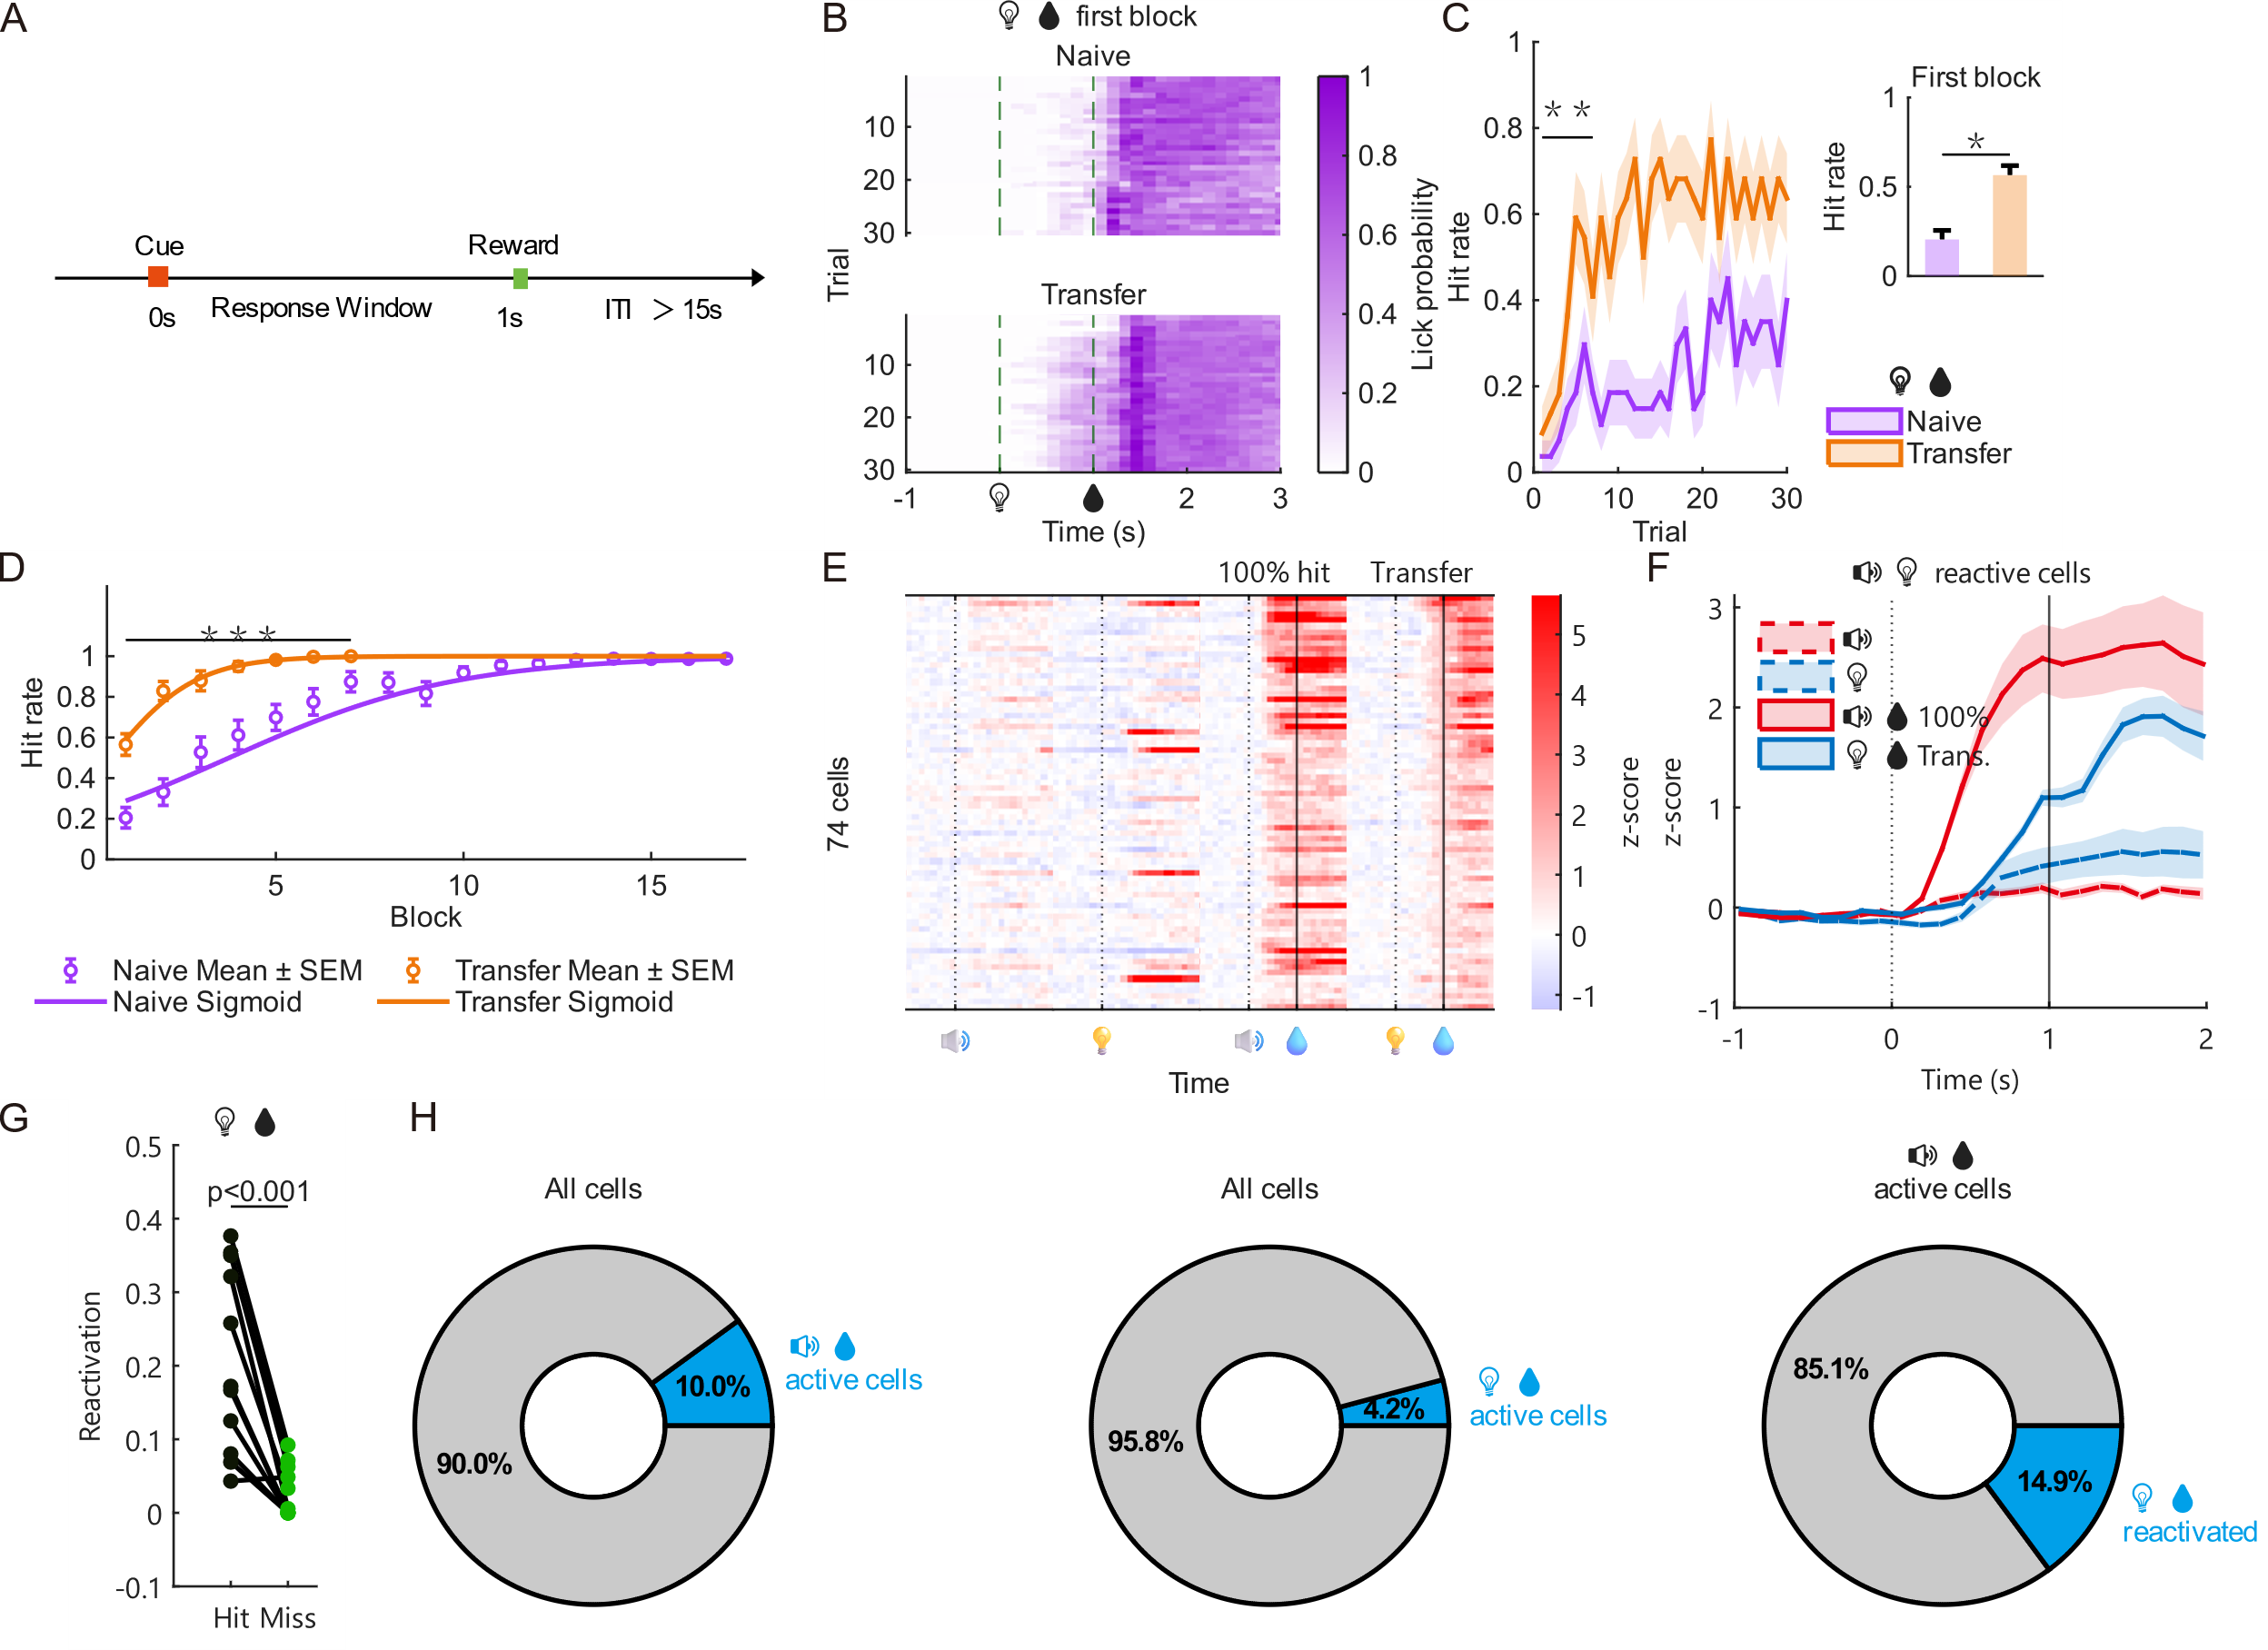
Figure S1 | The transfer advantage is independent of the cue–response delay, and the learned ensemble is reactivated by the light cue
- Schematic of the undelayed paradigm used for all imaging analyses: the response window opens together with the 200 ms cue, and water is delivered 800 ms after cue offset on every trial regardless of licking, providing a response-independent, fixed temporal anchor for trial alignment. This contrasts with the delayed paradigm of Figure 1A, B, in which the response window opens 1.5 s after cue onset and water depends on the first lick.
- Lick probability of the first light-water block, shown as a trial × time raster of the lick-related calcium component (rescaled to 0–1) for naïve (top, n = 18 mice) and transfer (bottom, n = 11 mice) groups; trials are ordered by trial number within the block. Dashed lines mark cue onset (0 s) and water delivery (1 s).
- Trial-wise hit rate within the first light-water block (mean ± SEM across mice; n = 27 naïve, 22 transfer mice). Significance bar spans trials 1–7: group effect of a linear mixed-effects model (Behavior ~ Trial × Group + (1|Mouse)); **p < 0.01.
- Undelayed block-wise learning curve (left, block-wise mean ± SEM with group-level sigmoid fits: naïve slope 0.33, R² = 0.32; transfer slope 0.89, R² = 0.29; significance bar spans blocks 1–7, group effect of a linear mixed-effects model, ***p < 0.001) and first-block hit rate (right, naïve 0.20 ± 0.05 vs transfer 0.57 ± 0.05, mean ± SEM; one-way ANOVA with multiple-comparison correction, *p < 0.05).
- Z-score heatmap of the common cell population across four conditions (naïve audio-only, naïve light-only, learned audio-water at 100% hit, transfer light-water). Cells were required to be active at cue +1 s (> baseline + 3σ) in both the learned audio-water and transfer light-water blocks, and are sorted by the smaller of the two responses at cue +1 s.
- Mean ± SEM population traces of the same cells as in **E** across the four conditions (dashed lines, naïve blocks; solid lines, learned/transfer blocks).
- Reactivation fraction of learned audio-water active cells during transfer light-water hit vs miss trials, paired per mouse (n = 11 mice; 511 participating learned-active cells; right-tailed sign-rank p = 9.8 × 10⁻⁴).
- Active-cell fractions (active = z-score at cue +1 s above baseline mean + 3σ, baseline −3 to 0 s; n = 11 mice). Left, cells active in learned audio-water blocks as a fraction of all recorded cells (511/5107, 10.0%). Middle, cells active in the first transfer light-water block as a fraction of all recorded cells (212/5105, 4.2%). Right, cells active in learned audio-water blocks that were reactivated in the first transfer light-water block (76/511, 14.9%).

