Temporal persistency and popular differentiation facilitate cross-modal transfer learning

Outline:

首先Fig1列出两条主线结论：持续存在的稳定编码结构（低散度）保证首个训练单元的命中（早期表现），以及细胞间分化（响应异质性）相关于学习速度。然后Fig2,3展开第一条线：Fig2先用解码器说明MO确实编码了任务信息且可以迁移且依赖相关细胞群体（cFos），Fig3再隔7天说明时间长了以后行为下降、解码器无法迁移。最后Fig4,5展开第二条线：Fig4讲响应异质性受TH调制，TH抑制则学习减慢、异质性下降；Fig5讲

Figure 1: Inter-trial stability and inter-cell heterogeneity of the cortical response of the transfer task
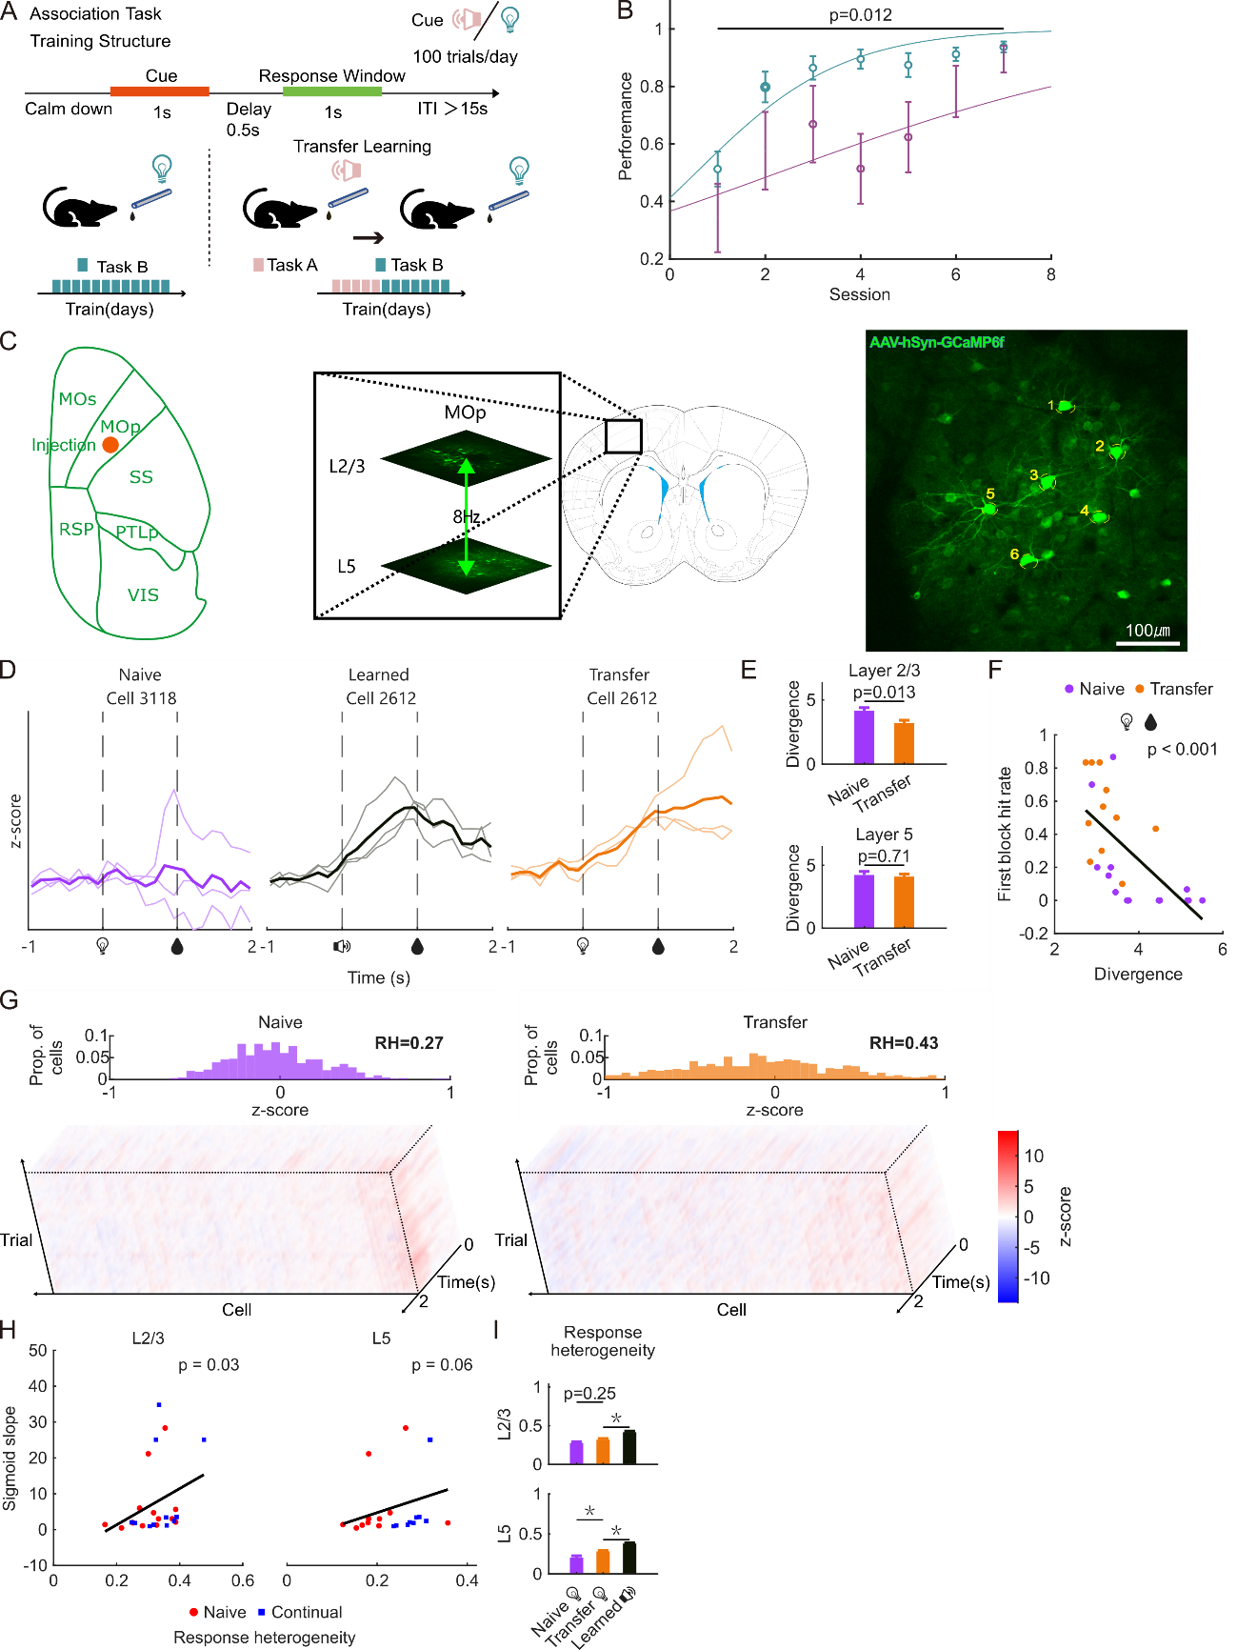
- Diagram of cross-modal transfer learning
- Performance advantage of transfer: first-block hit rate and learning slope
- Diagram of L2/5 two-photon imaging
- Representative trials of naïve/transfer light water
- Inter-trial divergence: transfer lower than naïve in L2 but not L5
- Correlation of divergence vs. first-block hit rate
- 3D-heatmap and histogram showing response heterogeneity
- Transfer RH higher than naïve
- RH correlates with learning slope

Figure S1: Undelayed paradigm and reactivation
- Undelayed diagram
- Undelayed learning curve and first-block hit rate
- Reactivation: heatmap
- Reactivation: calcium curve
- Reactivation: hit/miss comparison
- Reactivation: pie chart of active proportion

Figure 2: Encoding ensemble facilitates first-block performance
待与杨青宁工作整合……
- Diagram of decoder: from calcium to cue/behavior
- Behavior decoder can transfer to light, but cue decoder cannot
- Hit weights larger than miss weights
- Hit cells in hit trials are more convergent among trials than miss cells in miss trials
- Activity of hit cells correlates with first-block hit rate, but miss cells do not.
- Diagram of cFos-TRAP
- cFos expression
- Lower first-block performance in cFos inhibition

Figure 3: Stable encoding ensemble fades over time
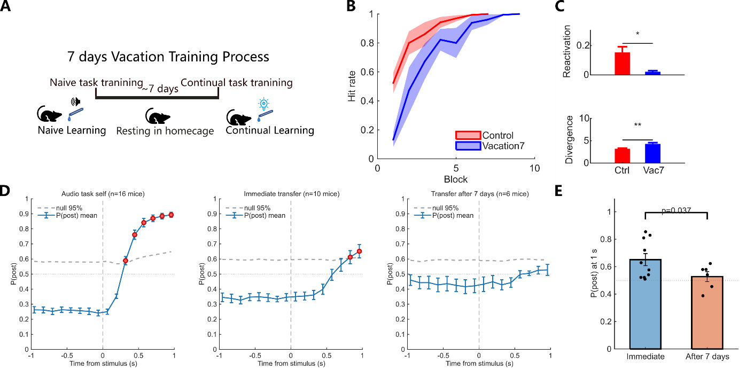
- Diagram of 7-day gap
- Lower performance after 7 days
- Higher divergence after 7 days
- Encoding ensemble does not transfer after 7 days
- Encoding ensemble is inactive after 7 days

Figure 4: Indirect manipulation on heterogeneity: TH inhibition
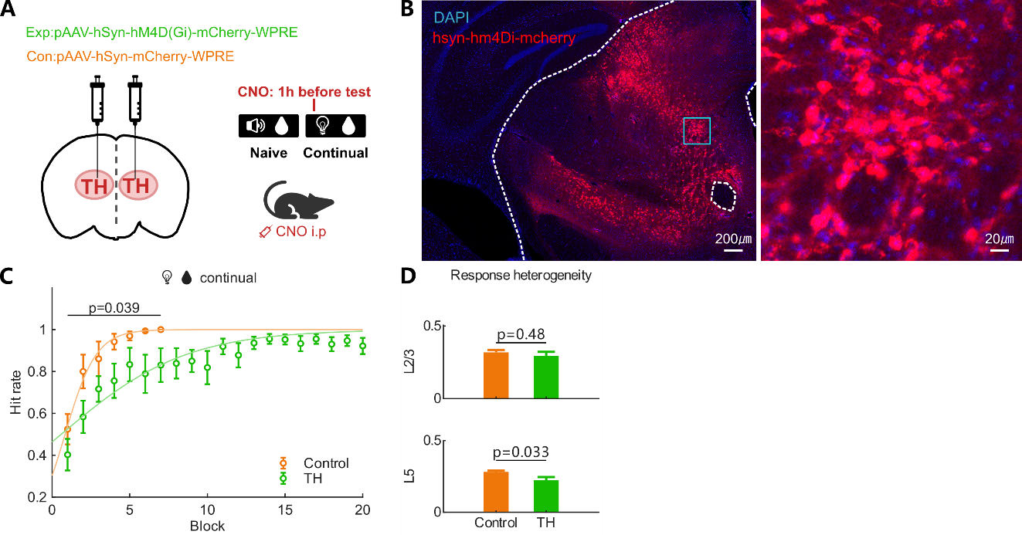
- Diagram of TH inhibition
- Expression
- Learning curve: lower slope but not first-block performance
- Lower population heterogeneity

Figure 5: Validation of response heterogeneity on RNN model
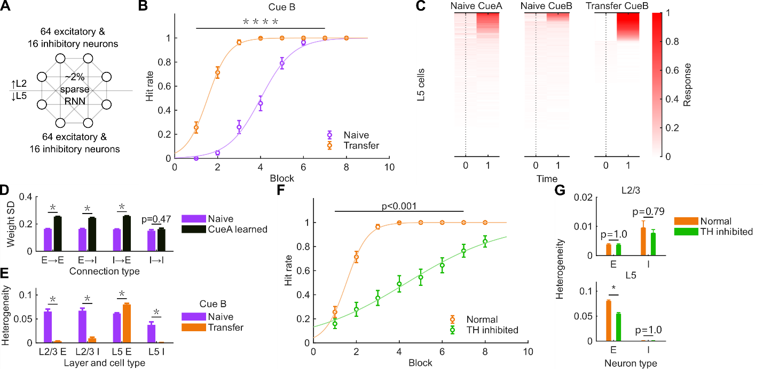
- RNN model diagram
- Model learning curve
- Heatmap showing heterogeneity
- Comparison of naïve/transfer heterogeneity
- Comparison of naïve/transfer weight SD
- Lower learning slope on simulated TH inhibition
- Lower heterogeneity on simulated TH inhibition

