Temporal persistency and popular differentiation facilitate cross-modal transfer learning

Introduction
Transfer of learning describes the influence of previously acquired knowledge and skills on the acquisition of new ones (Thorndike and Woodworth, 1901). The phenomenon pervades adaptive behavior, and its reach has long been taxonomized from near to far transfer (Barnett and Ceci, 2002). Prior frameworks have characterized transfer mainly at the behavioral and psychological levels (Perkins and Salomon, 1994), and even contemporary neural evidence on transfer itself has remained largely at brain-region resolution (Rasooli et al., 2024). A persistent conceptual difficulty is that the overall transfer advantage conflates at least two distinct processes: the ability to start a new task from an elevated initial state, and the ability to keep improving faster once the new task is underway. Whether and how these two components are supported by different cellular and circuit mechanisms is largely unknown.
Recent work has begun to approach this question at the level of neural populations. Mice can bidirectionally generalize sensorimotor task rules between touch and vision through abstract cortical representations, and silencing experiments indicate that congruent multimodal representations in associative cortex support such cross-modal generalization (Guyoton et al., 2025). At the representational level, cross-context decoder generalization has been used to define abstract coding geometry in hippocampus and prefrontal cortex (Bernardi et al., 2020). These studies establish that shared, abstract population codes can underlie rule transfer, but they leave open how previously recruited cell ensembles are reused at the onset of a new task, and how population organization evolves over subsequent training days.
Two long-standing literatures provide candidate mechanisms for these processes. In the engram literature, specific sparsely distributed cell assemblies are recruited during learning, and their tagging, inhibition, and reactivation causally control memory retrieval (Tonegawa et al., 2015), a framework consolidated in current reviews of engram cells (Josselyn and Tonegawa, 2020). Engrams of temporally proximate events tend to overlap through excitability-based competition (Rashid et al., 2016), providing a cellular substrate for linking related experiences (Choucry et al., 2024). The extent to which such ensemble reuse drives transfer of a sensorimotor association to a cue of a different modality, however, has not been tested directly. In the population-dynamics literature, behavior is generated within low-dimensional neural manifolds whose structure constrains what can be learned (Sadtler et al., 2014), and population dynamics more generally serve as the computational substrate of behavior (Vyas et al., 2020). Short-timescale learning can proceed by reassociating population activity within the existing manifold (Golub et al., 2018), and changes within a preserved population structure can likewise enable rapid learning (Perich et al., 2018), while manifold stability across months maintains consistent behavior (Gallego et al., 2020). Learning in motor cortex refines population structure at fine spatial scales rather than uniformly elevating activity (Komiyama et al., 2010); its structural counterpart is the rapid formation and selective stabilization of motor-learning synapses (Xu et al., 2009), and cross-day imaging shows that learning also amplifies sensory representations in visual cortex (Poort et al., 2015). In addition, stimulus-driven engagement of cortex is accompanied by a widespread reduction of trial-to-trial variability (Churchland et al., 2010). These findings suggest that prior training could leave behind a reusable population geometry that lowers trial-to-trial divergence at the onset of transfer and shapes how quickly the new task is subsequently learned.
A key open question is whether the initial advantage at transfer onset and the later advantage in learning speed rest on the same or on dissociable cellular signatures and circuits. Computational work provides one specific hypothesis for the latter: heterogeneity in intrinsic neuronal properties makes spiking network learning faster, more stable, and more robust in temporally structured tasks (Perez-Nieves et al., 2021). If response heterogeneity plays an analogous role in vivo, it should be elevated during transfer learning and should predict the speed of subsequent improvement, ideally with an identifiable upstream modulator. The motor thalamus is a plausible candidate, because motor learning refines thalamic influence on primary motor cortex to enable reliable execution of learned movements (Ramot et al., 2025); moreover, higher-order thalamocortical motifs are positioned to modulate cortical processing in a state-dependent manner (Halassa and Sherman, 2019), within cortico-thalamo-cortical loops whose cellular composition supports flexible top-down control (Shepherd and Yamawaki, 2021).
Here we addressed these questions by longitudinally imaging the same neurons across days in the tongue-related region of mouse primary motor cortex (MOp) during a cue-delayed-licking paradigm, in which mice first learned an auditory-cued water task and were then transferred to a visually cued version of the same task. This approach builds on our laboratory's earlier in vivo imaging of immediate early gene expression, which revealed layer-specific, sparsely coded long-term memory engram cells in the mammalian neocortex (Xie et al., 2014). MOp sits on the cue-to-lick sensorimotor pathway delineated by cortical activity flow in mice (Guo et al., 2014), and mouse motor-cortical populations exhibit low-dimensional, monotonic preparatory dynamics well suited to state-space analysis (Inagaki et al., 2018). Its output neurons are organized into projection classes with layer-specific functions (Oswald et al., 2013), and movement-specific signaling is distributed differentially across these classes (Currie et al., 2022), enabling a layered analysis of transfer. Combining across-day two-photon imaging in layers 2/3 and 5 with chemogenetic inhibition of tagged ensembles and of posterior thalamus, we decomposed the cross-modal transfer advantage into an initial-performance component tied to reactivation of prior ensembles and reduced trial-to-trial divergence, and a subsequent-learning component tied to enhanced response heterogeneity under thalamic modulation. A one-week pause between tasks abolishes the reuse of prior ensembles and attenuates the transfer advantage, whereas a network simulation reproduces how inhibition inherited from prior training raises response heterogeneity, suppresses noise-triggered reverse learning, and thereby accelerates transfer. Encoding and decoding analyses further characterize how cue and choice information is carried by MOp populations during transfer (Runyan et al., 2017), and how this relates to the reuse of prior-task cells.

Introduction highlights
- Studies of transfer itself have remained at behavioral, psychological, and brain-region levels of resolution, leaving its mechanism unresolved at the level of cell ensembles.
- Adjacent population-level work has crossed this resolution limit but not the object: shared abstract population codes support cross-modal generalization, yet how prior-task ensembles are reused during transfer is unknown.
- Engram studies establish that specific cell assemblies are tagged, reactivated, and causally control memory retrieval, but whether such ensemble reuse transfers a sensorimotor association across cue modalities remains untested.
- Population-dynamics studies show that learning reorganizes activity within constrained low-dimensional manifolds with preserved structure and reduced trial-to-trial variability, but have not examined how a manifold left by one task shapes acquisition of another.
- Computational models suggest that neuronal heterogeneity accelerates learning in temporally structured tasks, yet this prediction, and thalamocortical circuits as its upstream modulator, await in vivo verification in transfer learning.

Results

Inter-trial stability and inter-cell heterogeneity of the cortical response of the transfer task
To determine how prior auditory learning shapes cortical processing of a novel visual cue, mice were trained on a cross-modal transfer paradigm: after learning an audio–water association task, the cue modality was switched to light while the reward rule remained unchanged (Figure 1A). Mice with auditory pre-training (transfer) attained a higher hit rate than naïve mice trained directly on the light cue across the first seven light-water blocks (Figure 1B). To follow the underlying cortical representations, we performed two-photon calcium imaging in layer 2/3 and layer 5 of the primary motor cortex (MOp) across auditory training and the subsequent light training (Figure 1C). In naïve mice, single cells responded to the first light cue with large and trial-variable calcium transients, whereas the same cells recorded after auditory learning responded more consistently from trial to trial, and this trial-to-trial consistency was already present in the first light-water block (Figure 1D).
We first quantified trial-to-trial stability at cue +1 s — the moment at which water is delivered, and thus the latest time point at which cortical activity can still influence the reward outcome of the trial — using an inter-trial divergence index, defined as the trial-to-trial variance of the population response relative to its squared mean, computed separately for each layer and each mouse. In L2/3, transfer mice showed markedly lower divergence than naïve mice upon their first light-water block, whereas in L5 the two groups did not differ (Figure 1E). Across the 25 mice of both cohorts, inter-trial divergence correlated strongly and negatively with first-block hit rate (Figure 1F), indicating that mice whose cortical population responses were more stable at cue +1 s performed better at the very first exposure to the light cue. Divergence, however, did not predict how fast mice subsequently learned (Figure 1G). Inter-trial stability therefore accounts for the starting point of transfer, but not for the speed of new learning, prompting us to search for a population property that tracks learning speed.
We next measured response heterogeneity (RH), the across-cell standard deviation of trial-mean z-scored responses at cue +1 s, as an index of functional differentiation within the recorded population. In learning theory, a spread of response profiles across network units provides the differentiated updates that gradient descent requires, and thereby accelerates convergence (Saxe et al., 2014); in cortical circuits, likewise, flexible and heterogeneous population dynamics have been linked to the speed of sensory encoding (Horrocks et al., 2024). Intuitively, RH reflects how strongly the recorded cells are polarized into cue-excited and cue-suppressed subpopulations: a single transfer block shows a wider spread of per-cell response amplitudes than a naïve block (Figure 1J). Quantitatively, RH correlated significantly with the sigmoid learning slope in L5 but not in L2/3 (Figure 1H): mice with more heterogeneous L5 responses learned the light task faster. Consistently, transfer mice exhibited significantly higher RH than naïve mice in L5, whereas the L2/3 difference did not reach significance; fully learned audio-water blocks showed the highest RH in both layers (Figure 1I). Thus, inter-trial stability governs immediate transfer performance, while inter-cell heterogeneity, particularly in L5, governs the speed of subsequent learning.
Two sets of control observations support this framework (Figure S1). First, the behavioral quantification in Figure 1B used the delayed paradigm, in line with the conventional design of such transfer tasks, whereas all imaging analyses above were performed in the undelayed paradigm, in which water is delivered at a fixed time (800 ms after cue offset) on every trial regardless of licking; this response-independent reward timing gives the external task events a trial-invariant temporal anchor, which is required for aligning calcium signals across trials. To confirm that the behavioral advantage does not depend on this paradigm difference, we re-examined learning in the undelayed variant: transfer mice still outperformed naïve mice from the very first block and reached asymptotic performance in fewer blocks (Figure S1A–D). Second, during transfer, the ensemble that had been active in learned audio-water blocks was re-engaged by the light cue: among cells active at cue +1 s in learned audio-water blocks, the reactivation fraction was higher on hit than on miss trials (Figure S1E–G), and roughly one seventh of them (76/511) were active again in the first transfer light-water block (Figure S1H). The ensemble carrying the auditory memory is therefore recruited by the novel visual cue, and the degree of this recruitment covaries with trial outcome.
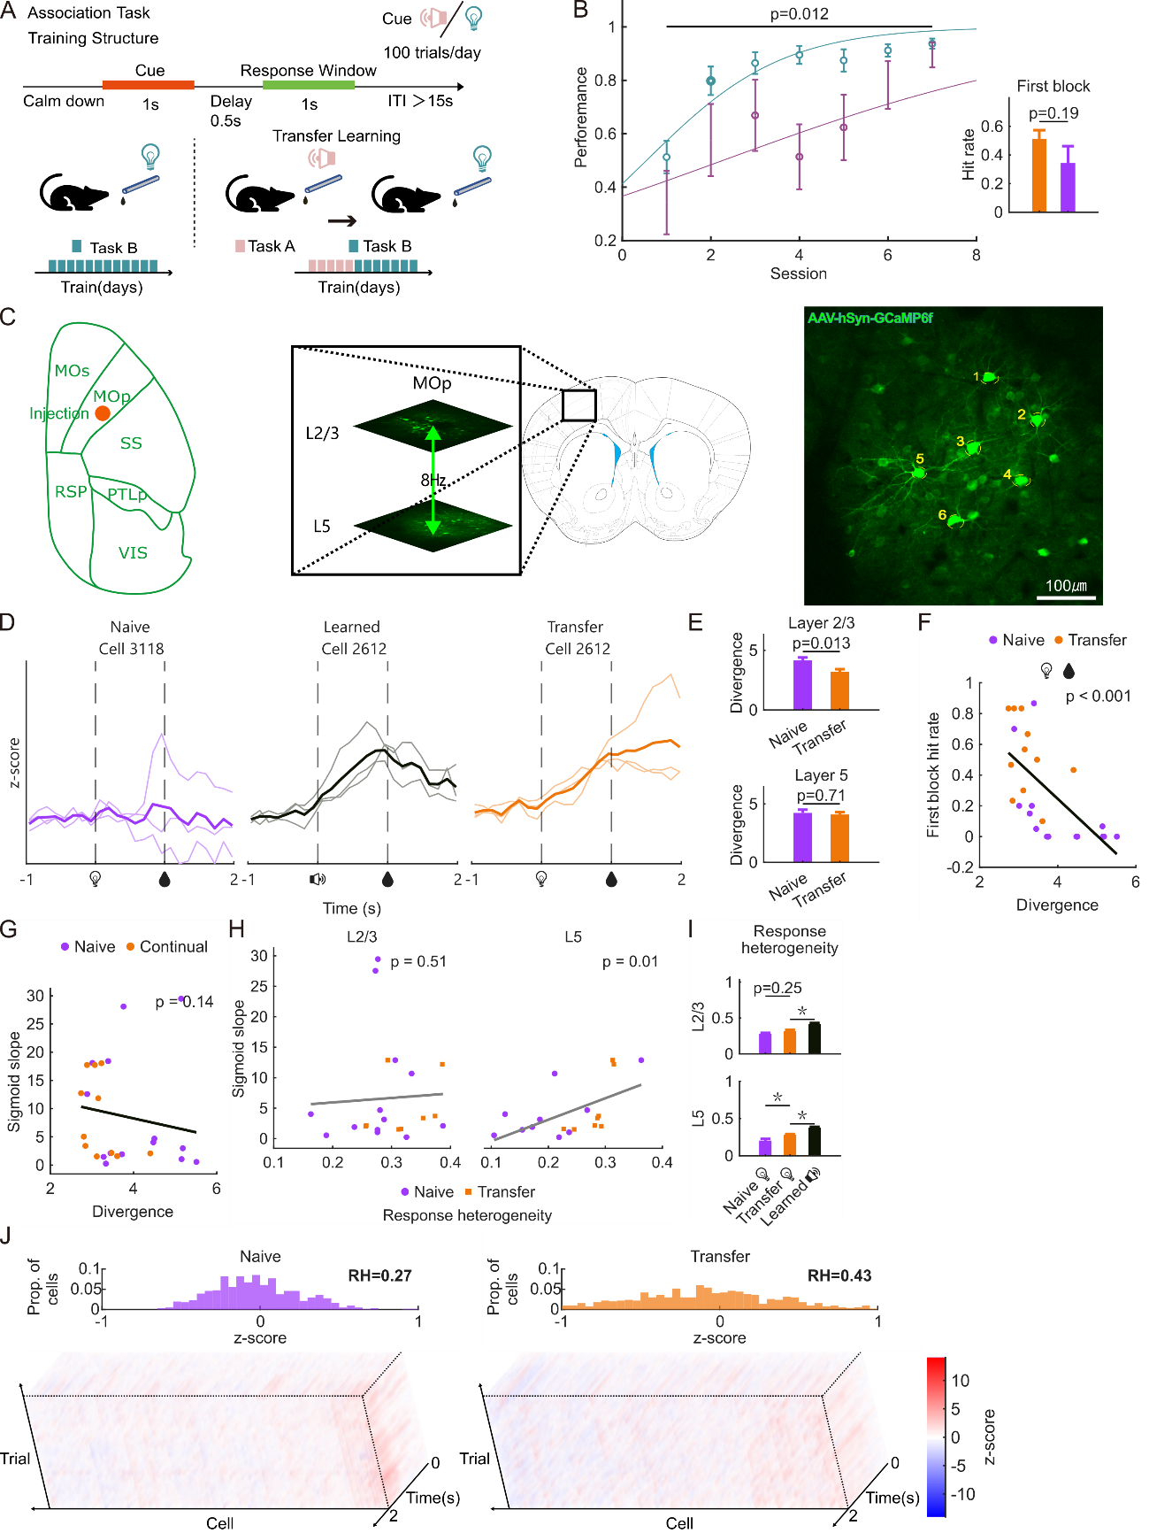
Figure 1 | Inter-trial stability and inter-cell heterogeneity of the cortical response predict distinct components of the transfer advantage
- Schematic of the cross-modal transfer paradigm (delayed version). Each trial comprised a calm-down period, a 1 s cue (auditory or visual), a 0.5 s delay and a 1 s response window; water was delivered immediately upon the first lick inside the response window, and trials without a lick in the window received no water (inter-trial interval > 15 s; 100 trials per day). Mice first learned the audio–water association (task A); after reaching criterion, the cue was switched to light with the reward rule unchanged (task B; transfer group), whereas control mice were trained directly on the light cue (task B only; naïve group).
- BLight-water learning performance in the delayed paradigm of **A** (1 s cue, 0.5 s delay, 1 s response window; water upon licking within the response window). Left, block-wise mean ± SEM hit rate across blocks 1–7 with group-level sigmoid fits: transfer (audio-pretrained; n = 15 mice) vs naïve (n = 8); transfer outperformed naïve overall (linear mixed-effects model, Performance ~ Block + Group + (1|Mouse), group effect p = 0.012). Right, first-block hit rate (transfer 0.51 ± 0.06 vs naïve 0.34 ± 0.13, mean ± SEM; p = 0.19 by one-way ANOVA with multiple-comparison correction, n.s.).
- Two-photon calcium imaging in MOp across auditory training and the subsequent light training, performed in the undelayed paradigm (Figure S1A). Left, dorsal view of the cortex with the AAV-hSyn-GCaMP6f injection site in MOp (orange dot; adjacent areas MOs, SS, RSP, PTLP and VIS outlined). Middle, coronal section with the imaging field enlarged: two imaging planes in L2/3 and L5 were sampled alternately at 8 Hz by vertically oscillating the objective lens of the two-photon microscope (green double-headed arrow). Right, example field of view with individually numbered GCaMP6f-expressing cells; scale bar, 100 μm.
- Representative single-cell traces across trials (z-score, cue onset at 0 s, water at 1 s): naïve light-water block (left), learned audio-water block (middle), and the first transfer light-water block of the same cell as the middle panel (right).
- Per-mouse inter-trial divergence at cue +1 s, computed within each layer. Top, L2/3: naïve 4.16 ± 0.25 (n = 14 mice) vs transfer 3.19 ± 0.24 (n = 11), rank-sum p = 0.0093. Bottom, L5: naïve 4.23 ± 0.29 (n = 11) vs transfer 4.09 ± 0.21 (n = 10), p = 0.70. Divergence is the trial-to-trial variance of the population response normalized by its squared mean.
- First-block hit rate vs inter-trial divergence across the 25 mice of both cohorts (Spearman ρ = −0.755, p = 1.3 × 10⁻⁵).
- Sigmoid learning slope vs inter-trial divergence (Spearman ρ = −0.296, p = 0.15, n = 25 mice, n.s.). Divergence explains early performance but not learning speed.
- Per-mouse response heterogeneity (RH) vs sigmoid learning slope. L5: ρ = 0.571, p = 0.015 (n = 18 mice: 10 naïve, 8 transfer); L2/3: ρ = 0.151, p = 0.51, n.s. (n = 21: 13 naïve, 8 transfer). Each mouse contributes one slope (fitted across blocks, layer-independent) plotted against its layer-specific RH.
- Per-mouse RH at cue +1 s for naïve light-water, transfer light-water, and learned audio-water cohorts, by layer (p values from multiple-comparison correction, as displayed). In L5, transfer > naïve (p = 0.009); in L2/3, transfer vs naïve n.s. (p = 0.25); learned audio-water exceeded transfer in both layers (L2/3, p = 0.002; L5, p = 0.002). RH is the across-cell SD of trial-mean z-scores at cue +1 s (cells restricted to |z| ≤ 1).
- Representative naïve (610 cells, RH = 0.27) and transfer (499 cells, RH = 0.43) light-water blocks: distributions of per-cell trial-mean z-score at cue +1 s (top) and single-trial × cell × time heatmaps (bottom).

Supplementary
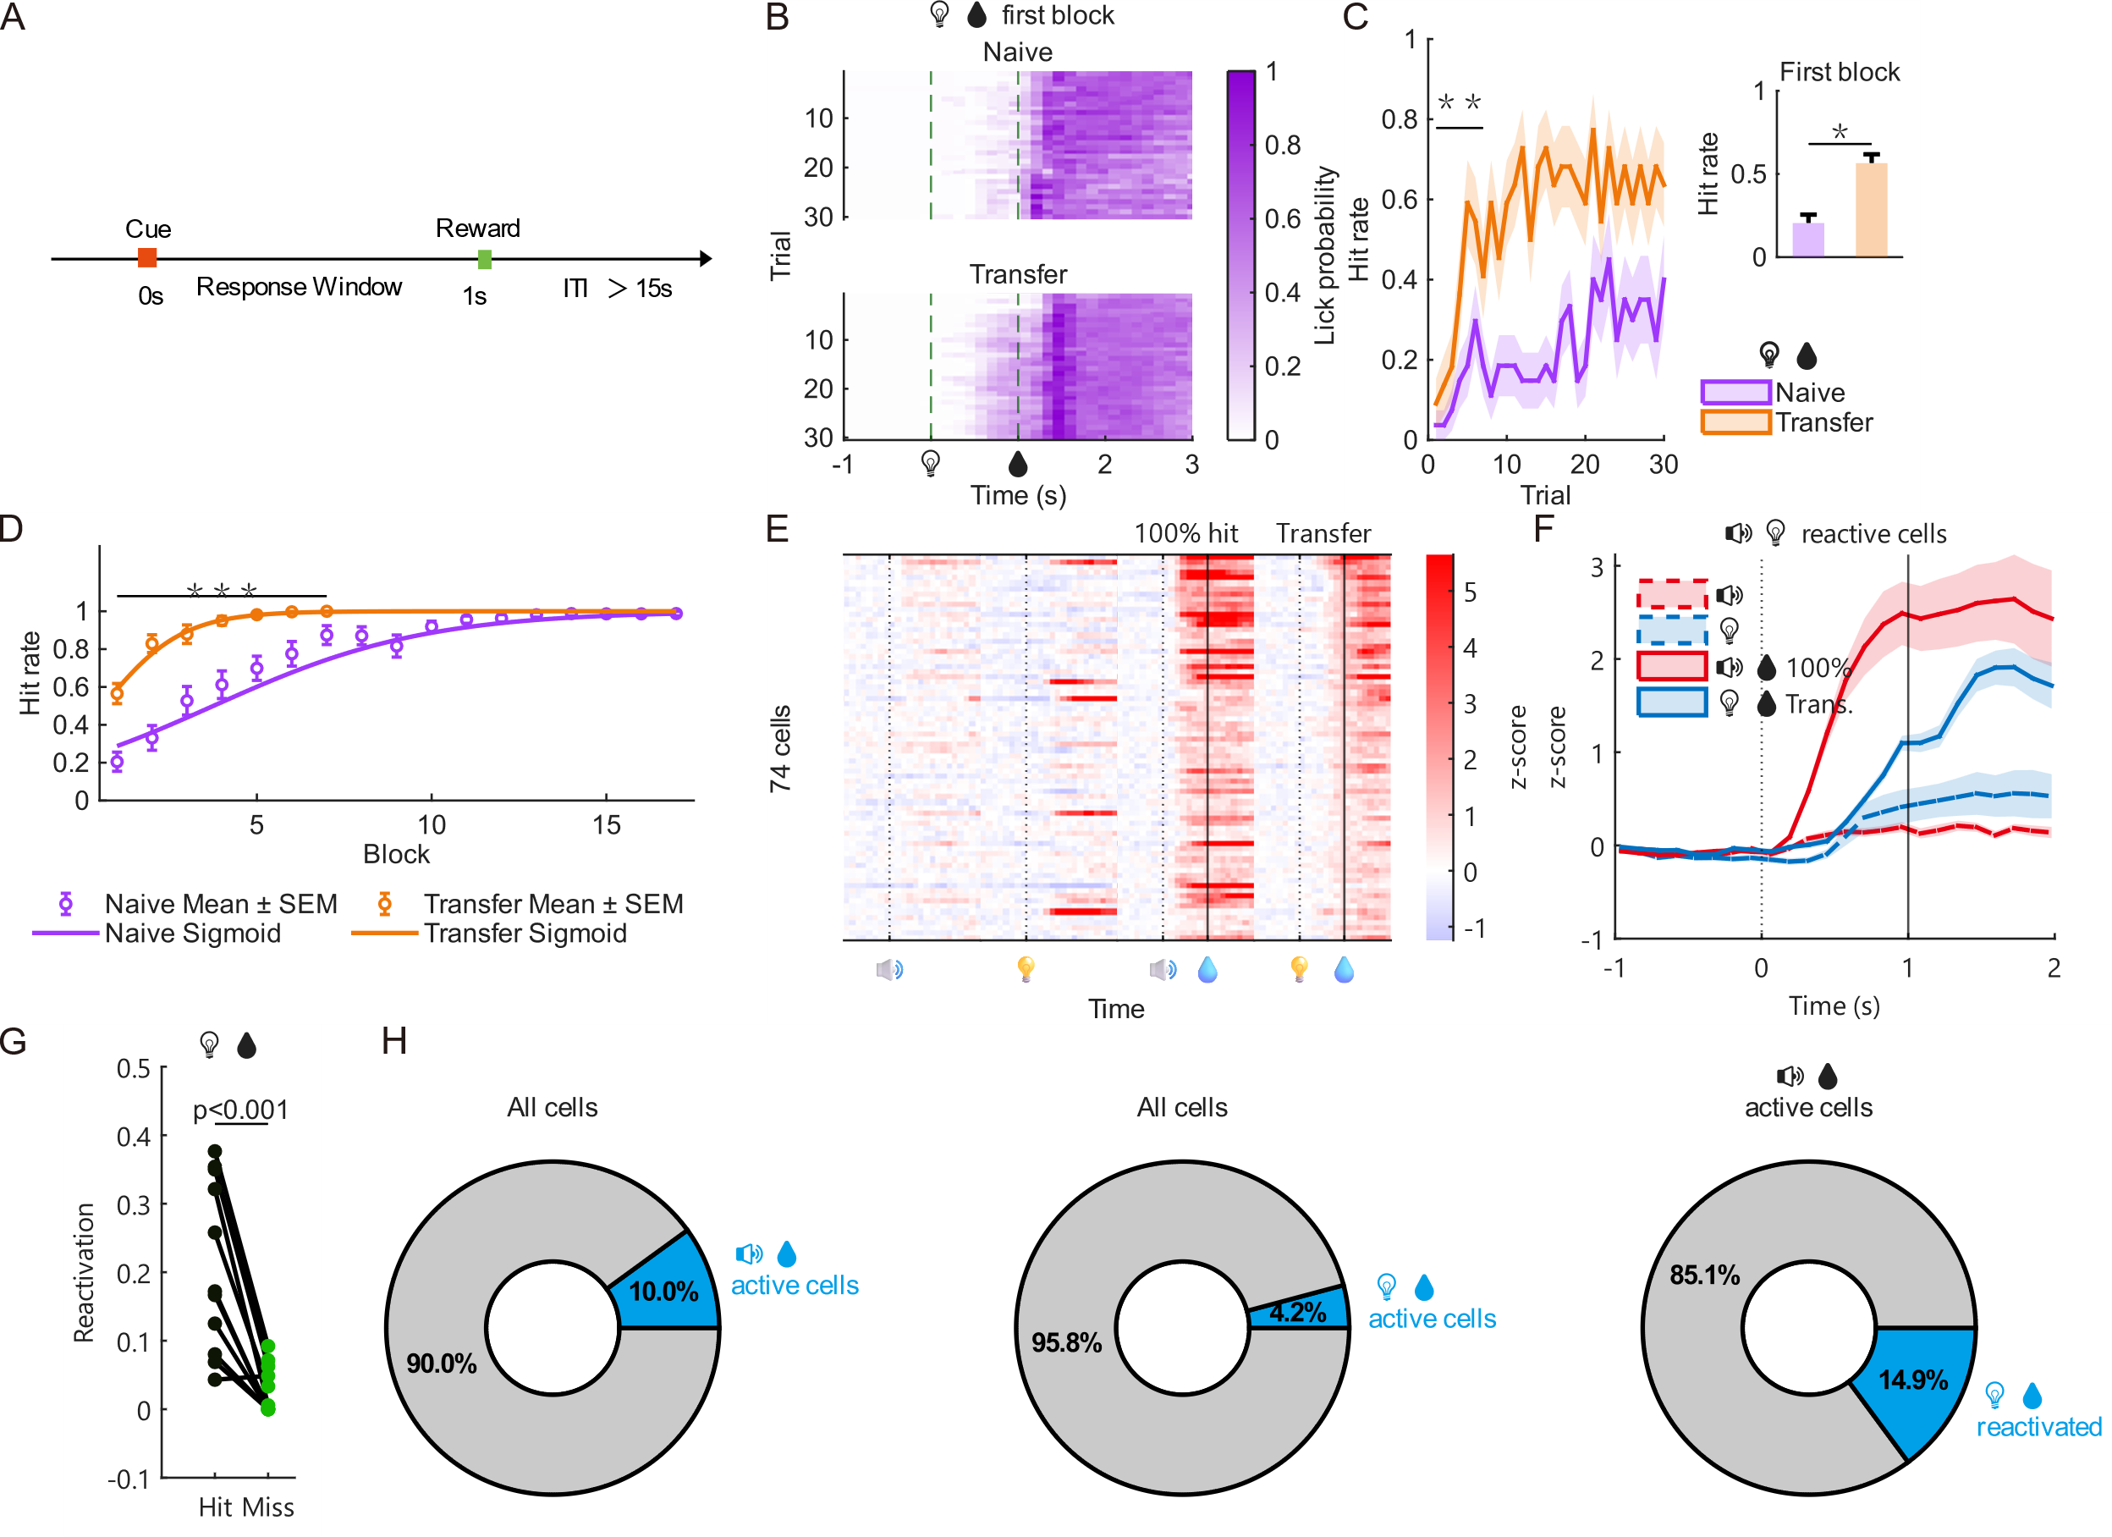
Figure S1 | The transfer advantage is independent of the cue–response delay, and the learned ensemble is reactivated by the light cue
- Schematic of the undelayed paradigm used for all imaging analyses: the response window opens together with the 200 ms cue, and water is delivered 800 ms after cue offset on every trial regardless of licking, providing a response-independent, fixed temporal anchor for trial alignment. This contrasts with the delayed paradigm of Figure 1A, B, in which the response window opens 1.5 s after cue onset and water depends on the first lick.
- Lick probability of the first light-water block, shown as a trial × time raster of the lick-related calcium component (rescaled to 0–1) for naïve (top, n = 18 mice) and transfer (bottom, n = 11 mice) groups; trials are ordered by trial number within the block. Dashed lines mark cue onset (0 s) and water delivery (1 s).
- Trial-wise hit rate within the first light-water block (mean ± SEM across mice; n = 27 naïve, 22 transfer mice). Significance bar spans trials 1–7: group effect of a linear mixed-effects model (Behavior ~ Trial × Group + (1|Mouse)); **p < 0.01.
- Undelayed block-wise learning curve (left, block-wise mean ± SEM with group-level sigmoid fits: naïve slope 0.33, R² = 0.32; transfer slope 0.89, R² = 0.29; significance bar spans blocks 1–7, group effect of a linear mixed-effects model, ***p < 0.001) and first-block hit rate (right, naïve 0.20 ± 0.05 vs transfer 0.57 ± 0.05, mean ± SEM; one-way ANOVA with multiple-comparison correction, *p < 0.05).
- Z-score heatmap of the common cell population across four conditions (naïve audio-only, naïve light-only, learned audio-water at 100% hit, transfer light-water). Cells were required to be active at cue +1 s (> baseline + 3σ) in both the learned audio-water and transfer light-water blocks, and are sorted by the smaller of the two responses at cue +1 s.
- Mean ± SEM population traces of the same cells as in **E** across the four conditions (dashed lines, naïve blocks; solid lines, learned/transfer blocks).
- Reactivation fraction of learned audio-water active cells during transfer light-water hit vs miss trials, paired per mouse (n = 11 mice; 511 participating learned-active cells; right-tailed sign-rank p = 9.8 × 10⁻⁴).
- Active-cell fractions (active = z-score at cue +1 s above baseline mean + 3σ, baseline −3 to 0 s; n = 11 mice). Left, cells active in learned audio-water blocks as a fraction of all recorded cells (511/5107, 10.0%). Middle, cells active in the first transfer light-water block as a fraction of all recorded cells (212/5105, 4.2%). Right, cells active in learned audio-water blocks that were reactivated in the first transfer light-water block (76/511, 14.9%).

Still working on …

Figure 2: Encoding ensemble facilitates first-block performance
待与杨青宁工作整合……
- Diagram of decoder: from calcium to cue/behavior
- Behavior decoder can transfer to light, but cue decoder cannot
- Hit weights larger than miss weights
- Hit cells in hit trials are more convergent among trials than miss cells in miss trials
- Activity of hit cells correlates with first-block hit rate, but miss cells do not.
- Diagram of cFos-TRAP
- cFos expression
- Lower first-block performance in cFos inhibition

Figure 3: Stable encoding ensemble fades over time
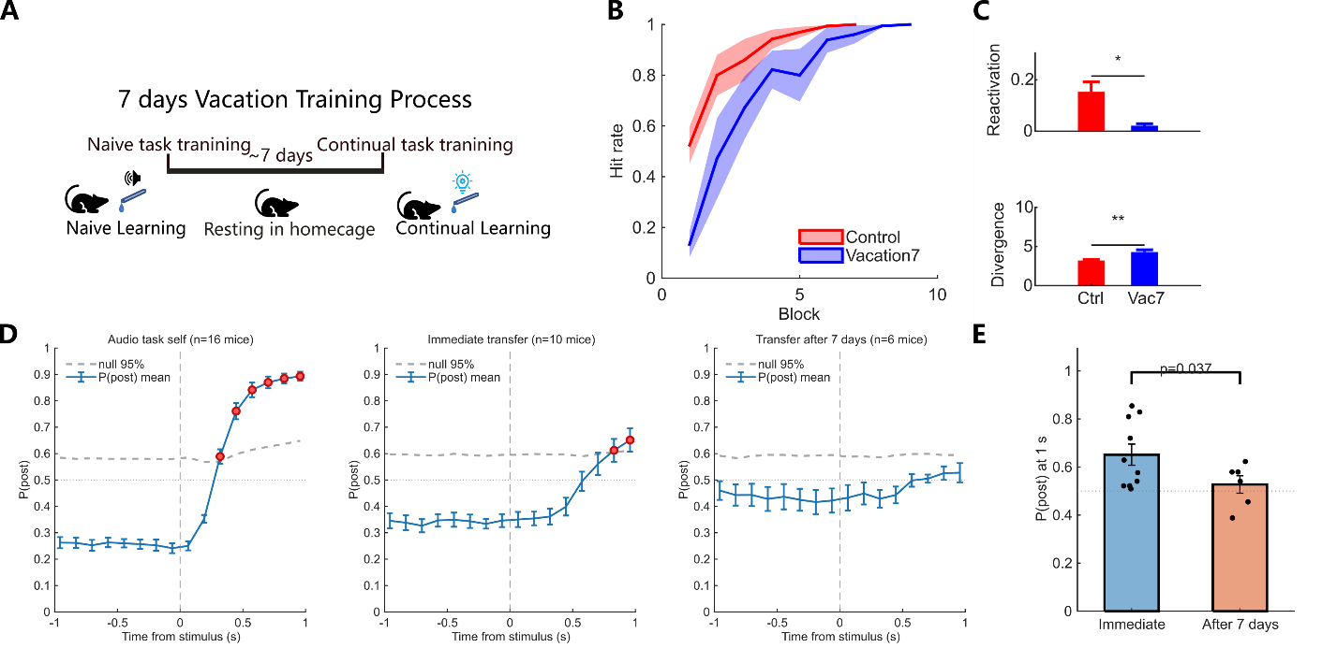
- Diagram of 7-day gap
- Lower performance after 7 days
- Higher divergence after 7 days
- Encoding ensemble does not transfer after 7 days
- Encoding ensemble is inactive after 7 days

Figure 4: Indirect manipulation on heterogeneity: TH inhibition
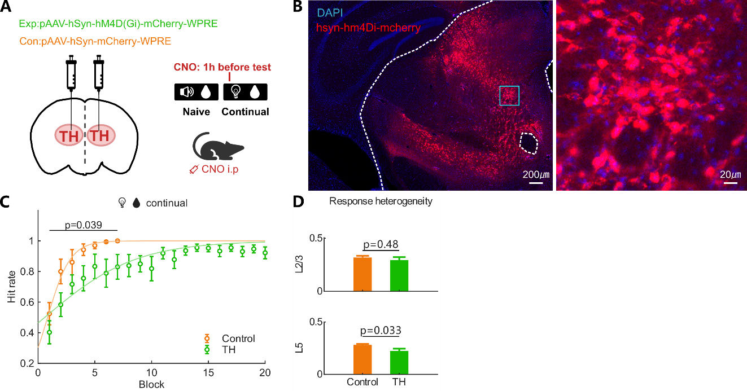
- Diagram of TH inhibition
- Expression
- Learning curve: lower slope but not first-block performance
- Lower population heterogeneity

Figure 5: Validation of response heterogeneity on RNN model
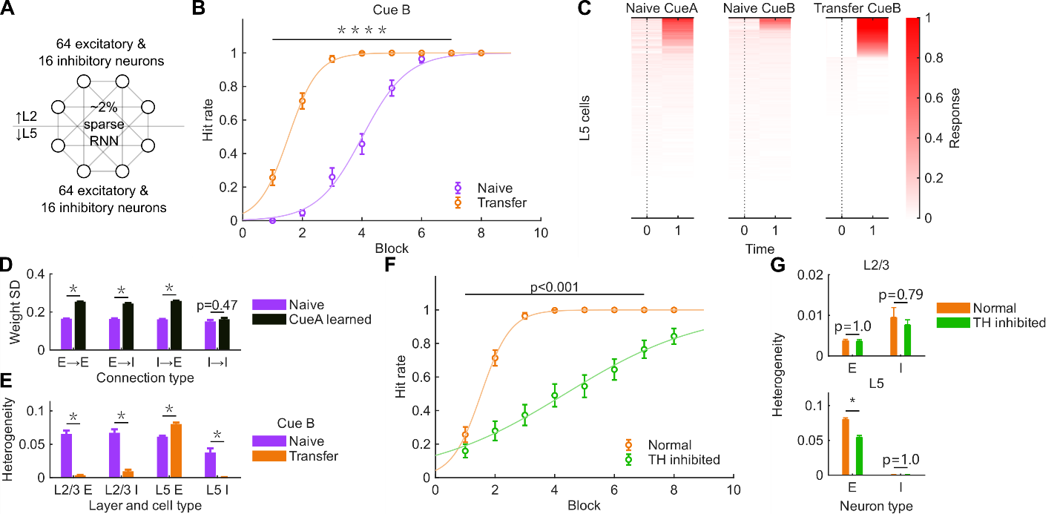
- RNN model diagram
- Model learning curve
- Heatmap showing heterogeneity
- Comparison of naïve/transfer heterogeneity
- Comparison of naïve/transfer weight SD
- Lower learning slope on simulated TH inhibition
- Lower heterogeneity on simulated TH inhibition

