Visualisation

Assignment 1

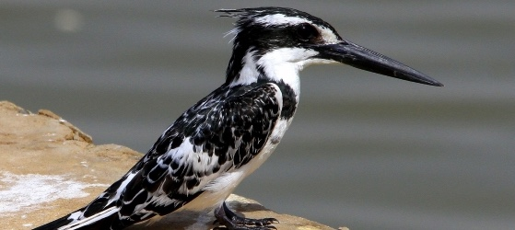

Liu Wenzhuo

Zhang Shangyuan

TAble of  
Contents

InTroduCtion 1

Data Processing 3

Map processing 3

Data processing 5

1.Potision

2. Records of birds by year

3. Records of birds by quality

**Introduction**

In 2017, the VAST Challenge results suggested that the Kasios Furniture manufacturing company may have been a primary contributor to the apparent reduction of the number of nesting pairs of the Rose-Crested Blue Pipit, a favorite bird of Mistford residents and Boonsong Lekagul Nature Preserve visitors. Kasios supposedly used the banned substance Methylosmolene in their manufacturing process. They surreptitiously dumped process waste in the northeast region of the Preserve (mini-challenge 1 from 2017) and Methylosmolene was detected in their smokestack emissions (mini-challenge 2 from 2017).

Kasios now claims that the analysis was flawed and biased. To combat these conclusions, Kasios has launched their own “investigation” into the Pipit situation, and they are now reporting that there are plenty of Rose-crested Blue Pipits happily living and nesting in the Preserve. To back up this claim, they have provided a set of Pipit bird calls, recently recorded across the Preserve, with locations of where they were recorded. Clearly, they claim, the Pipits are a thriving population, and Kasios will provide even more supporting evidence as their investigation proceeds.  
In last year’s Challenge, an ornithology grad student from Mistford College named Mitch Vogel discovered the plight of the Pipit and carried out an investigation. Normally, we would call on Mitch again to help validate Kasios’ claim. Unfortunately, Mitch is working far from Mistford in a remote area without internet access for an extended time and cannot be easily reached!

The Pangera Ornithology Conservation Society, who sponsored Mitch last year, is at their wit’s end at what to do about this turn of events. The townsfolk and Preserve rangers seem satisfied that the recordings back up Kasios’ claims. Mistford College does not have another Pipit expert they can call upon for help. But, they do have a collection of bird calls from the Preserve that has been vetted by various ornithology groups as having accurate identifications. They have heard that new techniques from machine learning and visual analytics can be applied to situations like this. Perhaps, the calls could be classified and analyzed using these technologies, and reviewed when Mitch returns.

We have one file named “AllBirdsv4.csv” which include all the metadata for the bird sounds. The File ID field is the index to the file names in the ALL BIRDS file collection. The English_name is the common English name for the particular bird. The Vocalization_type is the kind of bird sound it is: a call, a song, or some other particular sound. The researchers did not provide additional descriptions of the differences between the vocalizations, so you will have to manage this data as best you can. Quality is a score A, B, C, D, or E. “The Map.bmp” is a 200 x 200 pixel map of the Preserve, with general indications of roadways thourgh the site. The coordinates (X,Y) for each bird from “AllBidsv4.csv” should be considered from bottom left to top right.

We can also find the file “All birds.zip”, it contains all the sounds recorded from the known birds, another file “Test Birds from Kasios” are the bird sounds Kasios claims as Pipits. We need to analyze these sounds and verify whether it is or not Blue Pipit.

**Data Processing**

First of all, we focus on the data from “AllBirdsv4.csv”, and try to find the similarity of Blue Pipits.

**Map Processing**

Here is the original map image:

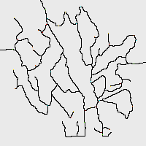

The pixel of this map is small and the background doesn’t seem nice. We will use the tools from opencv to show this map in a nicer way.

Firstly, we zoom out the map by resize, and we get a map with pixel 600x600. However the black lines representing roads ways aren’t beautiful. So we apply the Gaussian Blur so as to have a smoother blur resembling. Secondly, we convert the rgb map to the binary image to get a higher contrast. Here is the map after the process:

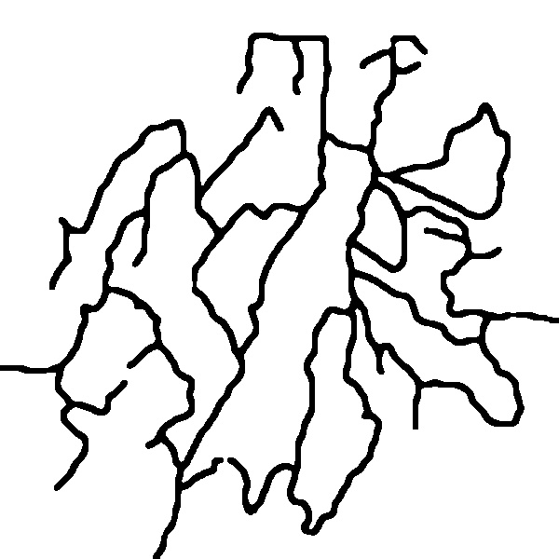

**Data processing**

1. Position

We show all the Birds positions from “AllBirdsv4.csv” over the map sorting by the type of birds:

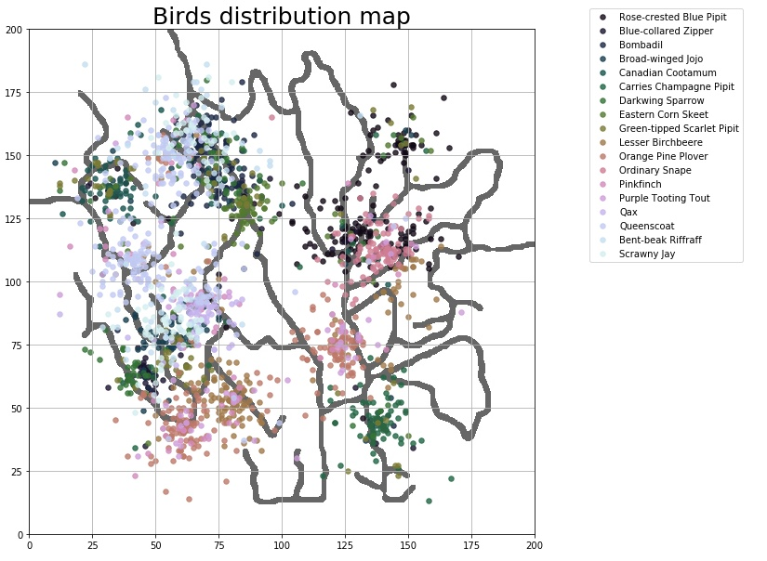

For the positions of Blue Pipit:

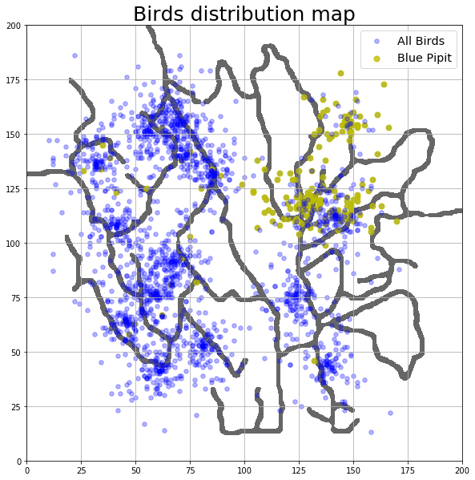

We find that most of Blue Pipits live in northeast. It can be considered as a feature of Blue Pipits.

But when we show the positions of Kasios Birds, we can see that the distribution of positions of Kasios Birds are very dispersive, it doesn’t correspond to the feature of position for Blue Pipits.

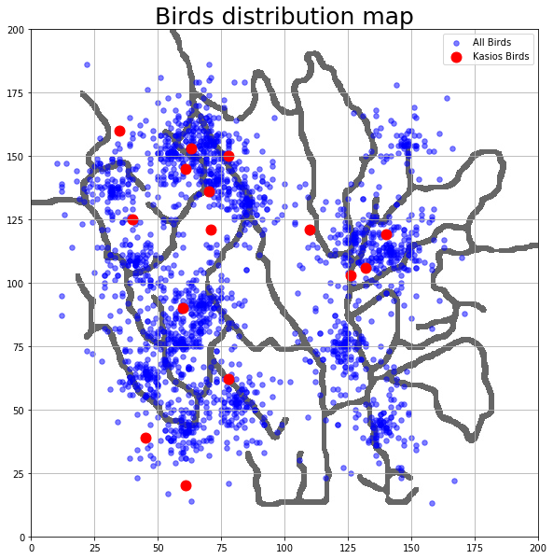

1. Records of birds by year

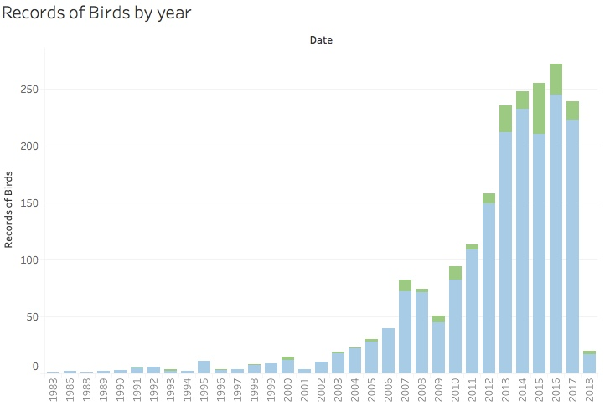

Green bar represents the number of records of Blue Pipit, and the blue one represent other birds. We can see that the records of Blue Pipit decrease for the four recent years. However there isn’t enough record for year 2018, we couldn’t find the tendency of Blue Pipit for 2018.

1. Records of Birds by quality

Like any other birds, the qualities of Blue Pipits are mainly A, B and C, we couldn’t find a lot of records for D and E.

## 

