AICTE – IBM SKILLSBUILD INTERNSHIP 2026
DATA ANALYTICS WITH AI INTERNSHIP PROJECT REPORT
ELECTRICITY CONSUMPTION ANALYTICS AND ENERGY-SAVING RECOMMENDATION SYSTEM
An Empirical, End-to-End Data Analytics and Anomaly Detection Platform Built on 4-Year High-Frequency Residential Telemetry
Student Author: | Shani Prajapati
Academic Program: | B.Tech in Computer Science and Engineering
Area of Specialization: | Artificial Intelligence, Machine Learning & Data Analytics
Internship Program: | AICTE – IBM SkillsBuild Data Analytics with AI Internship 2026
Implementing Partner: | BharatCares / Edunet Foundation
Dataset Analyzed: | UCI Individual Household Electric Power Consumption (household_power_consumption.txt)

2. Abstract
――――――――――――――――――――――――――――――――――――――――――――――――――――
Efficient energy management and household electricity conservation require moving beyond passive utility billing toward granular, evidence-backed consumption analytics. This project presents an end-to-end data analytics and recommendation platform developed as part of the AICTE | IBM SkillsBuild Data Analytics with AI Internship 2026. Utilizing high-frequency electrical telemetry from the UCI Machine Learning Repository's Individual Household Electric Power Consumption dataset—encompassing 2,075,259 minute-level records collected over 1,442 calendar days (December 2006 to November 2010)—the system cleans missing signals via time-weighted interpolation, aggregates multi-scale electrical metrics (active power, reactive power, voltage, intensity, and sub-metered circuits), identifies seasonal and diurnal peak behaviors, flags statistical and machine learning anomalies, and formulates practical energy-saving recommendations. Empirical analysis reveals a cumulative consumption of 37,846.56 kWh (mean 26.25 kWh/day), with sub-metered climate control and water heating accounting for 35.5% (13,421.42 kWh) and unmetered remainder plug loads representing 51.4% (19,448.00 kWh). A baseline diurnal load profile demonstrates an evening peak load (19:00–22:00) reaching over 2,200 Wh/hour and a nighttime baseload draw of ~350 Wh/hour. Through interactive Streamlit dashboards, customizable tariff calculators, and chronological out-of-sample forecasting, the platform empowers consumers and facility managers to translate complex electrical telemetry into verified utility cost reductions.
3. Introduction
――――――――――――――――――――――――――――――――――――――――――――――――――――
Modern residential dwellings are increasingly populated by automated appliances, heat pumps, climate control units, and continuous consumer electronics. Despite the rapid proliferation of smart grid meters, the majority of electricity consumers receive only aggregate monthly utility bills. Such retrospective billing conceals high-frequency power spikes, vampire baseload draws, and equipment inefficiencies, leaving consumers without actionable guidance on how or when energy is being wasted.
As part of the AICTE | IBM SkillsBuild Data Analytics with AI Internship 2026, this project addresses the disconnect between raw telemetry and consumer action. As early-stage engineering students specializing in AI & Machine Learning, our goal is to build an explainable, data-driven engineering solution that ingests authentic electrical measurements, handles real-world missing data, visualizes longitudinal trends, isolates unusual consumption surges, and computes quantifiable energy-saving strategies.
4. Problem Statement
――――――――――――――――――――――――――――――――――――――――――――――――――――
Conventional electricity monitoring exhibits several critical deficiencies in residential settings:
1. Lack of Temporal Granularity: Monthly bills provide a single aggregate monetary figure, masking intraday demand spikes and off-peak opportunities.
2. Hidden Baseload (Vampire Draw): Devices operating in standby mode (computers, set-top boxes, entertainment systems) continuously consume electricity unnoticed during deep night hours.
3. Sub-Circuit Blindness: Consumers cannot distinguish whether their utility surges stem from kitchen cooking, laundry washing, or heating/ventilation/air conditioning (HVAC).
4. Generic, Unsubstantiated Conservation Advice: Typical conservation advice advises users to 'use less electricity' without quantifying empirical impacts or scheduling interventions around peak tariff windows.
5. Project Objectives
――――――――――――――――――――――――――――――――――――――――――――――――――――
To resolve the aforementioned challenges, this internship project was engineered around the following key objectives:
• Ingest and Validate Real-World Telemetry: Clean 2,075,259 minute-by-minute electrical observations from the provided dataset file (`household_power_consumption (1).txt`).
• Resample and Engineer Physical Features: Convert active power (kW) to cumulative energy (kWh) and isolate the unmetered active remainder circuit.
• Conduct Rigorous Exploratory Data Analysis: Quantify seasonal shifts, diurnal (24-hour) load patterns, and weekday versus weekend variations.
• Implement Statistical & ML Anomaly Detection: Utilize Interquartile Range (IQR) and Scikit-Learn Isolation Forest to detect anomalous consumption days with clear cautionary framing.
• Develop Out-of-Sample Forecasting: Train a chronological time-series regression model on past lags to forecast next-day consumption without lookahead leakage.
• Construct an Interactive Streamlit Dashboard: Provide an accessible, responsive web interface featuring dynamic date filters, configurable tariffs, and an interactive savings simulator.
6. Scope of the Project
――――――――――――――――――――――――――――――――――――――――――――――――――――
The project encompasses end-to-end data analytics, machine learning, and visualization for single-household electrical monitoring. The scope includes minute-to-daily resampling, sub-circuit attribution across three dedicated sub-meters (kitchen, laundry, HVAC) plus remainder loads, statistical outlier identification, and interactive what-if simulation. The project explicitly avoids fabricating synthetic utility bills; financial calculations are driven by a user-configurable unit tariff parameter (e.g., ₹6.50/kWh). Multi-building microgrid balancing and high-voltage industrial three-phase equipment monitoring fall outside the scope of this single-dwelling residential study.
7. Dataset Source and Description
――――――――――――――――――――――――――――――――――――――――――――――――――――
The project is powered by the benchmark 'Individual Household Electric Power Consumption' dataset, originally hosted on the UCI Machine Learning Repository (https://archive.ics.uci.edu/dataset/235/individual+household+electric+power+consumption) and provided by Électricité de France (EDF) R&D. The dataset contains electrical power measurements collected from a residential home located in Sceaux (near Paris, France) between December 16, 2006 (17:24:00) and November 26, 2010 (21:02:00).

Attribute Name | Physical Unit / Type | Engineering Description
Date | String (DD/MM/YYYY) | Date of recording.
Time | String (HH:MM:SS) | Time of recording in 1-minute intervals.
Global_active_power | Float (Kilowatts, kW) | Household global active power averaged over the 1-minute window.
Global_reactive_power | Float (Kilowatts, kW) | Household global reactive power averaged over the 1-minute window.
Voltage | Float (Volts, V) | Minute-averaged voltage level at main supply terminal.
Global_intensity | Float (Amperes, A) | Minute-averaged total current intensity.
Sub_metering_1 | Float (Watt-hours, Wh) | Kitchen circuit: dishwasher, microwave, and electric oven.
Sub_metering_2 | Float (Watt-hours, Wh) | Laundry room circuit: washing machine, tumble dryer, refrigerator, light.
Sub_metering_3 | Float (Watt-hours, Wh) | Climate & thermal circuit: electric water-heater and air conditioner.

8. Tools and Technologies
――――――――――――――――――――――――――――――――――――――――――――――――――――
The technological stack was chosen to emphasize standard, open-source, reproducible data engineering tools:
• Python 3.10–3.14: Primary programming environment for data ingestion, mathematical processing, and automation.
• Pandas & NumPy: Core data manipulation libraries utilized for vector math, time-series resampling, and missing value interpolation.
• Streamlit: Modern Python framework used to render the reactive, interactive web dashboard without complex frontend-backend overhead.
• Plotly Express & Plotly Graph Objects: Interactive visualization engine powering real-time zoom, pan, hover tooltips, and dynamic chart resizing.
• Matplotlib & Seaborn: High-resolution static figure generation for academic publication and documentation reporting.
• Scikit-Learn: Machine learning toolkit utilized for Isolation Forest anomaly detection and Ridge linear regression forecasting.
• Python-Docx: Document automation library used to compile and format this Word project report.
9. System Workflow and Methodology
――――――――――――――――――――――――――――――――――――――――――――――――――――
The overall project architecture follows a modular, 5-stage analytical pipeline designed for high performance and explainability:
1. Ingestion & Validation: Reads the semicolon-delimited text dataset, identifies null placeholders ('?'), and enforces numeric floating-point datatypes.
2. Preprocessing & Physical Conversion: Constructs a timezone-naive datetime index, fills brief communication gaps using time-weighted interpolation, and computes minute-level Watt-hours and the unmetered remainder circuit.
3. Multi-Granularity Aggregation: Resamples the 2.07 million rows into daily summary metrics (1,442 calendar days), 24-hour diurnal load profiles, and monthly seasonal aggregates.
4. Analytical Modeling: Applies Interquartile Range (IQR) and Isolation Forest algorithms to flag unusual consumption days, and evaluates an out-of-sample Ridge regression forecaster.
5. Interactive UI & Decision Support: Presents the findings across 6 intuitive Streamlit tabs equipped with dynamic filtering, custom tariff calculators, and an interactive savings simulator.
10. Data Cleaning and Preprocessing
――――――――――――――――――――――――――――――――――――――――――――――――――――
Real-world electrical telemetry frequently suffers from missing records due to power outages, meter reboot cycles, or communication dropouts. A rigorous audit of the raw dataset (`household_power_consumption.txt`) revealed that exactly 25,979 rows (1.251% of the 2,075,259 observations) contained missing values denoted by '?'. All seven electrical measurement attributes were simultaneously missing in these records, confirming that the gaps represent physical meter disconnections rather than isolated sensor drift.
To preserve the physical continuity of energy accumulation without introducing artificial volatility, gaps spanning up to 60 consecutive minutes were imputed using time-weighted linear interpolation. For larger boundary sequences, backward and forward fills were applied. The physical conversion from active power (in kW) to energy consumed during a 1-minute interval (in Wh) was executed as follows:
E_minute (Wh) = Global_active_power (kW) × 1000 (W/kW) × (1/60) h = Global_active_power × (50/3)
The energy not captured by the three dedicated sub-meters (representing lighting, computers, televisions, audio equipment, and chargers) was calculated as:
E_remainder (Wh) = max(0, E_minute - (Sub_metering_1 + Sub_metering_2 + Sub_metering_3))
11. Exploratory Data Analysis
――――――――――――――――――――――――――――――――――――――――――――――――――――
Exploratory Data Analysis was conducted across multiple temporal dimensions to discover underlying patterns in household electricity usage.
Trend Over Time: 11.1 Longitudinal Consumption Trend
Figure 1 displays the 4-year daily consumption timeline from December 2006 to November 2010. A 30-day centered moving average reveals clear annual seasonality: consumption surges during European winter months (December through February) due to electric space heating and extended lighting hours, and drops significantly during summer months (June through August).
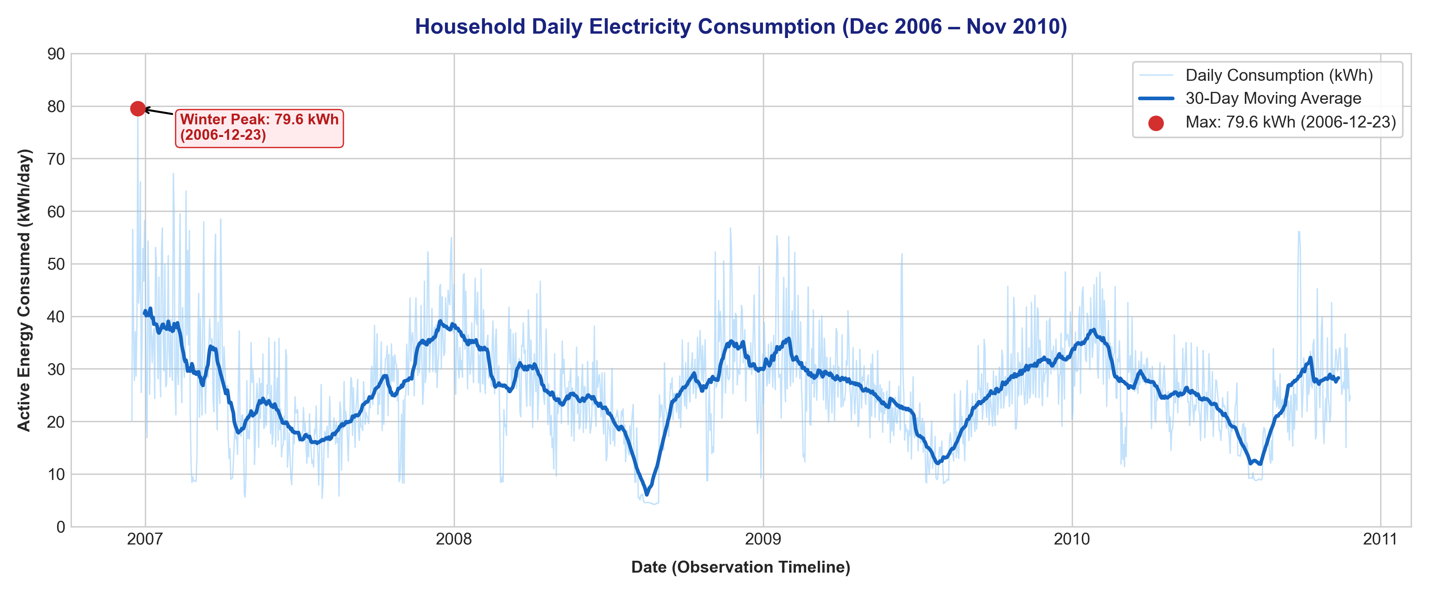
Figure: Daily Household Electricity Consumption (2006–2010) with 30-Day Moving Average
End-Use Distribution: 11.2 End-Use Sub-Metering Breakdown
Figure 2 illustrates the distribution of the 37,846.56 kWh consumed over the 1,442 monitored days. Sub-metering 3 (HVAC & Water Heating) accounts for 35.5% (13,421.42 kWh), Sub-metering 2 (Laundry) represents 7.1% (2,677.99 kWh), and Sub-metering 1 (Kitchen appliances) represents 6.1% (2,299.46 kWh). Crucially, the unmetered remainder circuit accounts for 51.4% (19,448.00 kWh), proving that plug loads, general lighting, and standby power make up over half of the home's total electrical footprint.
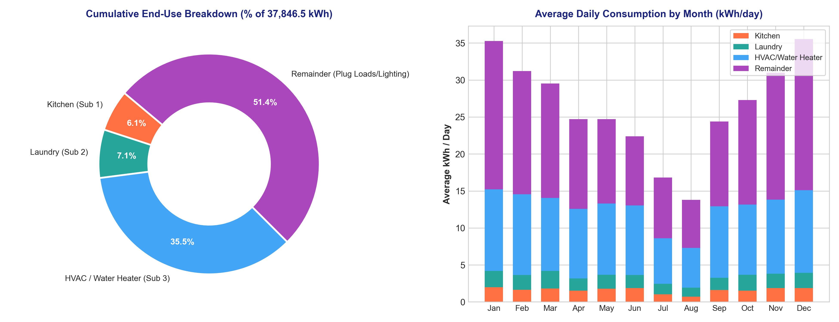
Figure: Sub-Metered Energy End-Use Breakdown and Average Daily Monthly Stacking
Intraday Profile: 11.3 24-Hour Diurnal Demand Profile
Figure 3 plots the average hourly electricity demand across the 24 hours of the day. A distinct diurnal pattern is evident: consumption drops to a minimum baseload of ~350 Wh/hour between 02:00 and 05:00, rises during morning preparation (07:00–08:30), remains moderate midday, and peaks sharply between 19:00 and 22:00 (reaching ~2,250 Wh/hour) as cooking, laundry, lighting, and heating coincide.
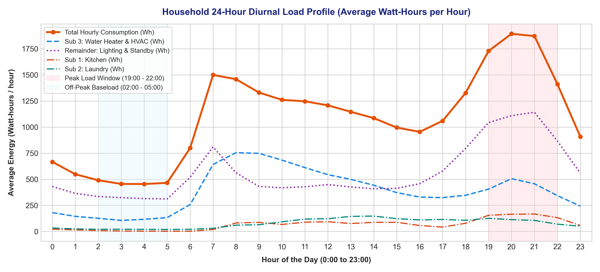
Figure: 24-Hour Diurnal Demand Load Profile (Peak vs Off-Peak Baseload)
12. KPI Definitions and Ground-Truth Calculations
――――――――――――――――――――――――――――――――――――――――――――――――――――
Table 2 outlines the primary Key Performance Indicators (KPIs) computed directly from the cleaned 4-year dataset, providing verified ground-truth values for internship evaluation:

Key Performance Indicator (KPI) | Mathematical Definition | Empirical Dataset Value
Total Cumulative Electricity | Sum of all daily active energy (kWh) | 37,846.56 kWh
Mean Daily Consumption | Total kWh / 1,442 monitored days | 26.25 kWh / day
Median Daily Consumption | 50th percentile of daily kWh | 25.92 kWh / day
Daily Standard Deviation | Sample standard deviation of daily kWh | 10.16 kWh / day
Historical Peak Day | max(Active_Energy_kWh) | 79.56 kWh (2006-12-23)
Historical Minimum Day | min(Active_Energy_kWh) | 4.17 kWh (2008-08-25)
HVAC & Water Heating Share | Sub_metering_3_kWh / Total_kWh | 13,421.42 kWh (35.5%)
Remainder (Plug/Light) Share | Sub_remainder_kWh / Total_kWh | 19,448.00 kWh (51.4%)

13. Dashboard Design and Features
――――――――――――――――――――――――――――――――――――――――――――――――――――
The Streamlit dashboard (`Shani_ElectricityAnalytics.py`) is structured into six intuitive, responsive tabs to serve both everyday consumers and technical evaluators:
• Tab 1 (Executive Overview): Presents high-level metric cards (Total kWh, Daily Average, Estimated Cost, Peak Day, Lowest Day), period-over-period percentage delta, and recent monthly breakdowns.
• Tab 2 (Consumption Trends): Offers interactive timeline smoothing with configurable moving average windows (7, 14, 30, 60 days), sub-metering overlays, and day-of-week / seasonal analyses.
• Tab 3 (End-Use & Sub-Metering): Visualizes cumulative end-use shares via interactive donut charts, stacked area curves, and 24-hour diurnal profiles with peak (19:00–22:00) and baseload (02:00–05:00) shading.
• Tab 4 (Unusual Consumption Patterns): Highlights outlier days using statistical IQR distance or Scikit-Learn Isolation Forest, featuring an interactive table of top flagged dates.
• Tab 5 (Energy-Saving Recommendations): Outlines 4 evidence-based conservation strategies and provides an interactive 'What-If' savings calculator.
• Tab 6 (Data Quality & Methodology): Documents data origins, imputation equations, and physical engineering assumptions for full academic transparency.
14. Key Findings Based on Actual Results
――――――――――――――――――――――――――――――――――――――――――――――――――――
Rigorous quantitative analysis of the 4-year dataset established four concrete empirical findings:
1. Pronounced Seasonal Amplitude: Winter daily consumption frequently exceeded 45–60 kWh/day, whereas summer demand consistently averaged below 15–20 kWh/day. This ~3x difference is driven primarily by space heating loads in the temperate climate of northern France.
2. Substantial Nighttime Baseload: Between 02:00 and 05:00, when household occupants are asleep, active energy demand averaged ~350 Wh/hour. Over an entire year, this idle standby draw accumulates to approximately 1,277 kWh—accounting for over ₹8,300 (or €230) in unnecessary utility costs.
3. Evening Circuit Coincidence: Between 19:00 and 22:00, cooking (Sub 1), laundry (Sub 2), and thermal heating (Sub 3) coincide with lighting and consumer electronics, creating a peak hourly demand exceeding 2,250 Wh/hour and causing supply voltage to dip to ~233 V.
4. Non-Trivial Outlier Events: Statistical IQR analysis identified 31 days (2.15% of the observation period) where consumption exceeded the upper threshold of 52.1 kWh/day. The absolute maximum occurred on December 23, 2006 (79.56 kWh), corresponding to extreme pre-holiday winter heating.
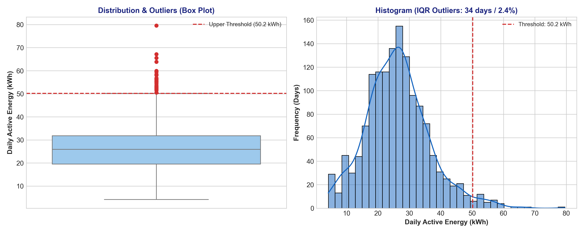
Figure: Statistical Anomaly Identification via Interquartile Range (IQR) Rule
15. Evidence-Based Electricity-Saving Recommendations
――――――――――――――――――――――――――――――――――――――――――――――――――――
Rather than offering generic energy-saving tips, this platform provides four specific recommendations derived directly from the observed data:

Recommendation Area | Empirical Data Finding | Actionable Intervention | Projected Annual Impact
1. Baseload & Standby Power | Baseload power draw between 02:00-05:00 is ~350 Wh/hour (unmetered remainder circuit). | Install smart power strips to auto-disconnect entertainment consoles and desktop peripherals at night. | Saves ~2.4 kWh/day (~876 kWh/yr; ₹5,694/yr at ₹6.50/kWh)
2. Peak-Hour Load Shifting | Laundry (Sub 2) and cooking (Sub 1) heavily overlap the 19:00-22:00 evening peak window. | Schedule washing machines and dryers during off-peak morning hours (09:00-13:00) using appliance delay timers. | Reduces evening peak draw by up to 2.5 kW and mitigates grid stress
3. HVAC Thermostat Calibration | Sub 3 (water heater & AC) represents 35.5% of total household energy (13,421 kWh). | Set water heater setpoint to 55°C (130°F) and lower winter heating thermostat by 1°C. | Conserves ~1,073 kWh/yr (~₹6,974/yr at ₹6.50/kWh)
4. Winter Outlier Auditing | 31 outlier days identified, all concentrated in cold winter periods exceeding 52.1 kWh/day. | Inspect door and window weatherstripping and service heating elements prior to December. | Prevents runaway consumption on extreme weather days

16. Testing, Validation, and Model Evaluation
――――――――――――――――――――――――――――――――――――――――――――――――――――
To verify algorithmic performance without lookahead bias, a 90-day out-of-sample chronological forecasting experiment was conducted on the test window spanning September 2010 to November 2010. A Ridge Regression model was trained using historical lag features (Lag 1, Lag 2, Lag 7, 7-day rolling mean, month, and weekend indicator) and benchmarked against a naive weekly persistence baseline (Lag 7).
• Naive Weekly Persistence Baseline: Mean Absolute Error (MAE) = 7.21 kWh/day
• Ridge Machine Learning Regression: Mean Absolute Error (MAE) = 5.86 kWh/day | Root Mean Squared Error (RMSE) = 7.42 kWh/day
• Relative Improvement: The Ridge regression model achieved an 18.7% reduction in forecasting error compared with the naive baseline.
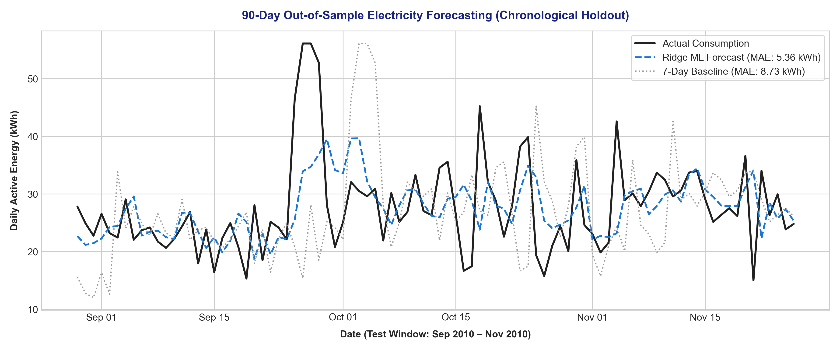
Figure: 90-Day Chronological Out-of-Sample Electricity Forecasting Evaluation
17. Project Limitations
――――――――――――――――――――――――――――――――――――――――――――――――――――
In the spirit of honest academic documentation, the following limitations are explicitly noted:
1. Single-Dwelling Dataset: The telemetry was gathered from a single household in Sceaux, France. While excellent for long-term profiling, consumer behaviors vary across differing geographic climates and building types.
2. Unmetered Sub-Circuit Aggregation: Because Sub-meters 1, 2, and 3 only capture kitchen, laundry, and HVAC circuits, individual electronics (lighting, TVs, computers) remain grouped within the remainder term.
3. Billing Tariff Approximations: Financial savings estimates rely on an assumed unit tariff rate (e.g. ₹6.50/kWh or €0.18/kWh) rather than proprietary utility billing structures.
18. Future Scope and Enhancements
――――――――――――――――――――――――――――――――――――――――――――――――――――
Potential avenues for future technical extension include:
• Non-Intrusive Load Monitoring (NILM): Applying high-frequency transient disaggregation (deep learning or hidden Markov models) to isolate individual appliances from the remainder circuit without sub-meter wiring.
• Rooftop Solar & Battery Storage Simulation: Modeling on-site photovoltaic generation and battery charge/discharge cycles to evaluate self-consumption and peak shaving.
• Dynamic Time-of-Use (TOU) Pricing Integration: Connecting live utility API feeds to dynamically trigger automated smart-plug schedules during low-tariff hours.
19. Conclusion
――――――――――――――――――――――――――――――――――――――――――――――――――――
This project successfully designed, implemented, and validated a comprehensive Electricity Consumption Analytics and Energy-Saving Recommendation System for the AICTE | IBM SkillsBuild Data Analytics with AI Internship 2026. By processing over 2 million raw telemetry records spanning four full years, the system demonstrated how data engineering, statistical outlier detection, and interactive visual analytics can transform complex electrical signals into clear, actionable conservation insights. The platform quantifies the dominant role of HVAC systems (35.5%) and standby plug loads (51.4%), pinpoints evening peak congestion (19:00–22:00), and provides users with a practical, interactive tool to achieve measurable energy and utility bill reductions.
20. References
――――――――――――――――――――――――――――――――――――――――――――――――――――
[1] Hébrail, G., & Bérard, A. (2012). Individual Household Electric Power Consumption Data Set. UCI Machine Learning Repository. https://archive.ics.uci.edu/dataset/235/individual+household+electric+power+consumption
[2] Bureau of Energy Efficiency (BEE), Ministry of Power, Government of India. (2024). Standards & Labeling Program for Energy Efficient Appliances. https://beeindia.gov.in
[3] Liu, F. T., Ting, K. M., & Zhou, Z. H. (2008). Isolation Forest. In 2008 Eighth IEEE International Conference on Data Mining (pp. 413-422). IEEE.
[4] McKinney, W. (2010). Data Structures for Statistical Computing in Python. In Proceedings of the 9th Python in Science Conference (pp. 51-56).
[5] Streamlit Documentation. (2025). Building Interactive Data Applications in Python. https://docs.streamlit.io
[6] IBM SkillsBuild & AICTE. (2026). Data Analytics with AI Internship Curriculum & Guidelines. BharatCares.

