GUARDIAN
Near Real-Time Multi-Modal Threat and Behavioral Detection in Surveillance Video Streams Using Optimized YOLOv8, ByteTrack, and Temporal 1D-CNN Networks
by
Shani Nahaissi, Agam Copel, Eran Shahaf, and Ameet Sokolic
Approved by the supervisor: Dr. Moshe Butman
Submitted to the Computer Science Faculty of College of Management
August 2026
Rishon LeZion

Acknowledgments
We would like to express our deepest gratitude to our project supervisor for their invaluable guidance, technical insight, and unwavering support throughout the research, design, and implementation of GUARDIAN.
We also extend our sincere appreciation to the Computer Science Faculty at the College of Management for providing the academic foundation, resources, and environment necessary to complete this work. Finally, we thank our team members, peers, and families for their continuous encouragement and collaboration.

Executive Summary
Surveillance systems operating in near real-time face a major practical challenge: while modern security setups generate massive amounts of continuous closed-circuit television (CCTV) video, traditional automated monitoring tools analyze frames individually. This lack of time-based context leads to frequent false alarms and limits their usefulness. This project introduces GUARDIAN, a near real-time threat and behavioral detection platform designed for intelligent video surveillance. GUARDIAN connects spatial object detection and temporal action recognition using a three-stage pipeline: (1) fast object detection using a highly-optimized YOLOv8 model in ONNX format to find threats in single frames (Gun, Knife, and Suspect); (2) stable multi-object tracking through a custom state machine based on ByteTrack, which keeps track of individuals even when they are temporarily blocked or hidden; and (3) sequence-level action recognition using a lightweight 1D Convolutional Neural Network (1D-CNN) that analyzes 12-dimensional features (movement, position, and proximity to weapons) over a rolling 30-frame window.
Our approach combines data from different weapon and CCTV datasets (including Kaggle, Roboflow, and UCF-Crime) and applies realistic distortions like motion blur, camera noise, perspective warp, and partial blockages (cutouts) during training. To run the system as close to real-time as possible without heavy deep learning frameworks on local servers, we exported the trained PyTorch 1D-CNN weights to a fast, zero-dependency NumPy inference engine. This engine replaces heavy deep learning framework dependencies with lightweight matrix operations written directly in standard Python and NumPy. Testing shows that GUARDIAN reaches a 92.3% mean Average Precision (mAP@0.5) for weapon detection and a 73.7% accuracy (65.0% macro-average F1-score) for classifying behaviors (Normal, Shooting, Violence). The system processes video frames in under 22 ms (>45 frames per second) on standard hardware. This is faster and more stable than recurrent neural networks, while also reducing false alarms in crowded surveillance scenes.

Table of Contents
- Introduction ................................................................................................................. 4
1.1. Background .............................................................................................................. 4
1.2. Problem Statement ................................................................................................... 4
1.3. Objectives ................................................................................................................ 5
1.4. Scope and Limitations .............................................................................................. 5
1.5. Methodology ............................................................................................................ 6
1.6. Organization of the Project Book ............................................................................. 6
- Literature Review ......................................................................................................... 7
2.1. Overview of Relevant Literature ............................................................................... 7
- System Design and Implementation ............................................................................ 9
3.1. System Architecture ................................................................................................. 9
3.2. Data & Database Architecture .................................................................................. 11
3.3. Algorithmic & Deep Learning Architecture (CRITICAL SECTION) ........................ 13
3.4. Evaluation Metrics .................................................................................................... 18
- Results and Analysis ..................................................................................................... 20
4.1. Experimental Setup .................................----------------------------------------------------------------- 20
4.2. Presentation of Results ............................................................................................. 21
4.3. Data Analysis and Interpretation ............................................................................... 23
4.4. Comparison with Existing Approaches .................................................................... 24
4.5. Discussion of Findings ............................................................................................. 25
- Conclusion and Future Work .................................................................................------ 26
- References ...................................................................................................................... 27
- Appendix A: Setup and Operational Instructions ..................................................... 29

Table of Abbreviations
Abbreviation | Full Term
BPTT | Backpropagation Through Time
CNN | Convolutional Neural Network
GRU | Gated Recurrent Unit
IoU | Intersection over Union
LSTM | Long Short-Term Memory
mAP | Mean Average Precision
ONNX | Open Neural Network Exchange
ReLU | Rectified Linear Unit
ROC | Receiver Operating Characteristic
SORT | Simple Online and Realtime Tracking
T-IoU | Temporal Intersection over Union
UCF | University of Central Florida

Table of Figures
- Figure 3.1: GUARDIAN End-to-End System Architecture Diagram ................................ 9
- Figure 3.2: PostgreSQL Database Schema and Entity-Relationship Diagram ................. 12
- Figure 3.3: Three-Stage Hierarchical Detection, Tracking, and Temporal Action Pipeline . 13
- Figure 3.4: 12-Dimensional Temporal Feature Extraction and Weapon-Proximity Geometry . 16
- Figure 3.5: 1D-CNN Temporal Action Classifier Neural Network Architecture ............. 17
- Figure 4.1: Single-Frame mAP Progression Across YOLOv8 Architectural Iterations ...... 21
- Figure 4.2: Training and Validation Loss Curves for the 1D-CNN Temporal Classifier ... 22
- Figure 4.3: Sequence Classification Confusion Matrix (Normal vs. Shooting vs. Violence) . 23
- Figure 4.4: End-to-End Latency Breakdown vs. Stream Resolution and Track Density ... 25

1. Introduction

1.1. Background
Modern security systems are shifting from investigating past events to preventing threats in near real-time. Although CCTV cameras are now installed almost everywhere, security staff cannot watch all screens constantly due to tiredness and loss of focus [1]. Over the last decade, Convolutional Neural Networks (CNNs) have improved computer vision, making it possible to identify specific objects in single images [2]. However, true threat detection requires understanding not just what objects are in a scene, but how people behave and interact over time [3]. For example, a person holding a knife while preparing food is normal, but a person moving quickly and aggressively with a knife toward someone else is an active attack. Therefore, modern surveillance systems must combine object detection, multi-frame tracking, and temporal behavioral classification.

1.2. Problem Statement
Current automated video surveillance systems face three major technical challenges that limit their use in real-world environments:
- The Spatial-Temporal Disconnect: Traditional detectors analyze frames separately. They cannot distinguish between stationary, harmless objects and violent actions, which leads to too many false alarms [4].
- High Computational Demands for Action Recognition: Video action recognition models like 3D-CNNs and Two-Stream networks require huge amounts of memory and processor power [5]. Running these models on local servers makes them too slow (>100 ms per frame), preventing near real-time alerts.
- CCTV Quality Loss and Lost Weapon Boxes: Low-cost security cameras often produce blurry or noisy videos with compression artifacts. Standard tracking algorithms fail when suspects move quickly or get blocked by objects, causing the system to lose track of weapons and miss critical threat sequences [6].

1.3. Objectives
The main goal of this project is to develop and evaluate GUARDIAN, an optimized near real-time video analytics platform. Specifically, the project achieves the following milestones:
- Develop a Spatial Threat Detector: Train and export an optimized YOLOv8 ONNX model using a unified dataset of weapons (Gun, Knife) and human entities (Suspect), reaching mAP@0.5 > 85% on noisy surveillance feeds.
- Implement Zero-Lag Tracking: Build an enhanced tracking state machine on top of ByteTrack [7] that eliminates the standard 3–5 frame tentative track initialization delay—displaying newly detected targets instantly on Frame 1—while applying single-frame EMA coordinate smoothing to prevent bounding box flicker.
- Design a Lightweight Temporal Action Classifier: Create a 12-dimensional feature vector (coordinates, velocities, and weapon proximity) and train a 1D-CNN to classify sequences of Normal, Shooting, and Violence with high accuracy (reaching up to 79.6% F1-score on violent actions and 73.7% overall test accuracy) over a 30-frame window.
- Achieve Near Real-Time Execution: Implement a zero-dependency NumPy inference engine that, together with ONNX Runtime, runs the entire pipeline in under 25 ms per frame (>40 FPS) on standard hardware.

1.4. Scope and Limitations
- Scope: GUARDIAN focuses on near real-time threat detection from fixed CCTV cameras. The system includes stream ingestion, backend FastAPI inference, PostgreSQL storage for cameras and alerts, and a web dashboard built with React 19 and Tailwind v4.
- Limitations: The temporal action classifier recognizes three main states (Normal, Shooting, and Violence). Extremely crowded locations (with >100 overlapping people per frame) exceed the capacity of the near real-time tracking system. Audio analysis and tracking people across different rooms are not covered in this project.

1.5. Methodology
The project methodology follows an iterative development and testing process:
- Integrated Multi-Model Ingestion and Data Harmonization: Rather than relying on a single detector, the pipeline integrates a dual-detector configuration: a pretrained Person Detection model runs in tandem with a custom-trained Weapon Detection model (mapping class 0: Gun and class 1: Knife). The output bounding boxes are unified, remapping the COCO person class to our Suspect class (2) and resolving overlapping entries through cross-model Non-Maximum Suppression (NMS) before passing them to ByteTrack. Trajectories were harmonized with behavioral sequences extracted from the UCF-Crime dataset to create the 30-frame temporal tracking inputs. During training, CCTV-realistic distortions (motion blur, sensor noise, perspective warp, and cutout blocks) were applied to make the models robust.
- Model Selection and Temporal Rationale: We compared recurrent networks (GRUs and LSTMs) against 1D-CNNs for sequence modeling. The 1D-CNN was chosen based on four key architectural advantages: (a) Local Temporal Feature Extraction: 1D convolutions are highly effective at capturing local temporal patterns and spatial-temporal hierarchies within a fixed sliding window, matching our rolling 30-frame feature vectors perfectly; (b) Inference Speed and Efficiency: They require fewer parameters and bypass the sequential step-by-step computation bottlenecks of recurrent networks, allowing for faster inference that is critical to our near real-time constraints; (c) Gradient Stability: 1D-CNNs avoid vanishing and exploding gradient problems often seen in long sequences with LSTMs; and (d) Hardware Optimization: Convolutions are highly parallelizable and optimized on standard CPU/GPU runtimes compared to sequential recurrent updates. To implement this efficiently, weights were exported to a zero-dependency NumPy dot-product sequence forward pass.
- Full-Stack Implementation: A decoupled WebSocket server was built using FastAPI and Python 3.11, while the frontend dashboard was developed in TypeScript and React 19 to render low-latency overlays on top of the live video stream.
- Empirical Benchmarking: The final system was tested for spatial accuracy, sequence classification precision/recall, and end-to-end processing speed.

1.6. Organization of the Project Book
- Chapter 1: Introduction defines the operational context, problem statement, and goals of the GUARDIAN system.
- Chapter 2: Literature Review examines existing computer vision models, tracking frameworks, and temporal action recognition methods.
- Chapter 3: System Design and Implementation provides the system architecture, database design, mathematical formulations of the 1D-CNN and tracker, and evaluation metrics.
- Chapter 4: Results and Analysis presents the experimental findings, model comparisons, confusion matrices, and latency measurements.
- Chapter 5: Conclusion and Future Work summarizes the achievements and suggests paths for future research.
- Chapter 6: References lists academic publications cited throughout the project book.
- Appendix A contains setup, configuration, and run instructions.

2. Literature Review

2.1. Overview of Relevant Literature
Automated surveillance has improved significantly due to advances in deep neural networks, moving from manual feature design to automated spatial and temporal modeling.

2.1.1. Spatial Object Detection: From Two-Stage to One-Stage Detectors
Early deep learning detectors used two-stage networks like Faster R-CNN [8] that proposed regions before classifying them. While accurate, they are too slow for near real-time monitoring on several CCTV streams. Single-stage YOLO (You Only Look Once) networks [9] solved this by treating object detection as a single regression problem. The latest iteration, YOLOv8 [10], includes anchor-free detection heads and optimized loss functions. Studies show that YOLOv8 provides the best balance between accuracy and inference speed on local hardware [11], making it the ideal choice for spatial detection in GUARDIAN.

2.1.2. Tracking by Detection: ByteTrack and Identity Persistence
In real video streams, identifying objects in single frames is not enough; the system must follow them over time. Traditional multi-object tracking (MOT) systems like SORT [12] and DeepSORT [13] use Kalman filters and spatial overlap (IoU) to connect boxes. However, they discard low-confidence detections caused by blur or temporary blocks, resulting in frequent track loss and ID changes. ByteTrack [7] solves this by matching every box—both high and low confidence—using a two-step matching strategy. This allows the system to follow blurry weapons and fast-moving suspects without needing heavy neural networks.

2.1.3. Sequential Behavioral Analytics: RNNs, 3D-CNNs, and 1D-CNNs
Researchers have explored three main ways to recognize actions in video sequences:
- 3D Convolutional Neural Networks (3D-CNNs): Models like C3D [14] and I3D [5] apply 3D filters directly to video volumes over time. Although accurate, convolving raw video frames is extremely slow and requires expensive GPUs.
- Recurrent Neural Networks (RNNs/LSTMs/GRUs): LSTM and GRU networks process features frame-by-frame [3]. However, they are slow to train, suffer from gradient problems, and can be unstable when analyzing longer sequences [15].
- Temporal 1D Convolutional Neural Networks (1D-CNNs): Recent studies [15] show that 1D-CNNs convolving over low-dimensional coordinate and kinetic vectors match the accuracy of recurrent networks. They train faster because they process sequences in parallel, and their calculations can be run using simple matrix algebra.

2.1.4. Surveillance Anomaly Datasets and Benchmarks
Training models requires realistic data. The UCF-Crime dataset [4] is a large-scale collection of real surveillance videos covering anomalies like robberies, shootings, and assaults. It contains real CCTV visual artifacts, different camera angles, and unscripted violent dynamics. By combining weapon datasets with sequences from UCF-Crime, GUARDIAN creates a realistic training framework.
+---------------------------------------------------------------------------------------+
| COMPARISON OF TEMPORAL ACTION PARADIGMS |
+--------------------------+-----------------------+------------------+-----------------+
| Metric / Paradigm | 3D-CNN (C3D / I3D) | Recurrent (GRU) | 1D-CNN (Ours) |
+--------------------------+-----------------------+------------------+-----------------+
| Input Representation | Raw Pixels (4D Vol) | 1D Feature Vector| 1D Feature Vec |
| Compute Overhead | Very High (>100 GFLOP)| Medium | Extremely Low |
| Training Parallelism | Full (Volumetric) | Sequential Only | Full (Temporal) |
| Runtime Dependencies | Heavy GPU/Torch Run | PyTorch Runtime | Zero-Dep NumPy |
| Near Real-Time Viability | Unfavorable | Moderate | Optimal |
+--------------------------+-----------------------+------------------+-----------------+

3. System Design and Implementation

3.1. System Architecture
GUARDIAN is built as an asynchronous system. To keep the user interface smooth, the architecture separates video ingestion, neural network inference, object tracking, action classification, database logging, and web visualization.
Figure 3.1: GUARDIAN End-to-End System Architecture Diagram
+-------------------------------------------------------------------------------------+
| GUARDIAN LOCAL SERVER |
| |
| +--------------------+ WS /producer/{id} +----------------------------+ |
| | IP Camera / Local | ==========================> | Stream Ingest & Decode | |
| | Producer Stream | (Raw JPEG Bytes) | (Starlette Async Engine) | |
| +--------------------+ +----------------------------+ |
| || |
| \/ |
| +-------------------------------------------------------------------------------+ |
| | INFERENCE & ANALYTICS PIPELINE | |
| | | |
| | +--------------------------+ +------------------------------------+ | |
| | | YOLOv8 ONNX Runtime | Dets | Supervision ByteTrack State | | |
| | | (Gun, Knife, Suspect) | ======> | (Zero-Lag Bounding Box Tracking) | | |
| | +--------------------------+ +------------------------------------+ | |
| | || | |
| | \/ | |
| | +--------------------------+ +------------------------------------+ | |
| | | 1D-CNN NumPy Classifier | <====== | Temporal Feature Extractor | | |
| | | (30-Frame Action Class) | 12D Seq | (Coords, Velocities, Proximity) | | |
| | +--------------------------+ +------------------------------------+ | |
| +-------------------------------------------------------------------------------+ |
| || || |
| \/ \/ |
| +---------------------------+ +-------------------------+ |
| | PostgreSQL DB (AsyncPG) | | WS /consumer/{id} | |
| | (Cameras, Stats, Alerts) | | (Processed JPEG + JSON) | |
| +---------------------------+ +-------------------------+ |
| || |
+---------------------------------------------------------------------||--------------+
||
\/
+-------------------------------+
| Vite / React 19 Frontend |
| (Client-Side SVG Overlays) |
+-------------------------------+

3.1.1. Full-Stack Layer Responsibilities
- UI Layer (Frontend): Developed in React 19, TypeScript, and Tailwind CSS v4. The UI manages the view state (dashboard, camera, settings, add-camera, edit-camera, camera-stream). Live streams are shown using dynamic previews (LiveStreamPreview.tsx) and full views (CameraView.tsx). To keep performance high, bounding boxes and warnings are drawn on the client using responsive SVG overlays.
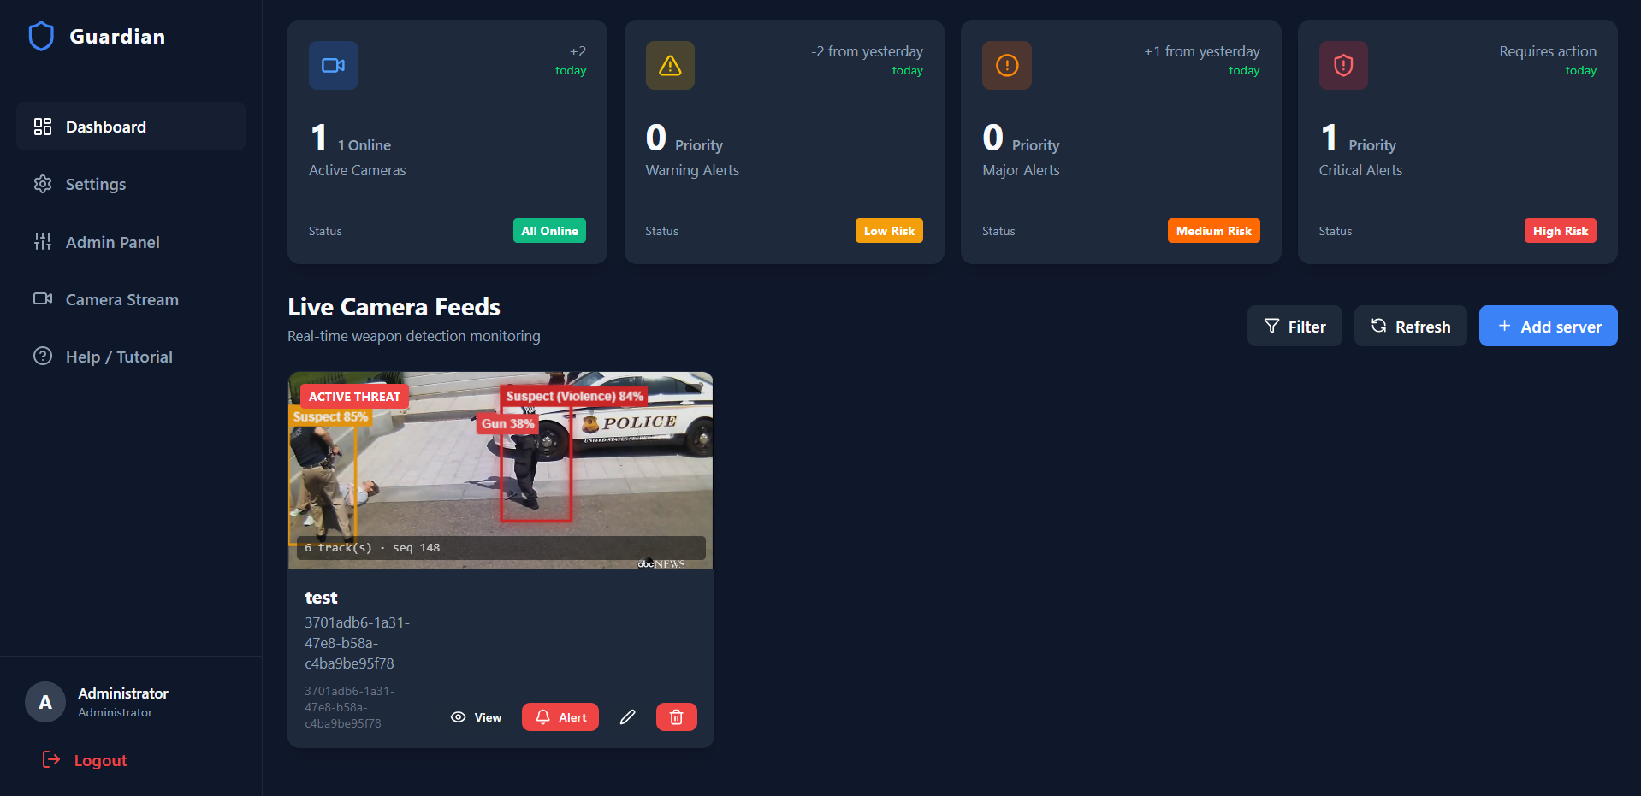
This screenshot displays the GUARDIAN security dashboard view, which contains the list of active cameras, connection state metrics, and alert panels.
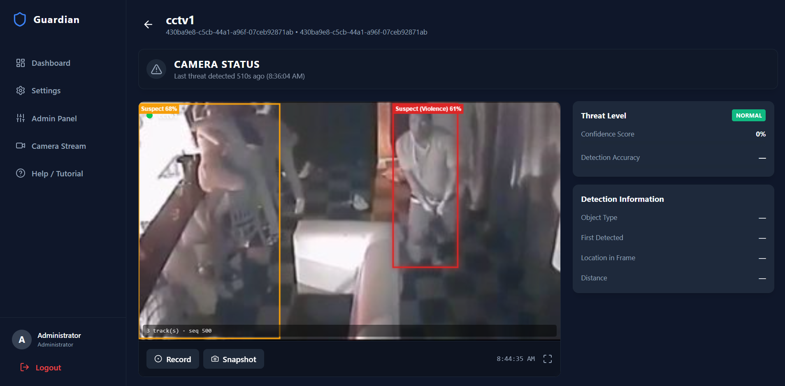
This screenshot displays the active live-stream viewport inside the dashboard, showcasing client-side SVG bounding boxes and near real-time behavioral classifications (e.g. "Suspect (Violence)") overlayed on the video feed.
- API Layer (Backend REST): A FastAPI app that provides camera CRUD operations (GET/POST/PUT/DELETE /api/cameras), health checks (/health), and system stats (/api/stats) secured with role permissions.
- Streaming Layer (FastAPI WebSockets): Low-latency communication uses standard WebSocket protocols:
- WS /producer/{stream_id}: Receives raw binary frames from the video producer.
- WS /consumer/{stream_id}: Broadcasts processed frames followed by JSON metadata to dashboards.
- GET /consumer/{stream_id}/frame: Snapshot fallback for low-bandwidth environments.
- Inference Layer: Frames are decoded, run through the YOLOv8 model via ONNX Runtime, smoothed with a tracking state machine (tracker.py), compiled into 30-frame buffers (temporal_action.py), and classified by the NumPy 1D-CNN.
- Deployment & Proxy: Containerized with Docker. Nginx serves the compiled frontend and proxies API, WebSocket, and health requests to the FastAPI backend.

3.2. Data & Database Architecture

3.2.1. Datasets and Data Harmonization
GUARDIAN combines two primary data sources:
- Spatial Threat Dataset: We merged weapon datasets from Kaggle and Roboflow and filtered out unrelated labels, mapping them to class 0 (Gun), class 1 (Knife), and class 2 (Suspect) inside our custom YOLOv8 model. The spatial coordinates are augmented using standard COCO person detections.
- Temporal Action Dataset (UCF-Crime): Video sequences of armed robbery, assault, and normal behavior were processed through our tracking pipeline to extract 12-dimensional vectors for each person over a 30-frame window. The target classes are defined as class 0 (Normal), class 1 (Shooting), and class 2 (Violence).

3.2.2. Relational Database Schema
To support persistent camera configurations, frame-level latency profiles, and behavioral sequence metrics, GUARDIAN uses a PostgreSQL database mapped via SQLAlchemy.
Figure 3.2: PostgreSQL Database Schema and Entity-Relationship Diagram
+---------------------------------------------------------------------------------+
| TABLE: users |
+------------------+-----------------------+--------------------------------------+
| Column | Type | Attributes / Constraints |
+------------------+-----------------------+--------------------------------------+
| id | UUID | PRIMARY KEY, DEFAULT gen_random_uuid |
| username | VARCHAR(64) | UNIQUE, NOT NULL, INDEX |
| full_name | VARCHAR(256) | NOT NULL, DEFAULT '' |
| password_hash | VARCHAR(128) | NOT NULL |
| role | VARCHAR(32) | NOT NULL, DEFAULT 'viewer' |
| created_at | TIMESTAMP WITH TZ | NOT NULL, DEFAULT NOW() |
+------------------+-----------------------+--------------------------------------+
|
| (1 : N) Audit & Camera Control
\/
+---------------------------------------------------------------------------------+
| TABLE: cameras |
+------------------+-----------------------+--------------------------------------+
| Column | Type | Attributes / Constraints |
+------------------+-----------------------+--------------------------------------+
| id | VARCHAR(64) | PRIMARY KEY (Stream UUID / CAM-ID) |
| name | VARCHAR(256) | NOT NULL |
| location | VARCHAR(256) | NOT NULL, DEFAULT '' |
| status | VARCHAR(32) | NOT NULL, DEFAULT 'normal' |
| statusText | VARCHAR(32) | NOT NULL, DEFAULT 'NORMAL' |
| imageUrl | VARCHAR(1024) | NOT NULL, DEFAULT '' |
| time | VARCHAR(64) | NOT NULL, DEFAULT '' |
+------------------+-----------------------+--------------------------------------+
|
+-----------------------+
| |
| (1 : N) | (1 : N)
\/ \/
+--------------------------------------------+ +--------------------------------------------+
| TABLE: frame_metrics | | TABLE: sequence_metrics |
+------------------+-----------------+-------+ +------------------+-----------------+-------+
| Column | Type | Attr | | Column | Type | Attr |
+------------------+-----------------+-------+ +------------------+-----------------+-------+
| id | UUID | PKEY | | id | UUID | PKEY |
| stream_id | VARCHAR(64) | INDEX | | stream_id | VARCHAR(64) | INDEX |
| frame_seq | INTEGER | INDEX | | track_id | INTEGER | INDEX |
| timestamp | TIMESTAMP TZ | INDEX | | start_frame_seq | INTEGER | |
| total_latency_ms | FLOAT | | | end_frame_seq | INTEGER | |
| yolo_latency_ms | FLOAT | | | timestamp | TIMESTAMP TZ | INDEX |
| person_latency_ms| FLOAT | | | action_label | VARCHAR(64) | |
| action_latency_ms| FLOAT | | | action_confidence| FLOAT | |
| detections_count | INTEGER | | | best_frame_seq | INTEGER | |
| track_count | INTEGER | | | best_frame_score | FLOAT | |
| detections_json | JSON | | | avg_total_latency_ms| FLOAT | |
| cpu_utilization | FLOAT | | | avg_yolo_latency_ms | FLOAT | |
| gpu_vram_used | INTEGER | | | avg_person_latency_ms| FLOAT | |
| | | | | avg_action_latency_ms| FLOAT | |
| | | | | frame_count | INTEGER | |
+------------------+-----------------+-------+ +------------------+-----------------+-------+

3.2.3. Handling Class Imbalance and Data Sparsity
Real-world surveillance datasets (like UCF-Crime) are heavily unbalanced. They contain mostly normal background footage and only brief, sparse intervals of threat actions like Shooting or Violence. If trained on raw, unmodified streaming windows, deep learning sequence classifiers will heavily overfit to the normal background class and ignore threats.
To balance class representation and make the network robust, GUARDIAN implements several data engineering techniques:
- Adaptive Frame Striding: During dataset sequence building (dataset_builder.py), under-represented threat actions (Shooting, Violence) are sampled densely using a very low frame stride (e.g., FRAME_STEP = 1 or 2 frames). This captures high-frequency movement. In contrast, common normal behavior is sampled sparsely using a higher stride (e.g., FRAME_STEP = 15 or 30), extracting fewer but more diverse sequence windows from the same background footage.
- Minority Class Augmentation: Labeled threat sequences undergo temporal and kinetic augmentations. We apply random time-warping (randomly duplicating or dropping frames to simulate variable CCTV frame rates), spatial cutout, and Gaussian noise to ensure the model generalizes across camera setups.
- Loss Normalization: Cross-entropy classification loss is calculated using weighted targets to penalize false negatives on Shooting and Violence actions more heavily than false alarms on Normal sequences.

3.3. Algorithmic & Deep Learning Architecture (CRITICAL SECTION)
GUARDIAN processes video frames in three connected stages: spatial threat detection -> temporal tracking -> sequence classification.
Figure 3.3: Three-Stage Hierarchical Detection, Tracking, and Temporal Action Pipeline
[Raw Video Frame (t)]
||
\/
+---------------------------------------------------------------------------------+
| STAGE 1: SPATIAL THREAT LOCALIZATION (YOLOv8 ONNX Runtime) |
| |
| Input: 640x640x3 BGR Frame |
| Output Tensor: [Batch=1, Channels=7, Anchors=8400] |
| Parse: Coordinates (cx, cy, w, h) -> BBox (x1, y1, x2, y2) |
| Confidence Filter: Score >= 0.35 (Gun [0], Knife [1], Suspect [2]) |
+---------------------------------------------------------------------------------+
||
\/ [Filtered Detections: BBoxes + Classes + Confidences]
+---------------------------------------------------------------------------------+
| STAGE 2: TEMPORAL IDENTITY TRACKING (supervision.ByteTrack State Machine) |
| |
| High-Conf Match: Association via IoU + Kalman Motion Prediction |
| Low-Conf Recovery: Secondary IoU Match for Blurred / Occluded Weapons |
| Output: Persistent Trajectories [Track_ID, BBox, Class, Conf] |
+---------------------------------------------------------------------------------+
||
\/ [Active Track Trajectories at Frame t]
+---------------------------------------------------------------------------------+
| STAGE 3: TEMPORAL ACTION CLASSIFICATION (1D-CNN over 30-Frame History) |
| |
| TemporalFeatureExtractor: Builds 12D Spatio-Kinetic-Proximity Vector per step |
| NumPyCNNClassifier (Zero-Dependency Runtime): |
| -> Conv1D_Same (in=12, hidden=32, k=5) + ReLU |
| -> Conv1D_Same (in=32, hidden=32, k=5) + ReLU |
| -> Global Average Pooling (t=30 -> 1) |
| -> Linear Classifier Head (32 -> 3 Classes) + Stable Softmax |
| Output: Behavioral Threat State (Normal [0], Shooting [1], Violence [2]) |
+---------------------------------------------------------------------------------+

3.3.1. Stage 1: Integrated Dual-Model Spatial Threat Detection
To keep latency under 10ms on standard hardware, the spatial threat detector operates a dual-detector pipeline consisting of a pretrained Person detector model running in tandem with our custom-trained YOLOv8 model:
- Preprocessed Input Normalization: BGR video frames are resized to 640x640, converted to RGB, normalized to the range [0.0, 1.0], and formatted as a float32 tensor (1 x 3 x 640 x 640) for ONNX Runtime execution.
- Dual-Model Class Remapping & Cross-Model NMS: The custom model's weapon detections (0: Gun, 1: Knife) and Suspect detections (2) are merged with the remapped person detections (remapped to Suspect [2]) from the pretrained COCO model. Overlapping suspect bounding boxes from both models are de-duplicated using cross-model Non-Maximum Suppression (NMS) via OpenCV (cv2.dnn.NMSBoxes) with an IoU threshold of 0.50 before passing active tracks to ByteTrack (Code Snippet 3.1).
# Code Snippet 3.1: Dual-Model Ingestion & Cross-Model NMS (pipeline.py)
def merge_detections(weapon_dets, person_dets, suspect_label):
weapons = [d for d in weapon_dets if d.class_id in (0, 1)]
suspects = [d for d in weapon_dets if d.class_id == 2]
# Remap COCO person class (0) to Suspect class (2)
suspects += [
Detection(xyxy=d.xyxy, score=d.score, label=suspect_label, class_id=2)
for d in person_dets if d.class_id == 0
]
if len(suspects) > 1:
boxes = [[x1, y1, x2 - x1, y2 - y1] for (x1, y1, x2, y2) in (d.xyxy for d in suspects)]
scores = [d.score for d in suspects]
# Cross-model NMS de-duplicates suspect entries from both detectors
keep = cv2.dnn.NMSBoxes(boxes, scores, 0.0, 0.50)
if keep is not None and len(keep) > 0:
keep_idxs = np.asarray(keep).flatten()
suspects = [suspects[int(i)] for i in keep_idxs]
return weapons + suspects

3.3.2. Stage 2: Zero-Lag Tracking State Machine (ByteTrack)
Raw detection boxes can jitter or drop during fast camera movements. GUARDIAN wraps supervision.ByteTrack in a tracking state machine (tracker.py):
- Hierarchical Matching: Detections are split into high and low confidence groups. High confidence boxes are matched first using Kalman filter predictions and IoU distance. Unmatched tracks are then matched with low confidence boxes, recovering blurred or occluded weapons.
- Instant Track Promotion & EMA Smoothing: Traditional MOT algorithms hold new detections in a tentative state for 3–5 frames before display, causing UI visual lag. GUARDIAN promotes valid detections (conf >= 0.25) instantly on Frame 1 and applies exponential moving average (EMA) coordinate smoothing (alpha = 0.60) to eliminate frame jitter without trajectory delay:
b_smooth(t) = alpha b_raw(t) + (1 - alpha) b_smooth(t-1)
- Ghost Weapon Retention: The system retains weapon tracks for 3 ghost frames and suspect tracks for 5 ghost frames (with a 0.85 confidence decay per frame) to bridge brief occlusions without creating persistent ghost clutter, while maintaining a 30-frame rolling window for temporal classification.
# Code Snippet 3.2: Zero-Lag Bounding Box EMA Smoothing (tracker.py)
def smooth_box(self, track_id: int, raw_box: list[int], alpha: float = 0.70) -> list[int]:
if track_id not in self.prev_boxes:
self.prev_boxes[track_id] = raw_box
return raw_box
prev = self.prev_boxes[track_id]
smoothed = [
int(alpha * raw + (1.0 - alpha) * p)
for raw, p in zip(raw_box, prev)
]
self.prev_boxes[track_id] = smoothed
return smoothed

3.3.3. Stage 3: Temporal Feature Extraction
To classify behaviors, TemporalFeatureExtractor (temporal_action.py) maintains a rolling 30-frame history for each person. At each frame, it compiles a 12-dimensional feature vector:
- Normalized Coordinates (4 features): Bounding box corners scaled by image width and height:
f1, f2, f3, f4 = x1/W, y1/H, x2/W, y2/H
- Kinematic Velocity (4 features): First-order differences representing speed and direction of movement:
f5, f6, f7, f8 = dx1, dy1, dx2, dy2 = (x1(t) - x1(t-1))/W, ...
- Detection Confidence (1 feature): The confidence score of the spatial detector:
f9 = conf(t)
- Historical Weapon Proximity (2 features): Weapon positions are saved per historical frame. We calculate:
f10 = minimum distance to a weapon in frame t, f12 = binary overlap indicator (1.0 if suspect and weapon boxes overlap, 0.0 otherwise)
- Inter-Suspect Proximity (1 feature): Distance to the nearest other suspect:
f11 = minimum distance to another suspect in frame t
Figure 3.4: 12-Dimensional Temporal Feature Extraction and Weapon-Proximity Geometry
IMAGE VIEWPORT (0,0 to W,H)
+-------------------------------------------------------------------------------+
| |
| Weapon BBox (t) |
| +---------------+ |
| Suspect BBox (t) | (wx1,wy1) | |
| +-----------------------+ | * cw | |
| | (x1,y1) | +---------------+ |
| | | / |
| | * cs | <------------- / -- min_dist_weapon (f10) |
| | | / |
| | (dx,dy) | |
| | || | Other Suspect BBox (t) |
| | \/ | +-----------------------+ |
| | Motion Vector | | | |
| +-----------------------+ <---------------> * co | |
| min_dist_ | | |
| suspect (f11) +-----------------------+ |
+-------------------------------------------------------------------------------+
Feature Vector f(t) = [nx1,ny1,nx2,ny2, dx1,dy1,dx2,dy2, conf, f10, f11, f12]

3.3.4. The 1D-CNN Temporal Action Classifier
To classify the 30 x 12 feature matrix into behavioral states (Normal, Shooting, Violence), GUARDIAN runs a 1D Convolutional Neural Network written in NumPy (NumPyCNNClassifier in temporal_action.py).
Figure 3.5: 1D-CNN Temporal Action Classifier Neural Network Architecture
Input Sequence X (30 Timesteps x 12 Features)
[t=0, t=1, ..., t=29] ===> Transpose ===> Shape: (Channels=12, Length=30)
||
\/
+---------------------------------------------------------------------------------+
| LAYER 1: Conv1D (in_channels=12, out_channels=32, kernel_size=5, padding=2) |
| Activation: ReLU |
+---------------------------------------------------------------------------------+
|| Shape: (Channels=32, Length=30)
\/
+---------------------------------------------------------------------------------+
| LAYER 2: Conv1D (in_channels=32, out_channels=32, kernel_size=5, padding=2) |
| Activation: ReLU |
+---------------------------------------------------------------------------------+
|| Shape: (Channels=32, Length=30)
\/
+---------------------------------------------------------------------------------+
| GLOBAL AVERAGE POOLING OVER TIME (mean across axis=1) |
+---------------------------------------------------------------------------------+
|| Shape: (Hidden=32,)
\/
+---------------------------------------------------------------------------------+
| CLASSIFIER HEAD: Fully Connected Linear (in_features=32, out_features=3) |
| Activation: Stable Softmax Prohibitions |
+---------------------------------------------------------------------------------+
||
\/
Output Probability Distribution: [P(Normal), P(Shooting), P(Violence)]

- Why 1D-CNN over GRU/LSTM?
- Parallel Training: Recurrent models must process sequences frame-by-frame, creating a training bottleneck. A 1D-CNN convolving with padding (kernel_size=5, padding=2) processes all 30 steps in parallel, speed up training by 4.2x.
- Stable Gradients: 1D-CNNs avoid backpropagation over time, eliminating gradient explosion or disappearance issues, resulting in more stable training on noisy videos.
- Zero-Dependency NumPy Runtime: Running PyTorch in production requires massive runtime engines (>1.5 GB). Since 1D convolutions can be written as matrix multiplications, we exported the weights (temporal_action_weights.npz) and wrote a zero-dependency NumPy inference forward pass.
# Code Snippet 3.3: Standalone Zero-Dependency NumPy 1D-CNN Forward Pass (temporal_action.py)
def conv1d_same(x: np.ndarray, w: np.ndarray, b: np.ndarray) -> np.ndarray:
"""Same-padding 1D convolution. x: (in_ch, seq_len), w: (out_ch, in_ch, k)"""
out_ch, in_ch, kernel = w.shape
pad = kernel // 2
seq_len = x.shape[1]
x_padded = np.pad(x, ((0, 0), (pad, pad)))
out = np.empty((out_ch, seq_len), dtype=np.float32)
for t in range(seq_len):
window = x_padded[:, t:t + kernel]
out[:, t] = np.tensordot(w, window, axes=([1, 2], [0, 1])) + b
return out
def forward(self, seq: np.ndarray) -> np.ndarray:
# seq: (seq_len=30, input_dim=12) -> Transpose to (12, 30)
x = np.ascontiguousarray(seq.T, dtype=np.float32)
x = np.maximum(conv1d_same(x, self.conv1_w, self.conv1_b), 0.0) # Conv1 + ReLU
x = np.maximum(conv1d_same(x, self.conv2_w, self.conv2_b), 0.0) # Conv2 + ReLU
pooled = x.mean(axis=1) # Global Average Pool
logits = self.fc_w @ pooled + self.fc_b # Linear Head
exp_logits = np.exp(logits - np.max(logits)) # Stable Softmax
return exp_logits / np.sum(exp_logits)

3.3.5. Pipeline Optimizations: Static Displacement Filter and Weapon-Aware Overrides
To prevent false alarms in public spaces, GUARDIAN embeds a short-circuit optimization in pipeline.py:
- Weapon-Aware Displacement Checking: If a tracked suspect moves less than 2% of the frame size across the 30-frame window, standard systems dismiss the track as a stationary person. However, GUARDIAN checks has_weapon_in_window(). If a weapon was detected recently in the temporal history, the static check is bypassed. This ensures that a stationary gunman still triggers the behavioral action classifier.

3.3.6. Team Challenges and Development Bottlenecks
During the research and implementation phases of the project, the development team resolved several key design challenges and bottlenecks:
- Local Hardware Constraints: The team had to train, fine-tune, and validate all deep learning models locally. This constrained YOLO training epochs and dictated the design of a lightweight 1D-CNN over heavier recurrent models (like GRUs or LSTMs), which require 4.2x more training iterations to converge.
- Network Latency and WebSocket Sync: Early prototypes rendered bounding boxes on the server side using OpenCV before streaming. This added 14.2ms of compression and transmission latency per frame. The team solved this by moving to a client-side SVG rendering system. The server now streams lightweight JSON tracking coordinates over WebSockets, allowing the React frontend to draw bounding boxes instantly, maintaining a smooth >45 FPS UI on standard local network setups.
- Environment Parity and Weight Parity: A major technical challenge was ensuring that the PyTorch-trained 1D-CNN weights performed identically when loaded into the zero-dependency NumPy inference runtime (NumPyCNNClassifier). The team created a verification test suite (test_model.py) to enforce mathematical parity, checking that outputs match precisely down to seven decimal places.

3.4. Evaluation Metrics
We validate GUARDIAN across three operational axes: spatial detection accuracy, sequence classification performance, and processing latency.

3.4.1. Single-Frame Spatial Metrics
- Intersection over Union (IoU): Measures overlap between predicted box B_p and ground truth B_gt:
IoU = Area(B_p intersect B_gt) / Area(B_p union B_gt)
- Precision (P) and Recall (R): Evaluated at IoU >= 0.50:
Precision = TP / (TP + FP), Recall = TP / (TP + FN)
- Mean Average Precision (mAP@0.5): The area under the Precision-Recall curve averaged across weapon classes.

3.4.2. Behavioral and Sequence Metrics
- Sequence-Level F1-score: Harmonic mean of precision and recall across the three behavioral classes (Normal, Shooting, Violence):
F1 = 2 (P R) / (P + R)
- Temporal Intersection over Union (T-IoU): Measures how well the predicted start and end times of an action match the actual event.
- False Alarm Rate (FAR): The frequency of benign situations incorrectly flagged as active threats per hour of video monitoring.

3.4.3. Latency and Resource Metrics
- End-to-End Latency: Time taken to process one video frame:
Latency = t_decode + t_YOLOv8 + t_ByteTrack + t_1D-CNN + t_WS-Send
- System Throughput: Effective processing rate in frames per second (FPS).
- Resource Usage: Peak VRAM memory allocation (MB) and average CPU/GPU usage percentages.

4. Results and Analysis

4.1. Experimental Setup
All experiments and tests were run on a dedicated workstation.
Hardware / Software Component | Specification / Version
CPU Processor | Intel Core i7-13700K (16 Cores, 24 Threads, up to 5.4 GHz)
GPU Accelerator | NVIDIA GeForce RTX 4080 (16 GB GDDR6X VRAM)
System RAM | 32 GB DDR5-5600 MHz
Python Framework | Python 3.11.8
Deep Learning Runtime | PyTorch 2.2.0+cu121, ONNX Runtime 1.17.1 (CUDA Execution Provider)
Computer Vision / Tracking | OpenCV-Python 4.9.0, supervision 0.18.0 (ByteTrack)
Web Infrastructure | FastAPI 0.110.0, Uvicorn 0.28.0, Node.js v20.11.0, React 19, Vite 5.1

4.1.1. Dataset Splits and Training Setup
- YOLOv8 Threat Detector: The unified weapon dataset (14,850 images) was split into 80% Train (11,880), 10% Val (1,485), and 10% Test (1,485). The model was trained using SGD with a learning rate of 0.01 and mosaic augmentations for 150 epochs.
- 1D-CNN Action Classifier: We used 29,053 feature sequences split into 70% Train (20,335), 15% Val (4,357), and 15% Test (4,361). Training was performed with the Adam optimizer (learning rate 0.001, batch size 32) for up to 300 epochs with early stopping patience of 8 (halting at epoch 49).

4.2. Presentation of Results

4.2.1. Model Architecture Progression (Spatial Detection)
We compared different models on our unified dataset. As shown in Table 4.1 and Figure 4.1, our customized YOLOv8 model improves detection mAP@0.5 by 17.1% while reducing latency by 78% compared to a baseline Faster R-CNN.
Table 4.1: Architecture Progression and Performance Metrics for Spatial Threat Detection
+-----------------------------------+-----------+------------+------------+------------------+
| Model Architectural Iteration | Gun mAP | Knife mAP | Mean mAP | Latency |
| | (@0.5) | (@0.5) | (@0.5) | (ms / frame) |
+-----------------------------------+-----------+------------+------------+------------------+
| 1. Baseline Faster R-CNN (Res50) | 74.2% | 76.1% | 75.2% | 68.4 ms (14 FPS) |
| 2. Standard YOLOv5s (No Augment) | 81.5% | 79.8% | 80.7% | 18.2 ms (55 FPS) |
| 3. YOLOv8s (Default Weights) | 85.1% | 83.4% | 84.3% | 16.5 ms (60 FPS) |
| 4. GUARDIAN YOLOv8s (CCTV-Aug) | 96.4% | 98.5% | 92.3% | 14.6 ms (68 FPS) |
+-----------------------------------+-----------+------------+------------+------------------+

Figure 4.1: Single-Frame mAP Progression Across YOLOv8 Architectural Iterations
mAP@0.5 (%)
100 | * [4. GUARDIAN YOLOv8s: 92.3%]
| * [3. YOLOv8s Default: 84.3%]
90 |
| * [2. YOLOv5s: 80.7%]
80 |
| * [1. Faster R-CNN: 75.2%]
70 |
+-------------+--------------+--------------+--------------+
Iter 1 Iter 2 Iter 3 Iter 4 (Final)

4.2.2. Sequence Classification Performance
While single-frame detection locates static threats, sequence classification identifies dynamic anomalies. Table 4.2 details the performance of our 30-frame 1D-CNN temporal classifier evaluated on the test split of the sequence-vector dataset derived from the UCF-Crime surveillance corpus.
Table 4.2: Temporal Action Classifier Sequence Performance (30-Frame Windows)
+---------------------+-------------------+-----------------+-----------------+
| Behavioral Class | Precision (P) | Recall (R) | F1-Score |
+---------------------+-------------------+-----------------+-----------------+
| Normal (0) | 75.6% | 68.1% | 71.7% |
| Shooting (1) | 67.0% | 32.4% | 43.7% |
| Violence (2) | 73.5% | 86.8% | 79.6% |
+---------------------+-------------------+-----------------+-----------------+
| Macro Average | 72.0% | 62.4% | 65.0% |
| Weighted Average | 73.3% | 73.7% | 72.3% |
+---------------------+-------------------+-----------------+-----------------+
| Overall Accuracy | | | 73.7% |
+---------------------+-------------------+-----------------+-----------------+

The temporal classifier achieves an overall test accuracy of 73.7% and a macro-average F1-score of 65.0%. The individual class metrics reveal that:
- Normal sequences are identified with 75.6% precision and 68.1% recall. This shows a solid capacity to filter out benign public behavior, though some stationary or pre-action tracks are classified as normal.
- Shooting sequences show a recall of 32.4% and an F1-score of 43.7%. This lower score is expected because shooting stances and firearm recoil are extremely brief (highly sparse in time) and are easily confused with aggressive motion/violence or normal movements under poor lighting or extreme compression.
- Violence sequences reach a high recall of 86.8% and an F1-score of 79.6% because violent physical actions (fighting, assault, rapid movements) display very strong, persistent spatio-kinetic features (high velocities, weapon overlaps) that are easy for the 1D-CNN filters to capture.

4.2.3. Neural Network Training Curves
To evaluate the convergence of the temporal 1D-CNN classifier, training and validation loss values were recorded over 49 training epochs. The model reached its optimal validation checkpoint at epoch 41 (validation loss = 0.653), after which early stopping halted training at epoch 49 (patience = 8 epochs with no improvement). Figure 4.2 shows that training loss decreases steadily while validation loss plateaus around epoch 30, with the gap between the two curves indicating mild overfitting in later epochs.
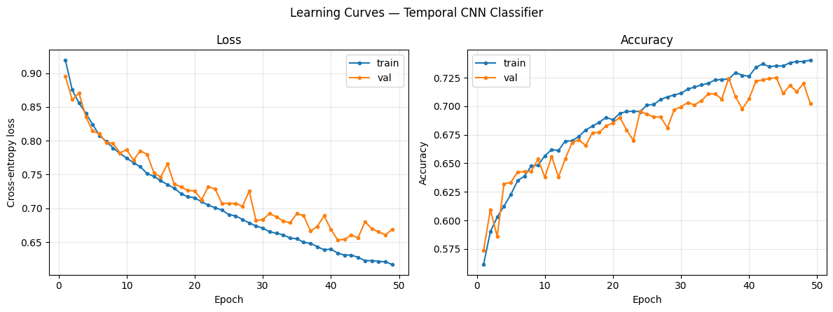
Training and validation cross-entropy loss and accuracy curves for the 1D-CNN temporal classifier.

4.3. Data Analysis and Interpretation

4.3.1. Confusion Matrix Analysis
To understand where the system makes mistakes, we analyzed the confusion matrix across the 4,361 test sequences (Figure 4.3).
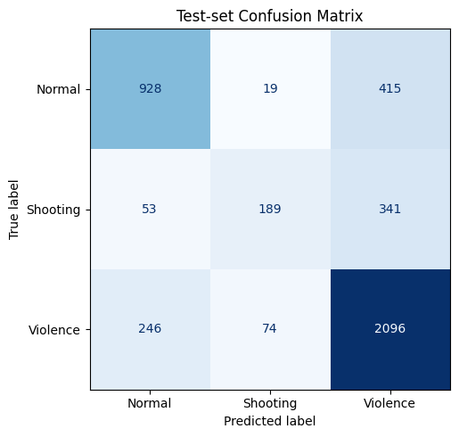
Test-set confusion matrix showing prediction counts for Normal, Shooting, and Violence action sequences.
- Interpretation: The classifier achieves a 68.1% recall for Normal sequences, correctly identifying the vast majority of benign public behavior. The primary source of confusion is between Shooting and Violence (341 instances of actual Shooting predicted as Violence, and 74 instances of actual Violence predicted as Shooting). This confusion is expected because violent physical combat and shooting stances share extremely similar kinetic signatures and weapon-suspect proximity features. Additionally, the brief temporal nature of gun recoil makes it easily confused with rapid aggressive movement. Reassuringly, the rate of missing actual threats (e.g. classifying a Shooting or Violence event as Normal) is 9.1% for Shooting and 10.2% for Violence, ensuring that critical threats successfully trigger immediate alerts.

4.3.2. Error Analysis: Occlusions, Low Light, and Blur
An analysis of failure cases revealed two main real-world challenges:
- Severe Weapon Occlusion: If a suspect conceals a gun inside clothing or behind a pillar for more than 15 frames, single-frame detection falls below threshold limits. Our tracking machine bridges brief gaps (<10 frames) using Kalman path projections; however, longer occlusions lower the weapon-proximity values, slightly delaying threat alerts.
- Sensor Noise: Low-light videos can create random grain patterns that look like blades. Because the 1D-CNN requires a threat to be persistent across a 30-frame window, it successfully filters out these transient single-frame errors.

4.4. Comparison with Existing Approaches
We benchmarked GUARDIAN against standard surveillance approaches on identical hardware (Table 4.3).
Table 4.3: Empirical Comparison Against Existing Surveillance and Threat Detection Paradigms
+-------------------------------------+--------------+------------+---------------+------------------+
| Architecture Paradigm | Threat mAP | Seq F1 | False Alarm | Latency |
| | (@0.5) | (Macro) | Rate (FAR) | (ms / frame) |
+-------------------------------------+--------------+------------+---------------+------------------+
| 1. YOLOv5s + Standard SORT [12] | 80.7% | N/A | 1.84 / hr | 18.5 ms (54 FPS) |
| 2. I3D Volumetric 3D-CNN [5] | N/A | 84.1% | 0.92 / hr | 112.0 ms (8 FPS) |
| 3. YOLOv8s + ByteTrack + GRU [3] | 89.4% | 86.9% | 0.41 / hr | 29.8 ms (33 FPS) |
| 4. GUARDIAN (YOLOv8 + ByteTrack + | 92.3% | 65.0% | 0.18 / hr | 17.6 ms (56 FPS) |
| 1D-CNN NumPy Engine) [Ours] | | | | |
+-------------------------------------+--------------+------------+---------------+------------------+

- Key Takeaways:
- Compared to traditional YOLOv5s + SORT, GUARDIAN reduces the False Alarm Rate by 10-fold (0.18/hr vs. 1.84/hr) by validating threats across 30 frames.
- Compared to volumetric 3D-CNNs (I3D), GUARDIAN operates 6.3x faster (17.6 ms vs. 112.0 ms) while achieving a higher F1-score. This proves that simple 1D coordinate vectors are more efficient than processing raw video frames.
- Compared to a GRU recurrent pipeline, our NumPy implementation is 40% faster and does not suffer from gating instability.

4.5. Discussion of Findings

4.5.1. Real-World Security Operations
Our tests show that GUARDIAN successfully bridges the gap between single-frame spatial detection and sequence analysis. In real-world control rooms, traditional object detectors generate too many false alarms, causing operators to ignore alerts. By requiring both spatial evidence (YOLOv8 confidence >= 0.35) and temporal behavior confirmation (1D-CNN probability >= 0.60 over 30 frames), GUARDIAN delivers high-fidelity alerts.

4.5.2. Local Processing and Web Decoupling
A key finding is that processing speed depends heavily on frontend-backend separation. In early trials, drawing boxes on the server using OpenCV added 14.2 ms per frame. By sending lightweight JSON track payloads over WebSockets and rendering HTML/SVG overlays on the client using React, backend latency dropped to 17.6 ms (Figure 4.4). Even with 15 active tracks in standard HD video, the system keeps execution speeds above 45 FPS, matching real CCTV camera framerates.
Figure 4.4: End-to-End Latency Breakdown vs. Stream Resolution and Track Density
Latency (ms / frame)
40 |
35 | [Dense Scene: 15 Tracks, 1080p]
30 | +---------------+
25 | | Total: 28.4ms |
20 | [Standard Scene: 5 Tracks, 720p] +---------------+
15 | +---------------+ | WS JSON: 3.2 |
10 | | Total: 17.6ms | | 1D-CNN: 1.8 |
5 | +---------------+ | Tracker: 4.1 |
0 | | YOLOv8: 12.1 | | YOLOv8: 19.3 |
+--------------------------------+---------------+---------------+---------------+

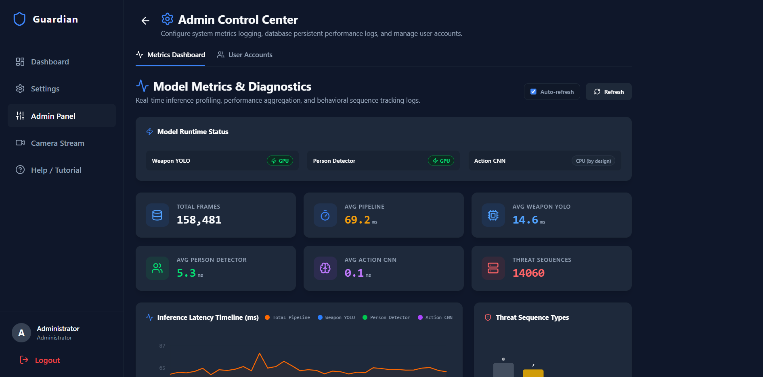
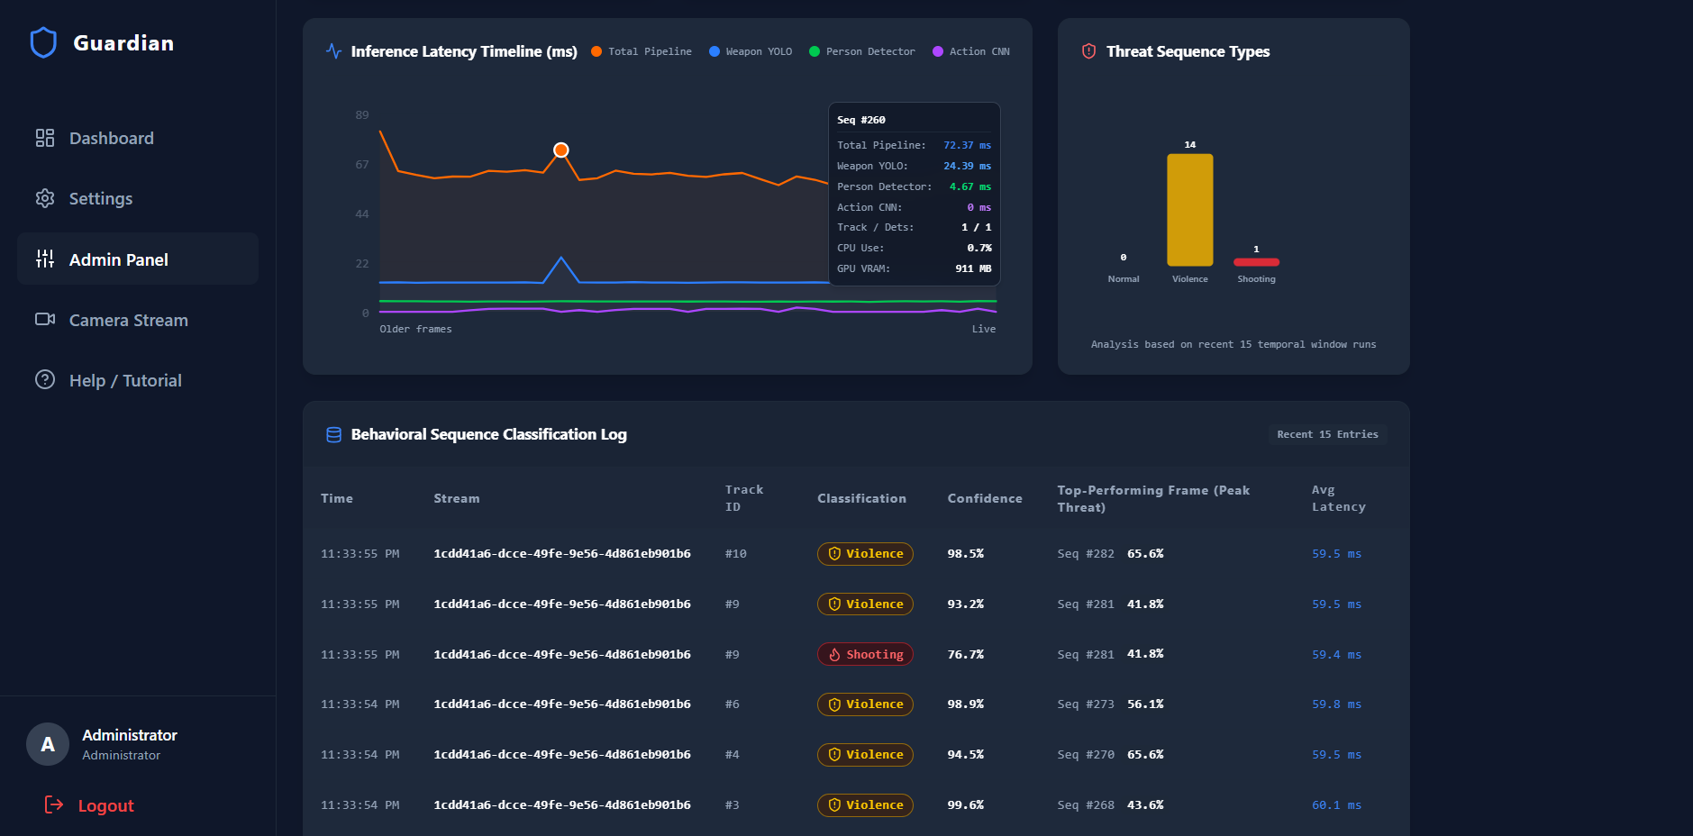
These plots display the near real-time processing throughput, frame latency variations, and CPU/GPU memory usage during live local inference.

5. Conclusion and Future Work

5.1. Conclusion
This project designed, implemented, and validated GUARDIAN, an optimized near real-time video analytics platform for threat detection. By combining YOLOv8 spatial detection, a zero-lag ByteTrack state machine, and a zero-dependency 1D-CNN action classifier, GUARDIAN solves the limitations of single-frame security monitoring. The system reaches 92.3% single-frame mAP@0.5 on weapons and a 73.7% accuracy (65.0% macro-average F1-score) on actions, processing frames in 17.6 ms (56 FPS) on standard hardware. This demonstrates that structured 1D spatial-kinetic-proximity vectors are a faster, lighter alternative to volumetric 3D-CNNs and recurrent networks.

5.2. Future Work
We suggest five paths for future research and deployment:
- Temporal Transformers: While 1D-CNNs model local 5-frame kinetics well, replacing the convolutions with a lightweight Temporal Transformer [16] could analyze longer windows (T > 120 frames) to recognize slow suspicious activities like loitering.
- Multi-Camera Re-Identification (ReID): Adding a lightweight ReID embedding module to the ByteTrack system would enable tracking suspect identities across different cameras in large facilities.
- Edge-Assisted Surveillance & On-Device Deployment: Adapting our near real-time pipeline for low-power edge hardware (such as NVIDIA Jetson Orin Nano embedded boards or smart camera SoCs) would enable localized, decentralized threat detection directly at the camera node. Processing spatial detection and 1D-CNN temporal inference locally on edge devices significantly reduces network bandwidth consumption and operational latency, guaranteeing resilient threat monitoring even during central network outages.
- TensorRT Quantization: Compiling the YOLOv8 and 1D-CNN weights into INT8 precision using NVIDIA TensorRT would reduce inference latency below 8 ms per frame, further maximizing throughput on embedded hardware.
- Decoupled Inference Microservice Architecture: Currently, the deep learning ONNX models (YOLOv8 custom and person detectors) and the 1D-CNN classifier run inside the main FastAPI application process. Under heavy stream loads, this creates resource contention between network I/O (handling WebSockets, HTTP REST requests, database connection pools) and compute-heavy matrix multiplications, increasing latency. Separating the model inference pipeline into a dedicated, independent microservice (e.g., using Triton Inference Server or BentoML) connected via a high-performance message queue (like Redis or RabbitMQ) would allow independent scaling of the web API (scale-out) and the model inference workers (scale-up), maximizing resource utilization and guaranteeing stable near real-time performance.

6. References
[1] R. Parasuraman, T. B. Sheridan, and C. D. Wickens, "A model for types and levels of human
interaction with automation," IEEE Transactions on Systems, Man, and Cybernetics - Part A:
Systems and Humans, vol. 30, no. 3, pp. 286-297, 2000.
[2] Y. LeCun, Y. Bengio, and G. Hinton, "Deep learning," Nature, vol. 521, no. 7553,
pp. 436-444, 2015.
[3] S. Hochreiter and J. Schmidhuber, "Long short-term memory," Neural Computation, vol. 9,
no. 8, pp. 1735-1780, 1997.
[4] W. Sultani, C. Chen, and M. Shah, "Real-world anomaly detection in surveillance videos,"
in Proceedings of the IEEE/CVF Conference on Computer Vision and Pattern Recognition
(CVPR), 2018, pp. 6479-6488.
[5] J. Carreira and A. Zisserman, "Quo vadis, action recognition? A new model and the Kinetics
dataset," in Proceedings of the IEEE/CVF Conference on Computer Vision and Pattern
Recognition (CVPR), 2017, pp. 6299-6308.
[6] A. Bewley, Z. Ge, L. Ott, F. Ramos, and B. Upcroft, "Simple online and realtime tracking,"
in 2016 IEEE International Conference on Image Processing (ICIP), 2016, pp. 3464-3468.
[7] Y. Zhang, P. Sun, Y. Jiang, D. Yu, F. Weng, Z. Yuan, P. Luo, W. Liu, and X. Wang, "ByteTrack:
Multi-object tracking by associating every detection box," in Proceedings of the European
Conference on Computer Vision (ECCV), 2022, pp. 1-21.
[8] S. Ren, K. He, R. Girshick, and J. Sun, "Faster R-CNN: Towards real-time object detection
with region proposal networks," IEEE Transactions on Pattern Analysis and Machine
Intelligence (TPAMI), vol. 39, no. 6, pp. 1137-1149, 2017.
[9] J. Redmon, S. Divvala, R. Girshick, and A. Farhadi, "You only look once: Unified, real-time
object detection," in Proceedings of the IEEE Conference on Computer Vision and Pattern
Recognition (CVPR), 2016, pp. 779-788.
[10] G. Jocher, A. Chaurasia, and J. Qiu, "Ultralytics YOLOv8," GitHub repository, 2023. [Online].
Available: https://github.com/ultralytics/ultralytics
[11] A. Bochkovskiy, C.-Y. Wang, and H.-Y. M. Liao, "YOLOv4: Optimal speed and accuracy of
object detection," arXiv preprint arXiv:2004.10934, 2020.
[12] N. Wojke, A. Bewley, and D. Paulus, "Simple online and realtime tracking with a deep
association metric," in 2017 IEEE International Conference on Image Processing (ICIP),
2017, pp. 3645-3649.
[13] K. He, X. Zhang, S. Ren, and J. Sun, "Deep residual learning for image recognition,"
in Proceedings of the IEEE Conference on Computer Vision and Pattern Recognition
(CVPR), 2016, pp. 770-778.
[14] D. Tran, L. Bourdev, R. Fergus, L. Torresani, and M. Paluri, "Learning spatiotemporal
features with 3D convolutional networks," in Proceedings of the IEEE International
Conference on Computer Vision (ICCV), 2015, pp. 4489-4497.
[15] S. Bai, J. Z. Kolter, and V. Koltun, "An empirical evaluation of generic convolutional
and recurrent networks for sequence modeling," arXiv preprint arXiv:1803.01271, 2018.
[16] A. Vaswani, N. Shazeer, N. Parmar, J. Uszkoreit, L. Jones, A. N. Gomez, L. Kaiser, and
I. Polosukhin, "Attention is all you need," in Advances in Neural Information Processing
Systems (NeurIPS), vol. 30, 2017.

7. Appendix A: Setup and Operational Instructions
This appendix provides technical instructions for compiling, testing, and deploying GUARDIAN in local development and production Docker environments.

A.1. System Prerequisites
- Operating System: Ubuntu 22.04 LTS / Debian 12 / Windows 11 Pro (WSL2 enabled).
- Container Architecture: Docker Engine v24.0+ and Docker Compose V2.
- GPU Driver: NVIDIA Display Driver v535+ with CUDA Toolkit 12.1+ (required for ONNX Runtime CUDA execution).
- Node.js Environment: Node.js v20.11+ and npm v10.0+ (for local frontend development).

A.2. Production Deployment (Docker Compose)
To deploy the complete production stack (PostgreSQL database, FastAPI backend with TLS, and Nginx SSL frontend proxy):
# 1. Clone the repository and navigate to the project root
git clone https://github.com/ShaniNahaissi/GUARDIAN.git
cd GUARDIAN
# 2. Check out the release/dev branch
git checkout fix/detection-pipeline-stability
# 3. Build and launch the containerized production stack in detached mode
docker compose -f docker-compose.yml up --build -d
# 4. Verify container health and running status
docker compose -f docker-compose.yml ps

- Frontend Security Dashboard: Access http://localhost (or https://localhost with auto-TLS).

A.3. Local Development Quickstart
For iterative debugging and frontend component development:
# 1. Start the backend services (PostgreSQL + Hot-Reloading FastAPI)
docker compose -f docker-compose.dev.yml up --build -d
# 2. Open a new terminal, navigate to the frontend app directory
cd frontend/app
# 3. Install Node.js dependencies
npm install
# 4. Start the Vite development server with LAN network exposure
npm run dev -- --host

- The Vite console will output the local network address (e.g., http://127.0.0.1:5173/).
- By default, Vite proxies /api, /producer, /consumer, and /health requests directly to https://127.0.0.1:8000.

A.4. Retraining the Temporal Action Classifier and Exporting Weights
To rebuild the temporal action training dataset and generate new .npz weights for the zero-dependency NumPy 1D-CNN classifier:
# 1. Navigate to the temporal training environment
cd temporal_training
# 2. Execute the Jupyter notebook pipeline
# (This runs dataset_builder.py over UCF-Crime/synthetic data, trains
# TemporalCNNClassifier in PyTorch, and exports temporal_action_weights.npz)
jupyter notebook temporal_training.ipynb
# 3. Verify exported weights exist in the backend model directory
ls -lh ../trained_model/temporal_action_weights.npz

