Student Details
ID#: 2404262
Name: Shania Foster
Assignment : Individual Assignment #2
Day/ Time: Friday 12pm
Module Name: Web Programming CIT2011

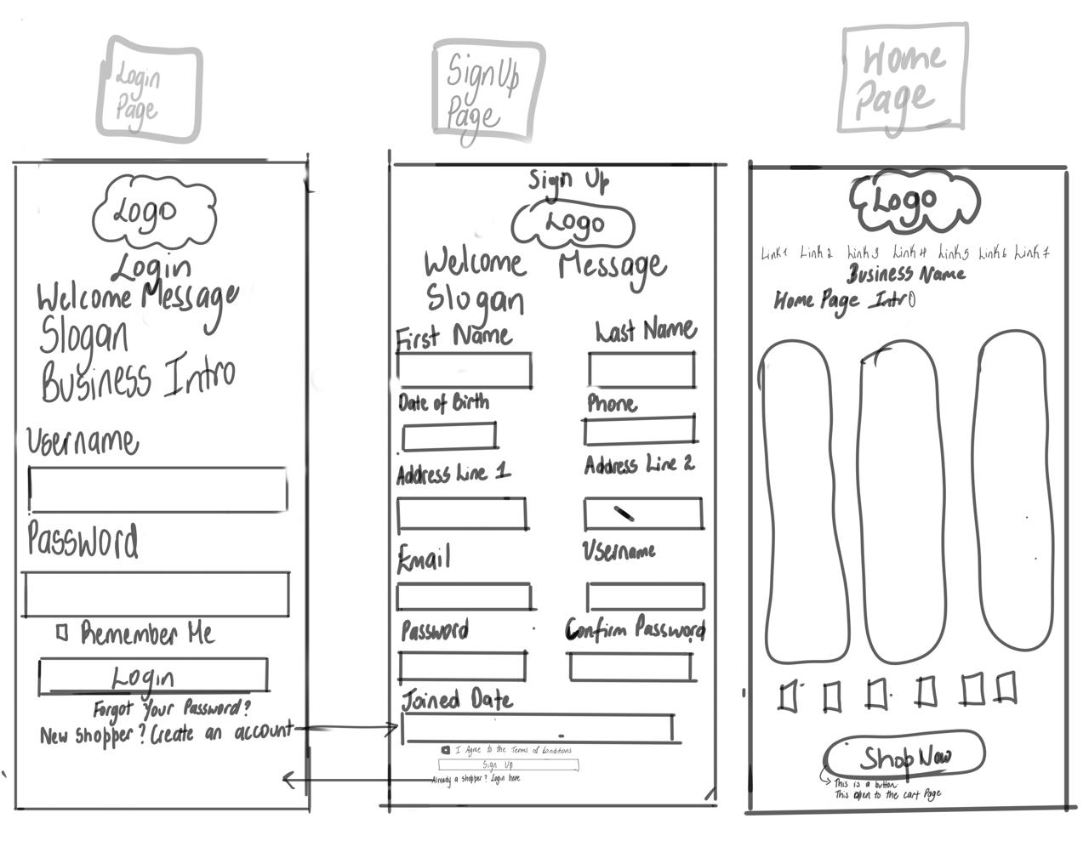

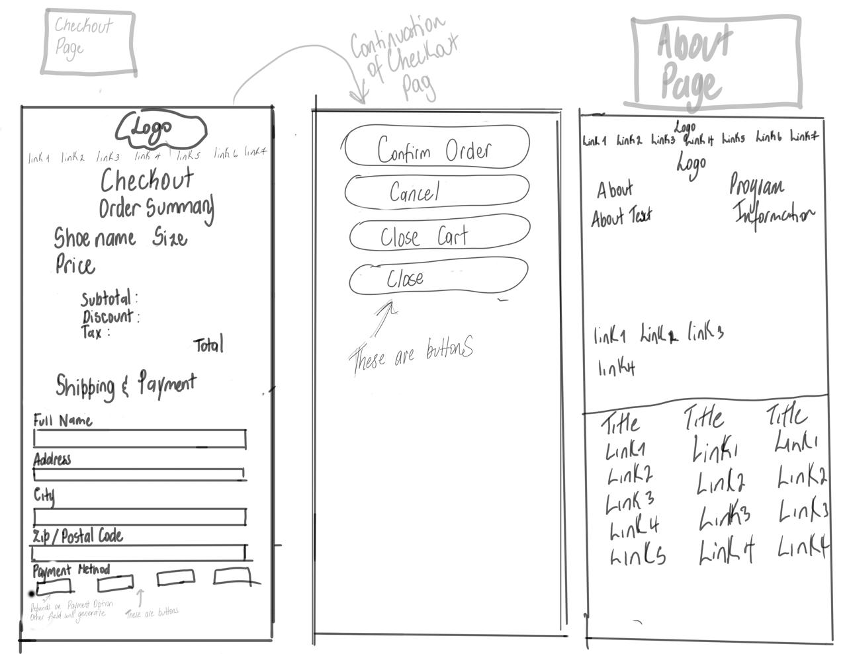

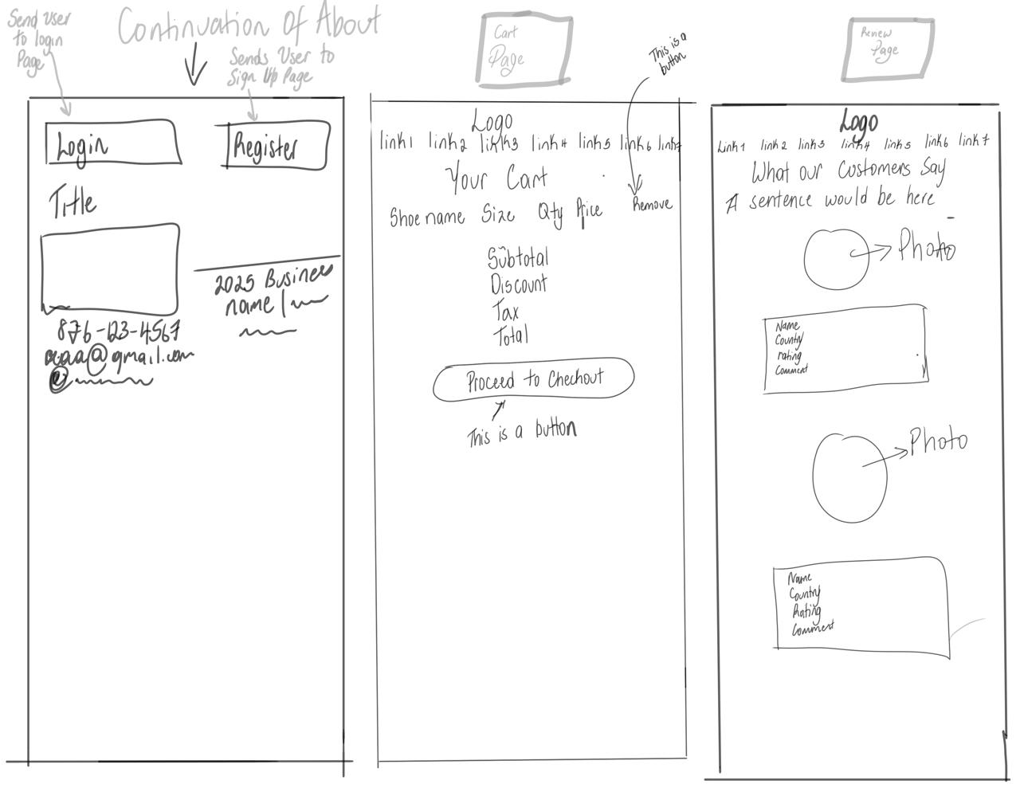

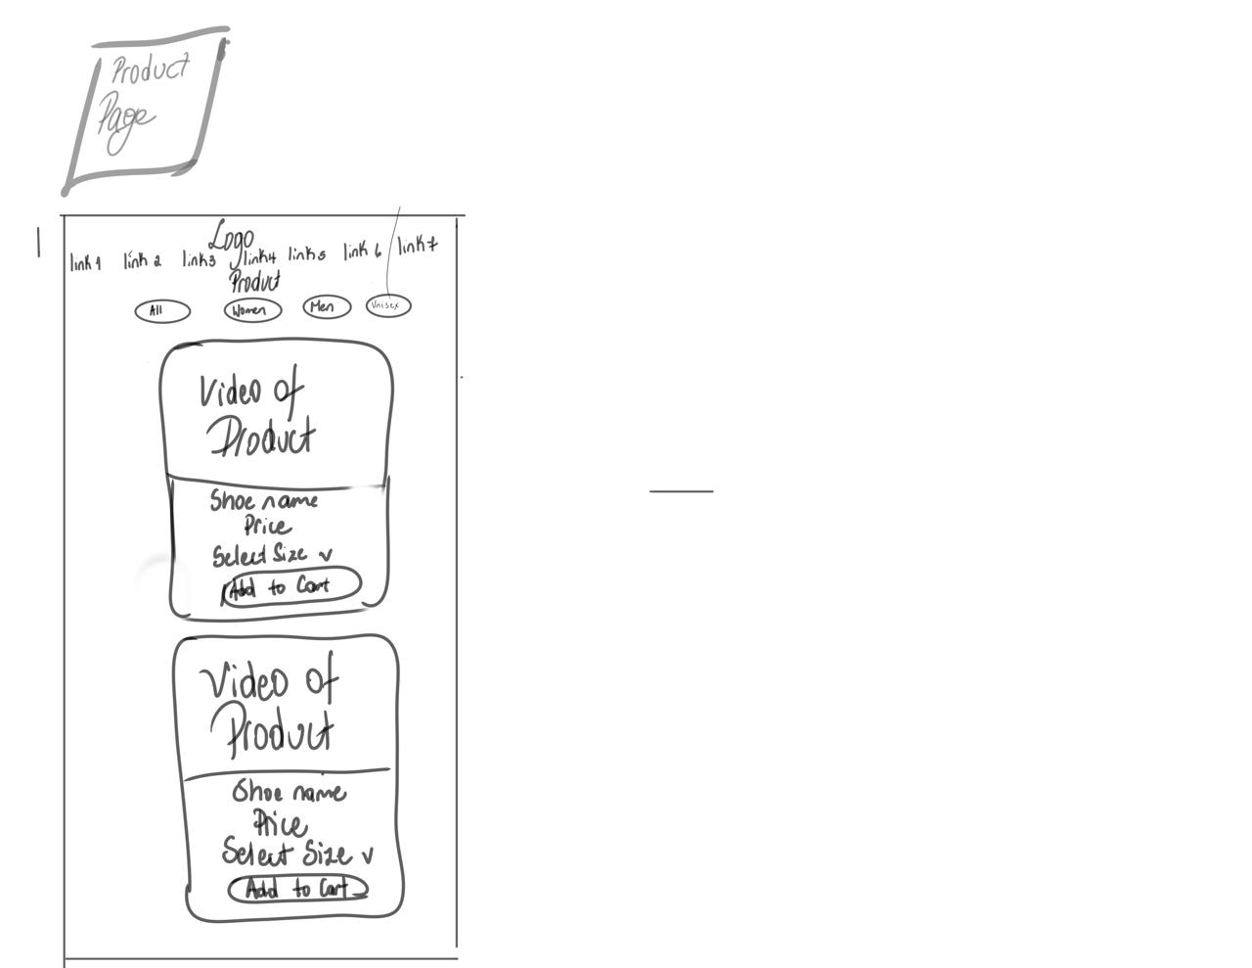

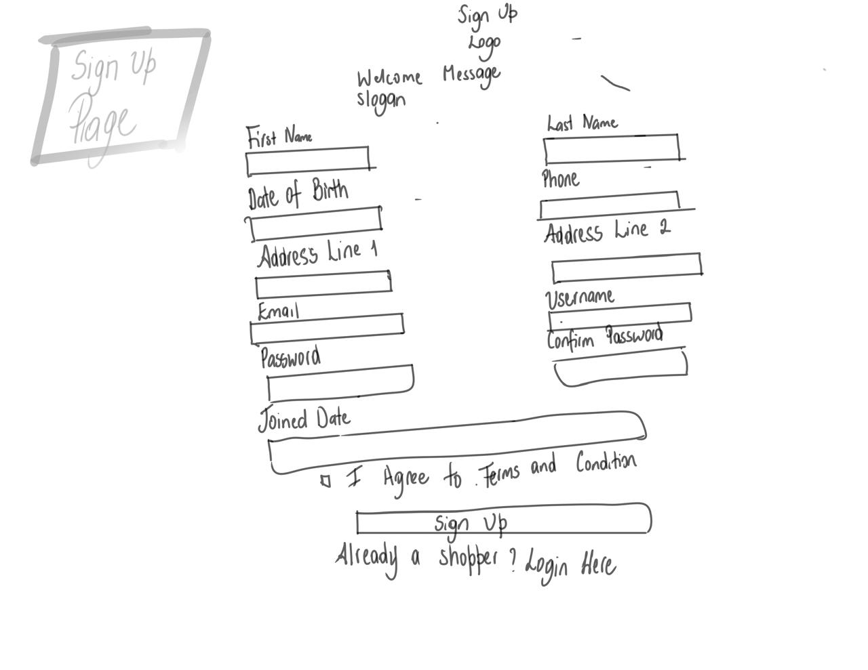
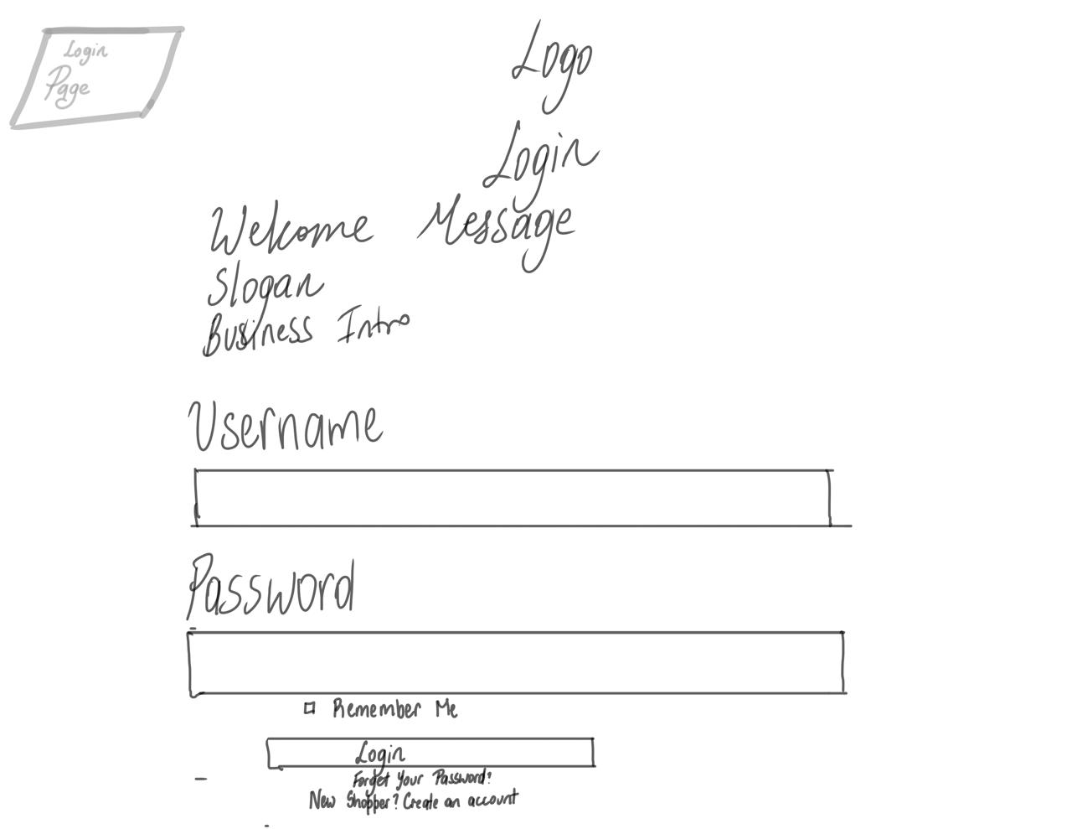
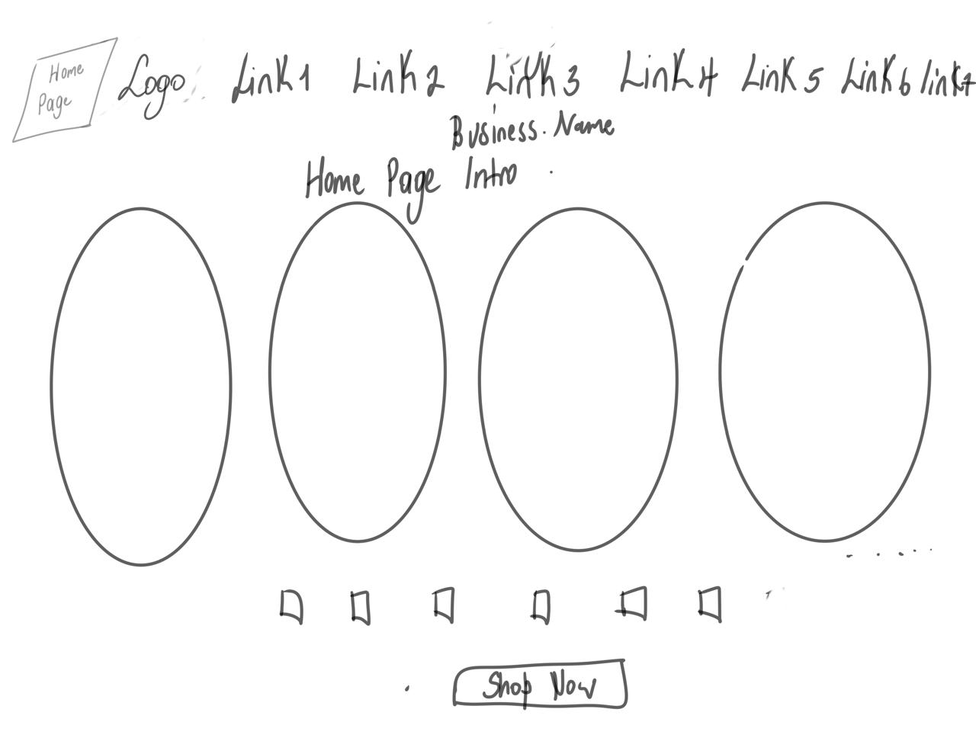
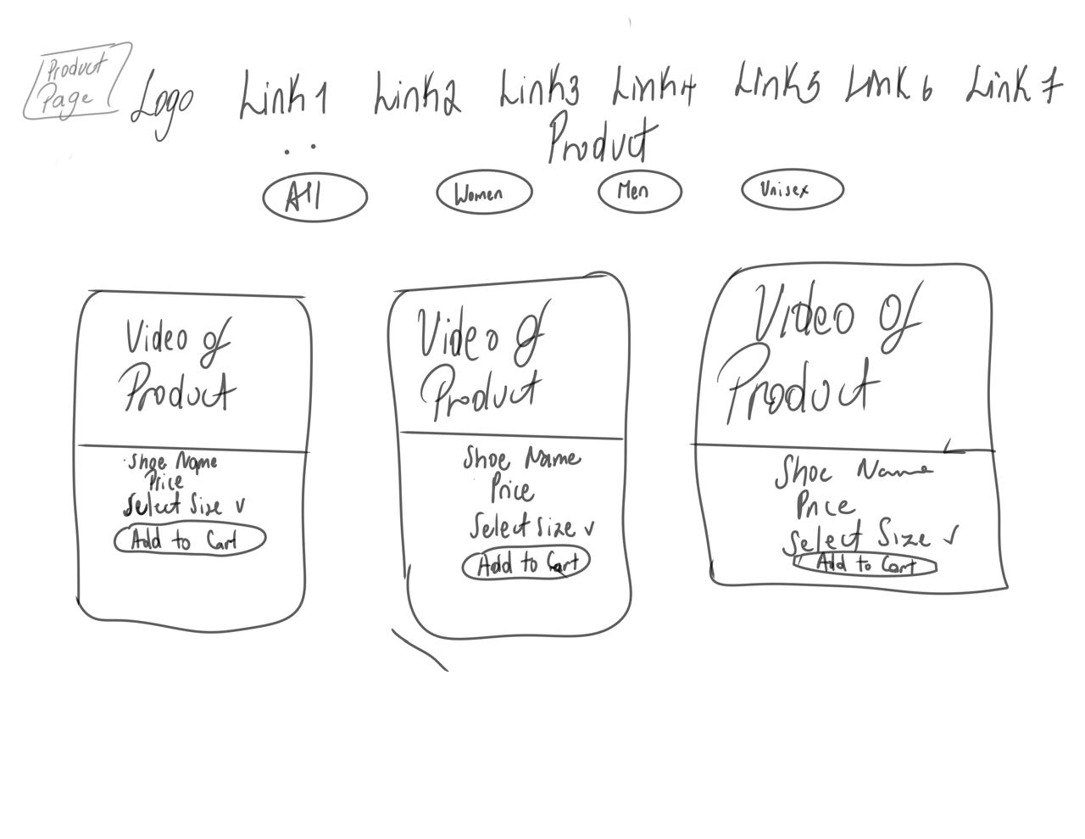
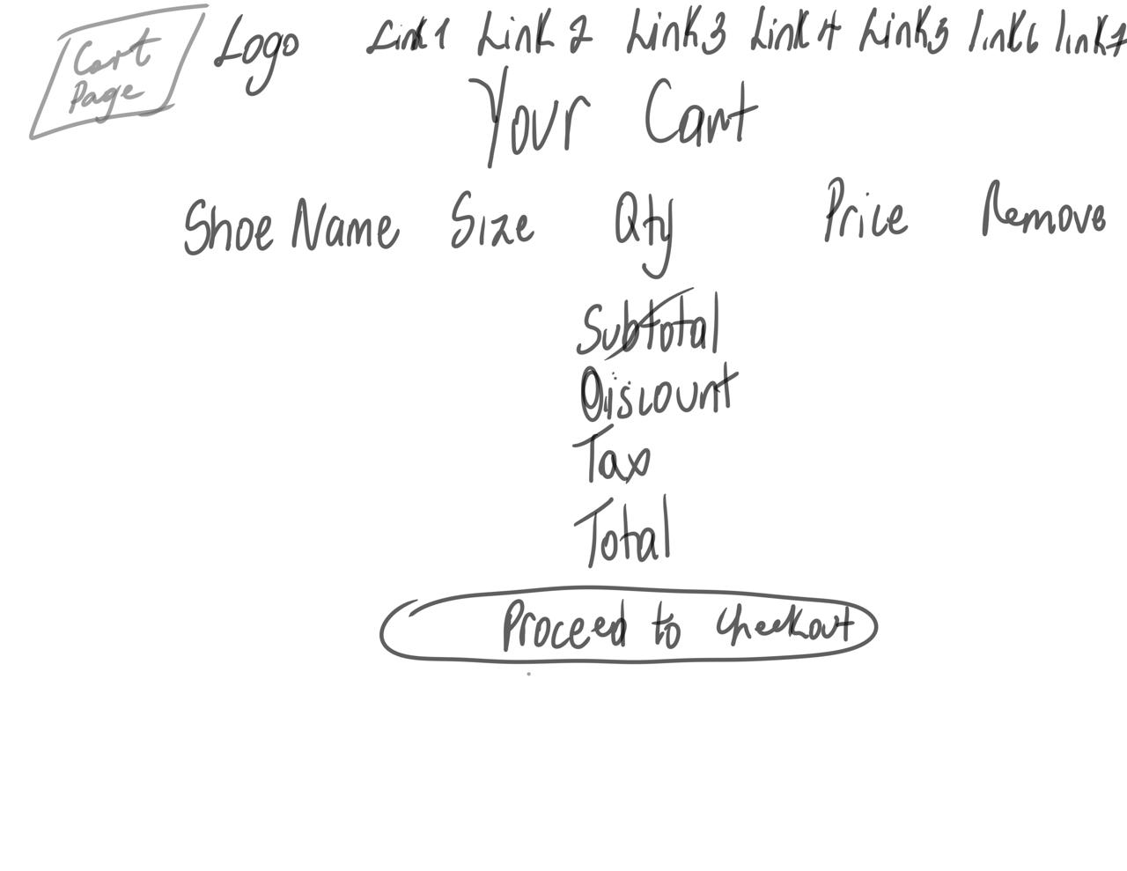
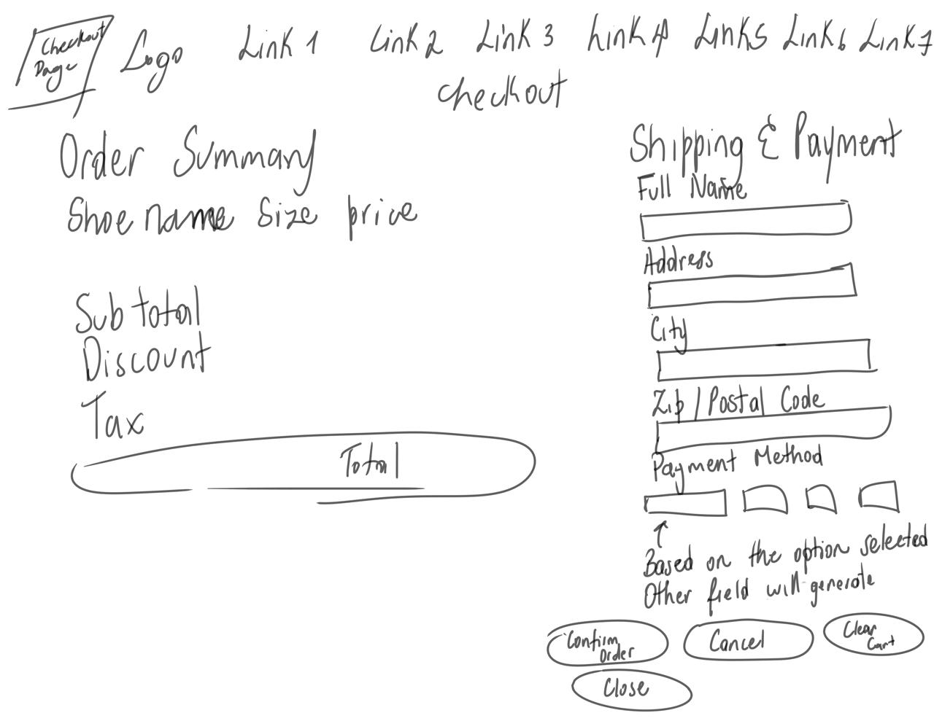
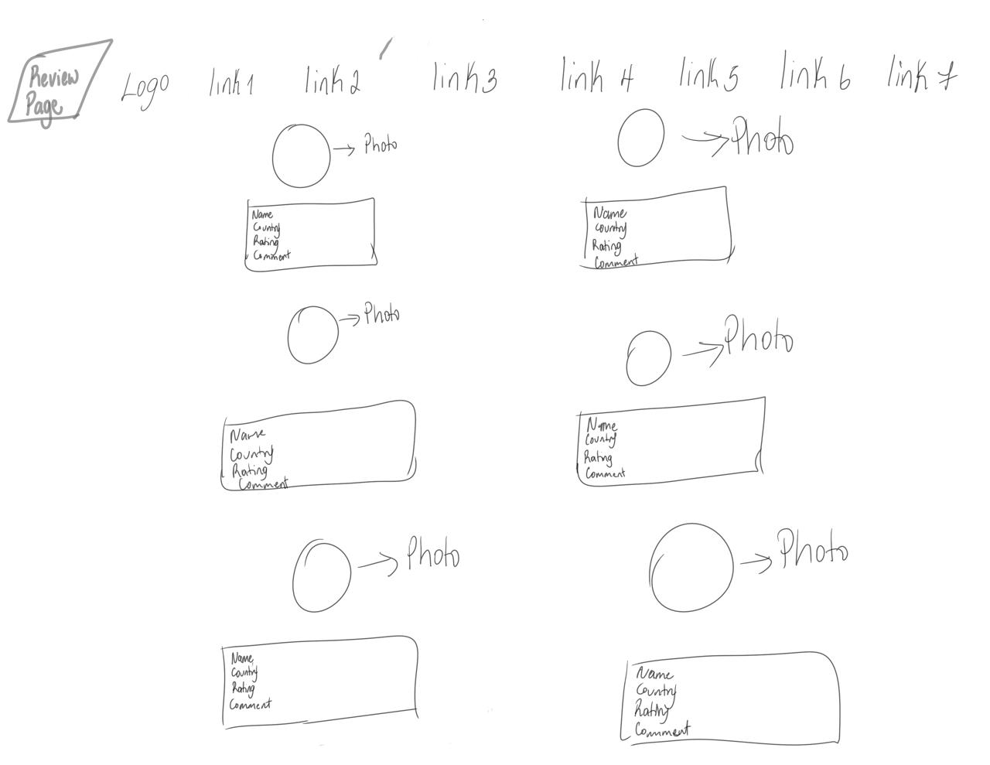
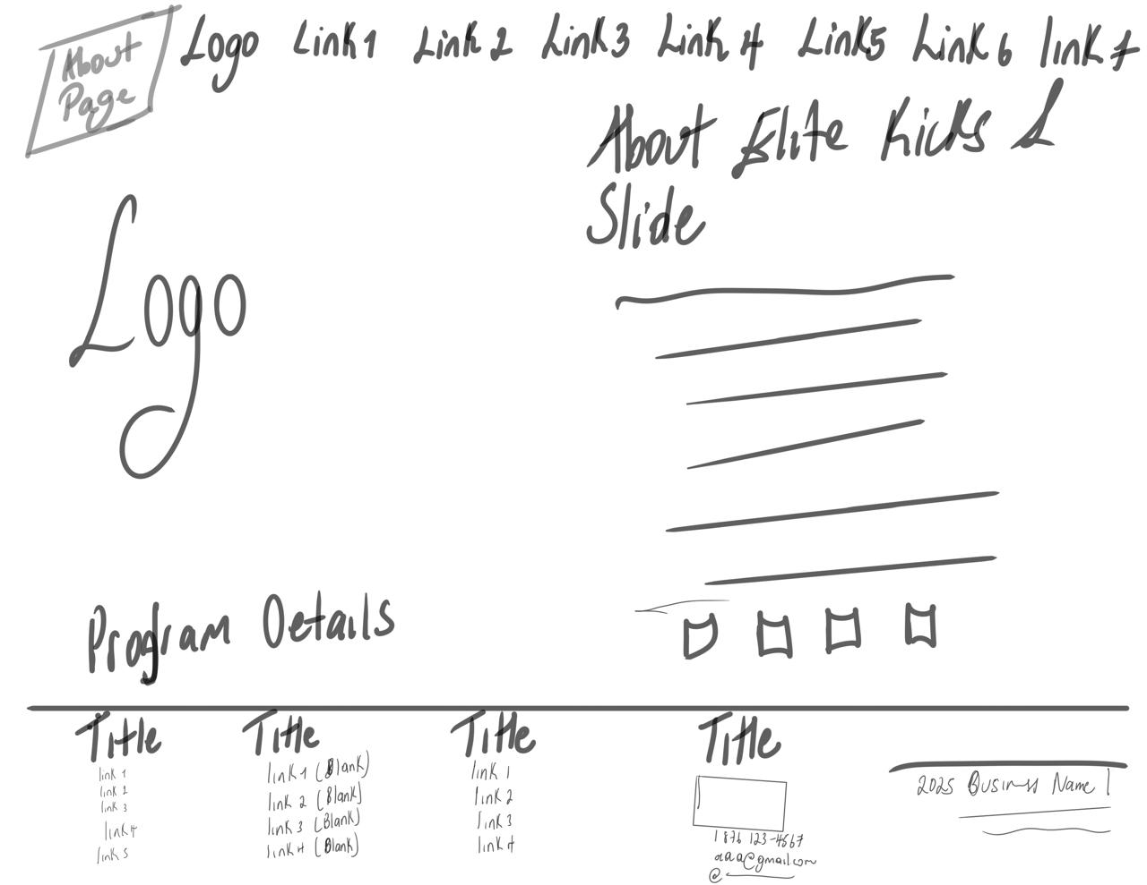


Logo



Mission Statement
Our mission is to blend style, comfort, and authenticity to make sure you look and feel your best. We bring you the latest footwear trends for every occasion — from bold streetwear to sleek casuals.

Description of Business
Welcome to Elite Kicks & Slides — your one-stop online store for premium, authentic footwear in Jamaica. We’re passionate about giving both men and women access to the hottest sneakers, slides, and slippers with unmatched quality.

Slogan
Step up your style with premium sneakers & slides for all.

Include a brief justification of the color palette you chose for your website
I chose a blue and white color palette for my e-commerce store because these colours create a clean, modern, and professional look that helps build trust with customers. Blue is commonly associated with reliability, security, and calmness, which makes shoppers feel more comfortable when browsing and making purchases online. The white background adds simplicity and allows the products to stand out clearly without distractions. Together, blue and white create a smooth and visually appealing shopping experience that encourages customers to stay on the site longer and view more items.

Hosting Link

Reference
Miss the videos and photo when I try to turn them into a source I am getting an error.

