OBJECT-ORIENTED PROGRAMMING PROJECT
GROUP 2
HOSPITAL OUTPATIENT MANAGEMENT SYSTEM
Short Design and Implementation Report
Group Members: ______________________________________________
Access Numbers: _____________________________________________
Python Implementation | UML Design | OOP Concepts | Validation & Testing

1. Project Overview
Project scenario. The system is a small outpatient management application for registering patients and health workers, creating consultations, recording complaints and dates, tracking consultation status, calculating service charges, searching records, and viewing patient consultation history and summary information.
Implementation approach. The solution is implemented in Python using multiple collaborating classes rather than placing all logic in the menu. Records are persisted in a JSON data file, while service charges are stored in a separate JSON configuration file so that the application is not dependent on patient records or monetary values hard-coded into the source code.

2. Functional Requirements Implemented
- Register patients and automatically assign unique patient IDs such as P0001, P0002, and so on.
- Register health workers as Doctor, Nurse, or Clinical Officer and automatically assign unique worker IDs.
- Create a consultation that links one registered patient to one registered health worker.
- Record consultation date, complaint, selected service type, calculated charge, and status.
- Display a patient’s full consultation history.
- Search patients by ID, name, or phone and health workers by ID, name, phone, or category.
- Calculate service charges according to the selected service for the particular health-worker category.
- Display current and completed consultations separately.
- Complete or cancel a consultation while preventing invalid state changes.
- Display a summary report containing counts by status and health-worker category plus completed-consultation revenue.

3. Identified Classes and Responsibilities
Class | Main responsibility
Patient | Stores patient identity and contact details and validates controlled attributes such as name, phone and age.
HealthWorker (abstract) | Defines the common health-worker interface and requires subclasses to implement service provision and charge calculation.
Doctor | Represents a doctor and implements doctor-specific services and charges.
Nurse | Represents a nurse and implements nursing services and charges.
ClinicalOfficer | Represents a clinical officer and implements the services and charges available to that category.
Consultation | Associates a patient with a health worker and records date, complaint, service, status and charge.
HospitalSystem | Coordinates use cases: registration, consultation creation, searches, history, status changes and summary reporting.
JsonRepository | Loads and saves persistent JSON records and generates the next unique identifier from existing records.
ConsultationStatus | Restricts consultation state values to CURRENT, COMPLETED or CANCELLED.

4. UML Class Diagram
The final design is shown below. The diagram includes key attributes, operations, visibility, inheritance, associations and multiplicities.
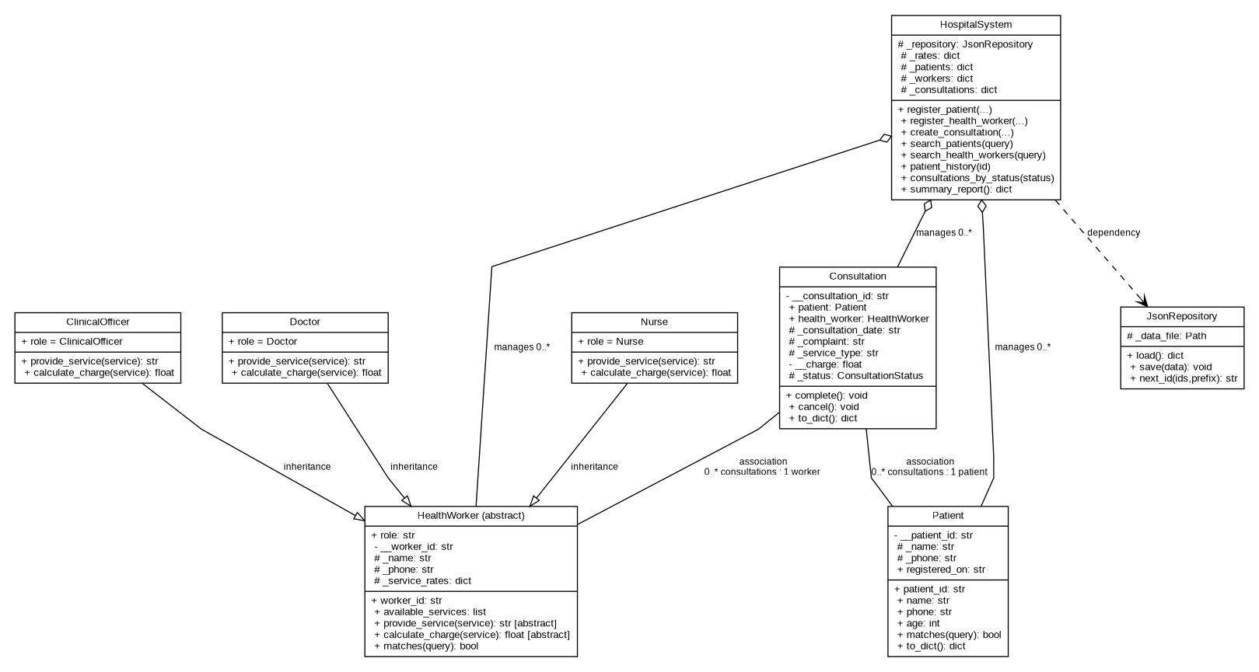
Figure 1: UML class diagram for the Hospital Outpatient Management System

5. Object-Oriented Design

5.1 Encapsulation
Private attributes: identifiers and consultation charge use double-underscore attributes such as __patient_id, __worker_id, __consultation_id and __charge. These values cannot be casually overwritten from menu code.
Protected/internal attributes: attributes such as _name, _phone, _service_rates and internal collections are marked with a leading underscore to indicate controlled internal use.
Properties and setters: @property setters validate age, phone, names, consultation date, complaint, service type and status before an object can enter an invalid state.

5.2 Inheritance and Abstraction
HealthWorker inherits from ABC and is not intended to be instantiated directly. It contains abstract methods that every concrete health-worker category must implement:
@abstractmethod
def provide_service(self, service_type: str) -> str: ...
@abstractmethod
def calculate_charge(self, service_type: str) -> float: ...
Doctor, Nurse and ClinicalOfficer are subclasses of HealthWorker. This creates one meaningful inheritance hierarchy with three concrete subclasses.

5.3 Method Overriding and Polymorphism
Each subclass overrides provide_service() and calculate_charge(). HospitalSystem works with the common HealthWorker type and calls these methods without needing separate consultation-creation algorithms for doctors, nurses and clinical officers. The object itself determines the valid service and charge for its category.

5.4 Object Relationships
- Association: each Consultation refers to exactly one Patient and exactly one HealthWorker. A patient or worker can participate in zero or many consultations.
- Aggregation/management: HospitalSystem maintains collections of Patient, HealthWorker and Consultation objects and coordinates how they collaborate.
- Dependency: HospitalSystem depends on JsonRepository for persistence rather than mixing file operations into the menu or domain models.

6. Avoiding Hard-Coded Operational Data
No patient, health-worker or consultation records are embedded in the Python source. The distributed data file begins with empty lists and records are created through the application. Unique IDs are generated from existing IDs rather than manually entered.
The assignment does not prescribe exact service charges. Example charges are therefore stored in config/service_rates.json, not inside Doctor, Nurse or ClinicalOfficer methods. This means charges can be changed without modifying Python source code. The current configuration provides different service options for the three categories, for example standard/review/specialist doctor services, nursing services and clinical-officer services.

7. Validation and Error Handling
- Names cannot be blank and must contain letters.
- Phone numbers must contain 7–15 digits, with an optional leading +.
- Age must be a whole number from 0 to 130.
- Duplicate patient phone numbers and duplicate health-worker phone numbers are rejected.
- Consultation dates must use YYYY-MM-DD format.
- Complaints and service types cannot be blank.
- A service must actually exist for the chosen health-worker category.
- A consultation cannot be completed twice, and a cancelled consultation cannot later be completed.
- Searches reject blank queries and record lookups return clear “not found” messages.
- Invalid menu selections produce a clear message instead of terminating the program.

8. Menu and Main Transactions
The console menu provides all required operations while delegating business logic to HospitalSystem and the domain objects. The main options are:
- Register patient.
- Register health worker.
- Create consultation.
- Complete or cancel consultation.
- Search patients and health workers.
- View patient consultation history.
- Display current consultations.
- Display completed consultations.
- Display all registered patients and workers.
- View system summary report.

9. Persistence and File Structure
JsonRepository stores application records in data/hospital_data.json. The file begins empty but is updated automatically after successful operations. A temporary file is used during saving and then replaces the main file, reducing the chance of leaving a partially written JSON file.
The final submission folder is separated into src, config, data, uml, report, tests and demo directories. This separation keeps presentation logic, business logic, persistence, documentation and validation checks easy to locate during the practical demonstration.

10. Testing and Cross-Check Results
The code was syntax-checked and executed with an automated unittest suite. Seven tests were used to verify core requirements and common failure cases:
- automatic unique patient IDs;
- Doctor/Nurse/ClinicalOfficer subclass creation and polymorphic charge results;
- consultation links and patient history;
- completing consultations and rejecting a second completion;
- invalid input and unsupported service rejection;
- duplicate phone rejection;
- saving and reloading records from JSON persistence.
Cross-check result: 7 tests passed, with no test failures or syntax errors.

11. How to Run
From the OOOP_G2 folder, run:
python src/main.py
To rerun the automated cross-checks:
python -m unittest discover -s tests -v

12. Conclusion
The completed solution satisfies the functional outpatient requirements while demonstrating the required object-oriented concepts in a way that can be pointed out directly during the practical demonstration. The implementation uses collaborating classes, controlled state, a meaningful HealthWorker inheritance hierarchy, abstract methods, overridden behavior, polymorphic method calls, associations with multiplicities, persistent records, validation and a clear menu interface.

