Name: Shanne Edralyn N. Erandio Date Submitted: 11/06/25
Course, Year and Section: BSIT2A Subject: Platform Technologies

Lesson 4 – Assessment 4 (Laboratory Activity):
Alison Course Completion + Understanding Bash Scripting & Commands
Activity Title:
Understanding Bash Scripting & Commands

1st Screenshot


2nd Screenshot
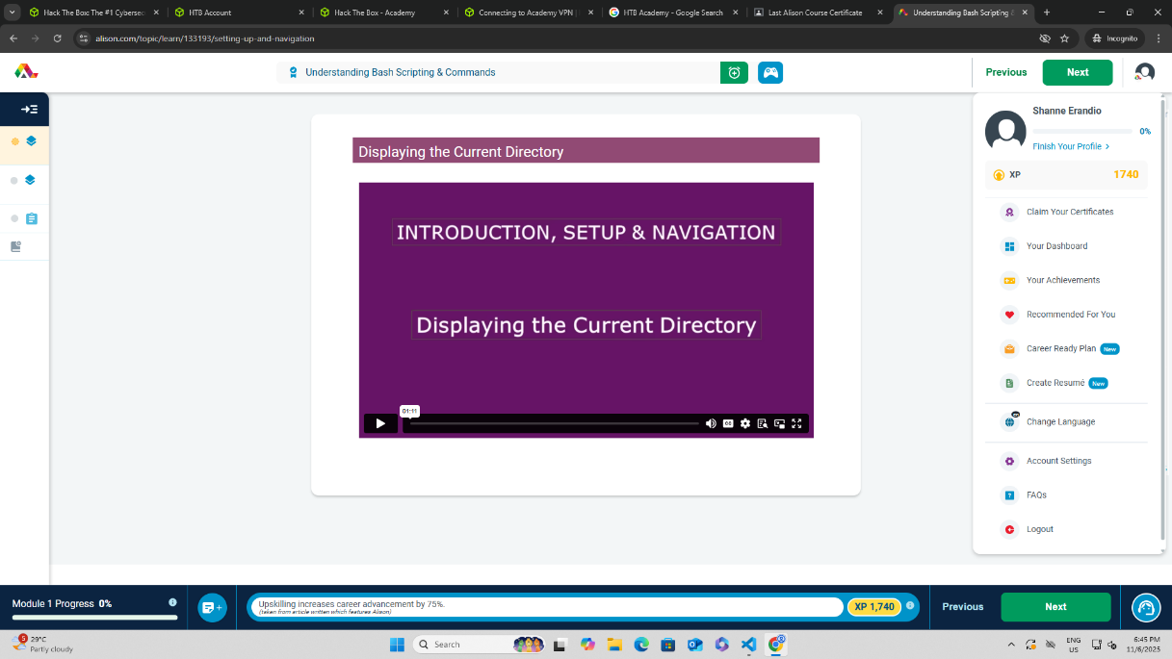
3rd Screenshot
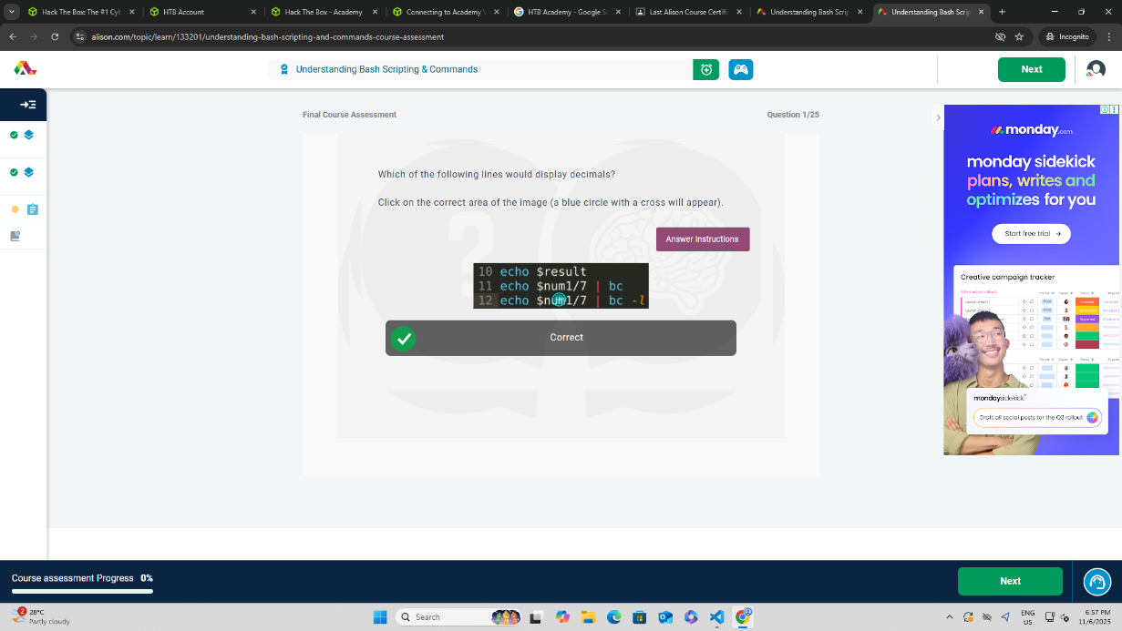

4th Screenshot


Reflection on “Understanding Bash Scripting & Commands”
The Understanding Bash Scripting & Commands module provided me with a solid foundation in using the Bash shell to perform and automate various computational tasks. Before this course, I often relied heavily on graphical user interfaces (GUIs) to manage files and directories. However, I have come to appreciate how Bash scripting offers a far more efficient, flexible, and powerful way to interact with the system. I learned how simple commands can accomplish complex tasks, such as creating, modifying, and organizing files or directories, often with just a single line of code.
One of the most valuable lessons from this module was understanding how Bash scripts can automate repetitive tasks. By writing and executing shell scripts, I realized that I could save significant time and reduce human error in routine processes like backups, updates, and permission changes. Additionally, learning to switch between users and manage access through the terminal deepened my understanding of system administration and security.
This module also improved my logical thinking and problem-solving skills. Writing Bash scripts requires careful attention to syntax, sequence, and flow control structures such as loops and conditional statements. I enjoyed experimenting with different command combinations and seeing how they interact within a script.
Overall, the course has enhanced my confidence in using the command line and inspired me to incorporate Bash scripting into my daily computing tasks. It emphasized the importance of automation and efficiency—key principles in programming and system management.

