# Project Report

# Image Processing Application

**S.W.Ediriweera**

**130147J**

## Step 1

* Five full colour images of natural scenes have been downloaded from ImageNet (<http://www.image-net.org/>) and saved in ‘step1’ folder.

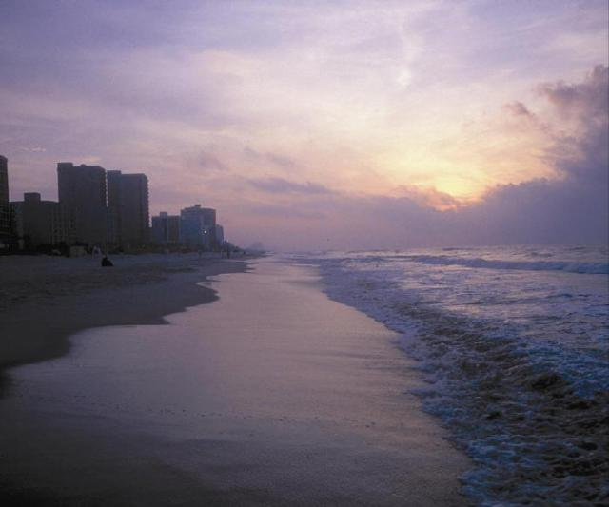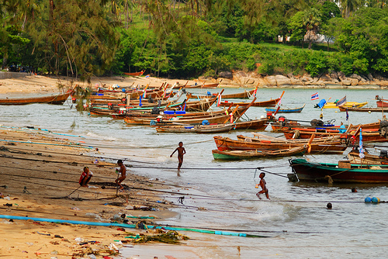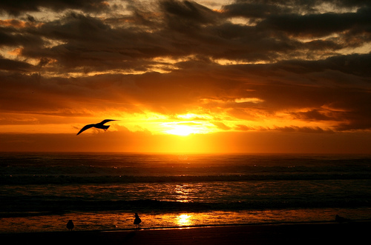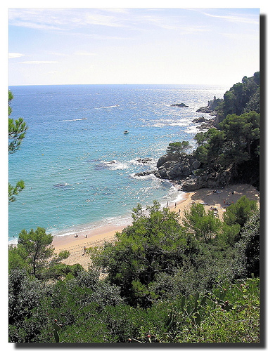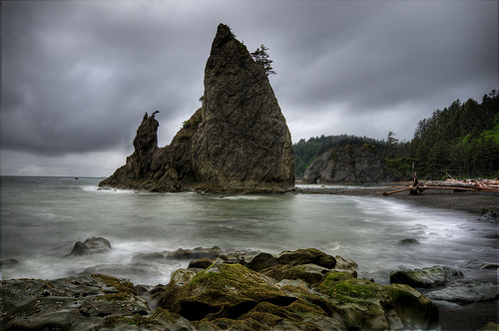

## Step 1

* This application can convert images from 24bit RGB format to 8bit gray scale format using two methods. First one is using the average level and second one is using luminance preserving method.

###### Average Gray Scale Conversion

* Take the red, green, blue values of each pixel.
* Calculate their average.
* Average = (red + green + blue) / 3
* Set that average value as all red, green and blue values for the new image.

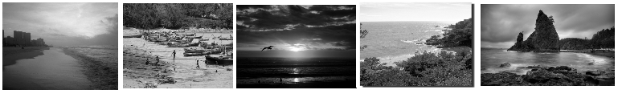

###### Luminance Preserving Gray Scale Conversion

* Take the red, green, blue, values for each pixel.
* Calculate their weighted average using following formula.
* Weighted average = (0.2126 * red) + (0.7152 * green) + (0.0722 * blue)
* Set that average value as all red, green and blue values for the new image.

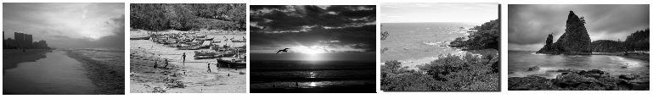

###### Images can be saved in both 24bit (RGB) and 8bit(Gray Scale) using this application.

* The name extension of saved image files is “.130281M”.
* First four bytes of the image file contains the width of the image.
* The next four bytes of the image file contains the height of the image.
* Above three things are same for both 24bit and 8bit formats.

For 24bit format

* Next every 3 bytes packet contain the red, green, blue values of each pixel.

For 8bit format

* Next every byte contains the gray scale value for each pixel.

Also both formats can be opened using this application.

## Task 3.

#### Re-sampling.

* Images can be both down sampled and up sampled.
* Down sampling is done using “Bi-linear interpolation” method and up sampling is done using “Nearest Neighbor” method.

###### Bi-linear interpolation

* When scaling an image, values for points even in between pixels have to be calculated. It can be calculated using following formula.
* The value for (x,y) pixel in the scaled new image can be calculated using weights of its four neighbors.
* let “a” is the horizontal distance between (x,y) and (i,j).
* let “b” is the vertical distance between (x,y) and (i,j).
* Then the value for (x,y) point F(x,y) can be calculated using following formula.
* F(x,y) = (1-a)(1-b)F(i,j) + a(1-b)F(i+1,j) + abF(i+1,j+1) + (1-a)bF(i,j+1)



###### Nearest Neighbor

* duplicate each row and column and create a double sized image.

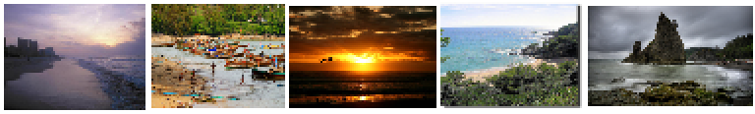

## Task 4.

#### Calculate Deviations

###### Standard Deviation

Below is the process of algorithm that has been used.

* First calculate the mean of the image. It is calculated using following formula.
  + Mean = sum of gray levels of a color of the whole image / number of pixels in the image
* Then for each pixel in the image, calculate the difference between mean and the particular value.
* Calculate the sum of all squares of those differences.
* The standard deviation is the square root of the sum.

###### Average Deviation

Below is the steps for calculating average deviations

* First calculate the mean of the image. It is calculated using the same formula that is given above.
* Calculate the absolute values of differences between the mean and the colour levels.
* Calculate the sum of those absolute values.
* Average deviation is the sum divided by the number of pixels.

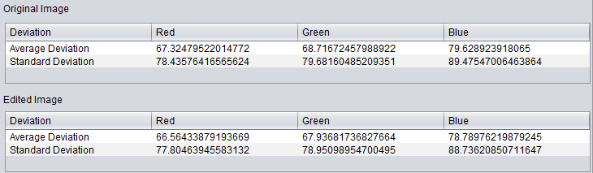

## Task 5.

#### Compression

###### Entropy Coding

* For the entropy coding, Huffman coding method is used.
* Algorithm is given below.
* Calculate the probabilities of each colour level.
* Build the Huffman tree.
* Generate the symbols.
* Create a bit stream for the image using Huffman symbols.
* Write it to the file.
* File additionally contains image width and image height.