SIMATS ENGINEERING
ASSESSMENT TOOL 1

COURSE CODE: CSA51 COURSE NAME: Cryptography and Network Security

COURSE OUTCOME COVERED
CO4: Implement best security practices for IP, email, and web service using PGP,
S/MIME for enhancing email Security.CO (BL3, BL6)
Assessment Tool Weightage: 40%

QUESTIONS: 5 TOTAL MARKS: 25

Annexure A
Coding Challenge

Code of Conduct:
I ENAMALA SHANI PRIYA 192371033(Name / Reg No) certify that this submission is my original
work and that I have adhered to the guidelines specified for this assessment.
I understand that any violation of academic integrity rules will result in disciplinary action.

Signature of the student:

Annexure A
Coding Challenge

1. Write a program to simulate the IPSec Authentication Header (AH) process that
generates and verifies a message authentication code (MAC) for IP packet
integrity.

2. Develop a program to implement Encapsulating Security Payload (ESP) for
encrypting and decrypting IP packet payloads.

3. Design a program to manage Security Associations (SA) in IPSec, including
creation, lookup, and deletion operations.

4. Implement a simplified Pretty Good Privacy (PGP) system for secure email
communication using public key encryption and digital signatures.

5. Create a program to classify emails as spam or legitimate using email header
analysis and content-based filtering techniques

CODING:
1.
# IPSec Security Association (SA) Management
security_associations = {}
def create_sa():
spi = input("Enter SPI: ")
if spi in security_associations:
print("SA with this SPI already exists.")
return
src = input("Enter Source IP: ")
dst = input("Enter Destination IP: ")
protocol = input("Enter Protocol (AH/ESP): ")
key = input("Enter Encryption/Authentication Key: ")
security_associations[spi] = {
"Source IP": src,
"Destination IP": dst,
"Protocol": protocol,
"Key": key
}
print("Security Association created successfully.")
def lookup_sa():
spi = input("Enter SPI to search: ")
if spi in security_associations: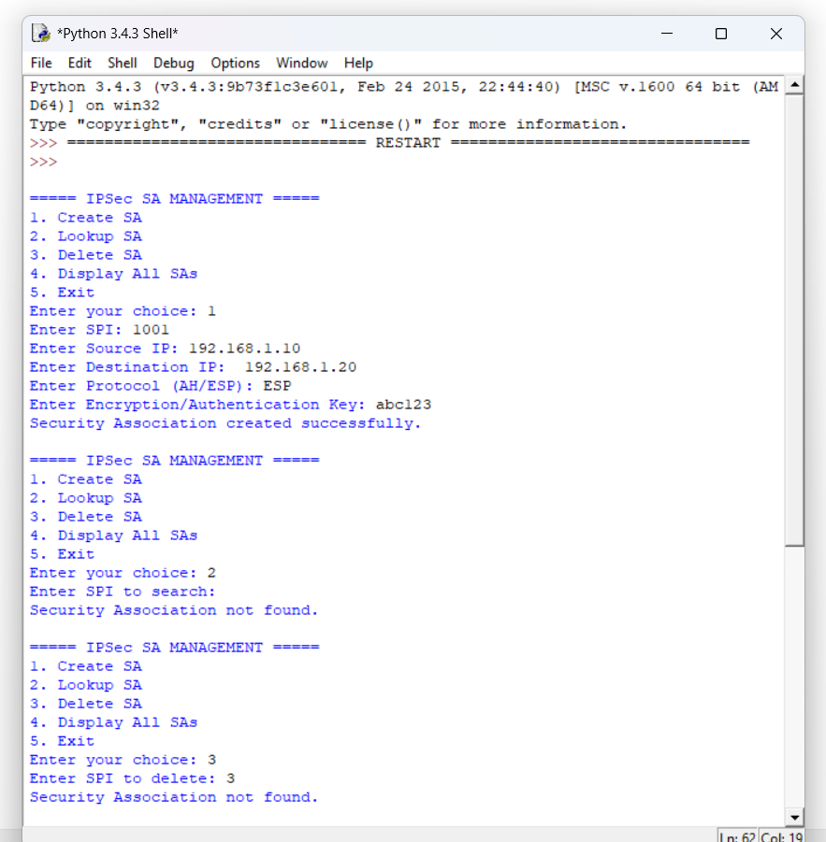
for key, value in security_associations[spi].items():
print(key + ":", value)
else:
print("Security Association not found.")

def delete_sa():
spi = input("Enter SPI to delete: ")
if spi in security_associations:
del security_associations[spi]
print("Security Association deleted successfully.")
else:
print("Security Association not found.")
def display_sa():
if not security_associations:
print("No Security Associations available.")
return
print("\n--- Security Associations ---")
for spi, details in security_associations.items():
print("\nSPI:", spi)
for key, value in details.items():
print(key + ":", value)
while True:
print("\n===== IPSec SA MANAGEMENT =====")
print("1. Create SA")
print("2. Lookup SA")
print("3. Delete SA")
print("4. Display All SAs")
print("5. Exit")
choice = input("Enter your choice: ")
if choice == "1":
create_sa()
elif choice == "2":
lookup_sa()
elif choice == "3":
delete_sa()
elif choice == "4":
display_sa()
elif choice == "5":
print("Program terminated.")
break
else:
print("Invalid choice.").

2.
# Simple Email Spam Classifier
spam_words = [
"free",
"winner",
"win",
"prize",
"lottery",
"offer",
"discount",
"money",
"urgent",
"claim",
"congratulations",
"click here"
]

def classify_email():
sender = input("Enter sender email: ")
subject = input("Enter email subject: ")
message = input("Enter email message: ")
email = (sender + " " + subject + " " + message).lower()
count = 0
found_words = []
for word in spam_words:
if word in email:
count += 1
found_words.append(word)
print("\n----- Email Analysis -----")
print("Sender:", sender)
print("Subject:", subject)
print("Spam keywords found:", count) 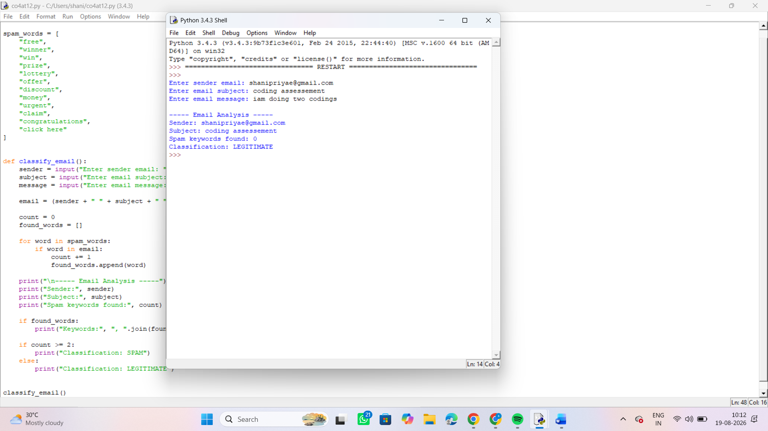
if found_words:
print("Keywords:", ", ".join(found_words))

if count >= 2:
print("Classification: SPAM")
else:
print("Classification: LEGITIMATE")
classify_email()

