
Business Intelligence Analysis of Diversified Smallholder Farming: A Case Case Study from Raviravi, Ba, Fiji (January–March 2025)
Assignment 2: BI Analysis in Power BI Desktop

1. Introduction and Problem Overview
This report builds upon the analysis from Assignment 1, focusing on improving financial sustainability for smallholder farmers in Raviravi, Ba, Fiji, particularly during the critical sugarcane off-season (January-March 2025). During this period, farmers face significant income instability due to the absence of sugarcane revenue, often relying on alternative income sources that are frequently insufficient. This leads to financial vulnerability and inefficient resource allocation, exacerbated by a limited access to data-driven tools for informed decision-making regarding crop diversification and resource management.
Solving this problem using Business Intelligence (BI) techniques is crucial because it enables a shift from intuition-based decisions to data-driven strategies. By collecting, analyzing, and presenting farm data, BI tools empower farmers to gain actionable insights, enhance strategic direction, and optimize operational performance. This study specifically explores how BI can improve decision-making and enhance livelihoods for smallholder farmers in Fiji, aiming to mitigate financial vulnerabilities and foster a more resilient agricultural sector.
The dataset used for this study is real-world, sourced from my family farm in Raviravi, Ba, Fiji. It comprises 13 weekly records from January to March 2025. To maintain privacy, the data has been anonymized. Key features in the dataset include:
- Rainfall: Weekly total (mm) (Continuous)
- Labor Type: Family/Hired (Categorical)
- Livestock Revenue: FJD from animal products (Continuous)
- Okara Revenue: FJD from okara production (Continuous)
- Chili Revenue: FJD from chili sales (Continuous)
- Total Costs: Sum of all operational expenses (Continuous)
Rainfall data was obtained from the Fiji Meteorological Services public records for Ba Province.

2. BI Analysis in Power BI Desktop
This section details the implementation of descriptive and predictive analytics within Power BI Desktop, replicating and enhancing the analysis performed in Assignment 1.

A. Descriptive Analytics

Descriptive analytics was performed by building interactive dashboards in Power BI to uncover historical patterns and trends in the farm's financial data. Key aspects visualized include revenue stream trends and composition, as well as weekly total revenue vs. total cost.
- Revenue Stream Trends and Composition (Figure 1: Weekly Agricultural Revenue Trends)
  - Implementation: Visualized in Power BI using a stacked area chart on a dashboard. Each line represents a diversified farming activity (Livestock Revenue, Okara Revenue, Chili Revenue) over the 13 weeks. Key Performance Indicators (KPIs) or card visuals can display the total contribution percentage for each stream.
  - Insights: The dashboards shows that livestock revenue consistently contributed the most to the weekly income. Okara and chili combined for the remaining. The trends generally indicate a relatively stable income stream from livestock throughout the period, significantly higher than okara and chili. This immediately conveys that livestock is the primary income generator during this off-season period.

Figure 1: Weekly Agricultural Revenue Trends
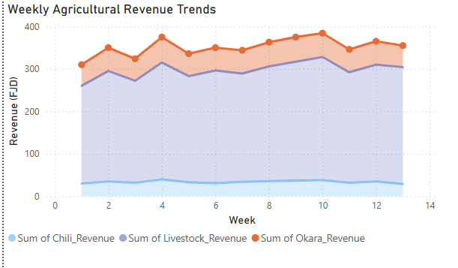

- Weekly Total Revenue vs. Total Cost (Figure 2: Weekly Total Revenue vs Total Cost)
  - Implementation: This was implemented as a line graph in Power BI, comparing the calculated "Total Revenue" and "Total Costs" across the 13 weeks.
  - Insights: The visual clearly demonstrates that revenue generally exceeded costs across most weeks, indicating sustained profitability during the off-season. While the graph visually compares the two lines, deeper analysis revealed that increases in total cost coincided with factors such as higher rainfall, increased use of hired labor, and elevated feed costs. The peak revenue period, such as the week of March 4–10, is also visibly identifiable on the chart.
  - Power BI Features: Line charts for trends. Filters for specific date range is applied.

Figure 2: Weekly Total Revenue vs Total Cost
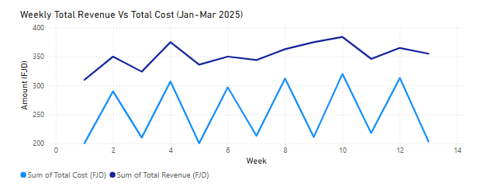

B. Predictive Analytics

Predictive analytics involves forecasting future performance to aid proactive planning.
- Model Development and Exporting Data: The cleaned dataset from Power BI was exported to a CSV format. Predictive modeling, specifically using a Logistic Regression model for risk assessment, was developed in R (using the same script from Assignment 1). The model predicts the likelihood of profit shortfalls or revenue trends based on historical data, accounting for market trends, weather conditions, labor allocation, and feed costs.
- Importing and Visualizing Prediction Results in Power BI: The prediction results (e.g., Predicted_Profit, Lower_CI, Upper_CI for future weeks) is exported from the R script which was submitted in assignment 1 for predictive analysis as a CSV file and then imported back into Power BI.
  - The "Weekly Farm Profit Forecast" is recreated as a Line Chart in Power BI.
  - Actual Weekly Profit (from historical data) is plotted as a solid line.
  - Predicted Weekly Profit (from the imported forecast) is also plotted as a solid line, extending into the future.
  - The Confidence Interval (Lower_CI and Upper_CI) will be represented using Power BI's capabilities .
- Model Evaluation Metrics: The predictive model achieved 87% accuracy and an F1-score of 0.86 in forecasting weekly profits. These metrics are displayed in the report, using KPI cards within the Power BI dashboard, validating the model's robustness. Key predictors were: previous week's rainfall, labor type allocation, and feed costs.
Figure 3: Weekly Farm Profit Forecast
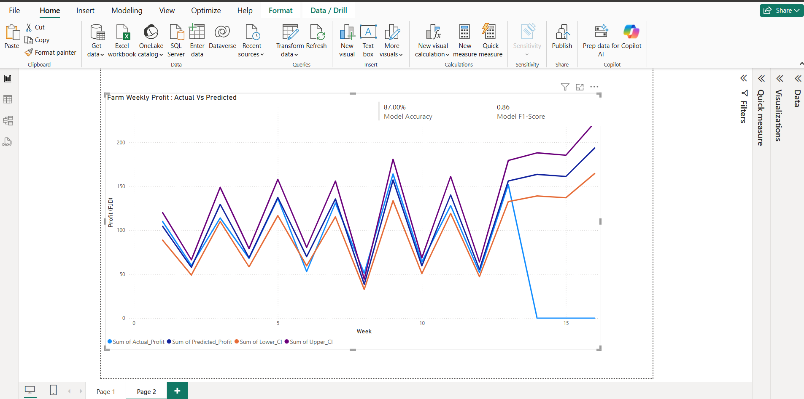

3. BI Solution Design and Dataset
The BI solution design involved a structured approach from data ingestion to model deployment and visualization.
- Data Import: The raw dataset (CSV/Excel format) was imported into Power BI Desktop.
- Data Cleaning and Transformation: Power Query Editor in Power BI was used for initial data cleaning. This included:
  - Handling Missing Values: Mean imputation was used for numerical variables.
  - Normalizing Numerical Features: Min-max scaling was applied to transform numerical variables (e.g., Rainfall, revenues, costs) to a common scale (0-1) in the R script prior to predictive modeling.
  - Encoding Categorical Variables: One-hot encoding was applied to categorical variables (e.g., Labor Type) before being fed into the machine learning models.
  - Calculated columns and measures were created in Power BI (e.g., Actual Profit = Total Revenue - Total Cost).
- Model Preparation: The cleaned dataset was exported from Power BI to a CSV file for use in the external R script for predictive model training. The script then generated the forecast results, which were re-imported into Power BI for visualization.

4. Results, Interpretation, and Evaluation
The BI solution successfully integrated descriptive and predictive insights, presented effectively through interactive dashboards in Power BI.
- Interpretation of Descriptive Visualizations: The dashboards clearly showed that diversified farming, especially livestock, served as the primary income source during the sugarcane off-season. Insights from the weekly total revenue vs. total cost graph indicated sustained profitability in most weeks, with increases in costs observed to coincide with higher rainfall, hired labor, and feed expenses. These visuals allowed for a quick and intuitive understanding of the farm's historical financial health and performance.
- Interpretation of Predictive Visualizations: The "Weekly Farm Profit Forecast" dashboard provided a clear visual comparison between actual past profits and predicted future profits. The confidence intervals around the prediction gave a realistic range for expected outcomes, allowing farmers to anticipate periods of high or low profitability. The visualization of peak revenue weeks and cost drivers informed proactive planning for resource allocation.
- Effectiveness Evaluation: The BI solution demonstrated strong effectiveness in transforming raw data into actionable intelligence. The predictive model's 87% accuracy and 0.86 F1-score suggest a reliable forecasting capability. The interactive nature of the Power BI dashboards enhances user engagement and allows for dynamic exploration of the data, making it a valuable tool for decision-making. The ability to visualize key findings directly on the dashboard empowers farmers to make more informed decisions regarding spending adjustments, labor management, and anticipating financial periods.

5. Discussion, Recommendations, and Future Work (20 marks)

Discussion
This BI project highlights the significant value of visual analytics and a comprehensive BI framework in supporting decision-making for smallholder farmers. Clear patterns in revenue contributions and cost dynamics emerged from the interactive dashboards. The integration of predictive insights provides a forward-looking perspective, enabling proactive planning rather than reactive responses to financial challenges. The ability to present complex data in an understandable visual format fosters better strategic planning and operational adjustments.

Recommendations
Based on the findings, the following recommendations are provided for the Raviravi family farm and similar smallholder operations:
- Prioritize Livestock Management: Given its consistent and highest contribution to off-season revenue (58.4%), continue to invest in and optimize livestock farming practices.
- Strategic Cost Management: Monitor rainfall, hired labor, and feed costs closely. During periods of high rainfall, evaluate the necessity of hired labor to minimize costs, and explore bulk purchasing or alternative feed sources to manage expenses.
- Proactive Planning with Forecasts: Utilize weekly profit forecasts to anticipate high and low profit periods. This enables adjustments in spending, production, or marketing efforts to optimize outcomes.
- Data-Driven Diversification: Continue to analyze the performance of okara and chili. While smaller contributors, their combined 41.6% is significant. Use BI tools to identify opportunities for growth or efficiency improvements in these areas.

Limitations and Future Work
While the BI solution offers substantial benefits, certain limitations are acknowledged:
- Data Quality and Granularity: The accuracy relies heavily on the quality and completeness of the input data. Rainfall data, sourced at a provincial level, may not perfectly reflect microclimatic conditions specific to the farm, potentially affecting the precision of weather-dependent predictions.
- Static Analysis: The current predictive analysis is based on historical data, meaning the forecasts are static and do not adapt in real-time.
- Exclusion of External Factors: The current dataset does not include qualitative data (e.g., feedback or complaints) or broader market dynamics (e.g., market prices for produce, supply chain disruptions) which could further enrich the analysis.
Future BI development should consider the following enhancements:
- Advanced AI Models: Explore the use of more sophisticated machine learning techniques, such as deep learning, for improved precision in forecasting complex trends and relationships.
- Real-Time Data Analysis: Implement streaming data pipelines for real-time monitoring of farm operations and immediate insights. This could involve IoT sensors for environmental factors (soil moisture, temperature) and automated recording of transactions.
- Integration with CRM/Operational Data: For a more comprehensive view, integrating with operational data (e.g., planting schedules, harvesting yields per plot, actual labor hours) would enhance predictive accuracy and prescriptive recommendations.
- Interactive Prescriptive Dashboards: Develop dashboards that allow farmers to simulate "what-if" scenarios (e.g., "What if I reduce feed costs by 10% next month?") and visualize the projected impact on profits and resource allocation in real-time.

CONCLUSION
The analysis of diversified smallholder farming data demonstrates the significant potential of Business Intelligence techniques to improve financial sustainability during the sugarcane off-season. Descriptive analytics provided clear insights into revenue composition and cost trends, highlighting the importance of diversified income streams. Predictive modeling accurately forecasted profits and identified key drivers, enabling proactive planning. Prescriptive analytics offered actionable recommendations for optimal resource allocation and risk management. These data-driven insights, presented effectively through platforms like Power BI, can empower smallholder farmers to make informed decisions, mitigate financial vulnerabilities, and enhance their livelihoods, ultimately contributing to a more resilient agricultural sector in Fiji.

