HANDSMEN THREADS: ELEVATING THE ART OF SOPHISTICATION IN MEN'S FASHION
User Story
HandsMen Threads is a menswear brand that wants to give its shoppers an easy, personalized buying experience while keeping its internal operations running efficiently. Shoppers expect to browse menswear, confirm that items are in stock, place orders, get confirmation once an order is accepted, and be kept up to date on its progress. The sales team needs one central system where they can store customer details, handle orders, and look up past purchases in order to serve customers better. Inventory managers need current and reliable stock figures so that shortages are avoided and replenishment happens on time. The marketing team needs access to customer data and buying history so they can run effective campaigns and strengthen customer engagement. Administrators and managers want a single view of customers, products, orders, inventory, and marketing work through reports and dashboards. Salesforce brings all of these activities onto one platform and automates the key business processes.

1. INTRODUCTION
1.1 Project Overview:
HandsMen Threads is a fashion retailer that places its emphasis on product quality and lasting customer relationships. As the business expands, handling customers, products, orders, and inventory by hand can cause data mistakes, slow communication, and problems with stock.
The proposed Salesforce solution offers one central platform for managing customer, product, order, inventory, financial, and loyalty data. Validation and automation raise data accuracy and cut down on manual effort.
The key processes covered are:
- Managing customers and products
- Handling and confirming orders
- Managing customer loyalty
- Tracking inventory and raising low-stock alerts
- Processing bulk orders and financial records
- Updating inventory automatically
The solution is built with Custom Objects, Validation Rules, Lightning App Builder, Record-Triggered Flows, Apex, and Asynchronous Apex.

1.2 Purpose:
The main goal of the HandsMen Threads Salesforce project is to build a dependable, automated business management system that strengthens data accuracy, customer communication, inventory visibility, and day-to-day efficiency.
The system is intended to:
- Keep all business information in one place within Salesforce.
- Keep customer and product records correct.
- Stop invalid data from being saved.
- Send order confirmations automatically.
- Update customer loyalty details without manual effort.
- Keep track of product stock levels.
- Alert warehouse staff when stock runs critically low.
- Handle bulk orders through scheduled automation.
- Keep financial and inventory data in sync.
- Cut down on repetitive manual tasks.
- Give users a well-organized Lightning interface.
- Enhance the customer experience as a whole.

2. IDEATION PHASE
The ideation phase is about pinpointing the main difficulties that HandsMen Threads faces when managing customer data, orders, inventory, loyalty programs, and finances. Several candidate solutions were weighed with the aim of lowering manual effort, improving accuracy, deepening customer engagement, and giving better control over operations.
The process moved through identifying the problems, understanding users through empathy analysis, brainstorming solutions, grouping the ideas, and ranking them by business impact and feasibility.

Key Ideas Identified
• Unified Customer Management: Store customer details and order history together on a single platform.
• Order Handling: Efficiently manage orders along with their status, quantities, payments, and delivery information.
• Stock Control: Follow product stock and flag items running low automatically.
• Automatic Notifications: Email order confirmations, payment notices, delivery updates, and stock alerts without manual action.
• Data Checks: Apply validation rules so that wrong product, order, and inventory data is rejected.
• Role-Based Access: Limit who can see customer, product, order, and inventory data according to each person's duties.

2.1 Problem statement
PS | User | I'm trying to | But | Because
PS-1 | Customer | Get a confirmation once an order is placed | Order updates might rely on manual messages | No automated confirmation process exists
PS-2 | Sales Staff | Keep customer and order details accurate | Wrong or missing details can get entered | Data entry lacks enough control
PS-3 | Customer | Be rewarded properly for buying repeatedly | Loyalty status might not update on its own | Purchase history is not assessed regularly
PS-4 | Warehouse Team | Keep an eye on product stock levels | Low stock might go unnoticed for a while | Stock tracking might need manual checks
PS-5 | Finance Team | Keep order-related financial data accurate | Bulk orders might need repeated manual updates | Order and finance handling is not fully automated
PS-6 | Administrator | Handle high order volumes efficiently | Processing in bulk can take a lot of time | Handling each order one at a time is inefficient

2.2 Empathy Map Canvas
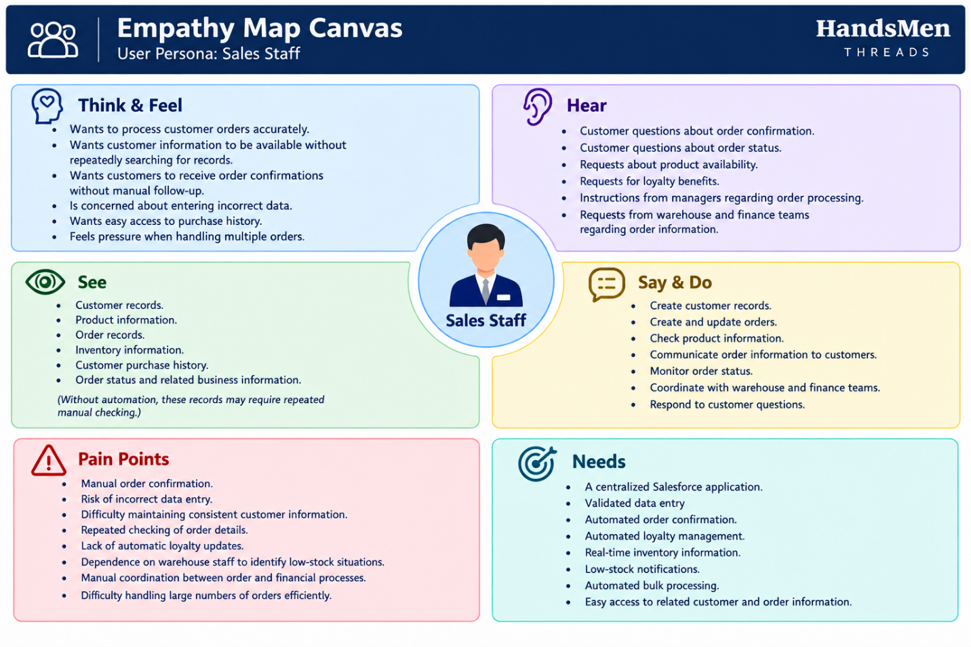
2.3 Brainstorming & Idea Prioritization
During brainstorming, a number of different approaches were explored for solving the business problems that had been identified.
Step 1: Brainstormed Ideas
1. Spreadsheet-Based Business Management
Spreadsheets would hold customer, product, order, inventory, loyalty, and financial data.
It would be easy to set up, but it would still rely heavily on manual data entry and upkeep.
2. Manual Email-Based Order Confirmation
Once an order is confirmed, sales staff would email the customer by hand.
Customers would be informed, but it would demand constant effort from employees and emails could be missed or sent late.
3. Standalone Fashion Retail Application
A dedicated web application could be built to handle customers, products, orders, inventory, and loyalty data.
It would be flexible, yet a separate application would need to be developed and maintained.
4. Salesforce-Based Management System
One central Salesforce application could handle the organization's customer, product, order, inventory, loyalty, and financial data.
Salesforce automation could take care of repetitive business processes.
5. Automated Order Confirmation
A Salesforce automation could send an email by itself as soon as an order reaches the confirmation status.

6. Dynamic Loyalty Management
The system could assess a customer's purchase history on its own and change the loyalty status based on set business criteria.
7. Proactive Inventory Alert System
Stock levels could be watched by the system, which would notify the warehouse team automatically once inventory drops under five units.
8. Scheduled Bulk Order Processing
Asynchronous Apex could run at midnight to process qualifying bulk orders and refresh the related financial and inventory data.
9. Centralized Business Interface
A Lightning application could act as a single interface where authorized users reach the business records they need.
Step 2: Grouping
Group | Ideas | Description
Manual Solutions | Spreadsheet-based management, manual email confirmation | Basic approaches that demand a lot of effort from users
Standalone / Semi-Automated Solutions | Standalone retail application | Offers more automation but needs its own development and upkeep
Salesforce-Based Automated Solution | Salesforce management system, automatic confirmation, loyalty automation, stock alerts, scheduled bulk processing, Lightning application | Delivers central data management, automation, and business processing that can scale

Step 3: Idea Prioritization
Every idea is rated against four criteria:
- Impact – The extent to which the idea improves business operations.
- Feasibility – How practical it is to put the idea into action.
- Cost – The relative effort needed to implement and maintain it.
- Efficiency – The amount of manual work expected to be saved.
Idea | Impact | Feasibility | Cost
Spreadsheet-based management | Low | High | High
Manual email confirmation | Low | High | High
Standalone retail application | Medium | Medium | Low
Salesforce-based management system | High | High | High
Automated order confirmation | High | High | High
Dynamic loyalty management | High | High | High
Proactive stock alerts | High | High | High
Scheduled bulk order processing | High | Medium | High

3. REQUIREMENT ANALYSIS PHASE
3.1 Customer Journey Map
The customer journey spans the main stages, starting with registration and product selection and continuing through order processing, stock verification, notification, and business monitoring.

Stage 1: Customer Registration
User Actions: Shares personal details and signs up with HandsMen Threads.
Touchpoints: Customer records and the sales team.
Pain Points: Customer details that are missing or wrong.
HandsMen Threads Solution: Customer data is kept in one place and checked through validation.
Emotion: Curious and optimistic.

Stage 2: Product Selection
User Actions: Chooses products and looks up their price and availability.
Touchpoints: Product records and stock data.
Pain Points: Hard to know what the current stock level is.
HandsMen Threads Solution: Product and stock data held in one place lets staff confirm availability.
Emotion: Curious but hesitant.

Stage 3: Order Creation
User Actions: Picks products, enters quantities, and places an order.
Touchpoints: Order records and the sales team.
Pain Points: Wrong quantities or missing order details.
HandsMen Threads Solution: Validation rules make sure the necessary order details are entered properly.
Emotion: Nervous.

Stage 4: Inventory Verification
User Actions: Confirms that enough stock exists to fulfil the order.
Touchpoints: Product and stock records.
Pain Points: Low stock may not be caught quickly.
HandsMen Threads Solution: Stock data is held centrally, and low-stock situations can be detected automatically.
Emotion: Careful.

Stage 5: Order Processing
User Actions: The order is handled once verification is done.
Touchpoints: Order records and the sales team.
Pain Points: Manual handling and updates that arrive late.
HandsMen Threads Solution: Salesforce automation assists with order handling and refreshes related records.
Emotion: Unsure.

Stage 6: Order Confirmation
User Actions: Waits for a confirmation after the order has been processed.
Touchpoints: Order records and email alerts.
Pain Points: Communication that is slow or manual.
HandsMen Threads Solution: Customers receive their order confirmation through automatic emails.
Emotion: Reassured.

Stage 7: Monitoring and Support
User Actions: The customer receives the order while staff and management keep watch over business activity.
Touchpoints: Reports, dashboards, customer records, and stock records.
Pain Points: Tracking many business activities by hand is difficult.
HandsMen Threads Solution: Salesforce records, reports, and dashboards give one central source of information for monitoring and making decisions.
Emotion: Content and assured.

3.2 Solution Requirements

Functional Requirements
FR-1: Customer Management
• Description: Handle customer data within one central system.
Details: Users must be able to add, edit, and view customer records, keeping the information correct and complete.
FR-2: Product & Inventory Management
Description: Handle product details and stock data.
Details: The system stores product data including name, category, price, quantity, and stock status so that inventory can be tracked.
FR-3: Order Processing
Description: Create and handle customer orders.
Details: Sales staff can place orders using customer and product data. Validation and automation lower the chance of wrong or incomplete order records.
FR-4: Order Confirmation
Description: Notify customers automatically once their order is confirmed
Details: Once an order reaches the required status, the customer is sent an automatic email.

FR-5: Customer Loyalty Management
Description: Handle customer loyalty data.
Details: Customer buying activity feeds into loyalty management and helps boost engagement.
FR-6: Inventory Alerts and Automation
Description: Spot low-stock products and automate routine tasks.
Details: If inventory drops below the set threshold, the system can alert the warehouse team in charge. Automated processes also help keep orders and inventory up to date.
FR-7: Scheduled Bulk Processing
Description: Handle bulk orders and their related updates automatically.
Details: Scheduled runs work through large order volumes and refresh the relevant financial and inventory data.
FR-8: Reports and Dashboards
Description: Supply business data for monitoring and decision-making.
Details: Reports and dashboards allow monitoring of orders, inventory, customers, loyalty activity, and overall business performance.
Non-Functional Requirements
NFR-1: Security
Description: Safeguard business and customer data.
Details: User access should be governed by Salesforce security features such as profiles, roles, permission sets, sharing settings, and field-level security.
Acceptance Criteria:
- Users can reach only the records and features they are permitted to use.
- Unauthorized users cannot view restricted information.
- Security settings reflect what each user is responsible for.
NFR-2: Usability
Description: Offer a clean and well-organized user interface.
Details: Lightning App pages, tabs, layouts, and record views should make it easy for users to find the information they need.
Acceptance Criteria:
- The needed objects are easy to reach.
- Key information is shown clearly.
- Users can carry out their core tasks with very little guidance.
NFR-3: Performance
Description: Keep the system running efficiently.
Details: Records, automation, reports, and dashboards should perform well during regular business use.
Acceptance Criteria:
- Routine record operations finish without errors.
- Automation runs whenever its conditions are met.
- Reports and dashboards open without problems.
NFR-4: Scalability
Description: Accommodate future business growth.
Details: The system should cope with growing numbers of customers, products, orders, and inventory records.
Acceptance Criteria:
- New records can be added without altering the underlying design.
- More users can be onboarded using the current security setup.
- Current automation keeps working as the data volume rises.

NFR-5: Reliability and Availability
Description: Give dependable access to business data.
Details: Authorized users should be able to use records, automation, reports, and dashboards whenever the system is operating normally.
Acceptance Criteria:
- Saved records stay available once updates succeed.
- Configured automation runs reliably every time.
- Business data can be viewed through reports and dashboards.
NFR-6: Data Accuracy
Description: Keep business data accurate and consistent.
Details: Mandatory fields, validation rules, controlled data entry, and automation reduce errors and keep data consistent.
Acceptance Criteria:
- Mandatory information cannot be left blank.
- Invalid business data is blocked.
- Automatic updates keep related records consistent with each other.
- Duplicate and conflicting information is kept to a minimum.

3.3 Data Flow Diagram
The diagram below is the Level-1 data flow diagram showing the main steps of the system.
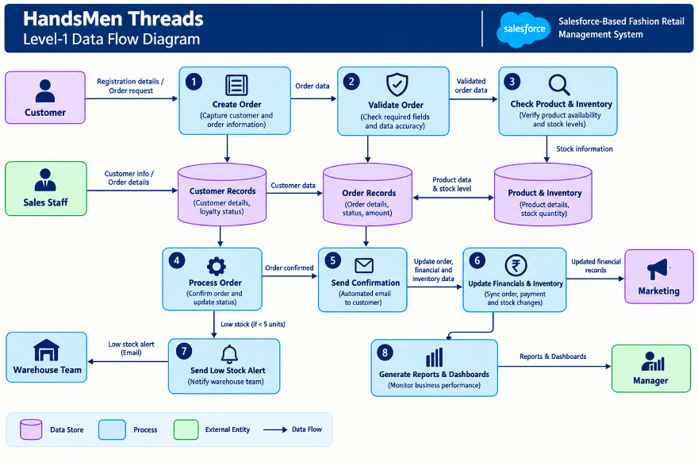

The diagram corresponds to the steps as follows:
Step 1 – Customer and Order Input: Customer and order details are entered into the system.
Step 2 – Validation and Storage: The system checks the details and saves the customer and order records. Product and stock data is also verified.
Step 3 – Inventory Verification: The system looks at the quantity available for the requested products. Where relevant, low-stock situations are detected.
Step 4 – Order Processing: The order is handled and its details are updated accordingly.
Step 5 – Notification and Updates: Once the order is confirmed, the customer gets an automatic notification. Related inventory and financial data is updated as needed.
Step 6 – Monitoring: Reports and dashboards draw on the stored business data so users can follow orders, customers, inventory, loyalty activity, and overall performance.

4. PROJECT DESIGN PHASE

4.1 Problem–Solution Fit
The design phase sets out how Salesforce will be used to tackle the business problems found earlier. Each major problem is matched with a fitting Salesforce solution, and the planned system architecture is described.
Problem Statement
The HandsMen Threads Salesforce solution deals with the usual difficulties of managing customers, products, orders, inventory, loyalty programs, and operations. Salesforce features centralize data, keep it accurate, and automate repetitive work.
Problem solving mapping
Problem / User Constraint | HandsMen Threads Solution | Salesforce Capability
Customer data may be entered incompletely or incorrectly. | Keep customer data centralized and validated. | Custom Objects, Fields, Validation Rules
Managing product data and availability by hand can be difficult. | Keep product and stock data in one central place. | Custom Objects, Fields, Lightning App
Sales staff could enter wrong or partial order details. | Check order data before it is processed. | Required Fields, Validation Rules, Flows
Customers might not get order updates on time. | Send confirmation emails automatically once an order is confirmed. | Record-Triggered Flow, Email Alerts
Low stock may not be caught quickly. | Track stock levels and alert the warehouse team when stock goes below the set threshold. | Flow Automation, Formula Fields, Email Alerts
Updating customer loyalty might need manual work. | Update loyalty data automatically from customer purchase activity. | Custom Fields, Flow Automation
Marketing staff might lack well-organized customer data for engagement efforts. | Rely on central customer and purchase data to back marketing efforts. | Reports, List Views, Customer Records
Bulk orders might call for repeated manual handling. | Run bulk orders through scheduled automation and refresh the related records. | Scheduled Apex, Batch Apex
Managers could have restricted insight into business activity. | Offer central reports and dashboards for monitoring. | Reports, Dashboards, Lightning App

4.2 Proposed Solution
Parameter | Description
Problem | Handling customers, products, orders, inventory, loyalty, and other activities manually can lead to inaccurate data, slow communication, stock problems, and repeated effort.
Solution | A HandsMen Threads management system built on Salesforce that gathers business information in one place and automates key retail processes.
Novelty | Using Salesforce capabilities, the solution brings together data validation, automatic order confirmation, loyalty updates, low-stock alerts, and scheduled bulk processing.
Social Impact | Customer service improves, manual work shrinks, notifications arrive on time, and staff can run business activities more efficiently.
Revenue Model | The system backs fashion product sales by strengthening customer engagement, loyalty, order handling, and inventory control.
Scalability | The system can handle growing numbers of customers, products, orders, and users. More automation and business features can be added as the organization grows.

4.3 Solution Architecture
1. Users Layer
Each type of user accesses the system based on their role.
- Sales Staff
- Warehouse Team
- Marketing Team
- Managers
- Administrators
2. Presentation Layer
The Salesforce Lightning interface gives users access to business information via:
- Lightning App
- Record Pages
- List Views
- Reports
- Dashboards
3. Automation Layer
Salesforce automation lowers repetitive manual work and supports business processes by means of:
- Validation Rules
- Record-Triggered Flows
- Scheduled Flows / Apex
- Batch Apex
- Email Alerts
- Automated record updates
4. Data Layer
The system holds and manages the organization's core business data, such as:
- Customer Records
- Product Records
- Order Records
- Inventory Information
- Loyalty Information
- Marketing-related Information
Links between these records let related business data be connected and managed from one place.
5. Security Layer
Salesforce security restricts access to business data according to user roles. The system can make use of:
- Profiles
- Roles
- Permission Sets
- Sharing Rules
- Field-Level Security
As a result, users get the information and functions their roles require, while restricted business data stays protected.

5. PROJECT PLANNING & SCHEDULING
5.1 Project Planning
The HandsMen Threads Salesforce project uses the Agile methodology, breaking the work into smaller modules known as epics and user stories. Development and configuration are delivered across several sprints, so the team can review progress and make improvements at every stage.
Product Backlog and Sprint Schedule
Sprint | Functional Requirement / Epic | User Story No. | User Story / Task | Story Points | Priority
Sprint 1 | Developer Setup | USN-1 | As an administrator, I want to set up the Salesforce environment so that the HandsMen Threads system can be built and tested. | 1 | High
Sprint 1 | Data Management | USN-2 | As an administrator, I want to create the necessary custom objects so that customer, product, order, inventory, and loyalty data can be stored. | 5 | High
Sprint 2 | Data Management | USN-3 | As a user, I want separate tabs for the key business records so that I can reach the information I need quickly. | 3 | High
Sprint 2 | Data Management | USN-4 | As an administrator, I want to create the necessary fields so that complete and correct business data can be recorded. | 5 | High
Sprint 2 | Data Management | USN-5 | As an administrator, I want to define relationships between related records so that business data is linked and can be managed efficiently. | 5 | High
Sprint 2 | App Management | USN-6 | As a user, I want one HandsMen Threads Lightning App so that I can open all the business records I need from a single interface. | 3 | High
Sprint 3 | Process Automation | USN-7 | As a system, I want validation rules so that wrong or incomplete customer, product, and order data is blocked. | 3 | High
Sprint 3 | Process Automation | USN-8 | As a system, I want automated flows for order confirmation, loyalty updates, and low-stock notifications so that manual effort is lowered. | 5 | High
Sprint 3 | Process Automation | USN-9 | As a system, I want to detect low-stock products and alert the warehouse team when stock drops under the required level. | 3 | High
Sprint 4 | Apex Development | USN-10 | As a system, I want Apex components to take care of complex business operations so that the required processing is automated efficiently. | 5 | High
Sprint 5 | Asynchronous Processing | USN-11 | As a system, I want scheduled and batch processing for bulk orders so that large volumes of records are handled efficiently. | 5 | High
Sprint 5 | Security | USN-12 | As an administrator, I want to set up suitable user access so that business data is available according to each user's role. | 5 | High
Sprint 6 | Reports & Dashboards | USN-13 | As a manager, I want reports and dashboards covering orders, inventory, customers, and business activity so that I can track performance and make well-informed decisions. | 4 | High
Epic Summary
Epic | User Stories | Story Points
Developer Setup | USN-1 | 1
Data Management | USN-2 to USN-5 | 18
App Management | USN-6 | 3
Process Automation | USN-7 to USN-9 | 11
Apex Development | USN-10 | 5
Asynchronous Processing | USN-11 | 5
Security | USN-12 | 5
Reports & Dashboards | USN-13 | 4
Total | 13 Stories | 52

Sprint Schedule Summary
Sprint | Main Activities
Sprint 1 | Salesforce environment setup and building of the core data objects
Sprint 2 | Fields, relationships, tabs, and the Lightning App
Sprint 3 | Validation rules, flows, notifications, and stock alerts
Sprint 4 | Apex development and advanced business logic
Sprint 5 | Batch and scheduled processing along with security setup
Sprint 6 | Reports, dashboards, testing, and the final review

6. PROJECT DEVELOPMENT PHASE

Milestone 1: Salesforce Developer Account Creation
Definition: A Salesforce Developer Edition supplies the environment needed to build, test, and demonstrate the HandsMen Threads application.
Key steps:
- Sign up for a Salesforce Developer account.
- Confirm the email address used to register.
- Sign in to Salesforce.
- Open Setup and set up the development environment.
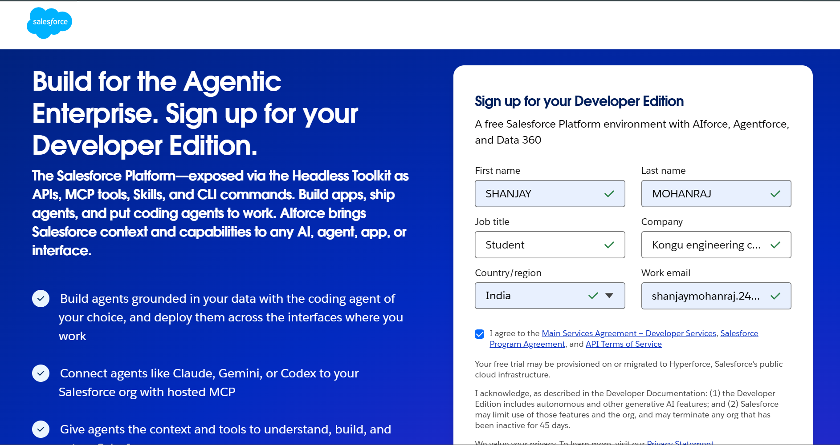

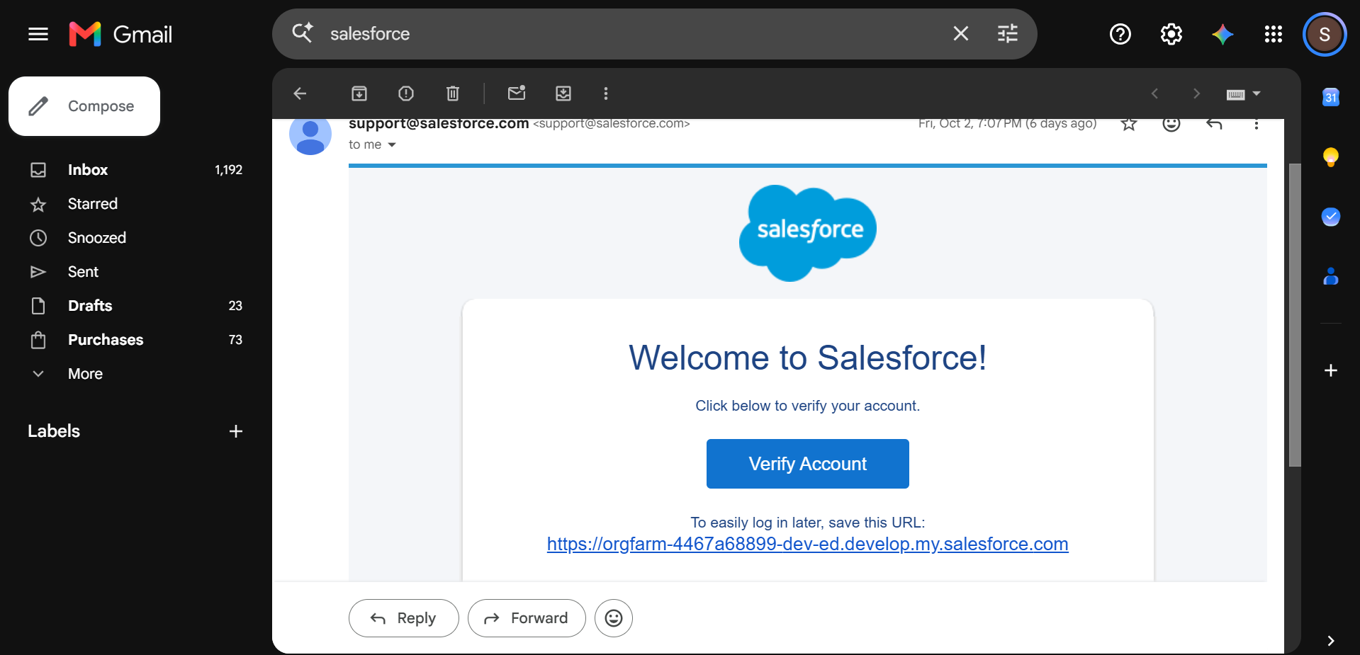

Milestone 2: Custom Object Creation
Definition: Custom Objects hold and organize the core business data of HandsMen Threads.
Objects:
- HandsMen Customer – Holds customer details and contact information.
- HandsMen Product – Holds product details such as name, category, price, and availability.
- HandsMen Order – Holds customer order data and order status.
- Inventory – Holds product stock and quantity data.
- Marketing Campaign – Holds marketing and customer engagement data.
Key steps:
- Go to Setup → Object Manager.
- Create the custom objects that are needed.
- Set the object labels and record names.
- Turn on features such as reporting and search.
- Create tabs for the objects that need them.

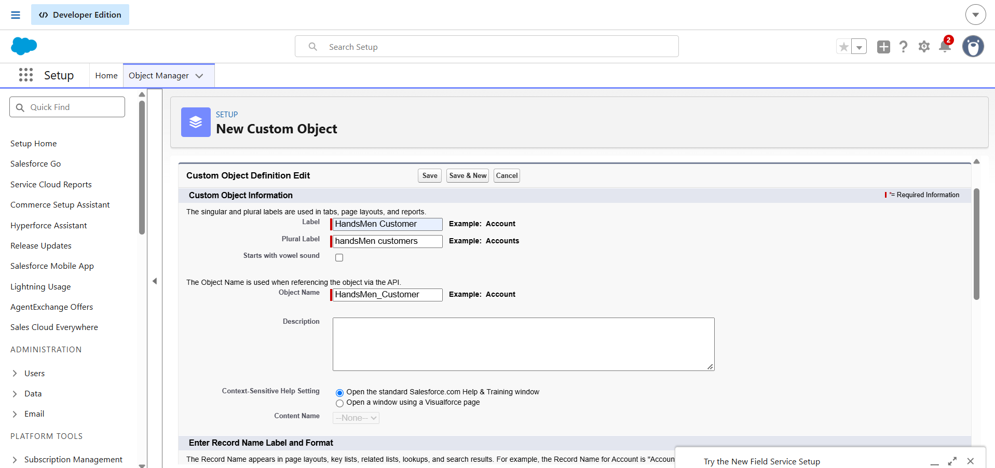
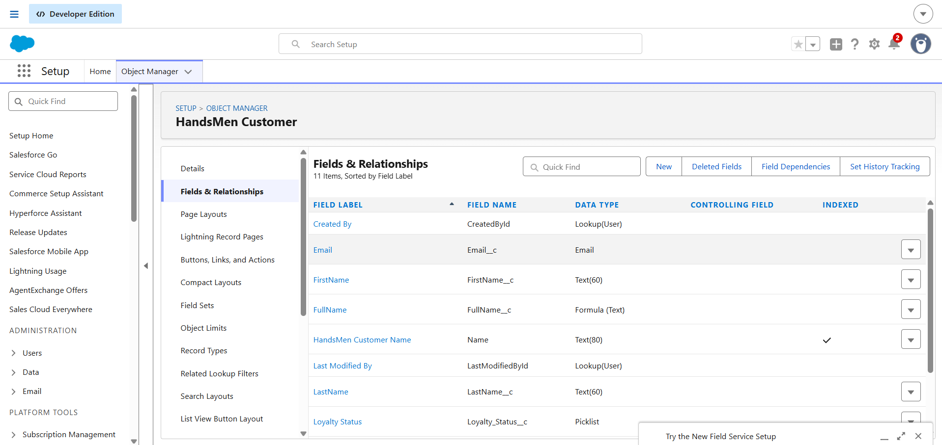
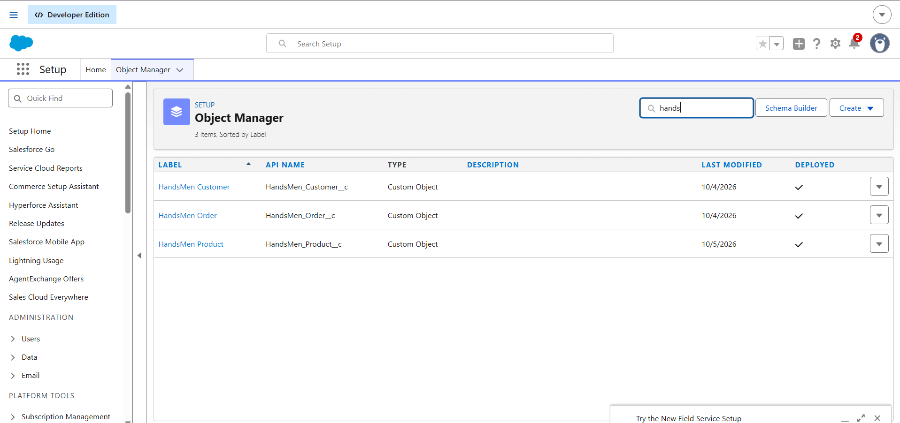

Milestone 3: Tabs Creation
Definition
Custom tabs give users quick, direct access to the HandsMen Threads records they need.
Create Tabs
- Go to Setup → Tabs → Custom Object Tabs → New.
- Choose the custom object.
- Pick a suitable tab style.
- Set the tab visibility.
- Save the tab.
- Include the tabs in the HandsMen Threads Lightning App.
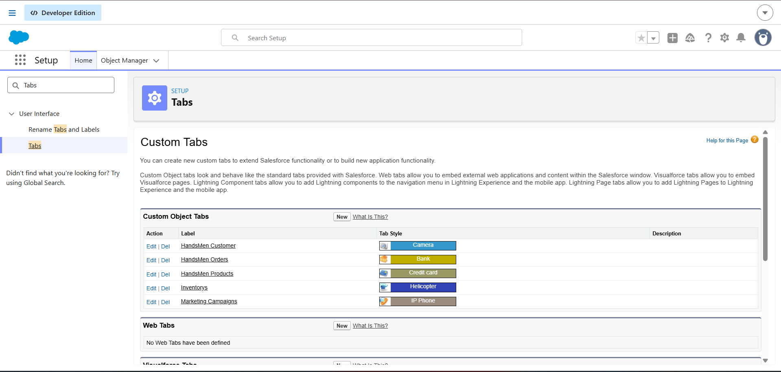

Milestone 4: Lightning App Creation
Definition: The HandsMen Threads Lightning App offers one central workspace for running the organization's business activities.
Key Steps:
- Go to Setup → App Manager → New Lightning App.
- Name the app HandsMen Threads.
- Set up the app navigation and branding.
- Add tabs such as Customer, Product, Order, Inventory, and Marketing Campaign.
- Include Reports and Dashboards where needed.
- Set the app visibility.
- Save the app and test it.
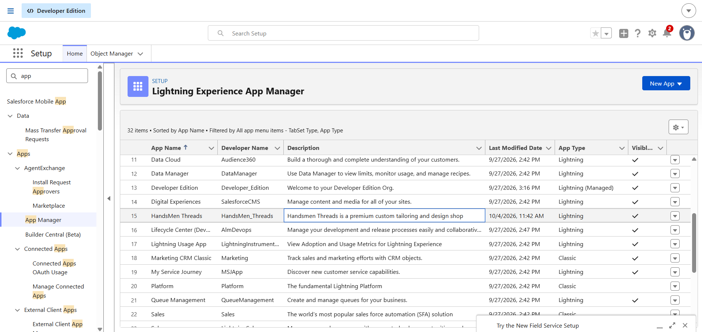

Milestone 5: Fields Creation
Definition: Fields capture the information needed to manage customers, products, orders, inventory, and marketing activities.
Key fields:
- Email – Holds the customer's email address.
- Phone – Holds customer contact details.
- Loyalty Status – Holds the customer's present loyalty status.
- Order Status – Shows the present stage of the order.
- Order Quantity – Holds the quantity ordered.
- Product Price – Holds product pricing data.
- Stock Quantity – Holds the stock available.
Relationships
- Customer → Order
- Product → Order
- Product → Inventory
Key Steps:
- Go to Object Manager → Object → Fields & Relationships → New.
- Choose a suitable field type.
- Provide the field label and name.
- Set mandatory values and field-level security.
- Add relationship and formula fields as needed.
- Place the fields on the relevant page layouts.
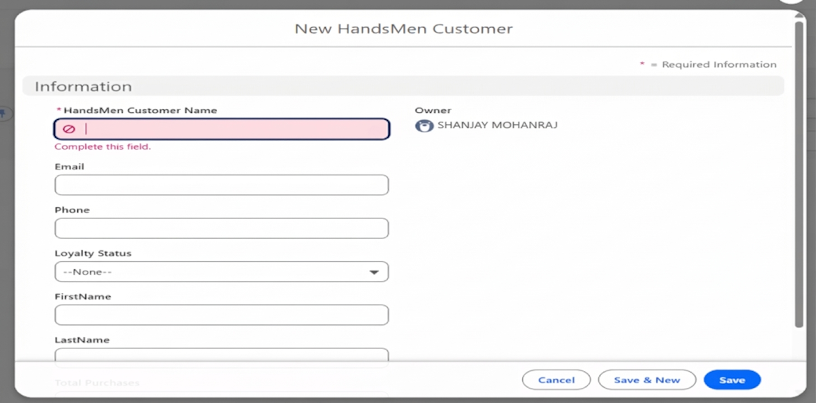
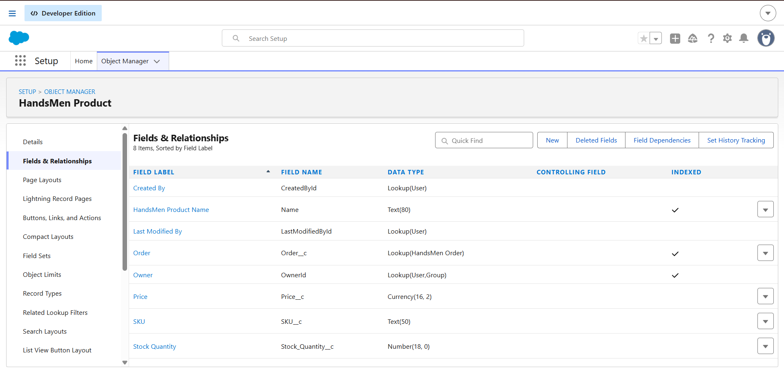
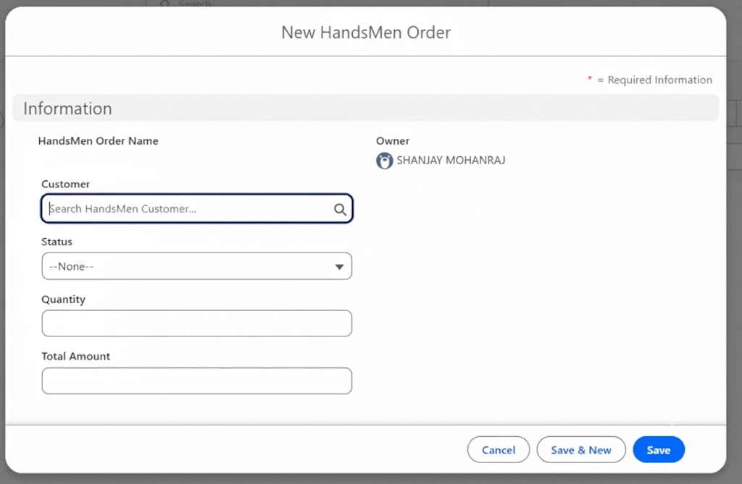

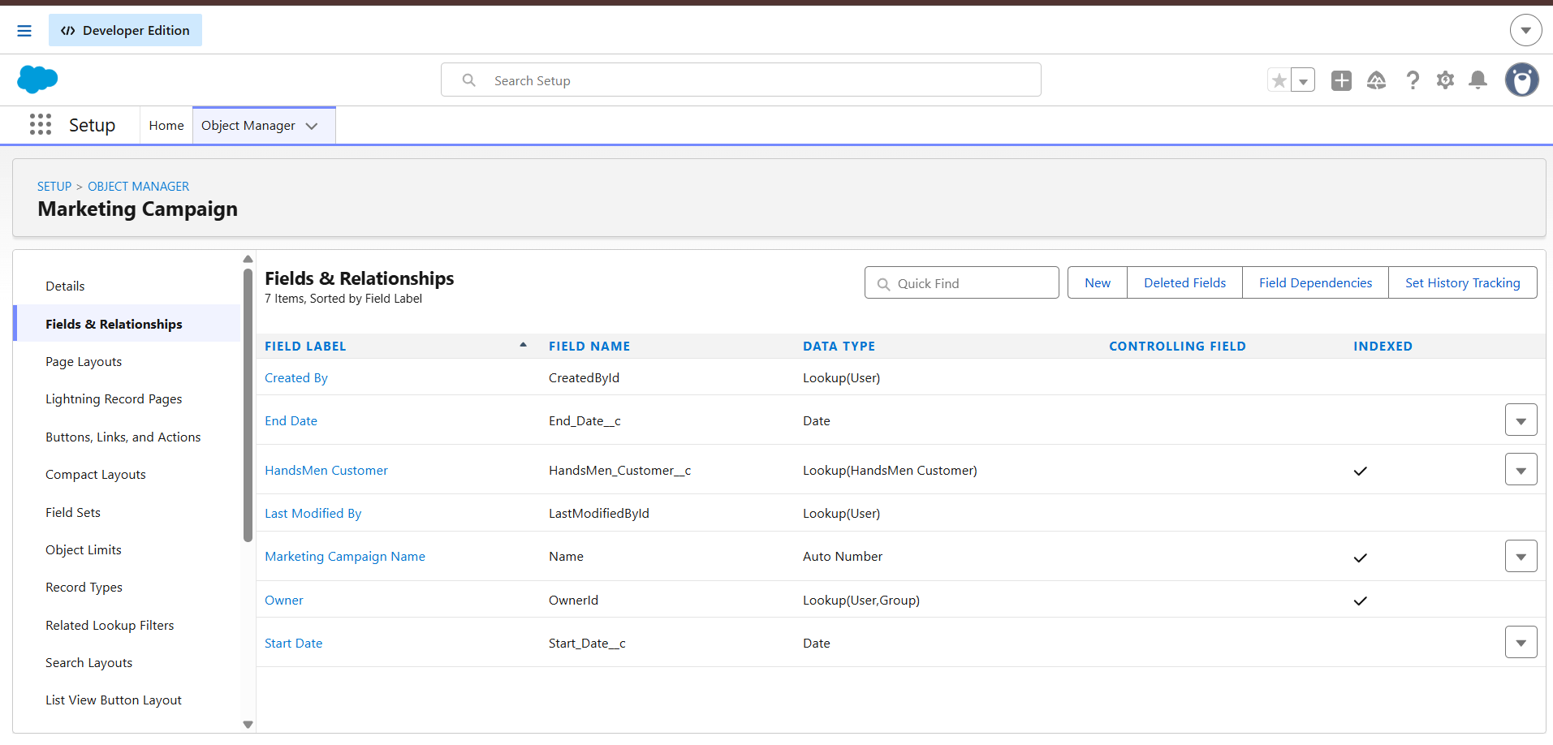

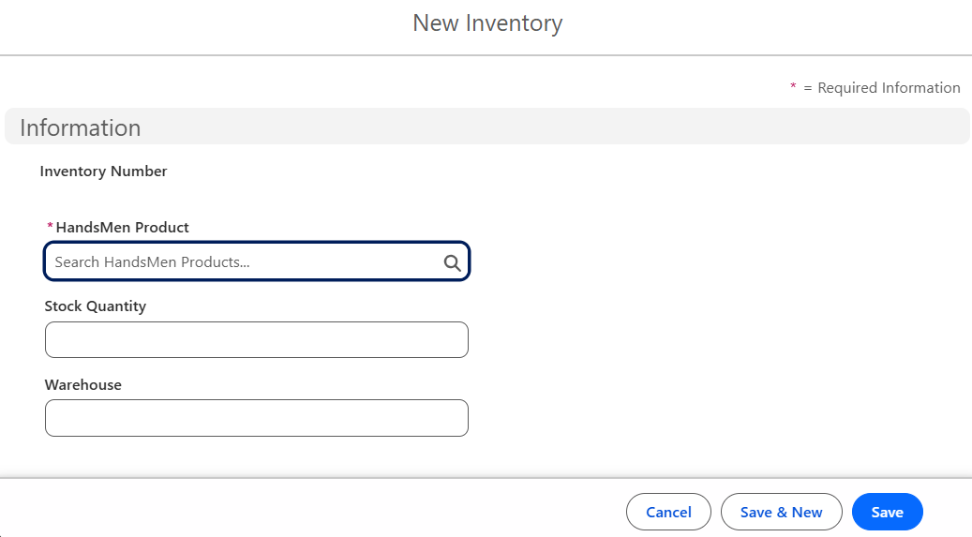
Milestone 6: Data Management – Field Creation & Field Types
Definition: Validation Rules confirm that the data entered in Salesforce meets the required business conditions. They stop users from saving invalid or incomplete records.
Key steps:
- Go to Setup → Object Manager → Select Object → Validation Rules → New.
- Provide a name for the rule.
- Write the validation condition as a Salesforce formula.
- Build rules covering key customer, product, order, and inventory data.
- Set meaningful error messages.
- Test the rules with both valid and invalid sample records.
Sample validations include:
- The order quantity must be valid.
- The product price must not hold an invalid value.
- Mandatory customer details must be supplied.
- The stock quantity must be valid.
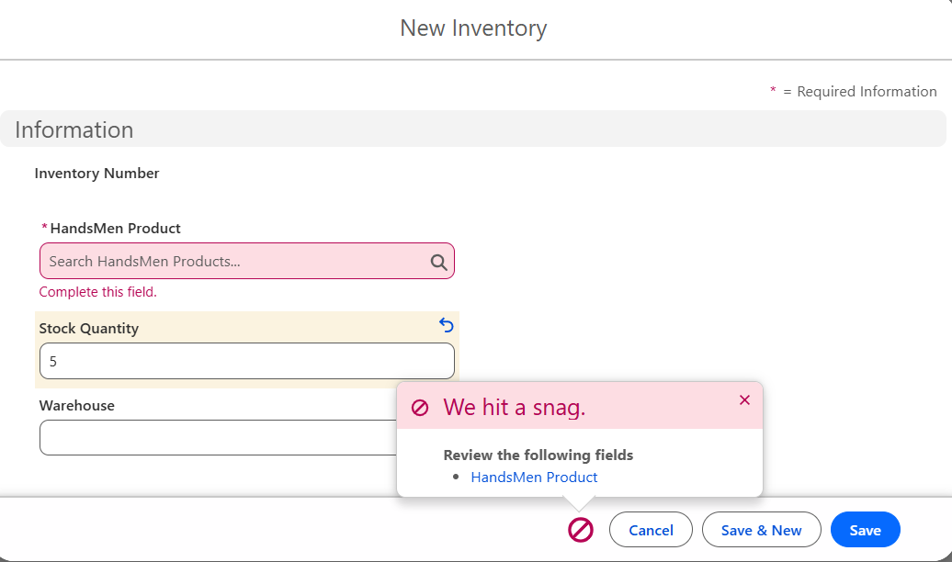
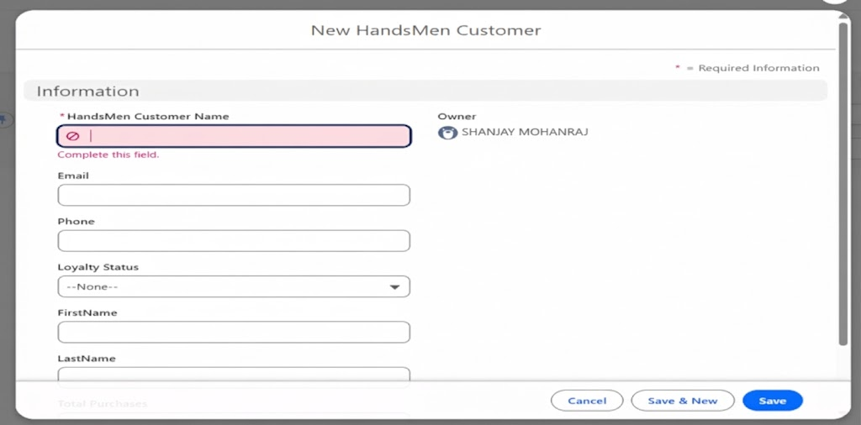

Milestone 7: Data Security – Roles
Definition: Roles and security settings determine who can access HandsMen Threads records, based on user responsibilities.
Key steps:
- Go to Setup → Roles → Set Up Roles.
- Create roles such as:
Sales Staff
Warehouse Team
Marketing Team
Manager
Administrator
- Order the roles to match responsibilities.
- Set Organization-Wide Defaults and sharing settings where needed.
- Place users into the right roles.
- Check the access permissions.
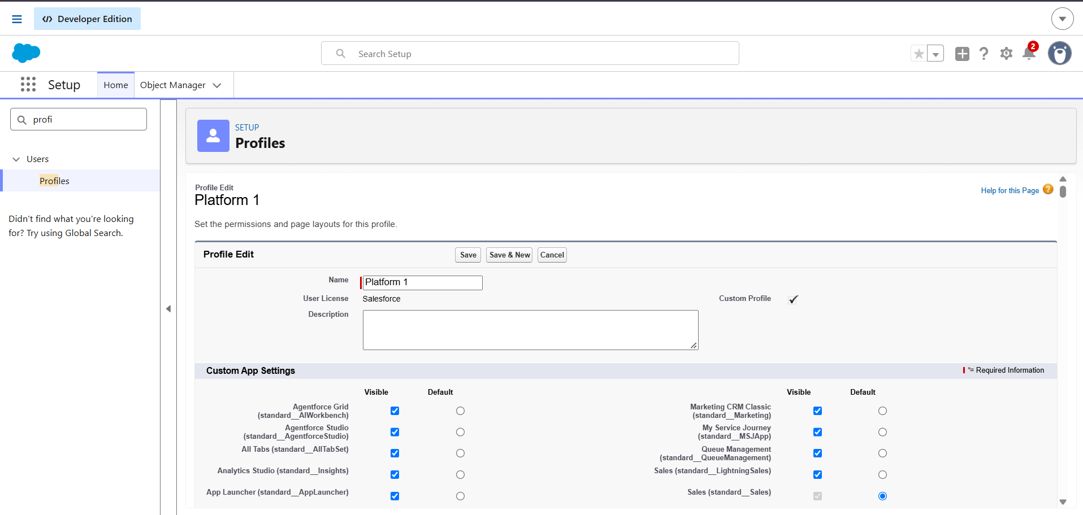
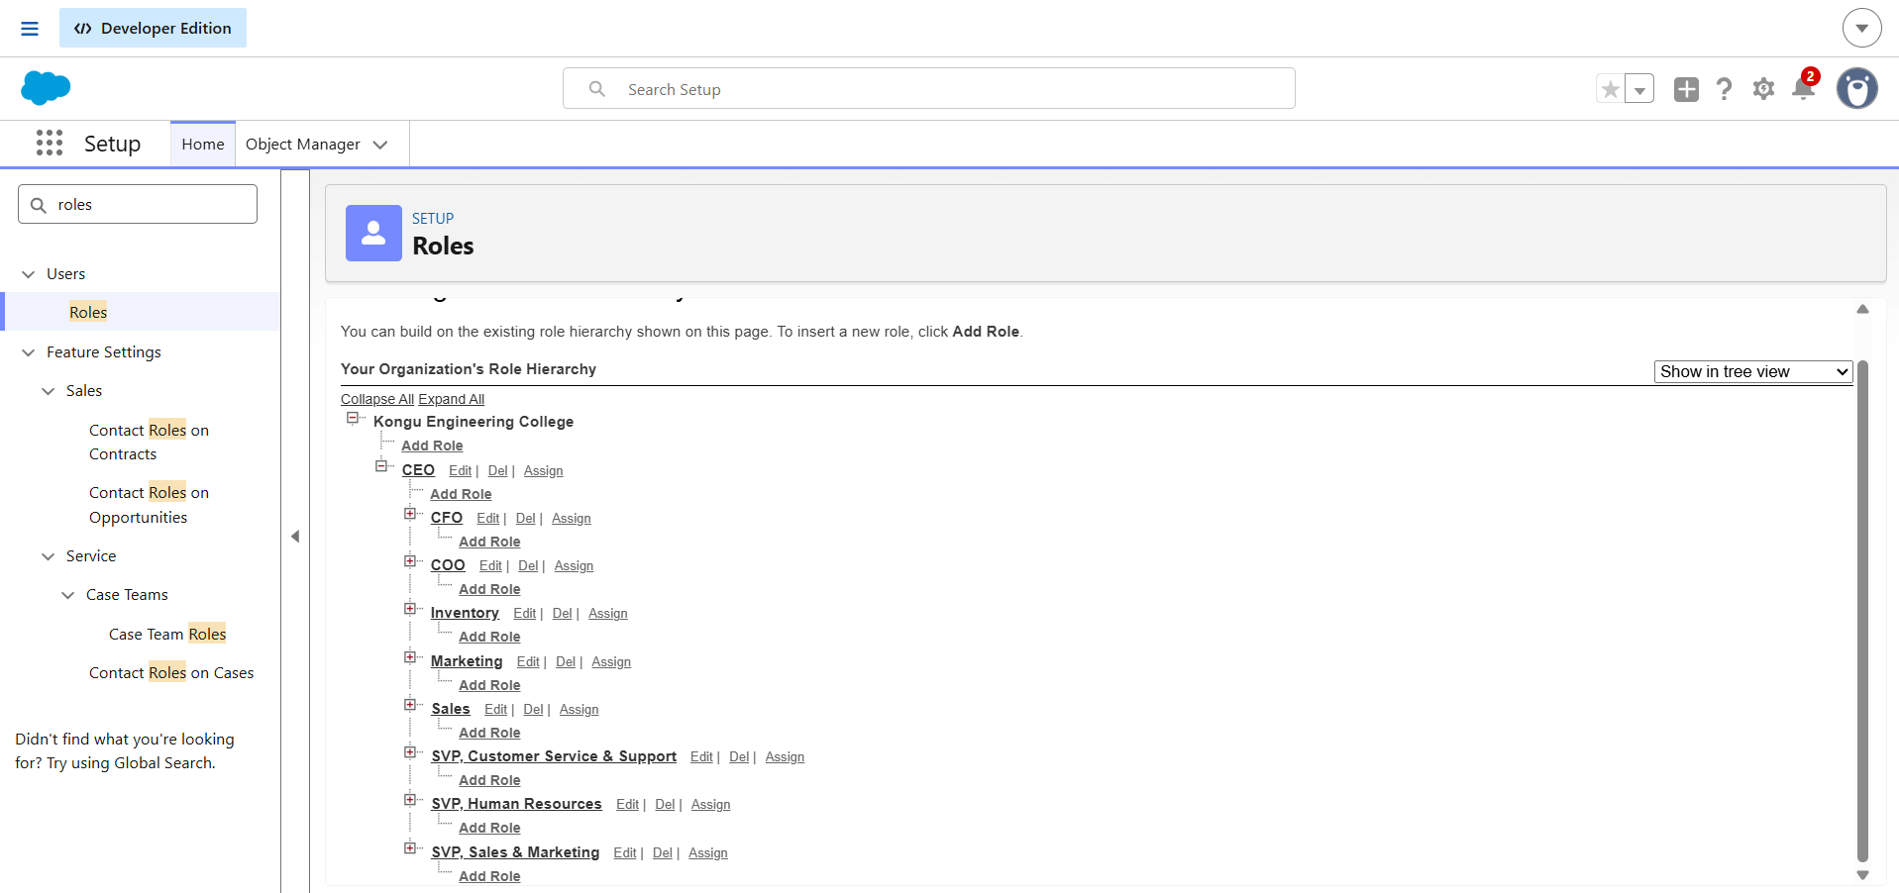
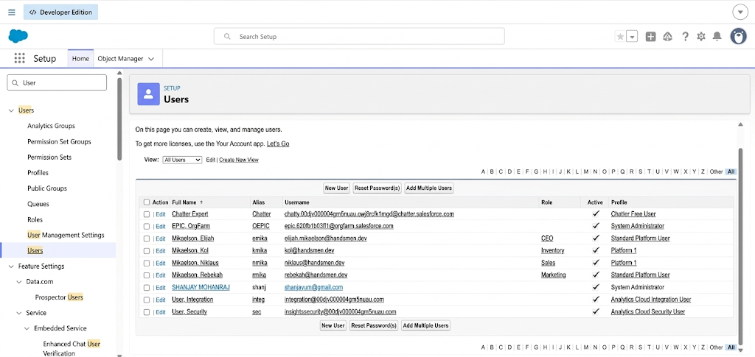

Milestone 8: Email Templates
Definition: Email Templates supply consistent messages for automated business notifications.
Key Templates
- Order Confirmation
- Low Stock Notification
- Loyalty Update
Key steps:
- Go to Setup → Email Templates.
- Create the email templates needed.
- Insert merge fields such as customer name, order number, product, quantity, and order status.
- Write the email subject and body.
- Save the templates and test them with sample records.
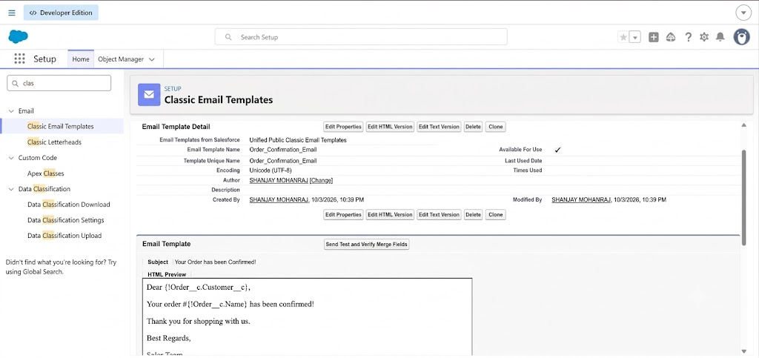

Milestone 9: Email Alert
Definition: Email Alerts send notifications automatically whenever a specified business condition is met.
Key steps:
- Go to Setup → Email Alerts → New Email Alert.
- Choose the object.
- Choose the matching email template.
- Add the recipients.
- Link the alert to the automation that triggers it.
- Save the email alert and test it.
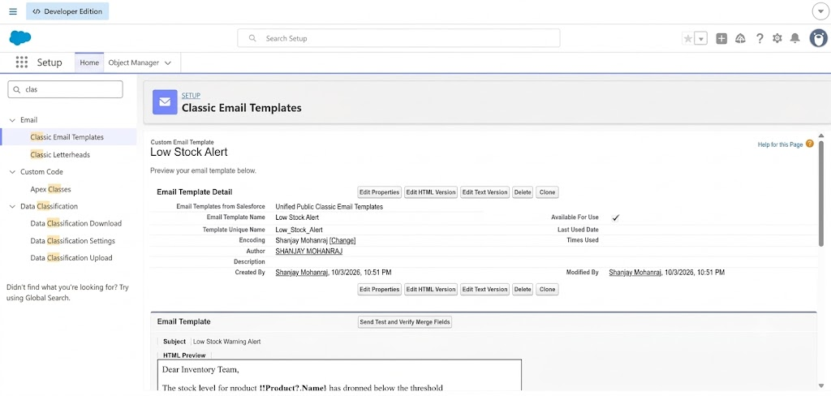

Milestone 10: FLOWS
Definition: Salesforce Flows automate repetitive business processes and lessen manual effort.
Main Flows
1. Order Confirmation Flow
Emails the customer automatically as soon as an order is confirmed.
2. Loyalty Update Flow
Changes the customer's loyalty data when the purchase conditions are met.
3. Stock Alert Flow
Finds products whose stock is under the set threshold and alerts the Warehouse Team.
4. Scheduled Processing Flow
Handles scheduled business tasks wherever needed.
Key steps:
- Go to Setup → Flows → New Flow.
- Choose a suitable flow type.
- Choose the object and the trigger conditions.
- Set up the actions needed.
- Include email notifications or record updates.
- Save the flow and activate it.
- Test the flow with sample records.
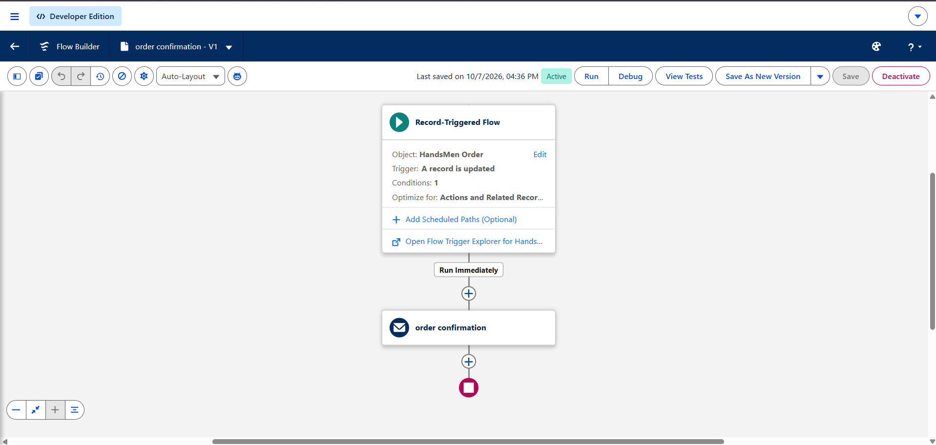

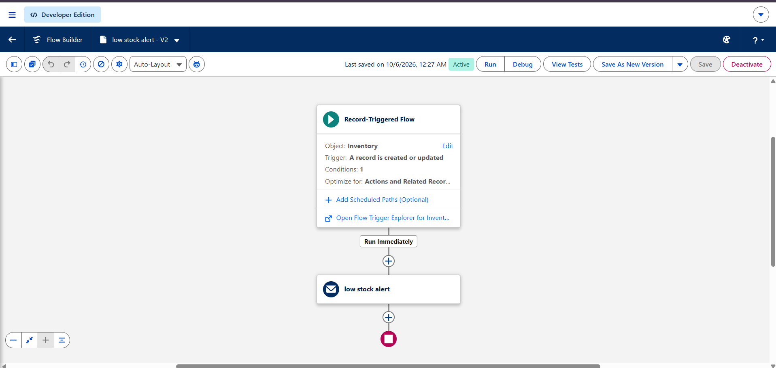

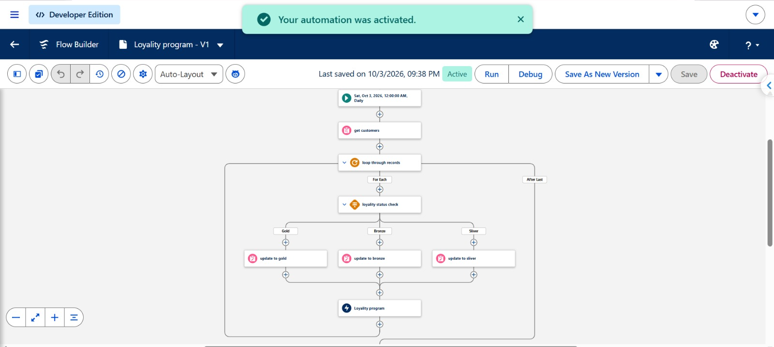
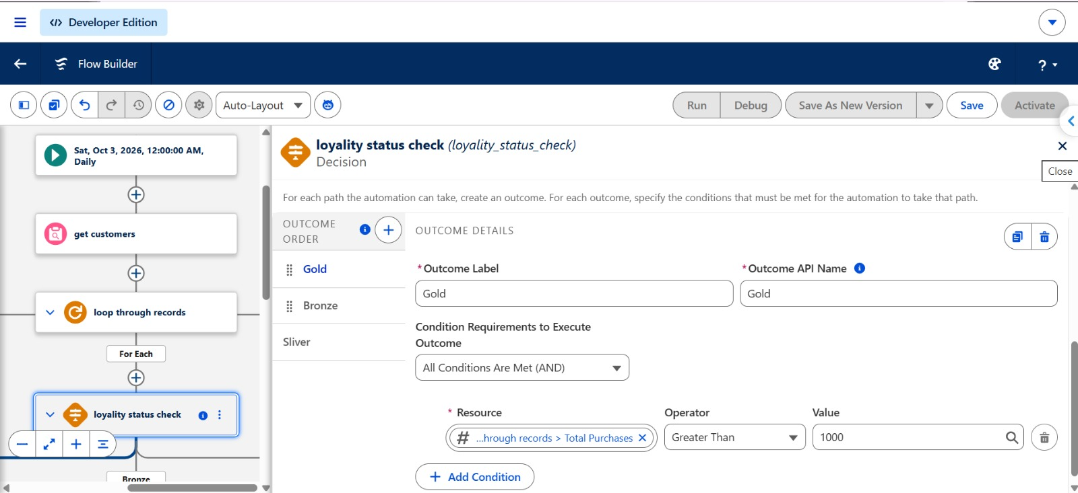

Milestone 11: Apex Class
Definition: Apex Classes implement business logic that needs programmatic handling beyond what standard Salesforce configuration and Flow can do.
Key steps:
- Go to Setup → Apex Classes → New.
- Create the Apex class.
- Write methods for the required business operations.
- Use Salesforce Objects, SOQL, and DML as needed.
- Add proper error handling.
- Save the class and compile it.
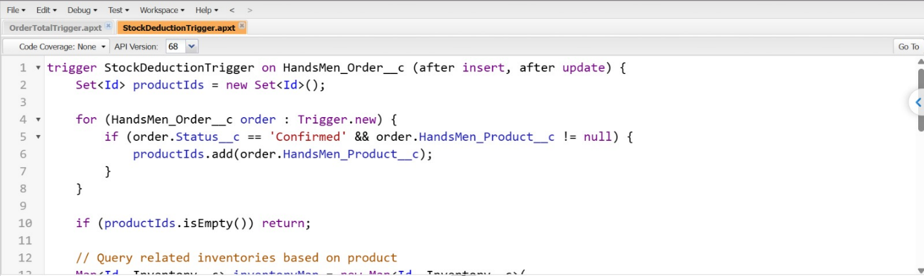
- Test the Apex logic with sample records.

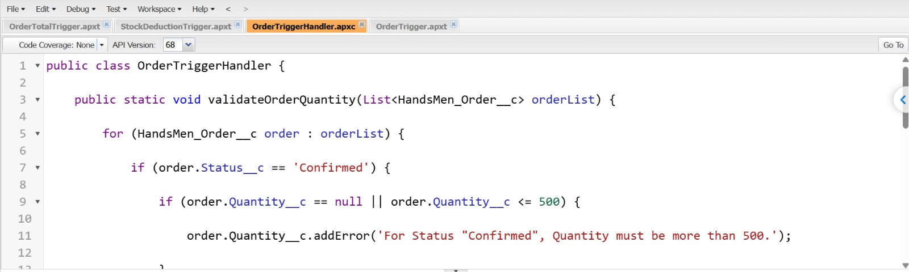

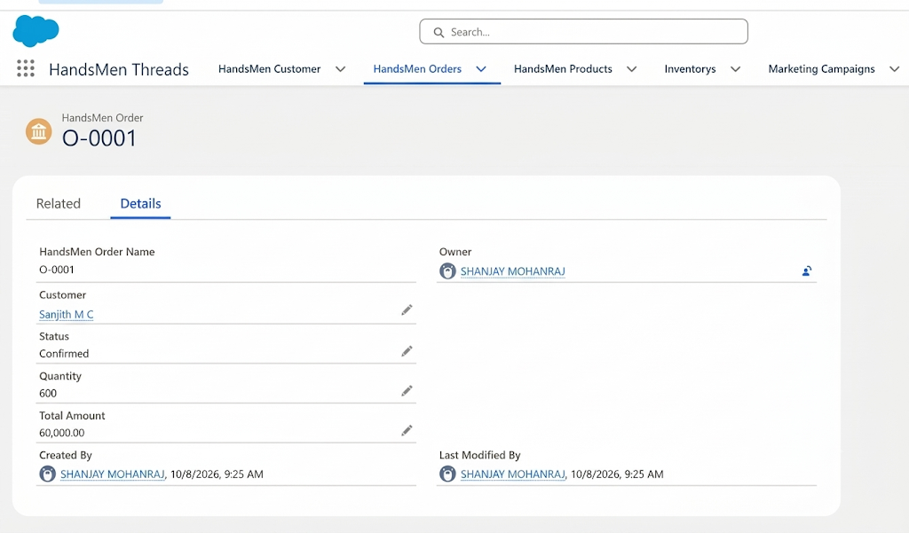

Milestone 12: Batch Jobs – Create Batch Apex
Definition: Batch Apex works through large volumes of Salesforce records efficiently by splitting them into smaller groups. It suits scheduled bulk order processing and the related inventory or business updates.
Key steps:
- Create a Batch Apex class that implements the Database.Batchable interface.
- Define the start, execute, and finish methods.
- Query the needed records with SOQL.
- Process the records batch by batch.
- Carry out the necessary order, inventory, or business updates.
- Run the batch job.
- Track the job via Setup → Apex Jobs.
- Test the batch process with sample records.
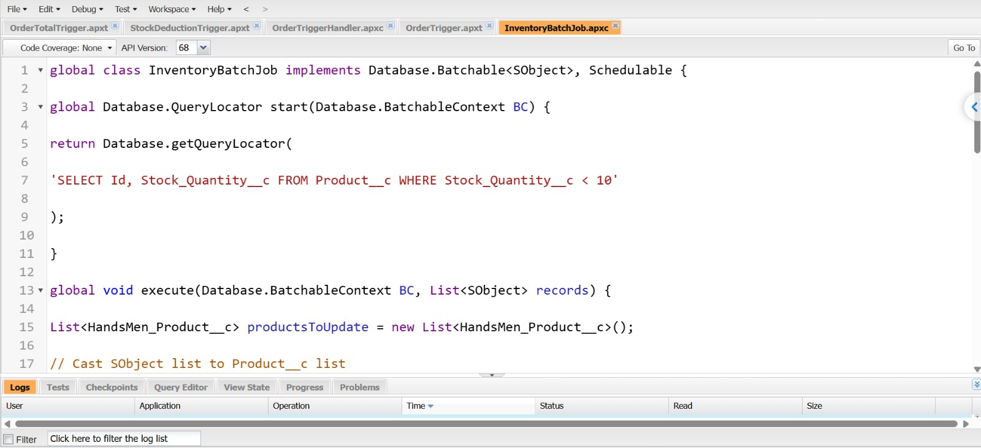
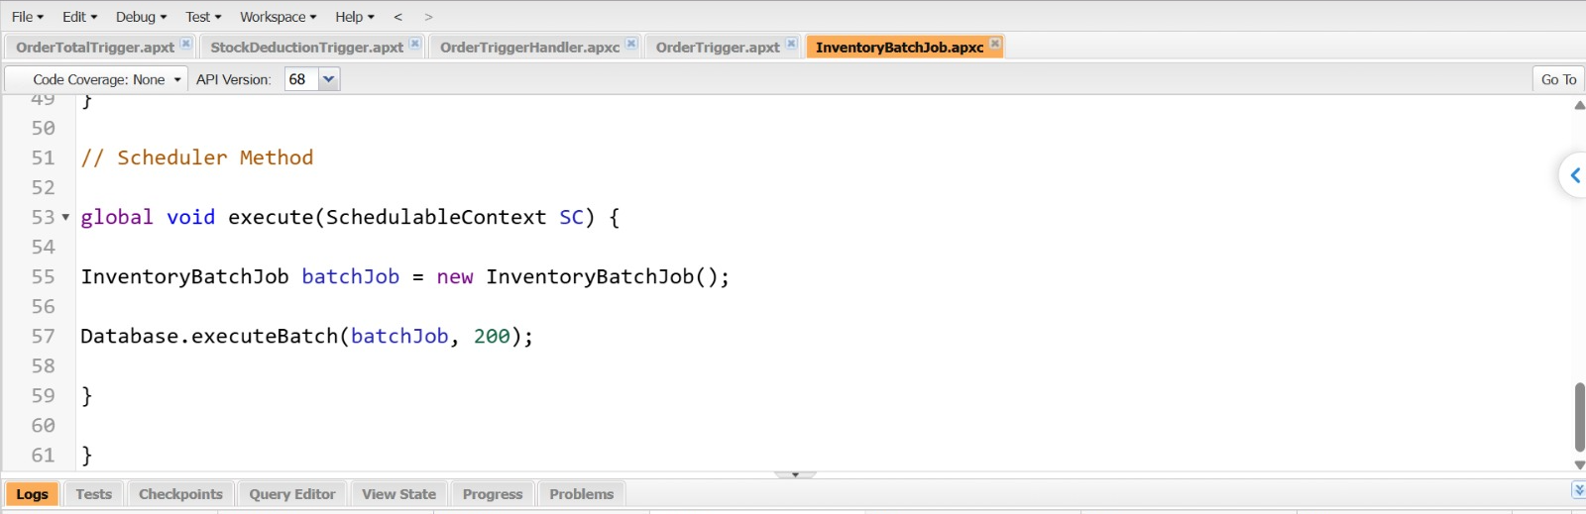

Milestone 13: Conclusion
Project Summary
The HandsMen Threads Salesforce system is a central platform for handling customers, products, orders, inventory, loyalty programs, and marketing data. Salesforce automation cuts repetitive work and helps the organization run its everyday processes more efficiently.
Outcomes and Benefits
- Efficiency: Automation lowers the amount of repetitive manual work.
- Accuracy: Validation rules keep wrong or incomplete data out.
- Faster Communication: Automatic emails deliver order and stock updates on time.
- Stock Control: Low stock can be spotted and reported without delay.
- Customer Engagement: Loyalty and customer data can be handled from one place.
- Better Visibility: Reports and dashboards let managers keep track of business activity.
- Security: Salesforce security features govern who can access business data.
- Scalability: The solution can grow along with customers, products, orders, and users.

Possible Future Enhancements
- A customer portal for placing and tracking orders online.
- Mobile access for the sales and warehouse teams.
- Deeper sales and inventory analytics.
- Integration with a payment gateway.
- Integration with delivery and logistics services.
- AI-driven demand forecasting and product recommendations.

