
University of Asia Pacific
Department of Computer Science & Engineering

Find your Car

Submitted To: Kazi Noshin

Submitted By: Rahat Bin Mobarak
ID: 19201007
Sanjidul Huda Shojon
ID: 19201013
Afnan Sunny
ID: 19201027
Abu Bakkar
ID: 19201034

Motivation:
The idea behind "Find Your Car" project is to provide a convenient platform to customers for renting and buying cars. Many people find it challenging to search for cars that meet their needs, budget, and preferences. This project aims to simplify the process of searching for cars by providing a user-friendly interface where customers can easily search and book/buy cars online.

Problem Definition:
The car renting and selling industry is highly competitive, and customers often face challenges while searching for cars that meet their requirements. These challenges include limited availability of cars, high rental costs, lack of transparency in pricing, and a lack of reliable information about the condition of cars. Moreover, traditional car rental and selling methods can be time-consuming and involve a lot of paperwork. So,We tried to bring something new for our customers to release their pressure.Every thing they are looking at about cars can get in one single platform.

Objective

The primary objective of the "Find Your Car" project is to develop an online platform that simplifies the process of searching, renting, and buying cars.

The solution is to create a user-friendly website and mobile application using HTML, CSS, Python, and Django, where customers can easily search for cars(as it’s also built for cross-platform) based on their location, preferences, and budget.

The project outputs include:

A website and mobile application for car renting and selling.

A user-friendly interface for customers to search, compare, and book cars.

Integration with various payment gateways for secure online transactions.

Integration with Google Maps to provide customers with accurate information about the location of cars and rental offices.

Integration with car inspection services to ensure the quality and safety of rented or purchased cars.

Impact on Society:
The "Find Your Car" project will have a significant impact on society by providing a more convenient and cost-effective way for people to rent and buy cars. It will reduce the time and effort required to search for cars, provide transparency in pricing, and improve the overall customer experience.
Moreover, it will create employment opportunities for car rental and sales professionals, contributing to the growth of the economy of Bangladesh.

Critical Challenges:
The critical challenges that the "Find Your Car" project may face include:
- Competition from established car rental and sales companies.
- Maintaining the quality and safety of rented or purchased cars.
- Managing customer expectations and addressing their complaints and concerns.
- Developing and implementing effective marketing strategies to attract customers.
- Security Challenges: Online transactions involve sensitive customer information such as personal and financial data. The platform needs to be secure enough to protect this information from theft or unauthorized access. As it’s still under development.

Conflicting Requirements
There may be conflicting requirements in this project, such as providing affordable rental rates while maintaining the quality and safety of cars. The project team must identify and address these conflicting requirements by prioritizing the needs of customers and maintaining a balance between affordability and quality.
As we working cross-platform projects can be complex to develop and require specialized skills and knowledge to ensure compatibility across different platforms.

"Find Your Car" project addresses some of the Programme Outcomes:

PO1: Engineering knowledge:
The project requires knowledge of HTML, CSS, Python, and Django programming languages and Machine Learning Algorithms, as well as expertise in integrating with various third-party services. This project helps students gain technical knowledge and skills in web development and integration.

PO2: Problem analysis: The project requires identifying the problems and needs of car rental and sales customers and addressing them through the development of a user-friendly website and mobile application. We will gain experience in problem analysis and problem-solving skills.

PO3: Design/development of solutions:
The project involves designing and developing a website and mobile application that meets the needs of car rental and sales customers, integrating with various third-party services, and ensuring secure online transactions and customer data protection. Students will gain experience in the design and development of solutions to real-world problems.

PO4: 5-Modern Tool Usage:
It is essential that the graduate is familiar with the latest tools and technologies in their field and can adapt to new ones as they emerge. The ability to use modern tools also requires knowledge of the underlying principles and concepts of the tools and their applications, enabling the graduate to make informed decisions about their use. We will gain experience in conducting investigations of complex problems and synthesizing information to develop effective solutions.

PO6: The Engineer and Society:
Firstly, the project promotes sustainable transportation by offering car rental services, which encourages people to use fewer cars and reduces carbon emissions. Additionally, by integrating with car inspection services, the project ensures that rented/ purchased cars meet safety and quality standards, which helps to promote public sound & safety.

Secondly, the project promotes social responsibility by providing a platform for customers to compare and book cars based on their preferences and budget they carry. This helps to reduce information asymmetry in the car rental and selling market, enabling customers to make informed decisions.

Lastly, the project promotes ethical behavior by integrating various payment gateways for secure online transactions. This ensures that customer data and financial information are protected, which promotes trust and transparency in the platform.
We will gain experience in professionalism, teamwork, time management, and communication skills.

PO11: Project management and finance:
The project requires to manage the project's timeline and cost analysis. This experience will help us to develop project management and financial management skills.

The "Find Your Car" project addresses several Knowledge Profile (K) aspects, including:

K2 Mathematics : The project requires knowledge of basic mathematics such as algebra and geometry for developing the website and mobile application. This aspect is addressed through the use of Machine Learning Algorithms to develop a user-friendly website and mobile application.

K3 - Engineering Fundamentals:
The project requires knowledge of web development and integration, software engineering, and project management, which are essential engineering fundamentals.

K5-Engineering Design: This aspect is addressed through the development of a website and mobile application that meet the needs of car rental and sales customers, integrating with various third-party services, and ensuring secure online transactions and customer data protection.

K6 - Engineering Practice: The project requires knowledge of engineering practice in the development of a website and mobile application that meets the needs of car rental and sales customers, integrating with various third-party services, and ensuring secure online transactions and customer data protection.

K7 - Comprehension: The project requires comprehension of the role of engineering in society and the impacts of engineering activity on economic, social, cultural, environmental, and sustainability terms. This includes complying with various regulations related to online transactions, data protection, and consumer rights.

K8 - Research Literature: The project involves engagement with selected knowledge in the research literature of the discipline, such as best practices in web development and integration with various third-party services.

CO’S AND PO’S in table:

Ps | Attribute | How Ps are addressed through the project
P2 | Range of Conflicting Requirement | Create an Ecommerce system where prepayment and Cash on delivery system will be available
P4 | Infrequent Issues | Mistakenly Ordered, Order Confirmation by calling the customer.
P5 | Outside Problems | Preventing Unwanted Access by activating multi step verification.
P6 | Diverse Groups | Customers, Students, Owners.
P7 | Many Components | Payment methods,data modeling, various interfacing.

Project Management (Time-table) and Cost Analysis:
The "Find Your Car" project will be developed using an Agile project management approach, with the following time-table:
Project planning and requirements gathering | 1 month
Website and mobile application development | 6 months
Testing and quality assurance | 2 months
Launch and deployment: | 1 month

The estimated cost of the project is $500,000, which includes the cost of website and mobile application development, server and hosting costs, salaries of project developers(if needed).

UML Diagram:-

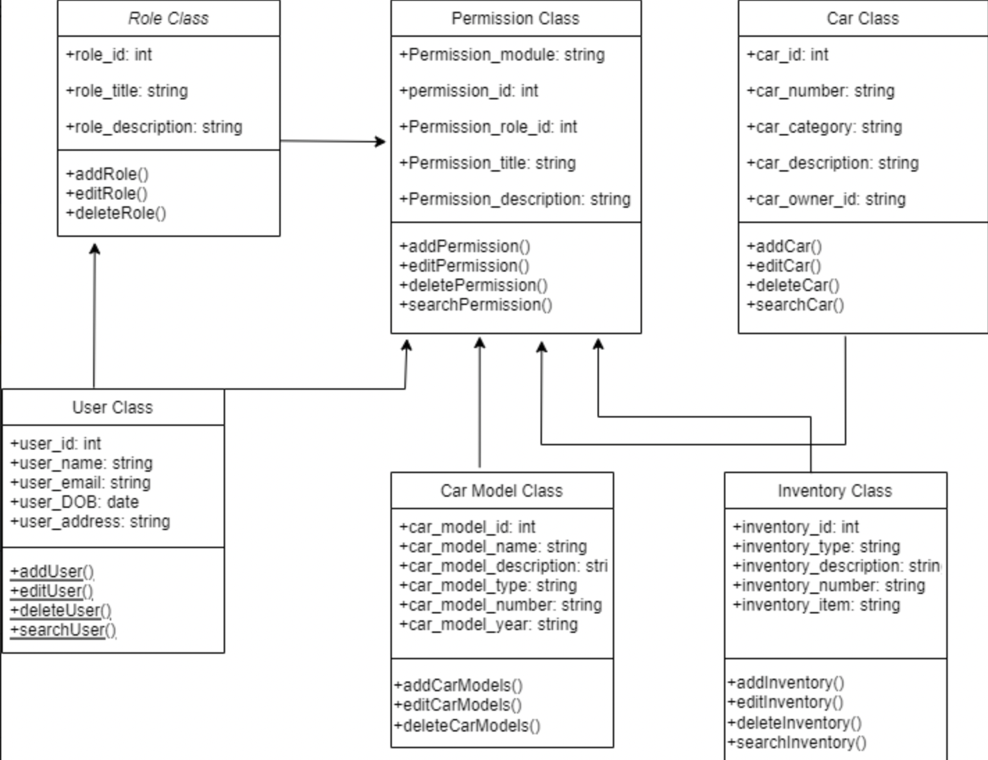

ERD Diagram:-
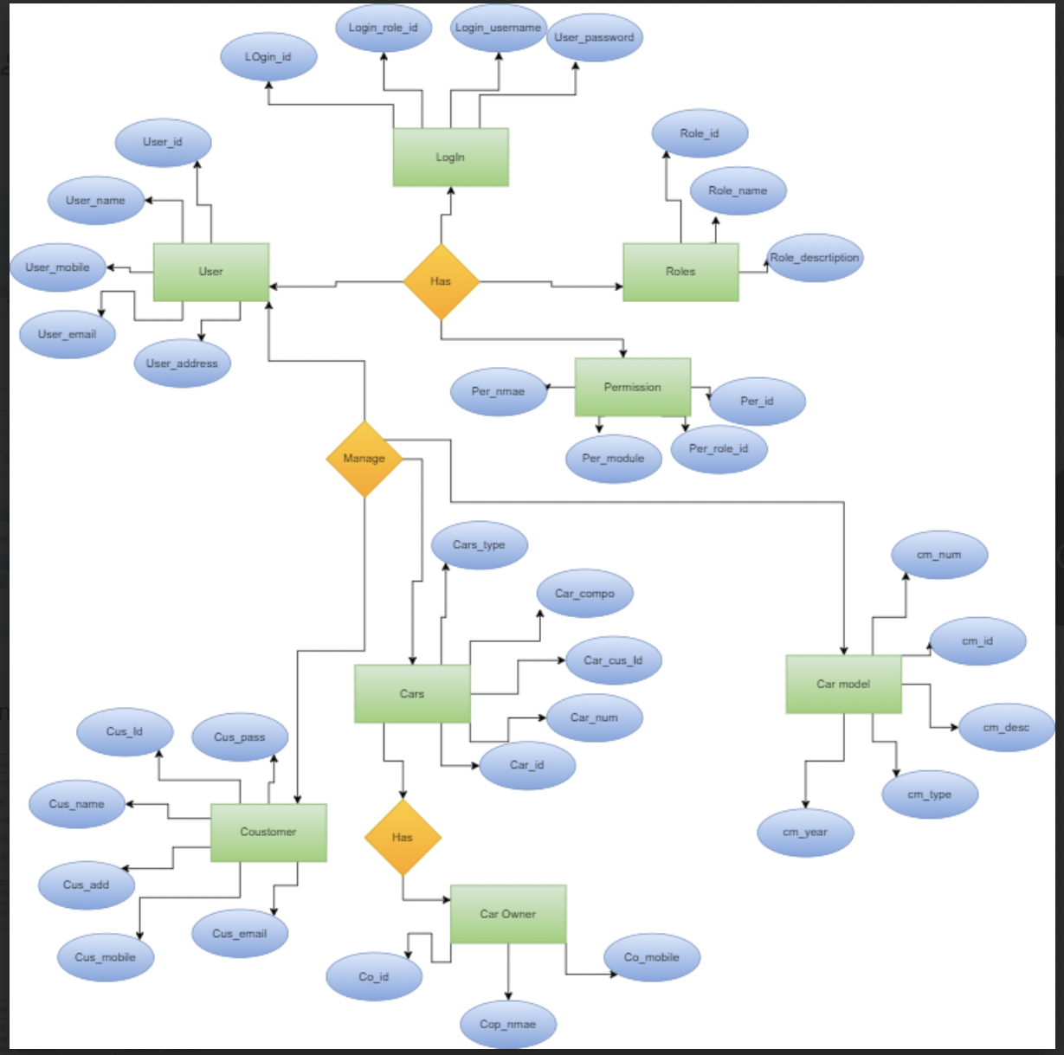

Contributors: (GIT Push)
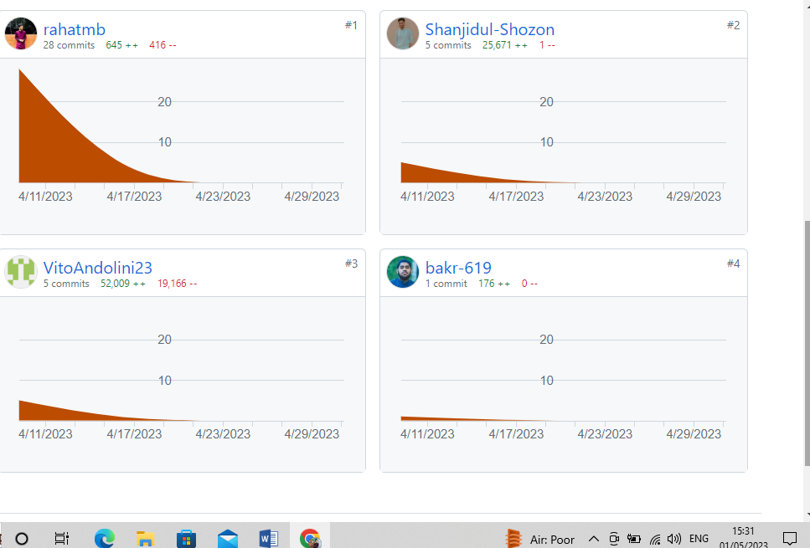

Learnings-
From the project work, there are several important learnings that can be drawn, including:

- Collaboration: The project involved a team of individuals with different skills and backgrounds, and effective collaboration was essential for its success.
- Planning and Organization: Effective planning and organization were crucial to the success of the project.
- Time Management: Managing time effectively was critical to meeting project deadlines and ensuring the timely completion of the project. We learned the importance of prioritizing tasks and avoiding procrastination to maximize productivity and achieve project goals.
- Technical Skills: The project required a range of technical skills, including HTML, CSS, Python, and Django programming languages. Through the project, we learned the importance of continuously developing and refining technical skills to improve project outcomes.

Website Picture:

