CATLA
Context-Aware Translation & Localization Algorithm
Dataset, Preprocessing, and Model-Combination Report
How ten source datasets were selected, cleaned, and unified into CATLA's training data; how three fine-tuned translation models are trained; and how their outputs combine into one Bengali-English tweet translation.

August 17, 2026
github.com/Shanjiv931/nlp_caslf

Contents
1. What this report covers
2. The data pipeline, end to end
3. The ten source datasets
4. Preprocessing and normalization techniques, by dataset
5. Problems found and how each was handled
6. What the pipeline produces
7. Training the three engines
8. Combining three engines into one translation
9. Sources and references
10. Licensing, scope, and what is still open

1. What this report covers
CATLA translates tweets between Bengali and English while keeping the things a generic translator throws away: emoji, hashtags, mentions, and slang. This document covers the part of the project that comes before any of that translation happens: where the training data came from, what was wrong with it, what was done to fix it, and what came out the other end. It also covers how the three fine-tuned translation models are trained and how their separate outputs get merged into a single answer at inference time.
Everything described here is real work already built and committed in the project repository. Sample rows, row counts, file names, and function names are pulled directly from the actual data files (data/raw/, data/processed/) and pipeline scripts (pipeline/clean.py, pipeline/split_and_augment.py, pipeline/train.py, pipeline/ensemble.py, and the rest of pipeline/), not reconstructed from memory.
The report has four parts. Section 3 goes dataset by dataset: what each one is, why it was picked, and what a raw row looks like before anything touches it. Section 4 lists the specific preprocessing and normalization techniques applied to each dataset, with a short reason for each. Section 5 covers every repair step: the specific bugs and data-quality problems found along the way, and how each was fixed. Sections 7 and 8 cover training and the ensemble that turns three separate models into one output.

2. The data pipeline, end to end
Ten raw sources, about 2.1 GB and roughly 17.5 million rows before any sampling, go through pipeline/clean.py and come out as one JSONL file with a single shared schema: data/processed/unified.jsonl, 811,204 rows, 512 MB. That file is then split by pipeline/split_and_augment.py into training, validation, and test sets, with one deliberate exception (the self-collected proxy test set goes entirely into TEST) and one deliberate addition (synthetic code-mixed rows, added to TRAIN only).
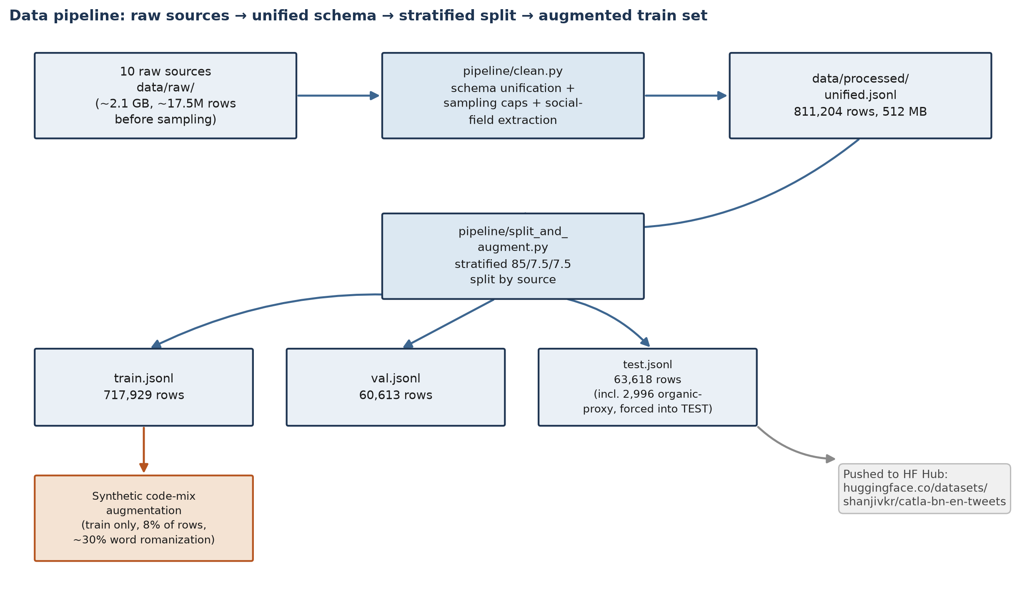
Figure 1. Raw sources through to the final train/val/test split.
Two of the ten sources, Samanantar and OPUS OpenSubtitles, are far larger than the rest: 8,604,580 and 8,931,628 raw pairs. Both were downsampled to 300,000 rows each before anything else happened. IndicTrans2, the primary translation engine, was already pretrained on Samanantar itself, so training on the full 8.6 million pairs again would mostly repeat what the base model has already seen. Free-tier Kaggle and Colab GPU time is also the real constraint on this project; several epochs over 17 million-plus combined pairs was never going to fit inside a usable training budget. The smaller, genuinely informal datasets, BanTH, BnSentMix, SentMix-3L, EmoMix-3L, are kept in full, since they cover the register gap this project actually needs to close.
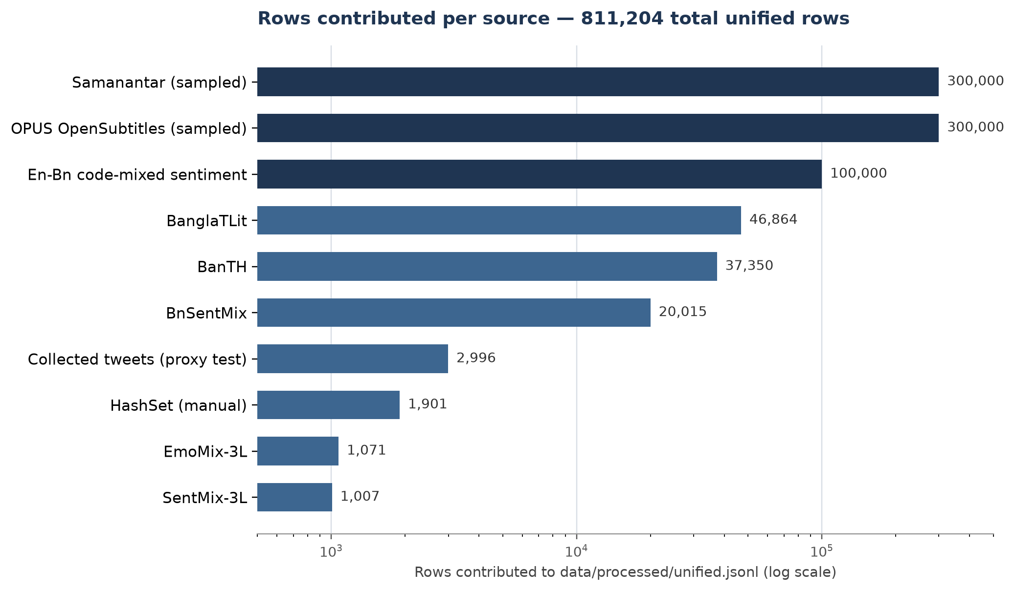
Figure 2. Rows contributed per source to the unified corpus (log scale).

3. The ten source datasets
Every entry below was checked to actually exist, either through the Hugging Face Hub API or by inspecting the downloaded files directly, before being counted as part of the corpus. The full source table with license and URL for each one lives in data/raw/SOURCES.md; what follows here is the reasoning behind each choice, plus a real sample row as it existed before pipeline/clean.py touched it.

3.1 Samanantar (Bengali configuration)
Source | License | Rows contributed | Pair type
ai4bharat/samanantar, HF Hub | CC-BY-NC-4.0 | 300,000 of 8,604,580 | bn <-> en translation, formal
Samanantar is the largest publicly available Bengali-English parallel corpus, built by AI4Bharat. It was picked as the anchor for general-domain vocabulary and grammar: named entities, numbers, dates, and the kind of formal sentence structure that never shows up in a tweet but that a translation model still has to get right when a user's message references it. IndicTrans2, the specialist engine in this project's ensemble, was itself pretrained on Samanantar, which is also the reason the full 8.6 million pairs were not used (Section 2).
Sample row, as it exists in the raw parquet shard (columns src = English, tgt = Bengali):
src (en) | tgt (bn)
The larger the building, the greater was the simplicity. | ইমারতের আকার যত বড় হয় তার সারল্যও তত বেশি হয়।
He said that keeping in view the situation, leave of all the health department officials has been cancelled. | তিনি জানান, স্বাস্থ্যবিভাগের সকল কর্মকর্তা-কর্মচারীর ছুটি বাতিল করা হয়েছে।

3.2 OPUS OpenSubtitles (bn-en)
Source | License | Rows contributed | Pair type
OPUS, via opustools | Per-file, OPUS redistribution terms | 300,000 of 8,931,628 | bn <-> en translation, informal subtitles
OPUS OpenSubtitles pairs subtitle lines across languages: short, conversational, closer to spoken dialogue than anything in Samanantar. It was added specifically to counter a risk called out early in this project's planning, that a corpus built entirely from formal, edited text would not match how people actually write on Twitter. Fetching it required opustools, which hit a Windows-specific SSL certificate verification failure on first run (CERTIFICATE_VERIFY_FAILED); pointing SSL_CERT_FILE at certifi's CA bundle for that call fixed it.
Sample row, from the raw aligned .bn/.en subtitle files:
bn | en
তরমনহয়শ ষপর্যন্তসসুস্থ হব ? | You think he'll last till after mess?
তুই তকচন সন! | You never even met her!
The first sample row above shows a real property of raw OpenSubtitles data worth flagging on its own: subtitle-timing artifacts sometimes merge words together with no space ("তরমনহয়শ" is several run-together words), a side effect of how subtitle lines get segmented for on-screen timing rather than for grammatical sentence boundaries. This is left as-is in the corpus; it is exactly the kind of noisy, informal text this dataset was chosen to contribute.

3.3 BanTH
Source | License | Rows contributed | Pair type
aplycaebous/BanTH, HF Hub (mirror of farhanishmam/BanTH) | MIT | 37,350 (train 29,879 + val 3,736 + test 3,735) | bn <-> en translation, informal, YouTube
BanTH is a Bengali hate-speech dataset built from YouTube comments, published at NAACL 2025 Findings. Its full_with_stats.csv file (449,265 rows) carries only hate-speech category labels, no bn/en text pair. The separate train.csv, val.csv, and test.csv splits, however, do carry genuine bangla and english columns, human-translated, plus a romanized Text column. Locating this took a real correction mid-project: an earlier check of only full_with_stats.csv concluded BanTH had no usable parallel text at all, and that conclusion had to be revised once the split files were checked directly.
It was picked because it is the largest source of authentically informal, human-translated bn-en pairs in the whole collection, and because it doubles as a source for the transliteration and code-mixing modules, since every row also has a romanized-Bengali column. BanTH does contain a meaningful share of offensive and political content by design (it is a hate-speech dataset); the examples below are chosen from its non-offensive rows to keep this report readable, but the training data itself keeps the offensive rows in, since they are still real, grammatically valid bn-en pairs and CATLA's job is translation, not moderation.
Sample rows (non-offensive, Label = 0):
bangla | english | romanized (Text)
কিন্ডলি চেক করে কন্টেন্ট এর অডিও ঠিক করেন | Kindly checks and fix audio of content | Kindly check koira content er audio thik koren
মামা,তুমি কই পালিয়ে আছো,দেশে আসো | Uncle, where are you running away, come home | Mama,tumi koi paliye acho,deshe aso
What the label columns mean: Label is the overall flag, 0 for not offensive and 1 for offensive (21,384 rows are 0, 8,495 are 1 in the training split, checked directly). The eight columns beside it, Political, Religious, Gender, Personal Offense, Abusive/Violence, Origin, Body Shaming, and Misc, are separate binary flags marking which specific category or categories of offense apply when Label is 1; a row can carry more than one at once, which is what "multi-label" refers to in the dataset's own title. Personal Offense (5,752 rows) and Abusive/Violence (2,335 rows) are by far the most common categories; Body Shaming (92 rows) and Religious (110 rows) are the rarest.

3.4 BanglaTLit
Source | License | Rows contributed | Pair type
aplycaebous/BanglaTLit, HF Hub | MIT | 46,864 usable pairs of 249,727 | bn transliteration
BanglaTLit is the only dataset in the collection that pairs genuine Bengali-script text with its romanized Banglish counterpart, which makes it the ground truth for CATLA's transliteration module: detecting when a user has typed Bengali using Latin letters and converting it to Bengali script before translation runs. It was chosen for exactly that reason; nothing else in the collection provides this pairing directly.
Sample row (real Bengali-script target present):
text_bengali | text_transliterated
কালী নেটহান্টার ইনস্টল এন্ড সেটআপ করার পর লিনুক্স এর কাজ গুলা টার্মক্স দিয়ে করতে পারবো কি ? | Kali nethunter install and setup korar por Linux er kaj gula termux diye Korte parbo ki?
Section 5.2 covers the data-quality issue found in this dataset: most of its rows do not actually have a Bengali-script target at all.

3.5 BnSentMix
Source | License | Rows contributed | Pair type
aplycaebous/BnSentMix, HF Hub | MIT | 20,015 | monolingual social, code-mixed
BnSentMix collects Bengali-English code-mixed sentences from Facebook, YouTube, and e-commerce comments, labeled for sentiment. It carries no English translation column, so it is not usable as translation training data directly. What it gives the pipeline instead is volume of genuine, natural code-switching, the kind of sentence where Bengali and English sit side by side in the same clause, which the fine-tuned models need to see even outside of formal translation pairs. It also fed 799 rows into the Phase 2 proxy test set.
Sample rows:
Sentence | Label
Hlw lovely faiza apiii onak cute lage | 0
Redmi 11 prime er review anen vai ! | 0
Match ta interesting chilo, but amader team harlo. | 3
The source file gives Label as a bare integer with no class name attached. Inspecting a sample of rows at each value shows a consistent pattern: 0 reads as positive (5,353 rows: "phone ta darun lagse", the phone looks great), 1 as negative or critical (6,172 rows: complaints and crude remarks), 2 as neutral (6,619 rows: plain questions and requests with no evaluative content, such as asking for a PC build recommendation), and 3 as mixed (1,871 rows: a single sentence that praises and criticizes in the same breath, such as "the app is user-friendly, but the ads are irritating"). This mapping is this project's own reading of the data, not a class-name list published with the dataset itself.

3.6 SentMix-3L
Source | License | Rows contributed | Pair type
md-nishat-008/SentMix-3L, HF Hub | AGPL-3.0 | 1,007 | monolingual social, trilingual code-mixed
SentMix-3L adds a third language into the mix: Bangla, English, and Hindi inside the same sentence, sentiment-labeled. It was picked to widen the range of code-switching patterns the models are exposed to beyond pure bn-en, since Bengali social media genuinely does mix in Hindi loanwords and phrases, particularly around entertainment and news topics. It contributed 399 rows to the Phase 2 proxy test set.
Sample row:
text | label
Few more paperwork from then আমি যেতে পারব back to my home ... Just কিছু administration form বাকি তারপর আমি বিদেশ। | Neutral
Its label column uses three plain-text classes, no numeric decoding needed: Positive (420 rows), Negative (353), and Neutral (234).

3.7 EmoMix-3L
Source | License | Rows contributed | Pair type
GoswamiDhiman/EmoMix-3L, GitHub | GPL-3.0 | 1,071 | monolingual social, trilingual code-mixed
EmoMix-3L is built the same way as SentMix-3L, same three languages mixed in one sentence, but labeled for emotion rather than sentiment, and labeled as a multi-label task in the source paper (a row can carry more than one emotion). Alongside SentMix-3L it broadens the emotional range of code-mixed text available to the models past a flat positive/negative/neutral split. It contributed 399 rows to the Phase 2 proxy test set.
Sample row:
text | label
আপনার কঠোর পরিশ্রম এবং idea credit অন্য কেউ নেয় এমন কারো সাথে কাজ করা so frustrating ... mujhe gussa aa raha hai ki meree mehanat kee choree ho rahee hai. | Angry
Its label column uses five plain-text emotion classes: Happy (228 rows), Surprise (227), Neutral (223), Sad (205), and Angry (188).

3.8 En-Bn code-mixed sentiment (two-class)
Source | License | Rows contributed | Pair type
DaliaBarua/En-Bn-Code-Mixed..., HF Hub | MIT | 100,000 | monolingual social, code-mixed
This dataset is built from Amazon-style product reviews with individual English words substituted into otherwise-Bengali sentences, word-by-word rather than clause-by-clause. That is a different code-mixing pattern than BnSentMix's whole-phrase switching, and at 100,000 rows it is the largest single source of code-mixed (non-translation) text in the collection. It was picked for both reasons: the pattern itself, and the volume needed to make that pattern a reliable signal during fine-tuning rather than a handful of anecdotal examples.
Sample row:
Code-Mixed-Text | Sentiment
It was খুব কঠিন to খুঁজুন a আঠা that does না ব্যবহার Aspartame . এমনকি the "চিনি" gums have this রাসায়নিক in it ... | Positive
Its Sentiment column uses two plain-text classes, matching the "two-class" name in the dataset's own title: Positive (79,300 rows) and Negative (20,700).

3.9 HashSet (manually annotated subset)
Source | License | Rows contributed | Pair type
prashantkodali/HashSet, GitHub (LREC 2022) | Research use | 1,901 of 3.3M+ | hashtag segmentation
HashSet is the only dataset here that solves hashtag word-segmentation directly, turning a run-together hashtag like "dobsonvillestadium" into its component words. CATLA's hashtag_segmenter.py needs exactly this: a validation set and a base vocabulary for the cases a hashtag was not typed in CamelCase and has to be split algorithmically instead. Only the 1,901-row manually annotated split was used, not the 3.3 million loosely-supervised rows in the same release, to keep this dataset's weight in the corpus proportionate to everything else.
Sample rows:
Hashtag | Final Segmentation
dobsonvillestadium | dobsonville stadium
farmersvstukdegang | farmers vs tukde gang

3.10 Self-collected proxy organic test set
Source | License | Rows contributed | Pair type
Built in this project (pipeline/collect_test_set.py) | Derived from sources above | 2,996 | monolingual social, held out in TEST
The original plan called for a genuinely organic, live-scraped Twitter/X test set, held out from training entirely. That plan did not survive contact with the platform: snscrape, the tool it depended on, has not had a working release since 2023 and crashes outright under Python 3.12; X's own free-tier API dropped search access some time ago. Neither route was usable without paid access, which this project rules out.
The fallback actually used resamples the noisiest, most social-media-shaped rows already present in the other nine datasets: 800 from BanTH (YouTube comments), 799 from BnSentMix (Facebook, YouTube, e-commerce), 599 from the En-Bn sentiment reviews, 399 each from SentMix-3L and EmoMix-3L, deduplicated on exact text and shuffled. Every row is tagged is_proxy_test_set: true and source_dataset, so nothing downstream can mistake it for genuine live tweets. A separate, real set of 2,640 tweets was later collected through a paid third-party API at the user's own initiative; it is kept strictly local and out of the published pipeline (Section 10), since this project runs on free tools only.
Sample rows:
text | source_dataset | domain
Ja nower ta toh Nia gaso bro. R vlo vlo bolo na go priyo Tumi desh chila na toh kih kore bolo | banth | youtube_comment
Watching a surprise proposal is one of the most heartwarming অভিজ্ঞতাগুলির মধ্যে একটি ... onno der valobasa dekhte valoi lage bt amr ta koi | emomix_3l | social_media

4. Preprocessing and normalization techniques, by dataset
Four techniques apply to every one of the ten datasets, run by the shared write_row() function in pipeline/clean.py regardless of source, and are not repeated under each entry below:
- Empty, missing, or literal "nan" text is dropped before a row is written.
- Code-mixing is detected by script presence, not guessed: a row is flagged is_code_mixed if it has at least one Bengali Unicode character (\u0980-\u09FF) and at least one Latin letter.
- Every row's license string, source dataset name, and pair type are attached directly, not inferred later.
- Whatever label or metadata columns a source shipped are preserved under task_labels rather than dropped, in case a later phase needs them.
What follows is what each dataset does on top of, or instead of, these four.

1. Samanantar (Bengali configuration)
- Read shard by shard with pandas.read_parquet() (5 shards), never loaded fully into memory at once.
- Row-level random sampling per shard, capped at roughly 60,000 rows per shard (300,000 total), fixed random_state=42 for a reproducible sample.
- Hashtag, mention, and emoji extraction turned off (extract=False).
Why: Formal encyclopedic and news-style sentences do not carry hashtags, mentions, or emoji worth extracting, and capping the sample at 300,000 of 8,604,580 pairs keeps training time inside a free-tier GPU budget while staying reproducible from the raw files.

2. OPUS OpenSubtitles (bn-en)
- Streamed line by line from two aligned .bn/.en text files rather than loaded as a table, since the source is plain aligned text, not a spreadsheet.
- Random line-index sampling (Python's random.Random(42).sample()) over the full line count, capped at 300,000 pairs.
- Each line stripped of trailing newline and whitespace before storage.
- Hashtag, mention, and emoji extraction turned off (extract=False).
- SSL_CERT_FILE pointed at certifi's CA bundle during the opustools fetch step, fixing a Windows certificate-verification failure.
Why: Subtitle dialogue does not carry hashtags or mentions, so extraction was skipped, and the sampling and certificate fix exist purely to get a usable, reproducible slice of a 8.9-million-line source onto this machine at all.

3. BanTH
- Read from the three split files, train.csv, val.csv, and test.csv, not from full_with_stats.csv, since only the splits carry genuine bangla/english parallel columns.
- Hashtag, mention, and emoji extraction turned on (extract=True).
- Nine original hate-speech label columns (Label plus eight category flags) preserved as a structured task_labels dictionary.
- The romanized Text column carried through unchanged into romanized_text, alongside the Bengali-script and English columns.
Why: BanTH is the largest source of authentically informal, human-translated bn-en pairs in the collection, and YouTube comments genuinely contain hashtags, mentions, and emoji, so extraction was left on rather than skipped as it was for the two formal corpora.

4. BanglaTLit
- Read from three CSV files (train, val, test) via pandas.
- Hashtag, mention, and emoji extraction turned off (extract=False).
- Rows with a null text_bengali column dropped automatically by the shared empty-text check, since text_bengali is mapped to the unified schema's primary text field for this dataset.
- text_transliterated carried through into romanized_text for every surviving row.
Why: The goal was a clean Bengali-script-to-Banglish pair table for the transliteration module, so rows without a real Bengali-script target were removed rather than kept as noise, and extraction was skipped since this is word-level transliteration data, not social commentary.

5. BnSentMix
- Read with pandas.read_csv(on_bad_lines="skip"): malformed rows in the source file are skipped rather than allowed to crash the read.
- Hashtag, mention, and emoji extraction turned on (extract=True).
- The single Label column preserved as task_labels = {"label": value}.
Why: Facebook, YouTube, and e-commerce comments are exactly the noisy code-mixed register this project needs, so the priority was keeping every well-formed row intact rather than filtering by content, with malformed-row skipping as the only cleaning step needed.

6. SentMix-3L
- Same generic path as BnSentMix: pandas.read_csv(on_bad_lines="skip"), extraction turned on, single label column preserved.
- AGPL-3.0 license tag carried through explicitly, distinct from the MIT-licensed sources.
Why: The trilingual code-switching pattern itself is the value this dataset adds, not a need for special cleaning, so it was run through the same lightweight, reproducible path as the other code-mixed sentiment sets rather than a bespoke script.

7. EmoMix-3L
- Same generic path as SentMix-3L and BnSentMix: pandas.read_csv(on_bad_lines="skip"), extraction turned on.
- The label column mapped to task_labels as-is (five emotion classes, Section 3.7), rather than remapped to a smaller set.
- GPL-3.0 license tag carried through explicitly.
Why: Identical handling to SentMix-3L was appropriate since the two datasets share the same trilingual code-mixed structure; the only real difference worth preserving was the label semantics (emotion instead of sentiment), which the generic path already handles.

8. En-Bn code-mixed sentiment (two-class)
- Same generic path as the other code-mixed sentiment sets: pandas.read_csv(on_bad_lines="skip"), extraction turned on.
- The Sentiment column preserved as task_labels = {"label": value}.
Why: This is the largest code-mixed, non-translation source in the collection at 100,000 rows, so reusing the same reproducible path as the smaller sets, rather than a bespoke script, kept the sampling and extraction logic consistent across every code-mixed source in the corpus.

9. HashSet (manually annotated subset)
- Only the manually annotated file (HashSet-Manual.csv) read; the 3.3-million-row loosely-supervised "Distant" file in the same release was not touched.
- Hashtag and Final Segmentation columns explicitly cast with str() before use, guarding against either column being read as a non-string type.
- Hashtag, mention, and emoji extraction turned off (extract=False).
Why: Only the human-verified segmentations were trustworthy enough to use as ground truth for the hashtag segmenter's fallback vocabulary (Section 5.3); the loosely-supervised majority was left out to avoid diluting that trust, and extraction was skipped since the "text" field here is a hashtag, not a sentence.

10. Self-collected proxy organic test set
- Read from JSONL, the format pipeline/collect_test_set.py itself writes, not CSV.
- Hashtag, mention, and emoji extraction turned on (extract=True).
- The original source_dataset and domain fields carried into task_labels, so every row still traces back to which of the other nine sources it was resampled from.
- is_proxy_test_set set to true on every row, and forced entirely into TEST at the split stage (Section 5.4) rather than entering the stratified split.
Why: This set exists specifically to approximate organic tweet data, so preserving its provenance and keeping it fully isolated from training were both necessary to keep the "held-out" claim honest.

4.11 One further technique that spans multiple datasets
sanitize_text() (Section 5.2) is not applied at the dataset-cleaning stage above; it runs later, at training time, on every source's bn_en_translation rows uniformly, stripping literal tokenizer-special-token strings such as "<unk>" that appear as data-collection artifacts in some rows. It is listed here rather than under any single dataset because it is not dataset-specific: it applies the same way regardless of which of the ten sources a row came from.

5. Problems found and how each was handled
This section covers every real cleaning, normalization, and repair step applied to the data, in the order it actually happens: schema unification first (every source, same code path), then the dataset-specific problems that unification surfaced, then the tweet-specific preprocessing that runs on top for hashtags, slang, and transliteration, then the final split and augmentation step. Nothing here is a hypothetical concern; each item below was found by inspecting the actual data or hit as a real failure while building the pipeline.

5.1 Schema unification (pipeline/clean.py)
Every source, regardless of its original format, gets converted into the same row shape by write_row() in pipeline/clean.py:
- Rows with empty, missing, or literal "nan" text are dropped before anything else runs.
- Hashtags and mentions are pulled out with regular expressions (#(\w+) and @(\w+)); emoji are pulled out character by character using the emoji library's is_emoji check.
- Code-mixing is flagged by presence: a row is marked is_code_mixed if it contains at least one character in the Bengali Unicode block (\u0980-\u09FF) and at least one Latin letter, checked with two compiled regular expressions, not a language-model guess.
- Whatever label columns a source dataset shipped (sentiment class, hate-speech category flags) are preserved as-is under task_labels rather than discarded, in case a later phase of the project wants them.
- Every row keeps its original license string and, for the two oversized sources, is capped by random sampling with a fixed seed (random_state=42 for Samanantar, the same seed for OPUS's line-index sample) so the exact sample is reproducible from the raw files.

5.2 Dataset-specific problems found

BanglaTLit: most rows have no Bengali-script target
BanglaTLit_train.csv reports 245,727 rows, but 202,863 of them have a null text_bengali column, checked directly with df['text_bengali'].isna().sum(). Only 42,864 of the training rows actually carry a gold Bengali-script transliteration target; validation and test are fully populated (1,500 and 2,500 rows). This is the dataset's real shape, not a bug in the cleaning script. Rows without a Bengali-script target were excluded from the transliteration pairs, leaving 46,864 usable rows (42,864 train + 1,500 val + 2,500 test). The untouched BanglaTLit-PT.txt (245,726 unlabeled lines) stays in data/raw/ in case a future phase finds a use for the unlabeled rows.
Example of a row that was excluded (real, from the raw file):
text_bengali | text_transliterated
(null) | photo verify hole ki korte hobe pls keo bolben? japan vpn dia connect korle fb te login hoina sodo sodo password Email. errors dekhai

BanTH: the parallel text lives in a different file than first checked
full_with_stats.csv (449,265 rows) carries hate-speech category labels and comment metadata only; it has no bangla or english columns at all. The genuine parallel pairs are in the separate train.csv, val.csv, and test.csv splits, 37,350 rows combined. This was caught as a real discrepancy during the project: an earlier pass checked only full_with_stats.csv, concluded BanTH had no usable bn-en pairs, and that conclusion had to be corrected once the split files were opened directly and their bangla/english columns confirmed. data/raw/SOURCES.md was updated to reflect the correction rather than silently overwritten.

OPUS OpenSubtitles: SSL certificate failure on Windows
opustools' API call failed on first run with CERTIFICATE_VERIFY_FAILED, a Windows-specific gap between the system certificate store and what Python's requests library expects. Pointing the SSL_CERT_FILE environment variable at certifi's own CA bundle for that call resolved it; no data was affected, only the initial download attempt.

download_hf_datasets.py: one failure was silently taking down every dataset after it
The first full run of the Hugging Face download script aborted entirely the moment it hit the gated facebook/flores repository (an uncaught exception on the first failure), which meant BnSentMix, SentMix-3L, and BanglaTLit never downloaded either, with nothing in the output suggesting they had been skipped. Wrapping each dataset's download in its own try/except fixed this; re-running afterward confirmed all three landed correctly.

Literal tokenizer strings inside real text
Some source rows contain the literal string "<unk>" as a data-collection artifact marking a redacted or unknown word, not as meaningful content. One BanTH row reads: "Notok kom koro priyo <unk>" followed by emoji. Left in place, this string collides with tokenizers' own special-token vocabulary and can corrupt tokenization outright; on IndicTrans2 specifically it broke the custom tokenizer's language-tag parsing, since a literal "<unk>" mid-sentence gets treated as a special-token boundary and splits the sentence before the required language-tag prefix. sanitize_text() strips literal <unk>, <pad>, <s>, and </s> occurrences from every row's text before it reaches any tokenizer, collapsing the whitespace left behind, and applies to every engine's training data, not only IndicTrans2's, since training on a literal "<unk>" as if it were real vocabulary is bad signal regardless of tokenizer.

HashSet: only the manually annotated subset was used
HashSet ships 3.3 million loosely-supervised hashtag segmentations alongside 1,901 manually annotated ones. Only the manual subset was used, to avoid letting a single dataset's weakly-labeled majority dominate a corpus where every other source is either fully human-authored or a much smaller curated set.

5.3 Tweet-aware preprocessing (Phase 4)
Five modules, each with its own unit tests, handle the parts of a tweet that a generic sentence-level translator was never built to respect: hashtags, protected spans, slang, romanized Bengali, and rebuilding the target-language output around whatever the translation step touched or dropped.
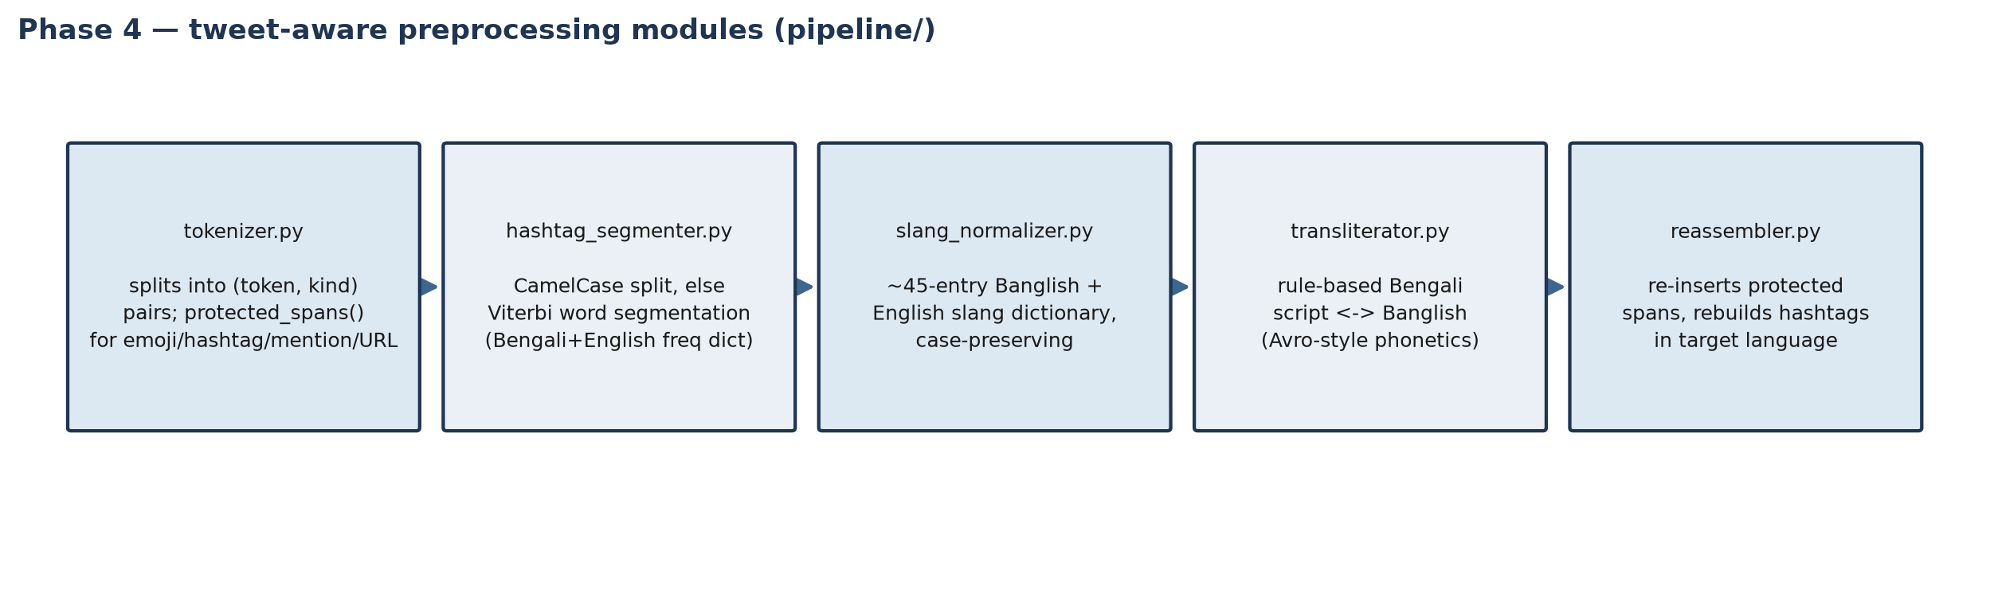
Figure 3. The five Phase 4 preprocessing modules, in the order they run.

tokenizer.py
Splits a tweet into (token, kind) pairs, keeping hashtags, mentions, URLs, and emoji as single, unsplit tokens rather than letting a generic tokenizer break them apart. Its protected_spans() function returns exactly the substrings that later stages (the LLM post-editor in Section 8) are told never to alter.

hashtag_segmenter.py
Tries CamelCase splitting first, which is exact whenever the author actually typed the hashtag that way. When it was not, it falls back to Viterbi word segmentation, the same algorithm behind the wordninja library, self-implemented here over a Bengali and English word-frequency dictionary built from samanantar_bn and opus_opensubtitles and cached at data/processed/word_freq.json (about 4.8 MB, not committed to git, regenerated automatically on first use). This fallback is a frequency heuristic, not a trained model, and it can misparse a hashtag that blends words the dictionary has never seen together: "duitattoo" segments to "du it at too" rather than the intended "dui tattoo" in manual testing. Hashtags typed in CamelCase are unaffected by this limitation.

slang_normalizer.py
A hand-curated dictionary of roughly 45 Banglish and English internet slang terms and abbreviations, matched whole-word only and case-preserving, so "kmn" becomes "kemon" and "u" becomes "you" without touching capitalization elsewhere in the sentence. It is explicitly a starting set, not claimed to be exhaustive.

transliterator.py
A rule-based, not trained, bidirectional converter between Bengali script and Banglish, built in the spirit of phonetic input schemes like Avro. Bengali orthography does not map one-to-one onto informal Latin spelling, which varies from typist to typist, so this is a deterministic baseline rather than a system evaluated for exact-match accuracy against any one person's spelling habits. A trained sequence-to-sequence transliterator using the 46,864 aligned BanglaTLit pairs (Section 3.4) remains an open upgrade path better suited to the fine-tuning infrastructure built in Phase 6.

reassembler.py
Re-inserts protected emoji, mention, and URL spans that a translation step dropped, and rebuilds hashtags in the target language from segmented and re-translated words, CamelCase for an English rebuild, joined directly for a Bengali one, matching how Bengali-language hashtags actually look on Twitter. A real bug in this module was found and fixed later, in Phase 9: once the LLM post-editor's protected-token rule existed (Section 8), the source-language hashtag would always survive verbatim inside the machine-translated output, since the editor was explicitly told not to touch it. The reassembler's original logic treated "hashtag already present in the output" as success, meaning it silently stopped translating hashtags at all the moment that protection rule was added elsewhere in the pipeline. The fix makes hashtag translation unconditional: segment, translate, and rebuild every time, removing the old verbatim hashtag first if one is present, rather than skipping the step whenever the untranslated version happens to already be there.

5.4 Splitting and augmentation (Phase 5)
pipeline/split_and_augment.py takes the 811,204-row unified.jsonl and produces the final train, validation, and test files with two deliberate departures from a plain random split.
- Stratified 85/7.5/7.5 split by source_dataset, so every split keeps a representative mix of registers instead of one split accidentally ending up formal-heavy or social-heavy by chance.
- The 2,996-row self-collected proxy test set is excluded from the stratified split entirely and appended wholesale to TEST, so the closest thing this project has to organic tweet data never leaks into training, matching the project's own requirement that any organic held-out data stay fully held out.
- Synthetic code-mixed augmentation, training set only: for 8% of eligible bn_en_translation rows in TRAIN, roughly 30% of the words in the Bengali target text are romanized using the same rule-based transliterator from Section 5.3, producing a Banglish-style variant tagged is_synthetic: true, with source_dataset suffixed +synthetic_codemix. Checked directly: zero synthetic rows appear in val.jsonl or test.jsonl.
Final split counts:
Split | Rows | Composition
train | 717,929 | 686,973 original + 30,956 synthetic code-mixed
val | 60,613 | stratified sample
test | 63,618 | 60,622 stratified + 2,996 organic-proxy
total | 842,160
Example of a synthetic code-mixed row, alongside the plain original-language row it was built from:
source_dataset | text | parallel_text (en)
samanantar_bn+synthetic_codemix | 1930 sale প্লুটো আবিষ্কারের পর এটিই ছিল কাইপার beltero প্রথম আবিষ্কৃত বস্তু । | In 1992, Albion was discovered, the first Kuiper belt object (KBO) since Pluto and Charon.
opus_opensubtitles+synthetic_codemix | তব,এরঅর্থএইনয়য amoro যব ন | But, that doesn't mean you cancel my water park trip.

6. What the pipeline produces
Every row in unified.jsonl, and therefore in the final train/val/test files, shares one schema regardless of which of the ten sources it came from:
Field | Type | Meaning
id | string | "<source_dataset>_<row_index>"
source_dataset | string | which of the ten sources this row came from
pair_type | string | bn_en_translation | bn_transliteration | monolingual_social | hashtag_segmentation
text | string | primary/source-side text
text_lang | string | bn | en | bn_en_mixed
parallel_text | string or null | aligned translation or transliteration, if the source provides one
parallel_lang | string or null | language of parallel_text
romanized_text | string or null | a distinct romanized form of text, if the source provides one
register | string | formal | informal_subtitles | informal_social_youtube | social_media | review | transliteration_data | hashtag_data
hashtags / emojis / mentions | list[string] | extracted directly from text
is_code_mixed | bool | text contains both Bengali-block and Latin characters
is_romanized_bn | bool | text is Latin-script but labeled as transliterated Bengali by the source
task_labels | dict or null | original source labels, preserved for possible later use
license | string | carried through from the source dataset
is_proxy_test_set | bool | true only for the 2,996 rows in Section 3.10
The split step adds one further field, is_synthetic (true for the 30,956 augmented rows described in Section 5.4). Nothing else changes shape between unified.jsonl and the final train/val/test files; the split is a partition and an addition, not a second transformation.
A representative row from each pair_type, exactly as it sits in the final data:
pair_type | source_dataset | text | parallel_text
bn_en_translation | samanantar_bn | কিন্তু, কীভাবে তা করা যেতে পারে? | But how can this be done?
bn_transliteration | banglatlit | ভাই কত পয়েন্ট লাগবে লাইক নিতে?? | (romanized_text) vai koto Point lagbe like nite??
monolingual_social | bnsentmix | Vai realmi narzo 50 pro ki nibbo plz reply | (none, no parallel field for this pair_type)
hashtag_segmentation | hashset | gobacmodiji | go bac modi ji
The final train/val/test splits were pushed to a public Hugging Face Hub dataset repository: huggingface.co/datasets/shanjivkr/catla-bn-en-tweets. Publishing them required one fix along the way: datasets.Dataset.from_json() infers its Arrow schema per streaming chunk, and because task_labels has a different shape per source (a nine-key hate-speech dictionary for BanTH, a single {"label": ...} for the sentiment sets, null for Samanantar, OPUS, BanglaTLit, and HashSet), an early all-null chunk locked in a null column type that then failed the moment a later chunk carried a real value. The fix reads the JSONL manually, serializes task_labels to a JSON string up front, and builds the dataset from a fully materialized list so Arrow sees every row's actual shape before committing to a schema.

7. Training the three engines
All three engines are trained the same way: LoRA fine-tuning, which freezes the pretrained base model entirely and injects small trainable low-rank matrices into a chosen set of attention and feed-forward projection layers. Only those injected matrices are trained; everything else in the model stays frozen at its pretrained weights. This keeps both GPU memory and the size of what gets saved and pushed to the Hugging Face Hub far below what full fine-tuning would need, which matters directly here since training runs on free Kaggle and Colab GPU sessions with weekly quotas, not dedicated hardware.
Which layers get the LoRA matrices depends on the base model's own architecture, and getting this wrong does not always throw an error. The first draft of pipeline/train.py hardcoded M2M100-style attention naming (q_proj, k_proj, v_proj, out_proj, fc1, fc2) for all three engines. NLLB and IndicTrans2 use that naming; BanglaT5, being a T5 model, uses HF's T5Attention naming instead (q, k, v, o, no _proj suffix). Left as-is, this would have silently attached LoRA to zero modules for BanglaT5 while appearing to work normally for the other two. default_target_modules() now selects the right module list automatically from the model name, overridable from the command line if needed.
Engine | Base model | Target modules | Trainable params
IndicTrans2 (1B) | ai4bharat/indictrans2-indic-en-1B (bn2en) /  ai4bharat/indictrans2-en-indic-1B (en2bn) | q_proj, k_proj, v_proj,  out_proj, fc1, fc2 | 17,694,720 of 1,040,701,440  (about 1.7%)
NLLB-200-distilled-600M | facebook/nllb-200-distilled-600M | q_proj, k_proj, v_proj,  out_proj, fc1, fc2 | 8,650,752 of 1,410,789,376  (about 0.61%)
BanglaT5 | csebuetnlp/banglat5 | q, k, v, o | (reported per training run;  smallest adapter of the three, 14.2 MB)
IndicTrans2 ships as two direction-specific checkpoints rather than one bidirectional model. This was caught by inspecting the notebooks before it caused a bad run: an early version of the engine list used the English-to-Indic checkpoint for both directions, which would not have crashed, it would have silently fine-tuned the bn2en direction starting from a base model pretrained for the opposite direction, with no error to flag it. The engine list is now a direction-specific dictionary for IndicTrans2, resolved the same way NLLB and BanglaT5's single checkpoints are, so the training cell works unchanged regardless of which shape a given engine's entry has.

7.1 What was actually trained
Each of the six engine-direction combinations (three engines times two directions) trained for 1 epoch on a maximum of 150,000 rows, sampled from the roughly 572,700 bn_en_translation rows available in train.jsonl, on a single Kaggle T4 GPU. This was a deliberate reduction from the original plan of 3 epochs over the full row set: at the original scope, the estimated cost was about 215,000 forward and backward passes per engine-direction combination, 15 to 40-plus hours each, which against a roughly 30 GPU-hour weekly free quota would have taken potentially months across all six combinations. Restricting training to a single GPU was also a deliberate fix, not a starting choice: transformers' Trainer auto-wraps a model in naive DataParallel across both GPUs on a T4x2 Kaggle session, but DataParallel funnels gradient-gathering through GPU 0 specifically, which ran out of memory during the very first backward pass on a real run even though the combined memory across both GPUs would have been enough. CUDA_VISIBLE_DEVICES=0 sidesteps the imbalance.
All six combinations are complete and verified directly against the Hugging Face Hub, checking for a real adapter_config.json and adapter_model.safetensors with a sane file size and a fresh timestamp, not taken on the training log's own claim of success. This check matters specifically because Seq2SeqTrainingArguments(push_to_hub=True) creates the Hub repository the moment Trainer.__init__ runs, before a single checkpoint has been pushed, so an interrupted run can leave behind a Hub repo that exists but is empty, a failure mode hit for real during this project and now handled explicitly (Section 8 covers the ensemble side of this; the training-side fix makes checkpoint resume attempt a load and catch failure, rather than checking whether the repo exists first, since an empty-but-existing repo would otherwise look like a valid resume target).
Hub repository | Direction | adapter_model.safetensors
shanjivkr/catla-nllb-bn2en | bn -> en | 34.6 MB
shanjivkr/catla-nllb-en2bn | en -> bn | 34.6 MB
shanjivkr/catla-indictrans2-bn2en | bn -> en | 70.9 MB
shanjivkr/catla-indictrans2-en2bn | en -> bn | 70.9 MB
shanjivkr/catla-banglat5-bn2en | bn -> en | 14.2 MB
shanjivkr/catla-banglat5-en2bn | en -> bn | 14.2 MB

7.2 Known compromises in this training run
Three tradeoffs were made for free-tier feasibility, disclosed here rather than left implicit:
- 1 epoch, 150,000-row cap. Not the full ~570,000-plus rows available per direction; a deliberate quality-for-feasibility tradeoff given LoRA's limited trainable capacity and the free GPU-hour budget.
- IndicTrans2 trained without IndicTransToolkit, AI4Bharat's own recommended preprocessing (script normalization, sentence splitting, NER and number masking). The root cause is a namespace collision: IndicTransToolkit depends on indic-nlp-library-itt, which installs to the same indicnlp/ path as the plain indic-nlp-library package this project's requirements.txt used to also install, and pip's conflict detection does not catch this since the two are different distribution names as far as pip is concerned. Removing indic-nlp-library from requirements.txt (confirmed by search that nothing in this codebase imports it directly) fixes the collision for the next fresh install, but the two already-trained IndicTrans2 adapters have not been retrained with the fix applied, pending the evaluation numbers that would justify spending the GPU time.
- BanglaT5 has no prior translation pretraining to build on, unlike NLLB and IndicTrans2, which are trained to translate before this project ever touches them. One epoch on top of a non-translation base model carries a real risk of undertraining specifically for this engine, flagged going in rather than assumed away.

8. Combining three engines into one translation
None of the three fine-tuned models is used alone in the finished product. A single model's single decode is treated as too unreliable to ship directly; instead, every request runs through a five-stage chain that generates multiple candidates, picks the best one, edits it for fluency without touching anything that should not change, checks the edit against the original meaning, and only then rebuilds the tweet-specific parts (hashtags, mentions, emoji) around it.
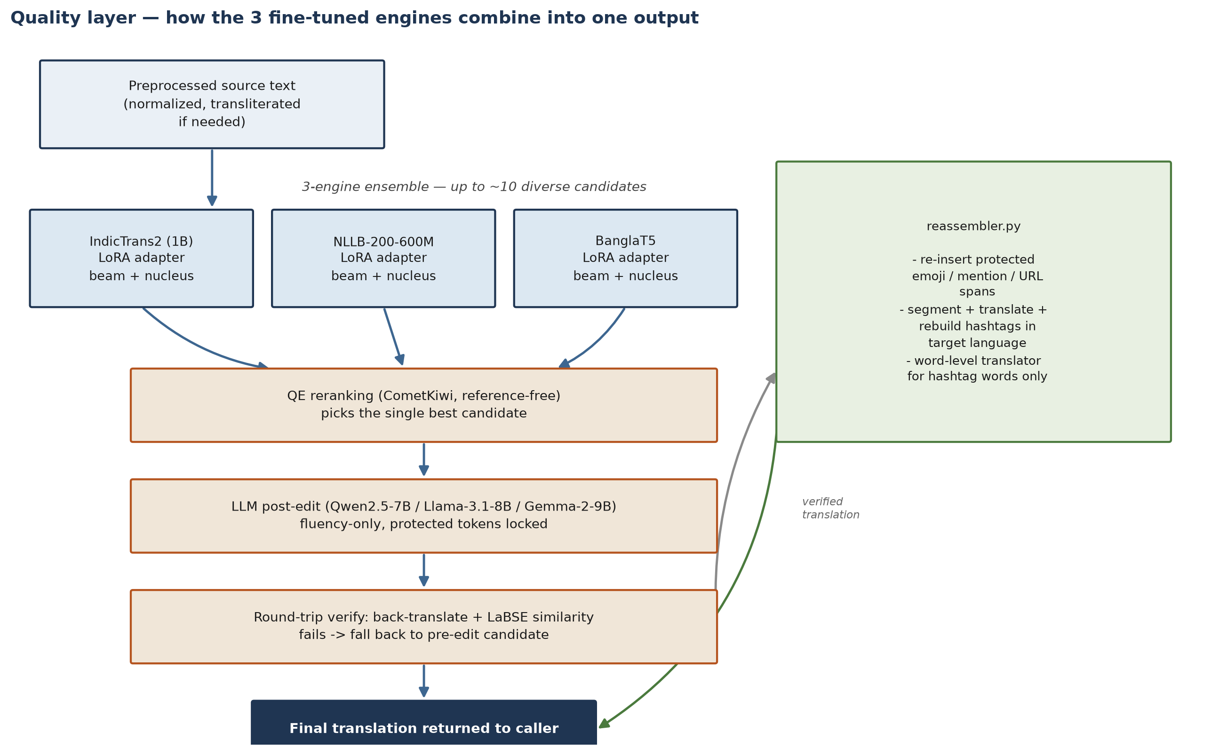
Figure 4. The full chain from preprocessed source text to a returned translation.

8.1 Candidate generation (pipeline/ensemble.py)
Each of the three engines generates candidates two ways: beam search (4 beams, 2 returned sequences) and nucleus sampling (top_p 0.9, temperature 0.9, 2 returned sequences), which gives diversity of decoding strategy on top of diversity of model, up to about 10 candidates total after exact-duplicate text is removed. Beam search candidates keep their sequence-level log-probability score for free, since transformers' generate() already computes it; this score becomes the fallback ranking signal one stage later if no quality-estimation model can be loaded.
A real failure mode was found and fixed here: nucleus sampling can raise a runtime error on invalid probability values (observed directly running the evaluation script: a RuntimeError from IndicTrans2's sampling call, "probability tensor contains either inf, nan or element < 0"), and that error used to propagate out of the whole candidate-generation function, discarding the beam-search candidates from the same call that had already succeeded moments earlier. The nucleus-sampling call now has its own try/except, isolated from beam search, so a sampling failure just logs a warning and the function still returns whatever beam candidates it already collected, rather than dropping the engine from the ensemble entirely for that request.

8.2 Picking the best candidate (pipeline/qe_rerank.py)
The candidate pool is scored with a reference-free quality-estimation model, CometKiwi, which does not need a gold translation to judge how good a candidate is. If no quality-estimation model can be loaded, scoring falls back to the beam-search log-probability already captured in Section 8.1; nucleus-sampled candidates have no comparable score, since scoring them properly would need a second, teacher-forced pass this stage does not perform, so they are ranked as unscored rather than given a misleading number, and never treated as equal to a genuinely scored candidate.

8.3 Fluency editing (pipeline/llm_postedit.py)
The winning candidate is passed to an instruction-tuned LLM (Qwen2.5-7B-Instruct first, then Llama-3.1-8B-Instruct, then Gemma-2-9B-it if the first is unavailable) with a strict system and user prompt: fix fluency only, keep the meaning exactly, and never touch the protected spans (emoji, hashtags, mentions, URLs) identified back in Section 5.3's tokenizer.protected_spans(). A cheap, deterministic check, protected_tokens_preserved(), runs before the far more expensive round-trip verification in the next stage and confirms none of those protected spans were altered. If the LLM violates that contract, returns an empty string, or cannot be loaded at all, the pipeline falls back to the pre-edit candidate rather than shipping a broken edit.

8.4 Round-trip verification (pipeline/roundtrip_verify.py)
The edited candidate is translated back toward the source language using a single engine, NLLB by default for speed, and compared to the original input using LaBSE cosine similarity. A failed check does not block the response; it is information the pipeline acts on. If the round-trip fails on the edited text but the pre-edit candidate's own round-trip passes, the pipeline falls back to the pre-edit candidate, on the reasoning that the LLM edit was the likely source of the drift, not the underlying translation. If both fail, or if there was no edit to fall back from in the first place, the result still ships, but flagged low_confidence: true with a verification note explaining why, rather than silently hiding a failed check.

8.5 Reassembly (pipeline/reassembler.py)
The verified translation gets its protected spans (emoji, mentions, URLs) re-inserted, and its hashtags segmented, translated, and rebuilt in the target language, using the same hashtag_segmenter.py from Section 5.3 plus a lightweight, single-engine word-level translator rather than the full five-stage chain, since running the whole pipeline per individual hashtag word would be far too expensive for what it buys.

8.6 Fast mode
A separate, deliberately smaller path exists for cases where the full chain is too slow: fast mode skips Sections 8.1 through 8.5 entirely and returns a single beam-search decode from one engine (NLLB by default), the same function used for the single_model_baseline comparison in the project's evaluation script, so both are defined identically rather than as two separate reimplementations of "what one fine-tuned engine alone produces." This exists specifically for CPU-only, free-tier hosting, where running three fine-tuned models plus a 7-billion-parameter LLM plus a fourth round-trip model on every request is not practical.

9. Sources and references
The datasets and models this project builds on each have a published paper behind them. Listed below are the ones with a clear, citable source; entries are the dataset or model's own paper, not a review of it.

9.1 Datasets
Ramesh, G., Doddapaneni, S., Bheemaraj, A., et al. Samanantar: The Largest Publicly Available Parallel Corpora Collection for 11 Indic Languages. Transactions of the Association for Computational Linguistics (TACL), 2022. AI4Bharat.
Tiedemann, J. Parallel Data, Tools and Interfaces in OPUS. Proceedings of LREC, 2012. (The OpenSubtitles collection used here is distributed through the OPUS platform this paper describes.)
Ishmam, F. et al. BanTH: A Multi-label Hate Speech Detection Dataset for Transliterated Bangla. Findings of NAACL 2025.
Kodali, P. et al. HashSet: A Dataset for Hashtag Segmentation. Proceedings of LREC, 2022.

9.2 Models
Gala, J., Chitale, P. A., A K, R., et al. IndicTrans2: Towards High-Quality and Accessible Machine Translation Models for all 22 Scheduled Indian Languages. Transactions on Machine Learning Research (TMLR), 2023. AI4Bharat.
NLLB Team, Costa-jussa, M. R., Cross, J., et al. No Language Left Behind: Scaling Human-Centered Machine Translation. Meta AI, 2022.
Bhattacharjee, A., Hasan, T., Ahmad, W. U., et al. BanglaNLG and BanglaT5: Benchmarks and Resources for Evaluating Low-Resource Natural Language Generation in Bangla. Findings of EACL, 2023. CSEBUETNLP.
Rei, R., Stewart, C., Farinha, A. C., Lavie, A. COMET: A Neural Framework for MT Evaluation. Proceedings of EMNLP, 2020.
Rei, R., C. Farinha, A., G.C. de Souza, J., et al. CometKiwi: IST-Unbabel 2022 Submission for the Quality Estimation Shared Task. Proceedings of WMT, 2022.
Feng, F., Yang, Y., Cer, D., Arivazhagan, N., Wang, W. Language-agnostic BERT Sentence Embedding. Proceedings of ACL, 2022. (LaBSE, used for round-trip similarity scoring.)
Joulin, A., Grave, E., Bojanowski, P., Mikolov, T. Bag of Tricks for Efficient Text Classification. Proceedings of EACL, 2017. (fastText, the basis for the lid.176 language-identification model used in the language gate.)

9.3 Project repository
Full source table with license and URL for every dataset: data/raw/SOURCES.md. Full phase-by-phase build log: logs/phase_0_status.md through logs/phase_12_status.md. Code: github.com/Shanjiv931/nlp_caslf.

10. Licensing, scope, and what is still open

10.1 Licenses in the corpus
Source | License
Samanantar | CC-BY-NC-4.0
OPUS OpenSubtitles | Per-file, OPUS redistribution terms
BanTH | MIT
BanglaTLit | MIT
BnSentMix | MIT
SentMix-3L | AGPL-3.0
EmoMix-3L | GPL-3.0
En-Bn code-mixed sentiment | MIT
HashSet (manual subset) | Research use
Self-collected proxy test set | Derived from the sources above
No dataset in the corpus required paid access. One dataset considered during sourcing, FLORES-200, is free but gated behind a manual Hugging Face access request; it was not pursued, since pursuing it needs an approval step no automated process can complete. The WAT Indic Multilingual Parallel Corpus was also considered and skipped: it aggregates many sub-corpora under a page that explicitly asks users to check with the original organizers before use, and it substantially overlaps with Samanantar and OPUS, both already in the corpus with clean, individually confirmed licenses.

10.2 Data kept outside the free pipeline
data/collected_tweets/live_eval_LOCAL_ONLY.jsonl holds 2,640 real tweets (1,348 Bengali, 1,292 English) collected through twitterapi.io, a paid third-party API, at the user's own initiative and expense. This file is excluded from git, from the public Hugging Face dataset, from training, and from every claim this project makes about running entirely on free tools. It exists only for local evaluation, by explicit decision when it was introduced; the full rationale is documented in data/raw/twitterapi_io_live_tweets/README_NOT_FREE.md.

10.3 Limitations specific to the data, not the models
- The proxy test set is not real tweets. Section 3.10 covers why: it resamples noisy rows from other sources rather than scraping X directly, since the tools that would have done that no longer work without paid access.
- BanglaTLit's transliteration pairs are a small fraction of the raw file. 46,864 of 249,727 rows, once null-target rows are excluded (Section 5.2).
- Hashtag segmentation can misparse novel word blends. The Viterbi fallback in hashtag_segmenter.py is a frequency heuristic over a corpus-derived dictionary, not a trained segmenter (Section 5.3).
- The transliterator is a deterministic baseline, not a learned model. It has not been evaluated for exact-match accuracy against real typists' spelling habits, which vary from person to person (Section 3.4, Section 5.3).
- IndicTrans2 was trained without its author-recommended preprocessing toolkit. The fix is written and ready; the two already-trained adapters have not been retrained with it applied (Section 7.2).
- BnSentMix's numeric label meanings are this project's own reading of the data, not a published codebook. Section 3.5 shows the sample-based reasoning; treat the Positive/Negative/Neutral/Mixed mapping there as inferred, not confirmed by the dataset's authors.

10.4 Open questions for future data work
- Whether to retrain IndicTrans2 with IndicTransToolkit applied, a decision explicitly deferred pending real evaluation numbers rather than made on the current adapter's untested assumption of quality loss.
- Whether the 150,000-row-per-direction training cap is worth raising, and if so, by how much; this project's own compute estimate puts a full, uncapped 3-epoch retrain at 15 to 40-plus hours per engine-direction combination, potentially months across all six on a free-tier weekly GPU quota, against a benefit that is genuinely uncertain given LoRA's limited trainable capacity and the base models' own extensive pretraining.
- A properly sized, curated benchmark for the language-identification gate; the accuracy figures produced so far come from an eleven-example illustrative set, not a rigorous evaluation.
- Human review of hashtag and slang translation naturalness, since no automatic metric in this project's evaluation suite scores that dimension honestly (documented explicitly in eval/RESULTS.md rather than approximated with a proxy score).

