Report: Optimising NYC Taxi Operations
Include your visualisations, analysis, results, insights, and outcomes. Explain your methodology and approach to the tasks. Add your conclusions to the sections.

Data Preparation
  - Loading the dataset
    - Sample the data and combine the files
While sampling the data, I created two new columns — “pickup_date” and “pickup_hour” — from the existing “tpep_pickup_datetime” column. This was done to ensure the sampling is distributed evenly across both date and hour.
For combining the files, I used 5% of the sampled data from each file and then merged all of them into a single Excel file. The sampling process was based on the “pickup_date” and “pickup_hour” columns.

Data Cleaning

Fixing Columns
    - Fix the index
When exporting the DataFrame to a CSV file, the index wasn’t meaningful and only added unnecessary clutter. Dropping it ensures that the saved file remains clean, without any unwanted row numbers.
    - Combine the two airport_fee columns
I used the combine_first method to merge the “Airport_fee” column with the “airport_fee” column, ensuring that any null values in one column are replaced with valid values from the other.

Handling Missing Values
    - Find the proportion of missing values in each column
I calculated the proportion of missing values across all columns and found that most columns had no missing data. However, a few columns — passenger_count, RatecodeID, congestion_surcharge, and airport_fee — contained missing values, accounting for about 3.4% of the total dataset.
    - Handling missing values in passenger_count
In this dataset, the ‘passenger_count’ ranges from 1 to 6. Therefore, I used the mode of the ‘passenger_count’ column to fill in the missing values.
    - Handle missing values in RatecodeID
In this dataset, RatecodeID is a categorical variable. Hence, I used the mode of the RatecodeID column to fill in the missing values.
    - Impute NaN in congestion_surcharge
In this dataset, the ‘congestion_surcharge’ column contains values of 2.5, 0, and 0.5. Therefore, I used the mode of the ‘congestion_surcharge’ column to replace the missing values.

Handling Outliers and Standardising Values
    - Check outliers in payment type, trip distance and tip amount columns
trip_distance
- I removed records where trip_distance was less than 0.1 miles and the fare_amount exceeded 300.
- Deleted records where trip_distance was 0 and fare_amount was also 0.
- Removed trips with trip_distance greater than 250 miles, as these were outliers.
- Deleted very short trips where trip_distance was 0 and trip_duration was less than 60 seconds.

payment_type
- Removed records where payment_type was 0, since it’s not a valid type.
tip_amount
- Deleted records where tip_amount exceeded 50% of the total fare and was greater than 100.
- Identified rows where payment_type was not 1 (credit card) but tip_amount > 0, since tips are only valid for credit card payments according to the data dictionary.
- Verified that there were no negative tip_amount values in the dataset.

Exploratory Data Analysis

General EDA: Finding Patterns and Trends
    - Classify variables into categorical and numerical
Categorise the varaibles into Numerical or Categorical.
VendorID: Categorical
tpep_pickup_datetime: Numerical (can be used to derive features like hour, day, duration)
tpep_dropoff_datetime: Numerical (can be used to derive features like hour, day, duration)
passenger_count: Numerical
trip_distance: Numerical
RatecodeID: Categorical
PULocationID: Categorical
DOLocationID: Categorical
payment_type: Categorical
pickup_hour: Numerical
trip_duration: Numerical
The following monetary columns are all Numerical:
- fare_amount
- extra
- mta_tax
- tip_amount
- tolls_amount
- improvement_surcharge
- total_amount
- congestion_surcharge
- airport_fee

    - Analyse the distribution of taxi pickups by hours, days of the week, and months
I plotted three histogram for hours, days of the weeks and then months .
Hours:
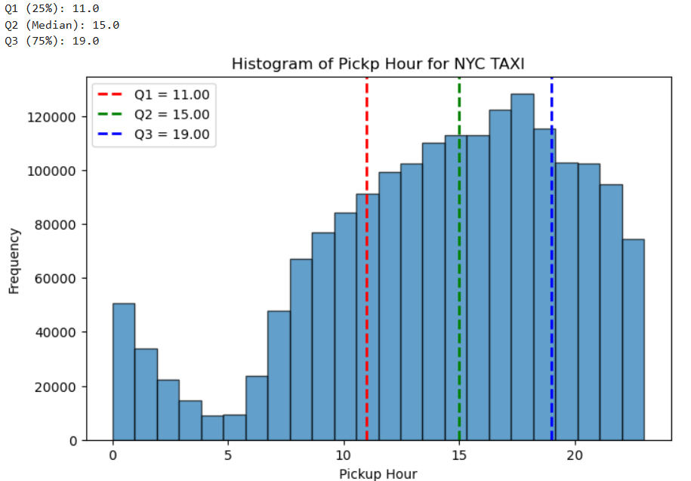

Findings from Hourly Trends of Taxi Pickups:
- The peak pickup hour is 18:00.
- Rush hours begin around 14:00 and reach their maximum at 18:00.
- The lowest number of pickups occurs between 04:00 and 05:00.
- 0–50% of daily traffic occurs between 00:00 and 15:00, while 50–100% of traffic occurs between 15:00 and 24:00.

Days of the Week:
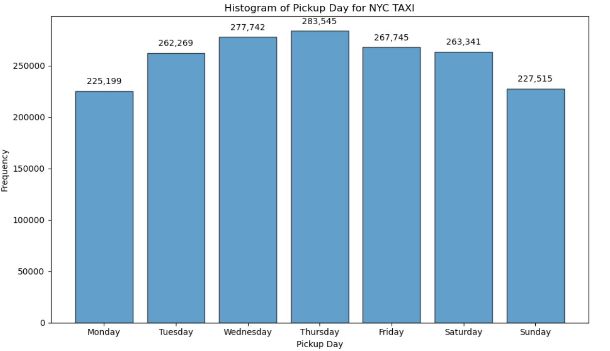
Thursday has the highest number of pickups, while Monday has the lowest. Pickups gradually increase from Monday, peaking on Thursday, and then gradually decrease afterwards.

Months:
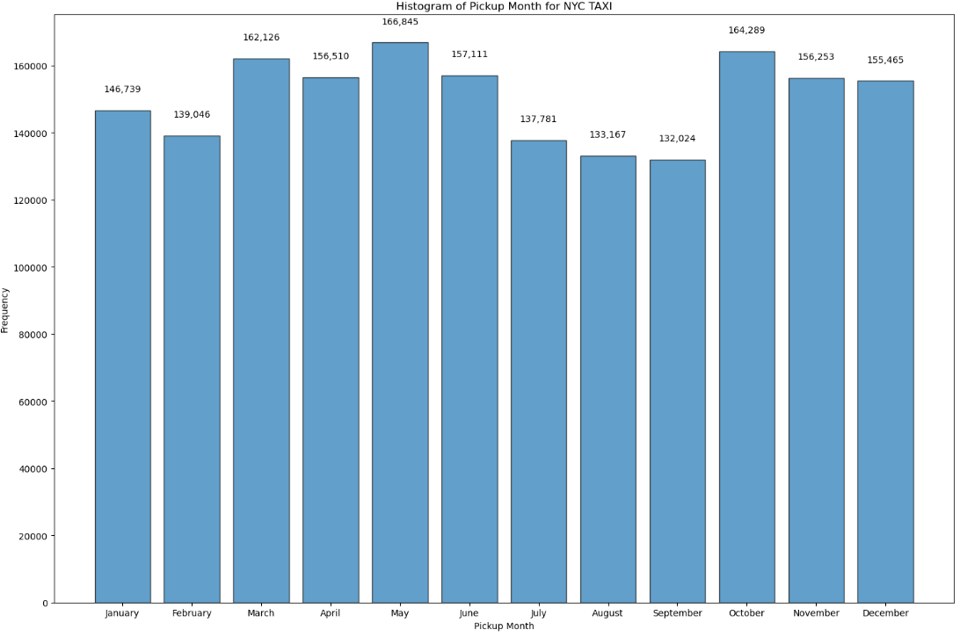
  - In February, July, August, and September, the number of pickups is relatively low.
  - In January, April, June, November, and December, the pickups are moderate.
  - In March, May, and October, the number of pickups is higher.
    - Filter out the zero/negative values in fares, distance and tips
I checked the dataset for negative values in the fields ‘fare_amount’, ‘total_amount’, ‘trip_distance’, and ‘tip_amount’, and confirmed that none were present. I then deleted records where ‘fare_amount’, ‘total_amount’, and ‘trip_distance’ were all zero.
    - Analyse the monthly revenue trends
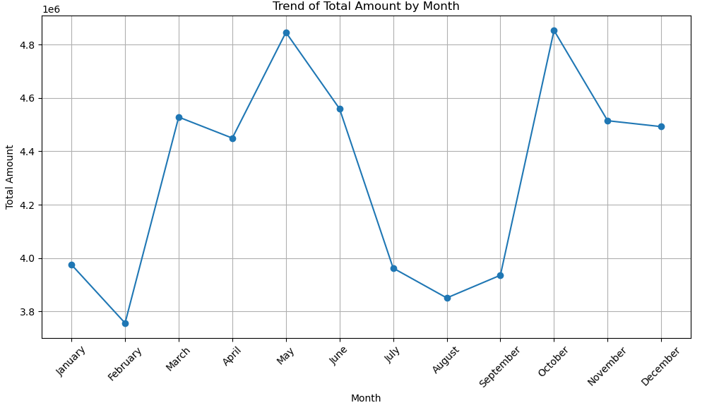
- Revenue is lowest in February and highest in May and October.
- There is a steep increase in revenue from February to March, April to May, and September to October.
- Revenue drops sharply from June to July and October to November.

    - Find the proportion of each quarter’s revenue in the yearly revenue
I created a ‘pickup_quarter’ column derived from ‘pickup_month’, calculated the revenue for each quarter, and plotted a pie chart to visualize the distribution.

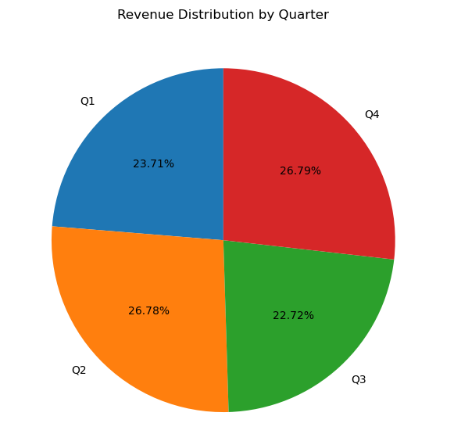
    - Analyse and visualise the relationship between distance and fare amount
I plotted a heat map against ‘trip_distance’ and ‘fare_amount’
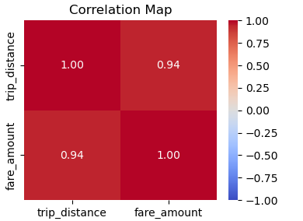
The trip_distance and fare_amount are strongly positively correlated, with a correlation coefficient of 0.94.
    - Analyse the relationship between fare/tips and trips/passengers
I calculated ‘trip_duration_sec’ by subtracting pickup time from dropoff time and then plotted a heatmap showing the relationship between trip_duration_sec and fare_amount.
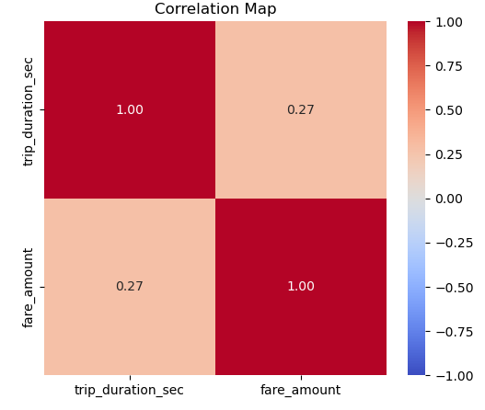
There is a weak positive correlation (r = 0.27) between trip_duration and fare_amount, suggesting that longer trips generally have higher fares, though the relationship is not very strong.
I also plotted a heatmap for ‘passenger_count’ versus ‘fare_amount’ to examine their relationship.
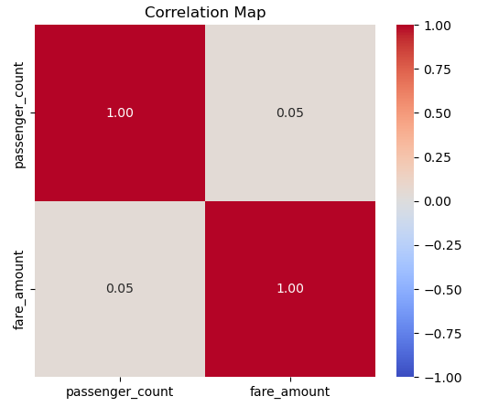
Passenger count and fare_amount show a very weak or negligible correlation (r = 0.05), indicating that the number of passengers has almost no impact on the fare.
Additionally, I plotted a heatmap to examine the relationship between ‘tip_amount’ and ‘trip_distance’.
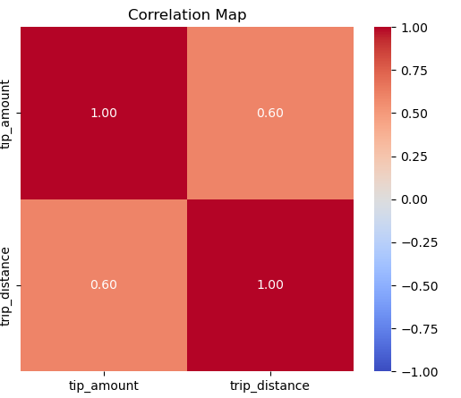
Tip amount and trip_distance show a moderate positive correlation (r = 0.60), indicating that longer trips tend to result in higher tip amounts.
    - Analyse the distribution of different payment types
I created a bar chart showing the distribution of all the different ‘payment_type’ values.
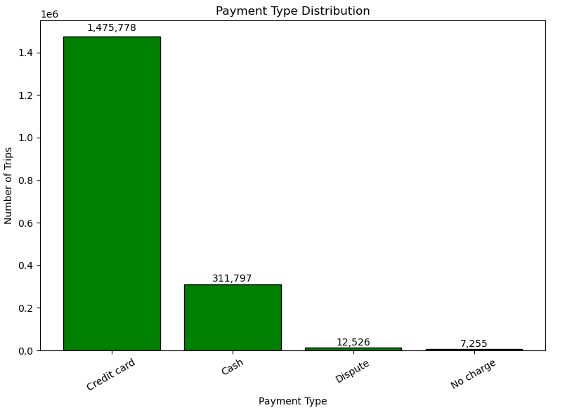
Over 82% of trips were paid using credit cards, while approximately 17% were paid in cash.

    - Load the taxi zones shapefile and display it
I read the shapefile using the geopandas library and plotted it.
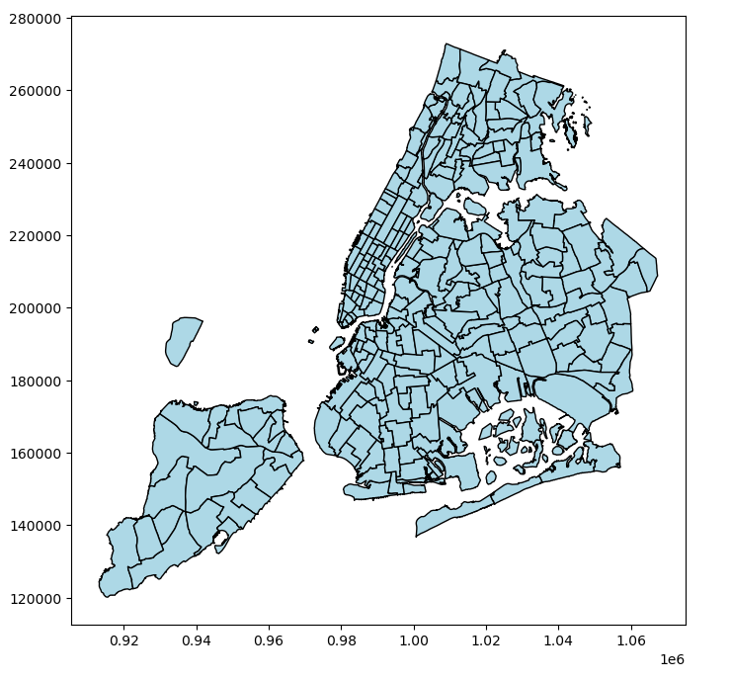
    - Merge the zone data with trips data
I merged the two datasets using the merge method with the parameters:
left_on='PULocationID', right_on='LocationID', how='inner'.
The resulting merged dataframe is named ‘merged_df’.
    - Find the number of trips for each zone/location ID
First, I created a temporary dataframe tripsperlocation, which counts the number of entries as ‘total_trips’, grouped by ‘PULocationID’:
tripsperlocation = merged_df.groupby("PULocationID").size().reset_index(name="total_trips")
Data is given as below :
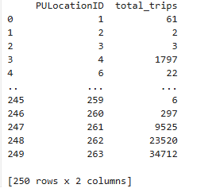
    - Add the number of trips for each zone to the zones dataframe
I created a temporary dataframe by merging the original zones dataframe with the newly created tripsperlocation dataframe:
zones_merged = pd.merge(zones, tripsperlocation, left_on='LocationID', right_on='PULocationID', how='inner')
zones_merged.drop(["PULocationID"], axis=1, inplace=True)

    - Plot a map of the zones showing number of trips
I have plotted the GeoDataFrame as a choropleth
zones_merged.plot(column="total_trips", cmap="YlOrRd", linewidth=0.8, edgecolor="gray", ax=ax, legend=True, legend_kwds={'label': "Total Trips per Zone",'orientation': "horizontal"}
)
ax.set_title("NYC Taxi Trips by Zone", fontsize=16)
ax.axis("off")
plt.show()
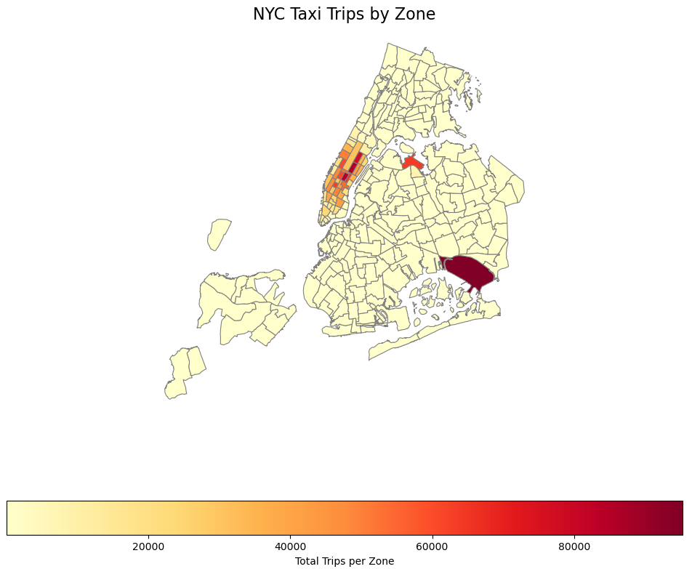
    - Conclude with results
Based on all the analysis and visualizations, I drew the following conclusions:
- Demand fluctuates significantly by hour (evening peaks), day (weekends are busiest), and month (summer sees higher activity).
- Revenue trends align with demand patterns; surcharges and longer trips in dense zones boost revenue during peak periods.
- Quarterly revenue shows seasonality — higher in summer, moderate in winter.
- Fare is strongly influenced by distance and trip duration, while passenger count has a weaker effect on fare.
- There is a positive correlation between trip distance and tip amount, though the data points are widely scattered.
- The most active pickup zones are concentrated in central Manhattan and the major airports (JFK, LGA), which consistently generate the highest trip volumes.

Detailed EDA: Insights and Strategies
    - Identify slow routes by comparing average speeds on different routes
# 1. Copy your DataFrame
# 2. Remove invalid/zero trips (to avoid divide by zero / garbage speeds)
# 3. Add average speed column (mph or km/h depending on your distance unit)
# Assuming distance is in miles, convert seconds → hours
# 4. Group by route + hour → calculate mean speed and mean trip time
# 5. Identify "slow routes"
# Sort by slowest avg speed (ascending), but keep only routes with enough trips (to avoid noise)
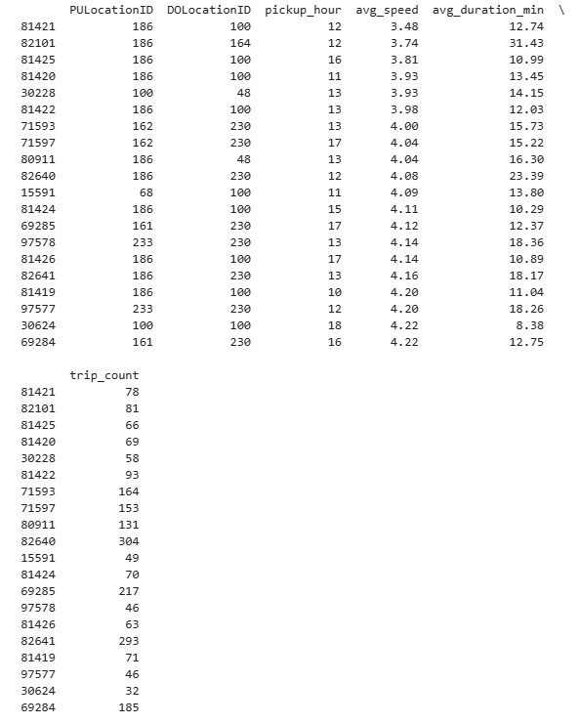
    - Calculate the hourly number of trips and identify the busy hours
Created a dataframe
trip_busy = (merged_df.groupby("pickup_hour")
.agg(trip_count=("VendorID", "count"))
.reset_index()
)
Plotted a bar chart with the values
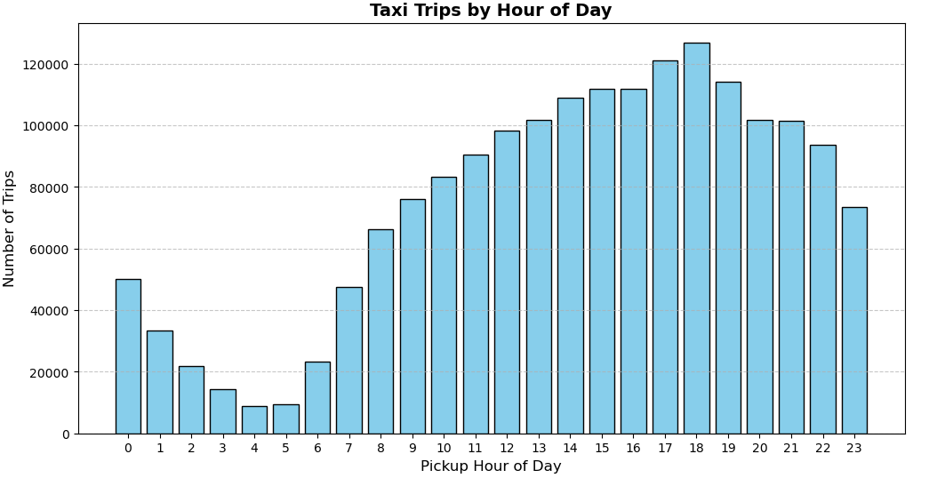
- The fewest trips occur during the 4th and 5th hours.
- The highest number of trips occurs at 17:00, 18:00, and 19:00, with the peak at 18:00.
- Trip counts during all other hours are moderate.
- Overall, the distribution is left-skewed.
    - Scale up the number of trips from above to find the actual number of trips
# Define your sampling ratio (example: 1% of trips taken)
# Scale trip counts to estimate actual total trips
# Plot histogram with scaled counts

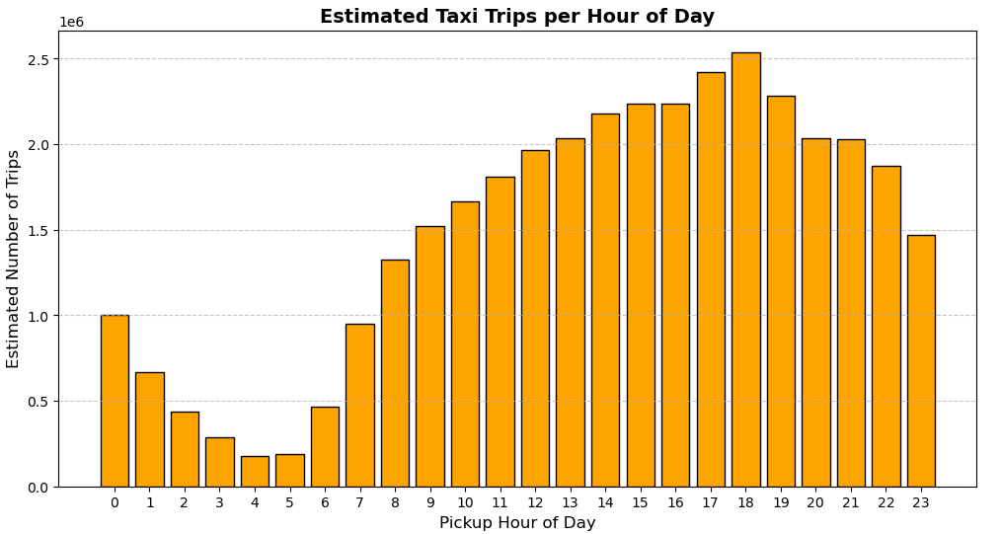
    - Compare hourly traffic on weekdays and weekends
In the jupyter, code analyzes taxi trip data by separating it into weekday and weekend trips, then filtering out short or unreliable trips to focus on meaningful ones. It calculates the average speed for each trip and groups the data by pickup hour to find patterns in traffic behavior—specifically average speed, trip duration, and trip count per hour. For weekdays, the trip count is averaged over five days, and for weekends, over two. Finally, it plots a line graph comparing average speeds across hours for weekdays and weekends, helping visualize how traffic flow differs depending on the day of the week.
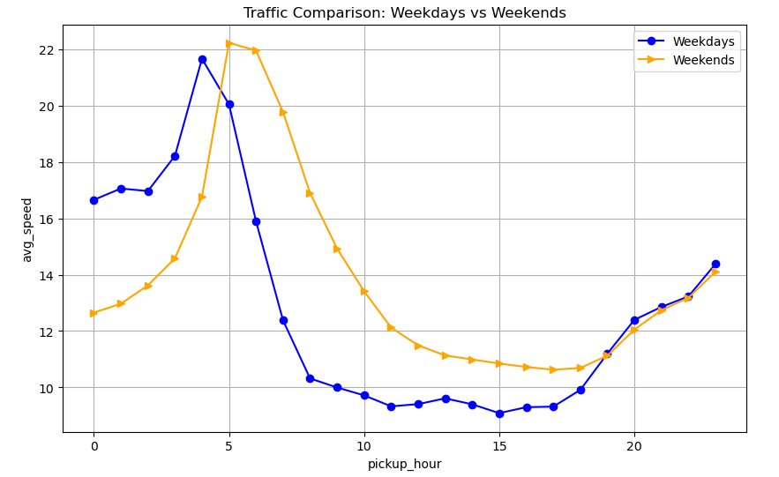
Conclusion:
- From midnight to 05:00, the average speed is slower on weekends compared to weekdays.
- Between 05:00 and 19:00, the average speed is higher on weekends.
- From 19:00 to 23:00, the speed is almost the same for both weekdays and weekends.
I plotted a line chart to compare the average trip count on an hourly basis between weekdays and weekends.
Created line chart comparing the average number of taxi trips per hour between weekdays and weekends. It uses two datasets—route_speed for weekdays and route_speed1 for weekends—and plots pickup_hour on the x-axis against avg_trip_count on the y-axis. The weekday line is styled in blue with circle markers, while the weekend line is orange with triangle markers. Labels for the axes, a title, a legend to distinguish the lines, and a grid for better readability are added before displaying the plot. This visualization helps highlight differences in hourly trip volumes across the week.
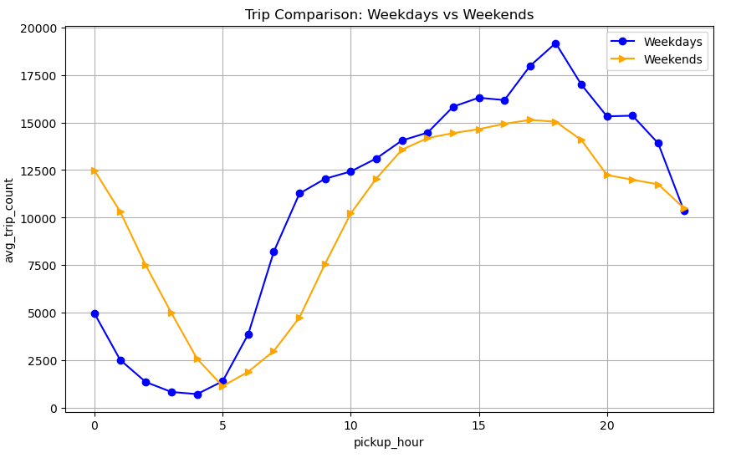
Conclusion:
- From midnight to 05:00, the average trip count is lower on weekdays.
- Between 05:00 and 23:00, the average trip count is higher on weekdays.
- During the 12th and 13th hours, trip counts are almost the same for weekdays and weekends.
- At 18:00, the trip count on weekdays is significantly higher than on weekends.
- Around midnight, more people use cabs on weekends.
    - Identify the top 10 zones with high hourly pickups and drops
Analyzed taxi trip data to identify the top 10 most active pickup and dropoff zones based on total trip counts. It first groups trips by pickup location and hour, then selects the top 10 pickup zones with the highest overall activity. Similarly, it extracts the top 10 dropoff zones by grouping trips by dropoff location and hour. For both sets, it filters the data to focus only on these top zones and plots two side-by-side line graphs: one showing hourly pickup trends and the other showing hourly dropoff trends. This visualization helps compare how trip volumes vary by hour across the busiest zones in the city.
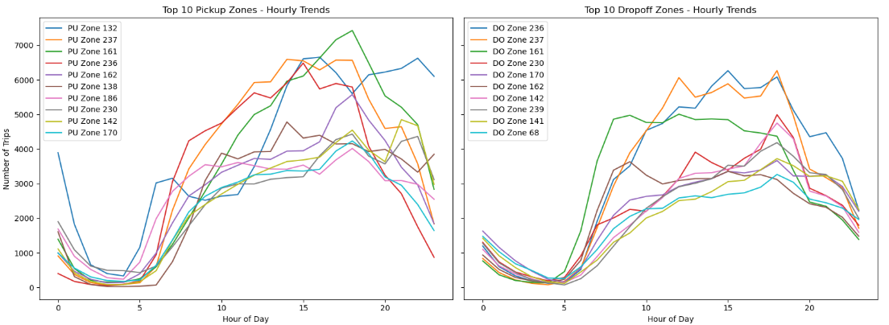
Conclusion
Pickup Conclusion:
Morning dip & strong rebound:
- Trips are very low between 3–6 AM, reflecting expected downtime.
- After around 6 AM, demand steadily increases.
Peak demand in the evening:
- Most pickup zones peak between 5–8 PM, with some zones (e.g., 161, 237, 132) reaching 6–7K trips/hour.
- Indicates high evening commute or leisure travel activity.
Consistent top performers:
- Zones 161, 237, 236, 132 dominate pickups, suggesting they are major residential, business, or transit hubs.
Unique trend for zone 132:
- At the 0th and 23rd hour, the trend differs from other zones.
Dropoff Conclusion:
Midday–evening concentration:
- Dropoffs rise from 6 AM, peak between 12–6 PM, and taper off at night.
- The peak occurs slightly earlier than pickups, aligning with work and commerce area activity during the day.
More spread out across zones:
- Dropoff curves are more evenly distributed than pickups.
- Suggests that dropoff activity occurs across multiple commercial/business areas rather than being concentrated in a few zones.
Strong overlap between pickup & dropoff hubs:
- Zones like 236, 237, 161, 170, 162 appear in both lists, indicating they are high-demand two-way zones, likely city centers, transit points, or major business districts.
    - Find the ratio of pickups and dropoffs in each zone
This code analyzes taxi trip data to identify zones with the most imbalanced pickup-to-dropoff activity. It first counts the number of pickups and dropoffs per zone, merges these counts into a single DataFrame using zone IDs, and fills any missing values with zero. Zones with no pickups or dropoffs are excluded to focus on active areas. Then, it calculates the ratio of pickups to dropoffs for each zone, which helps highlight places that are primarily origins or destinations. Finally, it sorts the zones by this ratio to find the top 10 zones with the highest pickup dominance and the bottom 10 with the lowest, offering insights into travel flow patterns across the city.
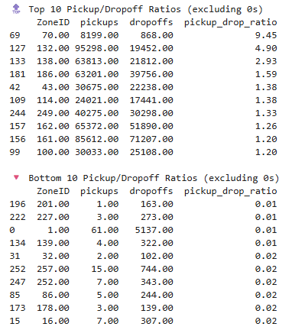
    - Identify the top zones with high traffic during night hours
Identify the top 10 taxi pickup and dropoff zones specifically during night hours, defined as 11 PM to 5 AM. It first ensures that the pickup and dropoff timestamps are in datetime format, then extracts the hour component from each. Using these hours, it filters the dataset to include only trips that occurred during the night. It then groups the filtered data by pickup and dropoff location IDs, counts the number of trips for each zone, and selects the top 10 zones with the highest activity during these hours. The result highlights which areas are most active for pickups and dropoffs late at night, offering insights into nocturnal travel patterns.
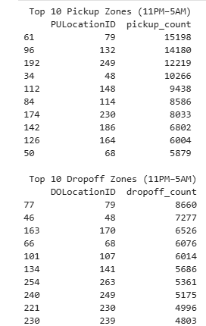
    - Find the revenue share for nighttime and daytime hours
Calculate how much revenue taxi trips generate during night hours (11 PM to 5 AM) compared to daytime hours (6 AM to 10 PM). It first ensures the pickup timestamps are in datetime format and extracts the hour of each trip. Using these time windows, it filters the dataset to sum up the total fare amounts separately for night and day trips. It then computes the overall revenue and calculates the percentage share contributed by each time period. Finally, it prints out the revenue figures and their respective shares, offering a clear comparison of how taxi earnings vary between night and day.
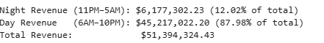

    - For the different passenger counts, find the average fare per mile per passenger
Analyze how taxi fare efficiency varies with the number of passengers by calculating the average fare per mile per passenger. It first filters out trips with zero distance or passenger count to ensure valid data, then computes a new metric—fare divided by the product of trip distance and passenger count—to measure cost per mile per person. The data is then grouped by passenger count, and the average of this metric is calculated for each group. The result reveals how fare-per-mile-per-passenger changes depending on how many people share the ride, offering insights into cost-effectiveness across different passenger loads.
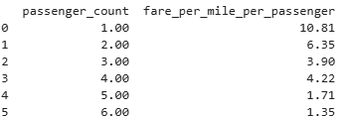
    - Find the average fare per mile by hours of the day and by days of the week
Calculate the average taxi fare for each hour of the day across different weekdays by grouping the data by both day name and pickup hour. It then visualizes the results using a line plot, where each line represents a different weekday and shows how the average fare varies throughout the day. The x-axis displays the hour of pickup (from 0 to 23), and the y-axis shows the average fare amount. This plot helps reveal patterns in fare pricing across time and days, such as peak hours or weekday-vs-weekend fare differences.
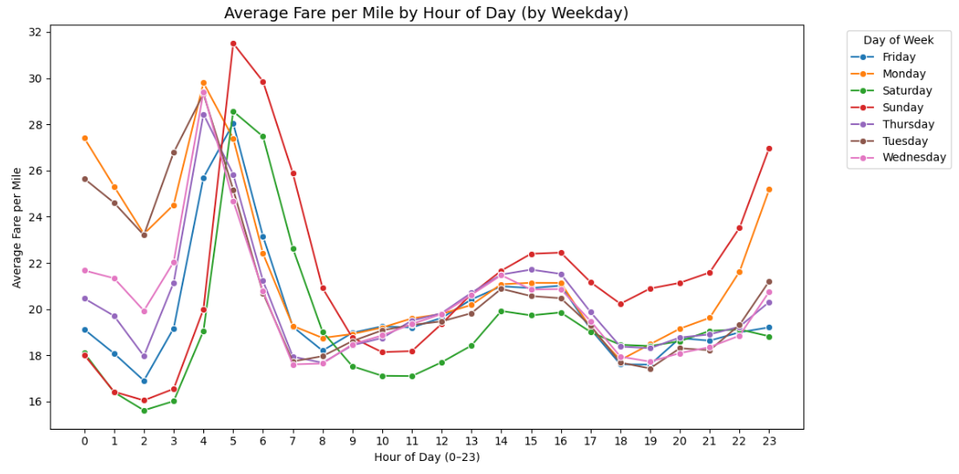
Conclusion:
- Fares are higher between 4:00 and 6:00 AM.
- The lowest fares occur around 2:00–3:00 AM.
- During the evening hours (18:00, 19:00, 20:00), fares are also relatively lower.
- On Sundays, fares tend to be higher after 4:00 AM compared to other days.
- On weekdays, average fares remain mostly consistent throughout the day, except from midnight to 5:00 AM.

    - Analyse the average fare per mile for the different vendors
Analyze how taxi fare efficiency varies across vendors and different hours of the day by calculating the average fare per mile. It first cleans the dataset by removing trips with zero fare or distance, then computes a new metric—fare divided by trip distance—for each ride. The data is grouped by vendor ID and pickup hour to calculate the mean fare per mile for each combination. A line plot is then generated to visualize how this metric changes throughout the day for each vendor, helping compare pricing patterns and operational behavior between vendors over time.
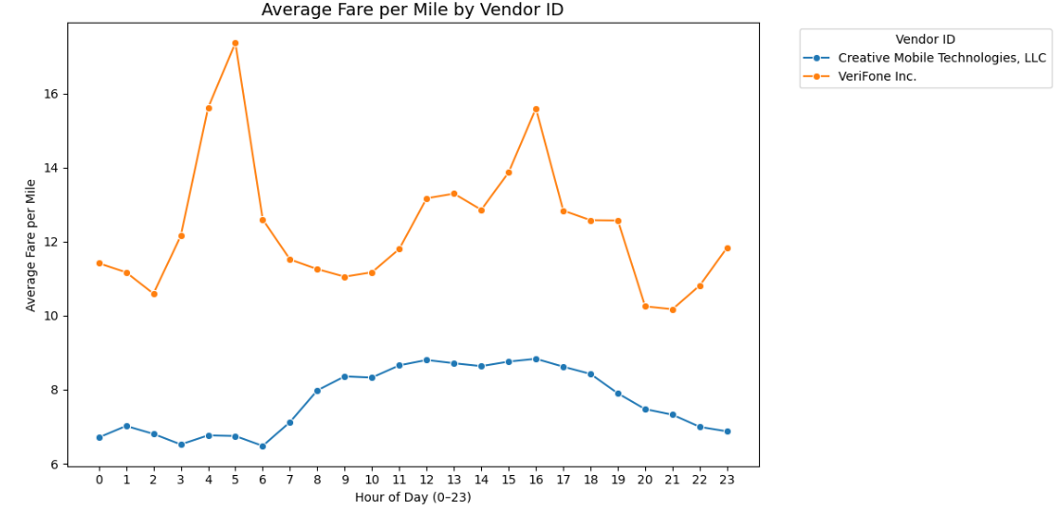
    - Compare the fare rates of different vendors in a distance-tiered fashion
Categorize taxi trips into three distance tiers—short (0–2 miles), medium (2–5 miles), and long (5+ miles)—using the pd.cut function, and then analyzes how fare efficiency varies across these tiers for different vendors. It calculates the average fare per mile and the number of trips in each tier for each vendor, storing the results in a grouped DataFrame. A bar plot is then created to visualize these metrics, with bars representing average fare per mile and annotations showing both the fare and trip count. This helps compare pricing behavior and trip volume across vendors and trip lengths, offering insights into fare structures and operational patterns.
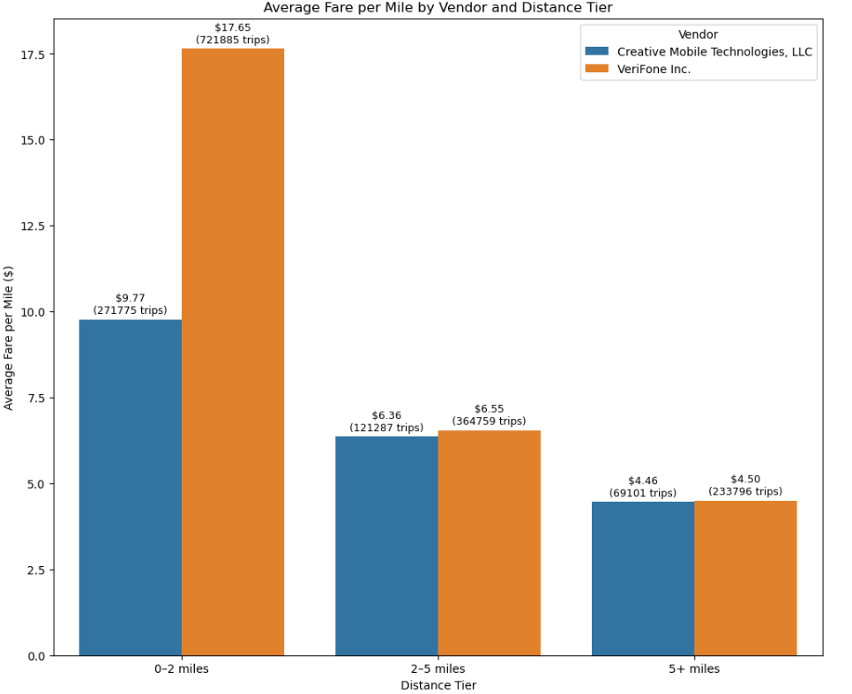
Conclusion:
For short trips, Vendor 2 charges slightly more. For medium and long trips, the fare amounts are nearly the same for both vendors.
    - Analyse the tip percentages
Analyze tipping behavior in taxi trips by calculating the tip percentage—defined as the tip amount divided by the fare amount—for valid rides with positive fare and passenger counts. It categorizes trips into distance tiers using custom bins and then computes the average tip percentage across three dimensions: trip distance, passenger count, and pickup hour. These aggregated insights are visualized using three plots: a bar chart showing how tipping varies with trip length, another bar chart comparing tips across different passenger counts, and a line chart illustrating hourly tipping trends throughout the day.
Together, these visualizations help uncover patterns in customer tipping habits, such as whether longer trips or solo rides tend to receive higher tips, and which hours of the day are most tip-generous. This kind of analysis is useful for understanding rider behavior, optimizing driver strategies, or even informing fare policy decisions.
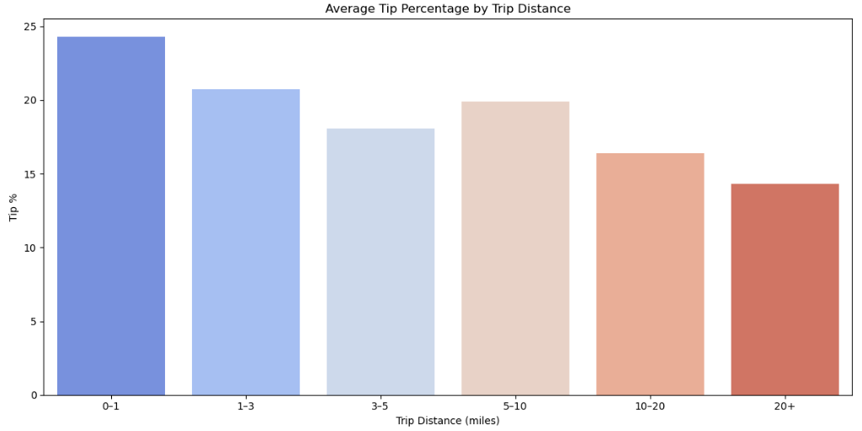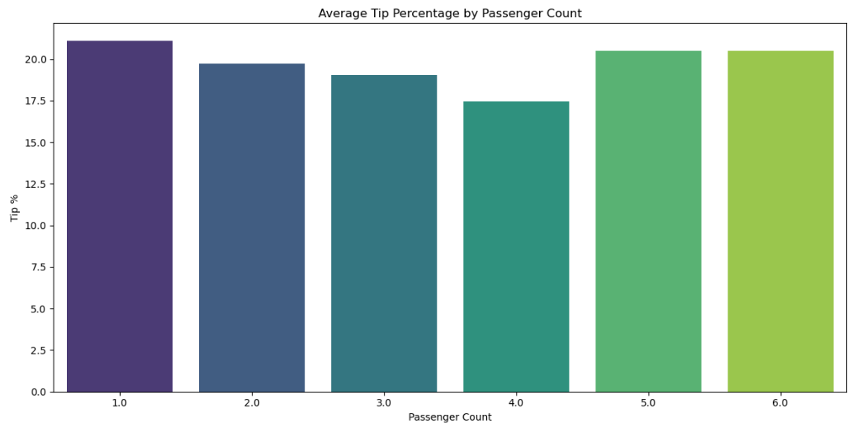
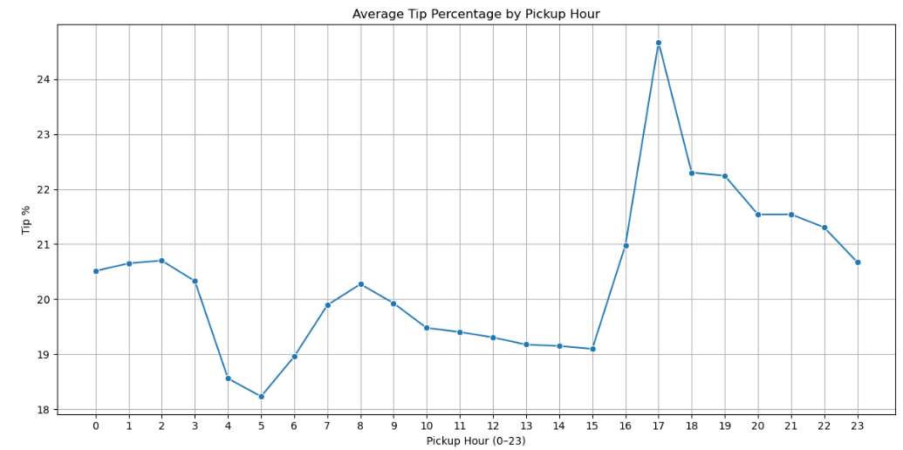
Compare taxi trips with very low tips (≤10%) to those with very high tips (>25%) to uncover behavioral differences across distance, passenger count, and time of day. It first filters out invalid data and calculates the tip percentage for each trip, then isolates trips that fall into either the low-tip or high-tip category. These trips are labeled into two tiers—"
The results are visualized using three subplots: a bar chart showing how tip generosity varies with trip distance, another showing its relationship with passenger count, and a line chart tracking tip behavior across pickup hours. This analysis helps identify patterns such as whether longer trips or solo rides tend to receive higher tips, and which times of day are more likely to yield generous tipping, offering valuable insights into rider behavior and driver performance.
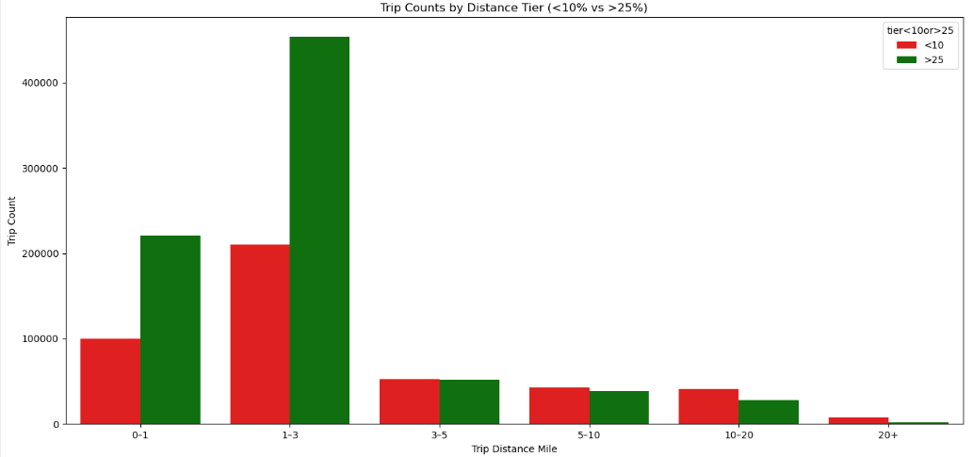
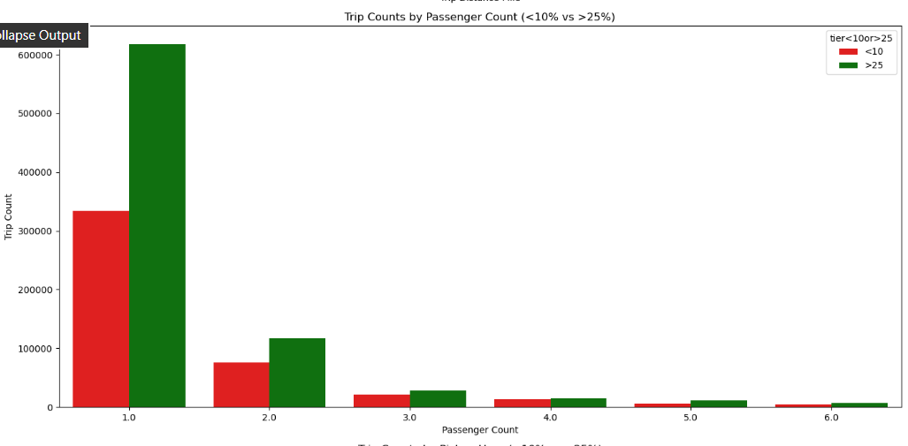
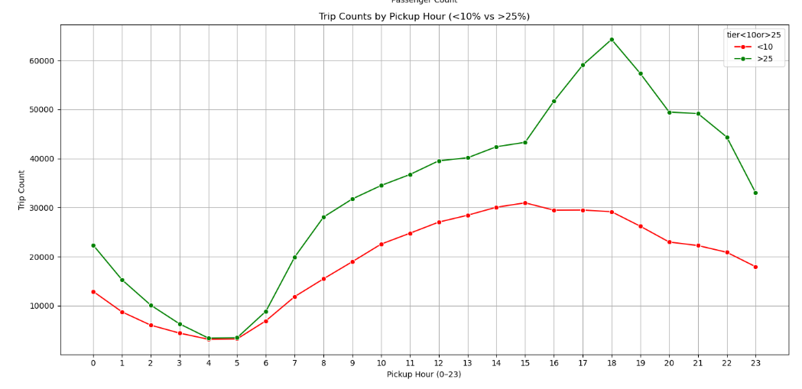
Conclusion:
- Distance: For trips up to 3 miles, tips exceed 25% in most cases. For trips longer than 3 miles, tip percentages remain fairly consistent.
- Passenger Count: For fewer than 3 passengers, tips are generally above 25%. For trips with 3 or more passengers, tip percentages are relatively uniform.
- Pickup Time: Tips are mostly greater than 25%, except around the 4th and 5th hours, where they are lower. Tips are notably higher between 15:00 and 22:00 hours.
    - Analyse the trends in passenger count
Analyze how the average number of passengers per taxi trip varies across different hours of the day and days of the week. It groups the data by both pickup_day_name and pickup_hour, calculates the mean passenger count for each combination, and visualizes the results using a multi-line plot. Each line represents a different day of the week, showing how passenger volume fluctuates throughout the day. This helps identify patterns such as peak travel hours, differences between weekdays and weekends, and potential times of higher shared ride activity.
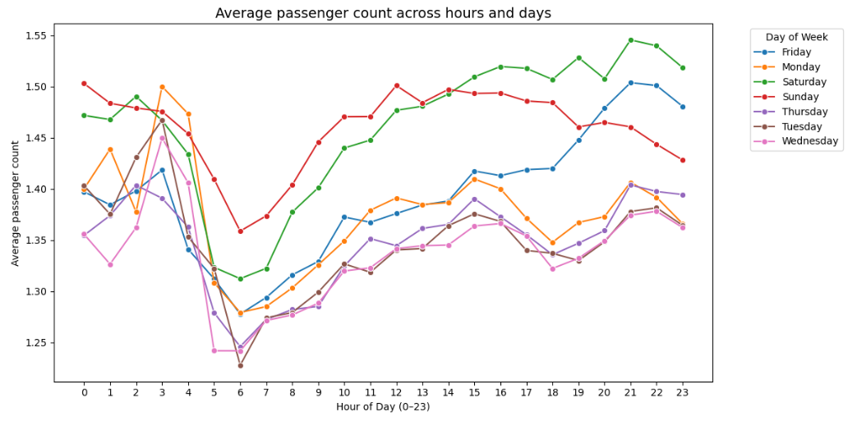
Analysis
- In the early morning (around 4–6 AM), average passenger counts drop to their lowest for all days.
- Peak periods occur in the late evening (around 19:00–23:00), especially on Friday and Saturday, where average passenger counts rise sharply.
- Saturdays have the highest average passenger load during most hours, peaking in the late evening, followed by Friday and Sunday.
- Weekdays like Tuesday, Wednesday, and Thursday consistently show lower passenger counts.
- Passenger count variation throughout the day follows typical demand patterns, with lower counts in the early morning and higher activity in the evening.
- Weekends experience higher passenger activity overall compared to weekdays.
This analysis indicates that ride demand is busier on weekends and during late evening hours.

    - Analyse the variation of passenger counts across zones
Calculate the average number of passengers per taxi trip for each pickup zone and visualizes the top 15 zones with the highest averages. It first groups the dataset by zone and computes the mean passenger count, renaming the resulting column for clarity. Then, it sorts the zones in descending order of average passenger count and selects the top 15. A bar chart is plotted to display these zones, with the x-axis showing zone names and the y-axis showing their corresponding average passenger counts. This visualization helps identify areas where taxis tend to carry more passengers, potentially indicating zones with higher demand for shared or group rides.
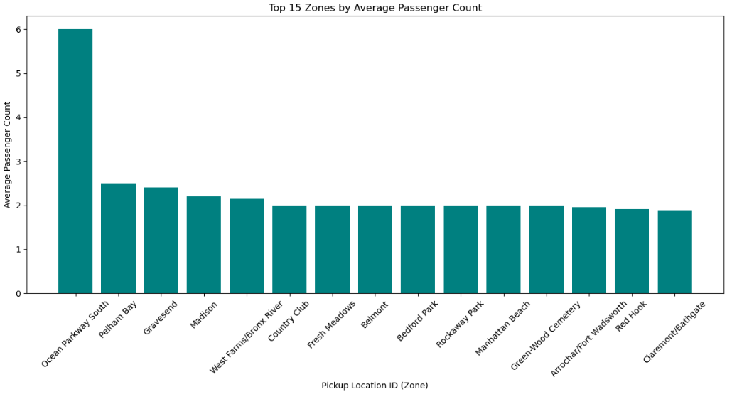
    - Analyse the pickup/dropoff zones or times when extra charges are applied more frequently.
Evaluate how frequently different surcharges—namely extra, improvement_surcharge, and congestion_surcharge—are applied across all taxi trips in the dataset. It first calculates the total number of trips, then iterates through each surcharge column to count how many trips had a positive surcharge value. For each surcharge, it computes the percentage of trips where the charge was applied and prints both the count and percentage in a formatted summary. This helps quantify the prevalence of additional fees in the fare structure and can be useful for understanding cost drivers in urban taxi operations.
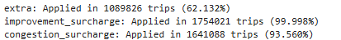
Analyze how frequently different surcharges—extra, improvement_surcharge, and congestion_surcharge—are applied across taxi trips, both by pickup zone and by hour of the day. It calculates the percentage of trips in which each surcharge was applied for every zone (PULocationID) and every pickup hour, then visualizes the results in two plots. The first is a bar chart showing the top 20 zones with the highest frequency of surcharge application, helping identify areas with elevated fare add-ons. The second is a line chart that tracks how surcharge usage varies throughout the day, revealing time-based patterns such as peak hours for congestion fees or late-night extras. These insights are useful for understanding fare dynamics and operational cost drivers across both geography and time.
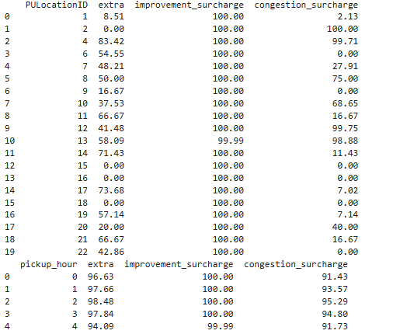
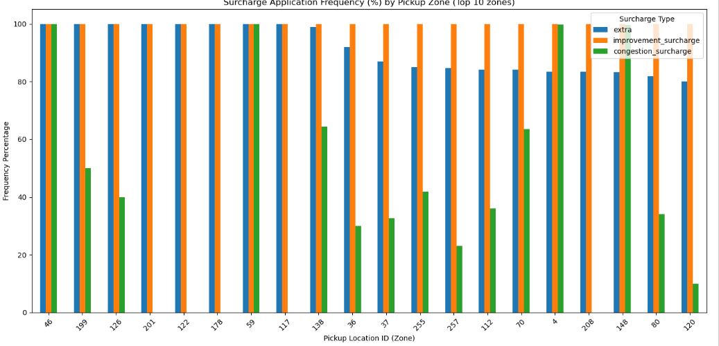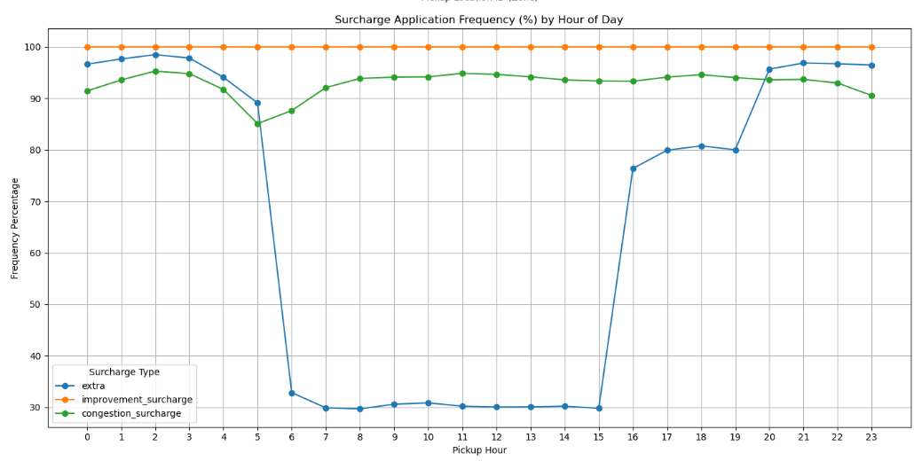

Conclusions

Final Insights and Recommendations
    - Recommendations to optimize routing and dispatching based on demand patterns and operational inefficiencies.

Insights
- Certain zones experience excessive dropoffs but few pickups, leaving drivers stranded away from high-demand areas.
- Idle drivers often cluster in low-demand zones, while nearby zones may have unmet requests.
- Some zones have a high proportion of short trips, which may reduce profitability after repositioning.
- Demand is highly time-dependent, with evening peaks and weekend surges.

Recommendations
- In high-density zones with overlapping demand, consider ride-pooling or merging routes, picking up additional passengers along the route with minimal detour.
- Use short-term demand forecasts (next 30–60 minutes) per zone to pre-position idle drivers ahead of surges.
- Develop a dedicated plan for airport pickups (stands or scheduled rotations at JFK/EWR) to reduce deadhead time and improve throughput during peak flight arrivals.
- Position drivers near known hotspots during peak times (Manhattan cores, airport pickup zones) to reduce wait times and increase utilization.
- After a dropoff in a low-demand zone, reposition the vehicle algorithmically to a nearby zone with predicted excess demand.
- Maintain a small reserve fleet or buffer drivers near emerging demand zones, ready for sudden surges.
- Increase driver availability (or incentives) during evening and weekend shifts; reduce fleet allocation in the early morning unless there’s a targeted need.

    - Suggestions on strategically positioning cabs across different zones to make best use of insights uncovered by analysing trip trends across time, days and months.

- Build a scheduling plan where drivers are pre-positioned in high-probability pickup zones about 10–20 minutes before the demand peak (e.g., at 4:30 PM, send drivers toward evening surge zones instead of waiting for the surge to start).
- For each zone, maintain a target number of idle/active vehicles per hour based on historical pickup density.
- Identify intermediate zones between hotspots and low-demand areas that can act as “staging corridors.”
- Use separate positioning strategies: for weekdays, focus on business districts and commuting hubs; for weekends, focus on entertainment, dining, nightlife corridors, and airports.
- For airports (JFK, LGA), maintain a controlled staging queue near terminals to prevent drivers from circling or driving long distances while waiting.
- Keep a fraction of drivers “floating”, not fixed to one zone, so they can respond dynamically to surges.

    - Propose data-driven adjustments to the pricing strategy to maximize revenue while maintaining competitive rates with other vendors.

- Adjust fares in real time (or near real time) based on supply–demand imbalance, similar to ride-sharing platforms. For example, if a zone is in high demand and driver supply is low, apply a multiplier (e.g., 1.2×, 1.5×) on the base fare.
- Cap the multiplier (e.g., max 2×) to prevent excessively high rates and maintain rider trust.
- Introduce a minimum fare to ensure profitability on short trips (e.g., rides under 1 mile have a fixed minimum).
- Ramp up surge pricing gradually (e.g., 1.1× → 1.2× → 1.3×) instead of sudden spikes to reduce rider rejection.
- Offer discounts or lower surcharges during off-peak hours to attract more riders.
- Incentivize longer trips with discounted per-mile or per-minute pricing if the route is profitable.
- Implement loyalty or subscription models (e.g., flat hourly or daily packages) to secure frequent user demand.
- Show riders transparently the base fare, any surcharges, and multipliers before confirmation.
- Share part of the surge/multiplier increase with drivers to motivate them toward high-priced zones.
- Use pricing to encourage pickups/dropoffs in slightly less busy zones by offering discounts, helping to shift demand and reduce congestion in hotspot areas.

