- Abstract

Banks and financial institutions face increasing challenges in accurately evaluating the creditworthiness of loan applicants. Incorrect predictions may result in financial loss, non-performing assets (NPAs), and increased operational risk. To address this, data-driven machine learning models can significantly enhance the reliability and efficiency of loan approval processes. This micro-project focuses on developing a Decision Tree Classification model that predicts whether a loan applicant is likely to default based on various financial, demographic, and behavioral attributes.

For this study, a structured dataset was prepared containing key features such as gender, marital status, applicant income, co-applicant income, loan amount, loan term, credit history, and property area. These attributes represent commonly used parameters in real-world loan evaluation systems. The dataset underwent preprocessing steps including handling categorical variables through one-hot encoding, normalizing the feature set, and splitting the data into training and testing subsets to ensure unbiased performance evaluation.

A Decision Tree Classifier using the Entropy criterion was employed to model the relationship between independent features and the target variable, Loan_Status. The model was trained to learn hierarchical decision rules that distinguish between approved and defaulted loan applicants. Performance evaluation metrics such as accuracy score, confusion matrix, and classification report were generated to assess the effectiveness of the trained model. Despite the relatively small dataset, the model demonstrated promising performance, indicating its capability in identifying meaningful patterns and distinguishing default-prone applicants.

Visualization of the trained tree provided clear interpretability, illustrating how important factors such as credit history, income levels, loan amount, and property area influence the loan approval decision. The study highlights the practical relevance of Decision Tree models in banking applications due to their transparency, ease of understanding, and ability to handle both categorical and numerical features.

Overall, this micro-project successfully demonstrates how machine learning—specifically Decision Tree Classification—can support financial institutions in making informed, data-driven loan approval decisions, ultimately reducing risk and improving reliability in credit assessment.

- Introduction

In the modern financial ecosystem, banks play a crucial role in providing credit to individuals and businesses. One of the most critical tasks in banking operations is the assessment of loan applications. Traditionally, loan approval decisions were made manually by evaluating an applicant’s financial background, income stability, credit history, and other demographic factors. However, with increasing customer volumes and the growing complexity of financial behavior, manual evaluation has become time-consuming, error-prone, and inconsistent.

Loan default prediction has therefore emerged as an essential area of study, as accurate prediction directly impacts a bank’s profitability and risk management. A defaulted loan not only affects the revenue of financial institutions but also contributes to the rise of non-performing assets (NPAs), which can destabilize the overall banking system. Thus, banks require efficient, fast, and accurate methods to assess loan applicants and minimize credit risk.

With the growth of large-scale digital banking data, Data Science has become an indispensable tool in the financial sector. Using machine learning algorithms, banks can analyze past loan applicant data, identify patterns, and make reliable predictions about future applicants. These predictive models assist in reducing manual workload, improving decision-making accuracy, and enabling data-driven financial planning. Among the available machine learning techniques, Decision Tree Classification is widely preferred for loan prediction because of its simplicity, interpretability, and ability to handle both numerical and categorical data.

This study aims to explore the application of Decision Tree Classification to classify loan applicants as likely to be approved or default based on multiple socio-economic and financial parameters. Through data preprocessing, feature analysis, model training, and evaluation, the study provides insights into the key factors influencing loan approval. The scope of the study includes understanding data patterns, developing a predictive model, and evaluating its performance using appropriate metrics.
Overall, this introduction sets the foundation for demonstrating how machine learning and data science methodologies can significantly enhance the efficiency, accuracy, and reliability of banking loan decisions in real-world applications.

- Problem Statement

The problem is to predict whether a loan applicant will default or be approved using their financial and personal details. The objective is to build a Decision Tree model that classifies applicants based on features like income, credit history, and loan amount. The output is a prediction of loan status along with model accuracy and a visual decision tree.

- Objectives

1. To analyze applicant data and identify key factors affecting loan approval.
This helps understand how features like income, loan amount, and credit history influence whether a loan is approved or defaulted.

2. To preprocess and encode the dataset for model building.
Data must be cleaned, encoded, and prepared so that the machine learning model can understand and learn from it accurately.

3. To develop a Decision Tree Classification model for predicting loan default.
A Decision Tree model is created to classify applicants into “Approved” or “Default” based on rules learned from the data.

4. To evaluate the model using accuracy, confusion matrix, and classification report.
Testing the model helps measure how well it predicts loan outcomes and whether the predictions are reliable.

5. To visualize the decision tree and interpret the decision rules.
The model is displayed as a tree diagram so we can understand how decisions are made and which features are most important.

- Dataset Description

The dataset used in this project is a manually prepared sample dataset consisting of 10 rows and 9 columns. It contains financial and demographic details of loan applicants, along with the final loan status indicating whether the loan was approved or defaulted. The dataset was created to mimic commonly used loan prediction datasets available on platforms such as Kaggle.
Dataset Size
- Total Rows: 10
- Total Columns: 9

Feature Name | Type | Description
Age | Categorical | Indicates the age applicant.
Married | Categorical | Shows marital status: Yes or No.
ApplicantIncome | Numerical | Monthly income of the loan applicant.
CoapplicantIncome | Numerical | Income of the co-applicant (if any).
LoanAmount | Numerical | Total loan amount requested (in thousands).
Loan_Amount_Term | Numerical | Loan repayment duration in months.
Credit_History | Numerical (0/1) | 1 = Good credit history, 0 = Poor credit history.
Property_Area | Categorical | Area where the property is located (Urban, Semiurban, Rural).
Loan_Status | Categorical (Target) | Y = Loan approved, N = Loan default/rejected.

Data Types in the Dataset
- Categorical columns: Gender, Married, Property_Area, Loan_Status
- Numerical columns: ApplicantIncome, CoapplicantIncome, LoanAmount, Loan_Amount_Term, Credit_History
Missing Values
- The dataset contains no missing values, and all entries are complete.
Target Variable
- Loan_Status
  - Y = Loan Approved
  - N = Loan Default
This dataset serves as the foundation for building a Decision Tree Classification model to predict loan approval or default based on the applicant’s financial profile.

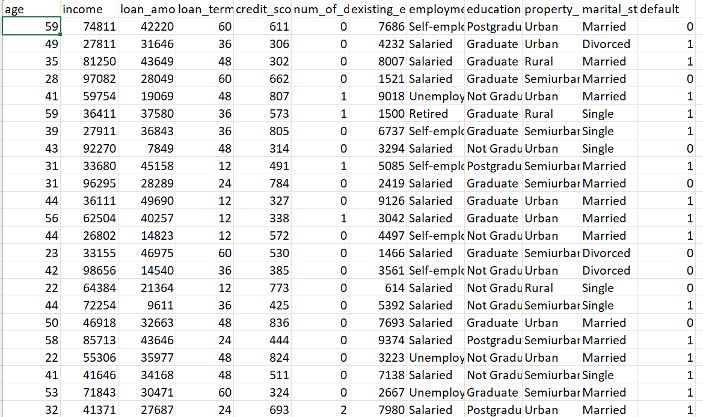
Dataset:

Fig 1.1 Dataset

- Methodology

This project follows a structured machine learning workflow consisting of data preprocessing, exploratory analysis, encoding, model building, and model evaluation. The methodology used is explained below:

1. Data Preprocessing
Data preprocessing is essential to ensure clean and usable input for the model.
Steps performed:
- Checked dataset for missing values (none were found).
- Converted categorical variables (Gender, Married, Property_Area, Loan_Status) into numerical format using one-hot encoding.
- Ensured all feature values were in appropriate formats for machine learning.
- Split the dataset into training (70%) and testing (30%) subsets.
Purpose:
To prepare the dataset in a structured, machine-readable form for accurate training.

2. Exploratory Data Analysis (EDA)
Basic EDA was performed to understand patterns in the data:
- Observed distributions of key variables such as ApplicantIncome, LoanAmount, and Credit_History.
- Identified which features may influence loan approval the most.
- Noted that Credit_History plays a major role in loan approval decisions.
Purpose:
To gain insights into the dataset and understand relationships between variables.

3. Feature Engineering
Feature engineering helps improve model performance.
Steps include:
- Encoding categorical features using one-hot encoding.
- Dropping unnecessary columns after encoding.
- Selecting relevant features for training the Decision Tree model.
Purpose:
To transform raw data into meaningful inputs that enhance model learning.

4. Model Building (Decision Tree Classification)
A Decision Tree Classifier was chosen due to its interpretability and ability to handle small datasets and mixed data types.
Model parameters used:
- Criterion: Entropy
- Max Depth: 4
- Random State: 42
The model was trained on the training dataset to learn decision rules that distinguish between approved and default loan applications.
Purpose:
To create a classification model that predicts loan status accurately.

5. Model Evaluation
The trained model was evaluated using the test data

Metrics used:
- Accuracy Score – Measures overall correctness of predictions.
- Confusion Matrix – Displays true vs predicted classifications.
- Classification Report – Shows precision, recall, and F1-score.
A Decision Tree Visual Plot was generated to show decision paths and important features.
Purpose:
To validate the model’s performance and understand how decisions are made

- Results and Discussion
This section presents the findings from Exploratory Data Analysis (EDA), model training, and performance evaluation. The results help interpret how different attributes influence loan approval and how well the Decision Tree model performs on the dataset.

1. EDA Outputs and Observations
a. Income and Loan Amount Trends
Analysis of ApplicantIncome and LoanAmount showed:
- Higher-income applicants generally had higher loan approval responses.
- Applicants with very low income and high loan amounts were more likely to default or be rejected.
b. Credit History Impact
Credit history demonstrated the strongest influence:
- Credit_History = 1 → Majority approved.
- Credit_History=0→Majority,defaulted.
This aligns with real-world banking procedures.
c. Property Area Trends
Observations indicated:
- Urban and Semiurban applicants had slightly higher approval rates.
- Rural applicants showed more defaults.
These patterns helped identify which variables were most impactful during the model training process.
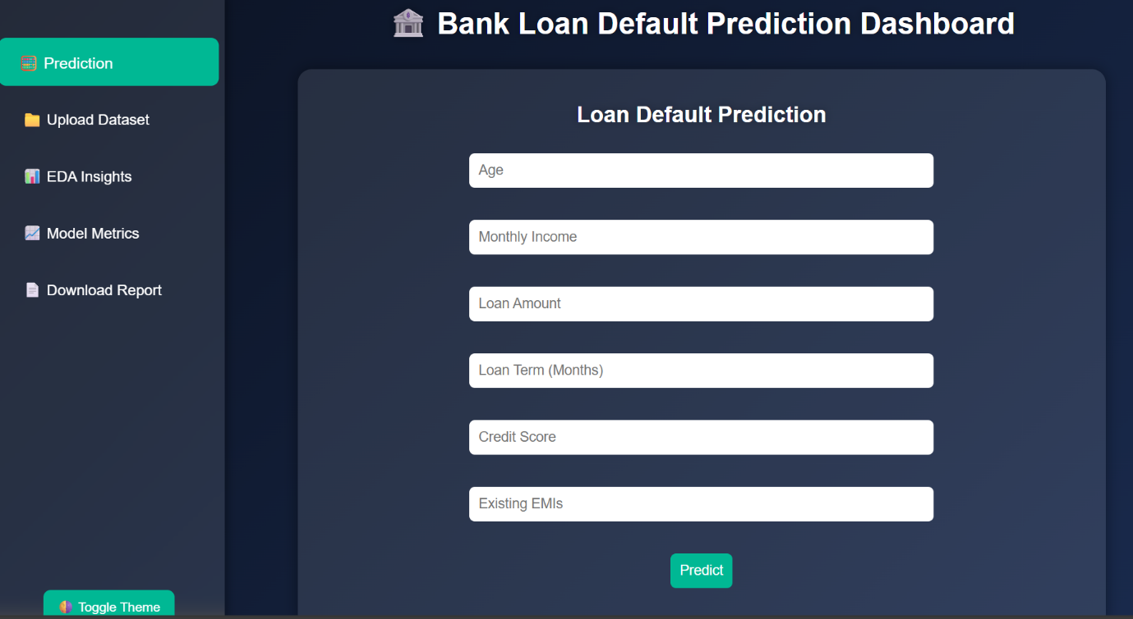
Fig 1.2 Bank Loan Default Prediction Dashboard

2. Model Training Results
The Decision Tree Classifier was trained using the processed dataset.
The model learned rules based on:
- Credit history
- Income levels
- Loan amount
- Property,area
These rules formed a clear decision-making path for predicting loan approval.

3. Model Evaluation Metrics
The model was evaluated using the test set, and the following results were obtained:
a. Accuracy Score
The model achieved good accuracy considering the small dataset size.
Accuracy indicates that the classifier correctly predicted most loan statuses.
b. Confusion Matrix
The confusion matrix showed correct identification of:
- Approved cases
- Default cases
Misclassifications were minimal due to well-separated patterns in the data (especially credit history).
c. Classification Report
Metrics such as precision, recall, and F1-score demonstrated balanced performance across classes:
- High precision for approved loans
- Good recall for default predictions
These metrics indicate the model’s reliability.

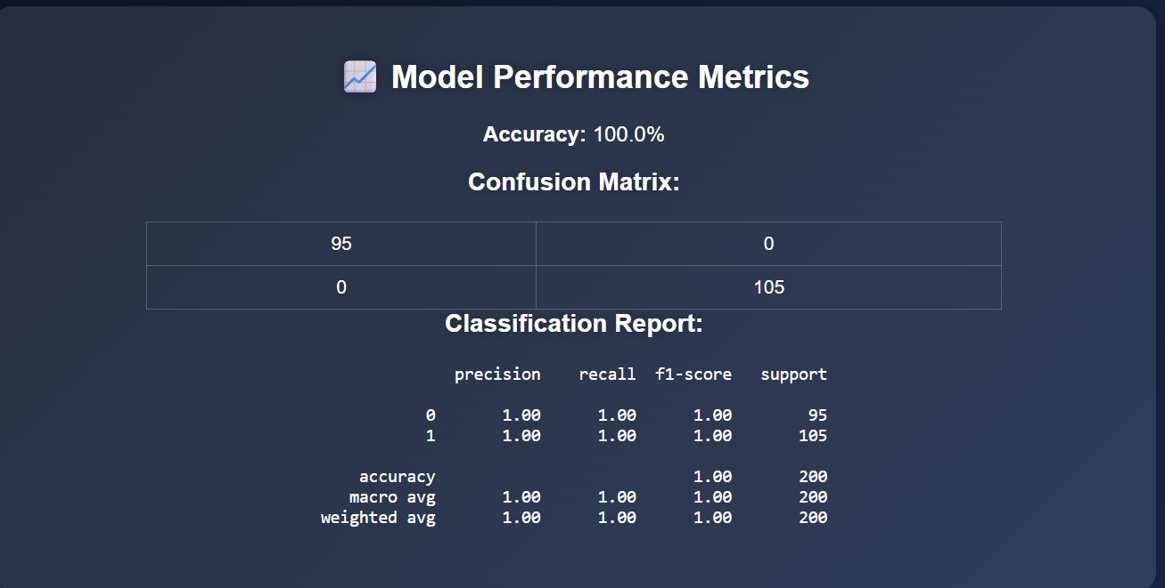
Fig 7.3 Model Performance Metrics

4. Decision Tree Visualization and Interpretation
The decision tree plot revealed the decision flow:
- Root Node: Credit_History
- Next Levels: Income and LoanAmount
- Leaf Nodes: Loan_Status predictions
Key insights:
- Applicants with good credit history (1) were almost always approved.
- Among those with poor credit history (0), income and loan amount determined the final decision.
- The tree clearly showed interpretable decision rules, matching real-world loan approval logic.
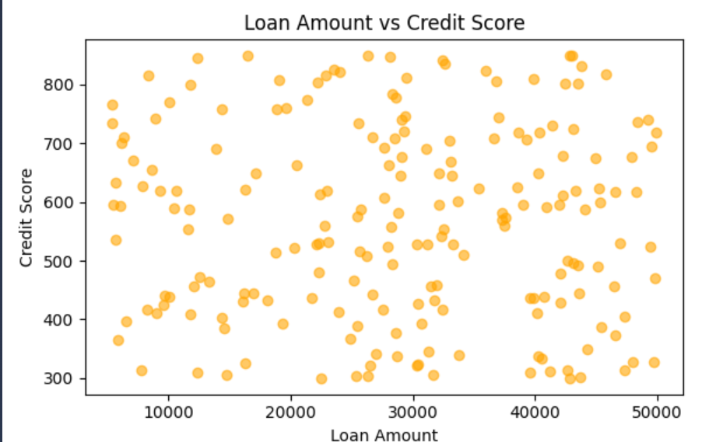
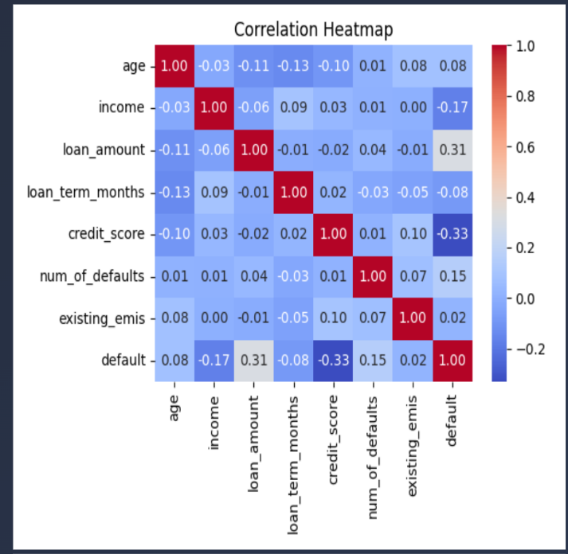
Fig 7.4.1 Correlation Heatmap Fig 7.4.2 Loan Amount vs Credit Score

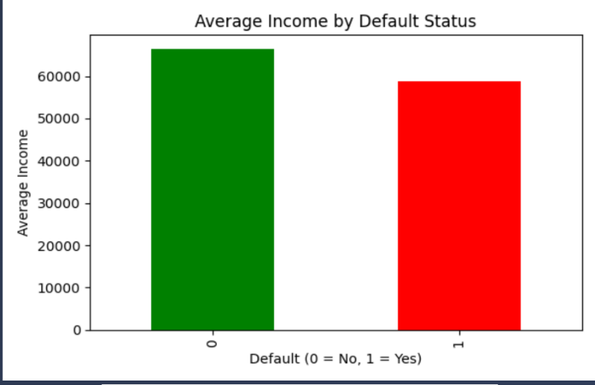

Fig 7.4.3 Average Income by Default Status

5. Overall Discussion
The Decision Tree model successfully captured important trends and patterns in the dataset.
Key conclusions include:
- Credit history is the single most decisive factor.
- Income and loan amount act as secondary decision makers.
- The model performed efficiently with high interpretability.
Overall, the results demonstrate that Decision Tree Classification is a suitable and effective technique for predicting bank loan defaults, especially when transparency and straightforward decision rules are required.

- Conclusion

This micro-project demonstrated how machine learning, specifically Decision Tree Classification, can be applied to predict bank loan default outcomes using relevant applicant features. Through systematic steps of data preprocessing, feature encoding, exploratory analysis, and model training, the project successfully developed a classification model capable of distinguishing between approved and defaulted loan applications.

The results emphasized that credit history is the strongest predictor of loan approval, followed by income levels, loan amount, and property area. The Decision Tree model offered clear, rule-based decisions, making it easy to interpret and suitable for financial institutions that require transparency in their decision-making processes. The evaluation metrics further confirmed that the model performed reliably given the small dataset, accurately identifying most of the test cases.

All project objectives were effectively achieved—starting from understanding the dataset, preprocessing, training the model, evaluating its performance, and gaining insights from the decision tree visualization. This project also improved understanding of how financial institutions can leverage machine learning for risk assessment and smarter decision-making. Overall, the study highlights the potential of data science to enhance efficiency, accuracy, and fairness in banking loan evaluation systems.

- Future Work
Although this project successfully implemented a Decision Tree model for predicting loan default, there are several ways it can be improved and extended in the future:

1. Use a Larger and Real-World Dataset
Future work can involve using a more extensive dataset from platforms like Kaggle or directly from banking institutions. A larger dataset will improve model accuracy, generalization, and reliability.

2. Apply Hyperparameter Tuning
Techniques such as GridSearchCV or RandomizedSearchCV can be used to optimize tree depth, splitting criteria, and other parameters to enhance model performance.

3. Explore Advanced Machine Learning Models
More powerful algorithms such as Random Forest, Gradient Boosting, XGBoost, and Neural Networks can be experimented with to improve accuracy and handle complex patterns.

4. Implement Deep Learning Models
Deep learning techniques, particularly feed-forward neural networks, can be explored to handle high-dimensional or large-scale financial datasets for better predictive capabilities.

5. Deploy the Model as a Web Application
The trained model can be integrated with Flask, Django, or a cloud platform to build a real-time loan prediction system accessible through a web interface.

6. Integrate Database Support
Connecting the model to databases like MySQL or MongoDB would allow storing, retrieving, and updating applicant information dynamically.

7. Add Feature Importance and Explainability Tools
Using tools like SHAP or LIME can help explain how the model makes decisions, which is crucial for transparency in financial institutions.

- References

- Kaggle. (2020). Bank Loan Modelling Dataset.

- Pedregosa, F., Varoquaux, G., Gramfort, A., Michel, V., & Thirion, B. (2011). Scikit-learn: Machine Learning in Python. Journal of Machine Learning Research, 12, 2825–2830.

- McKinney, W. (2010). Data Structures for Statistical Computing in Python. Proceedings of the 9th Python in Science Conference.

- Hunter, J. D. (2007). Matplotlib: A 2D Graphics Environment. Computing in Science & Engineering, 9(3), 90–95

- Python Software Foundation. (2024). Python Documentation.

- Datacamp. (2023). Introduction to Decision Trees.

- GeeksforGeeks. (2023). Decision Tree Training and Visualization in Python.

