Components

* 1. Arduino *2
  2. LED *5

3) nRF24L01 modules *2

4) Breadboard *1

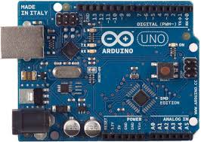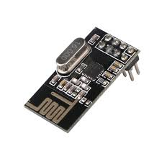

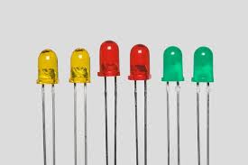 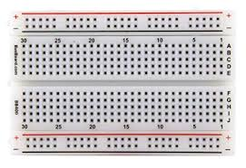

CIRCUIT DIAGRAM

TRANSMITTER

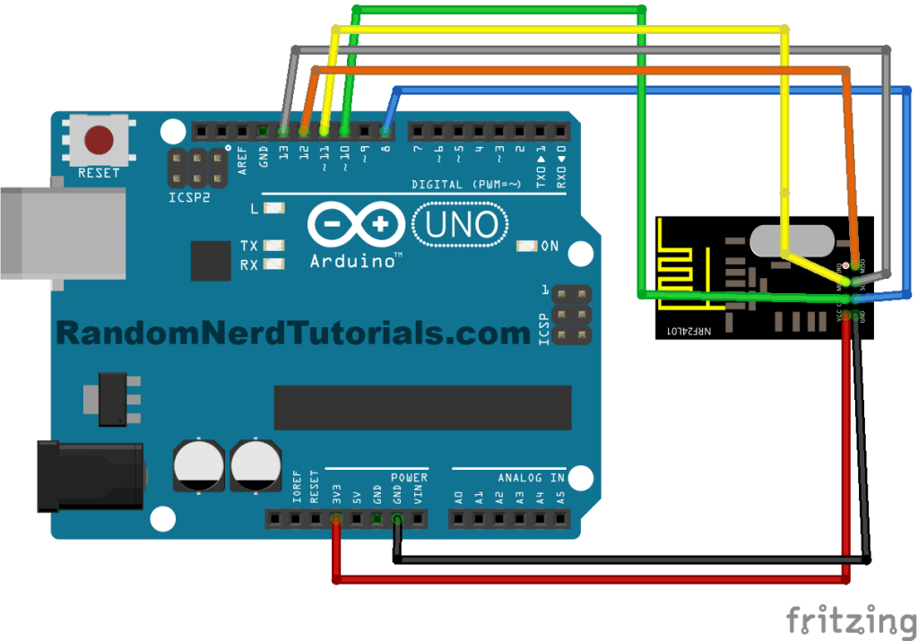

RECEIVER



WORKING

|  |  |  |  |  |  |
| --- | --- | --- | --- | --- | --- |
| LETTER | Qa | Qb | Qc | Qd | Qe |
| A | 0 | 0 | 0 | 0 | 0 |
| B | 0 | 0 | 0 | 0 | 1 |
| C | 0 | 0 | 0 | 1 | 0 |
| D | 0 | 0 | 0 | 1 | 1 |
| E | 0 | 0 | 1 | 0 | 0 |
| F | 0 | 0 | 1 | 0 | 1 |
| G | 0 | 0 | 1 | 1 | 0 |
| H | 0 | 0 | 1 | 1 | 1 |
| I | 0 | 1 | 0 | 0 | 0 |
| J | 0 | 1 | 0 | 0 | 1 |
| K | 0 | 1 | 0 | 1 | 0 |
| L | 0 | 1 | 0 | 1 | 1 |
| M | 0 | 1 | 1 | 0 | 0 |
| N | 0 | 1 | 1 | 0 | 1 |
| O | 0 | 1 | 1 | 1 | 0 |
| P | 0 | 1 | 1 | 1 | 1 |
| Q | 1 | 0 | 0 | 0 | 0 |
| R | 1 | 0 | 0 | 0 | 1 |
| S | 1 | 0 | 0 | 1 | 0 |
| T | 1 | 0 | 0 | 1 | 1 |
| U | 1 | 0 | 1 | 0 | 0 |
| V | 1 | 0 | 1 | 0 | 1 |
| W | 1 | 0 | 1 | 1 | 0 |
| X | 1 | 0 | 1 | 1 | 1 |
| Y | 1 | 1 | 0 | 0 | 0 |
| Z | 1 | 1 | 0 | 0 | 1 |
|  | 1 | 1 | X | X | X |