Emotion Detection & Learning Support Engine

Project Title
Emotion Detection & Learning Support Engine

Abstract
The Emotion Detection & Learning Support Engine is an AI-powered educational platform that detects students' emotional states from free-text learning queries and provides personalized learning support. The system combines Natural Language Processing (NLP), Deep Learning models (BiLSTM and BERT), and Google Gemini AI to analyze learner input, classify emotions such as Bored, Confident, Confused, Curious, and Frustrated, and generate personalized guidance. An interactive Streamlit interface allows users to compare models, visualize analytics, and track interactions through CSV logs.

Problem Statement
Students often struggle to express their learning difficulties, while educators spend valuable time interpreting emotions before providing appropriate guidance. Manual analysis is time-consuming and inconsistent. This project automates emotion detection and delivers instant, empathetic, AI-powered learning support.

Features
- Emotion detection using NLP
- BiLSTM and BERT based emotion classification
- Gemini AI personalized learning guidance
- Confidence score prediction
- Mixed emotion detection
- Interactive Streamlit web interface
- Side-by-side model comparison
- Analytics dashboard with Plotly visualizations
- CSV interaction logging
- Training and pipeline configuration panel

Tech Stack
Programming Language: Python
Frontend: Streamlit
Deep Learning: TensorFlow, Keras, BiLSTM, BERT
NLP: NLTK, Transformers, Scikit-learn
Visualization: Plotly
AI: Google Gemini API
Development: Kaggle GPU, VS Code
Data Storage: CSV

Installation Steps
- Clone the repository.
- Install dependencies using: pip install -r requirements.txt
- Configure the Gemini API key.
- Run the application using: streamlit run src/app.py

Usage Instructions
- Launch the Streamlit application.
- Enter a student's learning problem.
- Click 'Analyze Emotion & Generate Guide'.
- View predicted emotion, confidence score, and AI guidance.
- Compare outputs from multiple models.
- Explore analytics dashboard and CSV logs.

Screenshots
Home Page
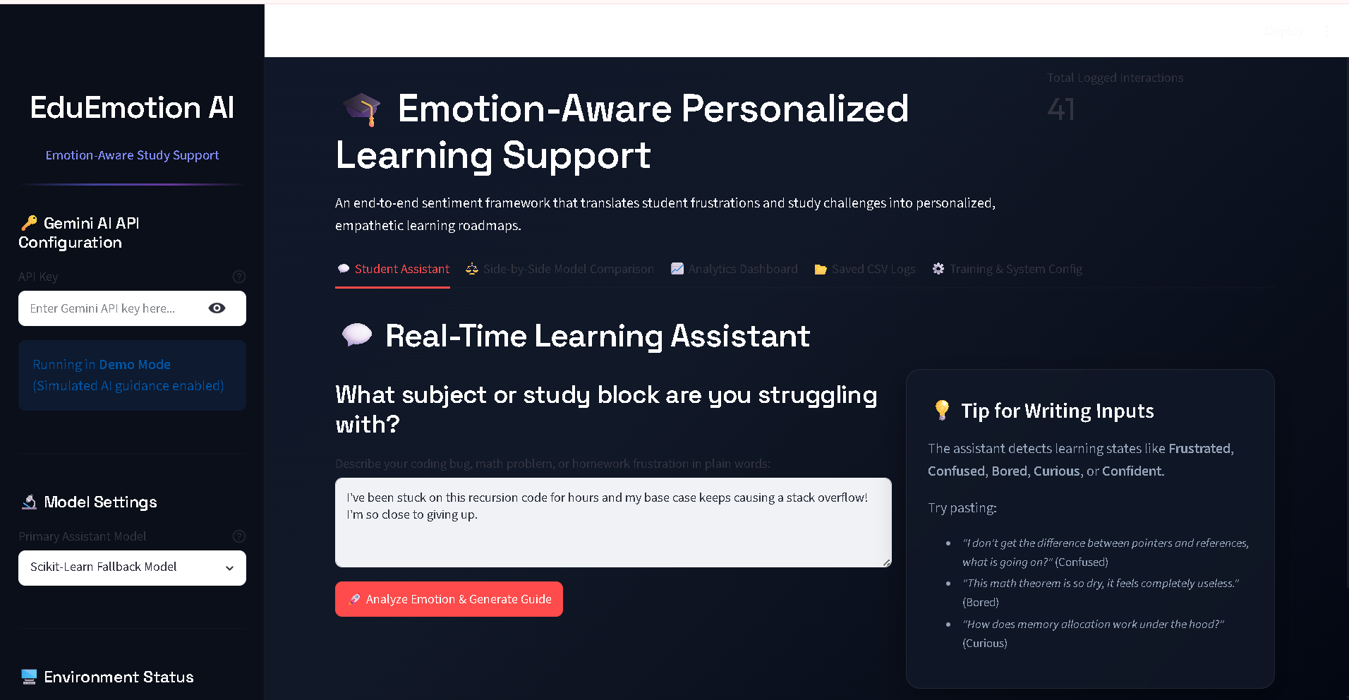
Student Assistant
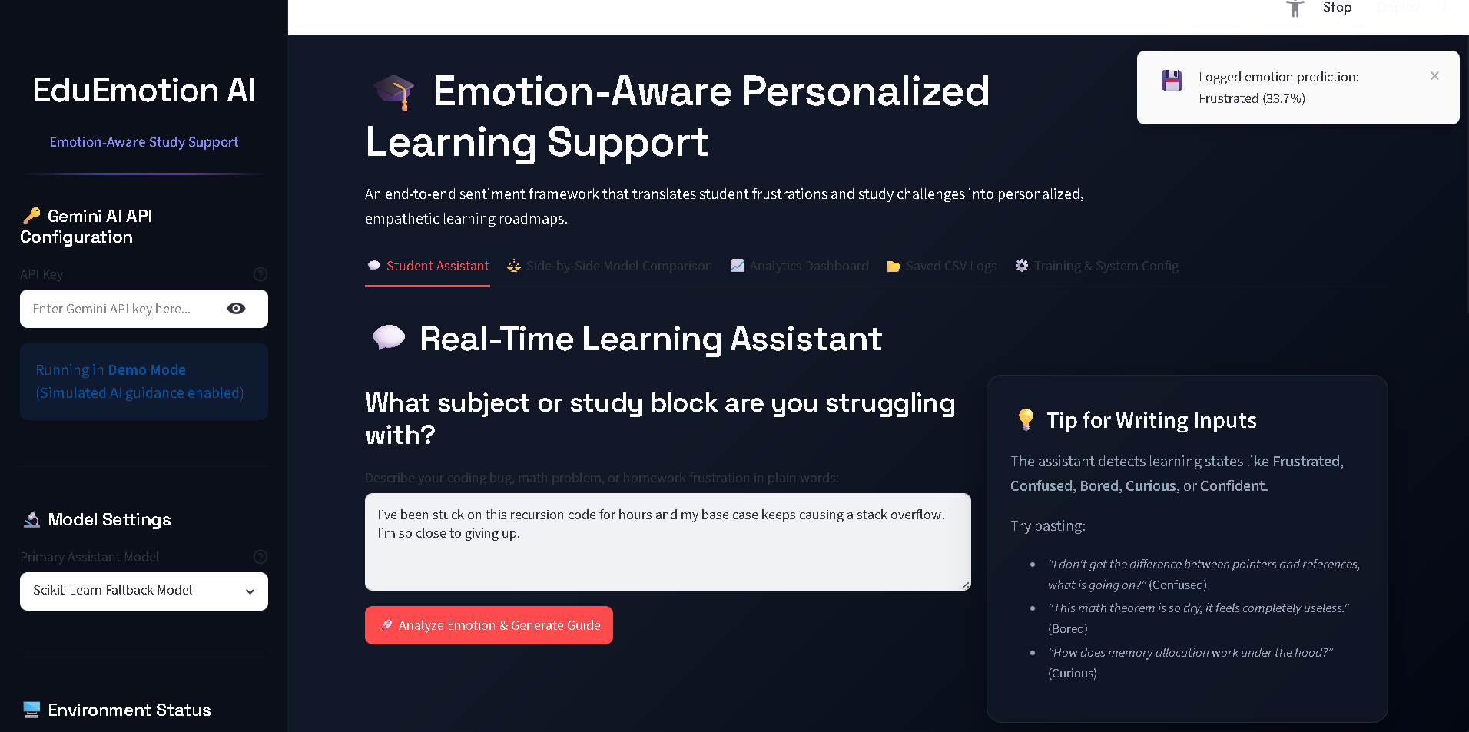
Model Selection
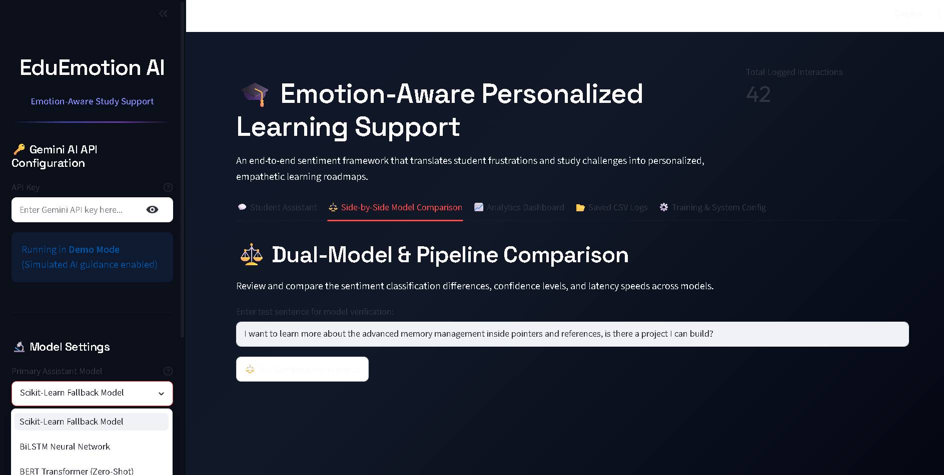
Model Comparison
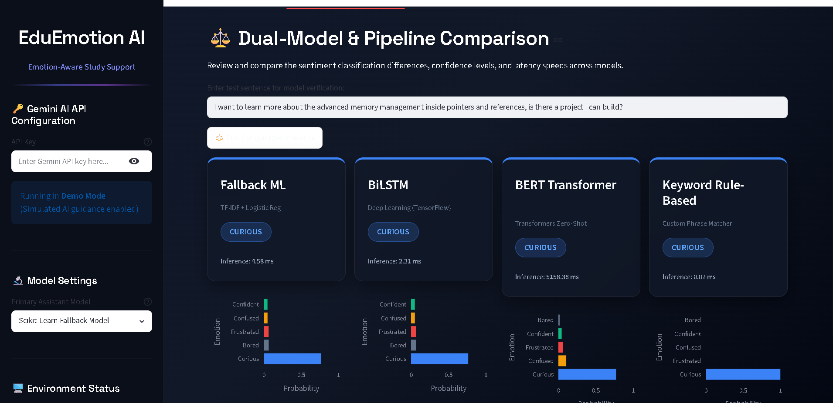
Analytics Dashboard
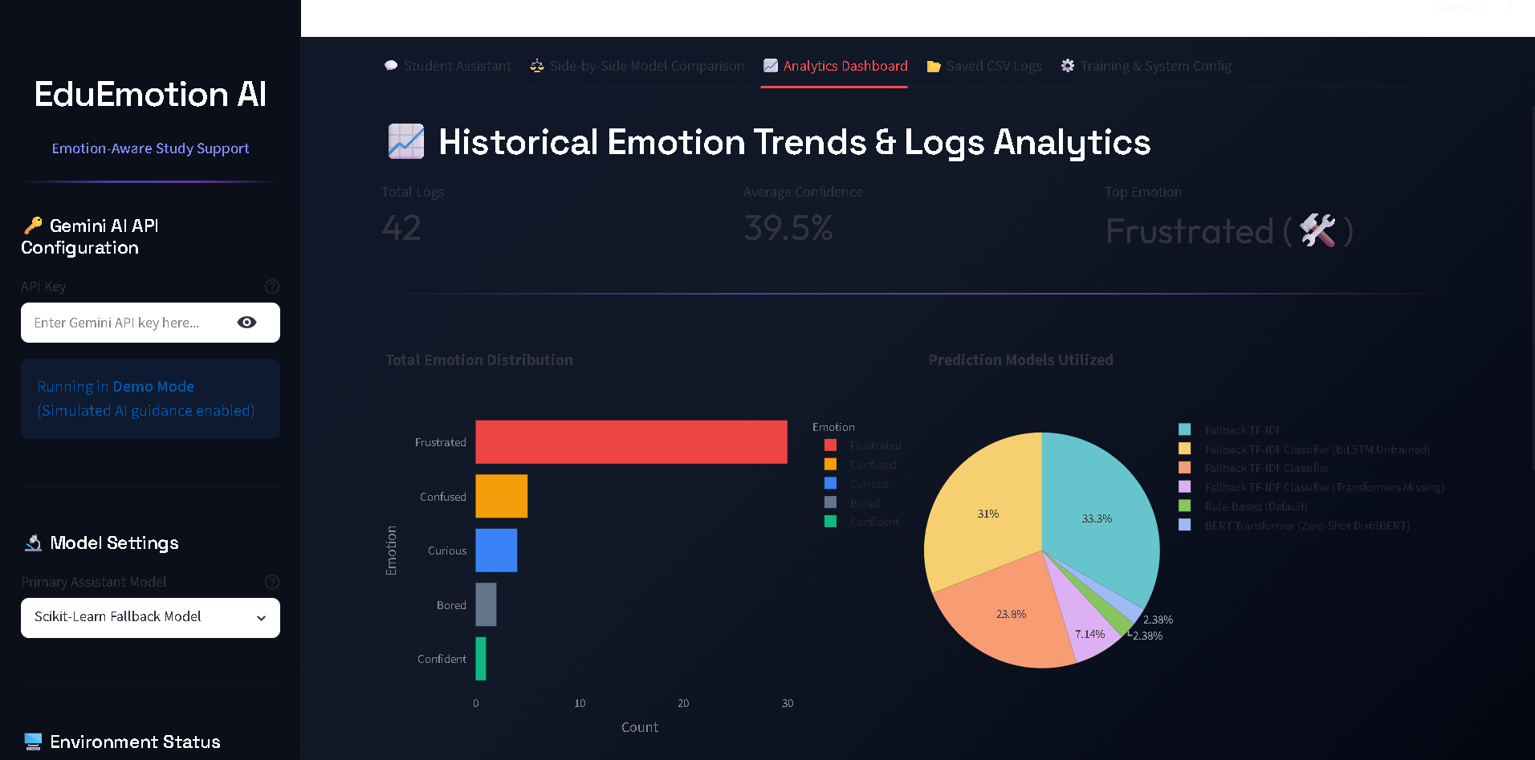
CSV Logs
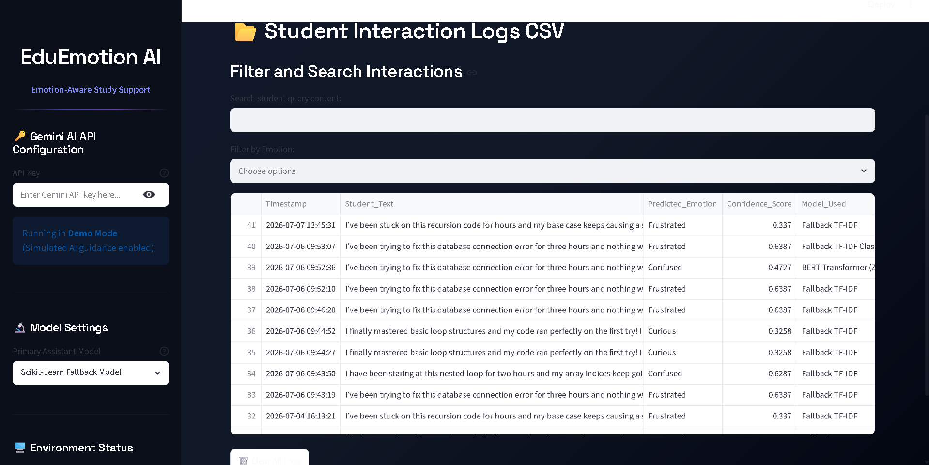
Training & Configuration
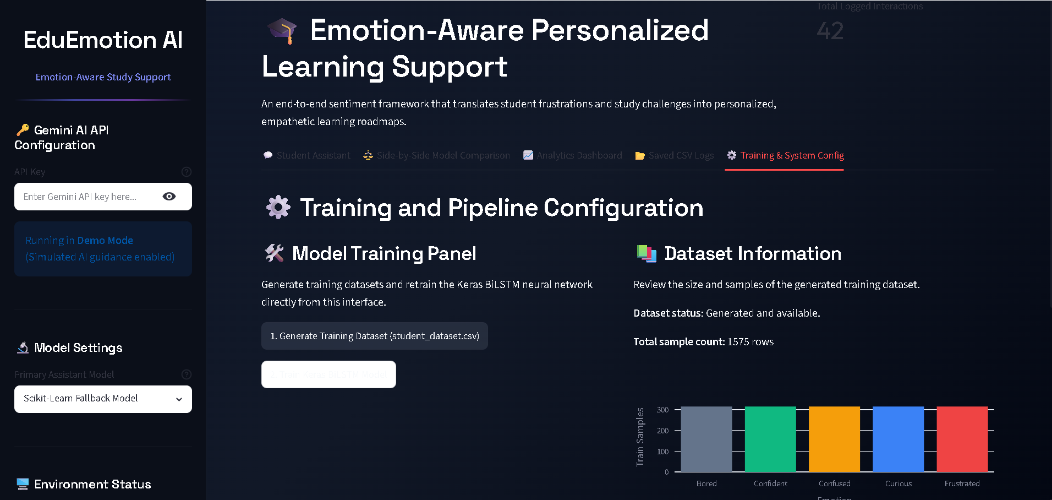

Future Scope
- Voice-based emotion detection
- Facial emotion recognition
- Mobile application
- Multilingual support
- LMS/Google Classroom integration
- Cloud deployment with CI/CD
- Personalized learning path recommendations

Team Member Details
Name | Role
Chakali Shankar | Team Lead
Miriyala Renuka | Member
Sriramula Vijaya Bhaskar Reddy | Member
V. Rajesh Achari | Member
Sri Bhagath Kakarawada | Member

