**SHANKAR WAGH**

1+ years of experience in Data Processing, Data Analytics, and Cloud Development with Expertise in ETL pipelines, Model Building, Development, Deployment, Business Intelligence, and Supporting large-scale distributed systems.

**Experience**   
**Scloudin Software Solutions Pvt Ltd - Bangalore**

Client - Qorbital   
Feb 2022 – Present

Data Scientist

Responsibilities:

|  |  |
| --- | --- |
| ⬥     | Working as Big data and ETL Developer, generating insights and recommendations, proposing new metrics by collating data from several sources.  Detail-oriented and resourceful in the completion of projects with an ability to multitask, meet strict deadlines, and be ready to take up challenges.  A logical, analytical thinker with excellent team player skills as well as good database knowledge. |

|  |  |
| --- | --- |
| shankarwagh297@gmail.com |  |
| +91-8329471855, Nasik, India |  |
| www.linkedin.com/in/shankar-wagh |  |
| https://github.com/Shankar297 |  |
| https://medium.com/@shankarwagh297/ |  |
| https://shankar297.github.io/portfolio/ |  |

**Technical Skills**   
**Statistical Modeling:**   
Descriptive Statistics, Inferential Statistics, Hypothesis Testing, ANOVA, T-test, Z-test, Exploratory Data Analysis

**Machine Learning:**   
Classification Algos: Decision Tree (CART), Random Forest, K-Nearest Neighbours (KNN), Support Vector Machines (SVM), Logistic Regression, Naive Bayes   
Regression Algos: Linear Regression   
Clustering Algos: Hierarchical, Non-hierarchical(K Means)

**Text Analytics and NLP:**   
NLTK, TextBlob, Spacy, TF-IDF Technique

|  |  |  |
| --- | --- | --- |
| ⬥ | Excellent interpersonal skills, confident and poised in | **Deep Learning:** |
| interaction with individuals at all levels. |
| Artificial Neural Networks (ANNs), Convolutional Neural |

Networks (CNNs), TensorFlow 2.x

**iNeuron – Bangalore**   
Aug 2021 – Jan 2022   
Machine Learning Intern   
Responsibilities:

|  |  |  |  |  |  |  |  |
| --- | --- | --- | --- | --- | --- | --- | --- |
| ⬥    | The main goal is to predict the risk of cultivating Thyroid disease. | | | | | | |
| Worked | on | Data | Exploration, | Data | Cleaning, | Feature |
| Engineering, Model Building, and Model Testing.  Predicting the Thyroid disease through different classification algorithms and accepting the model based on available metrics. | | | | | | |

**The Spark Foundation**   
Aug 2021 – Aug 2021   
Machine Learning Intern   
Responsibilities:

**Visualization:**   
Tableau, AWS Quicksight, PowerBI, Seaborn, Matplotlib

**Programming Languages:** Python, R(basic)

**Databases:**   
SQL

**Big Data:**   
Hadoop, Spark

**Deployment Techniques:**   
Deployment on various cloud platforms like AWS, Heroku

Using Flask, Streamlit

|  |  |  |
| --- | --- | --- |
| ⬥ | Perform Exploratory Data Analysis on datasets to | **I Miscellaneous** |
| ⬥ | understand the trend of the data. |
| AWS Glue, Google Big Query, AWS Sagemaker, MSK |
| To find out the best suitable models for Regression and |
| predictive analysis. | Kafka, Jira |
| ⬥ |
| Used Various visualization libraries and tools for presenting |
| ⬥ | data. | **Education** |
| Propose solutions and strategies to various business |
| challenges. |
| |  | | --- | | **Matoshri College of Engineering, Nashik**  Bachelor of Engineering in Mechanical Engineering **Learnbay Academy, Bangalore**  Full Stack Data Science and Artificial Intelligence Program in association with IBM | |

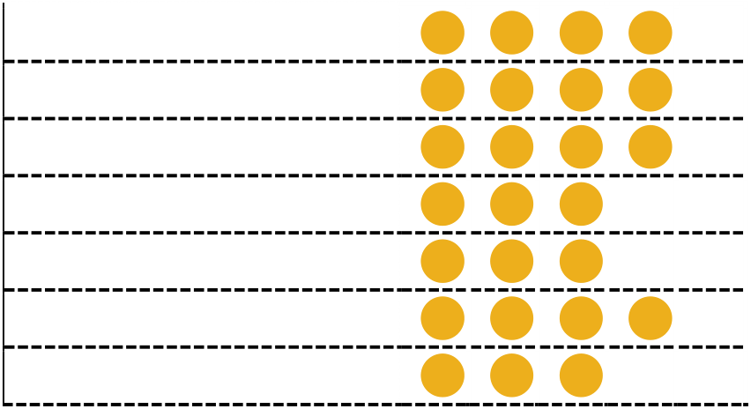

**Certification & POC**   
  **Data Science And AI Training**

Dec 2020– Jan 2022

**Project: Crop Recommendation Engine.**

[GitHub Link](https://github.com/Shankar297/Agreecultur-Production-Engine)   [Heroku Link](https://agricultural-crop-selector.herokuapp.com/)

|  |  |
| --- | --- |
| ⬥ | Create a data model that recommends the best suitable crop based on some input features such as the ratio of nitrogen |

content in the soil, temperature, ph value of soil and humidity, etc.

**Course**   
**Course by ISRO(IIRS)**   
 Machine Learning to Deep Learning

**Awards**

|  |  |
| --- | --- |
| ❖  | First in Roborace at Tech-Feast 2017. First prize in Drama at Jamboree 2018. |

**Extra-Curricular**

|  |  |  |  |
| --- | --- | --- | --- |
| ⬥ | Perform Data Cleaning, Feature Engineering, Model Building, | ❖ | Volunteered for Bike Mania at Tech-Feast 2017. |
| ⬥ | and Model Testing. | ❖ | Volunteered for National Service Scheme for 2 |
| Create a web app and deploy it on the cloud using web | years |
| frameworks. | ❖ | MESA member for 2 years |
| ⬥ |
| ❖ | Attend the Tech Learn session on how TESLA |
| The model gives the best suitable crop for the particular soil |
| works using computer vision. |
| based on user-selected input data. |

⬥  
Tool Used – Jupyter Notebook, VSCode, Pandas, Scikit-Learn, Heroku **Languages**

**Project: Hollywood Movie Recommendation Engine.** [GitHub Link](https://github.com/Shankar297/Hollywood-Movie-Recommendation-Engine)[Heroku Link](https://hollywood-movie-recommendor.herokuapp.com/)

|  |  |
| --- | --- |
| ⬥   | Created a content-based movie recommendation engine using cosine similarity. Use Tf-IDF vectorization for making vectors. Apply text pre-processing for cleaning data.  Build a model and deployed it on the cloud using web frameworks. |

Tool Used – Jupyter Notebook, VSCode, Sklearn, Streamlit, Heroku

**Project: Language Translation Using NLP.** [GitHub Link](https://github.com/Shankar297/Language-Traslation-Using-TextBlob)   [Heroku Link](https://language-translator-app.herokuapp.com/)

|  |  |
| --- | --- |
| ⬥    | Created Language Translation app using NLP-based library. Take input text from the user and produce user-selected language.  Deployed the app in the cloud using web frameworks. |

|  |  |  |  |  |  |  |
| --- | --- | --- | --- | --- | --- | --- |
| 1 Beginner  2 Elementary  3 Intermediate  4 Professional  Proficiency  5 Full professional Proficiency |  | **Listening** | **Reading** | **Spoken Interaction** | **Spoken Production** | **Writing** |
| English |  | **5** | **5** | **5** | **5** | **5** |
| Hindi |  | **5** | **5** | **5** | **5** | **5** |

**Consulting Skills**

Tool Used – Jupyter Notebook, VSCode, Texblob, Flask, Heroku Oral Communication Written Communication Building Rapport Team Building Project Management Time Management **Past Experience**   
 Questioning and probing **Varroc Engg Pvt Ltd, Pune**   
Quality Engineer(Mechanical)   
June 2018 – June 2019

|  |  |
| --- | --- |
| ⬥    | Checking Quality of product using standard gauges.  Making reports of daily production.  Planning and scheduling of quality with zero defects.  Minimize break-down time and increase the productivity of the |

machine.