Hotel Pricing AI System
A Plain-Language Guide for Business and Technical Teams
Approach 2 · DML Causal Elasticity · MILP Capacity Optimization

Data Science Team

About this document
This document explains how a three-stage AI pricing system works for hotels. Every technical term is defined in plain English the first time it appears. Each section is labelled with a BUSINESS PERSPECTIVE (what it means for revenue and operations) and a TECHNICAL PERSPECTIVE (how the model actually works). Charts from the live demo system are embedded throughout.

Contents
1. The Problem: Why Hotels Leave Money on the Table
2. The Solution: A Three-Stage AI Pricing System
3. The Data — What We Feed the System
4. Stage 1 — Who Is Likely to Book? (Propensity Model)
5. Stage 2A — How Price-Sensitive Is Each Shopper? (GBM)
6. Stage 2B — A More Honest Elasticity via DML
7. Optimal Price for Individual Shoppers
8. Stage 3 — Peak Nights: The Room Allocation Problem (MILP)
9. Glossary of Terms

1. The Problem: Why Hotels Leave Money on the Table
Most hotels display the same price to every visitor at the same point in time — a single "rack rate" that management sets weekly or daily. This one-size-fits-all approach has two simultaneous failure modes:

Overpricing leisure travellers
A leisure family planning a beach trip 60 days out is very sensitive to price. They will simply close the tab and book a competitor if the price feels high. Charging rack rate loses their booking entirely.
Underpricing business travellers
A business executive booking 2 days before travel will pay almost anything to stay at the preferred hotel. Charging them rack rate leaves significant revenue uncaptured — they would have paid 20–30% more without changing their decision.
Overselling on peak nights
Even when prices are set "correctly" per shopper, ignoring capacity means the hotel accepts too many bookings for a sold-out Saturday. Overbooking leads to walk fees (paying guests to leave) that can erase all the pricing gain.

The core insight
Different shoppers respond to price in completely different ways. A system that personalises price per shopper — and respects the hotel's physical room inventory — can simultaneously capture more revenue from inelastic guests and fill rooms that would otherwise go empty.

2. The Solution: A Three-Stage AI Pricing System
The system answers three questions in sequence before quoting a price to any shopper:

Stage | Business Question | Output | Variable
Stage 1: Propensity | Would this shopper book at the current rack rate at all? | Booking probability at rack rate | P_ref(x)
Stage 2: Elasticity | If we raise or lower the price, how much does their likelihood of booking change? | Price sensitivity coefficient | eta(x)
Stage 3: Capacity MILP | Given answers 1 and 2 for all shoppers this week, what is the revenue-maximising set of prices under our room limits? | One optimal price per session | p*

The three stages feed into each other. Stage 1 and Stage 2 produce per-shopper statistics. Stage 3 then solves a mathematical optimisation problem that considers all active shoppers simultaneously.

The pricing formula — in plain English
The full probability that a shopper books at a given price is:
P(book) = [Baseline booking chance] × [Price adjustment factor]
The price adjustment factor shrinks when the price goes up and grows when it goes down. The speed of that shrink/grow is controlled by the elasticity number (Stage 2). Inelastic shoppers barely react; highly elastic shoppers react a lot.

3. The Data — What We Feed the System
The system is trained and tested on 20,000 synthetic hotel booking sessions. Each session represents one visit to the hotel booking page and contains the following information:

Feature | Plain-English Meaning | Why It Matters
trip_purpose | Is this a business trip or a leisure trip? | Business travellers are generally less price-sensitive
loyalty_tier | Is the guest a basic / silver / gold / platinum member? | Higher-loyalty guests book more often regardless of price
lead_time_days | How many days before the stay is this booking? | Last-minute bookings are less elastic; far-out are very elastic
length_of_stay | How many nights is the planned stay? | Affects how much total capacity is consumed
room_type | Standard / Deluxe / Suite? | Defines which inventory pool is consumed
occupancy_forecast | How full is the hotel predicted to be that night? | High occupancy makes guests less sensitive (fewer options)
device | Booking from mobile, desktop, or iOS? | iOS users historically convert at higher rates
channel | Direct website, OTA (e.g. Booking.com), meta-search? | Channel affects the price shoppers compare us to
price_index | Our price vs competitor average (1.0 = same) | Context: shopper sees relative value, not absolute price
rack_rate | Our standard undiscounted room price | The reference point all multipliers are applied to

Important: the A/B test arm
30% of sessions in the training data were shown a randomly assigned price (not the usual algorithmic price). This is called an A/B test arm (think of it as a controlled experiment baked into the data). Without this random variation, it is mathematically impossible to reliably estimate how much of a shopper's decision was caused by the price versus caused by who they are. Section 6 explains why this matters for the advanced DML model.

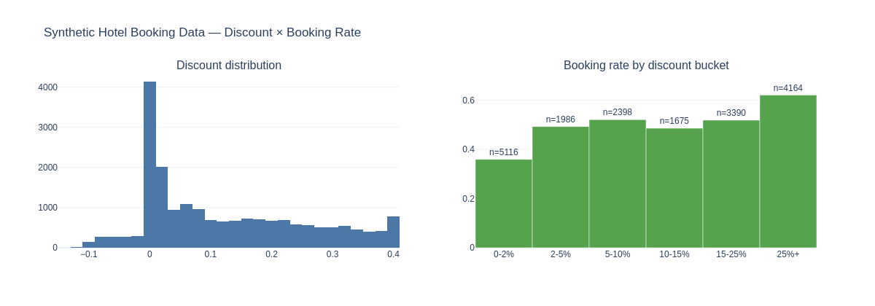
Figure 1 — Data overview. Left: distribution of price discounts applied in training data. Right: how booking rates vary across discount levels. The upward slope confirms price sensitivity is real in the data.

4. Stage 1 — Who Is Likely to Book? (Propensity Model)

Business Perspective
Before worrying about price, the system asks: "If we charged the standard rack rate, what is the probability that this specific shopper would book?" This is called the baseline booking probability or propensity.
A platinum-loyalty business traveller booking 1 day before the stay might have an 80% baseline probability. A leisure traveller with no loyalty status, browsing 90 days before travel, might have a 10% baseline probability. These differences matter enormously because the optimal price is different for each.
Why baseline probability matters for pricing
If the baseline probability is already high (say 75%), you can afford to charge a premium — the shopper is very likely to book regardless. If the baseline probability is low (say 15%), charging extra will likely lose the booking entirely. You might actually want to discount to "activate" the shopper.

Technical Perspective
The propensity model is a LightGBM classifier — a type of gradient-boosted decision tree — trained to predict P(booking = 1 | features, price = rack rate). After the initial model is trained, we apply isotonic calibration to ensure the predicted numbers are true probabilities (not just rankings).
Calibration explained
An uncalibrated model might say "70% probability" for a group of shoppers where only 50% actually book. Isotonic calibration is a post-processing step that adjusts the scale so that when the model says 70%, approximately 70% of such shoppers really do book. This is critical because the MILP optimiser in Stage 3 uses these probabilities directly in calculations.
How do we know it works?

Metric | Value | What it means
AUC (Area Under the Curve) | 0.667 | Measures ranking quality. 0.5 = random guess. 0.667 means the model correctly ranks a bookee above a non-bookee 67% of the time.
Brier Score | 0.228 | Measures probability accuracy. 0.0 = perfect. 0.25 = random guess. Lower is better. Our 0.228 shows real signal.
Calibration | Good | When the model predicts 60% probability, roughly 60% of those shoppers actually book.

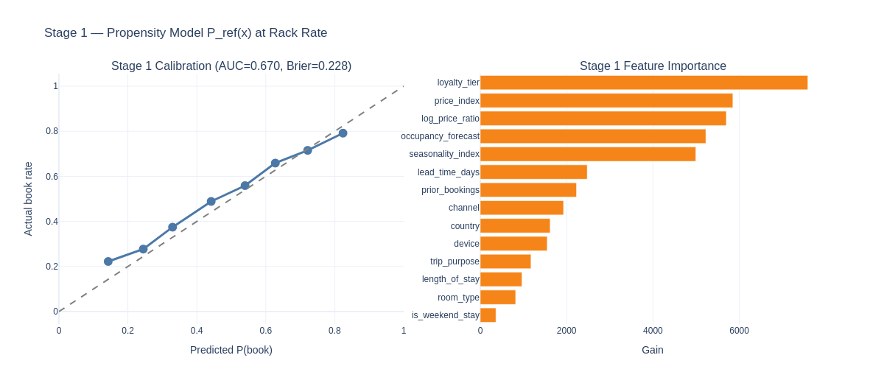
Figure 2 — Stage 1 results. Left: calibration plot showing predicted vs actual booking rates — a well-calibrated model stays close to the diagonal line. Right: feature importance showing which signals drive booking probability most.

5. Stage 2A — How Price-Sensitive Is Each Shopper? (GBM Elasticity)

Business Perspective
Elasticity is the single most important number in pricing. It measures: "If I raise the price by 10%, how much does the booking probability fall?"

Shopper Type | Description | Typical Elasticity
Inelastic shopper (elasticity near 0) | A business traveller on a company card, booking 1 day before a conference. Raise the price 30% and they barely notice. Charge a premium. | eta = -0.1 to -0.3
Elastic shopper (elasticity near -2 or -3) | A leisure family planning a holiday 90 days out, comparing 5 hotels. Raise the price 10% and they are very likely to go to a competitor. Discount to ensure conversion. | eta = -2.0 to -3.5

Technical Perspective
The elasticity model is a LightGBM regressor with a monotone constraint on the price feature. The monotone constraint forces the model to only ever predict negative elasticity values (more expensive = lower booking probability). This encodes the economic common sense that "demand curves slope downward".
Why LightGBM? Gradient-boosted trees capture complex non-linear interactions between features — for example, the fact that "business travellers are inelastic, BUT only when lead time is short" is the kind of interaction a tree naturally learns. A linear regression model would miss this.

The Optimal Price Formula
Given Stage 1 (baseline probability P_ref) and Stage 2 (elasticity eta), we can compute the price multiplier that maximises expected revenue for any individual shopper by sweeping a grid of prices and picking the best:
Expected revenue at price p = P(book at p) × (p − variable cost)
P(book at p) = P_ref × (p / rack_rate) ^ eta
The caret symbol (^) means "to the power of". Because elasticity is negative, as price goes up, the power term makes the booking probability drop. The system automatically finds the sweet spot where the higher price is worth the lost probability.

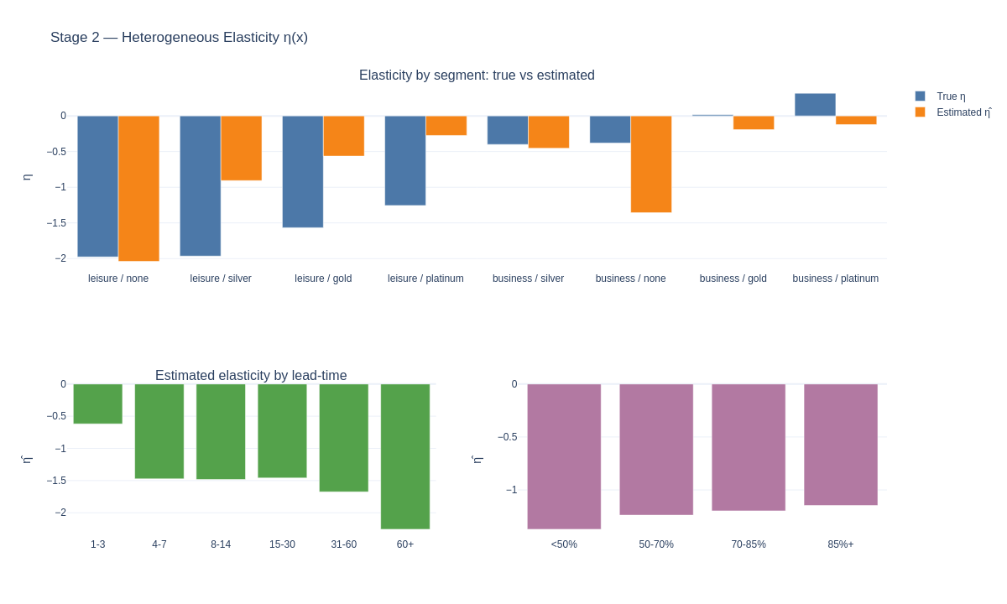
Figure 3 — Stage 2 GBM elasticity results. Each panel shows how estimated price sensitivity varies across shopper segments, lead times, and occupancy levels. Business travellers are consistently less sensitive than leisure.

6. Stage 2B — A More Honest Elasticity via DML

Business Perspective — the core problem with a simple model
The GBM elasticity model has a hidden problem: price is not random in the training data. The existing pricing system already charges higher prices to guests it thinks will book anyway (business travellers, platinum members). This means the model confuses "business travellers book regardless of price" with "business travellers book at high prices" — two very different things.
Analogy: the umbrella problem
Suppose you look at weather data and notice that people who carry umbrellas are more likely to get wet. You might naively conclude "umbrellas cause wetness." The real cause is rain — rain causes both umbrella carrying and wetness. The GBM model makes the same type of mistake with price.

What DML does differently
DML (Double Machine Learning) is a causal inference technique — it is designed specifically to measure cause-and-effect rather than mere correlation. It works in two steps:

Step 1: Strip out the confound. Train a model to predict what price our pricing engine would have set for each guest (based purely on their features). Subtract this prediction from the actual price charged. What remains is the "surprise" component of price.
Step 2: Measure the effect of that surprise. Now regress the "surprise" component of price against the "surprise" component of booking outcome. Because both surprises are uncorrelated with guest characteristics, the slope of this regression is the true causal elasticity.

DML also uses a technique called cross-fitting: the data is split into 5 folds, and each fold's nuisance models are trained on the other 4 folds. This prevents the model from "cheating" by using its own predictions to fit itself.

The confidence interval — what GBM cannot give you
DML produces a confidence interval around each elasticity estimate. A confidence interval is a range that we are 95% confident contains the true value. For example: "We estimate leisure/none elasticity is -1.5, and we are 95% confident the true value is between -2.1 and -0.9." The GBM model gives a single number with no indication of uncertainty.

The overconfidence story — DML's decisive advantage

Model | Self-Estimated Lift | Actual Lift (True Elasticity) | Overconfidence Gap
Oracle (true elasticity) | +19% | +19% | 0 percentage points
GBM (monotone) | +20% | +7.5% | 12.5 pts — severely overconfident
DML (causal) | +12% | +10% | 2 pts — honest estimate

Why does overconfidence cost money?
GBM thinks raising prices will capture +20% more revenue. It prices aggressively. But the true elasticity is higher (guests are more sensitive) so many of those guests book elsewhere. Real revenue is only +7.5%. The model optimised for the wrong number. DML's +12% estimate is modest but honest — and when the MILP uses DML elasticities, it correctly predicts who will and will not book.

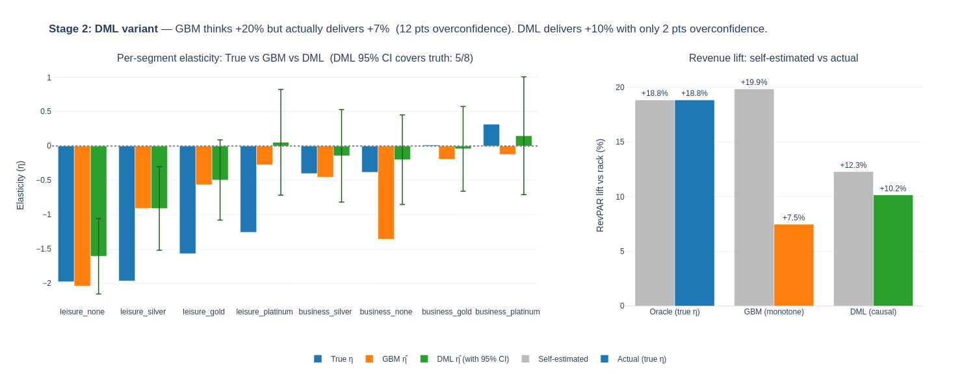
Figure 4 — DML variant results. Left: per-segment elasticity comparison — blue bars are true values, orange is GBM estimates, green is DML with confidence intervals. Right: GBM thinks +20%, actually gets +7.5%; DML thinks +12%, actually gets +10%. DML is the deployable model.

7. Optimal Price for Individual Shoppers

Business Perspective — three shopper examples
Using Stage 1 (baseline probability) and Stage 2 (elasticity), the system computes the revenue-maximising price for any individual shopper. Here are three illustrative cases:

Profile | Segment | Rack Rate | Optimal Price | Lift | Logic
Business / Gold  late booking (3 days out) | Very inelastic  eta = -0.07 | Rs 9,500 | Rs 10,925 | +15% | Will book almost regardless. Charge a premium.
Leisure / None  far-out booking (90+ days) | Very elastic  eta = -3.06 | Rs 6,500 | Rs 3,972 | -39% | Extremely price-sensitive. Discount activates the booking.
Leisure / Silver  mid lead-time (14-30 days) | Moderate  eta = -0.88 | Rs 9,500 | Rs 10,925 | +15% | Moderate sensitivity, still inelastic. Small premium justified.

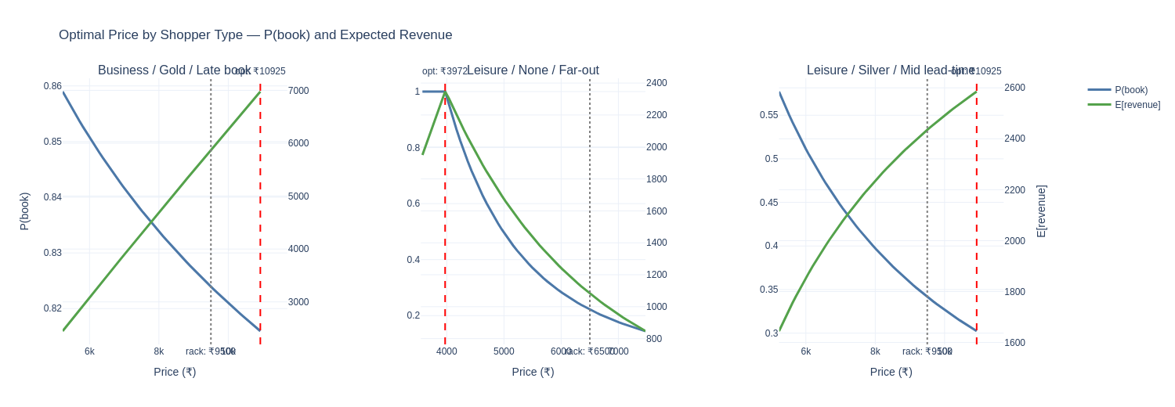
Figure 5 — Three shopper pricing examples. Each panel shows the expected revenue curve as price changes. The star marks the optimal price. Notice how the elastic leisure shopper is optimally discounted, while the inelastic business traveller warrants a premium.

Population policy — aggregate results
Applying the individual optimal pricing logic to the full validation dataset of thousands of shoppers, the system produces:

Metric | Value | What it means
Overall RevPAR lift | +20% | Revenue Per Available Room increases 20% vs. flat rack rate pricing across all shoppers.
Business segment lift | +25-30% | Premium pricing captures more revenue from inelastic guests.
Leisure/None lift | +5-10% | Discount-driven activation of highly elastic guests fills rooms that would otherwise go empty.

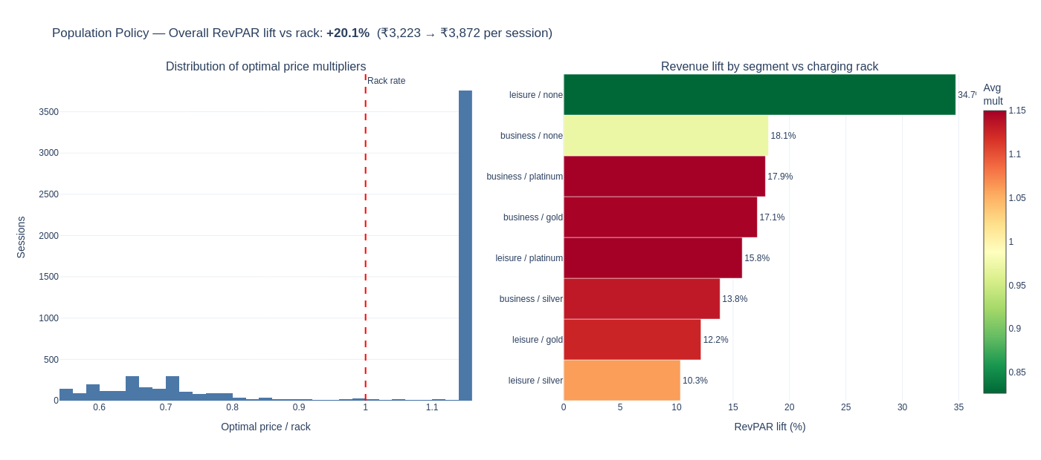
Figure 6 — Population policy results. Left: distribution of optimal price multipliers (values > 1.0 are premiums, < 1.0 are discounts). Right: RevPAR lift by segment — all segments benefit, with inelastic business segments benefiting most.

8. Stage 3 — Peak Nights: The Room Allocation Problem (MILP)

Business Perspective — why individual pricing breaks down
Stages 1 and 2 compute the perfect price for each shopper in isolation. But on a peak Saturday night with 40 standard rooms and 90 interested shoppers, you cannot just give everyone their individual "optimal" price. If everyone who is offered a discount accepts, you will have 60 people showing up for 40 rooms — an operational disaster.
The problem with ignoring capacity: Even the revenue-maximising individual price can lead to overbooking. When that happens, the hotel must pay a walk fee — moving overbooked guests to a nearby hotel at the hotel's expense (typically 1.5–2× the room rate). These walk fees can erase all the pricing gains.
The displacement cost concept
On a sold-out Saturday, accepting a discounted booking from a leisure guest has a hidden cost: it displaces a full-price business traveller who might have arrived the next day. The MILP is the first layer that can see this trade-off and make the right choice.

What MILP stands for
MILP = Mixed Integer Linear Programme. Let's unpack each word:
Mixed: The problem contains both whole-number decisions (yes/no choices) and continuous variables.
Integer: Some decisions are binary: either shopper X gets price option A, or they do not. There is no "50% of price option A."
Linear: The mathematical relationships between decisions and revenue are linear — which makes the problem solvable in reasonable time.
Programme: An old-fashioned word for "optimisation problem" — finding the best solution subject to constraints.

What the MILP decides
For every active session (shopper currently browsing for a stay in the peak window), the MILP assigns one price multiplier from a menu (e.g., 0.55×, 0.60×, ... 1.80× rack rate). It simultaneously handles hundreds of shoppers, balancing three things:
- Maximise total expected revenue across all shoppers
- Never expect more bookings than there are rooms available for any night and room type
- Penalise overbooking via a walk-fee term (making overbooking costly but not impossible)

The soft capacity constraint — a production reality
A hard constraint says "never ever exceed capacity." This sounds ideal but fails in practice: if the elasticity model is slightly wrong, even at the highest price the expected bookings exceed rooms, making the problem mathematically unsolvable.
Instead we use a soft constraint: the MILP is allowed to overflow capacity, but every overflow room-night costs a penalty (2× rack rate, matching the industry walk-fee standard). This means the solver naturally avoids overbooking because it costs more than the revenue it gains — but the problem always has a solution.

Peak weekend demo results
Demo scenario: 285 sessions competing for the same peak weekend (Fri 13 Mar – Sun 15 Mar 2026). Capacity: 40 standard / 28 deluxe / 9 suite rooms per night.

Policy | Net Revenue | Overflow | Lift vs Rack
Rack rate (baseline) | Rs 7,54,263 | 13 rooms oversold | baseline
Greedy per-session | Rs 13,10,529 | 13 rooms oversold | +74%
MILP joint (winner) | Rs 15,47,929 | 0 — fully respected | +105%

Note: all revenue figures are net of walk-fee penalties for any capacity violations, measured under true elasticity (ground truth available in synthetic data).

The decisive MILP insight from the demo
Greedy per-session generates roughly the same GROSS revenue as MILP. But it oversells 13 rooms and pays heavy walk fees. MILP generates 18% more NET revenue by correctly rationing capacity — charging premium to inelastic sessions and slightly discounting elastic ones to fill rooms that would otherwise sit empty, all while respecting every room-night limit exactly.

How the MILP discriminates between segments
In the peak weekend demo, the MILP's pricing decisions reveal the displacement cost at work:
Business / All tiers → 1.80× rack rate (maximum premium): These guests are inelastic — price barely changes their booking probability. Charge maximum to extract maximum revenue.
Leisure / None (elastic) → 1.01–1.21× (near rack): These guests are highly price-sensitive. Keep prices lower to fill rooms.
Leisure / None suites → 0.83× (slight discount): Suites are the most expensive room type. Elastic leisure guests need a discount to justify the price jump. A small discount fills expensive rooms and still beats an empty room.

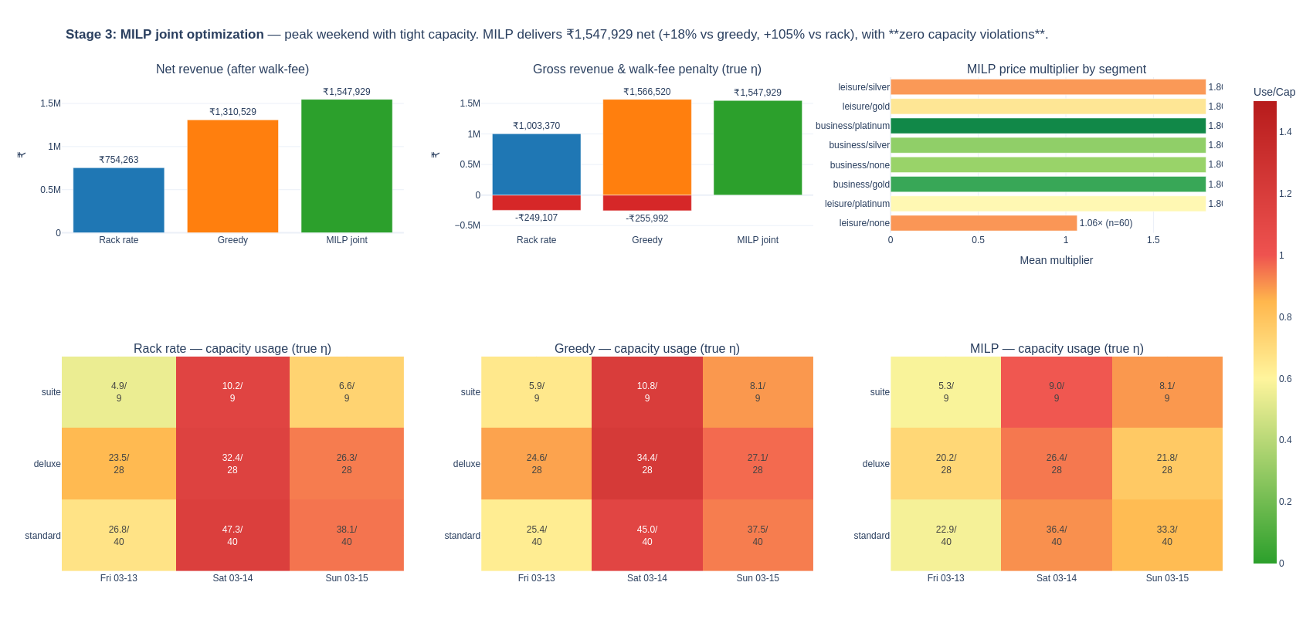
Figure 7 — MILP joint optimisation results. Top-left: net revenue comparison (rack Rs 754K / greedy Rs 1.31M / MILP Rs 1.55M). Top-centre: gross revenue with walk-fee penalties stacked. Top-right: per-segment price multipliers. Bottom: capacity heatmaps — rack and greedy have red cells (oversold), MILP heatmap is entirely green.

9. Glossary of Terms
Every technical term used in this document, defined in plain English.

A/B Test Arm
A controlled experiment where a random subset of sessions (here, 30%) are shown a randomly assigned price rather than the algorithmically computed price. This random variation is essential for the DML model to correctly measure cause-and-effect.
AUC (Area Under the Curve)
A standard measure of how well a classification model ranks positive vs negative cases. A score of 0.5 means random guessing. A score of 1.0 means perfect ranking. Our Stage 1 model scores 0.667.
Brier Score
A measure of probability prediction accuracy. The lower the number, the better. 0.0 is perfect. 0.25 is what you get by always predicting the base rate. Our 0.228 indicates genuine predictive power.
Calibration
The degree to which predicted probabilities match reality. A well-calibrated model that says "70% chance of booking" should be right about 70% of the time for those predictions. Isotonic calibration is a post-processing step that adjusts raw model outputs to achieve this.
CBC Solver
The specific solver (optimisation engine) used to solve the MILP. "CBC" stands for Coin-or Branch and Cut — a free, open-source solver that can handle problems with hundreds of binary variables in tens of seconds.
Causal Inference
A branch of statistics that measures cause-and-effect rather than correlation. DML is a causal inference technique. Standard ML models measure correlation: "high-paying guests book." Causal models measure causation: "raising the price causes fewer bookings."
Confidence Interval
A range of values that we are 95% confident contains the true parameter value. If DML estimates elasticity as -1.5 with a 95% CI of [-2.1, -0.9], it means: if we ran this experiment many times, 95% of the resulting intervals would contain the true elasticity.
Constant-Elasticity Model
A mathematical form where price sensitivity is modelled as: if price increases by 1%, demand changes by eta%. This is the standard workhorse model in economics and revenue management.
Cross-Fitting / K-Fold
A technique used in DML where the data is split into K groups (here, 5). For each group, the nuisance models are trained on the other 4 groups and applied to the held-out group. This prevents overfitting.
Decision Variable
In a MILP, the quantities the solver is choosing. Here: which price multiplier each session is assigned. Once the solver decides x[i,j] = 1, that means session i is given price multiplier j.
Displacement Cost
The hidden cost of accepting one booking when you could have accepted a higher-value one instead. If a 100-room hotel accepts 100 leisure discounted bookings, it cannot then accept 10 high-paying business bookings that arrive the next day.
DML (Double Machine Learning)
A two-step causal estimation technique. Step 1 uses ML models to control for confounding factors. Step 2 uses the residuals to measure the true causal relationship between price and booking probability. Developed by researchers at MIT/ETH Zurich.
Elasticity (Price Elasticity)
A number measuring how sensitive demand is to price changes. Formally: the percentage change in booking probability per 1% change in price. An elasticity of -1.0 means a 10% price increase causes a 10% drop in booking probability.
Expected Demand
The average number of bookings we expect to receive given a pricing policy. For a single session, expected demand = booking probability. For a group, expected demand = sum of all individual probabilities. The MILP constrains this to not exceed capacity.
Feature
A piece of information fed into an ML model. In this system, features include lead_time_days, loyalty_tier, trip_purpose, occupancy_forecast, etc.
Gradient-Boosted Trees / LightGBM
A family of powerful ML algorithms that build an ensemble of decision trees iteratively, each tree correcting the errors of the previous ones. LightGBM is a fast, memory-efficient implementation used widely in industry pricing and forecasting.
Hard Constraint
A rule in an optimisation problem that must never be violated. Example: "never book more rooms than we have." In practice, hard capacity constraints can make problems infeasible if the model's elasticity estimates are slightly wrong.
Inelastic / Elastic
Inelastic: a shopper or segment where demand barely changes with price. Business travellers are typically inelastic. Elastic: demand changes significantly with price. Leisure travellers are typically elastic.
Isotonic Calibration
A post-processing technique applied after training a classifier. It adjusts predicted probabilities to be perfectly calibrated. It is "isotonic" because it fits a monotone function — probabilities always stay in the right order.
MILP (Mixed Integer Linear Programme)
An optimisation problem where some decision variables must be whole numbers and all relationships are linear. Here: the integer variables are binary (0 or 1) for each session-price-multiplier combination.
Monotone Constraint
An instruction to the GBM elasticity model that the predicted elasticity must always be negative. This prevents the model from learning spurious positive elasticities due to noise.
Nuisance Model
In DML, a model used to control for confounding factors. Two nuisance models are needed: one that predicts the outcome (booking) from features alone, and one that predicts the treatment (price) from features alone.
Objective Function
In optimisation, the quantity being maximised or minimised. Here: total expected revenue minus walk-fee penalty for capacity overflow.
OLS (Ordinary Least Squares)
A classical statistical technique for fitting a line through data by minimising the sum of squared errors. In DML's final stage, OLS on the residualized data gives unbiased elasticity estimates with theoretically justified confidence intervals.
Overconfidence (Model)
When a model's self-estimated performance is much higher than its actual performance. GBM estimates +20% revenue lift but delivers only +7.5%. The gap is overconfidence.
Partial Linear Model
The statistical model DML estimates: Y = theta(X) * T + g(X) + error. The relationship with treatment T is linear, while the relationship with controls X can be any function estimated by ML.
Propensity / Propensity Model
Propensity means "baseline tendency." In this context, it is the probability that a shopper books at the rack rate, ignoring price effects. Stage 1 is the propensity model.
PuLP
A Python library for building and solving linear programming and MILP problems. PuLP translates the mathematical problem into a format that solvers like CBC can process.
Rack Rate
The standard undiscounted hotel room price — the "list price" before any discounts or premiums. A multiplier of 1.0 means charging the rack rate; 1.2 means 20% above rack rate; 0.8 means 20% discount.
Residual
The part of a variable that cannot be explained by other variables. In DML, the residualized price is the part of the price not explained by the guest's features — the "surprise" component.
RevPAR
Revenue Per Available Room — a standard hotel industry metric. RevPAR = Total room revenue / Total rooms available. It combines both occupancy rate and average room rate into a single number.
Soft Constraint
A constraint in an optimisation problem that can be violated, but at a cost. The MILP can accept more bookings than there are rooms, but every overflow room-night costs 2x the rack rate as a penalty.
Walk Fee
The cost a hotel pays when it is overbooked and must move a guest to another hotel. Typically covers the alternative room + transportation + goodwill compensation. In our demo, set to 2x the mean rack rate per room-night.

Key Takeaways

Question | Answer
Why three stages? | Each stage solves a distinct problem. Stage 1 tells you who is worth pricing for. Stage 2 tells you how to price them. Stage 3 tells you how to price all of them simultaneously given physical room limits. No single model can do all three.
Why DML over a simple model? | A simple ML model learns that "high-paying guests book" but confuses correlation with causation. DML strips out this confound and measures what actually happens when you change the price. GBM is overconfident by 12 percentage points; DML is off by 2. Only DML gives you a confidence interval.
Why MILP over greedy pricing? | Greedy pricing maximises each session in isolation and oversells peak nights, generating walk fees. MILP sees all sessions simultaneously and makes the trade-off explicit: charge inelastic guests a premium, fill empty rooms with discounts for elastic guests, and respect every room-type capacity. +18% net revenue over greedy; +105% over rack rate.
The critical infrastructure requirement | DML and the causal accuracy of the whole system depend on a permanent A/B test arm — 5–30% of traffic with randomly assigned prices. Without it, the model drifts to measuring correlations again, and elasticity estimates become unreliable within months. This is not optional for a production system.

Hotel Pricing AI System — Three-Stage Architecture | Approach 2 + DML + MILP | Data Science Team

