
Visvesvaraya Technological University Belagavi

A Project Report on
“AEROCRASH”
Project Report Submitted in Partial Fulfillment of the Requirement for the Award of the Degree of
Bachelors of Engineering in
Computer Science and Engineering
by

Ramadevi Sanadi (2KL21CS409) Supriya Sangolli (2KL20CS107)
Under the guidance of

Dr. Santosh Pattar Prof.PremaAkksaligar
Assistant Professor,
KLE Technological University’s Dr. MSSCET, Belagavi.

Department of Computer Science and Engineering,
KLE Dr. M. S. Sheshgiri College of Engineering and Technology, Belagavi–590008.
June2023

KLE DR. M. S. SHESHGIRI COLLEGE OF ENGINEERING & TECHNOLOGY,
Udyambag, Belagavi-590008.

DEPARTMENT OF COMPUTER SCIENCE & ENGINEERING



Certificate

This is to certify that the Mobile Application Development Mini Project entitled “Aerocrash” carried out by Miss. Ramadevi Sanadi bearing USN 2KL21CS409 and Miss.Supriya Sangolli bearing USN 2KL20CS107 have satisfactorily completed the academic requirements for the partial fulfilment of Computer Graphics Laboratory with Mini Project(18CSL67) of VI Semester Bachelor of Engineering in Computer Science and Engineering of the Visvesvaraya Technological University, BelagavifortheAcademicyear2022-2023.

Project Coordinator HOD

Internal Examiner External Examiner
Name: Name:
Signature: Signature:
Date: Date:

DECLARATION

I hereby declare that the matter embodied in this dissertation entitled “Aerocrash” submitted to Visvesvaraya Technological University for the award of degree of Bachelors of Engineering in Computer Science and Engineering is the result of the work done by me in the Department of Computer Science and Engineering, KLE Dr. M. S. Sheshgiri College of Engineering, under the guidance of Dr.Santosh Pattar and Prof.Prema Akkasaligar, Department of Computer Science and Engineering, KLE Dr. M.S. Sheshgiri College of Engineering. I further declare that to the best of my knowledge and belief, the work reported here in doesn’t form part of any other project on the basis of which a degree or award was conferred on an earlier occasion on this by any other student, also the results of the work are not submitted for the award of any degree or diploma within this or in any other University or Institute. I here by also confirm that all of the experimental work in this report has been done by myself.

Belagavi–590008 (Ramadevi Sanadi and Supriya Sangolli ) Date:20.06.2023 2KL21CS409and2KL20CS107

Acknowledgments

The satisfaction that accompanies the successful completion of any task would be in complete without mentioning the people who made it possible, whose constant guidance and encouragement crowned my effort with success.
First and foremost, I would like to express my sincere words of gratitude and respect to the organization KLE Dr. M. S. Sheshgiri College of Engineering, Belagavi, for providing me an opportunity to carryout my projectwork.
I thank my guide and guru, Dr. Santosh Pattar Department of Computer Science and Engineering, KLE Dr. M. S. Sheshgiri College of Engineering, for providing me with all the facilities that helped me to carry out the work easily. I also appreciate his help to improve the quality of my dissertation report.
I would like to express my deepest thanks to Dr. Rajeshri Khannai Head of the Department, Department of Computer Science and Engineering, KLE Dr.
M. S. Sheshgiri College of Engineering, for her encouragement.
Last but not the least, I extend my thanks to all the people in the Department of Computer Science and Engineering, KLE Dr. M. S. Sheshgiri College of Engineering, for always being helpful over the years.
I am very grateful to my parents and well-wishers for their continuous moral support and encouragement.

Ramadevi Sanadi Supriya Sangolli

Abstract

Aeroplane Crash is the project of demolishing the building with the help of aeroplane using computer graphics libraries.
This project titled as aerocrash has been successfully completed. The very purpose of developing the project is to exploit the strength of graphics capabilities and to illustrate the concepts of aeroplane crash.
The project helped us a lot to learn about the proper utilization of various- graphics library functions and also about the aeroplane crash.

Contents

Acknowledgments | i
Abstract | ii
Contents | ii
List of Tables | v
1 Introduction | 1
1.1 OPENGL:1 ... . . . . . . . . . . . . . . . . . . . . . . . . . . | 1
1.1.1Computer Graphics.. . . .. .. . .. . . . . . .. . . .. . . .. | 1
1.1.2 FEATURES OF OPENGL... . . . . . . . . . . . . | 2
1.2 Operation Of OpenGL. . . . . . . . . . . . . . . . . . . . . . . . . | 3
1.3 OPENGL Libraries.. . . . . . . . . . . . . . . . . . . . .  . . . . . | 4
- Literature Survey  - Survey.. . . . . . . . . . . . . . . . . . . . . . . . . . .  - description.. . . . . . . . . . . . . . . . . . . . . . . . . . .  - Requirements and Requirements | 6
- Purpose of the Requirements document.. . . . . . . . . . . . . . .  - Specification Requirements.. . . . . . . . . . . . . . . . . . . . . | 6
 | 8
- Design  - User Defined Functions.. . . . . . . . . . . . . . . . . . . . . . . . . . .  - Implimentation  - Functions.. . . . . . . . . . . . . . . . . . . . . . . . . . .  - Functions used to set the viewing volume.. . . . . . . . . . . . . .  - Call back Functions.. . . . . . . . . . . . . . . . . . . . . . . . . . .  - List of Figures | 8

Some Code Here | 13
Bibliography | 15

Chapter1

Introduction

OPENGL

OpenGL is the abbreviation for Open Graphics Library. It is a software interface for graphics hardware. This interface consists of several hundred functions that allow you, a graphics programmer, to specify the objects and operations needed to produce high- quality color images of two-dimensional and three-dimensional objects. Many of these functions are actually simple variations of each other, so in reality there are about 120 substantially different functions. The main purpose of OpenGL is to render two- dimensional and three-dimensional objects into the frame buffer. These objects are defined as sequences of vertices (that define geometric objects) or pixels (that define images).OpenGL performs several processes on this data to convert it to pixels to form the final desired image in the frame buffer.[?].

Computer Graphics

Graphics provides one of the most natural means of communicating within a computer, since our highly developed 2D and 3D pattern recognition abilities allow us to perceive and process pictorial data rapidly and effectively. Interactive computer graphics is the most important means of producing pictures since the invention of photography and television. It has the added advantage that, with the computer, we can make pictures not only of concrete real world objects but also of abstract.

FEATURES OF OPENGL

      - Industry standard: An independent consortium, the OpenGL Architecture Re-view Board, guides the OpenGL specification. With broad industry support, OpenGL is the only truly open, vendor-neutral, multi platform graphics standard.
        - Stable: OpenGL implementations have been available for more than seven years on a wide variety of platforms .Additions to the specification are well controlled, and proposed updates are announced in time for developers to adopt changes. Backward compatibility requirements ensure that existing applications do
not be- come obsolete.
        - Reliable and portable: All OpenGL applications produce consistent visual display results on any OpenGL API compliant hardware, regardless of operating system or windowing system.
        - Evolving: Because of its thorough hand forward-looking design, OpenGL al-lows new hardware innovations to be accessible through the API via the OpenGL extension mechanism. In this way, innovations appear in the APIinatimely fashion, letting application developers and hardware vendors incorporate.
        - Scalable: OpenGL API-based application can run on systems ranging from consumer electronics to PCs, workstations, and supercomputers. As a result, application scan scale to any class of machine that the developer chooses to target.
        - Easy to use: OpenGL is well structured with an intuitive design and logical commands. Efficient OpenGL routines typically resultinapplicationswithfewerlinesofcodethanthosethatmakeupprogramsgeneratedu singothergraphics
libraries or packages. In addition, OpenGL drivers encapsulate information a but the underlying hardware, freeing the application developer from having to design for specific hardware features.

Well-documented: Numerous books have been published about OpenGL, and a great deal of sample code is readily available, making information about OpenGL in expensive and easy to obtain.
As shown in Figure3.2,a computer is a machine.

Operation of OpenGL

The following diagram illustrates how OpenGL processes data. As shown, command center from the left and proceed through a processing pipeline. Some commands specify geometric objects to be drawn, and others control how the objects are handled during various processing stages.
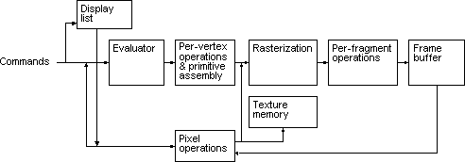
FIGURE1.1:Operation of OpenGL

Initialize: the OpenGL context within your application. Set up the necessary configurations, such as the window size and display mode. Create and configure an OpenGL rendering context.
Setting up the View: Define the projection matrix to establish the perspective or ortho graphic view of the scene. Specify the model-view matrix to define the position and orientation of objects in the scene. Configure the view port to determine the area of the window where the rendering will occur.
Creating Objects: Define the vertices, normal, and texture coordinates of the objects you want to render. Store this data in buffers, such as vertex buffer objects(VBOs)or vertex array objects(VAOs).
Shaders: Create vertex shaders and fragment shaders. Compile and link the shaders into a shader program. Bind the shader program to the OpenGL context.

Rendering Loop: Begin the rendering loop, which repeats until the applicationis closed. Clear the frame buffer to prepare for rendering the next frame. Set theappropriate transformations and other rendering settings. Bind the necessarytextures, if applicable. Issue draw calls to render the objects using the definedverticesandshaders.
HandlingInput:Implementevent handlingtorespond touserinput, such asmouse movements and keyboard interactions. Update the model-view matrix otherrelevantparametersbasedontheinput.
Buffer Swapping: Swap the front and back buffers to display the rendered imageonthescreen.
Termination: Perform cleanup operations, release allocated resources, and de- stroy the OpenGL context. Properly handle any errors or exceptions that may oc- cur during the operation. It’s important to note that this is a simplified overview,and the actual implementation may involve additional steps and more complexoperationsbasedonthespecificrequirementsofyourapplication.
TheTablelistsasampletable.

OPENGLLibraries

GLEW (OpenGLExtension WranglerLibrary):GLEW is across- platformC/C++extension loading library that manages the OpenGL extensions available on a par-ticular platform. It simplifies the process of initializing OpenGL and accessing itsextensions. The OpenGL Extension Wrangler Library (GLEW) is a cross-platformopen-source C/C++ extension loading library. GLEW provides efficient run-timemechanisms for determining which OpenGL extensions are supported on the tar-get platform.OpenGL core and extension functionality is exposed in a singleheader file. GLEW has been tested on a variety of operating systems, includingWindows,Linux,MacOSX,FreeBSD,Irix,andSolaris.
GLFW(GraphicsLibraryFramework):GLFWisalightweightlibrarythatprovidesasi mpleAPIforcreatingwindows,handlinginput,andmanagingOpenGL

texts.It supportsmultipleplatforms and is commonly usedfor creating OpenGLapplications.Multi- platformlibraryforOpenGL,OpenGLESandVulkandevelop-ment on the desktop. It provides a simple API for creating windows, contexts andsurfaces, receiving input and events. GLFW is written in C and supports Windows,macOS,X11andWayland.
GLUT(OpenGL Utility Toolkit): GLUT is a library that provides a simpleAPI for creating windows, handling input, and managing basic user interactionsforOpenGLapplications.Itis older and less actively maintained than GLFWbut can still be useful for simple projects. The GLUT library has both C, C++(same as C), FORTRAN, and Ada programming bindings.The GLUT source codedistribution is portable to nearly all OpenGL implementations for the X WindowSystem and Windows 95 and NT. GLUT also works well with Brian Paul’s Mesa,afreelyavailableimplementationoftheOpenGLAPI.

Chapter2Literatu reSurvey

Survey

A literature review is a survey of scholarly sources on a specific topic. It provides anoverview of current knowledge, allowing you to identify relevant theories, methods,andgapsintheexistingresearchthatyoucanlaterapplytoyourpaper,thesis,ordis sertationtopic.

Description:

This project is ademonstrationofanimationon“Aerocrash”.Wehave taken the helpofbuiltinfunctions present intheheaderfile.Toprovidefunctionality to our project we have written sub functions.These functions provideus the efficient way to design the project.In this chapter we are describing thefunctionalityofourprojectusingthesefunctions.

Chapter3Requirementsandspecifications

Chapter 3 REQUIREMENTS AND SPECIFICATIONS

Purpose of the requirements document
The software requirement specification is the official statement of what is required for development of particular project. It includes both user requirements and system requirements. This requirement document is utilized by variety of users starting from project manager who gives project to the engineer responsible for development of project.

It should give details of how to maintain, test, verify and what all the actions to be carried out through life cycle of project.

Scope of the project

The scope is to use the basic primitives defined in openGL library creating complex objects. We make use of different concepts such as pushmatrix(),translate()
,popmatrix(),timer function.

Definition

The project DEMOLITION OF A BUILDING BY AEROPLANE CRASH
is created to demonstrate OpenGL’s concepts. It encompasses some of the skills learnt
in our OpenGL classes such as pushmatrix(),translate() ,popmatrix(),timer function
.

Acronyms & Abbreviations

OpenGL provides a powerful but primitive set of rendering command, and all higher level design

must be done in terms of these commands.

References
OpenGL Utility Toolkit(GLUT):- windows-system-independent toolkit.

OpenGL tutorials

Interactive Computer Graphics(Edward Angel)

Specific requirements

User Requirement:

    - Easy to understand and should be simple.

    - The built-in functions should be utilized to maximum extent.

    - OpenGL library facilities should be used.

Software Requirements:
    - Ubuntu Os.

    - Eclipse compiler.

Hardware Requirements:

    - Processor- Intel or AMD(Advanced Micro Devices)

    - RAM- 512MB(minimum)

    - Hard Disk-1MB(minimum)

    - Mouse

    - Keyboard

    - Monitor

Chapter 4

DESIGN

User Defined Functions

myinit():
This function initializes light source for ambient, diffuse and specular types.

display():
This function creates and translates all the objects in a specified location in a particular order and also rotates the objects in different axes.

glClear(GL_COLOR_BUFFER_BIT); glFlush();
    - timerfunc():
This function starts a timer in the event loop that delays the event loop for delay miiliseconds.

MainLoop():
This function whose execution will cause the program to begin an event processing loop.

PushMatrix():
Save the present values of attributes and matrices placing ,or pushing on the top of the stack.

PopMatrix():
We can recover them by removing them from stack;

Translated();
In translate func the variables are components of the displacement vector.

main():
The execution of the program starts from this function. It initializes the graphics system and includes many callback functions.

PostRedisplay():
It ensures that the display will be drawn only once each time the program goes through the event loop.

Chapter 5

5.1 FUNCTIONS

GL_LINES -

IMPLEMENTATION

Treats each pair of vertices as an independent line segment. Vertices 2n - 1 and 2n define line n. N/2 lines are drawn.

GL_LINE_LOOP -
Draws a connected group of line segments from the first vertex to the last, then back to the first. Vertices n and n + 1 define line n. The last line, however, is defined by vertices N and N lines are drawn.

Basic Functions

glPushMatrix, glPopMatrix Function
The glPushMatrix and glPopMatrix functions push and pop the current matrix stack.
SYNTAX: void glPushMatrix();
void glPopMatrix(void);

glBegin, glEnd Function
The glBegin and glEnd functions delimit the vertices of a primitive or a group of like primitives.
SYNTAX:
void glBegin, glEnd(GLenum mode); PARAMETERS:


mode -
The primitive or primitives that will be created from vertices presented between glBegin and the subsequent glEnd. The following are accepted symbolic constants and their meanings:

Transformation Functions

glTranslate Function
The glTranslated and glTranslatef functions multiply the current matrix by a translation
matrix. SYNTAX:

void glTranslate( x, y, z); PARAMETERS:
x,
y, z - The x, y, and z coordinates of a translation vector

Funtions used to displayglMatrixMode Function
The glMatrixMode function specifies which matrix is the current matrix.
SYNTAX: void glMatrixMode(GLenum mode); PARAMETERS:
- mode - The matrix stack that is the target for subsequent matrix operations. The mode parameter can assume one of three values:

Value Meaning
GL_MODELVIEW Applies subsequent matrix operations to the modelview matrix stack.

glLoadIdentity Function
The glLoadIdentity function replaces the current matrix with the identity matrix.
SYNTAX:
void glLoadIdentity(void);

FUNCTIONS USED TO SET THE VIEWING VOLUME

glOrtho
This function defines orthographic viewing volume with all parameters measured from the centre of projection. multiply the current matrix by a perspective matrix.
SYNTAX:
void glOrtho( GLdouble left, GLdouble right, GLdouble bottom, GLdouble top, GLdoublenear, GLdouble far)

PARAMETERES:
    - left, right -
Specify the coordinates for the left and right vertical clipping planes.
    - bottom, top -
Specify the coordinates for the bottom and top horizontal clipping planes.
    - nearVal, farVal -
Specify the distances to the nearer and farther depth clipping planes. These values are negative

if the plane is to be behind the viewer.

CALL BACK FUNCTIONS
glutDisplayFunc Function
glutDisplayFunc sets the display callback for the current window.
SYNTAX:
void glutDisplayFunc(void (*func)(void));

glutReshapeFunc Function
glutReshapeFunc sets the reshape callback for the current window.
SYNTAX:
void glutReshapeFunc(void (*func)(int width, int height));

  - MAIN FUNCTIONglutInit Function
glutInit is used to initialize the GLUT library.
SYNTAX:
glutInit(int *argcp, char **argv); PARAMETERS:
    - argcp - A pointer to the program's unmodified argc variable from main. Upon return, the value pointed to by argcp will be updated, because glutInit extracts any command line options intended for the GLUT library.
    - Argv -
The program's unmodified argv variable from main. Like argcp, the data for argv will be updated because glutInit extracts any command line options understood by the GLUT
library.

glutInit(&argc,argv);

glutInitDisplayMode Function
glutInitDisplayMode sets the initial display mode.
SYNTAX:
void glutInitDisplayMode(unsigned int mode); PARAMETERS:
    - mode -
Display mode, normally the bitwise OR-ing of GLUT display mode bit masks. See values below:

GLUT_RGB: An alias for GLUT_RGBA.
GLUT_DOUBLE:Bit mask to select a double buffered window. This overrides GLUT_SINGLE.
GLUT_DEPTH: Bit mask to select a window with a depth buffer.

glutMainLoop Function
glutMainLoop enters the GLUT event processing loop.

SYNTAX:
void glutMainLoop(void);

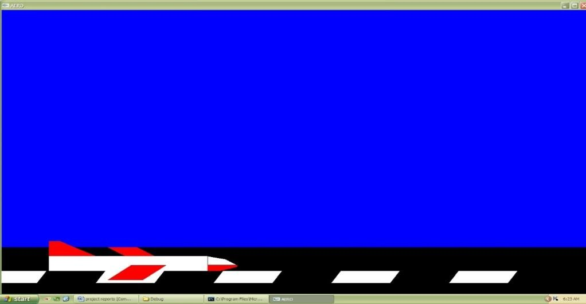

Figure1

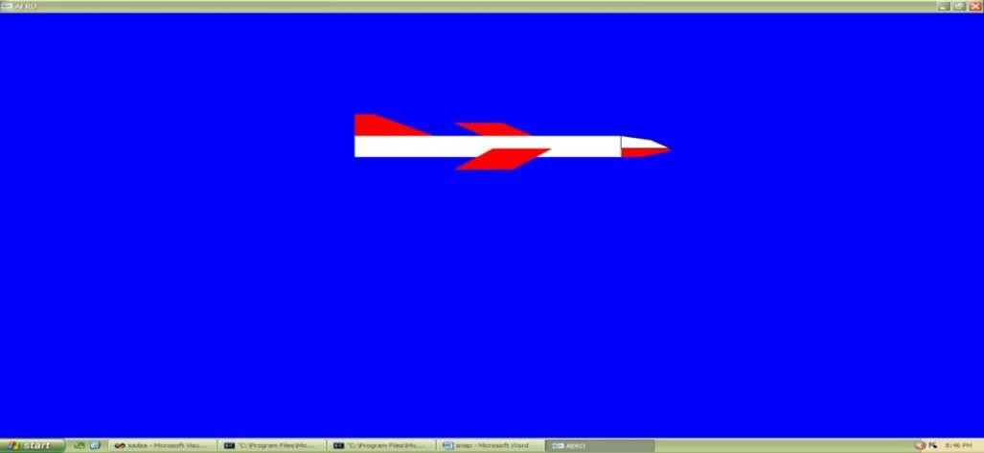

FIGURE2

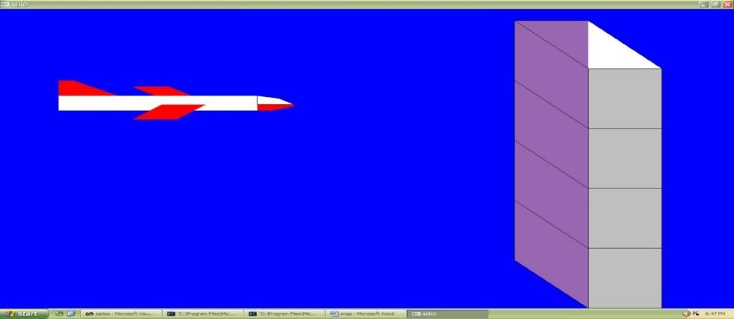

Figure3

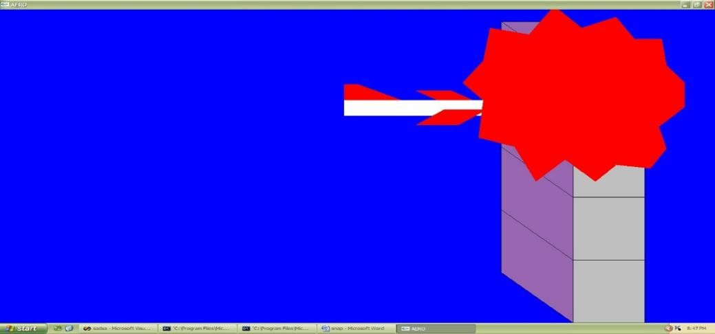

Figure4

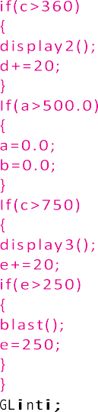
Some Code Here
1

2

3

4

5

6

7

8

9

10

11

12

13

14

15

16

17

18

19

20

21

22

23

24

25

26

27

28

29

30

31

32

33

34

35

36

37

38

39

40

41

42

43

44

45

46

47

48

49

50

51

52

53

54

55

56

57

58

Bibliography

- OpenGL Programming Guide (Addison-Wesley Publishing Company)
- The OpenGL Utility Toolkit (GLUT)Programming Interface
-API Version 3 BY MARK J. KILGARD
- Interactive computer graphics
-A top down approach by using Open GL by EDWARD ANGEL

