Problem 3

Imagine you are tasked with optimizing a web application that frequently crashes under high load. Outline your approach to diagnosing the issue, and describe what tools or techniques you would use to improve its performance. Be specific about the areas you would investigate (e.g., database queries, memory usage, etc.)

…………………………………………………………………………………………………………

Solution:

**1. Initial Diagnosis**

First I will check logs.

Profiling: Using **dotnet-counters** monitor CPU, memory usage, and garbage collection events in real time. This will good information about the system.

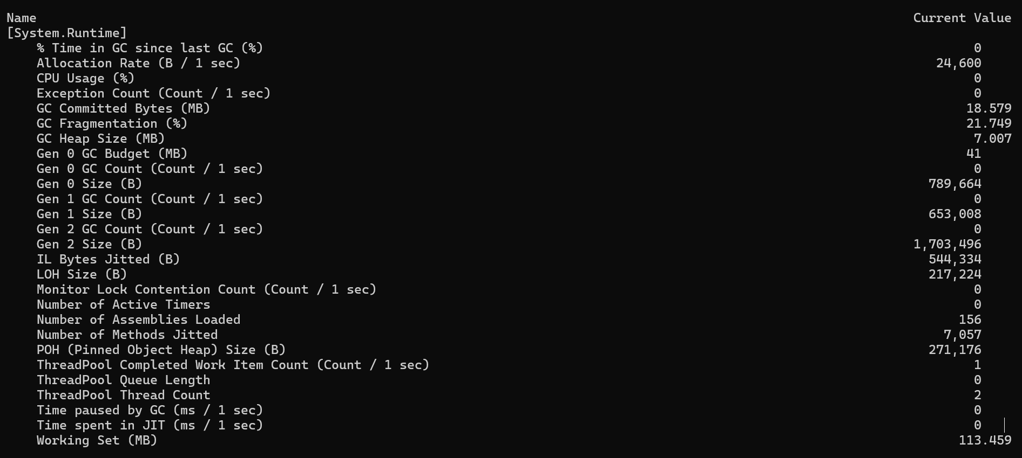

**2. Load Testing and API Optimization**

**Load Testing**: I’ll run tests using **K6** to simulate high traffic and observe which APIs cause performance issues or crashes.

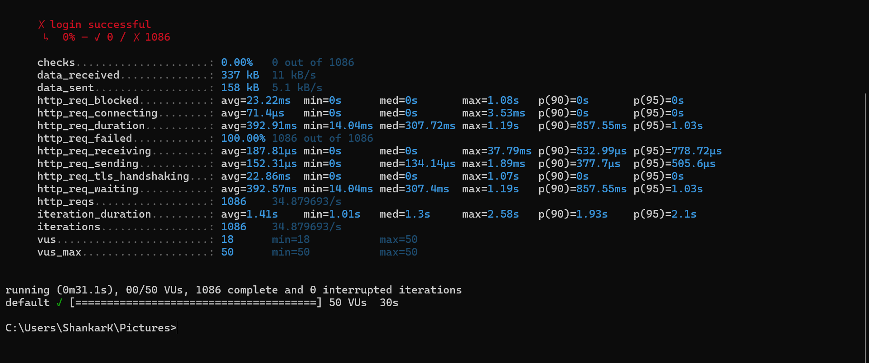

**Async Optimization**: I will ensure all I/O operations are handled asynchronously to avoid blocking threads under load.

3. **Database Performance**

**Query Optimization**: Reviewing SQL queries and analyzing database logs (using SQL Profiler) to identify and optimize slow queries.

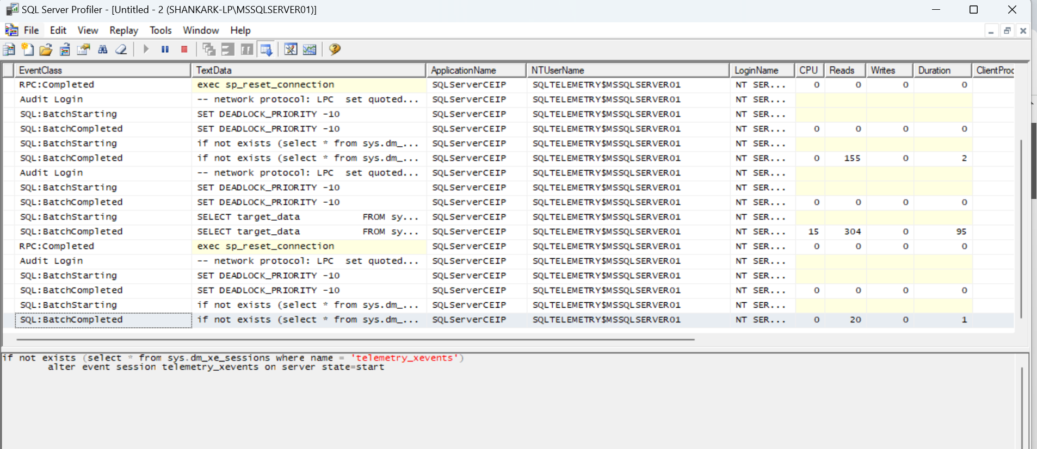

**Caching**: Implementing **MemoryCache** to reduce database load for frequently accessed data.

**4**. **Code Optimization**

**Refactoring**: Reviewing and simplifying complex or inefficient code, focusing on CPU-intensive tasks and avoiding unnecessary blocking operations.

**5. Auto-Scaling**

For hosted services (e.g., Azure), I’ll implement auto-scaling to dynamically handle high traffic.

**6. Continuous Monitoring and Future Load Testing**

After optimizations, I’ll set up continuous monitoring (using Azure Monitor) and regularly perform load tests to ensure the application can handle future demands.