🍕 Pizza Sales(SQL) Performance Report

**A. KPI’s**

**1. Total Revenue:**

select

round(sum(orders_detail.quantity*pizzas.price)::NUMERIC,2 )as revenue

from

orders_detail

join

pizzas

on

orders_detail.pizza_id = pizzas.pizza_id

OUTPUT:

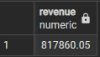

**2. Average Order Per Day**

select

round(avg(quantity),0) as average_pizzas_orderd_per_day

from

(select orders.date,sum(orders_detail.quantity) as quantity

from orders join orders_detail

on orders.order_id = orders_detail.order_id

group by orders.date) as order_quantity;

OUTPUT:



**3. Total Pizzas Orderd**

select count(order_id) as total_orders from orders

OUTPUT:

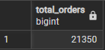

**4. Top 3 Most Ordered Pizzas**

SELECT

pizza_name,

quantity

FROM (

SELECT

pizza_type.pizza_name,

SUM(orders_detail.quantity) AS quantity,

RANK() OVER (ORDER BY SUM(orders_detail.quantity) DESC) AS rnk

FROM

pizza_type

JOIN

pizzas ON pizza_type.pizza_type_id = pizzas.pizza_type_id

JOIN

orders_detail ON orders_detail.pizza_id = pizzas.pizza_id

GROUP BY

pizza_type.pizza_name

) AS ranked_pizzas

WHERE

rnk <= 3;

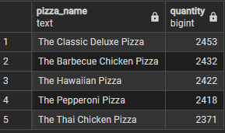

**5. Highest-Priced Pizza.**

select

pizza_type.pizza_name, pizzas.price

from

pizza_type

join

pizzas

on

pizza_type.pizza_type_id = pizzas.pizza_type_id

where

pizzas.price= (select max(pizzas.price) from pizzas)



**6. Most common pizza size orderd.**

select

pizzas.size,count(orders_detail.order_id) as order_count

from

pizzas join orders_detail

on

pizzas.pizza_id=orders_detail.pizza_id

group by

pizzas.size order by order_count desc

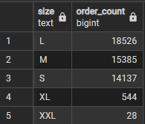

**7. Total quantity of each pizza category ordered.**

SELECT

pizza_type.category,

SUM(orders_detail.quantity) AS total_quantity

FROM

orders_detail

JOIN

pizzas ON orders_detail.pizza_id = pizzas.pizza_id

JOIN

pizza_type ON pizzas.pizza_type_id = pizza_type.pizza_type_id

GROUP BY

pizza_type.category

ORDER BY

total_quantity DESC

OUTPUT:

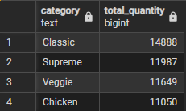

**B. Daily Trend for Orders (distribution of orders by hour of the day).**

SELECT

EXTRACT(HOUR FROM time) AS hour,

COUNT(order_id) AS order_count

FROM

orders

GROUP BY

EXTRACT(HOUR FROM time)

ORDER BY

hour;

OUTPUT:

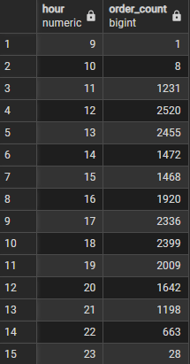

**C. % of Sales by Pizza Type**

select pizza_type.category,

round(sum(orders_detail.quantity*pizzas.price):: NUMERIC /(select

round(sum(orders_detail.quantity*pizzas.price)::NUMERIC, 2) as total_sales

from orders_detail

join pizzas on pizzas.pizza_id = orders_detail.pizza_id)*100,2) as revenue

from pizza_type join pizzas on

pizza_type.pizza_type_id = pizzas.pizza_type_id

join orders_detail on

orders_detail.pizza_id = pizzas.pizza_id

group by pizza_type.category order by revenue desc

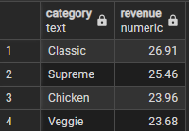

**D. The Cumulative Revenue Generated Over Time.**

SELECT

date,

revenue,

SUM(revenue) OVER (ORDER BY date) AS cum_revenue

FROM (

SELECT

orders.date,

SUM(orders_detail.quantity * pizzas.price) AS revenue

FROM

orders_detail

JOIN pizzas ON orders_detail.pizza_id = pizzas.pizza_id

JOIN orders ON orders.order_id = orders_detail.order_id

GROUP BY orders.date

) AS sales;

OUTPUT:

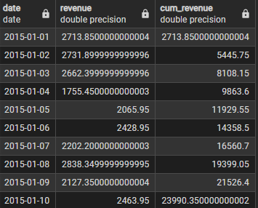

**E. Top 3 most ordered pizza types based on revenue for each pizza category.**

SELECT pizza_name, revenue

FROM (

SELECT category, pizza_name, revenue,

RANK() OVER (PARTITION BY category ORDER BY revenue DESC) AS rn

FROM (

SELECT pizza_type.category, pizza_type.pizza_name,

SUM(orders_detail.quantity * pizzas.price) AS revenue

FROM pizza_type

JOIN pizzas ON pizza_type.pizza_type_id = pizzas.pizza_type_id

JOIN orders_detail ON orders_detail.pizza_id = pizzas.pizza_id

GROUP BY pizza_type.category, pizza_type.pizza_name

) AS a

) AS b

WHERE rn <= 3;

OUTPUT:

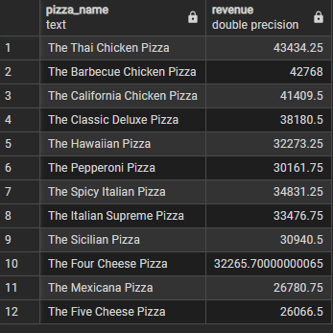

**F. The Category-wise Distribution of Pizzas.**

select category, count(pizza_name) from pizza_type

group by category

OUTPUT:

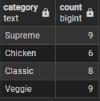

**B. Analyze Monthly Sales Performance and Track Growth Trends.**

SELECT

DATE_TRUNC('month', orders.date) AS month,

ROUND(SUM(orders_detail.quantity * pizzas.price)::NUMERIC, 2) AS monthly_sales,

LAG(ROUND(SUM(orders_detail.quantity * pizzas.price)::NUMERIC,2)) OVER (ORDER BY DATE_TRUNC('month', orders.date)) AS prev_month_sales,

ROUND(

(ROUND(SUM(orders_detail.quantity * pizzas.price)::NUMERIC,2) -

LAG(ROUND(SUM(orders_detail.quantity * pizzas.price)::NUMERIC, 2)) OVER (ORDER BY DATE_TRUNC('month', orders.date)))

, 2

) AS month_on_month_change

FROM

orders

JOIN

orders_detail ON orders.order_id = orders_detail.order_id

JOIN

pizzas ON orders_detail.pizza_id = pizzas.pizza_id

GROUP BY

DATE_TRUNC('month', orders.date)

ORDER BY

month;

OUTPUT:

