
DATA MINING PROJECT REPORT
Shankara Narayanan Bangalore Ramalingam

Table of Contents
Problem Statement: 3
Introduction: 3
Discussion: 3
Dataset: 4
Python Libraries: 4
Pandas: 4
Matplotlib and Seaborn: 4
Keras: 4
Miceforest: 4
Scikit-Learn: 4
Methodology: 5
Exploratory Analysis: 5
EMMISSION_LEVEL Feature Analysis: 9
Class Imbalance: 11
Data Imputation: 12
Classification Algorithm: 13
Time Series Forecasting: 13
Regression Algorithm: 15
Algorithm Performance: 17
Unsupervised Learning: 17
Feature Engineering: 18
Anomaly detection algorithms: 19
Algorithms Implementation: 21
Conclusion: 25

Problem Statement:
The main aim of the project is finding interesting patterns in the dataset and try to solve these interesting problems by using algorithms and AI techniques. In this project I have solved 2 supervised learning problems and 1 unsupervised learning techniques.
Keywords: Supervised learning, classification, regression, unsupervised learning, Anomaly detection, Time Series forecasting

Introduction:
As mentioned in the above problem statement, we will be solving 2 supervised learning tasks, and in this case, I have worked on a classification and a regression problem. The dataset consists of almost 900 thousand records and 76 features. Some of the features included in the csv file are Vehicle_ID, EMMISION_LEVEL, Battery_Replacement_Date etc.
To perform the classification task, I have taken the EMMISSION_LEVEL column which has 2 classes in it, and they are namely ‘1’ and ‘2’. This EMMISSION_LEVEL classes represent the European Emission standards which are followed in many countries. To perform this task, I employed the use of Pandas, Scikit-learn, seaborn and matplotlib. One of the main reasons to choose this binary classification problem was because of the class imbalance which was present in the column.
For the second supervised learning task, I had taken a regression problem wherein I was trying to predict the number of batteries which will be replaced on a monthly basis. The features which was used for this task was the Battery Replacement Date and the Mounted Battery Generation. One of the main reasons which I found this interesting was because it is a very practical problem and a good business case to solve. This also resulted in creating new features using existing ones.
In the first task I have implemented the following classification algorithms such as KN Classifier, Logistic Regression and MLP Classifier. In all these tasks we use accuracy as the metric for judging the model performance. In the regression task I had implemented the Long-term short Memory (LSTM) method which is quite popular for these cases. To measure the model’s performance in the regression task we are using root mean square error (RMSE) as the metric.
For the unsupervised learning task, I am performing anomaly detection of the battery state health at different times of the day. I have done feature engineering and created features such as Dayoftheweek, weekday etc. For the anomaly detection I have used algorithms such as LocalOutlierFactors, OneClassSVM etc. To evaluate the performance of these algorithms I have used RMSE as the metric.

Discussion:
In this part the whole project methodology will be explained that means the flow of the project
including loading dataset, explanatory analysis, data cleaning, handling class imbalance, downsampling, feature extraction, standard scaler, MinMax scaler, machine learning model. For all the models we are using accuracy for classification, and root mean square error for regression and anomaly detection.

Dataset:
In this dataset each vehicle has a number which is provided in the “Vehicle_ID” column. All
the vehicle in the dataset will operating either in electric, diesel or hybrid modes. A number of
features are measurements that are calculated at the corresponding time. The features such as
“State of Battery Health”, “Operation_TIME” etc. are measured with corresponding time. There
are also other features in the dataset, such as country, geographical area in which vehicle is
used, date of the battery replacement date etc. The dataset contains about 861916 samples and
is corresponding to 4031 vehicles. All the information in the dataset is anonymized.

Python Libraries:
This section briefly explains all about the libraries which are used in the project. In this project
I have used pandas, Matplotlib, seaborn, keras, miceforest, numpy, scikit-learn.

Pandas:
Pandas is a software library which is written in python and it offers data manipulation and
analysis features. It also offers data structures and operations for manipulating numerical tables
and time series. Some of the most salient features of pandas include data merging, slicing,
reshaping etc. In the time series functionality side include date range generation, frequency
conversion etc.

Matplotlib and Seaborn:
Matplotlib and seaborn are both plotting libraries which are provided in python and is used for
visualization of data present in the dataset. Pandas and matplotlib have a built-in integration,
i.e. if we use pandas for visualization in uses matplotlib internally.

Seaborn is another library which was built on top of matplotlib and has a close integration
with python. The seaborn library offers a variety of functionality such as automatic estimation
and plotting linear regression plots. It also supports univariate and bivariate distribution.

Keras:
Keras is another open source library that provides a python interface for ANN. This library
also has multiple backends supported such as TensorFlow, Microsoft Cognitive Toolkit etc.
This library is very popular for implementing deep learning algorithms etc. Some of them are
convolution and recurrent neural networks etc.

Miceforest:
Miceforest library provides fast, memory efficient Multiple Imputation by Chained Equations
(MICE) using random forests. It can impute both categorical and numeric data
without much setup and has an array of diagnostic plots available. This package is
available in both Python as well with R.

Scikit-Learn:
This is an open source machine learning written in Python. It is used to implement various
machine learning algorithms which ranges from classification, regression, and clustering
algorithms. Some of the most popular machine learning algorithms which are present in the
Logistic Regression, Decision Tree, Support Vector Machines, DBSCAN etc.
The same library was also used in the unsupervised learning task as well. I have used it for the algorithms such as LocalOutlierFactor, OneClassSVM etc.

Methodology:
The dataset was loaded using the pandas library. The below screenshot shoes the loading of the
dataset using pandas library.
Figure 1: Loaded Dataset

Exploratory Analysis:
After loading the dataset to the pandas library, I had started to work with exploratory analysis
where I had performed finding the percentage of missing values in the data frame column wise,
and I have also visualized it using the heatmap, the image of the heatmap is shown below
Figure 2: HeatMap to check null values in dataset
The red in the heatmap represents the empty values and green is the non-empty ones. From the
above heatmap I had dropped the features which had empty values of more than 70%, as it
would be computationally more expensive to impute these values. Hence, I had dropped all the
following features from the data frame.
Figure 3: Deleted Columns
After dropping these columns, I had started to work on the data analysis part of the task. After
this I had performed analysis of different features present in the column, I had initially worked
on “Vehicle_MRK_TYPE”, and the “EMMISION_LEVEL”. On performing the analysis in
the, I had taken the “Vehicle_MRK_TYPE”, feature. I wanted to check the number of values
present in each category, I have attached the screenshot below
Figure 4: Pie Chart for EMMISSION_LEVEL across VEHICLE_MRK_TYPE
I have also checked for more analysis on the above-mentioned feature with other features such
as City, Cluster, Current Yearly Mileage. We are checking the count category wise and we are
visualizing it.
Figure 5

Figure 6
In the below graph I also wanted to check which vehicle MRK Type had the highest number
of battery replacements. So, I have done a plot to check the count of each category. I have
attached the plot below
Figure 7: Battery Replacement across VEHICLE_MRK_TYPE
Now after analyzing the Vehicle_MRK_TYPE I had wanted to analyze the EMMISSION_LEVEL feature. This feature has just 2 values in them it was either 1 or 2. Similar to what was done in the Vehicle_MRK_type, I have checked the number values of 1 and 2. The below pie chart shows the number of 1’s and 2’s in the feature.

Figure 8: EMMISSION_LEVEL Imbalance
Straightaway we can see that there are a lot more 1’s than 2’s. This is called class imbalance.
Hence, I thought this will be an interesting problem, as it has this problem of class imbalance. I
chose this problem for solving my classification process. I had done some more analysis to get
a better idea on the feature.
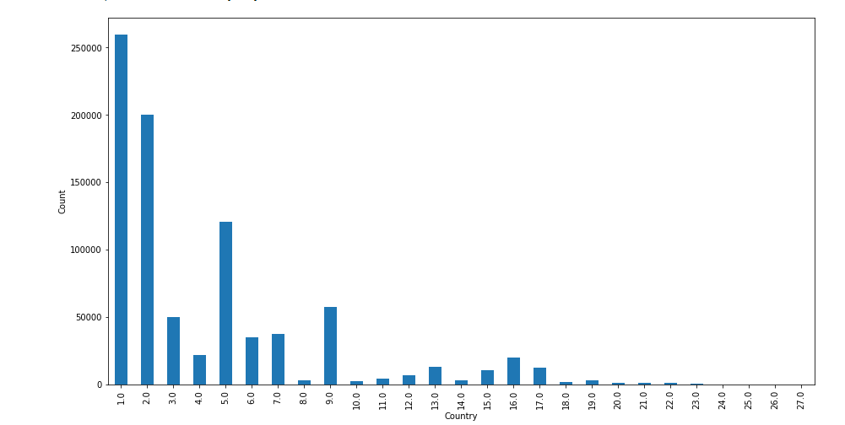
Figure 9: Country Wise EMMISSION_LEVEL Count
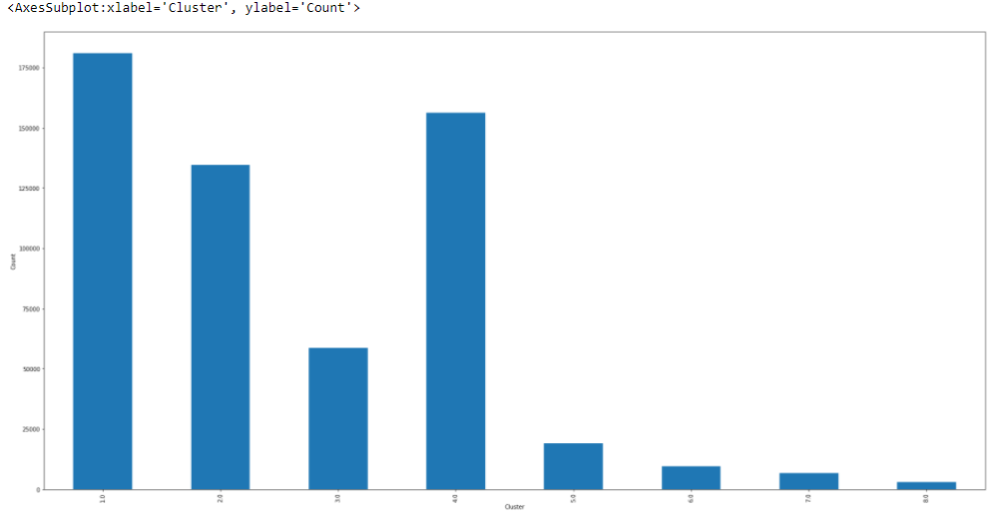
Figure 10 : Cluster Wise EMMISSION_LEVEL Count
The above the figure shows the cluster-wise emission levels. The below figure shows the
EMMISSION_LEVEL, per ‘Vehicle_MRK_TYPE’. The below figure is shown below
Figure 11: Count plot of EMMISSION_LEVEL with Vehicle_MRK_TYPE & Engine_Type
I have also done a similar analysis for the emission level separately. In the next step I have
taken the features which are positive correlation with the EMMISSION_LEVEL feature and
created a smaller dataframe.
This dataframe consisted of 16 features. I have selected it based on the below heatmap.
Figure 12: Cor-relation matrix of features

Class Imbalance:
Class imbalance is a scenario in which there the number of occurrences of one type of class is more than the other class. It is very important to handle this as it could lead to bias while implementing our machine learning algorithms.
To handle this problem, I have performed under sampling of the majority class, and from the pie chart above we can see that class 1 has greater number of 1’s than 2’s. The below figure shows the differences before and after down sampling.
Figure 13 : Class Imbalance of EMMSSION_LEVEL Feature
Now we can see that the dataset is balanced as it has equal number of entries.

Data Imputation:
The data did have some more missing values even after down sampling; hence I have used the MICE algorithm to impute the missing values. Here I have used the “miceforest” library to impute the missing values. The below screenshot shoes the percentage of missing values of the features present in it.
Figure 14 : Missing value percentage after imputing missing value
As we can see the missing values are not present anymore. This cleaned dataframe is stored in another csv file which will be used hereon.
Figure 15 : Reloading the dataset after imputing the missing value

Classification Algorithm:
After this I had started to work on the implementation of machine learning algorithms. Before
implementing the machine learning algorithm, I have applied the StandardScaler function in
the dataset, this will cause the mean to be 0 and standard deviation of 1.

Following which I have split the data into train and test set, so that we can implement the ML
algorithms.
Figure 16: Splitting the dataset to train and test set
After this I had have started to implement the ML algorithms, and in this case. I have implemented 3 algorithms, namely KNN, Logistic Regression, MLP Classifier. The below table shows the performance of the each of the models.
Performance Metric | MLP Classifier | Logistic Regression | KNN Classifier
Accuracy | 0.54014111 | 0.86857 | 0.91095679

From the above table we can see that the KNN classifier works better than all the algorithms.

Time Series Forecasting:
This task is a regression task, where in I have chosen to find the number of battery replacements which would happen monthly. One of the main reasons why this problem was chosen was the amount of feature engineering which goes into developing this. Another reason is because it is a very interesting business case, and would be useful to know this information as it would be useful for manufacturing, supplier chain management of the company etc. It also presents a new challenge to me personally of working on time series forecasting problem.

This is a regression problem where we can use the battery replacement, Battery Mounted
Generation, to create new features such as Battery_Replacement_count, Battery_Replacement_monthwise etc.

The below screenshot the number of new features which were used in the process, for this
process.

Figure 17: New Features after Feature Engineering
The last above screenshot shows the use Battery_Replacement_Date and
Mounted_battery_Generation to find the count of the battery replacement on the daily basis.
From the screenshot we can see that there are many duplicate dates present in the dataframe.
To overcome this, I have dropped the duplicates, after removing all the duplicates, I
have sorted all the dates in the ascending order. Following this I have plotted the monthly
battery sales current and taken the difference in battery replacement numbers.
Figure 18: The battery replacement difference on a monthly basis
After calculating the difference, I have checked the forecasting of battery replacements. In
order to achieve this I have introduced a look back period which will be 1 to 12, as we are
calculating month wise. So, what we need to do is to create columns from lag_1 to lag_12 and
assign values by using shift() method.

Regression Algorithm:
In this model, we will basically fit the linear regression model and calculate the adjusted Rsquared. Following which I have used the MinMax scaler to and then split the train and test
set. The below screenshot shows the train-test split.
Figure 19: Splitting the dataset into Train and Test Set
Following which I have also implemented the machine learning algorithm, in this case I have
used the keras library. The Long-term short memory (LSTM) algorithm is used in this case, it is a very common deep learning algorithm for these cases. From the below code, we can see that the error decreases after every epoch. The below screenshot shows the same.

Figure 20: Loss for each epoch
Following which I have implemented the model in the training and test sets. The screenshot is
shown below for both.
Figure 21: Applying the LSTM model for both train and test
Following this we will be predicting the monthwise sales, the y_pred and monthwise
predictions are given below. The plot is shown below.
Figure 22 : The prediction of monthly wise sales

Following which I had also done the same prediction for the top 2 countries where the battery
replacements were high.
Figure 23 : Battery replacement prediction Monthly wise

Algorithm Performance:
The algorithm works well with Country 1.0 as the RMSE for the train set around 1.53, and for the test set was 1.2989, but it did not work well for Country 2.0 as the train set RMSE is 0.05464,but the test set RMSE was 3.81, which is a case of overfitting.

Unsupervised Learning:
Unsupervised learning refers to the use of artificial intelligence (AI) algorithms to identify patterns in dataset containing data points that are neither classified nor labelled.
The algorithms are thus allowed to classify, label and/or group the data points contained withing the datasets without having any external guidance in performing that task. In other words, unsupervised learning allows the system to identify patterns within datasets on its own.
In supervised learning, an AI system will group unsorted information according to similarities and difference even though there are no categories provided.
Unsupervised learning algorithms can perform more complex processing tasks than supervised learning systems. Additionally, subjecting a system to unsupervised learning is one way of testing AI.
In this unsupervised learning task, I am finding anomalies in the State_of_Battery_health feature using different features which were created such dayoftheweek, weekday, daylight etc.

Feature Engineering:
To get new features out of existing ones, I have done feature engineering to create features such as Electric Mode Speed, Hours, daylight, Dayoftheweek, time epoch etc. I have provided the screenshot for some of the feature engineering steps I have done
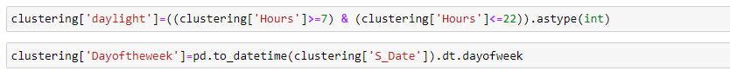
Figure 24: Feature Engineering using SEND_TIME feature
Following which I have checked the “State_of_Battery_Health” feature at different times of the day. The graph below shows the Battery State of health the different times.
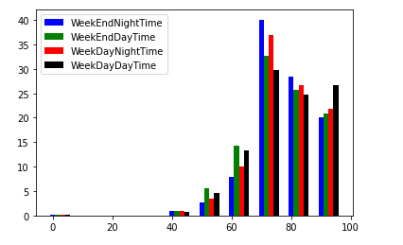
Figure 25: Battery State of Health at different times of the week
Following which there are several missing values in the dataframe, namely there was 1681 empty values present in the dataset. The below screenshot is shown below
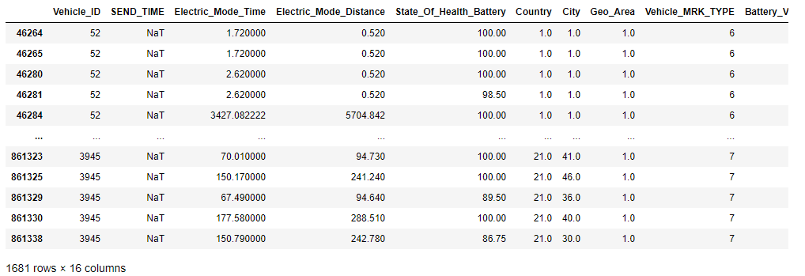
Figure 26: Number of missing values in SEND_TIME
The missing values where them dropped from the dataframe using the dropna() function.

Anomaly detection algorithms:
In this project I have used the following anomaly detection algorithms
- Elliptic Envelope
- Isolation Forest
- Local Outlier Factor
- OneclassSVM
Elliptic Envelope:
The Elliptic Envelope method fits a multivariant gaussian distribution to the dataset. Use the contamination hyperparameter to specify the percentage of observations the algorithm will assign the outliers.
The sklearn library is one which is used for using this algorithm.
Isolation Forest:
Isolation forest is an unsupervised learning algorithm for anomaly detection that works on the principle of isolating anomalies, instead of the common techniques of profiling normal points.
Isolation forest is a method which in principle is like the well-known and popular Random Forest. This is a tree-based algorithm wherein partitions are created by first randomly selecting a feature and then selecting a random split value between the minimum and maximum value of the selected feature.
The sklearn library is used for this algorithm as well.
Local Outlier Factor:
Local Outlier Factor (LOF) is an unsupervised machine learning algorithm that uses the density of datapoints in the distribution as a key factor to detect outliers.
LOF compares the density of any given data point to the density of its neighbors. Since outliers come from low-density areas, the ratio will be higher for anomalous data points.
The sklearn library is used for this algorithm as well.
OneClassSVM:
OneclassSVM (one-class Support Vector Machine) is an unsupervised learning algorithm that is trained only on the ‘normal’ data. It is used to detect the outliers and anomalies in the dataset. Based on Support Vector Machines (SVM) evaluation, the One-class SVM applies a one-class classification method for novelty detection.
The sklearn library is used for this algorithm.

Algorithms Implementation:
The first algorithm which I have used for anomaly detection is the Elliptic Envelope algorithm. To implement the algorithm, I have split the dataset based on the category, in this case we have split in into 4 categories. The below screenshot shows the split into different datasets.
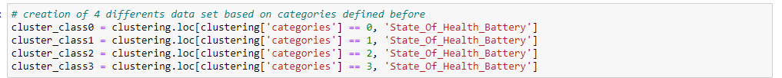
Figure 27 : Creating different classes based on different categories
The algorithm is implemented after this step, and the anomaly performance is shown in the below figure for
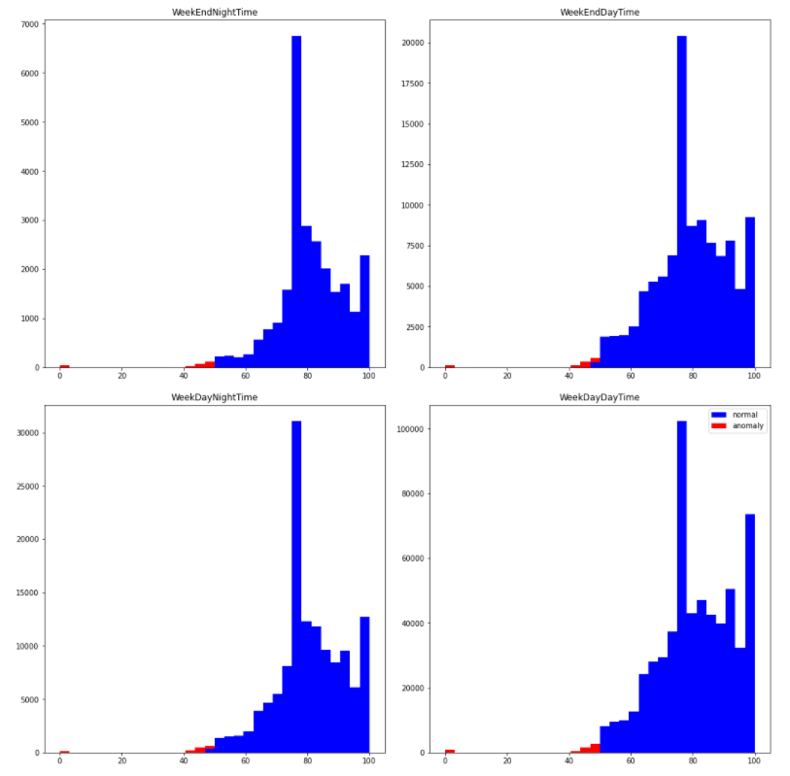
Figure 28: Anomalies detected different times of the week
After which we have concatenated all the different data frames based on different categories. I below figure shows the anomalies after concatenating together.
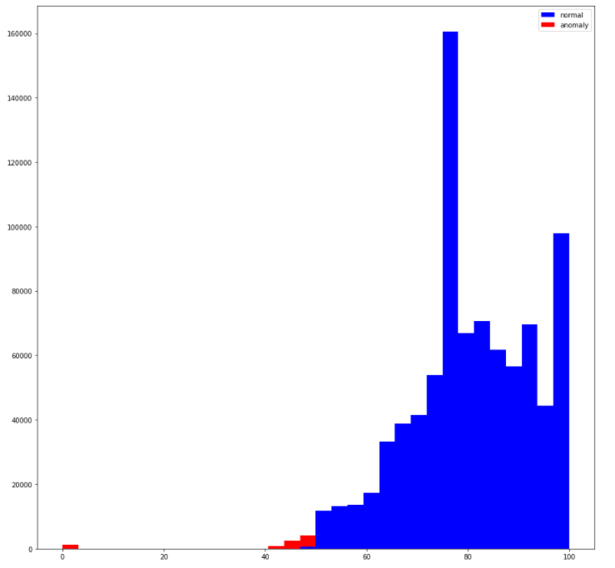
Figure 29: Anomalies concatenated together
The next algorithm which I have used in the project was the Isolation forest algorithm. I have implemented StandardScaler before applying the algorithm. After, that I have implemented the algorithm in the dataset.
The below figure the number of anomaly points detected by the algorithm
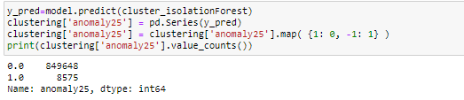
Figure 30: Number of anomalies detected by isolation Forest algorithm
The below screenshot shows the anomaly with respect to time.
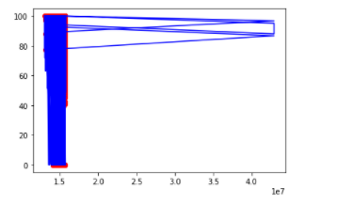
Figure 31 : Anomalies detected with respect to time_epoch
The below figure shows the anomaly points which are detected in the dataset,
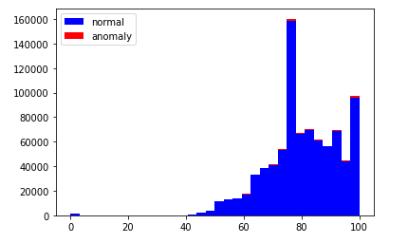
Figure 32
In the next step, I have implemented the Local Outlier factor algorithm, and like before I have implemented the StandardScaler function before the algorithm. The below screenshot shows the number of anomaly points found by the algorithm
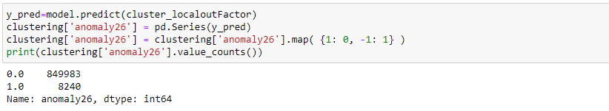
Figure 33
The next screenshot shoes the anomaly points with respect to time.
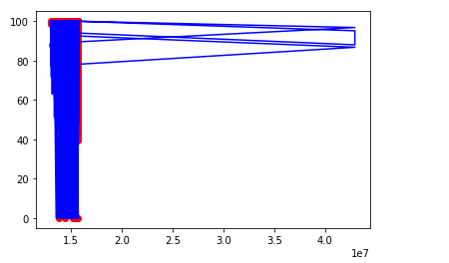
Figure 34
The next figure shows the anomaly detected points with respect the State of Battery Health.

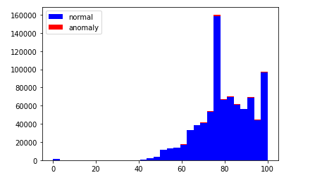
Figure 35

The last algorithm which I have implementing is the OneclassSVM algorithm. The below screenshot shows the number of anomaly points detected by the algorithm.

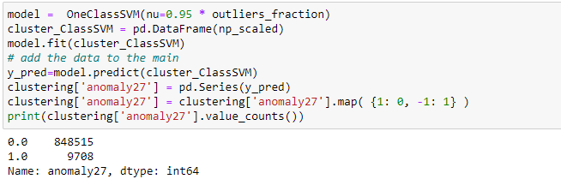
Figure 36
The below screenshot shoes the anomalies in the battery health based on the time.
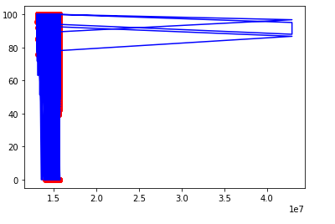
Figure 37
In the next screenshot I have plotted the anomaly detection of the battery health state.
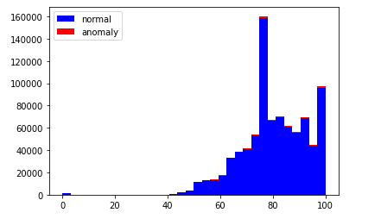

Figure 38
The below table shows the MSE of all the models implemented in the project.
Performance metric | OneClassSVM | LocalOutlierFactor | Isolation Forest
Mean Square Error | 6449.8817999 | 6449.501804489 | 6449.802499

To evaluate better performance of the anomaly detection algorithms used above, I have removed the anomaly points detected by the algorithms and then applied regression algorithms to check the performance. In this case I have applied 2 algorithms 1) Linear Regression 2) Lasso
If the RMSE goes down after removing the anomaly points detected by the algorithms, it means that proper anomaly points were removed. Consider the below table
The below tables show the performance of Linear and lasso regression algorithms before and after anomaly points removal for different algorithms.
RMSE of algorithms | Linear regression/OneClassSVM | Lasso regression/OneClassSVM
BeforeAnomalyPointRemoved | 0.07517665312789695 | 0.06863900465643427
AfterAnomalyPointRemoved | 0.020845536656445417 | 0.02666615856619127

RMSE of algorithms | Linear regression/LocalOutlierFactor | Lasso regression/LocalOutlierFactor
BeforeAnomalyPointRemoved | 0.059071558930220855 | 0.06643364475359777
AfterAnomalyPointRemoved | 0.037379265893670424 | 0.03147444249199228

RMSE of algorithms | Linear regression/IsolationForest | Lasso regression/IsolationForest
BeforeAnomalyPointRemoved | 0.057954083088657266 | 0.06770364538061739
AfterAnomalyPointRemoved | 0.03443539950663728 | 0.03405035487607842

Conclusion:
Classification: From the above tasks we can see that the accuracy of KNN is better than all the other models.
Regression: From the above task we can see that the prediction of the LSTM model performs better for country 1.0 but does not perform well for country 2.0.
Unsupervised Learning: Based on the above RMSE of Linear and Lasso regression algorithms we can see that for all the anomaly detection algorithms there is difference in RMSE, this proves that only the anomaly points were removed from the dataset.

