Submitted To: Ivan Wong

Submitted By:

Bao Vuong Chi (300301875)

Navneet Kaur (300294398)

Shankarenfo Pannagiani Dharma (300304800)

Varun Saini (300292468)

CSIS 3275- Software Engineering

Project Interim Report

**Spring MVC based Cloths Online Shopping System**

**Web Application**

**Due Date: 01/03/2020**

# Introduction

The Cloths Online Shopping is a web-based application intended for online retailers. The main objective of this application is to make searching, viewing and selection of product easier. It contains a sophisticated search engine for users to search for products specific to their needs. The search engine provides an easy and convenient way to search for products where users can search for a product interactively and the searching engine would refine the products available based on the users inputs, the users can then view the complete specification of each product. In Cloths Online Shopping System if an intermediary service is present the process is called Electronic Commerce (e-commerce).

# Software Scope

## Product Description

The project aims to develop Cloths Online Shopping System: A web-based electronic market to allow registered users to browse and make purchases on the web application’s inventory. This web application can be accessed by customers using their internet browser. The inventory of items for sale are stored in MYSQL.

This project aims to create a suitable interface for registered customers to make direct purchases to the shop’s inventory as well as allow owners/admin to manage, record and handle sales, stocking, deliveries and shoppers.

## Project Constraints

The project is given further constraints by “investors” to place additional focus on user friendliness and resistance against input errors made by users.

## Market Review

There are many similar systems available in the market which can be easily find on the internet. Following Strength and the weakness can be considered for every online shopping system:

**Strengths:**

* Online shoppers do not have to physically move to make purchases, thus incurring extra expenses such as vehicle gas and parking.
* Online shoppers rarely have to deal with aggressive salespeople. There are no crowds- They do not have to wait in long lines to check out.
* Many online retailers allow shoppers to post reviews about the products that they purchased. Customers are able to have secondhand reviews about products they are interested in.
* Online stores are almost never closed. Shoppers can shop anytime.
* Online sales representatives often receive more intensive product training than those at the local stores.
* Online sales representatives often have more flexibility in making decisions such as applying coupons, meeting competitors’ prices and expediting shipping at no extra charge.

**Weaknesses:**

* Online shoppers do not have the ability to physically inspect or try on the items being considered for purchase.
* Online shoppers sometimes lose the power to negotiate the price and payment terms that may exist in local stores.
* Items ordered online are sometimes back-ordered, but shoppers may not find out until weeks later. This is particularly problematic when buying gifts.
* Online shoppers do not always know if a site is a legitimate retail store and if is safe to shop.
* Restocking and shipping costs are often charged on returns.
* Online shoppers often do not have a person to talk to when dealing with a problem.
* It is sometimes easier to get money refunded locally when the item purchased drops in price within the guaranteed price period.
* Online shoppers do not get to take advantage of seasonal statewide tax-free shopping events.

## Functions and features of the system

The Application will have two user roles:

1. Admin
2. Customers

### Use-case diagrams

|  |  |
| --- | --- |
| **Admin:**   * Manage store inventory   + Add, edit, delete clothing items   + Add, edit, delete clothing categories * Edit registered users’ data * Review sales records   + Item sale statistics   + Total shop profits   + Previous sale records | **Customers:**   * Create account * Manage self account * Browse shop inventory   + Filter/Search inventory * Make orders   + Add items to cart (batch purchase)   + Set destination address   + Confirm purchase * Review ongoing orders   + Cancel orders |

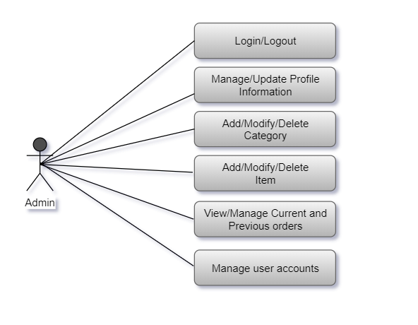

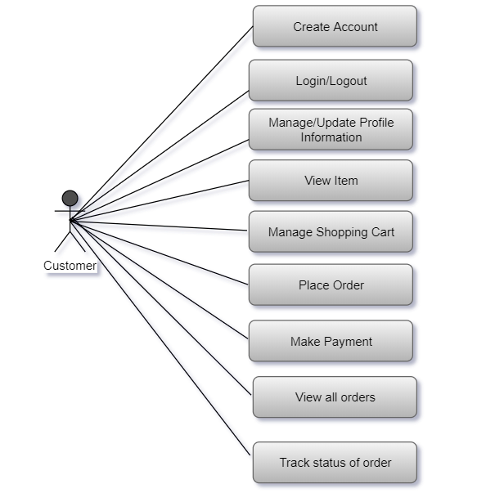

### (Projected) UI Diagrams:

Main Screen User Account Screen

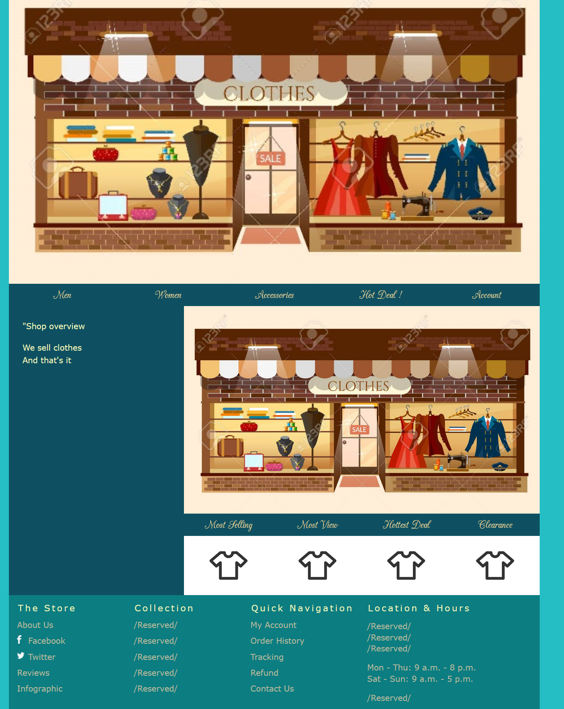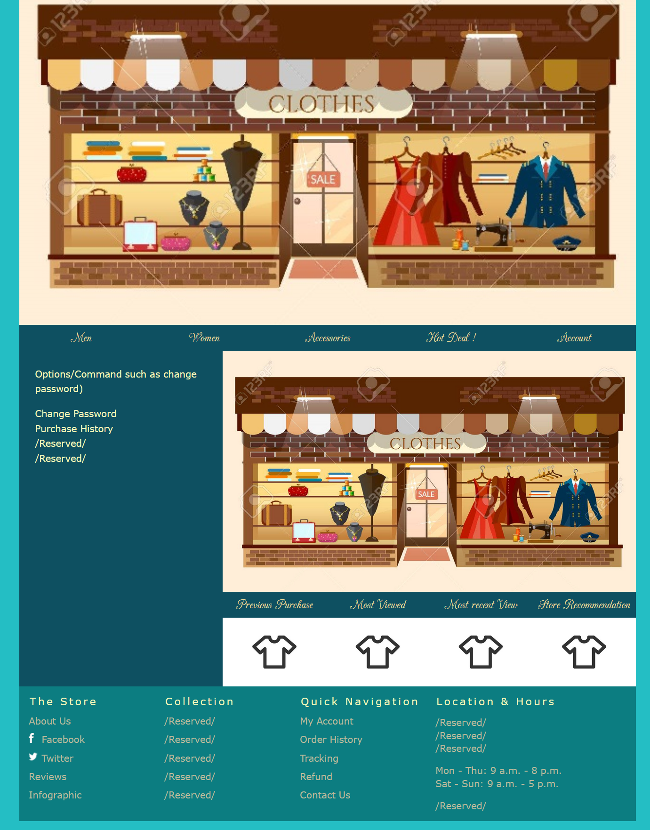

‘Hot Deals’ Screen

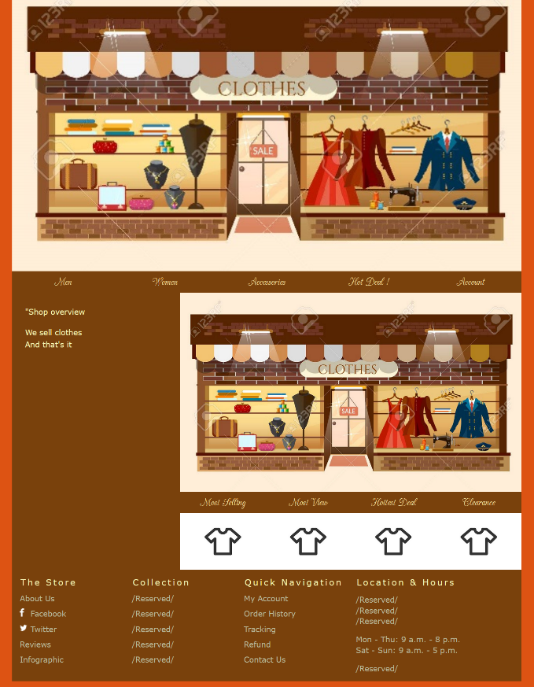

The projected interface would hold a similar layout structure throughout the application. The main difference would be the contents of the left-hand side (displaying appropriate controls and buttons) while the right-hand side will display different selections of the shop’s inventory; for example, the user account screen will display a personalized set of options, while the ‘Hot Deals’ interface will display the most purchased items the shop has inventory of.

### Functions and Features of Cloths Online Shopping Web App:

**Eclipse IDE :** The complete Cloths Online Shopping Web App’s source code is built in eclipse.

**Database:** The data related to different categories will be fetched from the database. Customer details and placed order details will be stored in database. The Admin panel will be built using MYSQL database. Using it, admin will able to delete/add/manage products, categories etc.

**Verification Email, Forgot Password:** In this app we will use email verification to avoid fake registration. App will also provide password reset feature, in case user forgot their password.

**Login:** The application will allow user to register his/her email in order to login into the system.

**Category Filters:** User will be able to select items based on the categories of cloths such as shirts, T-shirts, Trousers etc.

**Cart with count Badge:** This app will create custom cart which gets updated with badge count in real time.

**Order:** user will be able to see the previous orders and able to place the order along with tracking the status of orders placed.

**Payment Integration:** We will integrate PayPal and cash on delivery in our app.

## Technology Used:

**Software Design:**

1. Front end user interface design/High level design using HTML, CSS, JSP.
2. Backend language: Core and Advanced JAVA.
3. Planning to create a Web application using Java spring framework.
4. GitHub tool used.

**Software and hardware requirements:**

**Hardware:**

1. Any PC/Mobile device (32 bit or 64 bit).
2. RAM with 512 MB or more.

**Software:**

1. Any Operating System (MacOS or Windows).
2. Web Browser with Java support.
3. JDK installed on computer for java application.

# Group Dynamics:

Project Manager: Shankarenfo Pannagiani Dharma

|  |  |  |  |
| --- | --- | --- | --- |
| Shankarenfo Pannagiani Dharma | Navneet Kaur | Bao Vuong Chi | Varun Saini |
| Manage the project  Java back-end coding  Testing  Documentation | Front end HTML/CSS development,  Documentation | Back-end Java  Interface development | Database  Back-end Java |

Due to members’ inexperience and unfamiliarity with each other’s skill sets and the SpringMVC in general, aside from the explicit role of Project Manager (who oversees the progress of the project as a whole), given roles are not concrete, and are expected to change or shift according to the situation the group is facing.

In case of disagreements, it is preferred for a discussion to be made to deliberate on the issue- at the very least, for the team to agree on options available for the team to make. Then, the team will each vote on their preferred solution. If the group is still not in agreement, further discussion may follow. However, in the case of a contentious problem, the project manager can decide for the group (this however is a last-ditch effort).

# Estimation:

|  |  |
| --- | --- |
| **Function** | **Estimated LOC** |
| User interface & control facilities (UICF) | 1060 |
| Two-Dimensional geometric analysis (2DGA) | 1200 |
| Database Management (DBM) | 1400 |
| Computer graphics display facilities (GCDF) | 1160 |
| Peripheral control function (PCF) | 1000 |
| Design analysis modules (DAM) | 1500 |
| **Estimated Total LOC** | **7320** |

Total estimated LOC: 7320

Estimated daily production of LOC= 105 LOC/4 members

Estimated work-days: 70 days.

# **Risk Summary**

1. **Time/Schedule:** Due to the complexity of the software there is a risk of its completion not being on time. Although our team will track the progress according to the schedule, it is likely for some tasks to take more than the expected, which will increase the overall project development time.
2. **Lack of Team Experience:** Our team lacks experience in related fields. This will impact most of our estimated plans as we also have to compensate for learning new methods and skills to develop the program.
3. **Security Threats:** As the system is dealing with online payment gateways, security breaches are a persistent threat to the project’s practical deployment.
4. **Performance:** The program, being a web application, may have trouble performing smoothly for users. The server-program communication may underperform from code inefficiencies and the scale of users may impact performance.

## Risk Mitigation

* Project development process is closely monitored with projected schedule.
* Unexpected code complexities may require some measure of flexibility on our code, so the team will be communicating closely with each other regarding their plans, solutions and changes. Members are encouraged to find alternative solutions through the internet if necessary.
* To make the system secure, we will use SSL Encryption of the data, hosted payment delivery and will ensure the user accounts’ security through password encryption, safe password recovery and automatic account reset in case of multiple invalid login tries.

## Damage Minimization

In the case of extreme time overflow or development difficulty, some functions can be downgraded or reduced in complexity to compensate for the loss. In the worst case scenario, we can try to replace the difficult functionality with a different but smaller, easier function.

# Project Log:

|  |  |  |  |
| --- | --- | --- | --- |
|  | **Tasks** | **Members Involved** | **Description** |
| Jan 06 | Meeting for proposal | Bao Vuong Chi,  Navneet Kaur,  Shankarenfo Pannagiani Dharma,  Varun Saini | Cloths Online Shopping System and selecting possible name for project.  (30 mins) |
| Jan 13 | Meeting for proposal | Bao Vuong Chi,  Navneet Kaur,  Shankarenfo Pannagiani Dharma,  Varun Saini. | Discussion about project planning phase. (40 mins) |
| Jan 20 | Writing proposal | Bao Vuong Chi,  Navneet Kaur, | Writing proposal (40 mins) |
| Jan 23 | Polishing Proposal | Shankarenfo Pannagiani Dharma,  Varun Saini. | Checking mistakes and make corrections. (40 mins) |
| Feb 20 | Interim Discussion | Bao Vuong Chi,  Navneet Kaur,  Shankarenfo Pannagiani Dharma,  Varun Saini. | Discussion of Interim report contents, UI design, Plan B. |
| Mar 2 | Week Planning | Bao Vuong Chi, Navneet Kaur,  Shankarenfo Pannagiani Dharma | Weekly planning- task assignment |
| Mar 7 | Week Overview | Bao Vuong Chi, Varun Saini,  Shanka P. Dharma | Database discussion, Interface flow rework. |