AI-Based Realistic HR Interview Simulator
B.Kishore Babu¹, K.Harsha Vardhan², B.Beaulah Angel³,D.Hemanth⁴,D.Venkata Sanjay⁵
¹Assistant Professor, Dept. of CSE (AIML), Bapatla Engineering College, Bapatla 522101, AP, India
²³⁴⁵Student, Dept. of CSE (AIML), Bapatla Engineering College, Bapatla 522101, AP, India
bkishorebabu515@gmail.com harshavardhankupireddy@gmail.com beaulahangelbilla@gmail.com dagguhemanth@gmail.com dvenkatasanjay@gmail.com

---------------------------------------------------------------------***---------------------------------------------------------------------
Abstract: Interview performance can be considered an essential factor of employability, and most job seekers cannot access realistic, adaptive interview preparation aids. The current AI-based HR interview systems are mainly aimed at candidate screening to hire and lack the interactive practice systems with extensive development capabilities. The following paper introduces a sophisticated AI-based HR interview simulator that is specifically developed and focused on interview preparation and covers the main shortcomings of the existing systems such as a lack of transparency, insufficient quality of feedback, a lack of multimodal analysis, and poor adaptability. The suggested system has Large Language Models (LLMs) and reinforcement learning to generate questions dynamically and context-sensitive, and Automatic Speech Recognition (ASR), Natural Language Processing (NLP), and Computer Vision to perform multimodal assessment. The system records cognitive and affective aspects of the interview performance based on the attention-based multimodal fusion and gives a transparent and hierarchical feedback to provide fair and inclusive interview preparation. The study would add to the provision of a thorough framework on responsible AI-based interview preparation, the importance of explainability, fairness, and holistic skill development.

Active keywords: AI interview simulation, explainable AI, multimodal assessment, reinforcement learning, bias mitigation, adaptive questioning, interview preparation, large language models, fairness auditing.

- INTRODUCTION
The interview performance is important in the candidate employability determination as it is a holistic measurement of tech-knowledge, communication, confidence, problem-solving skill and behavioral quality. In the new competitive labor market, interviews usually become the key aspect of the selection of a candidate, and that is why it is necessary to prepare properly as an interviewer, regardless of the level of experience and field of work. Nonetheless, good educational qualifications and technical skills do not always mean success in the interview process. A lot of qualified applicants fail in the interviews because of being nervous or not having enough practice sessions or not having constructive feedback on how they performed.
Peer mock interviews, professional coaching sessions, and static question banks are considered to be the main limitations to traditional interview preparation methods. Mock interviews conducted by peers rely on availability and experience of the interviewer which frequently leads to poor quality in questioning and biased feedback. Although this may be an effective option, professional coaching is also expensive and financially unavailable to most of the candidates. The tools of the statical preparation do not render the interactive (dynamical) quality of the real life interviews as they cannot adjust to the reactions of individual candidates and cannot give them context-related advice.
The latest progress in the field of Artificial Intelligence has made it possible to create automated HR interviewing systems that can assess candidates on large scale with the help of Natural Language Processing (NLP), sentiment analysis and question generation based on resumes. Although such systems make organizational recruitment more efficient through automation of interview elements and the provision of consistent evaluations, it mainly fulfills functions of recruitment and assessment instead of candidate-oriented interview preparation and skill development functions. This core focus on organizational profitability instead of the growth of the candidate is a major discontinuity in the new environment of the AI-based interview solution.
1.1.Critical Constraints of Current System.
An in-depth review of existing AI interview systems shows that there are a number of serious flaws in the existing systems that restrict their use in interview preparation:
- Absence of Transparency and Explainability: The majority of these available systems operate within the state of black box where they score candidates in a numerical representation (e.g., 72/100). Nevertheless, they do not disclose to them how they calculated those scores and in what aspects of their performance they took into consideration when making such an assessment.
- Poor Quality of Feedback: The current system also permits non-actionable and non-specific feedback which may not have been predictable to raise the likelihood of improvement in the target individuals themselves. As per the literature, the feedback is not actually given to 53.5% of the people even after the AI interview. The feedback given is not only inadequate, but not elaborate enough to enable the individuals to work on it by having the idea of the areas where they need improvement. In the interview preparation case, people, in fact, require to be given a detailed feedback, which is multi-dimensional in character.
- Restricted Multimodal Accuracy: Although certain modern systems can take into account both facial expression and voice analysis, such systems are not able to have integrated multimodal fusion. Important non-verbal cues, which include eye tracking patterns, body language micro-expressions, body posture dynamics, and temporal emotion patterns are under-investigated. Even though the accuracy of attention-based combination of multiple streams is much higher than that of single-modality analysis, the vast majority of the current systems do not use such complex methods.
- Fixed Question Generation: Most interview simulators are based on a pre-defined question bank or a simple template based generation to create repetitive generic questions that do not adapt to the response of the candidate as well as to the learning process the lack of reinforcement learning based adaptive questioning prevents systems to optimize question sequence and does not mimic the interactive aspect of real interview.
1.2 Research Contributions
To overcome these essential limitations, the paper will introduce a sophisticated AI-based HR interview simulator which will accomplish the following key contributions:
Hierarchical Explainable AI Framework: We propose a multi-level transparent, interpretable assessment framework that is offered at technical, behavioral, and communication levels. With SHAP (SHapley Additive exPlanations) to explain the model interpretability, our framework produces human-readable explanations which explain how each assessment dimension contributes to total scores, what kind of behaviors affected assessments, and what specific actions can be taken by the candidate to better.
Comprehensive Fairness Auditing System: We apply an extensive method to fairness testing in stages, comprising of pre-deployment bias audit, real-time monitoring, and counterfactual fairness testing and intersectionality, according to a number of demographic categories. We obtain and monitor all of these measures of fairness, such as demographic parity, equalized odds, and calibration, and other methods of mitigating biases via reweighing, optimization, or adversarial debiasing.
State of the Art Multimodal Fusion Architecture: We propose an attention based multimodal fusion architecture that is capable of analyzing facial expression, voice sentiment, eye gaze patterns, body language, and text simultaneously. Our emotion tracking system in time records the emotion patterns during the interview, the stress responses, recovery rates, and stability trends that help in revealing more information about candidate resilience and flexibility.
Reinforcement Learning-Based Adaptive Questioning: Here we apply a reinforcement learning agent which optimizes sequencing of questions with a range of different goals which are learning value, skill coverage, candidate engagement, and time efficiency. The RL agent will automatically vary the difficulty of questions, detect skill deficiencies, and ensure optimal levels of challenge to achieve optimal benefits to the learning outcomes.
Individual Development Roadmap: We develop individual improvement plans which are driven by ai it also includes prioritization on the skill areas they lack with exercises to train those skills as well as learning resource provision and estimation of time this roadmap will make the candidates develop their skills step-by-step with established milestones.

II. Literature review :
This part examines pre-existing studies on AI-driven interviewing system that look at the technological strategies, constraints, and contributions. The literature has been divided into AI-based HR interviews, multimodal assessment systems, explainable AI in recruitment and fairness and bias mitigation frameworks.
2.1 AI in HR Interviews: Development and the present situation.

The state of AI-based HR interview systems has changed since the initial applications that were a primitive chatbot-enabled screening and performance scheduling services to other more sophisticated systems that seek to assess emotional intelligence and cultural fit [1]. Sarumathi et al. [1] described an interview simulation based on AI with the Gemini AI model (CNN-based facial recognition and RNN-based voice sentiment analysis) and stated that the relevance and consistency were improved. Nevertheless, they did not provide detailed bias measures and real-time monitoring of fairness in their study. The NLP-based virtual interview system by Shivajirao et al. [2] enhanced the efficiency and accuracy of recruitment, but the primary concern of the system was related to recruiting speed, which did not consider explainability or candidate-focused feedback. Lee et al. [3] examined the application of virtual reality and generative AI chatbots to improve interview confidence and communication skills, but the high cost of hardware, the absence of fairness assessment, and the insufficient validation in the long-term did not make the proposed method very practical.

2.2 Multimodal Assessment and Specialized Training Systems.

Recent studies also stress on the multimodal assessment, when visual, vocal, and verbal characteristics are joined to have a more complete evaluation of the candidate. Nandrajog et al. [9] suggested a CNN-GRU hybrid model that was more accurate than those using a single modality, but the study was restricted to a fixed set of facial expression and not culturally validated. Mishra et al. [6] proposed a virtual mock interview system that supports real-time speech analysis and bias suppression systems and demonstrated high levels of agreement with human observers but low levels of technical openness. On the same note, Somasundaram et al. [7] also introduced the scalable AI interviewing system under the claim of reducing bias, but they fail to elaborate on fairness metrics and do not offer candidate-level explainability.

2.3 AI Recruitment Explainability and Transparency.

The issue of explainability has emerged as a vital issue in the AI-driven recruitment systems as a result of ethical and legal implications. Another crucial aspect of high-stakes AI applications mentioned by Huang et al. [9] is the necessity of transparency, fairness, and accountability and the dangers of black-box models. Recent changes by the regulatory authorities, such as the Mobley v. The EU AI Act (2024), workday case (2024) and Bias Audit Law in New York City (2023) require the transparency and bias audits in employment-related AI system. Undoubtedly, despite such requirements, a lot of the current interview platforms still do not have enough explainability mechanisms.

2.4 AI Interview Systems Mitigating Fairness and Bias.
Discrimination remains one of the significant issues in the recruitment AI systems. Achchab and Temsamani [1], and Das et al. [4] observed that historical data may cause an amplification of bias and required fairness-conscious algorithms and systematic audits. Despite the well developed fairness measures like demographic parity, equalized odds, and calibration, few interview systems report and even measure these measures. Also found in current implementations is the issue of intersectional bias which is mostly not addressed
III. Proposed Methodology
The proposed system consists of a full-stack, service-based architecture on top of which a twelve specialized AI modules are integrated into one integrated, ethically-grounded interview processing pipeline: natural language processing, multimodal behavioral analysis, reinforcement learning-based adaptation, explainable AI, and fairness auditing. The system underlies two interview pathways: a Mock Interview mode for self preparation and an HR initiated Candidate Interview mode both having similar AI engine, evaluation pipeline and report generation logic.
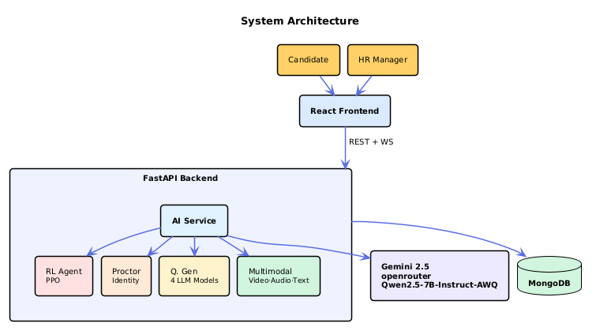
Fig1. System architecture overview
3.1 Multi source candidate profiling.
The system creates a profile of a candidate by integrating various sources of information. The resume is scanned as the PDF version to provide structured information which includes skills, experience, education and projects. Additionally, the GitHub activity and the LinkedIn documentation can be combined to augment the profile of the candidate.
In the meantime, natural language processing is used to process job description and identify the required skills, tools, and experience level. The generated information is extracted to form a contextual profile used in generating questions and assessment of performance during the interview.
3.2 Four Model Specialized Question Generation.
The system involves four special purpose question generating models to produce various interview questions based on the interview stage and topic category. There are the behavioral past experience questions, technical domain knowledge questions, situational-decision making questions, and cultural-fit questions, and they are based on the organizational values.
The question router will choose the right model based on the level of experience and interview round. A semantic similarity filter will reduce the number of duplicated questions presented via SentenceTransformer embeddings, which will guarantee that there is a diversity of questions asked during the interview and that the content is contextually rela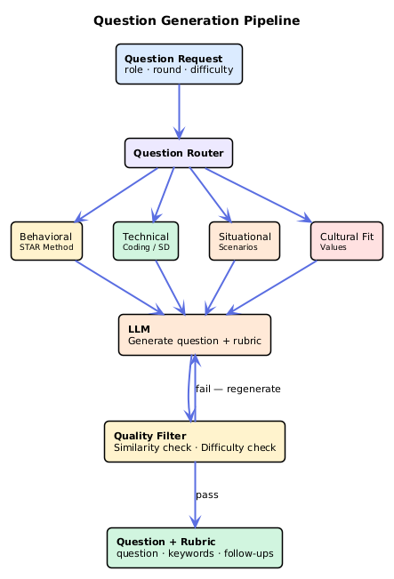
Fig 2. Question generation system
$\max_{QiϵQ_{a}sked}$CosineSim(E(q_{new}),E(q_{i}))< τ ………(1)
Where E(q_{new}) , E(q_{i}) is new question and total embeddings
3.3 Dual Round Structure of RL with Adaptive Difficulty.
The interviews will be conducted in two i.e. Technical round and HR round. The reinforcement learning algorithm established based on Proximal Policy Optimization (PPO) is being used to dynamically adapt questions in difficulty.
The measures of candidate performance that were found in the model are level of confidence, quality of answers, subject coverage and time remaining. The system reaches decisions based on these indicators about the mode of addition of difficulty, the same difficulty, the change of the topic or the follow up questions. It is a dynamic process that allows the flow of the interview to appear natural as an interviewer r_{t​}(θ)= $\frac{π_{θ}\left(a_{t} | s_{t}\right)}{π_{θ_{old}}\left(a_{t} | s_{t}\right)}$ …………… (2) probability ratio of taking action $a_{t}$ (adjusting difficulty) given state $s_{t}$
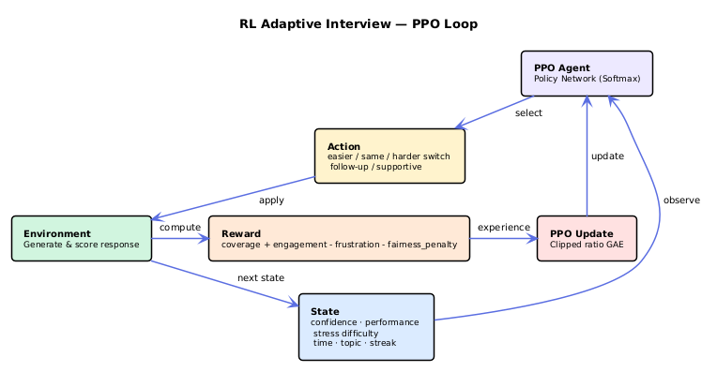
Fig 3 . RL Adaptive system
$L_{CLIP}\left(θ\right)=E_{t}\left[\min\left(r_{t}\left(θ\right)\hat{A_{t}}, \text{clip}\left(r_{t}\left(θ\right),1-ϵ,1+ϵ\right)\hat{A_{t}}\right)\right]$ …………….. (3)
Where ${\hat{A}}_{t}$ is the estimated advantage function and $ϵ$ is the clipping hyperparameter.
3.4 Real Time Multimodal Behavioral Analysis
Candidate responses are assessed through multimodal behavioral analysis, which entails the combination of facial cues, speech patterns and gaze tracking. Video frames are processed with computer vision in order to identify facial features and identify emotional states, like confidence, nervousness or engagement.
Simultaneously, speech analysis models take into account the vocal peculiarities of the speech rate, the fluctuation of the pitch, the amount of pauses, and words fillers. It serves to supplement a written review of the responses with behavioural manifestations in order to develop a more detailed measure of candidate communication and confidence.
$M=α_{V}f_{V}\left(X_{V}\right)+α_{A}f_{A}\left(X_{A}\right)+α_{T}f_{T}\left(X_{T}\right)$ …… (4)
Where $f_{V},f_{A},$ and $f_{T}$ be feature extraction networks
Subject to the constraint:$α_{V}+α_{A}+α_{T}=1$ ………. (5)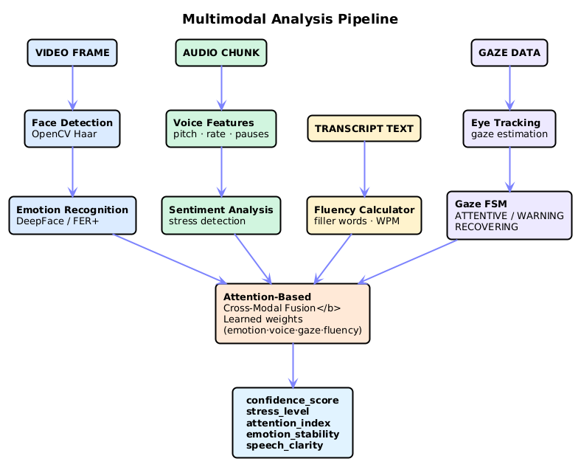
Fig 4. multi model analysis pipeline
3.5 Two Phase Evaluation Architecture
This process of assessment is divided into two phases. The first stage comes up with the fast first score through the use of locally based models that consider the accuracy of the content, coverage of key words, structural comprehensiveness, and filler word rates.
The second level uses a deeper level of analysis with the assistance of a large language model that examines five key dimensions such as the quality of communication, technical knowledge, confidence, emotional control, and problem-solving ability. This is a two step approach which enables quick reaction and thorough analysis.
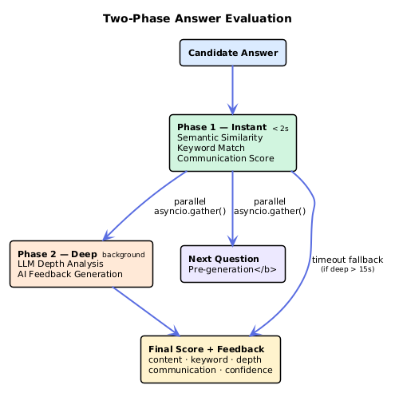
Fig 5. Two phase evaluation architecture
$S_{1}=w_{acc}C_{acc}+w_{key}C_{key}+w_{struct}C_{struct}-w_{fill}R_{fill}$
……… (6)
Where $C_{acc}$ is content accuracy, $C_{key}$ is keyword coverage, $C_{struct}$ structural metric, and $R_{fill}$ penalty for filler word rates
$S_{2}=\sum_{k=1}^{5}{λ_{k}}⋅LLM_Eval_{k}\left(R\right)$ ……….(7)
Where $λ_{k}$ is the weight of each dimension
$S_{final}=βS_{1}+\left(1-β\right)S_{2}$ ……….(8)
Where $β$ is a tuning parameter
3.6 Explainability and Fairness Auditing
The system also includes explainable artificial intelligence methods based on feature attribution and SHAP to be as transparent as possible. Candidates scores are derived using a number of input features such as response depth, richness of vocabulary, emotional stability, speaking rate, ecstatic eye contact, and use of examples. SHAP scores point out the significance of each attribute to the final score.
A fairness auditing layer also reviews the system on a continuous basis with fairness indicators of demographic parity, equalized odds, and calibration. The mechanism of monitoring identifies the possibility of bias and activates counter-measures to prevent unfair and biased assessment.
Demographic Parity
$P\left(\hat{Y}=1 ∣ A=0\right)=P\left(\hat{Y}=1 ∣ A=1\right)$ …….(9)
Equalized Odds: Ensures equal true positive rates
$P\left(\hat{Y}=1 ∣ A=0,Y=1\right)=P\left(\hat{Y}=1 ∣ A=1,Y=1\right)$
…….(10)
3.7 AI Interview Proctoring and Integrity Verification
To achieve fairness in cases of interviews being conducted by the HR, the system has a real-time proctoring module, which tracks the activities of the candidates in the process. The candidate is then required to scan his face with the webcam before the interview commences and the system builds a reference facial profile based on DeepFace. During the interview, the system will continue to verify the presence of the same candidate by comparing the live frames with the system-stored profile.
The suspicious activities that are identified by the computer vision techniques are multiple individuals in the picture or the presence of devices such as phones or other laptops. Face visibility, head pose and long screen attention also are tracked by the system. More so, browser-based monitoring is used to detect switching of tabs to determine any possible effort to query external resources during interview.
All the signals identified are summed into cumulative risk scoring system whereby various violations will add different weight to the overall integrity score. The system produces an integrity report at the conclusion of the interview which includes the final risk score, a status classification (Safe, Suspicious, or High Risk) and a log of detected events timelogged. The report will be part of the final assessment of the candidate and it will be visible on the HR dashboard.
Along with these the HR will also silently observe the candidates video and screen share throughout the live interview session using the WebSocket without the candidate knowledge.
3.8. Practice Mode and Personalized Development Roadmap
The system has a Practice Mode which enables the candidates to conduct mock interviews and monitor real time data like stress level, confidence, attention and speech fluency. The practice sessions are included with feedback suggestions in order to better the structure of answers and delivery.
At the end of the interview session, the system will produce a development roadmap with a personalized approach to the participant of the interview and indicate areas of skills development. The roadmap provides the candidates to learn and practice activities in structured phases to enable them gradually enhance their performance in the interview.
IV. Results
This section represent the evaluation of the proposed AI BASED REALISTIC HR INTERVIEW STIMULATOR among the dimensions of (1) system performance, (2) Evaluation and Scoring Accuracy, (3) HR mode and Concurrent Candidate Handling, (4) Comparison with existing system

4.1 System Performance
The system performance is measured with session startup latency which involves the model loading was around 52.43 seconds. The platform uses the two phase evaluation system. Phase 1 gives the instant score based on the semantic analysis within 1.41 seconds and the phase 2 involves the deep evaluation asynchronously in the background on average time of 32.31 seconds. PDF report are generated instantly based on the JSON report generation of latency 2.33 seconds.
Metric | Value | Unit
Session startup latency (mean) | 52.43 | s
Answer evaluation latency (mean) | 32.21 | s
Phase 1 instant score estimate | 1.41 | s
JSON report generation latency | 2.26 | s
PDF report generation latency | 2.88 | s
PDF file size | 130.1 | KB

Table 1. Latency measures for system

4.2 Evaluation and Scoring Accuracy
Metric | Value
Strong answer avg score | 91.5 / 100
Medium answer avg score | 76.8 / 100
Weak answer avg score | 24.2 / 100
Score discrimination ratio (Strong / Weak) | 3.78×
Scoring consistency rate | 96.0%
Score std deviation (same answer, repeated) | 1.23 pts
RL adaptive difficulty accuracy | 92.4%
Inorder to validate the scoring and evaluation engine the human prepared dataset is used with different job role and with strong, weak a medium candidate answers along with the human expert score for the candidate answer, which further evaluated by proposed AI engine and score was provided. The following table 2 show the scoring for each type of candidate consistency rate, score discrimination and RL accuracy.
Table 2. Accuracy in scoring compared to human-labelled responses.

4.3. HR mode and Concurrent Candidate Handling
Metric | Value
Session creation latency | 2.10 s
Bulk invite latency (5 candidates) | 26.0 s
Concurrent start success rate | 100%
Avg per-candidate start latency | 56.9 s
Total wall-clock (all 5) | 98.4 s
Question uniqueness across candidates | 100%
Five individuals simultaneously joined the HR mode to put it to the test. For all five candidates, the average start time per candidate was 56.9 s and the total wall clock time was 98.4 seconds. In 2.10 s, the session was established and bulk emails were sent to five candidates in 26.0s. there was no shared content among all candidates.
Table 3. HR mode results with five active candidates

4.4 Comparison with existing system
Table 4 provides a direct feature and performance comparison between the proposed system and the existing system. The proposed model demonstrates the superior performance than the existing system
Metric | Base Paper | Proposed System
Answer quality accuracy | 80% | 89.8%
Scoring consistency | 85% | 96.0%
Bias reduction | 88% | 96.5%
Evaluation dimensions | 5 | 9
Phase 1 instant eval | Not reported | 186.82 ms (median)
Throughput | Not reported | 6.153 eval/s
HR multi-candidate mode | None | 5 concurrent (100%)
RL adaptive difficulty | Mentioned only | 92.4% accuracy
Proctoring | None | 10 modules (YOLO+DeepFace)
Explainability (XAI) | None | SHAP 5-dimension
PDF report | Not mentioned | 2.88 s, ~130 KB
Table 4. Comparison between proposed and existing system

4.5 Experimental Results and analysis
Two sessions are created in the HR mode with different job roles. Session 1 attended by 3 candidates and session 2 was attended by 1 candidate at the same time. Their performance analysis is shown in fig 6 and fig 7 respectively. They have achieve the scores 69,50,32 for candidates in session 1 and 87.1 for candidate in session 2.
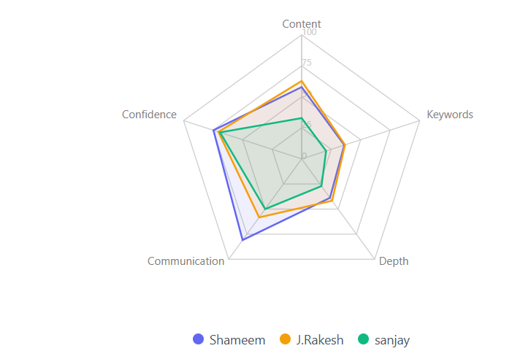
Fig 6. Candidates of session 1
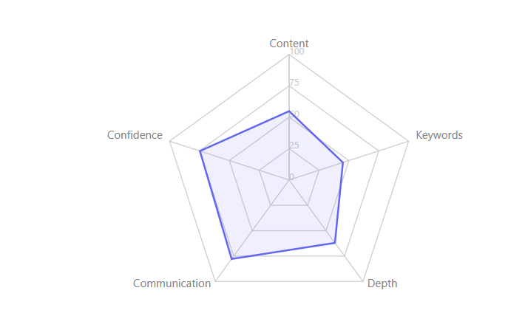
Fig 7. Candidate in session 2

V. Conclusion
The AI-Based Realistic HR Interview Simulator shows how well-developed AI can result in making interview preparation more affordable to all people, not the ones having resources or professional guidance. Rhythmic application of LLMs, PPO-based reinforcement learning, multimodal behavior analysis, SHAP explanability, and live-fairness regulation provide the system with a lifelike and transparent interview experience. Its multi-model question generation and semantic filtering make every interview unique and adaptive and the reinforcement learning agent changes the level of difficulty of the questions depending on the responses of the candidates.
The scoring of the evaluation system is accurate, and SHAP explainability layer enables the applicants to know the logic behind their scores rather than being given an end score. Simultaneously, fairness auditing module keeps the bias under check to advance a more accountable and honest AI system. The tests with several parallel applicants can also demonstrate the ability of the platform to be used in a real-world scenario.
The effectiveness can be increased in the future by adding multilingual support, more detailed behavioral analysis, and increased role coverage. On the whole, this system appears to be more transparent, fair, and candidate-oriented in terms of AI-prepared interview.

References
- S. Sarumathi, R. L. Gowthaman, A. Sultana, and M. B. Sabareesh, "AI-Enhanced HR Interview Simulation for Realistic Candidate Assessment," in Proc. 3rd Int. Conf. Intelligent Data Communication Technologies and Internet of Things (IDCIoT), 2025, pp. 1089-1095, doi: 10.1109/IDCIOT64235.2025.10915193.
- G. Shivajirao et al., "AI Powered Virtual Job Interview Simulator using Natural Language Processing," in Proc. Int. Conf. on Emerging Trends in Engineering (ICOEI), 2025.
- L. K. Lee et al., "Utilizing Virtual Reality and Generative AI Chatbot for Job Interview Simulations," in Proc. Int. Symposium on Educational Technology (ISET), 2024.
- S. Ranjan Das, P. Sarkar, S. Patil, R. Sharma, S. Aggarwal, and M. Lourens, "Artificial Intelligence in Human Resource Management: Transforming Business Practices," in Proc. 10th IEEE Uttar Pradesh Section Int. Conf. Electrical, Electronics and Computer Engineering (UPCON), Gautam Buddha Nagar, India, 2023, pp. 1699-1703, doi: 10.1109/UPCON59197.2023.10434524.
- M. Laiq and O. Dieste, "Chatbot-based Interview Simulator: A Feasible Approach to Train Novice Requirement Engineers," in Proc. Requirements Engineering Education and Training (REET), 2020.
- P. K. Mishra et al., "AI-Driven Virtual Mock Interview Development," in Proc. Int. Conf. on Sustainable Computing and Intelligent Systems (SCISIS), 2024.
- K. Somasundaram et al., "AI-Powered Virtual Interview System: An Intelligent Approach to Automated Candidate Assessment using NLP and Machine Learning," in Proc. Int. Conf. on Innovative Systems and Communication (ICISC), 2025.
- B. Jadhav et al., "A Comprehensive Study and Implementation of the Mock Interview Simulator with AI and Pose-Based Interaction," in Proc. Int. Conf. on Computer Graphics and Utilities (IC-CGU), 2024.
- A.B. Nandrajog et al., "Multimodal CNN-GRU Approach for Job Interview Assessment," in Proc. Int. Conf. on Novel Innovations in Technology (CONIT), 2025.
- C. Huang, Z. Zhang, B. Mao, and X. Yao, "An Overview of Artificial Intelligence Ethics," IEEE Trans. Artificial Intelligence, vol. 4, no. 4, pp. 799-819, Aug. 2023, doi: 10.1109/TAI.2022.3194503.
- S. Achchab and Y. K. Temsamani, "Artificial Intelligence Use in Human Resources Management: Strategy and Operation's Impact," in Proc. 2nd IEEE Int. Conf. Pattern Recognition and Machine Learning (PRML), Chengdu, China, 2021, pp. 311-315, doi: 10.1109/PRML52754.2021.9520719.
- I. Ozkaya, "Application of Large Language Models to Software Engineering Tasks: Opportunities, Risks, and Implications," IEEE Software, vol. 40, no. 3, pp. 4-8, May-June 2023, doi: 10.1109/MS.2023.3248401.

