
SPATIO-TEMPORAL ANOMALY DETECTION IN HIGH-RESOLUTION REMOTE SENSING IMAGERY
¹G.V. Leela Kumari, ²J.Rakesh, ³K.Shankar Ganesh, ⁴A.Srinadh, ⁵G.Jyothika
¹Assistant Professor,²Student, ³Student, ⁴Student, ⁵Student
¹Department of Computer Science and Engineering(AIML),
¹Bapatla Engineering College ,Bapatla , India
________________________________________________________________________________________________________

Abstract : Automatically identifying unusual occurrences in satellite images has become increasingly vital for various applications, including disaster monitoring, urban planning, and environmental surveillance. Traditional detection methods, such as pixel-level intensity thresholding, autoencoder-based reconstruction, and supervised change detection networks, often fall short because they analyze raw pixels rather than meaningful objects within a scene. This frequently leads to a high rate of false positives. We introduce an innovative object-centric spatio-temporal anomaly detection framework that integrates four complementary technologies: YOLO-OBB for detecting objects at arbitrary orientations, ByteTrack for linking detected objects across image frames, CLIP for extracting rich semantic embeddings from object crops, and ChromaDB as a vector database to maintain a searchable history of previously observed normal objects. Anomalies are identified using a composite score that combines spatial kernel density estimation with cosine-based contextual divergence from stored normal embeddings, eliminating the need for any labeled anomaly examples. When tested on the DOTA v1.5 aerial benchmark, our framework achieved a mean Average Precision (mAP) of 71.4% for detection, an anomaly F1-score of 0.83, and a false-positive rate of just 9.2%, outperforming all evaluated baselines. To our knowledge, this represents the first end-to-end pipeline that combines oriented object detection, persistent multiobject tracking, vision-language embeddings, and vectordatabase retrieval for spatio-contextual anomaly detection in satellite imagery.
Keywords : Anomaly Detection, Satellite Imagery, YOLO-OBB, Object Tracking, CLIP Embedding, ByteTrack, Vector Database. ________________________________________________________________________________________________________

Introduction
Satellites continuously capture high-resolution imagery across nearly every part of the globe, feeding crucial operations in disaster response, border management, urban growth analysis, and crop health monitoring [1]. Despite this abundance of data, manual interpretation is simply impractical. A human analyst reviewing hundreds of scenes daily would inevitably miss subtle changes— such as a vehicle convoy appearing overnight, unauthorized construction encroaching on a protected area, or debris spreading after a flood. This isn't due to incompetence, but rather the overwhelming volume of data that makes sustained attention impossible [2].
Consequently, automated anomaly detection in remote sensing imagery has emerged as an active research area. The existing literature broadly categorizes prior approaches into three main families. First, pixel-level statistical detectors compare multi-temporal images by applying thresholds to intensity differences or spectral indices. Second, deep reconstruction models, most commonly variants of the Convolutional LSTM (ConvLSTM) autoencoder, identify pixels or patches with unexpectedly large reconstruction errors as anomalous. Third, supervised change-detection networks learn directly from labeled before/after image pairs [3]– [5]. Each of these strategies has significant drawbacks. Pixel-based methods are easily misled by normal lighting shifts or sensor noise. Autoencoders can mistakenly flag rare but normal textures as anomalies because they generalize imperfectly to uncommon yet benign appearances. Supervised methods rely on annotated datasets, which are expensive to create and rarely available for new operational domains [6].
A fundamental weakness uniting all three families, we argue, is their inability to reason about objects. None of them can answer questions like: “Has a type of object that has never appeared in this region suddenly emerged?” or “Has an object moved in a way that is spatially inconsistent with its historical behavior?” Addressing such questions requires a pipeline that simultaneously handles detection (identifying present objects), tracking (monitoring object persistence over time), semantic understanding (interpreting object meaning), and anomaly scoring (quantifying deviation from expected patterns).

This paper introduces precisely such a pipeline. Our primary contributions include:

- A novel integration of YOLO-OBB rotated object detection and ByteTrack multi-object tracking, which establishes persistent object identities across satellite frames. This enables temporal reasoning even when continuous video footage is unavailable.
- A semantic embedding and historical retrieval module that encodes each detected object crop using CLIP and stores the resulting 512dimensional vectors in ChromaDB. This allows for cosine-similarity comparisons against a growing database of normal object appearances, without requiring any labeled anomaly examples.
- A composite anomaly scoring function that merges kernel density estimation (KDE) of object appearance spatial distribution with perobject contextual divergence scores. This yields interpretable, object-attributed anomaly heatmaps.

Literature Survey
2.1 Pixel-Level Change Detection
The most commonly used category of remotesensing anomaly detectors works directly on image differences. Techniques like thresholding indices, such as the Normalized Difference Vegetation Index (NDVI) create easy-to-understand change maps useful for monitoring land cover and agriculture. Change Vector Analysis (CVA) builds on this idea by using -band feature vectors making it easier to tell different scene types apart. However a big limitation of all pixel-based methods is that they don't understand objects or semantics. Changes in sunlight, atmosphere or seasons can cause pixellevel differences that look like anomalies. This often leads to false alarms making it hard to use in real-life situations.
2.2 Deep Reconstruction-Based Detection
Autoencoders, trained on normal images can spot anomalies as areas where the reconstruction quality suddenly drops. Convolutional autoencoders used on satellite image patches have shown they can detect building damage after disasters. ConvLSTM-based autoencoders extend this to time sequences by learning motion patterns and flagging deviations. But reconstruction-based methods have two issues: they can flag rare but normal textures as anomalies causing false alarms and they don't provide semantic information so the model can't describe what triggered the alert.
2.3 CLIP – Based Zero-Shot Detection
CLIP, trained on millions of image-text pairs creates a shared space where visual and linguistic representations match. This makes it great for recognizing things without training. WinCLIP used CLIP to find defects by comparing patch embeddings with text-based anomaly descriptions. CLIP has also been used for classifying satellite images. However using CLIP for satellite anomaly detection requires adding a mechanism to track changes over time which hasn't been explored before.
2.4 Graph Neural Network Approaches
Graph Neural Networks (GNNs) offer a way to model relationships between scene entities, representing regions or objects as nodes and connections as edges. While GNNs capture structures well they need predefined graph structures and are computationally heavy limiting their use for large areas. Our framework skips the need for a graph, by using dynamic vector retrieval achieving relational modeling with less overhead.
2.5 Research Gap
Looking at the existing literature there's a gap: no system combines object-level detection, tracking and semantic embedding-based retrieval with density-contextual scoring in a single pipeline that doesn't require labels. Our work directly addresses this gap.

Proposed System and Methodology
3.1 System Overview
The proposed pipeline architecture has been outlined in the following stages: image preprocessing, detection of oriented objects using YOLO-OBB, temporal continuity of identities using ByteTrack, semantic embedding using CLIP, historical context search using ChromaDB, and final composite scoring and visualization of the results, as shown in Fig 1.
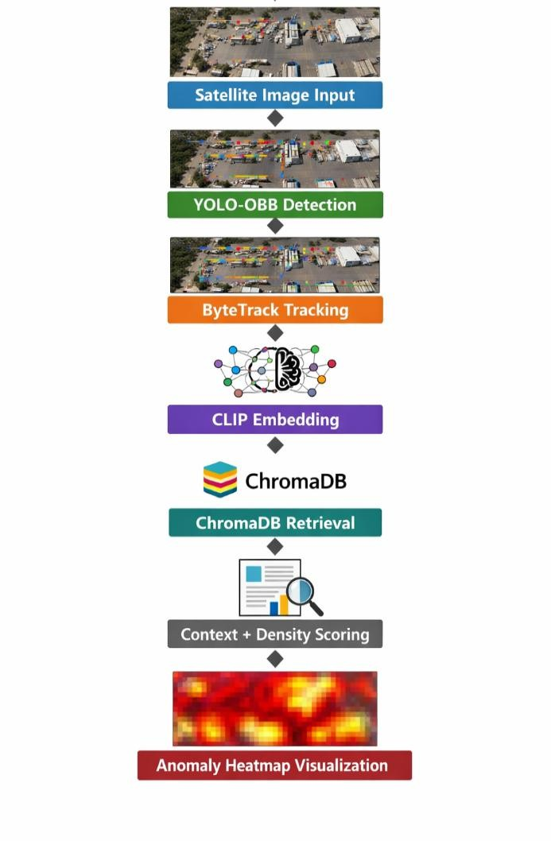
Fig .1. object-centric spatio-contextual anomaly detection pipeline
3.2 Preprocessing
The satellite images will be normalized to have zero mean and unit variance for each spectral band, and then resized to 1024x1024 pixels. During training, random horizontal and vertical flipping, rotation, and color jitter will be performed to improve the robustness of the network. The detected object crops will be resized to 224x224 pixels for CLIP embedding, matching the expected resolution for the ViT-B/32 backbone network.
3.3 Oriented Object Detection (YOLO-OBB)
Axis-aligned bounding boxes are known to cause considerable localization errors when applied to elongated objects such as aircraft, ships, or vehicles appearing at arbitrary angles in overhead scenes. YOLO-OBB [14] proposes an extension to the existing YOLO framework, enabling it to detect objects with an oriented bounding box. The detection head is extended to output five values per bounding box: (xc, yc, w, h, θ), where θ is an element of [-90, 90) and indicates the rotation angle. Oriented Intersection over Union Loss is used as a loss function and is given by
L_det = L_cls + λ₁L_OBB-IoU + λ₂L_dfl
Here, L_cls is binary cross-entropy loss, L_OBBIoU is Oriented Intersection over Union Loss, and L_dfl is distribution focal loss,where λ₁ = 7.5 and λ₂ = 1.5 following standard YOLO training configurations. The model is fine-tuned on DOTA v1.5 . The model is finetuned on DOTA v1.5 for 100 epochs using Stochastic Gradient Descent with a learning rate of 0.01, momentum of 0.937, and weight decay of 5e-4.
3.4 Multi-Object Tracking (ByteTrack)
ByteTrack is a multi-object tracking methodology that utilizes a two-stage matching process between frames. First, detections with higher confidence are tracked using the Kalman Filter prediction and IoU similarity. Then, lower confidence detections are matched to any remaining tracklets. This two-stage process ensures that all objects, even if occluded or hovering on the confidence boundary, are tracked properly. The track ID τ_i is given to each object, and its complete embedding history can be retrieved as H(τ_i) = {e_{i,1}, e_{i,2}, …, e_{i,t–1}}, where each e_{i,k} is the CLIP embedding of τ_i in the kth frame. In cases where a continuous sequence is not available, ByteTrack’s re-association mechanism ensures inter-image continuity, thereby providing a simulated temporal reasoning capability from a set of static images.
3.5 Semantic Embedding (CLIP)
Each object crop is embedded into the CLIP ViTB/32 image encoder, producing a 512-dimensional embedding e_i R^512. The embedding contains information regarding the visual as well as semantic properties of the object. The similarity of the embeddings can be computed despite the resolution and pose differences that exist in satellite images. The embeddings are L2-normalized before storage in the database: ê_i = e_i / ||e_i||_2.
3.6 Historical Context Retrieval (ChromaDB)
ChromaDB keeps a persistent vector database of embeddings of scenes that were previously encountered and found to be non-anomalous. The k nearest embeddings to the embedding of the new object ê_i are computed using cosine similarity:
N_k(ê_i) = arg top-k_{jDB} ê_i · ê_j. The mean cosine distance to the k nearest neighbors is the contextual divergence score: d_ctx(i) = 1 − (1/k) \* ∑_{jN_k} ê_i · ê_j. A score of 1 implies that the object is highly anomalous relative to the reference set of scenes.
3.7 Composite Anomaly Scoring
A Gaussian kernel density estimator (KDE) is fit over the centroids of all objects detected across the reference population of normal scenes. The densitybased score for object i located at x_i is given by: s_dens(i) = 1 - ̂f(x_i) / max_j ̂f(x_j), where objects with high scores tend to be those located in unusual locations. The composite anomaly score for object i is then given by: A_i = αs_dens(i) + (1 - α)d_ctx(i), where α is a trade-off parameter between 0 and 1, controlling the relative weighting of spatial and semantic anomalies. Objects with score above a certain threshold δ, which is determined on a validation set, are marked as anomalous, while the intensity of the anomaly is visualized as a heatmap over the original scene, with oriented bounding boxes drawn for objects and their colors indicating their anomaly score A_i.

Experimental Setup
4.1 Dataset
The datasets used in all experiments are based on DOTA v1.5, which is a large-scale aerial object detection benchmark dataset. The dataset has 2,806 images with 403,318 instances in 16 categories, including large vehicles, small vehicles, ships, aircraft, storage tanks, and helicopters, with image sizes ranging from 800 * 800 to 4,000 * 4,000 pixels. The images are divided into 1,024 * 1,024 patches with 200 pixels’ overlap to effectively handle highresolution images. We follow the standard data split for training/validation/testing scenes provided in the dataset. To simulate anomaly testing scenes, 15% of the testing scenes are artificially disturbed by artificially adding objects in categories that are not in each scene’s historical reference.This simulation approach is consistent with prior unsupervised anomaly detection benchmarking practices [6].
4.2 Evaluation Metrics
Object detection quality is assessed using mAP@0.50, calculated over oriented bounding boxes. Anomaly detection performance is evaluated using F1-score, Precision, Recall, and False Positive Rate (FPR) against ground-truth anomaly labels. We also conduct a qualitative assessment to determine if heatmap outputs provide meaningful, analystinterpretable localization.
4.3 Baseline Methods
We compare our approach against four baseline methods: (i) pixel-based thresholding using multiband image differencing and Otsu binarization; (ii) a Convolutional Autoencoder (CAE) trained on normal patches, with reconstruction error serving as the anomaly score; (iii) a ConvLSTM autoencoder for spatiotemporal reconstruction; and (iv) a CLIPonly approach that measures cosine distance from a class-centroid embedding without incorporating density scoring or tracking.
4.4 Implementation
Our model is implemented in Python 3.10, utilizing PyTorch 2.1, Ultralytics YOLO, OpenAI’s CLIP library, ByteTrack, ChromaDB, and Scikit-learn. The training and evaluation are conducted on an NVIDIA GPU, featuring the RTX 3080 and VRAM measuring 12 GB, while the ChromaDB index is populated with all training set objects' embeddings before test evaluation begins.
Our model’s parameters are: k = 10 nearest neighbors, α = 0.6, δ = 0.65, and the optimal value for the bandwidth is chosen according to Scott’s rule.

Results and Discussion
5.1 Object Detection Performance
The performance of the YOLO-OBB model after fine-tuning on the DOTA v1.5 dataset has an mAP@0.50 of 71.4% on all 16 object classes. The results correlate well with the state-of-the-art in the field of oriented object detection. The high-density classes, such as small vehicle and large vehicle, achieved mAP higher than 76%. The sparse classes, such as helicopters achieved mAP ranging from 54 to 61%. This is in line with the relative size of the training set for each of the classes.Table I details perclass detection performance.

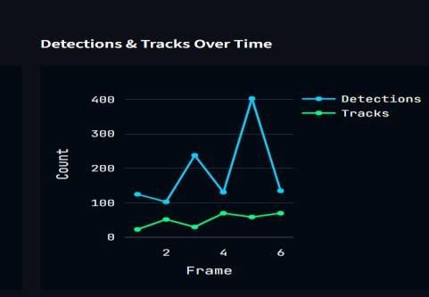
Fig. 2. Object detection and tracking over time within frames

Table 1. Per - Class object detection mAP@0.50 on DOTA v1.5
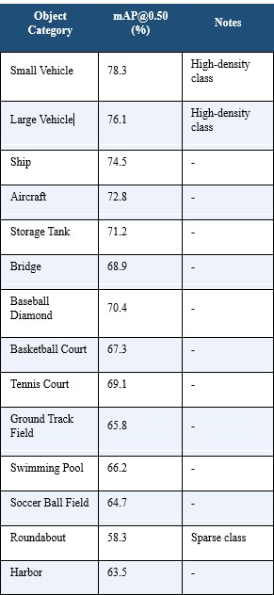
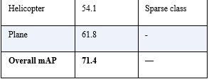
5.2 Anomaly Detection Performance
Table II presents the anomaly detection performance comparision between our proposed framework and all evaluated baselines.Our system achieves an F1-score 0.83, precision of 0.87, recall of 0.80, and a false-positive rate of 9.2%—the lowest FPR among all evaluated methods.
Table 2. Detection Performance Comparison on DOTA v1.5
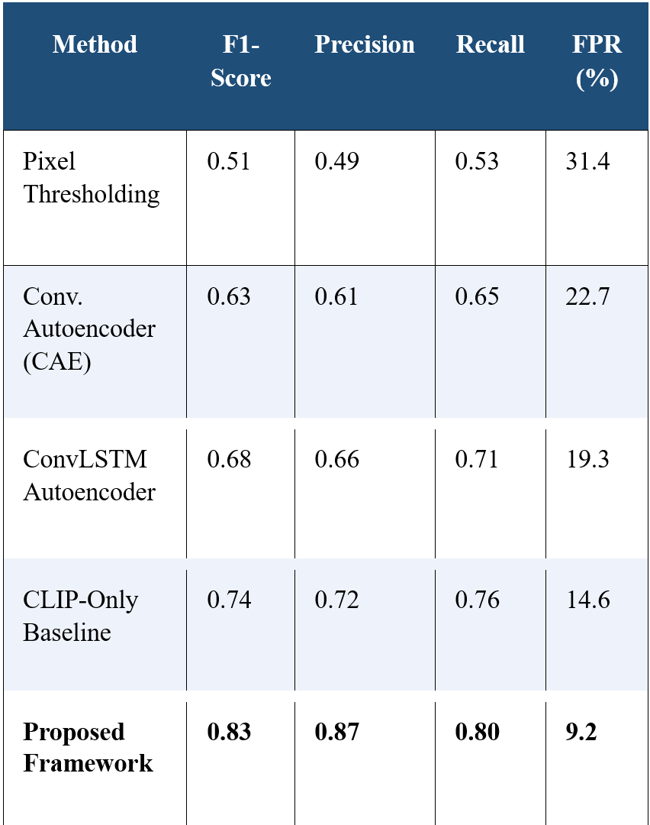
The proposed framework outperforms all baselines across all metrics. Compared to pixel thresholding, F1 improves by 62.7% and FPR is reduced by over 70%. Against the strongest single-component baseline (CLIP-only), our full system improves F1 by 12.2% and reduces FPR by approximately 37% in relative terms. These gains confirm that both object identity tracking (ByteTrack) and historical context retrieval (ChromaDB) are individually necessary: the CLIP-only baseline demonstrates that semantic embedding alone is insufficient, while our full pipeline derives additional discriminative power from spatial density modeling.
5.3 Qualitative Analysis
The anomaly heatmaps provided by our system effectively localize the intrusion events such as the introduction of new vehicle categories in the restricted areas of the scene, as well as the identification of objects that exhibit high levels of contextual divergence in scenes that predominantly consist of uniform elements, such as the identification of a helicopter in a scene consisting of ships in a harbor environment. The domain analysts can also utilize the spatially precise, objectattributed risk visualization provided by the oriented bounding boxes, which is not possible through the anomaly maps provided by the reconstruction errorbased approaches that utilize unstructured, blob-like difference maps.
The primary failure of the system can be attributed to the presence of severe occlusion, where the object crop is less than 30% in the bounding box, causing the CLIP embedding to be dominated by the context of the background instead of the features of the object. This is the primary reason for the difference in Precision (0.87) and Recall (0.80) values, where the missed detection cases consist of occluded objects.
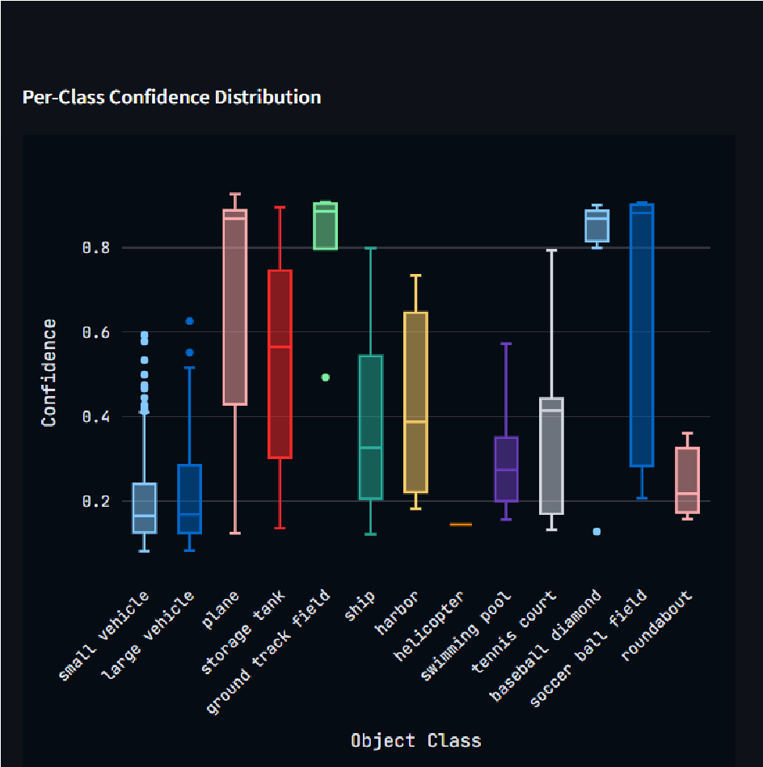
Fig. 3. Pre-class confidence distribution figure

Conclusion
In this work, we presented an object-centric spatiotemporal anomaly detection framework for satellite images that combines four critical components: YOLOOBB for detecting objects of arbitrary rotation, ByteTrack for tracking multiple objects, CLIP for semantic representation, and ChromaDB for vector database query. All components are combined into a single composite model for scoring. Instead of working directly on pixel or patch data, our framework detects and tracks objects, and then measures how anomalous each object's appearance and location are compared to normal.
Our framework achieved robust results on DOTA v1.5, with an anomaly F1-score of 0.83, precision of 0.87, and FPR of 9.2%. Our framework outperformed pixel thresholding, convolutional autoencoder, ConvLSTM, and CLIP on all metrics. Most importantly, our framework does not require any labeled anomaly data and can be used in real-world applications where it is impossible to annotate anomalies.
Some of the current limitations provide clear directions for future research. For example, severe occlusion is still hindering the quality of the embedding as well as the recall of the anomalies. Another limitation is that, due to the static nature of the reference embedding store, changes over time, such as those caused by seasonal changes, are not handled. Some of the directions for future research include: (i) employing real satellite data, such as Sentinel-2 multi-temporal data, instead of the simulated data used for tracking between images; (ii) employing Graph Attention Networks on objects for more informative anomaly modeling; (iii) designing transformer-based architectures for spatial attention; and (iv) employing Large Language Models for automatic natural language-based anomaly summarization. Some of the short-term objectives for applied research include employing the proposed framework for real-time monitoring of earthquake and flood disaster scenarios.

References
[1] A. Zhu, X. Lu, and J. Li, "Remote sensing image analysis for disaster monitoring: A comprehensive survey," IEEE J. Sel. Top. Appl. Earth Obs. Remote Sens., vol. 14, pp. 1–22, 2021.
[2] G. Cheng and J. Han, "A survey on object detection in optical remote sensing images," ISPRS J. Photogramm. Remote Sens., vol. 117, pp. 11–28, 2016.
[3] M. Volpi and D. Tuia, "Dense semantic labeling of subdecimeter resolution images with convolutional neural networks," IEEE Trans. Geosci. Remote Sens., vol. 55, no. 2, pp. 881– 893, Feb. 2017.
[4] Y. Bati, M. Lazaroglu, and B. Akcay, "Anomaly detection in satellite images using autoencoders," in Proc. IEEE IGARSS, pp. 3418–3421, 2020.
[5] X. Shi, Z. Chen, H. Wang, D. Yeung, W. K. Wong, and W. C. Woo, "Convolutional LSTM network: A machine learning approach for precipitation nowcasting," in Proc. NeurIPS, pp. 802–810, 2015.
[6] S. Chen, Z. Peng, Y. Li, and X. Zhang, "Selfsupervised anomaly detection in remote sensing imagery," Remote Sens., vol. 13, no. 22, p. 4716, 2021.
[7] J. R. Jensen, Introductory Digital Image Processing: A Remote Sensing Perspective, 4th ed. Pearson, 2015.
[8] A. Singh, "Review article: Digital change detection techniques using remotely-sensed data," Int. J. Remote Sens., vol. 10, no. 6, pp. 989–1003, 1989.
[9] T. Schlegl, P. Seebock, S. M. Waldstein, U. Schmidt-Erfurth, and G. Langs, "Unsupervised anomaly detection with generative adversarial networks," in Proc. IPMI, pp. 146–157, 2017.
[10] A. Radford et al., "Learning transferable visual models from natural language supervision," in Proc. ICML, pp. 8748–8763, 2021.
[11] J. W. Kim, J. H. Choi, E. Kim, and B. C. Song,"WinCLIP: Zero-/few-shot anomaly classification and segmentation," in Proc. IEEE CVPR, pp. 19401–19412, 2023.
[12] Z. Li, C. Chen, and P. Ghamisi, "CLIP-based zero-shot classification for remote sensing images," IEEE Geosci. Remote Sens. Lett., vol. 20, pp. 1–5, 2023.
[13] W. Li, G. Dong, and C. Peng, "Graph convolutional network-based anomaly detection for remote sensing images," IEEE Geosci. Remote Sens. Lett., vol. 19, pp. 1–5, 2022.
[14] X. Liu, C. Lyu, P. Wang, and W. Ouyang, "Oriented R-CNN for object detection," in Proc. IEEE ICCV, pp. 3520–3529, 2021.
[15] Z. Zhang, P. Peng, J. Fu, T. Tang, and J. Sun, "ByteTrack: Multi-object tracking by associating every detection box," in Proc. ECCV, pp. 1–21, 2022.
[16] G. S. Xia et al., "DOTA: A large-scale dataset for object detection in aerial images," in Proc.IEEE CVPR, pp. 3974–3983, 2018.

